CHRONICLES

Modern Full-Stack Blogging Platform

A Major Project Report
Submitted by:
Field | Details
Student Name | Himanish Giri
Registration Number | 12406162
University | Lovely Professional University
Department | Department of Computer Science and Engineering
Submission Date | July 2026

Abstract
The rapid growth of digital content creation has led to an increasing demand for performant, scalable, and user-friendly blogging platforms. Traditional content management systems such as WordPress, while widely adopted, often suffer from monolithic architectures, security vulnerabilities arising from plugin ecosystems, and difficulty in adopting modern development workflows such as containerized deployment and continuous integration.
Chronicles is a modern, full-stack blogging platform designed and built from the ground up to address these limitations. The platform provides a rich, responsive single-page application (SPA) for content creation and consumption, backed by a type-safe RESTful API and a relational database.
Key Objectives: - Build a production-grade, full-stack web application using a modern TypeScript-centric technology stack. - Implement robust authentication supporting both email/password credentials and social login (Google, GitHub) via Firebase Authentication. - Design a normalized relational database schema with Prisma ORM for type-safe data access. - Containerize the entire application using Docker and Docker Compose for reproducible deployments. - Deploy to AWS EC2 and automate the release cycle with a GitHub Actions CI/CD pipeline.
Technology Stack: The frontend is built with React 19, Vite, TailwindCSS 4, and React Router 7. The backend uses Express 5, Prisma ORM, and MySQL 8.0, with Firebase Admin SDK for social token verification. The application is containerized with multi-stage Docker builds and orchestrated via Docker Compose. Continuous deployment is automated through GitHub Actions, which triggers a remote deployment script on an AWS EC2 instance via SSH.
Outcomes: The resulting platform is a fully functional, production-deployed blogging application featuring blog creation with a rich text editor, category and tag management, bookmark and trending systems, dark/light theme support, user profile management, and a complete password reset flow via email. The system is deployed on AWS EC2 with automated zero-downtime deployments triggered on every push to the main branch.

Table of Contents
- Chapter 1: Introduction
  - 1.1 Problem Statement
  - 1.2 Need for the System
  - 1.3 Objectives
  - 1.4 Scope
  - 1.5 Expected Outcomes
- Chapter 2: Literature Survey
  - 2.1 Existing Platforms
  - 2.2 Comparative Analysis
  - 2.3 Advantages of Chronicles
- Chapter 3: System Analysis
  - 3.1 Functional Requirements
  - 3.2 Non-Functional Requirements
  - 3.3 User Roles
  - 3.4 Use Cases
  - 3.5 Constraints
  - 3.6 Assumptions
- Chapter 4: System Design
  - 4.1 Overall Architecture
  - 4.2 Deployment Architecture
  - 4.3 Authentication Flow
  - 4.4 Docker Architecture
  - 4.5 Database ER Diagram
  - 4.6 Sequence Diagrams
  - 4.7 CI/CD Pipeline
  - 4.8 Component Diagram
  - 4.9 Directory Structure
- Chapter 5: Technology Stack
- Chapter 6: Implementation
- Chapter 7: Database Design
- Chapter 8: Security
- Chapter 9: Testing
- Chapter 10: Deployment
- Chapter 11: Results
- Chapter 12: Future Enhancements
- Chapter 13: Conclusion
- References
- Appendices

Chapter 1: Introduction

1.1 Problem Statement
The modern web demands content platforms that are fast, secure, and maintainable. Traditional blogging solutions like WordPress rely on monolithic PHP architectures with server-rendered pages, extensive plugin dependencies, and shared hosting environments. These designs introduce several problems:
- Performance degradation due to server-side rendering on every request and bloated plugin stacks.
- Security vulnerabilities arising from a vast ecosystem of third-party plugins with inconsistent maintenance.
- Difficult DevOps workflows — deploying changes requires manual FTP uploads or SSH sessions, with no built-in CI/CD pipeline.
- Tight coupling between the content layer and the presentation layer, making it difficult to serve content across multiple clients (web, mobile, API consumers).
Chronicles was conceived to solve these problems by building a blogging platform that treats the frontend and backend as independent, stateless services, connected through a well-defined REST API, and deployed as Docker containers with a fully automated CI/CD pipeline.

1.2 Need for the System
- Decoupled Architecture: A clear separation between the React SPA frontend and the Express API backend enables independent scaling, testing, and deployment of each layer.
- Type Safety End-to-End: Using TypeScript on both the frontend and backend, along with Zod for runtime validation and Prisma for type-safe database queries, eliminates entire classes of bugs at compile time.
- Modern Authentication: Supporting Firebase-based social logins (Google, GitHub) alongside traditional email/password authentication provides a flexible, industry-standard authentication flow.
- Containerized Deployment: Docker containers guarantee that the application behaves identically in development and production, eliminating the “works on my machine” problem.
- Automated Deployments: A GitHub Actions CI/CD pipeline ensures that every push to main is automatically built, tested, and deployed to the production EC2 instance without human intervention.

1.3 Objectives
- Design and develop a full-stack blogging platform with a React 19 SPA and an Express 5 REST API.
- Implement hybrid authentication using Firebase (Google/GitHub social login) and JWT-based session management.
- Create a normalized relational database schema using Prisma ORM on MySQL 8.0.
- Containerize all services (frontend, backend, database, migrations) using multi-stage Docker builds.
- Deploy the application to AWS EC2 using Docker Compose.
- Automate the deployment lifecycle with GitHub Actions CI/CD.
- Implement security best practices: Helmet.js headers, CORS, rate limiting, bcrypt password hashing, and environment-based secret management.

1.4 Scope
The scope of this project covers:
- User Management: Registration, login (email and social), profile management, password change, and password reset via email.
- Content Management: Blog creation with a rich text editor, cover image upload (via Firebase Storage), category assignment, tag management, draft/publish workflow, and soft deletion.
- Content Discovery: Blog listing with search, category filtering, pagination, trending blogs (based on views within 7 days), featured blogs, and bookmark management.
- Commenting: Threaded comments with nested replies (self-referencing parent-child relationship).
- Theming: Dark mode and light mode toggle with localStorage persistence.
- DevOps: Docker Compose orchestration, multi-stage Docker builds, Nginx reverse proxy, and GitHub Actions CI/CD.
The following areas are explicitly out of scope for this version: - Real-time notifications (WebSocket) - Rich text formatting (WYSIWYG editor) - Admin dashboard for content moderation - HTTPS/TLS certificate management (planned for future phases)

1.5 Expected Outcomes
- A fully functional, deployed blogging platform accessible via a public IP address on AWS EC2.
- A clean, maintainable codebase organized into a layered architecture (Controllers → Services → Repositories → Prisma → MySQL).
- Automated deployments triggered by every push to the main branch.
- A comprehensive security posture covering authentication, authorization, input validation, rate limiting, and secret management.
- Production-quality Docker configuration with health checks, graceful shutdowns, and volume persistence.

Chapter 2: Literature Survey

2.1 Existing Platforms

2.1.1 Medium
Medium is a proprietary blogging platform known for its clean reading experience. However, it lacks self-hosting capabilities, limits free articles behind a paywall, and provides no control over the underlying technology stack. Content creators are locked into Medium’s ecosystem with no ability to customize the platform or own their data infrastructure.

2.1.2 Dev.to
Dev.to is an open-source community platform built on Ruby on Rails (Forem). While it provides an excellent developer community, its monolithic Rails architecture makes self-hosting complex. The platform is optimized for community-driven content rather than individual blogging needs, and customization requires deep knowledge of the Ruby ecosystem.

2.1.3 Hashnode
Hashnode offers a headless CMS approach with a GraphQL API. While modern in its API design, Hashnode is primarily a hosted service. Self-hosting requires their enterprise plan. The platform’s strength is its community features, but it provides limited control over the deployment infrastructure.

2.1.4 Traditional CMS (WordPress)
WordPress powers over 40% of the web but carries significant technical debt. Its PHP-based architecture, reliance on server-side rendering, and vast plugin ecosystem create security and performance challenges. Deploying WordPress in a containerized, CI/CD-driven workflow requires significant custom tooling that the platform was not designed for.

2.2 Comparative Analysis
Feature | Chronicles | Medium | Dev.to | Hashnode | WordPress
Architecture | Decoupled SPA + REST API | Monolithic | Monolithic (Rails) | Headless CMS | Monolithic (PHP)
Language | TypeScript (full-stack) | Proprietary | Ruby + JS | Node.js + GraphQL | PHP
Self-Hosting | ✅ Full control | ❌ | ⚠️ Complex | ⚠️ Enterprise only | ✅
Containerized | ✅ Docker Compose | ❌ | ⚠️ Manual | ❌ | ⚠️ Manual
CI/CD Built-in | ✅ GitHub Actions | N/A | ❌ | ❌ | ❌
Social Auth | ✅ Firebase (Google, GitHub) | ✅ | ✅ | ✅ | ⚠️ Plugin
Type Safety | ✅ End-to-end TypeScript | N/A | ❌ | Partial | ❌
API-First | ✅ REST API | ❌ | Partial | ✅ GraphQL | ⚠️ REST Plugin
ORM | Prisma (type-safe) | N/A | ActiveRecord | N/A | None (raw SQL)

2.3 Advantages of Chronicles
- Full-Stack TypeScript: A single language across the entire stack reduces context switching, enables shared type definitions, and catches errors at compile time.
- API-First Design: The decoupled architecture allows the React frontend to be replaced with any client (mobile app, CLI, third-party integration) without modifying the backend.
- Production-Ready DevOps: Docker Compose with health checks, multi-stage builds, Nginx reverse proxy, and automated GitHub Actions deployments — all built into the project from the beginning, not bolted on as an afterthought.
- Modern Security Stack: Firebase for social authentication, bcrypt for password hashing, JWT for stateless session management, Helmet.js for security headers, Zod for input validation, and tiered rate limiting — all implemented as first-class concerns.
- Reproducible Environments: Docker containers ensure that development, staging, and production environments are byte-identical, eliminating environment-specific bugs.

Chapter 3: System Analysis

3.1 Functional Requirements

FR-1: User Authentication
- Users can register with name, email, and password.
- Users can log in with email/password or via Google/GitHub social login (Firebase).
- The system issues JWT access tokens (15-minute expiry) and refresh tokens (7-day expiry).
- Users can log out, which revokes all refresh tokens.
- Users can request a password reset via email.

FR-2: Blog Management
- Authenticated users can create blog posts with title, content, excerpt, cover image, category, tags, and status (draft/published).
- The system auto-generates URL-friendly slugs from titles, appending a random suffix on collision.
- The system auto-calculates estimated read time (words / 200 WPM).
- Authors can edit and soft-delete their own blogs.
- Admin users can edit or delete any blog.

FR-3: Content Discovery
- Public users can browse published blogs with pagination (default 10 per page).
- Users can search blogs by title, excerpt, or content.
- Users can filter by category.
- Sorting options: latest (by publish date), popular (by views), trending (views within 7 days).
- The landing page displays featured blogs and trending blogs.

FR-4: Bookmarking
- Authenticated users can bookmark/unbookmark blogs (toggle operation).
- Users can view all their bookmarked blogs from the dashboard.

FR-5: Commenting
- Authenticated users can comment on published blogs.
- Comments support nested replies (self-referencing parentId).
- Soft deletion is supported for comments.

FR-6: User Profile
- Users can view and update their profile (name, bio, avatar, social links).
- Users can change their password (requires current password verification).

FR-7: Theming
- Users can toggle between dark mode and light mode.
- Theme preference is persisted in localStorage.

3.2 Non-Functional Requirements
ID | Requirement | Implementation
NFR-1 | Performance | Nginx gzip compression, static asset caching (1 year), React SPA (no full page reloads)
NFR-2 | Security | Helmet.js security headers, CORS whitelist, bcrypt (12 salt rounds), JWT, rate limiting
NFR-3 | Scalability | Stateless backend (horizontal scaling possible), Docker containers
NFR-4 | Reliability | Docker health checks, graceful shutdown handlers (SIGTERM/SIGINT), container restart policies
NFR-5 | Maintainability | Layered architecture (Controller → Service → Repository), TypeScript, Zod validation
NFR-6 | Portability | Docker containers, environment variable configuration, no hardcoded secrets
NFR-7 | Availability | restart: unless-stopped policy on all Docker services, automated CI/CD re-deployment

3.3 User Roles
The system defines two roles in the Role enum within the Prisma schema:
Role | Permissions
USER | Register, login, create/edit/delete own blogs, comment, bookmark, manage profile
ADMIN | All USER permissions + edit/delete any blog
Authorization is enforced by the authorize() middleware, which checks req.user.role against the required roles for a given route.

3.4 Use Cases
# | Use Case | Actor | Description
UC-1 | Register Account | Guest | User creates an account with name, email, and password
UC-2 | Social Login | Guest | User logs in via Google or GitHub popup
UC-3 | Create Blog | USER | Author writes a blog with title, content, category, cover image
UC-4 | Browse Blogs | Guest/USER | User browses published blogs with search, filter, sort
UC-5 | Read Blog | Guest/USER | User reads a blog; view count increments
UC-6 | Bookmark Blog | USER | User bookmarks a blog for later reading
UC-7 | Comment on Blog | USER | User writes a comment or replies to an existing comment
UC-8 | Manage Profile | USER | User updates name, bio, avatar, social links
UC-9 | Reset Password | Guest | User requests a password reset email and sets a new password
UC-10 | Delete Blog | USER/ADMIN | Author or admin soft-deletes a blog

3.5 Constraints
- Database: The system uses MySQL 8.0 as the sole relational database. No NoSQL or caching layer is currently implemented.
- Image Storage: Cover images are uploaded to Firebase Storage from the client side. The backend only stores the resulting download URL.
- Email: Password reset emails are sent via Gmail SMTP. The system requires a valid Gmail app password.
- Single Region: The application is deployed to a single AWS EC2 instance. No multi-region or load-balanced deployment is implemented.

3.6 Assumptions
- The user has a modern browser that supports ES2020+ JavaScript.
- Docker and Docker Compose are available on the deployment target.
- A Firebase project is configured with Google and GitHub sign-in providers enabled.
- The EC2 instance has sufficient resources (at least 2 GB RAM recommended for Docker builds).

Chapter 4: System Design
This chapter presents the architectural diagrams that describe the Chronicles system. All diagrams are generated using Mermaid and are available as standalone .mmd files in the docs/diagrams/ directory.

4.1 Overall Architecture
The Chronicles platform follows a three-tier architecture with an Nginx reverse proxy fronting a React SPA and an Express API backed by MySQL.
graph TB
subgraph "Client Layer"
A["Browser / Client"]
end
subgraph "Reverse Proxy"
B["Nginx (Port 80)"]
end
subgraph "Frontend Container"
C["React 19 + Vite SPA"]
end
subgraph "Backend Container"
D["Express 5 API (Port 5000)"]
E["Prisma ORM"]
end
subgraph "Database Container"
F["MySQL 8.0"]
end
subgraph "External Services"
G["Firebase Auth"]
H["Firebase Storage"]
I["Gmail SMTP"]
end
A -->|"HTTP :3000"| B
B -->|"Static Files"| C
B -->|"/api/* Proxy"| D
D --> E
E -->|"TCP :3306"| F
A -->|"OAuth Popup"| G
A -->|"Image Upload"| H
D -->|"Verify ID Token"| G
D -->|"Send Reset Email"| I
Design Rationale: Nginx serves dual purpose — it delivers the pre-built React static assets for all non-API routes and reverse-proxies /api/* requests to the Express backend. This means the browser makes all requests to a single origin (port 3000), eliminating CORS issues in production and allowing the backend to remain on an internal Docker network without exposing its port to the host.

4.2 Deployment Architecture
graph TD
subgraph "Development"
DEV["Developer Workstation"]
end
subgraph "Version Control"
GH["GitHub Repository"]
GA["GitHub Actions Runner"]
end
subgraph "AWS Cloud"
subgraph "EC2 Instance - Ubuntu 24.04"
SSH["SSH Port 22"]
DC["Docker Compose"]
subgraph "Containers"
C1["Frontend - Nginx"]
C2["Backend - Node.js"]
C3["MySQL 8.0"]
end
end
SG["Security Group"]
end
DEV -->|"git push main"| GH
GH -->|"Trigger Workflow"| GA
GA -->|"SSH + deploy.sh"| SSH
SSH --> DC
DC --> C1
DC --> C2
DC --> C3
SG -.->|"Inbound: 22, 3000"| SSH

4.3 Authentication Flow
The application implements a dual authentication strategy: traditional email/password login and Firebase-based social login. Both flows converge into the same session management system (JWT access + refresh tokens).
sequenceDiagram
participant U as User
participant FB as Firebase Auth
participant FE as React Frontend
participant BE as Express Backend
participant DB as MySQL
Note over U,DB: Email/Password Login
U->>FE: Enter email + password
FE->>BE: POST /api/auth/login
BE->>DB: Find user by email
BE->>BE: bcrypt.compare(password, hash)
BE->>BE: generateAccessToken(JWT)
BE->>DB: Store RefreshToken
BE-->>FE: user, token, refreshToken
FE->>FE: localStorage.setItem token
Note over U,DB: Social Login (Google/GitHub)
U->>FB: signInWithPopup(provider)
FB-->>FE: Firebase ID Token
FE->>BE: POST /api/auth/social idToken
BE->>FB: verifyIdToken(idToken)
FB-->>BE: Decoded uid, email, provider
BE->>DB: Find or Create AuthIdentity + User
BE->>BE: generateAccessToken(JWT)
BE->>DB: Store RefreshToken
BE-->>FE: user, token, refreshToken
FE->>FE: localStorage.setItem token
Design Decision: Firebase handles the OAuth popup flow and provider-specific token exchange on the client side. The backend only receives and verifies the Firebase ID token, meaning the backend never handles OAuth credentials directly. This significantly reduces the attack surface and implementation complexity.

4.4 Docker Architecture
graph TB
subgraph "Docker Host - EC2"
subgraph "chronicles-app Network"
FE["chronicles-frontend<br/>Nginx 1.27-alpine<br/>Host:3000 → Container:80"]
BE["chronicles-backend<br/>Node 22-alpine<br/>Port 5000 internal"]
end
subgraph "chronicles-db Network"
BE2["chronicles-backend"]
MG["chronicles-migrate<br/>One-shot container"]
DB["chronicles-mysql<br/>MySQL 8.0<br/>Port 3306 internal"]
end
subgraph "Persistent Volume"
VOL["chronicles-mysql-data"]
end
end
FE -->|"/api/* proxy_pass"| BE
BE2 -->|"Prisma TCP"| DB
MG -->|"prisma migrate deploy"| DB
DB --- VOL
Key Design Decisions: - Two isolated networks: chronicles-app (frontend ↔ backend) and chronicles-db (backend ↔ database). The frontend container cannot reach the database directly. - One-shot migration container: The chronicles-migrate service runs prisma migrate deploy and then exits. The backend waits for it to complete successfully (service_completed_successfully) before starting. - Named volume: chronicles-mysql-data persists database files across container recreations. - Multi-stage builds: Both frontend and backend Dockerfiles use multi-stage builds to keep runtime images minimal (Node 22-alpine for backend, Nginx 1.27-alpine for frontend).

4.5 Database ER Diagram
The database schema consists of 9 tables, designed using Prisma ORM and deployed to MySQL 8.0.
erDiagram
User ||--o{ Blog : "authors"
User ||--o{ Comment : "writes"
User ||--o{ Bookmark : "bookmarks"
User ||--o{ RefreshToken : "has"
User ||--o{ PasswordResetToken : "requests"
User ||--o{ AuthIdentity : "authenticates via"
Blog ||--o{ BlogCategory : "categorized as"
Blog ||--o{ Comment : "receives"
Blog ||--o{ Bookmark : "bookmarked by"
Category ||--o{ BlogCategory : "applied to"
Comment ||--o{ Comment : "has replies"
User {
string id PK
string name
string email UK
string passwordHash
string avatar
string bio
enum role
json socialLinks
datetime createdAt
datetime updatedAt
datetime deletedAt
}
Blog {
string id PK
string title
string slug UK
string excerpt
string content
string coverImage
enum status
int readTime
int views
int likes
boolean isFeatured
json tags
string authorId FK
datetime publishedAt
datetime createdAt
datetime updatedAt
datetime deletedAt
}
Category {
string id PK
string name
string slug UK
string color
}
BlogCategory {
string blogId PK_FK
string categoryId PK_FK
}
Comment {
string id PK
string content
int likes
string authorId FK
string blogId FK
string parentId FK
}
Bookmark {
string userId PK_FK
string blogId PK_FK
datetime createdAt
}
AuthIdentity {
string id PK
string userId FK
string provider
string providerUserId
}
RefreshToken {
string id PK
string token UK
string userId FK
datetime expiresAt
datetime revokedAt
}
PasswordResetToken {
string id PK
string token UK
string userId FK
datetime expiresAt
datetime usedAt
}

4.6 Sequence Diagrams

4.6.1 Registration Flow
sequenceDiagram
participant U as User
participant FE as React Frontend
participant BE as Express Backend
participant DB as MySQL
U->>FE: Enter name, email, password
FE->>BE: POST /api/auth/register
BE->>BE: authLimiter (10 req / 15 min)
BE->>BE: validate(registerSchema)
BE->>DB: Check email uniqueness
DB-->>BE: null
BE->>BE: bcrypt.hash(password, 12)
BE->>DB: INSERT user
BE->>BE: generateAccessToken(JWT)
BE->>DB: Store RefreshToken
BE-->>FE: user, token, refreshToken
FE->>FE: localStorage.setItem token
FE-->>U: Redirect to Dashboard

4.6.2 Create Blog Flow
sequenceDiagram
participant U as User
participant FE as React
participant FS as Firebase Storage
participant BE as Express API
participant DB as MySQL
U->>FE: Fill title, content, category
U->>FE: Drag and drop cover image
FE->>FS: Upload image to Storage
FS-->>FE: Download URL
FE->>BE: POST /api/blogs
BE->>BE: authenticate (verify JWT)
BE->>BE: validate (Zod schema)
BE->>DB: Verify category exists
BE->>BE: generateUniqueSlug(title)
BE->>BE: calculateReadTime(content)
BE->>DB: INSERT blog + BlogCategory
DB-->>BE: Blog record
BE-->>FE: Blog response
FE-->>U: Redirect to blog page

4.6.3 Bookmark Toggle Flow
sequenceDiagram
participant U as User
participant FE as React
participant BE as Express API
participant DB as MySQL
U->>FE: Click bookmark icon
FE->>BE: POST /api/blogs/:id/bookmark
BE->>BE: authenticate middleware
BE->>DB: Find existing bookmark
alt Bookmark exists
BE->>DB: DELETE bookmark
BE-->>FE: bookmarked false
else No bookmark
BE->>DB: INSERT bookmark
BE-->>FE: bookmarked true
end
FE-->>U: Update bookmark icon

4.7 CI/CD Pipeline
graph TD
A["Developer pushes to main"] --> B["GitHub Actions Trigger"]
B --> C["ubuntu-latest Runner"]
C --> D["Checkout Code"]
D --> E["Configure SSH Key"]
E --> F["ssh-keyscan known_hosts"]
F --> G["SSH into EC2"]
G --> H["git pull origin main"]
H --> I["chmod +x scripts/deploy.sh"]
I --> J["Execute deploy.sh"]
subgraph "deploy.sh on EC2"
J --> K["docker compose down"]
K --> L["docker compose build"]
L --> M["docker compose up -d"]
M --> N["docker image prune -f"]
N --> O["Wait 20 seconds"]
O --> P["docker compose ps"]
P --> Q{"All services running?"}
Q -->|Yes| R["Deployment Successful"]
Q -->|No| S["Print logs and exit 1"]
end

4.8 Component Diagram
graph TB
subgraph "Frontend - React 19 SPA"
subgraph "Layouts"
ML["MainLayout"]
AL["AuthLayout"]
DL["DashboardLayout"]
end
subgraph "Public Pages"
P1["Landing"]
P2["BlogListing"]
P3["BlogDetail"]
P4["Categories"]
P5["Trending"]
P6["About"]
end
subgraph "Auth Pages"
P7["Login"]
P8["Register"]
P9["ForgotPassword"]
P10["ResetPassword"]
end
subgraph "Dashboard Pages"
P11["DashboardHome"]
P12["MyBlogs"]
P13["CreateBlog"]
P14["Profile"]
P15["Bookmarks"]
P16["Settings"]
end
subgraph "Contexts"
CTX1["AuthContext"]
CTX2["ThemeContext"]
end
end
subgraph "Backend - Express 5 API"
subgraph "Routes"
R1["/api/auth/*"]
R2["/api/blogs/*"]
R3["/api/categories/*"]
R4["/api/health"]
end
subgraph "Middleware"
M1["authenticate"]
M2["validate (Zod)"]
M3["rateLimiter"]
M4["errorHandler"]
end
subgraph "Services"
S1["authService"]
S2["blogService"]
S3["categoryService"]
end
subgraph "Repositories"
RP1["userRepository"]
RP2["blogRepository"]
RP3["categoryRepository"]
RP4["refreshTokenRepository"]
RP5["passwordResetRepository"]
end
end

4.9 Directory Structure
chronicles/
├── .github/
│ └── workflows/
│ └── deploy.yml # GitHub Actions CI/CD workflow
├── backend/
│ ├── prisma/
│ │ ├── schema.prisma # Database schema (9 models)
│ │ ├── migrations/ # SQL migration files
│ │ └── seed.ts # Database seeder
│ ├── src/
│ │ ├── config/
│ │ │ ├── database.ts # Prisma client singleton
│ │ │ ├── env.ts # Zod-validated environment config
│ │ │ └── firebaseAdmin.ts # Firebase Admin SDK init
│ │ ├── controllers/
│ │ │ ├── auth.controller.ts # Auth endpoint handlers
│ │ │ ├── blog.controller.ts # Blog endpoint handlers
│ │ │ └── category.controller.ts # Category endpoint handlers
│ │ ├── middleware/
│ │ │ ├── auth.middleware.ts # JWT auth + optional auth + RBAC
│ │ │ ├── error.middleware.ts # Global error handler
│ │ │ ├── rateLimiter.middleware.ts # Tiered rate limiting
│ │ │ └── validate.middleware.ts # Zod validation factory
│ │ ├── repositories/
│ │ │ ├── blog.repository.ts # Blog data access layer
│ │ │ ├── category.repository.ts # Category data access
│ │ │ ├── user.repository.ts # User data access
│ │ │ ├── refreshToken.repository.ts
│ │ │ └── passwordReset.repository.ts
│ │ ├── routes/
│ │ │ ├── index.ts # Route aggregator + health check
│ │ │ ├── auth.routes.ts # Auth route definitions
│ │ │ ├── blog.routes.ts # Blog route definitions
│ │ │ └── category.routes.ts # Category route definitions
│ │ ├── schemas/
│ │ │ ├── auth.schema.ts # Zod schemas for auth inputs
│ │ │ └── blog.schema.ts # Zod schemas for blog inputs
│ │ ├── services/
│ │ │ ├── auth.service.ts # Auth business logic
│ │ │ ├── blog.service.ts # Blog business logic
│ │ │ └── category.service.ts # Category business logic
│ │ ├── types/
│ │ │ └── index.ts # Shared TypeScript interfaces
│ │ ├── utils/
│ │ │ ├── apiResponse.ts # Standardized API responses
│ │ │ ├── email.ts # Nodemailer + password reset emails
│ │ │ ├── errors.ts # Custom error class hierarchy
│ │ │ ├── jwt.ts # JWT sign/verify utilities
│ │ │ └── slug.ts # Slug generation + read time calc
│ │ ├── app.ts # Express app setup + middleware
│ │ └── server.ts # Bootstrap, DB connect, graceful shutdown
│ ├── Dockerfile # Multi-stage build (build → runtime)
│ ├── docker-entrypoint.sh # Migration + seed script
│ └── package.json
├── frontend/
│ ├── src/
│ │ ├── components/ # 14 shared UI components
│ │ ├── config/
│ │ │ └── firebase.ts # Firebase client SDK init
│ │ ├── contexts/
│ │ │ ├── AuthContext.tsx # Auth state management
│ │ │ └── ThemeContext.tsx # Dark/light theme state
│ │ ├── hooks/
│ │ │ └── useDebounce.ts # Debounce hook for search
│ │ ├── layouts/
│ │ │ ├── MainLayout.tsx # Public pages layout
│ │ │ ├── AuthLayout.tsx # Login/register layout
│ │ │ └── DashboardLayout.tsx # Dashboard layout with sidebar
│ │ ├── pages/ # 17 page components
│ │ ├── routes/
│ │ │ └── index.tsx # React Router v7 configuration
│ │ ├── services/
│ │ │ ├── api.ts # Fetch-based API client
│ │ │ ├── authService.ts # Auth API calls
│ │ │ ├── blogService.ts # Blog API calls
│ │ │ ├── categoryService.ts # Category API calls
│ │ │ ├── socialAuthService.ts # Firebase social auth
│ │ │ └── storageService.ts # Firebase Storage uploads
│ │ ├── types/ # Frontend TypeScript types
│ │ ├── utils/ # Constants, formatters
│ │ ├── App.tsx # Root component
│ │ ├── main.tsx # Entry point
│ │ └── index.css # Global styles + theme variables
│ ├── Dockerfile # Multi-stage (Vite build → Nginx)
│ ├── nginx.conf # Nginx config: SPA + API proxy
│ └── package.json
├── scripts/
│ └── deploy.sh # EC2 deployment script
├── docs/
│ ├── architecture.md # Architecture documentation
│ ├── diagrams/ # Mermaid diagram source files
│ └── phase-*.md # Phase completion reports
├── docker-compose.yml # Service orchestration (4 services)
├── .env.example # Environment variable template
└── .gitignore

Chapter 5: Technology Stack

5.1 Frontend Technologies
Technology | Version | Purpose
React | 19.0.0 | UI component library with functional components and hooks
Vite | 6.3.5 | Build tool with HMR for development and optimized production builds
TypeScript | 5.7.3 | Static type checking across the entire frontend codebase
TailwindCSS | 4.1.8 | Utility-first CSS framework for responsive design
React Router | 7.5.0 | Client-side routing with nested layouts and SPA navigation
React Hook Form | 7.55.0 | Performant form management with uncontrolled components
Zod | 3.24.2 | Schema-based form validation (shared with backend)
TanStack React Query | 5.75.5 | Server-state management with caching, background refetching
Framer Motion | 12.15.0 | Animation library for page transitions and micro-interactions
Lucide React | 0.475.0 | Open-source SVG icon library
Firebase Client SDK | 12.15.0 | Social authentication (Google/GitHub popup) and Storage

5.2 Backend Technologies
Technology | Version | Purpose
Node.js | 22 (Alpine) | JavaScript runtime for the API server
Express | 5.1.0 | Minimal HTTP framework for RESTful APIs
TypeScript | 5.8.3 | Static type checking and compile-time safety
Prisma ORM | 6.9.0 | Type-safe database client with auto-generated types and migrations
MySQL | 8.0 | Relational database for structured data storage
Firebase Admin SDK | 13.10.0 | Server-side verification of Firebase ID tokens
JSON Web Tokens | 9.0.2 | Stateless authentication via signed access/refresh tokens
bcrypt | 5.1.1 | Password hashing with configurable salt rounds (12)
Helmet | 8.1.0 | HTTP security headers (CSP, HSTS, X-Frame-Options, etc.)
CORS | 2.8.5 | Cross-Origin Resource Sharing middleware
express-rate-limit | 7.5.0 | Tiered rate limiting (global, auth, password reset)
Zod | 3.25.36 | Runtime input validation for API request bodies/params/queries
Nodemailer | 6.10.1 | Email transport for password reset functionality
Slugify | 1.6.6 | URL-friendly slug generation from blog titles
Morgan | 1.10.0 | HTTP request logging middleware

5.3 DevOps Technologies
Technology | Purpose
Docker | Application containerization with multi-stage builds
Docker Compose | Multi-container orchestration (frontend, backend, MySQL, migrate)
Nginx | Reverse proxy, static file serving, gzip compression
AWS EC2 | Ubuntu 24.04 LTS cloud compute instance
GitHub Actions | CI/CD pipeline triggered on push to main
SSH | Secure remote access for automated deployments

Chapter 6: Implementation

6.1 Frontend Implementation

6.1.1 Application Structure
The React frontend uses a layout-based routing architecture with react-router-dom v7. Three layout components define the structural regions of the application:
- MainLayout: Used for public pages (Landing, BlogListing, BlogDetail, Categories, Trending, About). Includes the Navbar and Footer.
- AuthLayout: Used for authentication pages (Login, Register, ForgotPassword, ResetPassword). Provides a centered, focused layout without navigation.
- DashboardLayout: Used for authenticated user pages (DashboardHome, MyBlogs, CreateBlog, Profile, Bookmarks, Settings). Includes a sidebar navigation.

6.1.2 API Client
The frontend communicates with the backend through a lightweight fetch-based API client (services/api.ts):
async function request<T>(endpoint: string, options?: RequestInit): Promise<T> {
const token = localStorage.getItem('chronicles-token');
const res = await fetch(`${API_BASE_URL}${endpoint}`, {
headers: {
'Content-Type': 'application/json',
...(token && { Authorization: `Bearer ${token}` }),
},
...options,
});
if (!res.ok) {
const error = await res.json().catch(() => ({ message: 'Request failed' }));
throw new Error(error.message || `HTTP ${res.status}`);
}
const json = await res.json();
return json.data !== undefined ? json.data : json;
}
This wrapper automatically attaches the JWT access token from localStorage to every request and unwraps the standardized { success, data, message } API response format.

6.1.3 Authentication Context
The AuthContext manages global authentication state and provides login, register, loginWithGoogle, loginWithGitHub, and logout methods to all child components. On application mount, it checks for an existing token in localStorage and attempts to restore the session by calling GET /api/auth/me.

6.1.4 Theme System
The ThemeContext implements a dark/light mode toggle. The active theme is persisted to localStorage and applied by toggling a dark or light class on the <body> element. CSS variables defined in index.css are overridden based on the active theme class, enabling glassmorphism effects and proper color adaptation across both modes.

6.1.5 Cover Image Upload
The blog creation page supports drag-and-drop cover image uploads via Firebase Storage. The storageService.ts module uploads the file directly from the browser to Firebase and returns the public download URL, which is then included in the blog creation API request.

6.2 Backend Implementation

6.2.1 Layered Architecture
The backend follows a strict four-layer architecture:
Controller → Service → Repository → Prisma → MySQL
- Controllers handle HTTP request/response concerns only. They extract parameters, call services, and format responses.
- Services contain all business logic — validation rules, authorization checks, slug generation, read-time calculation, and data transformation.
- Repositories are thin data-access wrappers around Prisma that encapsulate query construction and relationship includes.
- Prisma generates a type-safe database client from the schema, handling SQL generation and connection pooling.

6.2.2 Middleware Pipeline
The Express middleware is applied in a specific order in app.ts:
app.use(helmet()); // 1. Security headers
app.use(cors({ origin })); // 2. CORS whitelist
app.use(morgan(...)); // 3. Request logging
app.use(express.json()); // 4. Body parsing (10kb limit)
app.use(cookieParser()); // 5. Cookie parsing
app.use('/api', globalLimiter); // 6. Rate limiting (100 req / 15 min)
app.use('/api', routes); // 7. API routes
app.use(errorHandler); // 8. Global error handler

6.2.3 Authentication Service
The authService implements six authentication operations:
- register: Validates input → checks email uniqueness → hashes password (bcrypt, 12 rounds) → creates user → issues tokens.
- login: Finds user → compares password hash → issues tokens.
- socialLogin: Verifies Firebase ID token → finds or creates AuthIdentity → issues tokens.
- refreshToken: Validates refresh token → revokes old token → issues new token pair (rotation).
- forgotPassword: Generates reset token → stores hashed token → sends email via Nodemailer.
- resetPassword: Validates reset token → hashes new password → revokes all refresh tokens.

6.2.4 Blog Service
The blogService handles content lifecycle operations:
- Slug Generation: Uses slugify to create URL-friendly slugs. If a collision is detected in the database, a random 6-character alphanumeric suffix is appended.
- Read Time Calculation: Counts words in the content and divides by 200 (average reading speed), with a minimum of 1 minute.
- Trending Logic: Filters published blogs with views within the last 7 days and orders by view count.
- Featured Fallback: If no blogs are explicitly marked as isFeatured, falls back to the most recently published blogs.
- Soft Deletion: Sets deletedAt timestamp instead of hard-deleting records.

6.2.5 Input Validation
All API inputs are validated using Zod schemas. The validate middleware factory accepts schemas for body, query, and params:
router.post('/',
validate({ body: createBlogSchema }),
blogController.createBlog
);
Invalid requests receive a 422 response with field-level error details.

6.2.6 Error Handling
A custom error hierarchy extends Error:
Class | Status Code | Use Case
BadRequestError | 400 | Invalid input that passes Zod but fails business rules
UnauthorizedError | 401 | Missing or invalid JWT
ForbiddenError | 403 | Insufficient role permissions
NotFoundError | 404 | Resource not found
ConflictError | 409 | Duplicate email, existing resource
ValidationError | 422 | Zod schema validation failures
TooManyRequestsError | 429 | Rate limit exceeded
The global error handler in error.middleware.ts catches all errors, including Prisma-specific errors (P2002 for unique constraint, P2025 for not found) and JWT errors, and returns standardized JSON responses.

6.2.7 Graceful Shutdown
The server.ts bootstrap function registers handlers for SIGTERM and SIGINT:
const gracefulShutdown = async () => {
server.close(async () => {
await prisma.$disconnect();
process.exit(0);
});
setTimeout(() => process.exit(1), 10000); // Force after 10s
};
process.on('SIGTERM', gracefulShutdown);
process.on('SIGINT', gracefulShutdown);
This ensures in-flight requests complete and database connections are properly closed before the process exits, which is critical in a Docker environment where containers are stopped with SIGTERM.

Chapter 7: Database Design

7.1 Schema Overview
The database consists of 9 models defined in backend/prisma/schema.prisma and deployed to MySQL 8.0. The schema uses the following Prisma features:
- UUIDs for all primary keys (generated by @default(uuid()))
- Enums for Role (USER, ADMIN) and BlogStatus (DRAFT, PUBLISHED, ARCHIVED)
- Composite primary keys for junction tables (BlogCategory, Bookmark)
- Self-referencing relationships for threaded comments (Comment.parentId → Comment.id)
- Soft deletion via nullable deletedAt timestamps on User, Blog, and Comment
- Database indexes on frequently queried columns (email, slug, authorId, status, publishedAt)

7.2 Table Descriptions

Users (users)
Stores registered users. The passwordHash field is nullable because social login users may not have a password set. The socialLinks field is a JSON column storing arbitrary key-value pairs (e.g., { twitter: "...", github: "..." }).

Auth Identities (auth_identities)
Links social login providers to user accounts. The composite unique constraint (provider, providerUserId) ensures each social identity maps to exactly one user. Supports Google and GitHub providers.

Blogs (blogs)
The central content table. Features include: - slug: Unique, URL-friendly identifier auto-generated from the title. - status: DRAFT, PUBLISHED, or ARCHIVED. Only PUBLISHED blogs appear in public listings. - readTime: Auto-calculated minutes based on word count. - isFeatured: Boolean flag for editorial curation. - tags: JSON array of string tags.

Categories (categories)
Stores blog categories with a unique slug and optional hex color code for UI display.

Blog Categories (blog_categories)
Many-to-many junction table linking blogs to categories. Uses a composite primary key (blogId, categoryId).

Comments (comments)
Supports threaded discussions via a self-referencing parentId. When a parent comment is deleted, child comments have their parentId set to NULL (onDelete: SetNull) to preserve the thread.

Refresh Tokens (refresh_tokens)
Implements refresh token rotation. Each token is stored with an expiry date and an optional revokedAt timestamp. When a refresh token is used, it is immediately revoked and a new one is issued.

Password Reset Tokens (password_reset_tokens)
Stores time-limited tokens for the password reset flow. Tokens expire after 1 hour and are marked as used (usedAt) after successful password change.

Bookmarks (bookmarks)
A many-to-many relationship between users and blogs, using a composite primary key (userId, blogId). The toggle operation checks for existence, deleting if present or inserting if absent.

7.3 Relationships Summary
Relationship | Type | Implementation
User → Blogs | One-to-Many | Blog.authorId FK
User → Comments | One-to-Many | Comment.authorId FK
User → Bookmarks | One-to-Many | Bookmark.userId FK
User → AuthIdentities | One-to-Many | AuthIdentity.userId FK
User → RefreshTokens | One-to-Many | RefreshToken.userId FK
User → PasswordResetTokens | One-to-Many | PasswordResetToken.userId FK
Blog → Categories | Many-to-Many | Via BlogCategory junction table
Blog → Comments | One-to-Many | Comment.blogId FK
Blog → Bookmarks | One-to-Many | Bookmark.blogId FK
Comment → Replies | Self-Referencing | Comment.parentId FK to Comment.id
All foreign keys use onDelete: Cascade except Comment.parentId, which uses onDelete: SetNull to preserve reply threads when a parent comment is deleted.

Chapter 8: Security

8.1 JWT-Based Authentication
The application uses short-lived JWT access tokens (15 minutes) and long-lived refresh tokens (7 days) with rotation. When a refresh token is used to obtain a new access token, the old refresh token is immediately revoked and a new one is issued. This limits the damage window if a refresh token is compromised.
// Access token: short-lived, sent in Authorization header
const accessToken = jwt.sign({ userId, role }, JWT_ACCESS_SECRET, { expiresIn: '15m' });
// Refresh token: long-lived, stored in database with expiry
const refreshToken = jwt.sign({ userId, role }, JWT_REFRESH_SECRET, { expiresIn: '7d' });

8.2 Firebase Authentication
Social login uses Firebase Authentication on the client side. The backend never handles OAuth credentials (client secrets, authorization codes). Instead, it receives the Firebase ID token and verifies it using the Firebase Admin SDK:
const decodedToken = await firebaseAdmin.auth().verifyIdToken(idToken);
This verification happens server-side and confirms the token was issued by the correct Firebase project.

8.3 Password Hashing
Passwords are hashed using bcrypt with 12 salt rounds, which provides approximately 300ms of computation per hash — slow enough to deter brute-force attacks while remaining acceptable for user-facing operations.

8.4 Input Validation
All API inputs are validated at the middleware level using Zod schemas before reaching the controller:
- Registration: Email format, password minimum length (8 characters), name required.
- Blog creation: Title (max 200 chars), content required, valid category ID, status enum.
- Query parameters: Page/limit as positive integers, sortBy as enum (latest, popular, trending).

8.5 Rate Limiting
Three tiers of rate limiting are implemented using express-rate-limit:
Limiter | Scope | Limit | Window
globalLimiter | All /api routes | 100 requests | 15 minutes
authLimiter | Login, register, social login | 10 requests | 15 minutes
passwordResetLimiter | Forgot password, reset password | 3 requests | 15 minutes

8.6 Security Headers
Helmet.js sets the following HTTP security headers on every response: - Content-Security-Policy - X-Content-Type-Options: nosniff - X-Frame-Options: DENY - Strict-Transport-Security - X-XSS-Protection

8.7 CORS Configuration
CORS is configured to allow requests only from the FRONTEND_URL environment variable:
app.use(cors({ origin: env.FRONTEND_URL, credentials: true }));
In production, this restricts API access to requests originating from the deployed frontend domain only.

8.8 Environment Variables
All secrets are stored in .env files that are excluded from version control via .gitignore. The env.ts configuration module validates all required environment variables at startup using Zod, and the process exits immediately if any required variable is missing.

8.9 Docker Security
- Non-root user: The backend container runs as the node user (provided by node:alpine), not root.
- Multi-stage builds: Build dependencies (TypeScript compiler, dev dependencies) are not present in the runtime image.
- Network isolation: The frontend container cannot directly access the database; only the backend has access to the chronicles-db network.
- dumb-init: The backend uses dumb-init as PID 1 to properly handle signal forwarding and prevent zombie processes.

8.10 GitHub Actions Security
- All deployment credentials (EC2 host, SSH key, username) are stored as GitHub Repository Secrets.
- The SSH private key is written to a file with chmod 600 permissions and used only during the deployment step.
- Concurrency control ensures that overlapping deployments are cancelled, preventing race conditions.

Chapter 9: Testing

9.1 Manual Testing
The following manual test cases were executed to verify application functionality:

9.1.1 Authentication Test Cases
# | Test Case | Steps | Expected Result | Status
T-1 | User Registration | Fill name, email, password → Submit | User created, redirected to dashboard | ✅ Pass
T-2 | Duplicate Email | Register with existing email | Error: “An account with this email already exists” | ✅ Pass
T-3 | Email/Password Login | Enter valid credentials → Submit | JWT issued, redirected to dashboard | ✅ Pass
T-4 | Invalid Login | Enter wrong password | Error: “Invalid email or password” | ✅ Pass
T-5 | Google Login | Click Google button → Complete popup | User created/found, session established | ✅ Pass
T-6 | GitHub Login | Click GitHub button → Complete popup | User created/found, session established | ✅ Pass
T-7 | Token Refresh | Wait 15 min, make API request | New access token issued transparently | ✅ Pass
T-8 | Password Reset | Request reset → Check email → Set new password | Password updated, old sessions revoked | ✅ Pass
T-9 | Rate Limiting | Send 11 login requests in 15 min | 429 Too Many Requests after 10th | ✅ Pass

9.1.2 Blog Management Test Cases
# | Test Case | Steps | Expected Result | Status
T-10 | Create Blog | Fill form with title, content, category → Publish | Blog created, accessible via slug URL | ✅ Pass
T-11 | Draft Blog | Create blog with status=draft | Blog not visible in public listings | ✅ Pass
T-12 | Edit Blog | Update title and content | Slug regenerated, readTime recalculated | ✅ Pass
T-13 | Delete Blog | Click delete on own blog | Blog soft-deleted (deletedAt set) | ✅ Pass
T-14 | Cover Image Upload | Drag and drop image file | Image uploaded to Firebase, URL stored | ✅ Pass
T-15 | Search Blogs | Enter search term | Results filtered by title/excerpt/content | ✅ Pass
T-16 | Category Filter | Select category chip | Only blogs in that category shown | ✅ Pass
T-17 | Bookmark Toggle | Click bookmark icon | Bookmark created/removed | ✅ Pass
T-18 | View Count | Navigate to blog detail page | views field incremented by 1 | ✅ Pass

9.1.3 Deployment Test Cases
# | Test Case | Steps | Expected Result | Status
T-19 | Docker Build | docker compose build | All 3 images built successfully | ✅ Pass
T-20 | Container Startup | docker compose up -d | All containers healthy | ✅ Pass
T-21 | Database Migration | Check migrate container logs | Prisma migrations applied, seed complete | ✅ Pass
T-22 | Nginx Proxy | curl http://localhost:3000/api/health | { status: "ok" } | ✅ Pass
T-23 | CI/CD Pipeline | Push to main branch | GitHub Actions deploys to EC2 successfully | ✅ Pass
T-24 | Service Recovery | docker stop chronicles-backend | Container automatically restarts | ✅ Pass

9.2 Docker Testing
Docker containers are validated using built-in health checks:
- MySQL: mysqladmin ping -h localhost (interval: 10s, start_period: 30s)
- Backend: wget -qO- http://localhost:5000/api/health (interval: 30s, start_period: 15s)
- Frontend: wget -qO- http://127.0.0.1/health (interval: 30s, start_period: 10s)
The deployment script (deploy.sh) performs post-deployment verification by checking that all three services report Up status in docker compose ps.

9.3 Browser Testing
The application was tested on the following browsers: - Google Chrome (latest) - Mozilla Firefox (latest) - Microsoft Edge (latest)
Cross-browser testing confirmed consistent rendering of the dark/light theme, responsive layouts, and Firebase social login popups.

Chapter 10: Deployment

10.1 Docker Configuration

10.1.1 Backend Dockerfile
The backend uses a two-stage Docker build:
Stage 1 (Build): Installs all dependencies (including devDependencies), generates the Prisma client, and compiles TypeScript to JavaScript.
Stage 2 (Runtime): Copies only production dependencies, the compiled JavaScript, and the Prisma client into a clean node:22-alpine image. Uses dumb-init for proper PID 1 signal handling and runs as the non-root node user.

10.1.2 Frontend Dockerfile
Stage 1 (Build): Installs dependencies and runs vite build to produce optimized static assets. Firebase configuration is injected as Docker build arguments (ARG VITE_FIREBASE_*).
Stage 2 (Runtime): Copies the built assets into an nginx:1.27-alpine image with a custom nginx.conf that handles SPA routing and API proxying.

10.1.3 Nginx Configuration
The Nginx server block performs three functions: 1. Static asset serving: Serves the React build output from /usr/share/nginx/html with 1-year cache headers for fingerprinted assets. 2. SPA fallback: Any request not matching a file is redirected to index.html via try_files $uri $uri/ /index.html, enabling client-side React Router navigation. 3. API reverse proxy: All /api/* requests are forwarded to http://backend:5000 using proxy_pass, keeping the backend on an internal Docker network.

10.2 Docker Compose Orchestration
The docker-compose.yml defines four services with strict dependency ordering:
mysql (healthcheck) → migrate (one-shot) → backend (healthcheck) → frontend
Each service in the chain waits for its dependency to reach a specific condition: - migrate waits for mysql to be service_healthy - backend waits for migrate to be service_completed_successfully - frontend waits for backend to be service_healthy

10.3 AWS EC2 Deployment
The application is deployed on an Ubuntu 24.04 EC2 instance with Docker and Docker Compose installed. The deployment uses the default VPC with a security group configured to allow: - Port 22 (SSH) for deployment access - Port 3000 (HTTP) for public web traffic

10.4 GitHub Actions CI/CD
The CI/CD pipeline (.github/workflows/deploy.yml) is triggered on every push to the main branch:
- Checkout: The GitHub runner checks out the latest code.
- SSH Setup: The EC2 SSH private key is loaded from GitHub Secrets and written to ~/.ssh/id_rsa with 600 permissions.
- Host Verification: ssh-keyscan adds the EC2 host to known_hosts to prevent interactive prompts.
- Remote Execution: The runner SSHs into the EC2 instance and executes scripts/deploy.sh.

10.4.1 Deployment Script
scripts/deploy.sh is the single source of truth for deployment logic:
#!/bin/bash
set -e
cd "$HOME/chronicles"
git fetch origin && git checkout main && git pull origin main
docker compose down
docker compose build
docker compose up -d
docker image prune -f
sleep 20
# Verify all services
for service in "mysql" "backend" "frontend"; do
if ! docker compose ps | grep -q "$service.*Up"; then
echo "❌ Service '$service' is not running!"
docker compose logs "$service"
exit 1
fi
done
The script fails immediately on any error (set -e) and performs post-deployment validation to ensure all three required services are running.

10.5 Concurrency Control
The GitHub Actions workflow uses concurrency groups to prevent overlapping deployments:
concurrency:
group: production-deployment
cancel-in-progress: true
If a new push occurs while a deployment is running, the in-progress deployment is cancelled and replaced by the new one.

Chapter 11: Results
The Chronicles platform has been successfully developed, containerized, and deployed to AWS EC2 with automated CI/CD. Below are the key results and screenshots demonstrating the application’s functionality.

11.1 Application Screenshots

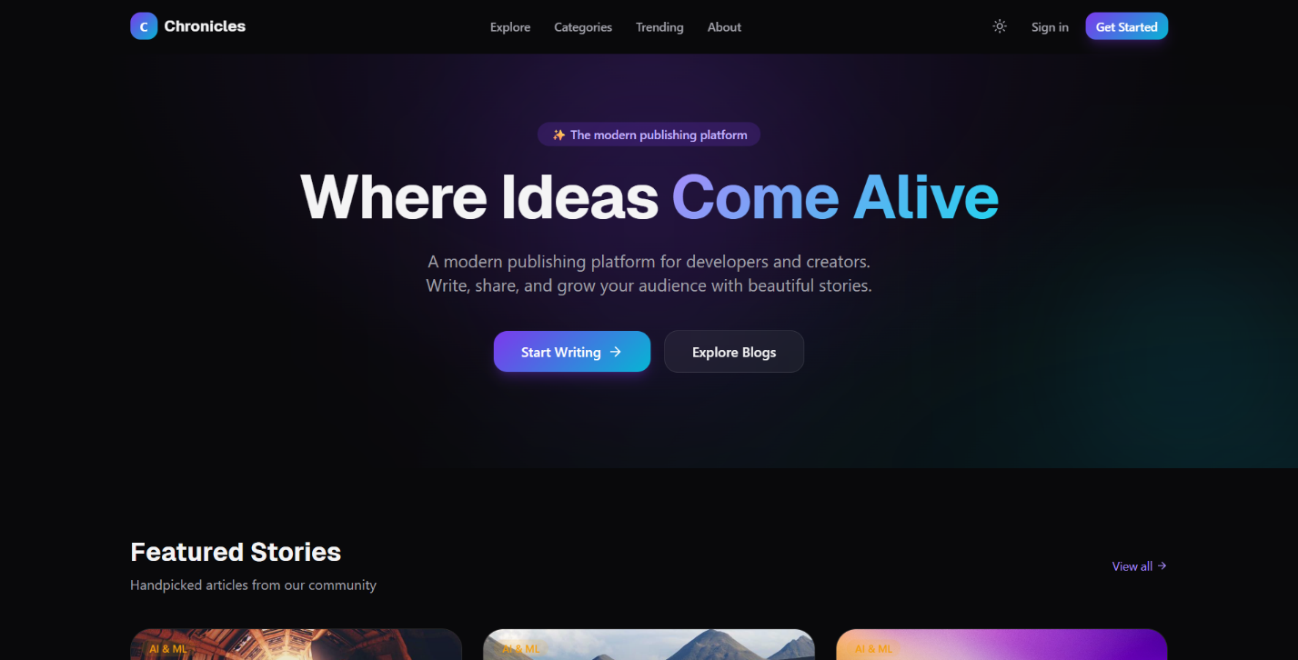
Landing Page

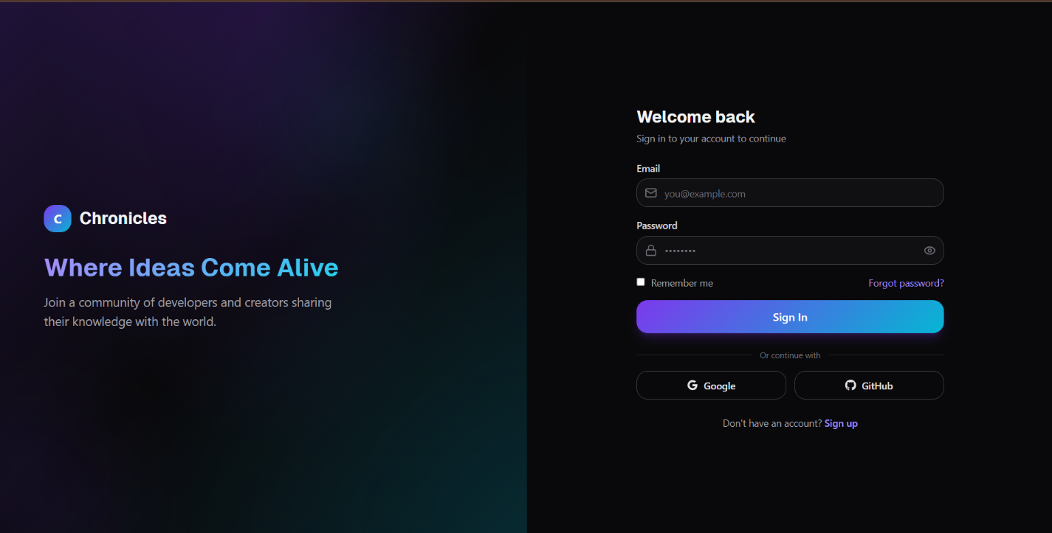
Login Page

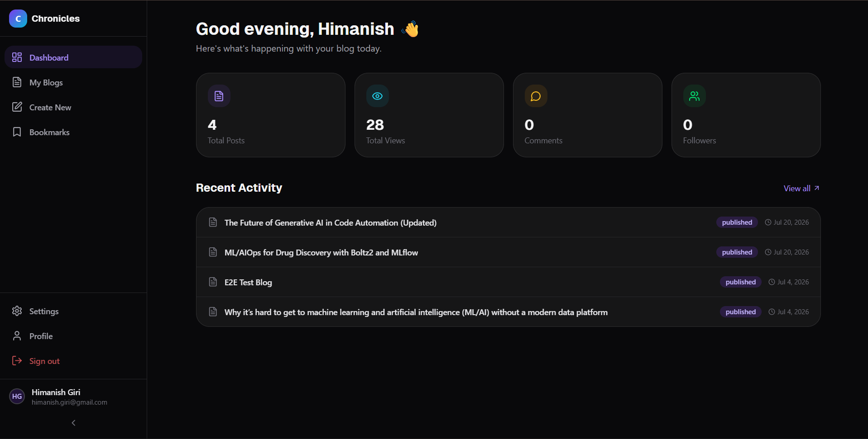
User Dashboard

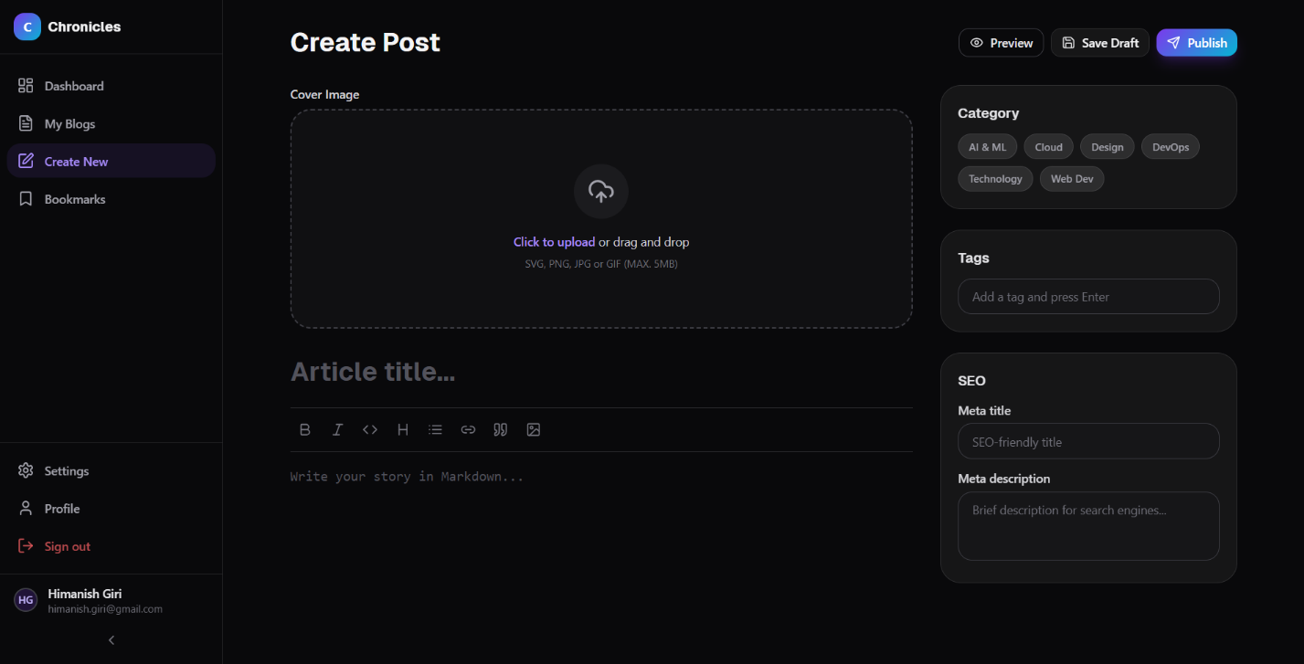
Blog Editor

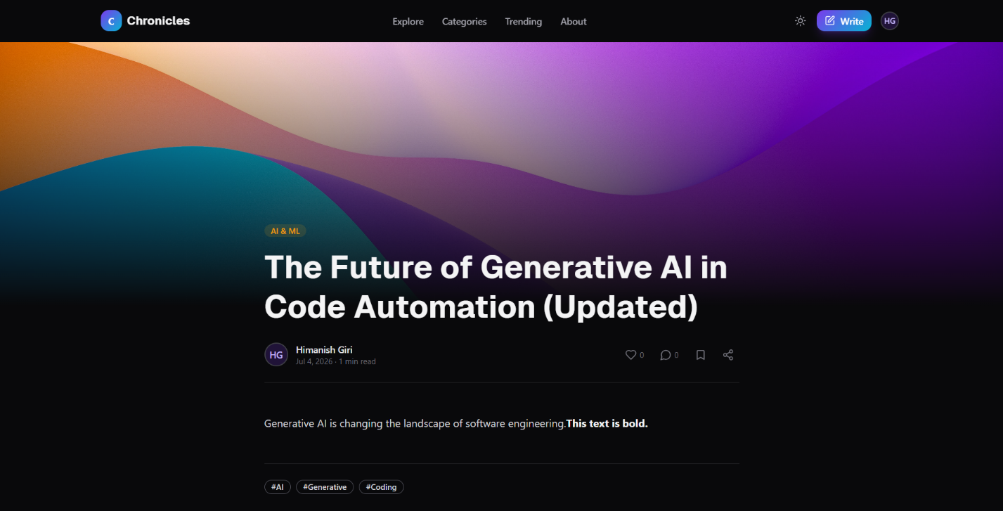
Blog Detail Page

Chapter 12: Future Enhancements

12.1 HTTPS and Domain Configuration
Implement TLS/SSL using Let’s Encrypt with Certbot for automated certificate management. Configure Nginx to redirect HTTP to HTTPS and enable HTTP/2 for improved performance. Register a custom domain name and configure DNS records.

12.2 Monitoring and Observability
Integrate Prometheus for metrics collection and Grafana for visualization. Implement structured logging with Winston or Pino. Set up alerts for container failures, high error rates, and resource exhaustion.

12.3 Caching with Redis
Introduce Redis as a caching layer for frequently accessed data (blog listings, featured blogs, category lists). Implement cache invalidation on write operations. Use Redis for session storage and rate limiting state, enabling horizontal scaling of the backend.

12.4 Kubernetes Orchestration
Migrate from Docker Compose to Kubernetes for production-grade container orchestration. Implement Horizontal Pod Autoscaling (HPA), rolling deployments, and resource limits. Use Kubernetes Services for internal service discovery.

12.5 Microservices Architecture
Decompose the monolithic backend into independent microservices: - Auth Service: User management and token operations - Blog Service: Content management and search - Notification Service: Email, push notifications, and webhooks

12.6 Real-Time Notifications
Implement WebSocket connections using Socket.IO for real-time features: - New comment notifications - Blog publication alerts for followers - Real-time view count updates

12.7 Full-Text Search
Replace MySQL LIKE queries with a dedicated search engine (Elasticsearch or Meilisearch) for fast, typo-tolerant full-text search across blog titles, content, and tags.

12.8 Analytics Dashboard
Build an analytics dashboard for authors showing: - View counts over time - Geographic distribution of readers - Most popular content by engagement metrics

12.9 AI-Powered Recommendations
Implement content recommendation using machine learning: - Collaborative filtering based on reading history and bookmarks - Content-based filtering using NLP on blog text - Trending topic detection using time-series analysis

12.10 Rich Text Editor
Integrate a WYSIWYG editor (TipTap or Lexical) for rich content creation with inline images, code blocks with syntax highlighting, embeds, and tables.

Chapter 13: Conclusion
The Chronicles project demonstrates the end-to-end development of a modern, production-grade blogging platform using current industry-standard technologies and practices. Starting from architectural design through implementation, containerization, deployment, and CI/CD automation, the project covers the complete software development lifecycle.
Key Technical Achievements:
- Full-Stack TypeScript: A unified language across the frontend (React 19), backend (Express 5), and data layer (Prisma ORM) enables shared type definitions, reduces cognitive overhead, and eliminates entire categories of runtime errors through compile-time type checking.
- Hybrid Authentication: The combination of Firebase Authentication for social logins with a custom JWT session management system provides the user-experience benefits of “Sign in with Google/GitHub” while retaining full control over authorization and session lifecycle on the backend.
- Production Docker Architecture: Multi-stage Docker builds, network isolation, health checks, graceful shutdown handling, and named volumes create a deployment environment that is both secure and resilient. The one-shot migration container pattern ensures database schema changes are applied atomically before the application starts.
- Automated CI/CD: The GitHub Actions pipeline transforms a git push into a fully automated deployment — pulling code, rebuilding Docker images, restarting containers, and validating service health — all within a 15-minute timeout with concurrency safeguards.
- Defense-in-Depth Security: Multiple layers of security — Helmet.js headers, CORS whitelist, tiered rate limiting, bcrypt hashing, JWT with refresh token rotation, Zod input validation, non-root container execution, and environment-based secret management — create a robust security posture.
The platform successfully serves as both a functional blogging application and a comprehensive demonstration of modern full-stack web development, DevOps practices, and cloud deployment strategies. It provides a solid foundation for future enhancements including HTTPS, caching, search, real-time features, and horizontal scaling.

References
[1] React Team, “React 19 Documentation,” Meta Platforms, Inc., 2024. [Online]. Available: https://react.dev/
[2] E. You, “Vite: Next Generation Frontend Tooling,” 2024. [Online]. Available: https://vitejs.dev/
[3] OpenJS Foundation, “Express.js 5.x API Reference,” 2024. [Online]. Available: https://expressjs.com/
[4] Prisma Data, Inc., “Prisma ORM Documentation,” 2024. [Online]. Available: https://www.prisma.io/docs
[5] Oracle Corporation, “MySQL 8.0 Reference Manual,” 2024. [Online]. Available: https://dev.mysql.com/doc/refman/8.0/en/
[6] Google LLC, “Firebase Authentication Documentation,” 2024. [Online]. Available: https://firebase.google.com/docs/auth
[7] Docker, Inc., “Docker Documentation,” 2024. [Online]. Available: https://docs.docker.com/
[8] Docker, Inc., “Docker Compose Documentation,” 2024. [Online]. Available: https://docs.docker.com/compose/
[9] GitHub, Inc., “GitHub Actions Documentation,” 2024. [Online]. Available: https://docs.github.com/en/actions
[10] Amazon Web Services, Inc., “Amazon EC2 User Guide,” 2024. [Online]. Available: https://docs.aws.amazon.com/ec2/
[11] NGINX, Inc., “NGINX Documentation,” 2024. [Online]. Available: https://nginx.org/en/docs/
[12] Microsoft Corporation, “TypeScript Documentation,” 2024. [Online]. Available: https://www.typescriptlang.org/docs/
[13] C. Collin, “Zod: TypeScript-first schema validation,” 2024. [Online]. Available: https://zod.dev/
[14] Auth0, Inc., “JSON Web Tokens Introduction,” 2024. [Online]. Available: https://jwt.io/introduction
[15] Tailwind Labs, Inc., “Tailwind CSS Documentation,” 2024. [Online]. Available: https://tailwindcss.com/docs
[16] OWASP Foundation, “OWASP Top Ten Web Application Security Risks,” 2021. [Online]. Available: https://owasp.org/www-project-top-ten/

