**ASSIGNMENT**

**AU‌ ‌2021‌ ‌-‌ ‌NoSQL‌ ‌Basics‌ ‌&‌ ‌Fundamentals‌ ‌**

Q1**.** Import `travel-sample` bucket.

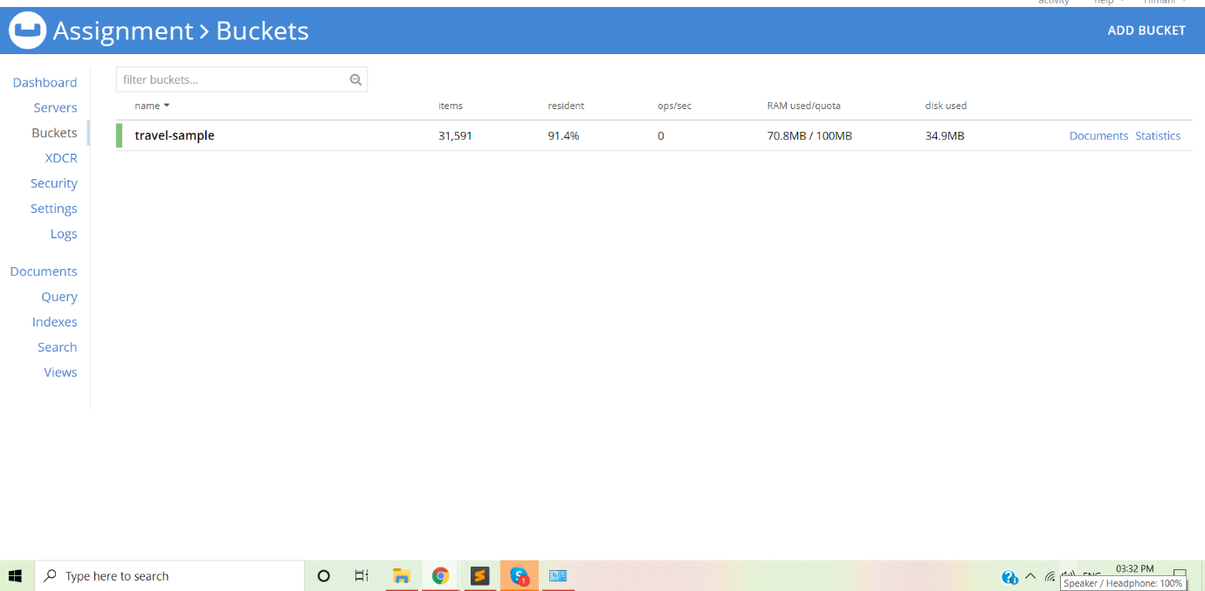

Q2. Write a query to get the sum of all distances where type=”route” for each airline id.

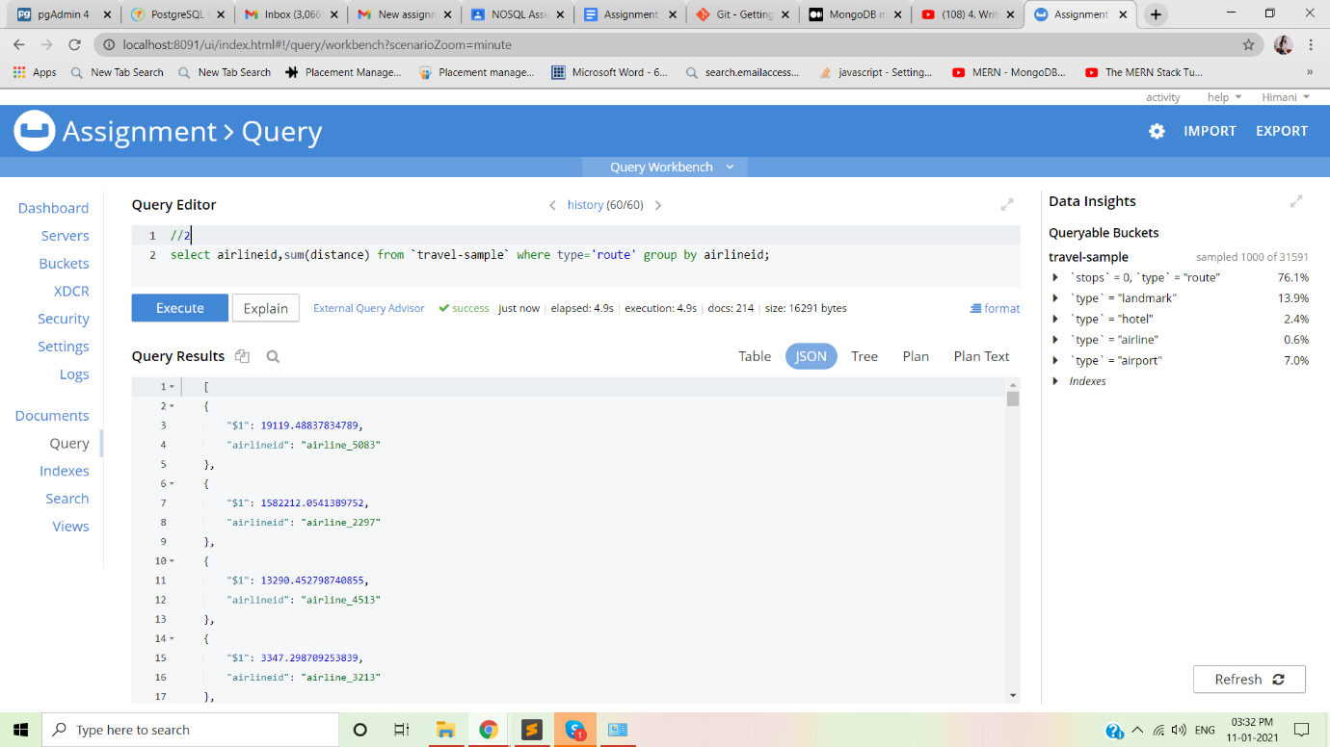

3. Write queries to join(LEFT,RIGHT,INNER) type=”route”&“airline” and  fetch the data whose sourceairport=”SFO”

LEFT JOIN

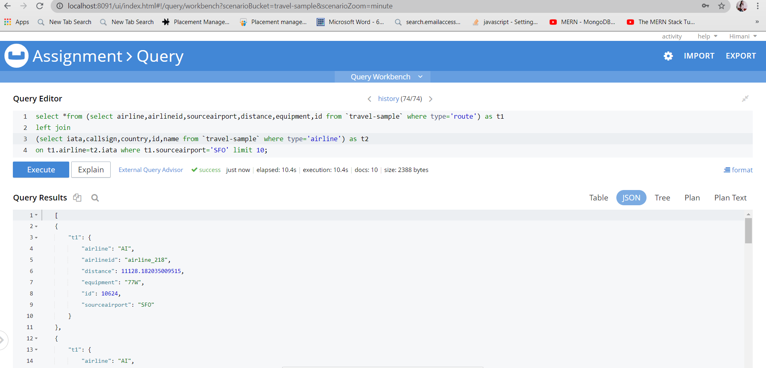

RIGHT JOIN

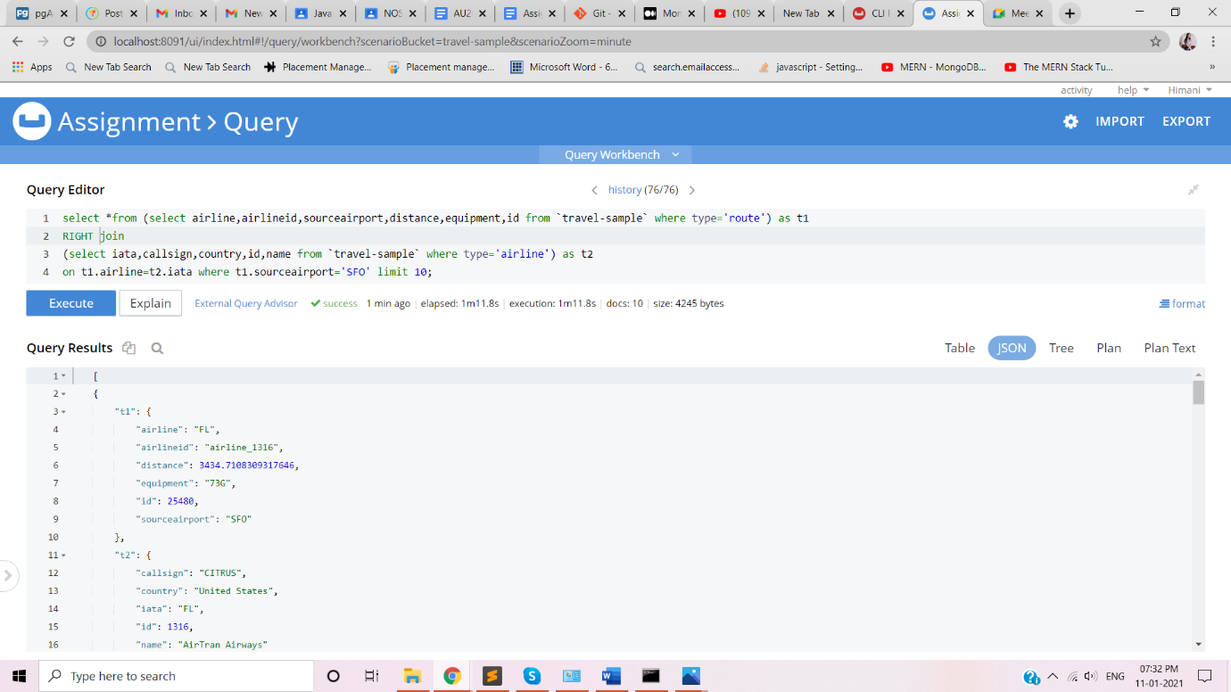

INNER JOIN

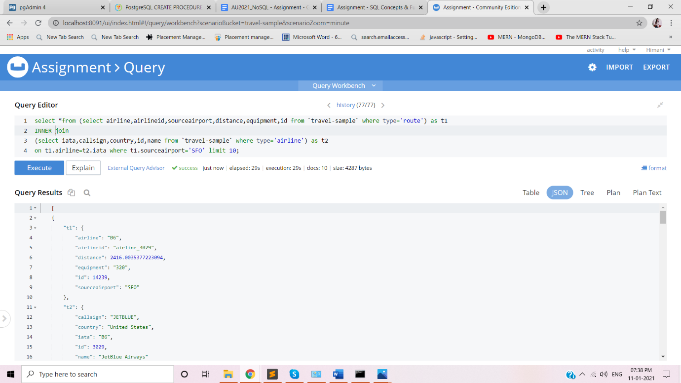

4. Write a mapreduce to get the number of all documents based on  entities(type).

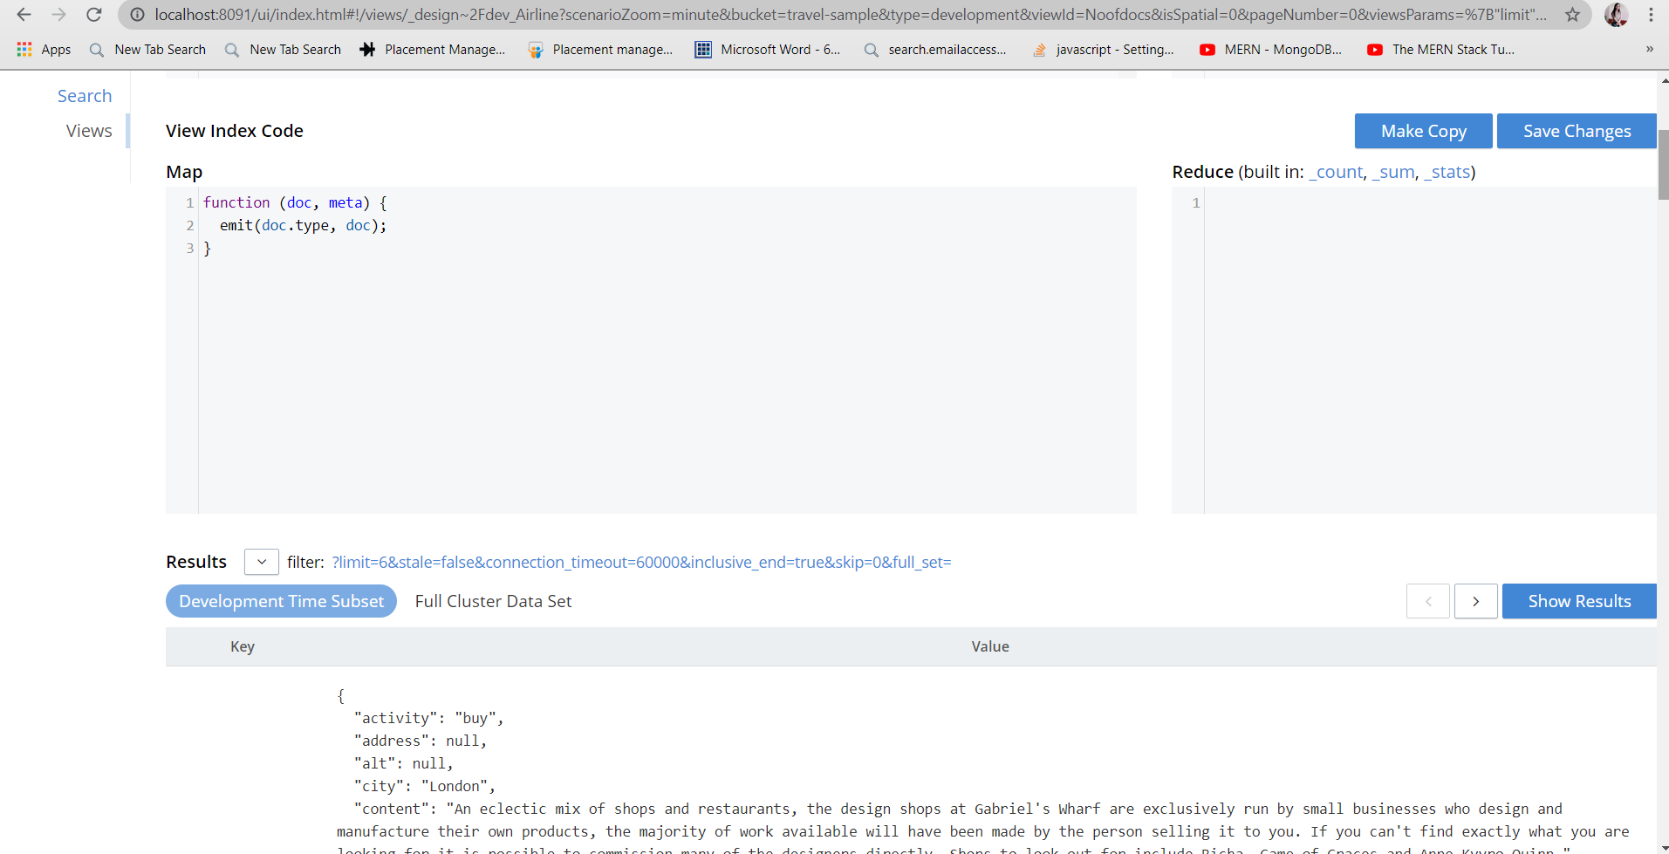

5. Refer CLI interface & try to export the travel sample data.

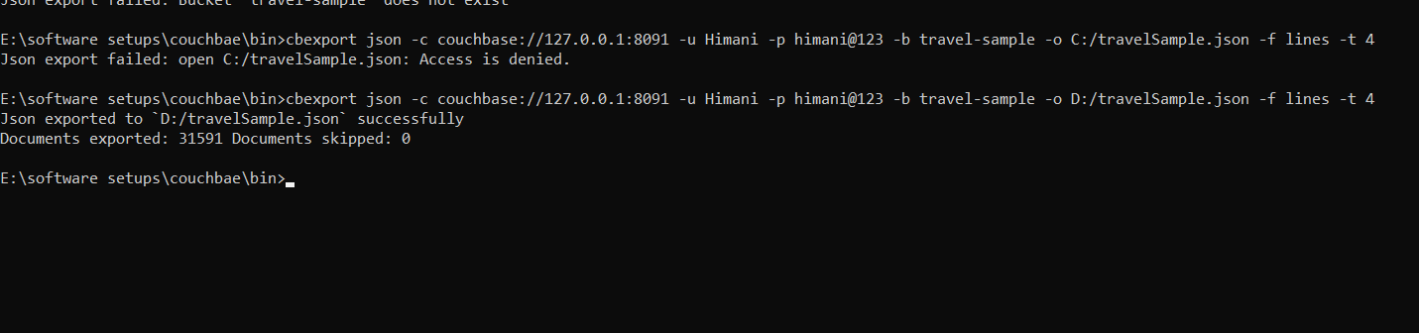

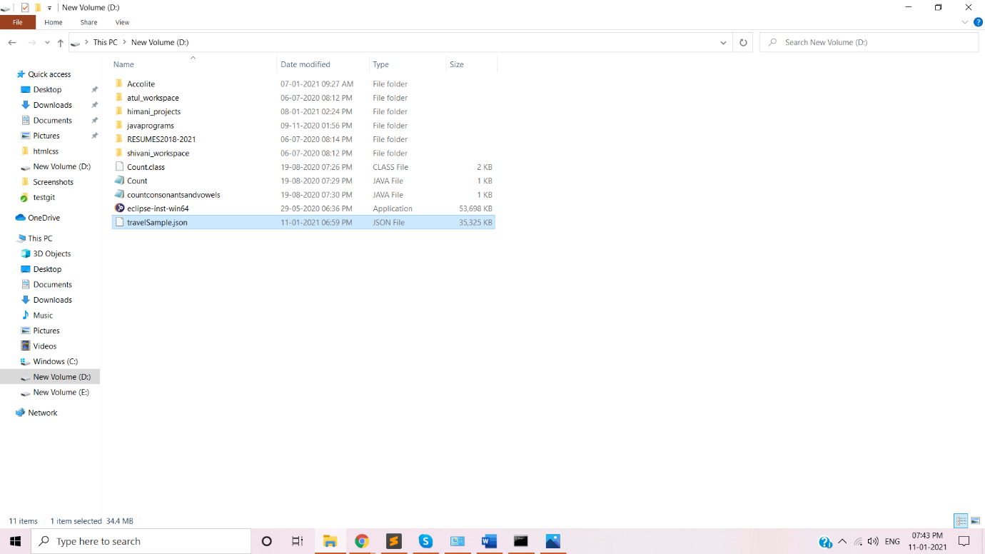

D. Create a new Bucket “NewBucket” & import the data to it:

