SQL ASSIGNMENT

Q1. Create the database Student.

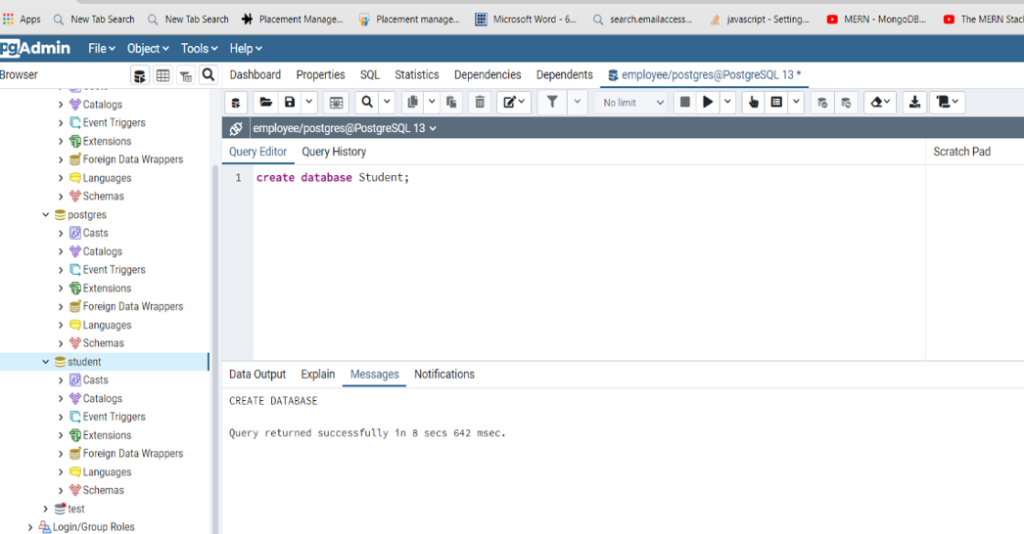

4. Snap of the all the tables once the insertion is completed.

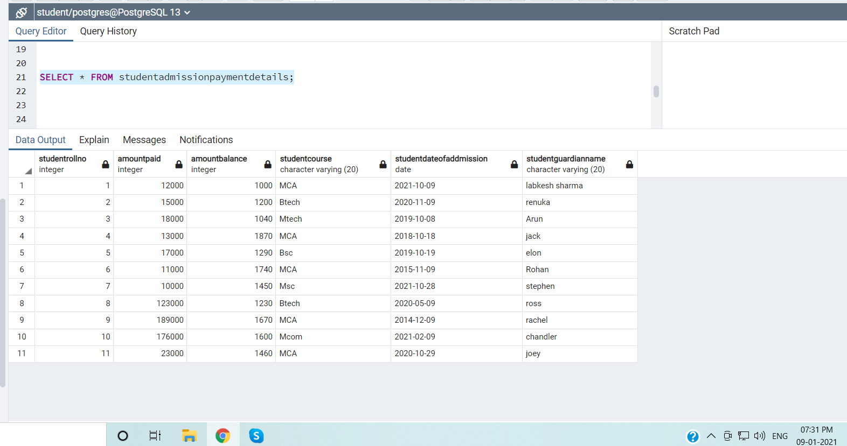

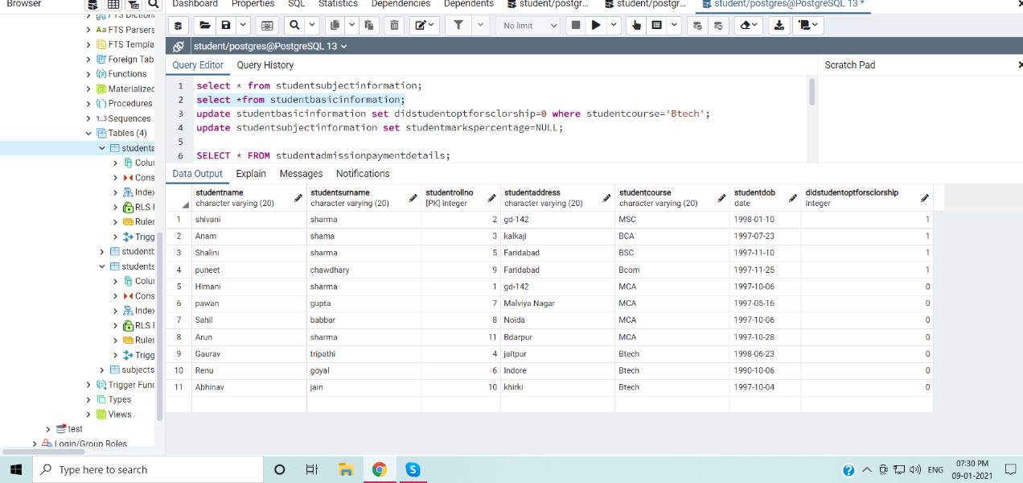

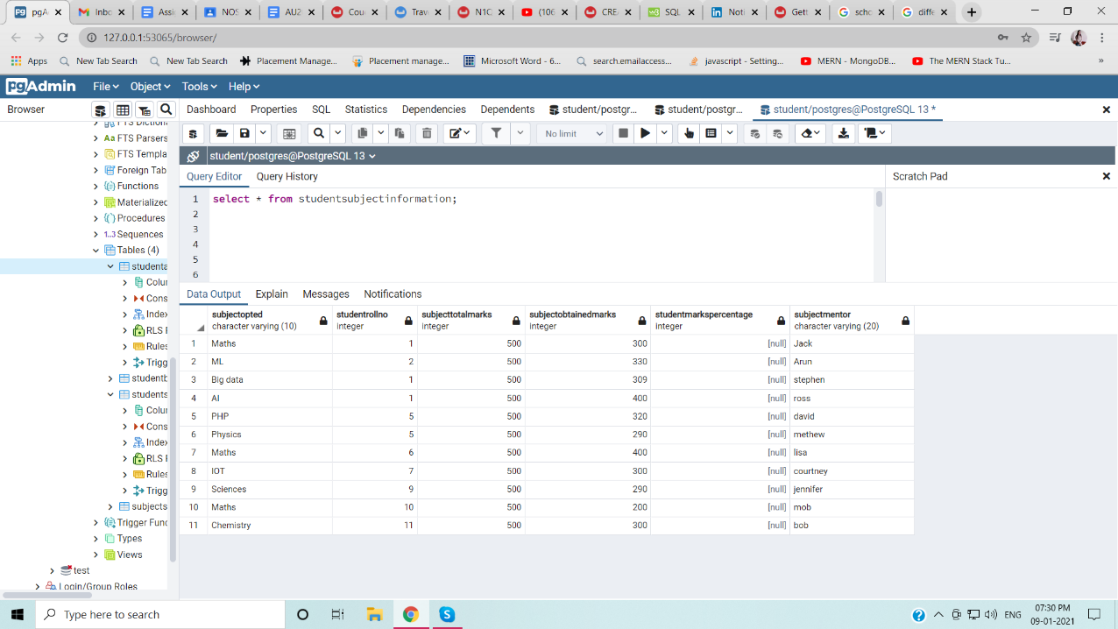

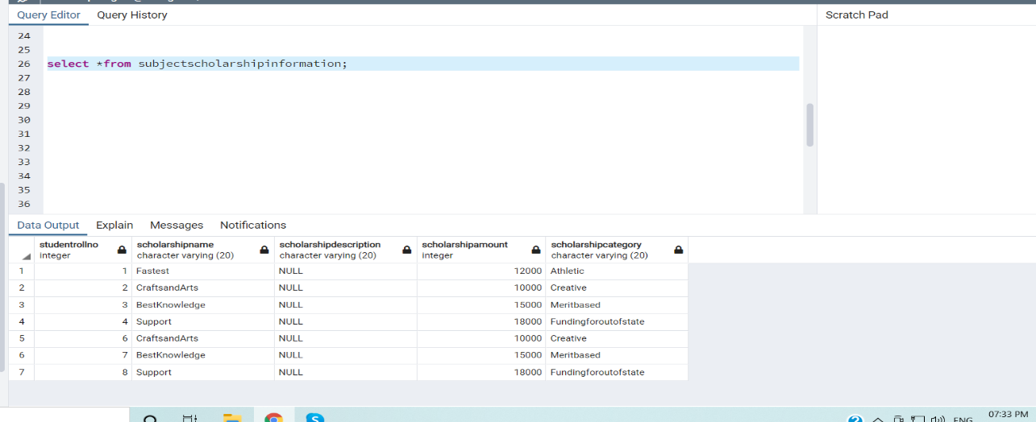

5. Update any 5 records of your choice in any table like update the StudentAddress with some other address content and likewise so on with any records of any table of your choice

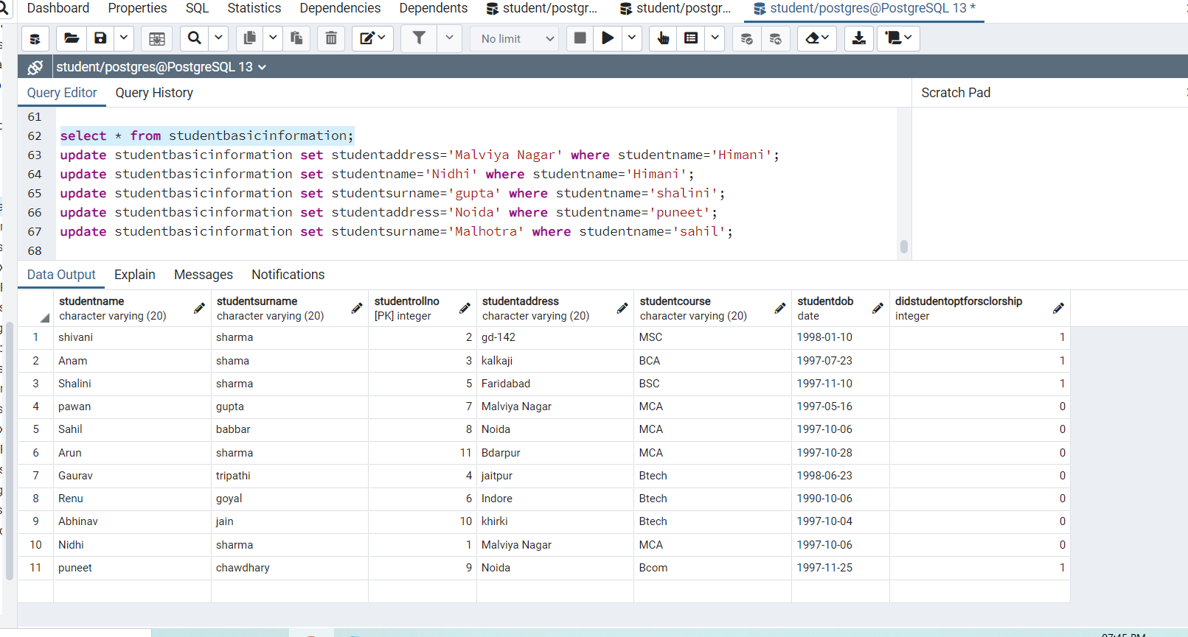

7.Select the student details records who has received the scholarship more than 5000Rs/-

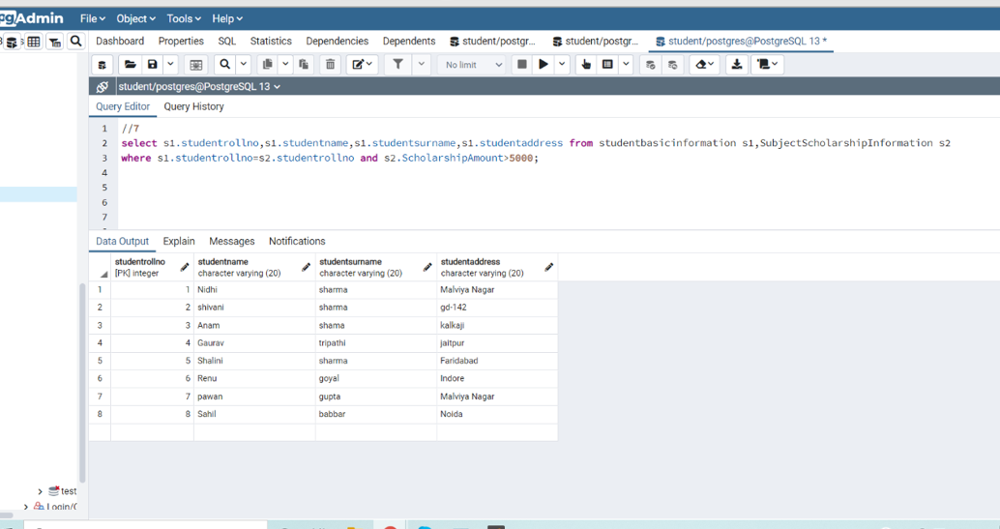

8. Select the students who opted for scholarship but has not got the scholarship.

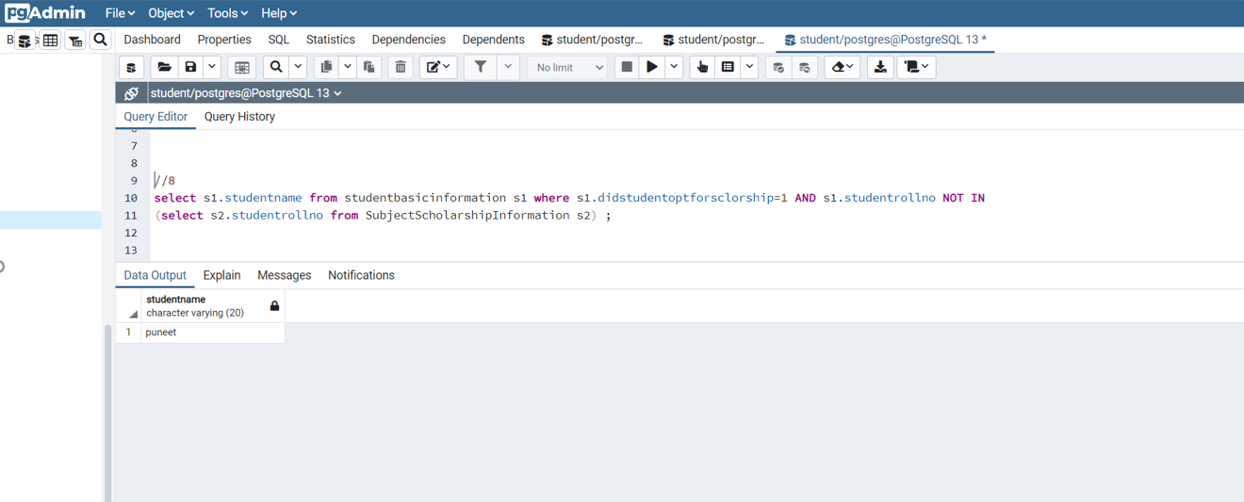

9. Fill in data for the percentage column ie. StudentMarksPercentage in the table StudentSubjectInformation by creating and using the stored procedure created

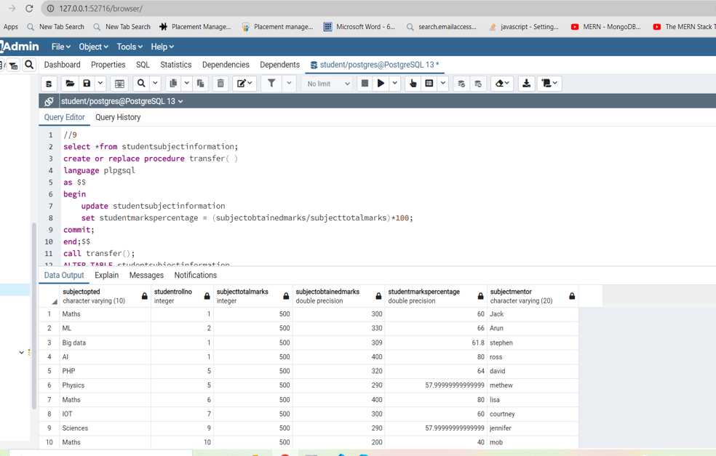

10. Decide the category of the scholarship depending upon the marks/percentage obtained by the student and likewise update the ScholarshipCategory column, create a stored procedure in order to handle this operation.

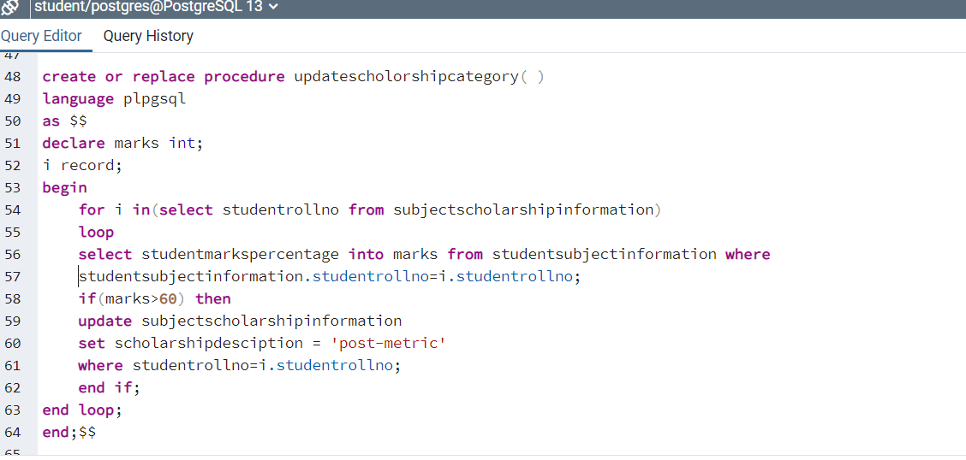

11. Create the View which shows balance amount to be paid by the student along with the student detailed information (use join)

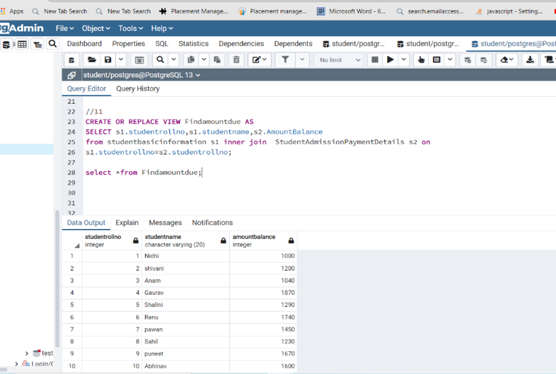

12. Get the details of the students who haven’t got any scholarship (use joins/subqueries)

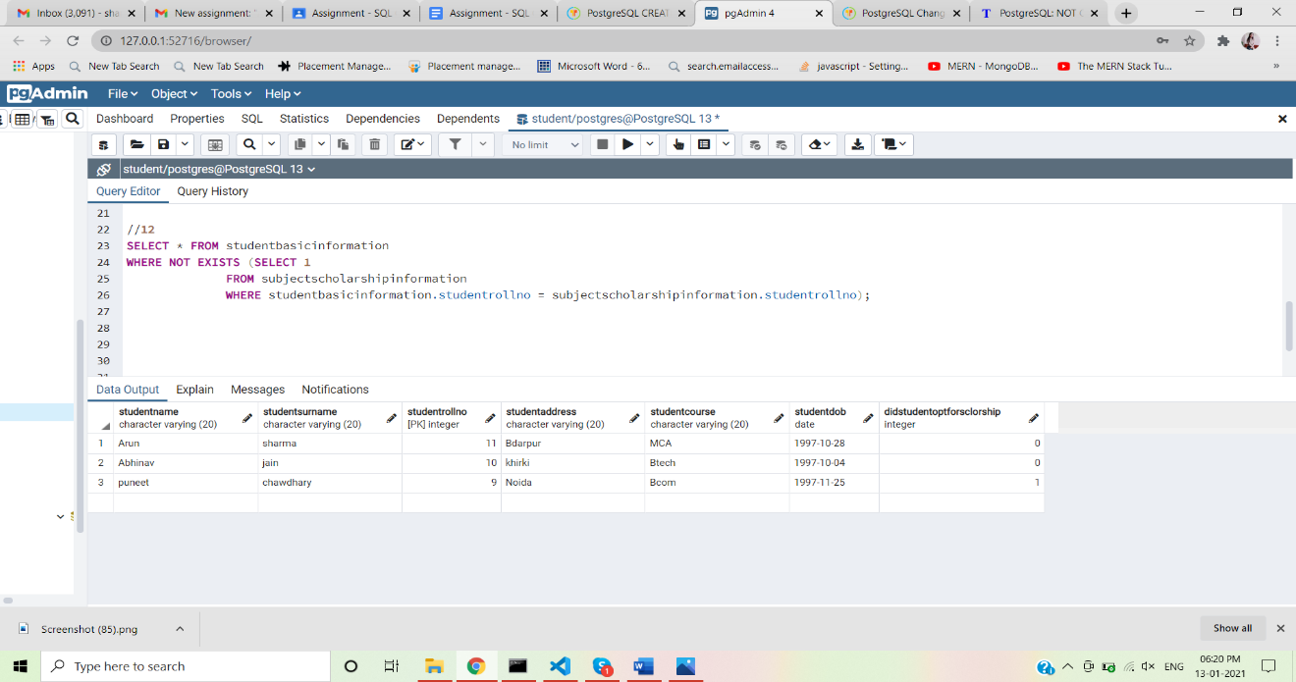

13. Create Stored Procedure which will be return the amount balance to be paid by the student as per the student roll number passed through the stored procedure.

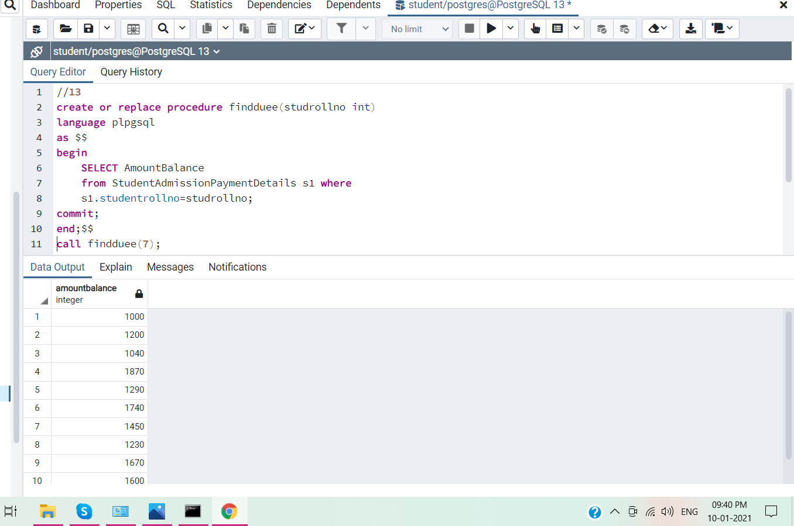

14. Retrieve the top five student details as per the StudentMarksPercentage values (use subqueries)

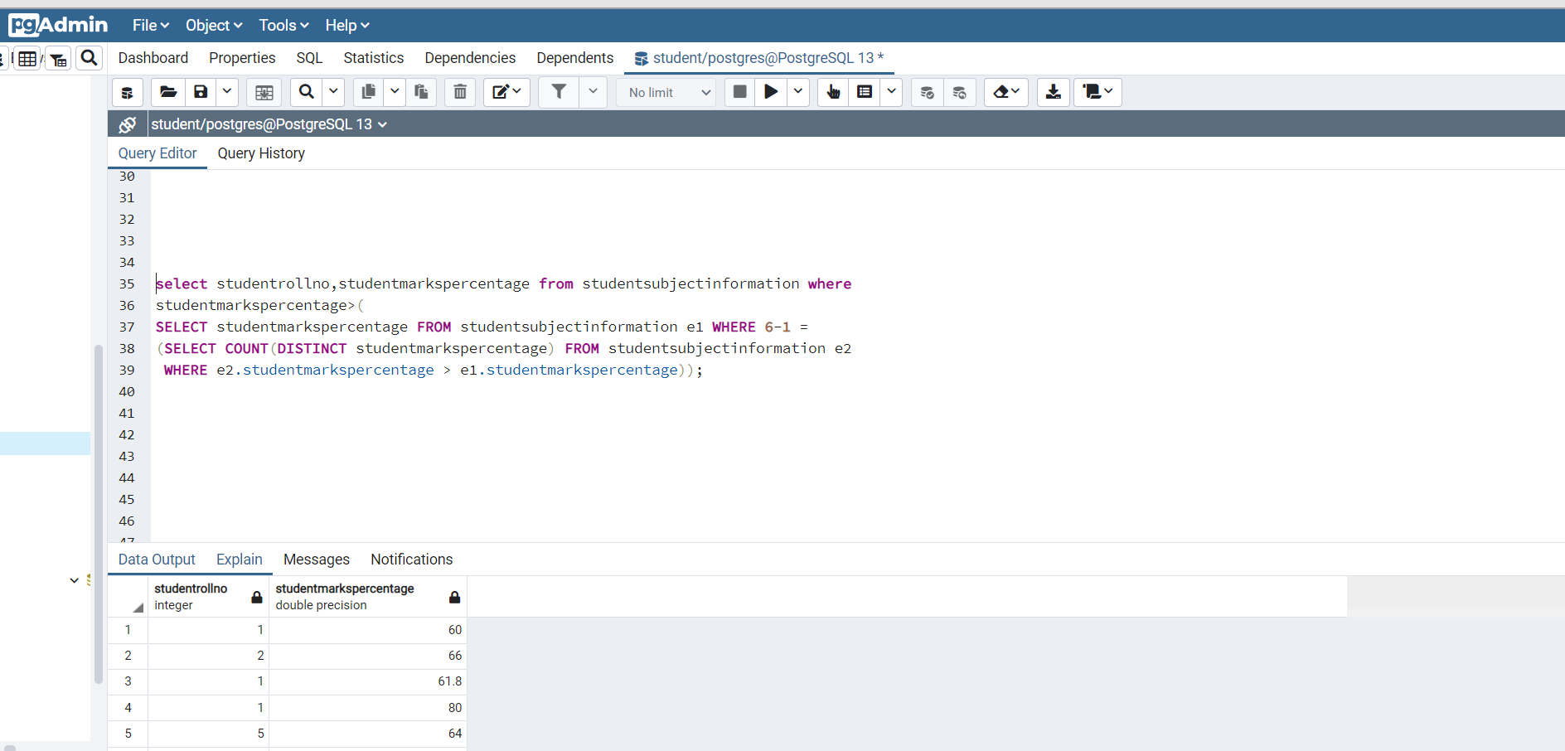

17.Get the count of the Scholarship category which is highly been availed by the students, i.e. get the count of the total number of students corresponding to the each scholarships category.

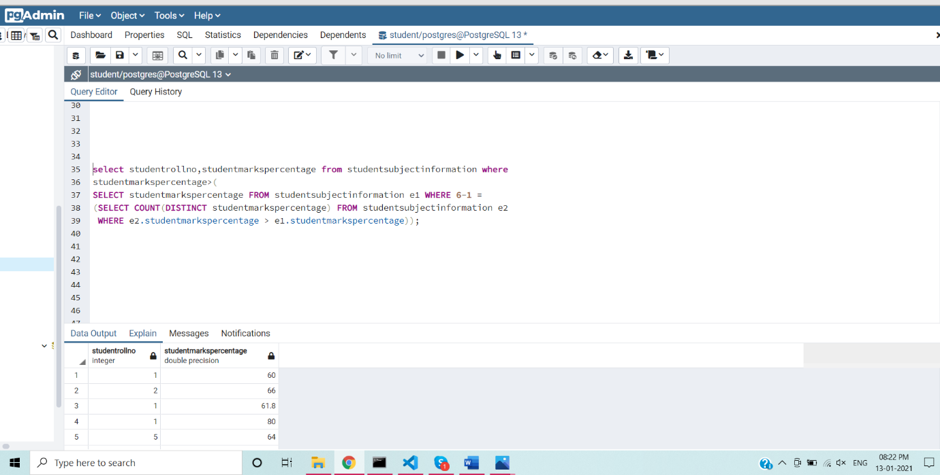

1. Mention the differences between the delete, drop and truncate commands

Trunctate

* TRUNCATE Command is a Data Definition Language operation. It is used to remove all the records from a table. It deletes all the records from an existing table but not the table itself**.** The structure or schema of the table is preserved.
* TRUNCATE TABLE statement is a DDL command so it can not be rolled back.

Delete

* The DELETE statement in SQL is a Data Manipulation Language(DML) Command. It is used to delete existing records from an existing table. We can delete a single record or multiple records depending on the condition specified in the query.
* The DELETE statement scans every row before deleting it. Thus it is slower as compared to TRUNCATE command
* DELETE is a DML Command so it can be rolled back*.*

Drop

* DROP statement is a Data Definition Language(DDL) Command which is used to delete existing database objects. It can be used to delete databases, tables, views, triggers, etc.
* DROP is a DDL Command. Objects deleted using DROP are permanently lost and it cannot be rolled back*.*

18. Along with the assignment no. 17 try to retrieve the maximum used scholarship category

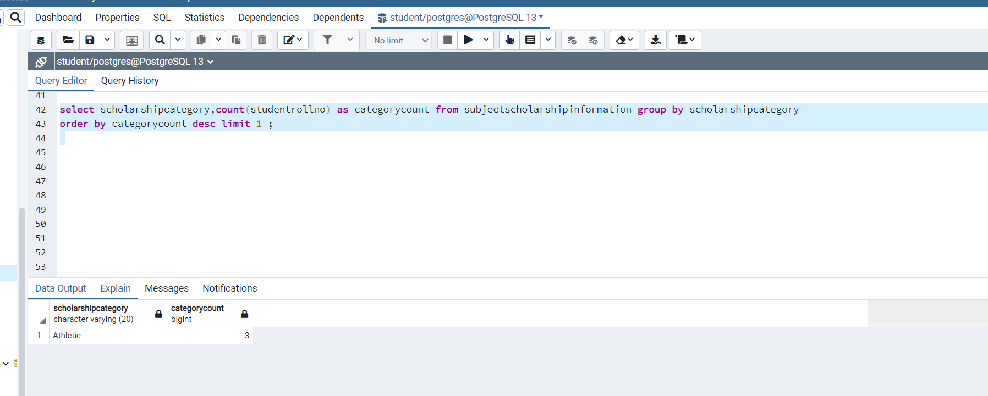

1. Retrieve the percentage of the students along with students detailed information who has scored the highest percentage along with availing the maximum scholarship amount

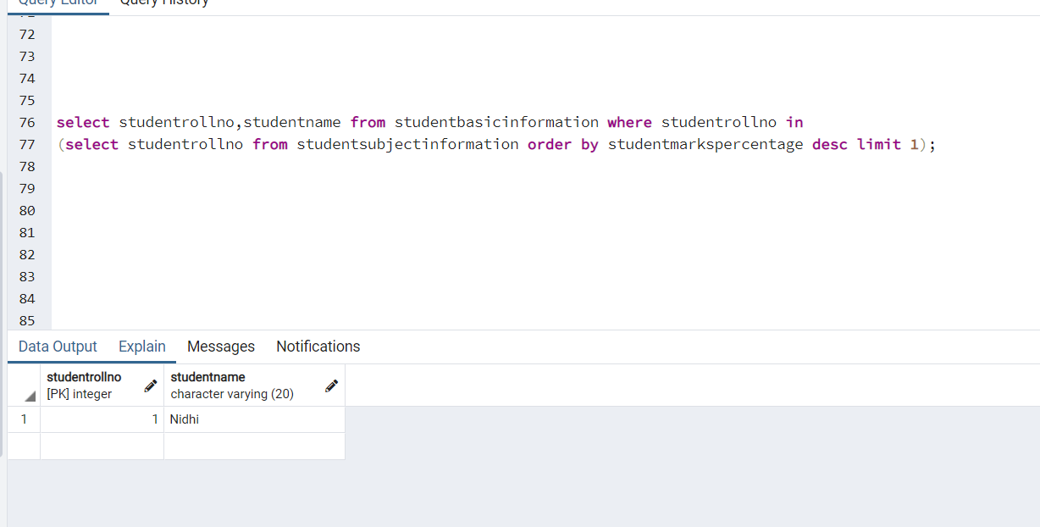

20.Difference between the Triggers, Stored Procedures, Views and Functions

**Executable**

Store procedure: We can execute the stored procedures when required.

Function: We can call a function whenever required. Function can't be executed because a function is not in pre-compiled form.

Trigger: Trigger can be executed automatically on specified action on a table like, update, delete, or update.

**Calling**

Stored procedure: Stored Procedures can't be called from a function because functions can be called from a select statement and Stored Procedures can't be called from. But you can call Store Procedure from Trigger.

Function: Function can be called from Store Procedure or Trigger.

Trigger: Trigger can’t be called from Store Procedure or Function.

**Parameter**

Store procedure: Stored Procedures can accept any type of parameter. Stored Procedures also accept out parameter.

Function: Function can accept any type of parameter. But function can’t accept out parameter.

Trigger: We can’t pass a parameter to trigger.

**Return**

Store procedure: Stored Procedures may or may not return any values (Single or table) on execution.

Function: Function must return any value.

Trigger: Trigger never return value on execution.