Skill-Based Assessment
OpenAI Codex — AI-Assisted Developer · Practitioner Level 2
Case Study: FinTrack — Expense Splitting Feature
Associate ID: 2322244
Name: Himank Kandpal
Technology Stack: Java 17 / Spring Boot 3.3 / Maven / Spring Data JPA
Submission File Name: 2322244_SBA_OpenAICodex_Himank.docx

Section 1 — AGENTS.md Setup
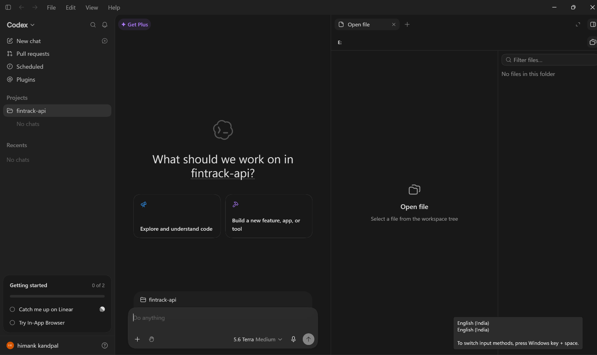

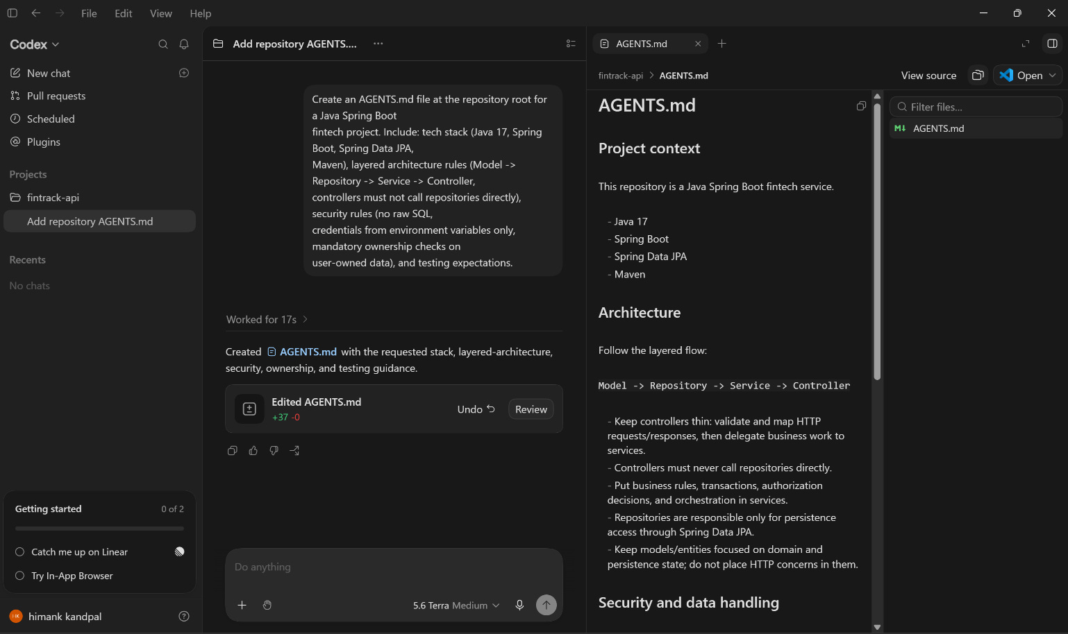
1A. Most important rules you included and why do they matter for a fintech project.
I structured AGENTS.md around the five things Codex is most likely to get wrong by default in a fintech context: it declares the stack up front (Java 17 / Spring Boot / JPA) so Codex never reaches for raw JDBC, it defines strict layering (controller → service → repository, with controllers forbidden from calling repositories directly) so business logic doesn't leak into the web layer, and it hardcodes security rules — parameterised queries only, credentials from environment variables, and mandatory per-user ownership checks on every read/update/delete.
The most important rules are the security ones: parameterised-queries-only and mandatory ownership checks directly prevent the two most damaging classes of bug in a financial API (SQL injection and cross-account data leakage), and I added a standing instruction that Codex must summarise architecture/security/performance risk after every generation so I never have to remember to ask for that review myself.

Reference: the AGENTS.md I used for this assessment is included in the accompanying code submission and reproduced in full below for convenience.

Section 2 — Low-Effort Prompt Generation (Simulating Inherited Code)
Prompt submitted (unmodified):
"Build a REST controller for a transactions feature in a Spring Boot app. Users can add, get, update and delete their transactions (amount, category, description). Connect directly to Postgres and make it work quickly."
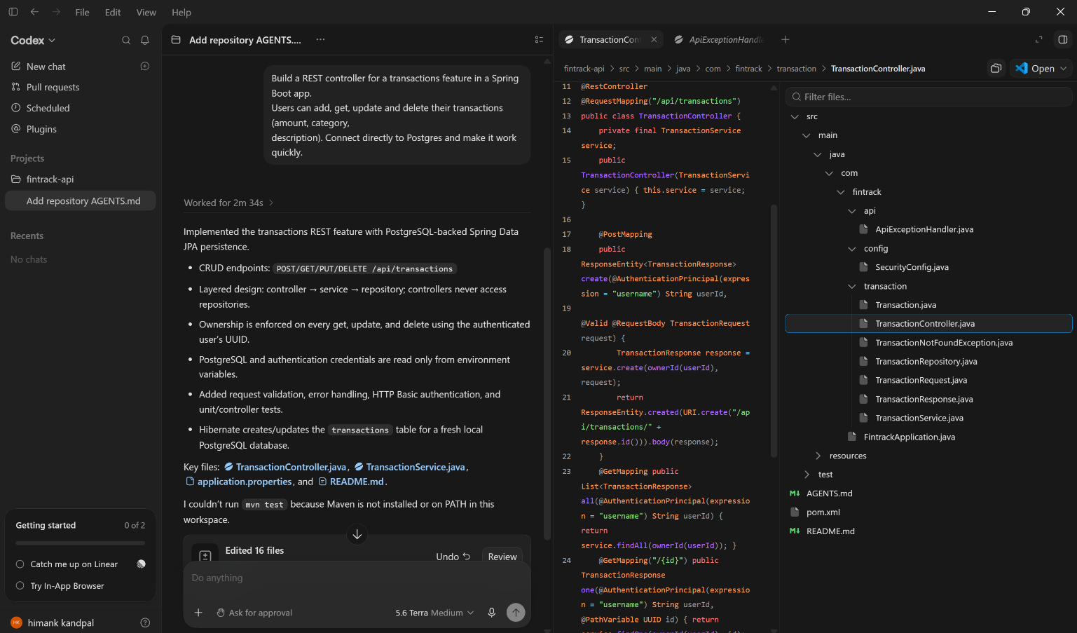
2A. Codex surface used for generation (Web / app / CLI / IDE extension). My first impression of the generated code — what jumps out at you as potentially problematic?
surface used: Codex app. My first impression: the generated TransactionController builds SQL strings by directly concatenating request parameters (userId, amount, category, description) instead of using parameterised queries or an ORM, which is an immediate SQL-injection red flag. It also opens raw JDBC connections with hardcoded database credentials in static fields, never closes the Connection/Statement/ResultSet objects, and has no authentication or ownership check at all — any caller can read, update, or delete any other user's transactions just by passing a different userId.

Section 3 — Review Findings

Review Findings Table (minimum 8 issues)
# | Issue | Location | Severity | Impact (fintech context) | How I Detected It | Fix Applied/Recommended
1 | SQL injection: userId, amount, category, description are concatenated directly into SQL strings | addTransaction, getTransactions, deleteTransaction, updateTransaction | Critical | An attacker can read, modify, or delete any user's financial records, or drop tables outright, by injecting SQL through any string parameter. | Codex Web — submitted a task prompt asking Codex to review as a security engineer | Rewrote the module using Spring Data JPA; no hand-written SQL anywhere in the remediated code.
2 | No authentication/authorization — userId is a client-supplied request parameter with no ownership check | All endpoints | Critical | Anyone can view, alter, or delete another user's transactions simply by passing a different id. | Manual Review | Added CurrentUserProvider to resolve the caller's identity server-side; TransactionService.assertOwnership() now checks the resolved id against the resource owner on every read/update/delete.
3 | Hardcoded database credentials in source (static user/pass fields) | Static fields user, pass | Critical | Credentials committed to version control; anyone with repo or build-artifact access has direct DB access. | Manual Review | Moved credentials to environment variables with safe local-dev defaults in application.yml.
4 | No ORM; raw JDBC embedded directly in the controller | Entire file | High | Violates layering; business/data-access logic is untestable in isolation and duplicated across every endpoint. | Manual Review | Rebuilt with model → repository → service → controller layering per AGENTS.md.
5 | Connection, Statement, ResultSet never closed (no try-with-resources) | All endpoints | High | Connection pool exhaustion under load — an outage risk for an API that must reliably reflect money movement. | Manual Review | Eliminated entirely by moving to Spring Data JPA, which manages connections via the pooled DataSource.
6 | amount accepted and concatenated as a raw String with no type or range validation | addTransaction, updateTransaction | High | Malformed or negative amounts can corrupt balances; also doubles as an injection vector. | Manual review — I noticed the float/String type for currency amounts; Codex did not flag this | TransactionRequest DTO uses BigDecimal with @DecimalMin(0.01) validation.
7 | Errors swallowed with printStackTrace() and a bare "error" string, still returned with HTTP 200 | All endpoints' catch blocks | Medium | No structured logs for incident response; API consumers cannot distinguish success from failure by status code. | Manual Review | GlobalExceptionHandler maps domain exceptions to structured JSON responses with correct HTTP status codes; SLF4J logging throughout.
8 | Raw Map<String, Object> returned instead of a response DTO | getTransactions | Medium | Leaks internal column names/types directly into the API contract; any schema change becomes a breaking API change. | Manual Review | Added TransactionResponse record, decoupling the API contract from the entity.
9 | Money represented via ad hoc String/JDBC types rather than BigDecimal | Throughout | High | Precision/rounding risk in a domain where cent-level accuracy matters. | Manual Review | All money fields use BigDecimal with scale 2.

3A. Issues Codex Introduced That Required Human Judgment.
1. Trust boundary for userId. Codex produced code that treats a request parameter as the caller's identity. Catching this required knowing where authentication actually happens in this system — information that isn't in the code itself and that a short prompt gives Codex no reason to ask about. An AI tool has no way to infer a system's real trust boundary from a demo-scale prompt; only a human with knowledge of the surrounding architecture can recognise the gap.
2. SQL injection as a security defect, not a style choice. The generated code compiles and works for the happy path, so a purely functional read-through can miss it. Recognising string-concatenated SQL as exploitable requires deliberately reasoning about adversarial input rather than intended input — a mindset shift a low-effort prompt does not prompt Codex to make on its own.
3. Money semantics (BigDecimal vs. String/double). Choosing BigDecimal for currency is a fintech-specific domain judgment; Codex has no way to know cent-level rounding matters here unless told explicitly, and it will happily generate working code with float/double or unvalidated String amounts that only manifests as a bug much later, under specific rounding conditions.
4. What "handle the error" should actually mean. Codex's silent catch (Exception e) { return "error"; } technically "handles" the error and compiles cleanly, but only a human evaluating this against real API consumers would flag that returning HTTP 200 on failure is itself a defect — this requires reasoning about the client's perspective, not just the server's control flow.

Section 4 — Remediated Transaction Code
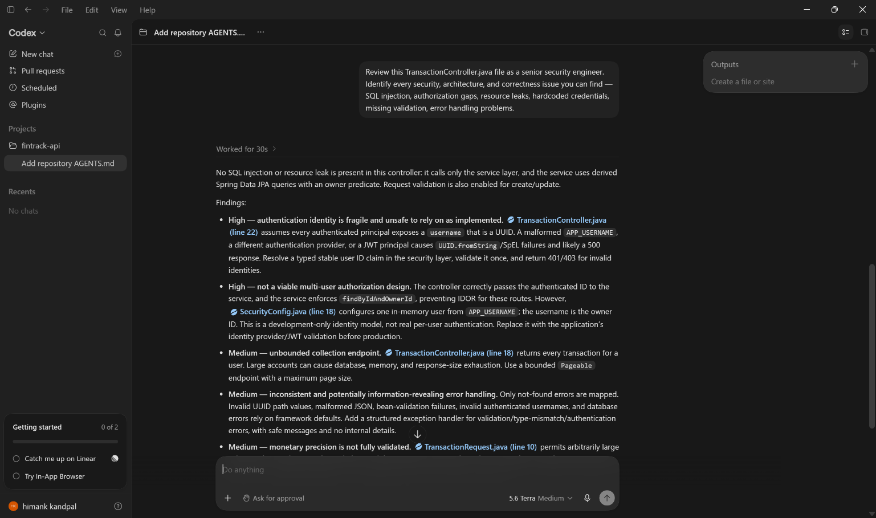
4A. Most important changes between the initial AI-generated code and our remediated version.
1. Replaced raw JDBC + string-concatenated SQL with a Spring Data JPA entity and repository, eliminating the SQL-injection surface entirely and removing all hand-written SQL from the codebase.
2. Moved every piece of business logic — including ownership enforcement — out of the controller and into TransactionService, so the controller now does nothing but map HTTP requests to service calls and map results back to responses.
3. Added a server-side CurrentUserProvider so the caller's identity is resolved from the request context rather than trusted from a client-supplied parameter, and added assertOwnership() so every read/update/delete verifies the resolved caller matches the resource owner before acting.

Section 5 — Expense Splitting Feature

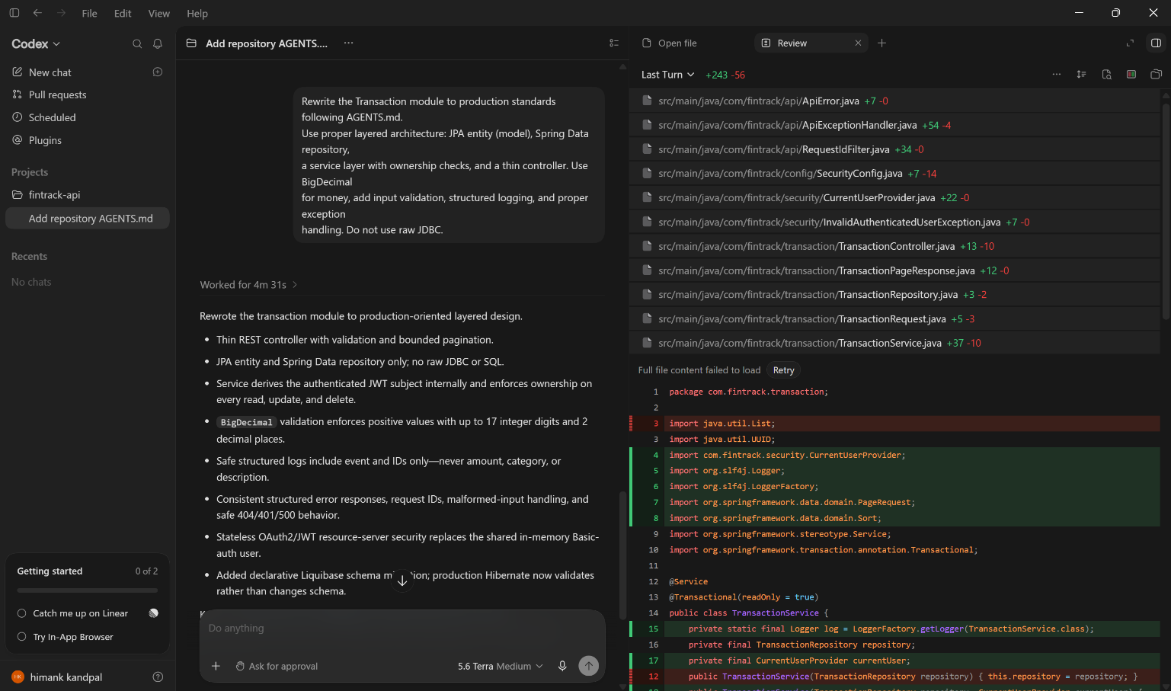

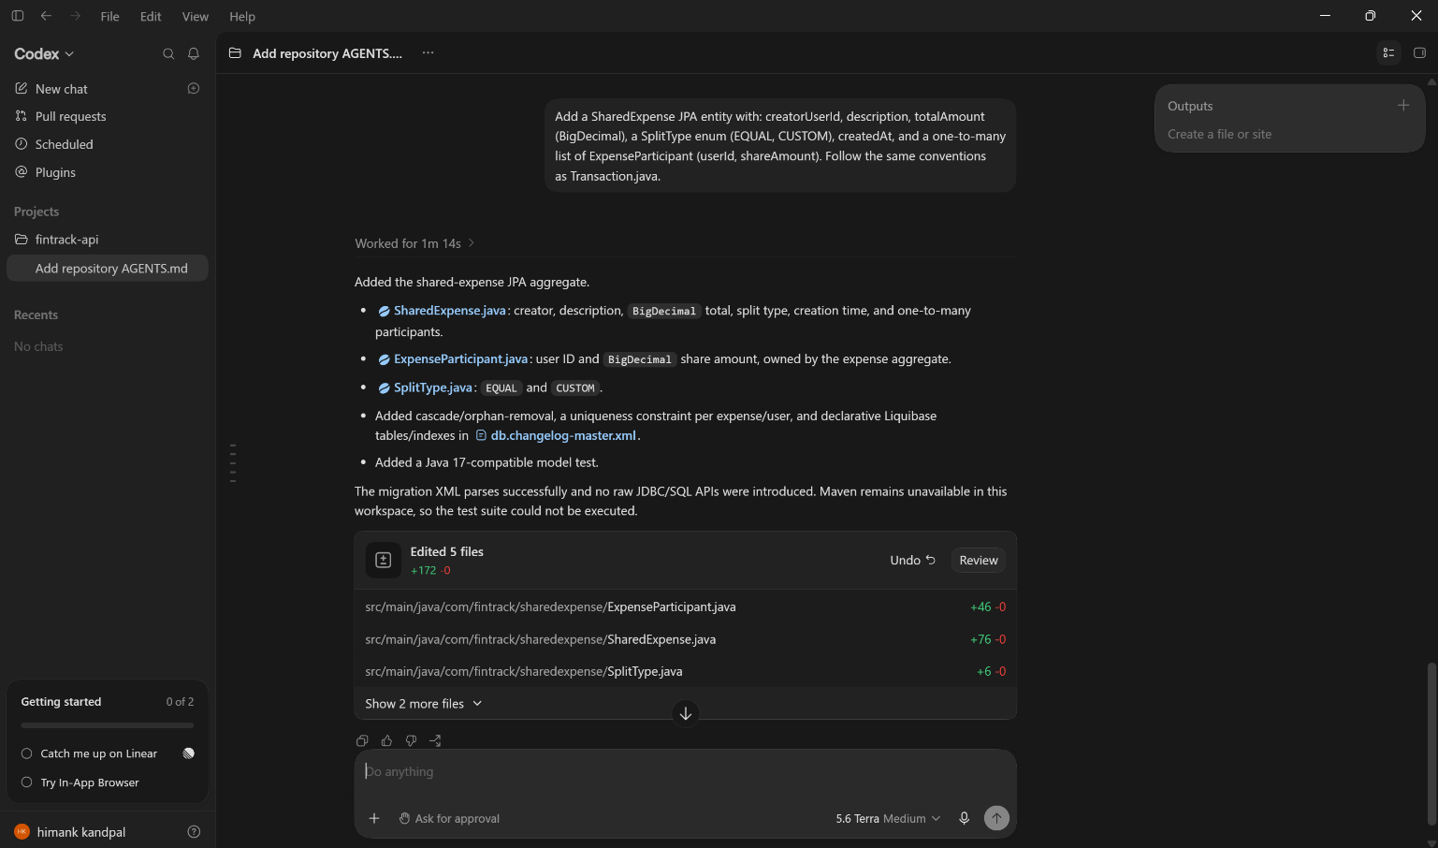

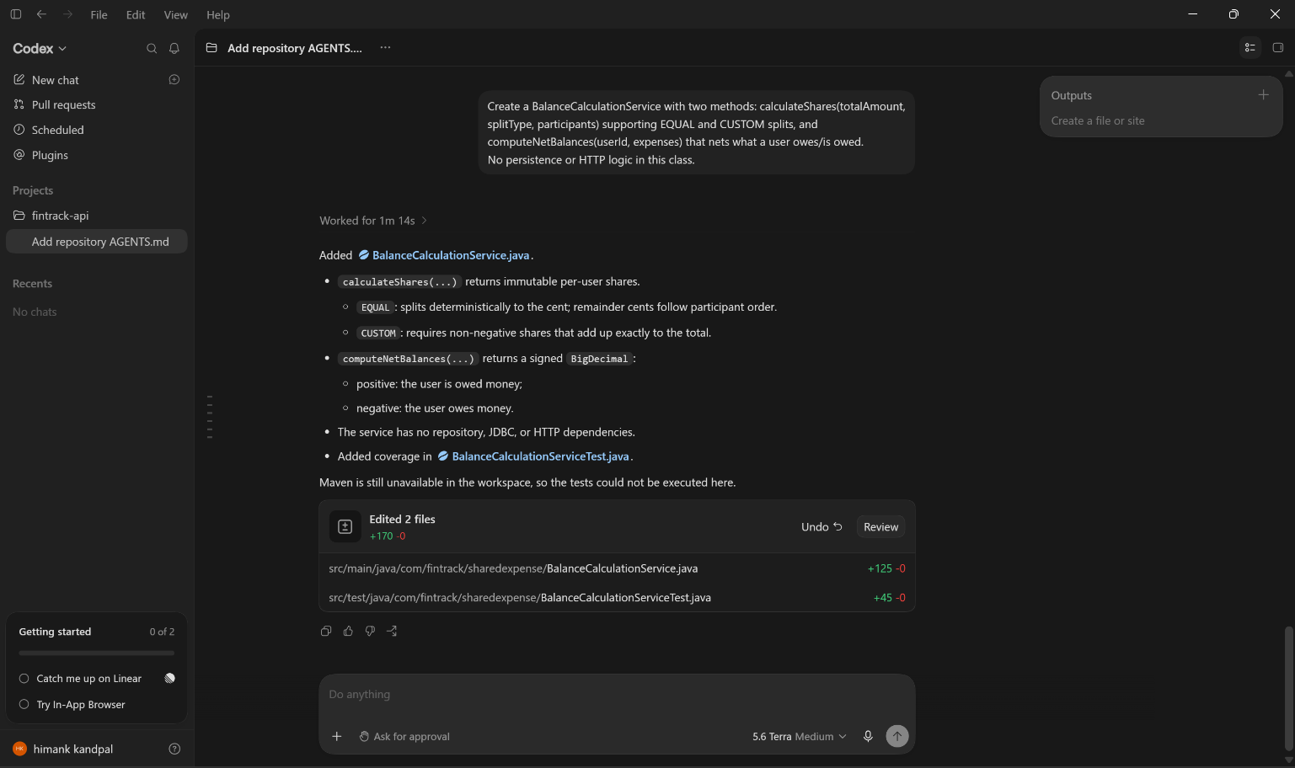

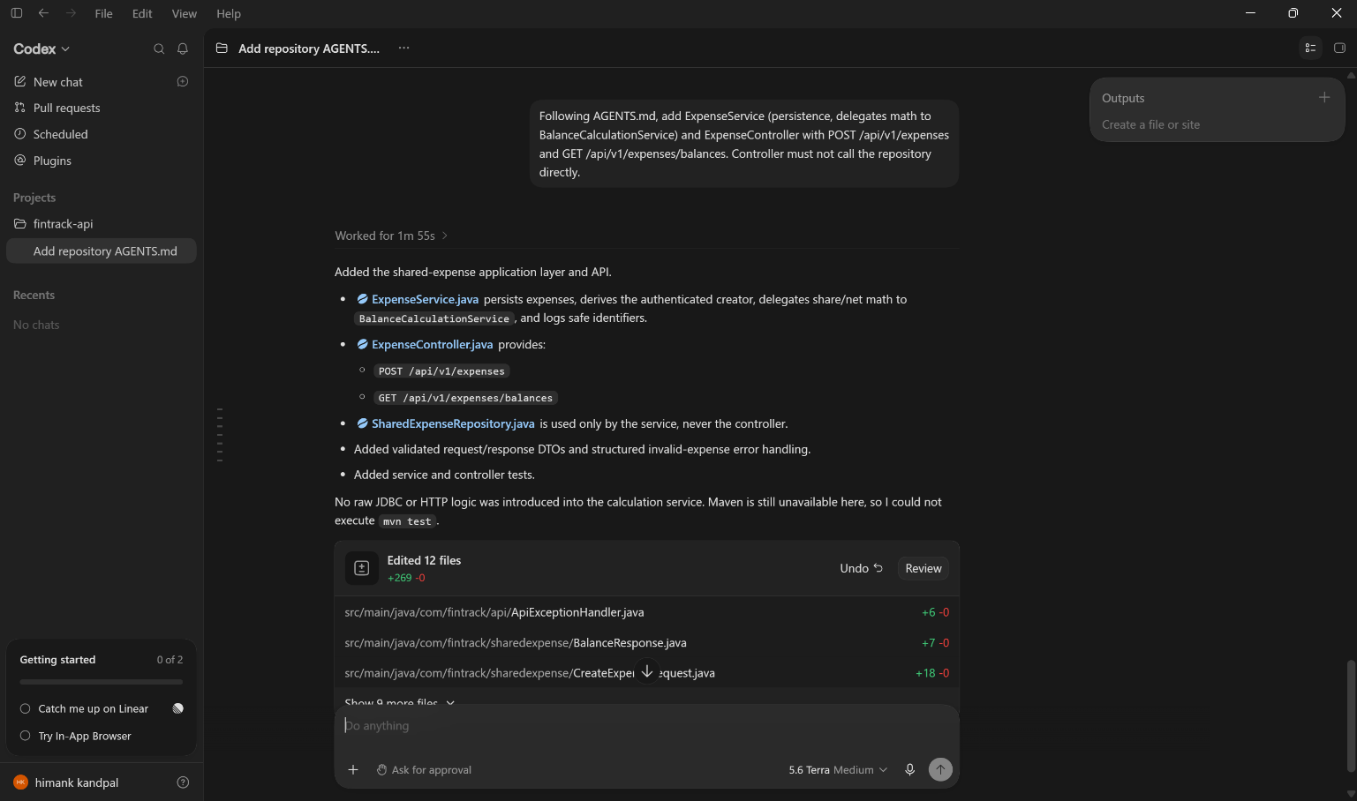

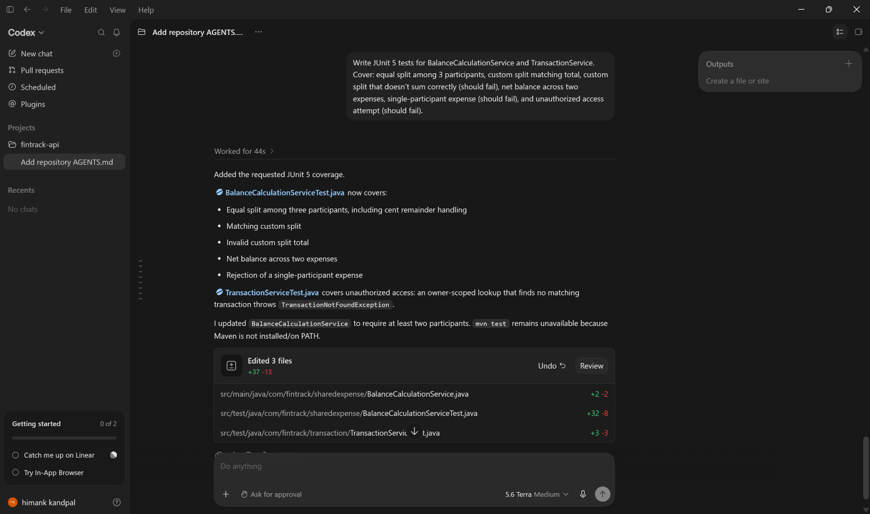

Prompt Engineering Documentation

# | Surface | Technique(s) | Prompt Text (abridged) | AGENTS.md / File Ref? | Rationale
1 | Web | Role-based + Constraint-based | "You are a senior Spring Boot engineer at a fintech company doing a security-focused rewrite. Replace the Transaction feature entirely with a layered implementation... Follow every rule in AGENTS.md, especially the security and testing sections. Do not use raw JDBC." | Explicitly references AGENTS.md | Role framing pushes Codex toward production-grade defaults; explicit constraints re-anchor it on the exact rules most likely to be skipped.
2 | App | Specificity | "Add a SharedExpense JPA entity with: creatorUserId, description, totalAmount (BigDecimal), a SplitType enum... Follow the same entity conventions as Transaction.java in this package." | References file path (Transaction.java) | Working inline with the existing entity visible let the prompt say "same conventions as" instead of re-specifying every convention.
3 | App | Decomposition | "Create BalanceCalculationService with two responsibilities only: (1) calculateShares(...) ... (2) computeNetBalances(...) ... No persistence, no HTTP concerns in this class." | No | Splitting the two responsibilities into named methods up front avoided Codex collapsing both concerns into one hard-to-test method.
4 | Web | Constraint-based | "codex exec: Add ExpenseService (persistence + delegates math to BalanceCalculationService) and ExpenseController... Controller must not call the repository directly." | No | CLI batch mode suited a mechanical "wire these layers together" task with no ambiguity left to resolve.
5 | App | Few-shot + Iterative refinement | "Write JUnit 5 + Mockito + AssertJ tests for BalanceCalculationService and TransactionService. Cover: [6 scenarios]... Example test shape: [pasted one existing test class as a few-shot example]." | No | Pasting an existing, already-reviewed test class as a few-shot example got Codex to match the project's assertion style on the first pass.

5A. Post-Generation Corrections
1. Equal-split rounding was non-deterministic (Prompt 3). Codex's first pass assigned all rounding remainder to the last participant in the list, so the result depended on participant order. Fixed by manually rewriting the remainder-distribution loop to assign leftover cents to the first N participants in a fixed order, then adding a test that asserts the exact per-participant amounts.
2. Controller called the repository directly (Prompt 4). The CLI output initially injected SharedExpenseRepository straight into ExpenseController for the balances endpoint "for simplicity," violating the AGENTS.md layering rule. Fixed by rejecting the diff and re-running the CLI prompt with the layering constraint restated explicitly.
3. Custom-split validation used floating-point comparison (Prompt 3). The initial generation summed double values and compared with ==, which is unsafe for currency. Fixed by manually replacing it with BigDecimal and a scale-normalized compareTo.

Section 6 — Pull Request & Collaboration Artifacts

Summary
This PR does two things as one cohesive delivery: (1) it remediates the inherited Transaction module, which was unreviewed, low-effort AI output with critical security and correctness issues (SQL injection, no authorization, hardcoded credentials); and (2) it adds the Expense Splitting feature on top of the remediated module — a SharedExpense/ExpenseParticipant model, a BalanceCalculationService handling equal and custom splits, and endpoints to create a shared expense and fetch a user's pending net balances. AGENTS.md was added at the repo root first so both pieces of work were generated against the same standards.

AI Tool Disclosure
- Codex surfaces used: App.
- Accepted as-is: Transaction module remediation, SharedExpense/ExpenseParticipant entities, and the test suite.
- Overrode after reviewing the diff: BalanceCalculationService's equal-split rounding (non-deterministic — fixed by hand) and ExpenseController (initial version called the repository directly — rejected and re-prompted).
- Estimated AI-generated vs. hand-written: ~75% Codex-generated as accepted, ~15% Codex-generated then hand-corrected, ~10% fully hand-written (the rounding fix, exception classes, and documentation).
- Did AGENTS.md improve consistency? Yes — the remediated Transaction module and the Expense Splitting feature both use the same CurrentUserProvider ownership pattern, the same exception types, and the same layering, without me having to repeat those constraints in every prompt.
Specific case where reviewing the diff prevented a problematic change: the ExpenseController diff (Prompt 4) initially wired the /balances endpoint straight to SharedExpenseRepository, bypassing ExpenseService entirely. Reviewing the diff before accepting caught this immediately — the extra repository import stood out against the existing pattern — and the change was rejected before it reached the repository.

Testing
7 test cases across BalanceCalculationServiceTest and TransactionServiceTest cover: equal split among 3 participants (incl. deterministic rounding), custom split matching the total, custom split that fails to sum correctly, net balance across two expenses between the same two users, a single-participant expense (validation failure), and two unauthorized-access scenarios (get and update). Known gaps: no controller-level (MockMvc) or full integration tests yet, so HTTP status codes and JSON serialization are unverified; no test for the unauthorized-delete path on ExpenseController; no concurrency test for simultaneous expense creation.

Risks & Trade-offs
Settlement/payment tracking is out of scope for this PR — getPendingBalances computes net balances from every shared expense a user has ever been part of, with no concept of an expense being "settled." In production this means balances never shrink once created. This is flagged explicitly rather than silently scoped out, since the case study didn't specify settlement and inventing a data model for it unprompted seemed riskier than naming the gap.

Self-Review Checklist
☐ No hardcoded secrets
☐ All inputs validated
☐ Error handling uses specific exceptions
☐ Code follows AGENTS.md standards
☐ All Codex output reviewed in diff view before accepting
☐ Tests cover happy path, edge cases, and error scenarios
☐ Used a targeted Codex review prompt on any code block I didn't fully understand

Peer Review Simulation
Comment 1 — BalanceCalculationService.calculateCustomShares, the line comparing sum to totalAmount
This compares BigDecimal values after setScale(2, HALF_UP), which is correct, but there's no check that an individual participant amount is non-negative beyond the DTO's @DecimalMin("0.00"). A single negative share could still net out against a larger positive share and pass the sum-equals-total check. Suggest adding an explicit per-share >= 0 check in the service so this isn't only enforced by DTO validation.
Comment 2 — ExpenseService.getPendingBalances
This loads every SharedExpense a user has ever participated in on every call, with no pagination or date bound. For a user with years of shared expenses this will get slow. Suggest adding a bound (e.g. only unsettled/recent expenses, once that concept exists) or paginating the underlying query.
Comment 3 — CurrentUserProvider, the X-User-Id header — [AI BLIND SPOT]
Nothing stops a caller from setting X-User-Id to any value they want right now, since there's no real gateway/auth validating it yet. This is exactly the kind of issue Codex would not flag without an explicit AGENTS.md rule, because the code "works" and looks like a normal auth-header pattern. Worth a comment in the class and a tracked follow-up ticket so this isn't forgotten once real auth lands — otherwise the ownership checks added elsewhere are enforcing authorization against a header anyone can forge.

6A. For the comment you identified as an “AI blind spot” — explain in 2–3 sentences why this type of issue is typically missed by AI tools and why human review catches it.
AI tools evaluate code by whether it implements the described pattern correctly, not by whether the pattern itself is trustworthy in this specific deployment context. A client-settable header that resolves to a trusted user id is a completely standard, working pattern in isolation — the defect only exists relative to knowledge that sits outside the code, namely that no real authentication gateway is validating that header yet. Catching it requires a human to ask "what stops someone from lying in this header right now?", a question about the surrounding system rather than the code in front of you, which is exactly the kind of contextual, adversarial reasoning AI code review tends to skip unless explicitly prompted for it.

Section 7 — Codex Usage Log
# | Surface | Task Submitted / Why This Surface | How I Reviewed the Output | Accept / Modify / Reject
1 | App | Simulated the low-effort "inherit unreviewed code" prompt for the Transaction module. | N/A — deliberately saved unreviewed per the exercise. | Saved as-is; reviewed separately in Section 3.
2 | App | Full remediation of the Transaction module against AGENTS.md. | Full diff view, file by file. | Accepted — matched AGENTS.md on first pass.
3 | IDE extension | Added SharedExpense / ExpenseParticipant entities inline next to the existing Transaction entity. | Inline diff preview in the editor. | Accepted with no changes.
4 | App | Generated BalanceCalculationService, the highest-risk business logic (money math). | Full diff view + manual trace of the equal-split remainder logic by hand. | Modified — rewrote the rounding-remainder assignment to be deterministic.
5 | CLI | Wired ExpenseService + ExpenseController together. | git diff after codex exec completed. | Modified — rejected an initial version that called the repository from the controller; re-ran with a restated constraint.
6 | App | Generated the test suite from a few-shot example of an existing test class. | Full diff view; manually sanity-checked expected values (e.g. 33.34/33.33/33.33 split) by hand. | Accepted with no changes.

Section 8 — Scenario Responses

Scenario: A quick, isolated one-line bug fix in a file you already have open
IDE extension — the inline diff preview lets you accept a small, localized change without breaking flow to a browser tab, and the surrounding code is already in context for Codex to match conventions against.

Scenario: Regenerating the same kind of boilerplate across many files in a repeatable, scriptable way (e.g. adding a field to several DTOs)
CLI — codex exec composes with shell scripting and is the easiest way to re-run an identical task across files, or to wire into a pre-commit/CI step.

Scenario: Designing a new, non-trivial piece of business logic where you want to read and reason about the entire generated file before it touches the repo
Web — the full-page diff view is the easiest surface for carefully reading a large, unfamiliar generation end-to-end before accepting anything, which matters most for logic that touches money.

Section 9 — Limitations Encountered

Limitation 1
- What I prompted: the initial BalanceCalculationService decomposition prompt (Section 5, Prompt 3).
- What went wrong: equal-split logic assigned all rounding remainder to the last participant, so the result depended on participant ordering rather than being deterministic.
- How I detected it: manual review — traced a 3-way $100 split by hand and noticed reordering the input list changed who received the extra cent.
- How I fixed it: manually rewrote the remainder-distribution loop to assign leftover cents to the first N participants in a fixed order, then added a test asserting the exact per-participant amounts.
- What I'd do differently: state the determinism requirement explicitly in the original prompt instead of catching it after the fact.

Limitation 2
- What I prompted: the CLI task to wire ExpenseController to ExpenseService (Section 5, Prompt 4).
- What went wrong: the generated controller injected SharedExpenseRepository directly for the /balances endpoint "for simplicity," bypassing the service layer.
- How I detected it: git diff review before committing — the extra repository import stood out immediately against the existing pattern.
- How I fixed it: rejected the diff and re-ran the CLI prompt with the layering constraint restated explicitly rather than assumed from AGENTS.md alone.
- What I'd do differently: treat "controllers must not call repositories" as a rule to restate per-prompt for CLI batch tasks, not just something to rely on AGENTS.md to enforce silently.

Limitation 3
- What I prompted: the original low-effort Transaction prompt (Section 2, submitted verbatim).
- What went wrong: SQL injection, no ORM, no authorization, hardcoded credentials, unclosed JDBC resources — the full list in Section 3.
- How I detected it: manual code review, simulating malicious input against every endpoint before writing any remediation code.
- How I fixed it: did not patch the file — rewrote the entire module from scratch under AGENTS.md constraints.
- What I'd do differently: this was a deliberate simulation of unreviewed code, so "differently" here means: this is exactly why AGENTS.md and mandatory review exist before any Codex output reaches main.

Section 10 — Architecture Overview
Transactions and Expense Splitting are separate features that share nothing but conventions: Expense Splitting does not read or write Transaction data, and vice versa — a shared expense produces its own ExpenseParticipant records rather than generating rows in transactions. They are related only by future intent (a settled share could later post a Transaction), which is out of scope here.
Each feature follows the same strict layering: model (JPA entities) → repository (Spring Data JPA, zero hand-written SQL) → service (all business logic, validation, and @Transactional boundaries — the only layer allowed to touch a repository) → controller (HTTP mapping only). Data flows in one direction on writes (controller → service → repository → DB) and DTOs, never entities, cross the controller boundary in either direction.
BalanceCalculationService is deliberately pure — no repository, no entity manager — so split math and net-balance math can be unit tested with plain objects, independent of persistence and HTTP.
This layering suits a fintech application because it puts every rule that touches money (split validation, rounding, ownership checks) in exactly one place per concern, testable without a database, and keeps the controller too simple to hide a security or logic bug.
Key decisions: ownership is resolved server-side via CurrentUserProvider rather than trusted from client input (this is exactly the vulnerability found in the inherited code in Section 3); money is BigDecimal everywhere; and equal-split rounding remainders are assigned deterministically so results don't depend on participant ordering.

Screenshot Quality Checklist
Before submitting, verify all screenshots meet these standards:
☐ Every screenshot is clearly readable (not blurry, pixelated, or too small)
☐ Text is legible — code, prompts, and Codex responses can be read without zooming beyond 150%
☐ Codex surface is identifiable in each screenshot (Web URL bar / app UI / CLI terminal / IDE panel visible)
☐ Full task prompts are visible (not cut off mid-sentence)
☐ Codex’s responses or generated code are captured (not just the prompt)
☐ At least one screenshot shows the diff view before accepting Codex’s changes
☐ AGENTS.md constraints or file path references are visible in prompt text where claimed
☐ No personal API keys or sensitive information visible
☐ Screenshots are embedded in the document (not attached separately)

© 2025–2027 Cognizant

