SYSTEM REQUIREMENT SPECIFICATION
Online Job Portal

INTRODUCTION

At present there is a job-crisis and it’s very hard to find jobs for employees. Even if the employees are having good talent, they suffer in finding the right job. Also that is not easy for the recruiters to recruit perfect employees what they exactly want. Some employees are employed, but not at the place where they really should be. So, this job portal helps the employees to find job vacancies appropriately online. Then recruiters view their profile from database and contact if they expect from those employees to be suitable for particular vacancy. So, hidden talent can be come out.

PROJECT overview

- Motto: This system is designed to help the candidates to find their jobs online and likewise to help recruiters to find appropriate candidates
- Features: To find job, a candidate can search for a job after making his/ her profile. He can search it by a category, by requirements, by company, by country. S/He can also make out resume. S/He can increase response booster in many ways. Recruiters are also having different features like to see resumes of candidates based on their skills, education, experience or other things to meet their requirements.

FUNCTIONAL REQUIREMENTS

- Candidate should be informed what things are remaining in his/her profile
This requirement states that after the candidate has made his/her profile and s/he is registered, some details or documents may remain unfilled. So, there should be status box which shows what are remaining. Candidate should also be allowed to fill that detail by clicking it on the sport. For example, if particular candidate has not attached resume then in status box, it should be mentioned and if s/he clicks on it, s/he should be asked to submit it now. The percentage of how much of profile is filled should also be mentioned.

- Link should be provided to view jobs based on candidate profile.
This requirement states that if s/he clicks on this link, s/he should be shown jobs based on his profile skills, education and experience. It means, only those jobs should be viewed, which fits his/her resume.

- Link should be provided to view jobs based on candidate requirements.
This requirement states that jobs should be viewed based on what requirements, the candidate enters. For example, s/he should be asked for entering desired salary, category, are of category, post of the job, location, working hours and some others.

- Link should be provided to view jobs based on Particular Company/Country/Category.
This requirement states that jobs should be viewed based on which Company and its location the candidate is looking for. Candidate would be asked to enter the name of the company and its location. A-Z alphabets should be given also. In case of country, s/he would enter the country and the jobs in that company related to his/her category. In case of category, she/he would enter particular category and see jobs.

- Resume development.
If a candidate wants to make out resume in perfect and impressive manner, he would go in this link. He would enter some of the details related to the resume. This is why because the administrator knows what recruiters see in the resume.

- Message service
The candidate should be informed about updates and other informations by message. S/He should also be informed about jobs or interviews or others.

- Packages
There should be packages by which the companies may have access to the profiles of the candidates. There should be 2 kinds of packages. One should be fixed in which amount and access to number of profiles are fixed. In variable, the company decides the number of profiles it wants to see and amount per profile is decided by administrator.

- Post job
This states that the company can open job offer for particular post. S/He should enter no of vacancy, category of the job, branch for which candidates are required and starting date of the job posting along with the ending date.

- View profiles by category
Company should have option to search for employees by category. Only those profiles of candidates should be shown who have applied for that job.
- View profiles by skills
Company should have option to search for employees by their skills. Only those profiles of candidates should be shown who have applied for that job.

- View profiles by experience
Company should have option to search for employees by their experience. Only those profiles of candidates should be shown who have applied for that job.

LIMITATION

- There is no any online Payment gateway provided in this portal. So, any company which would register would not be able to pay online. Payment would be done by check/case.
- There are no banners for advertisement on the site.
- This system can run only on Windows platform.
- Supported only in My SQL database.
- No security of data.
- No N-level category.
- Supportive language is only English.

ABSTRACT

- Employee Sign-up: This section would be seen first whenever the candidate opens the website. If a candidate has not been signed up, he would have to create account. Later on, s/he can sign-in to his/her profile. In form, all personal details, educational background, qualification, resumes, experience, expectation.

- Search job: In this section, the candidate search for jobs. There are 4 ways in which the candidate can search.
First is “Jobs for you”. In it, the candidate can view all the jobs according to their profile. Those jobs are showed here which fits and suites their education and qualities. Company names, details, occupation all are shown. Link is also provided for further details.
Second is “Advance search”. In this, candidate requirement is given priority. So, the candidate enters his needed salary, working hours, occupation, city, category and for other facilities. Then candidate press the ‘see’ button to view all suitable jobs with details. At every particular job, there is ‘save’ button provided by which, s/he can save her/his job in his ‘saved jobs’ section. This helps employees who want to work in particular fixed city or hoping salary or occupation appropriately.
Third is “search by company”. In this section, 2 textboxes are provided for entering company name and location. Also a-z alphabets are located to find a company of an alphabet starting with. Then ‘search’ button is provided. At that time, all the available jobs are shown in that company which matches their profile. All company details are shown including the contact person. The salary and other company facilities are also mentioned. There is also an option to find vacancies in some government companies,
Forth is “search by category”. In it, different optional categories are shown i.e. Banking, Accounting, Production, IT, Medical, Engineering, IPO/BPO sector, Networking etc. The candidate would have to select the category and all the available jobs would be shown with respect to their profile and expected category.
Fifth is “saved job”. As mentioned above, whenever an available job is shown, an option is provided to save it. All saved jobs are shown here. This helps the candidate to manage his/her job objectives.

- My Profile: This is the main profile-page of the candidates account. S/he can check the status of his account here. Candidate is expected to fill maximum details as possible. So, remaining details or documents are viewed and s/he can add it in just one click. Other status is also shown like which companies viewed his/her profile, what their response is. Calls for interview are also mentioned.

- Resume: The most important thing that the recruiters would see in profile is CV. So, if you want to make resume impressive, you can go further in this section to make resume. The job portal vendors know what exactly the recruiters see in resume, so you can give them your details to make it better and well designed. The other thing is response booster. If you want to find a place fast, you can set priority by which your profile would be indexed up in the database. Also response from industries would be faster.

- Education: If the candidate is also thinking for further study, this section would help them well to find best study scopes. The database knows what you have studied, so you are given best suitable categories, courses, institutes, countries with the details of different loans. So, you can be informed about all your alternatives both in study and job.

- Mobile-services: You can have SMS and GPRS services here. If you want to get regular job alerts in mobile and other details, you can go into SMS service option and type your mobile number. Every update would be informed you by an SMS. In GPRS, you can access this web on your mobile.

- Job with fun: This is just like a social web site in which you can find jobs with chatting with friends. You can join with your friends, chat, and exchange information about different jobs also.

PRODUCT PERSPECTIVE

This software is totally self contained and works relatively as efficient as other packages related to the subject. It provides simple database rather than complex ones for high requirements and it provides good and easy graphical user interface to both new ,naïve as well as experienced users of the computers.

- System Interfaces:-

Interface :
The software provides good graphical interface for the front end of the database and a good informative interface for the rear end

- Hardware Interface :-

The system should have these hardware requirements :
- The processor should be at least Pentium 3 or above
- The processor speed should be greater than 400Mhz
- The video device should support graphics
- Ram should be or greater than 120 mb

- Software Interfaces :-

The software requires the support of the following soft wares for the database and other requirements
- Php and html editor for web interface
- Mysql for database
- Server(windows 2000,apache or…)

- Communication Interfaces :-

Local intranet and internet protocols.
Supports all HTTPS,SMTPS and POP3 services

- User characteristics :-

- No pre knowledge of html
- No pre knowledge of database management
- Should be familiar with internet
- Should know English
- Should be able to use and do according to the graphical user interface

- Assumptions and Dependencies :-

The product assumes that the users don’t opt for the same product number simultaneously .
Cannot support multiple user interface.

- Performance Requirements :-

Performance requirements are :
- good working pc with all the requirements as stated in the hardware interfaces
- works for medium size information databases
- should not be overloaded

- Future Developments :-

- multiple user interface
- support for large database
- Oracle for database

DATA FLOW DIAGRAM

Candidate CCCandidate

Candidate Profile

Recruiter checks profile

Searched for job

Qualified?

Reject
No

Yes
Call for Interview

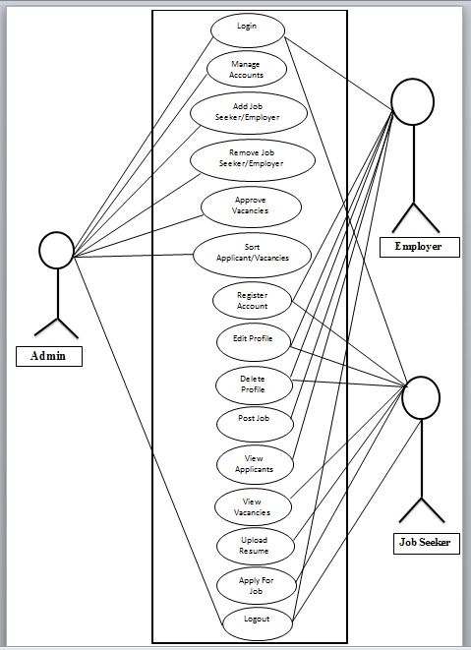

USE CASE DIAGRAM

