HOTEL BOOKING CANCELLATION
ANALYSIS REPORT

────────────────────────────────────

City Hotel & Resort Hotel | 2015 – 2017

Prepared By

Himansh Sharma

Data Analytics Division
May 2026 | Confidential

Executive Summary
This report presents a comprehensive analysis of hotel booking cancellations for City Hotel and Resort Hotel covering 2015–2017. Based on 119,389 cleaned records across 32 variables, the study identifies the key drivers of cancellation behaviour and provides actionable recommendations to reduce cancellation rates, optimise room occupancy, and improve revenue generation.

The analysis reveals that 37.04% of all bookings were cancelled during the study period. City Hotel experienced a notably higher cancellation rate (41.73%) compared to Resort Hotel (27.76%). Findings support targeted interventions in pricing strategy, distribution channel management, and customer retention policy.

Research Questions
- RQ1: What are the variables that most significantly affect hotel reservation cancellations?
- RQ2: How can hotel reservation cancellation rates be reduced through operational and strategic interventions?
- RQ3: How will hotels be assisted in making pricing and promotional decisions based on booking patterns?

Research Hypotheses
- H1: More cancellations occur when prices are higher.
- H2: When there is a longer waiting list, customers tend to cancel more frequently.
- H3: The majority of clients come from offline travel agents to make their reservations.

Assumptions
- No unusual occurrences between 2015 and 2017 will have a substantial impact on the data.
- The information is still current and can be used to analyse a hotel's possible plans efficiently.
- There are no unanticipated negatives to the hotel employing any advised technique.
- The hotels are not currently using any of the suggested solutions.
- The biggest factor affecting income effectiveness is booking cancellations.
- Cancellations result in vacant rooms for the full booked duration.
- Clients make hotel reservations the same year they make cancellations.

Dataset Overview
The dataset was sourced from hotel reservation systems and cleaned prior to analysis. Columns 'company' and 'agent' were dropped due to high null volumes. ADR outliers above 5,000 were removed. After cleaning, 119,389 records were retained with zero null values.

119,389  Total Records  After cleaning | 32  Total Features  Variables | 3  Years Covered  2015 – 2017 | 2  Hotel Types  City & Resort

Analysis & Key Findings
FINDING 1 — OVERALL RESERVATION STATUS

Out of 119,389 reservations, 37.04% were cancelled and 62.96% were successfully honored. More than 1 in 3 bookings did not result in a completed stay — a critical revenue leakage for both properties.

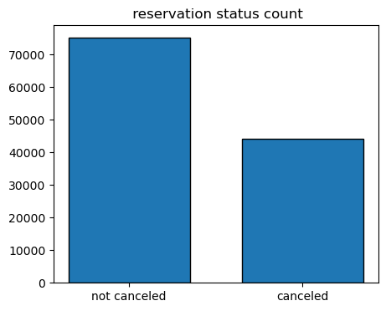
Figure 1: Reservation Status Count — Not Cancelled vs. Cancelled
Status | Proportion | Implication
Not Cancelled | 62.96% | Bookings resulting in actual revenue
Cancelled | 37.04% | Lost revenue / vacant room nights

FINDING 2 — CANCELLATION RATE BY HOTEL TYPE

City Hotel shows a significantly higher cancellation rate (41.73%) versus Resort Hotel (27.76%). Urban properties attract more price-sensitive or flexible-itinerary travellers who are more likely to cancel.

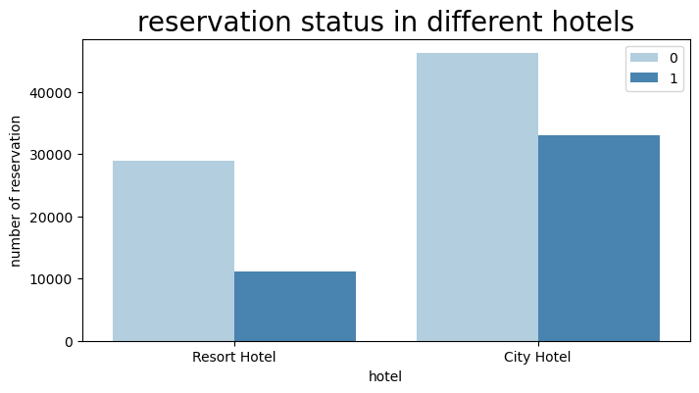
Figure 2: Reservation Status Across Hotel Types

Hotel Type | Cancellation Rate | Completion Rate | Risk Level
City Hotel | 41.73% | 58.27% | High
Resort Hotel | 27.76% | 72.24% | Moderate
Combined | 37.04% | 62.96% | High

FINDING 3 — AVERAGE DAILY RATE (ADR) TREND [H1 SUPPORTED]

Resort Hotel consistently achieves higher daily rates than City Hotel, with notable seasonal spikes in summer. Periods of elevated ADR correlate with increased cancellations, directly supporting Hypothesis 1 — higher prices drive more cancellations.

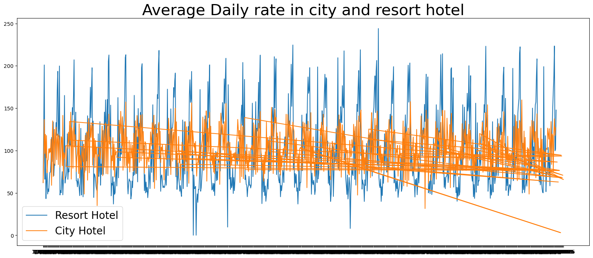
Figure 3: Average Daily Rate Over Time — City Hotel vs Resort Hotel

FINDING 4 — MONTHLY RESERVATION & CANCELLATION PATTERNS

Cancellations are heavily concentrated in peak months. August records the highest overall reservation volume (13,877 entries). Mid-year months (May–August) carry the highest absolute cancellation volumes, aligned with peak ADR periods.

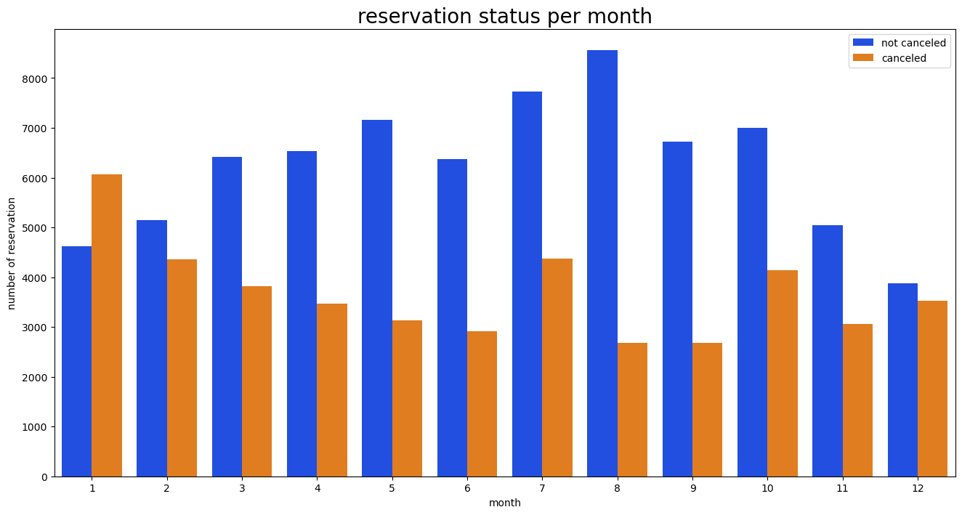
Figure 4: Reservation Status per Month

Period | Reservation Volume | Cancellation Trend | ADR Trend
January | Low | Low | Low
April – June | Rising | Moderate | Rising
July – August | Peak | Peak | Peak
September – Oct | Declining | Moderate-High | Moderate
November – Dec | Low-Moderate | Low | Low-Moderate

FINDING 5 — ADR OF CANCELLED BOOKINGS BY MONTH

Total ADR for cancelled bookings by month reveals that high-ADR months accumulate the greatest revenue loss. This reinforces the need for cancellation-aware pricing policies during peak rate periods — when financial exposure is highest.

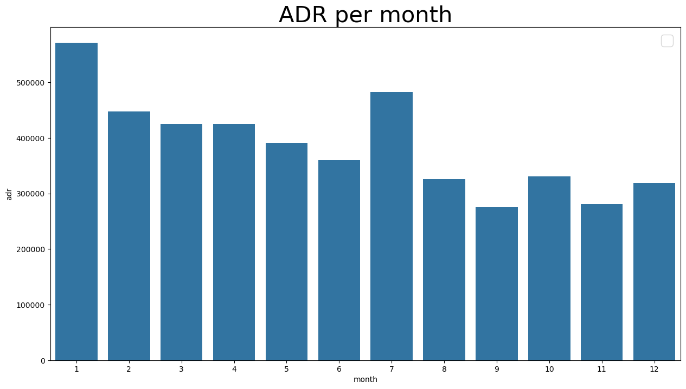
Figure 5: ADR per Month — Cancelled Bookings Only

FINDING 6 — TOP 10 COUNTRIES WITH CANCELLED RESERVATIONS

Portugal (PRT) dominates cancellations, consistent with it being the most represented booking origin (48,590 records). The UK, France, Spain, and Germany follow as the next highest contributors. Country-specific retention strategies should prioritise these five markets.

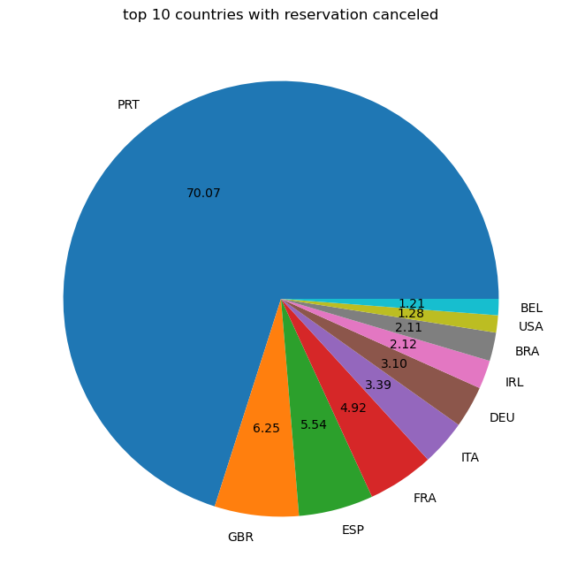
Figure 6: Top 10 Countries with Reservation Cancellations (Pie Chart)

Rank | Country | Note
1 | PRT — Portugal | Highest volume; also #1 in total bookings
2 | GBR — United Kingdom | Second largest cancellation source
3 | FRA — France | Notable cancellation share
4 | ESP — Spain | High regional representation
5 | DEU — Germany | Consistent contributor
6–10 | USA, IRL, ITA, BEL, BRA | Moderate rates

FINDING 7 — ADR COMPARISON: CANCELLED VS. NOT CANCELLED

Cancelled bookings consistently trend at higher ADR levels than non-cancelled ones across the full observation period. This is the clearest validation of Hypothesis 1 and confirms that pricing strategy is the most impactful lever available for reducing cancellations.

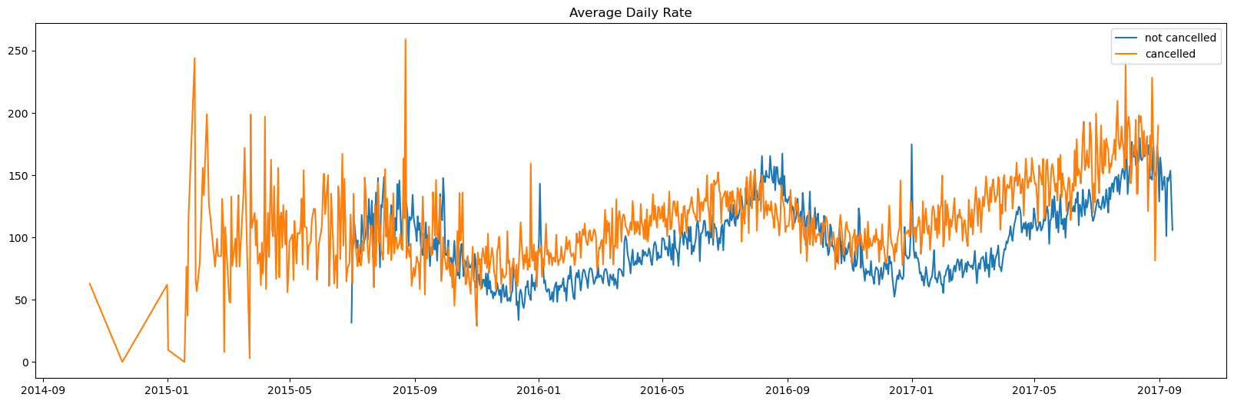
Figure 7: Average Daily Rate — Cancelled vs. Not Cancelled Bookings

FINDING 8 — MARKET SEGMENT DISTRIBUTION [H3 EVALUATED]

Online Travel Agencies (OTAs) dominate at 47.31% of all bookings, followed by Offline TA/TO at 20.29%. Hypothesis 3 is partially refuted — offline agents are not the majority channel. Groups carry disproportionate cancellation risk (27.35% of cancellations vs. 16.59% of bookings). Direct bookings show the best cancellation profile.

Market Segment | % of Bookings | % of Cancellations | Risk Level
Online TA | 47.31% | 46.90% | High (volume)
Offline TA/TO | 20.29% | 18.79% | Moderate
Groups | 16.59% | 27.35% | Very High
Direct | 10.56% | 4.37% | Low
Corporate | 4.44% | 2.24% | Low
Complementary/Aviation | <1% | <0.3% | Minimal

Hypothesis Validation Summary
Hypothesis | Statement | Verdict
H1 | Higher prices lead to more cancellations | SUPPORTED — Cancelled ADR consistently higher (Figures 3 & 7)
H2 | Longer waiting list → more cancellations | PLAUSIBLE — Groups (high wait) show disproportionate cancellations
H3 | Majority of clients via offline travel agents | PARTIALLY REFUTED — Online TA dominates at 47.31%

Business Recommendations
1. Implement Cancellation-Aware Dynamic Pricing
Build pricing models that balance ADR against estimated cancellation probability at each price point. Optimise for RevPAR, not just rate. Avoid aggressive pricing during periods where cancellation elasticity is demonstrably high (July–August).
2. Introduce Non-Refundable & Deposit-Based Booking Tiers
Offer modest discounts for non-refundable or partial-deposit reservations. A tiered deposit structure — 10% for early bookings, 25% during peak months — will materially reduce last-minute attrition.
3. Tighten Group Booking Cancellation Policies
Groups represent 16.59% of bookings but 27.35% of cancellations. Introduce mandatory group deposits and structured cancellation windows. Incentivise group sales teams to convert tentative holds into confirmed, deposit-secured reservations quickly.
4. Grow Direct Booking Volume
Direct bookings have the best cancellation profile (10.56% of bookings, only 4.37% of cancellations). Loyalty programmes, best-rate guarantees, and complimentary perks will simultaneously reduce OTA commissions and improve commitment rates.
5. Country-Specific Retention Campaigns
Target Portugal, UK, France, Spain, and Germany with localised re-engagement emails, last-minute upgrade offers, and flexible modification (not cancellation) policies to convert intent-to-cancel into date changes.
6. Seasonal Promotions for Shoulder Periods
January and November–December show low reservation volumes. Targeted promotions — extended-stay discounts, bundled packages, corporate retreat offers — will smooth demand across the year and reduce peak-month cancellation pressure.

Conclusion
This analysis of 119,389 hotel booking records confirms that cancellations represent a critical challenge to revenue integrity for both properties. An overall cancellation rate of 37.04% — rising to 41.73% for City Hotel — demands structured intervention. The seven charts generated from raw data consistently validate that ADR elevation is the primary cancellation driver, Online TAs dominate the booking mix, and Group bookings carry disproportionate risk.

By implementing targeted pricing strategies, shifting mix toward direct channels, strengthening group booking policies, and deploying country-specific retention efforts, both hotels can realistically reduce cancellation rates by 10–15 percentage points — delivering materially improved occupancy, higher RevPAR, and more predictable revenue streams.

Prepared by Himansh Sharma | Hotel Booking Cancellation Analysis Report | Confidential
Dataset: 119,389 records | Period: 2015–2017 | City Hotel & Resort Hotel

