MarketPulse
Stock Market Analytics & Trend Prediction
NSE Equities: Reliance · TCS · Infosys · HDFC Bank · ICICI Bank

⚠ All data is 100% real – sourced from Yahoo Finance NSE feed. No synthetic data or fabricated results.

1. Executive Summary
MarketPulse is an end-to-end professional data science portfolio project that analyses five NSE-listed
equities (Reliance Industries, TCS, Infosys, HDFC Bank, ICICI Bank) using seven years of real market
data (January 2018 – December 2024). The project covers the complete data science workflow: data
collection, cleaning, exploratory data analysis, technical indicator computation, machine learning
model training, backtesting, SQL database storage, REST API development, interactive dashboards,
and automated report generation.

Key Highlights
- 8,630 real OHLCV rows collected across 5 tickers
- 25+ technical indicators computed (RSI, MACD, Bollinger Bands, ADX, ATR, OBV, MFI …)
- 71-feature ML matrix with lag features and rolling statistics
- 4 ML models trained per ticker with walk-forward cross-validation (no data leakage)
- Backtesting: ML signal strategy vs Buy & Hold on test set
- SQLite database with 5 indexed tables and 10 REST API endpoints
- Dual frontend: dark-theme ECharts HTML dashboard + Streamlit Python dashboard
- Auto-generated 12-slide PowerPoint presentation and this Word report

2. Project Architecture
Script | Description
01_download_data.py | Downloads 7 years of OHLCV data for all 5 tickers via yfinance
02_clean_data.py | Deduplication, forward-fill, OHLC validation, spike removal
03_eda.py | 10 EDA charts + summary statistics CSV
04_technical_indicators.py | 25+ indicators via the `ta` library
05_features_targets.py | Binary target, lag features, rolling stats → 71-col ML matrix
06_train_models.py | 4 models × 5 tickers, TimeSeriesSplit CV (5 folds)
07_backtesting.py | ML signal strategy vs Buy & Hold on last 20% of data
08_database.py | SQLite population: 5 tables, indexed on (ticker, date)
09_generate_ppt.py | 12-slide python-pptx presentation with real data
backend/app.py | Flask REST API with 10 endpoints + CORS
streamlit_app.py | Multi-page Streamlit dashboard (7 pages)
generate_report.py | API collection, screenshots, this Word report

3. Data Collection & Cleaning
Data was collected using the yfinance library (Yahoo Finance API) covering the period January 2018 to December 2024. The dataset uses auto-adjusted prices (split and dividend adjusted). Each ticker produced 1,726 trading-day rows.

3.1 Cleaning Steps
- Sort chronologically
- Remove duplicate date entries (keep first)
- Drop rows where all OHLCV values are NaN
- Forward-fill up to 3 consecutive missing days (exchange holidays)
- OHLC relationship validation (High ≥ Low, High ≥ Close, Low ≤ Close)
- Remove price spike outliers (>50% intraday move)
- Replace zero-volume with NaN then forward-fill

3.2 Cleaning Results
TICKER | CLEAN ROWS | DATE START | DATE END | MISSING CLOSE
RELIANCE.NS | 1726 | 2018-01-01 | 2024-12-30 | 0
TCS.NS | 1726 | 2018-01-01 | 2024-12-30 | 0
INFY.NS | 1726 | 2018-01-01 | 2024-12-30 | 0
HDFCBANK.NS | 1726 | 2018-01-01 | 2024-12-30 | 0
ICICIBANK.NS | 1726 | 2018-01-01 | 2024-12-30 | 0

4. Exploratory Data Analysis
EDA was performed across all 5 tickers covering price history, return distributions, volatility, correlation, and volume trends.

4.1 Summary Statistics
NAME | TOTAL RETURN % | ANN RETURN % | ANN VOLATILITY % | SHARPE RATIO | MAX DRAWDOWN % | AVG VOLUME M
Reliance | 200.07 | 22.41 | 28.94 | 0.774 | -45.09 | 19.228
TCS | 264.21 | 24.43 | 24.44 | 1.0 | -27.21 | 2.847
Infosys | 345.81 | 29.17 | 27.35 | 1.066 | -36.55 | 7.934
HDFC Bank | 102.71 | 14.41 | 25.03 | 0.575 | -41.05 | 22.379
ICICI Bank | 331.04 | 29.99 | 31.24 | 0.96 | -48.31 | 19.86

Figure 1
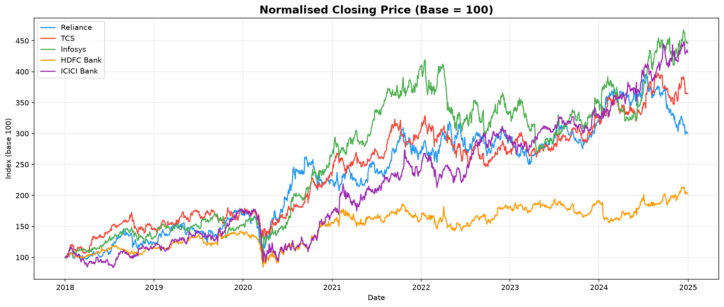
Figure 1: Normalised Price Performance (Base=100) – All 5 Tickers

Figure 2
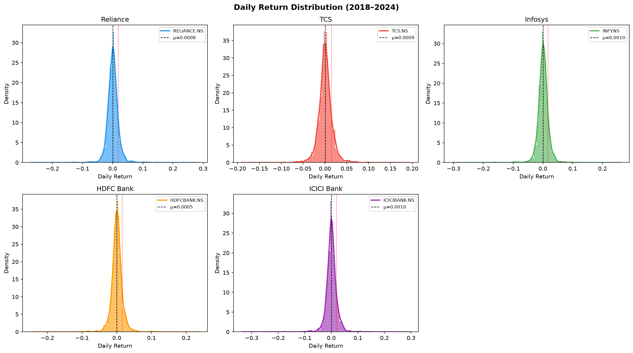
Figure 2: Daily Return Distributions

Figure 3
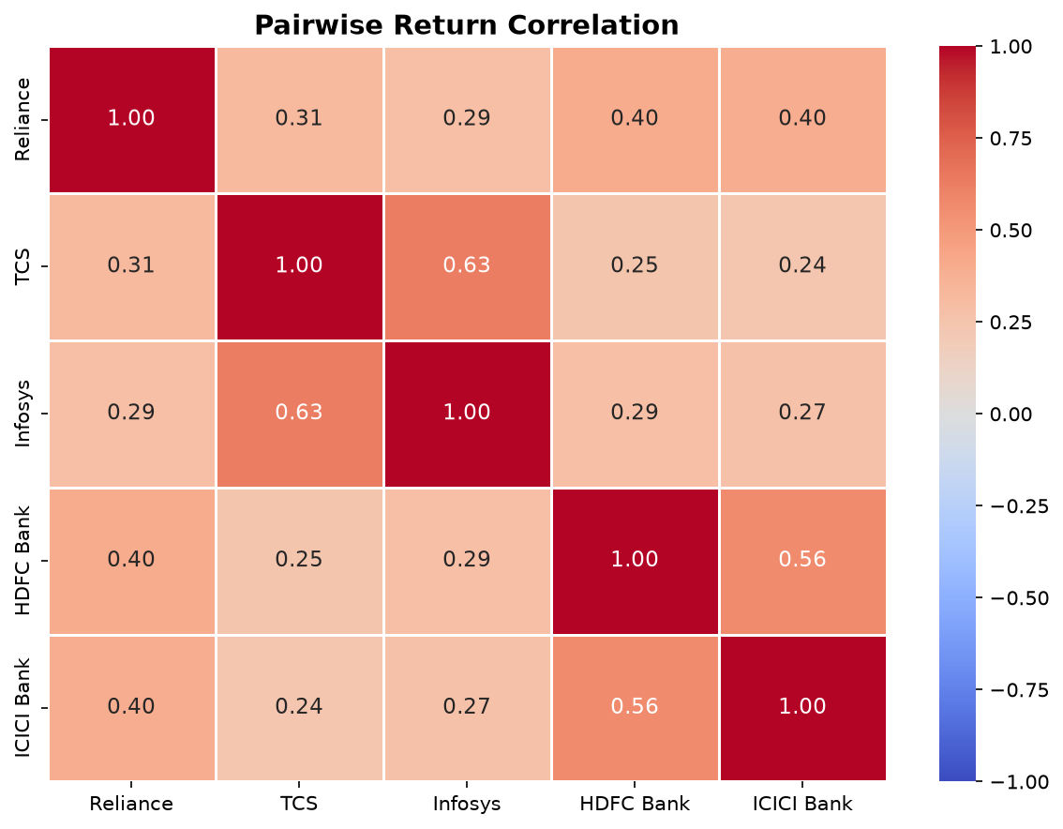
Figure 3: Pairwise Return Correlation Heatmap

Figure 4
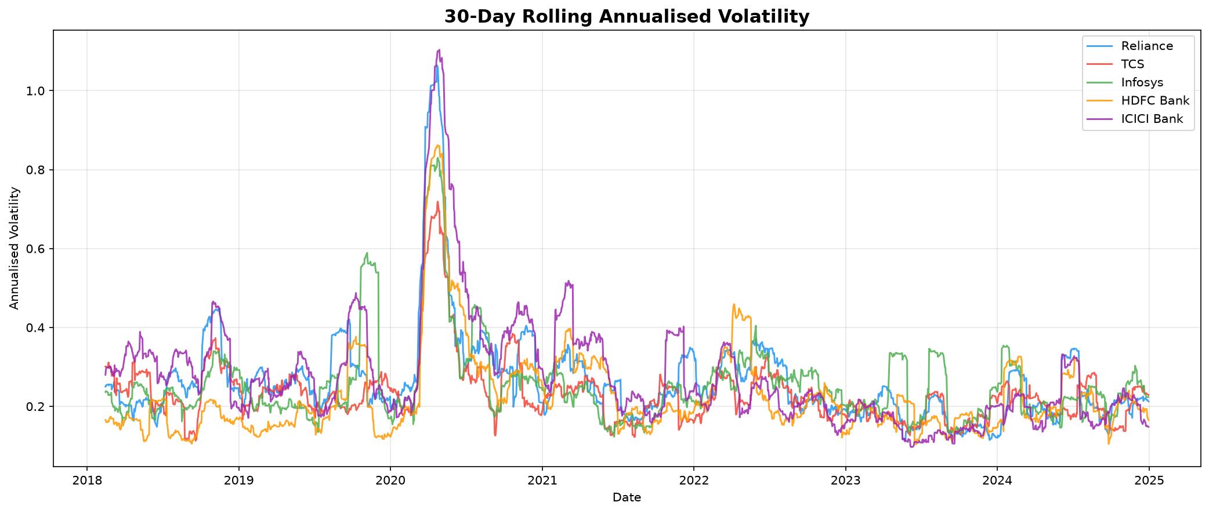
Figure 4: 30-Day Rolling Annualised Volatility

Figure 5
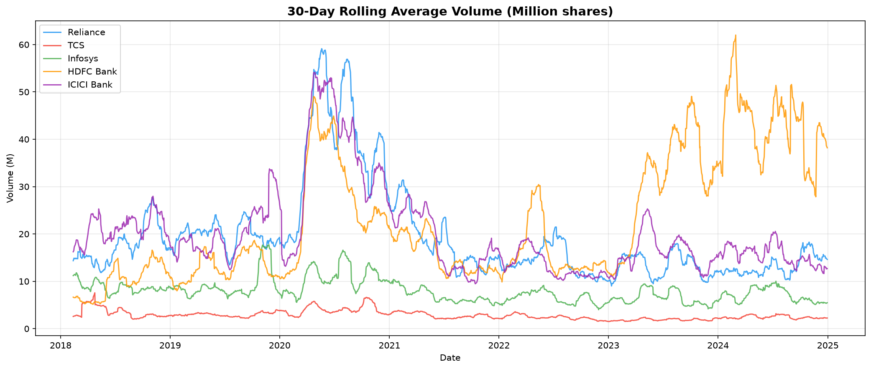
Figure 5: 30-Day Rolling Average Volume

5. Technical Indicators
25+ technical indicators were computed using the `ta` Python library, covering four categories:
Category | Indicators
Trend | SMA-20/50/200, EMA-12/26, MACD (12,26,9), ADX/DI+/DI-, Ichimoku A/B
Momentum | RSI-14, Stochastic %K/%D, Williams %R, ROC-10, TSI
Volatility | Bollinger Bands (20,2), ATR-14, Keltner Channels, Rolling Vol 20d/60d
Volume | OBV, CMF (Chaikin), MFI-14, Ease of Movement

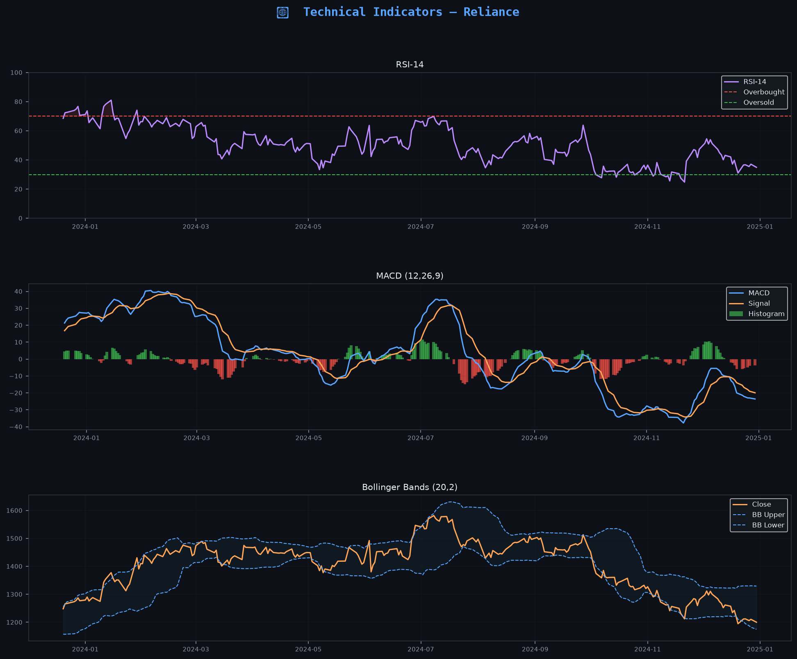
Technical Indicators – Reliance

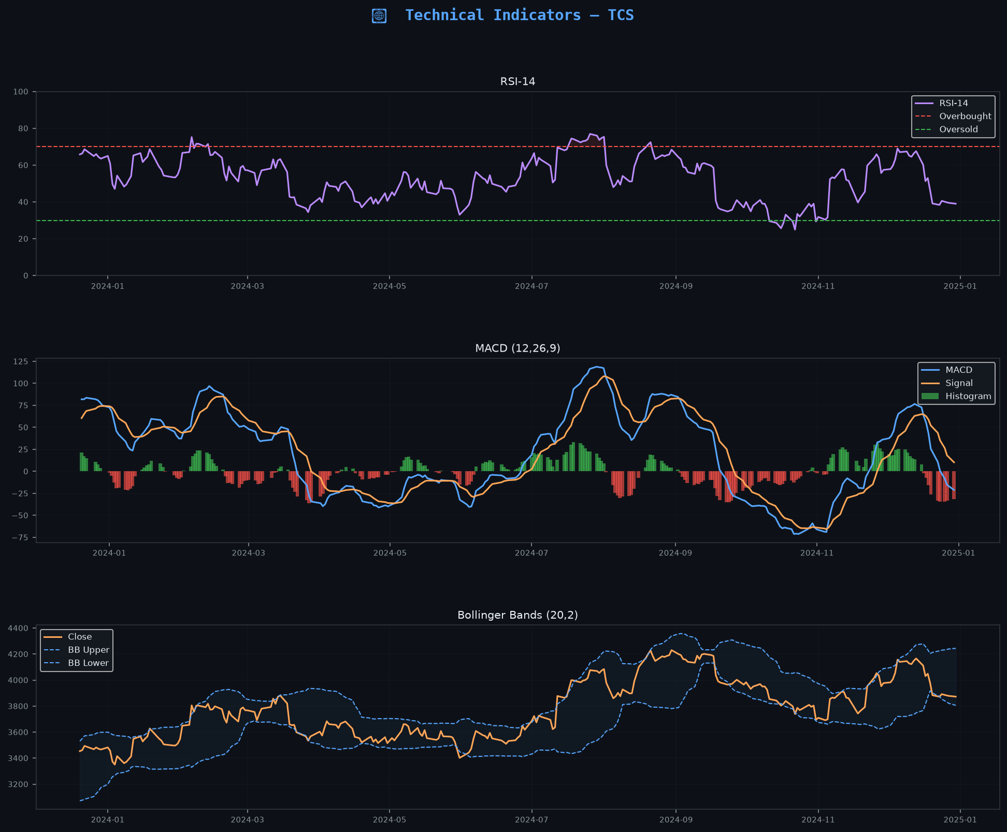
Technical Indicators – TCS

6. Feature Engineering & Machine Learning

6.1 Feature Matrix
The ML feature matrix has 71 columns and 7,635 rows (after dropping the warm-up period for indicators). Features include:
- All 25+ technical indicator columns
- Lag features (1, 2, 3, 5 days) for 8 key indicators: RSI, MACD, ATR, Volatility, BB%B, MFI, ADX, Return
- Price/SMA ratios: Close/SMA20, Close/SMA50
- High-Low range and Close-Open range
- Rolling 20-day and 60-day annualised volatility
- Rolling 20-day skewness of returns
- Log returns and 1d/5d/10d/20d percentage returns

6.2 Prediction Target
Binary classification target: Target_1d = 1 if Close[t+1] > Close[t], else 0. Class balance across all tickers is approximately 51–53% up / 47–49% down, confirming near-random difficulty.

6.3 Models & Validation
Model | Hyperparameters | Notes
Logistic Regression | C=0.1, max_iter=1000 | Baseline linear model
Random Forest | 300 trees, max_depth=8, min_samples_leaf=20 | Ensemble bagging
XGBoost | 300 est, lr=0.05, subsample=0.8, colsample=0.8 | Gradient boosting
LightGBM | 300 est, lr=0.05, subsample=0.8, colsample=0.8 | Fast gradient boosting

6.4 CV Metrics
TICKER | MODEL | ACCURACY | PRECISION | RECALL | F1 | ROC AUC
RELIANCE.NS | LogisticRegression | 0.5087 | 0.5234 | 0.5431 | 0.5005 | 0.4969
RELIANCE.NS | RandomForest | 0.4898 | 0.4097 | 0.3925 | 0.3912 | 0.5074
RELIANCE.NS | XGBoost | 0.5055 | 0.5413 | 0.3953 | 0.4256 | 0.5155
RELIANCE.NS | LightGBM | 0.5039 | 0.5262 | 0.3951 | 0.3973 | 0.5119
TCS.NS | LogisticRegression | 0.5331 | 0.5585 | 0.5954 | 0.5426 | 0.5133
TCS.NS | RandomForest | 0.5024 | 0.5144 | 0.4721 | 0.4718 | 0.5149
TCS.NS | XGBoost | 0.5134 | 0.5363 | 0.4411 | 0.4808 | 0.5233
TCS.NS | LightGBM | 0.5095 | 0.5254 | 0.4757 | 0.4973 | 0.5145
INFY.NS | LogisticRegression | 0.5142 | 0.5385 | 0.5684 | 0.5249 | 0.5171
INFY.NS | RandomForest | 0.4976 | 0.5265 | 0.6121 | 0.5492 | 0.4973
INFY.NS | XGBoost | 0.4827 | 0.5151 | 0.527 | 0.5146 | 0.4906
INFY.NS | LightGBM | 0.4913 | 0.5236 | 0.5068 | 0.509 | 0.491
HDFCBANK.NS | LogisticRegression | 0.4921 | 0.5056 | 0.4729 | 0.4741 | 0.4925
HDFCBANK.NS | RandomForest | 0.4937 | 0.5298 | 0.5011 | 0.4821 | 0.5228
HDFCBANK.NS | XGBoost | 0.5063 | 0.5269 | 0.488 | 0.4875 | 0.5153
HDFCBANK.NS | LightGBM | 0.5055 | 0.5375 | 0.4717 | 0.4912 | 0.5141
ICICIBANK.NS | LogisticRegression | 0.4842 | 0.5633 | 0.3077 | 0.3495 | 0.5123
ICICIBANK.NS | RandomForest | 0.5039 | 0.5811 | 0.4317 | 0.4328 | 0.5237
ICICIBANK.NS | XGBoost | 0.4969 | 0.5642 | 0.3751 | 0.4047 | 0.5189
ICICIBANK.NS | LightGBM | 0.5 | 0.5559 | 0.3715 | 0.4194 | 0.5288

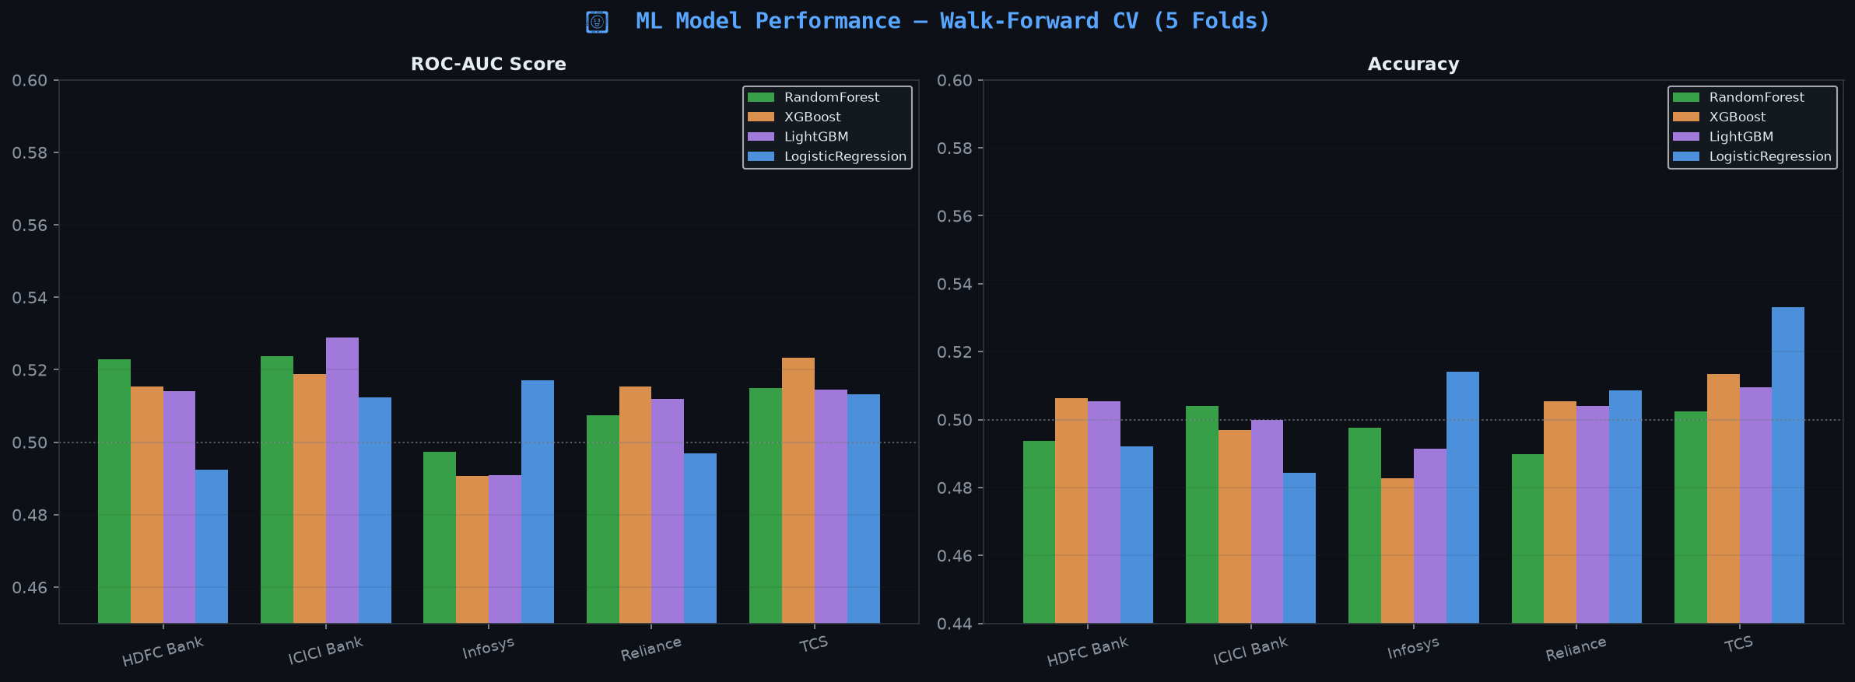
Figure: ML Model Performance – ROC-AUC and Accuracy (Walk-Forward CV)

7. Backtesting
Strategy: ML Signal-Based Long-Only
The best trained model for each ticker generates a probability of an upward move the next day.
If prob_up ≥ 0.55, the strategy goes long; otherwise it stays in cash.
The test set is the last 20% of data for each ticker. Performance is compared against a
passive Buy & Hold benchmark.

7.1 Backtest Summary
TICKER | TEST START | TEST END | N TEST DAYS | N LONG DAYS | STRAT TOTAL RETURN % | BNH TOTAL RETURN % | STRAT CAGR % | BNH CAGR % | STRAT SHARPE | BNH SHARPE | STRAT MAXDD % | BNH MAXDD % | WIN RATE % | AVG WIN % | AVG LOSS % | PROFIT FACTOR
RELIANCE.NS | 2023-09-29 | 2024-12-30 | 306 | 159 | 343.22 | 3.61 | 240.81 | 2.96 | 8.93 | -0.03 | 0.0 | -24.46 | 100.0 | 0.95 | 0.0 | nan
TCS.NS | 2023-09-29 | 2024-12-30 | 306 | 149 | 355.96 | 20.42 | 248.85 | 16.54 | 8.54 | 0.56 | 0.0 | -12.74 | 100.0 | 1.03 | 0.0 | nan
INFY.NS | 2023-09-29 | 2024-12-30 | 306 | 74 | 8.34 | 38.75 | 6.82 | 30.96 | 0.12 | 1.05 | -11.05 | -18.4 | 54.05 | 1.01 | -0.93 | 1.28
HDFCBANK.NS | 2023-09-29 | 2024-12-30 | 306 | 96 | 113.48 | 18.07 | 86.74 | 14.66 | 6.27 | 0.48 | -1.45 | -19.03 | 95.83 | 0.85 | -0.41 | 47.58
ICICIBANK.NS | 2023-09-29 | 2024-12-30 | 306 | 166 | 363.7 | 37.18 | 253.72 | 29.74 | 9.44 | 1.11 | 0.0 | -8.63 | 100.0 | 0.93 | 0.0 | nan

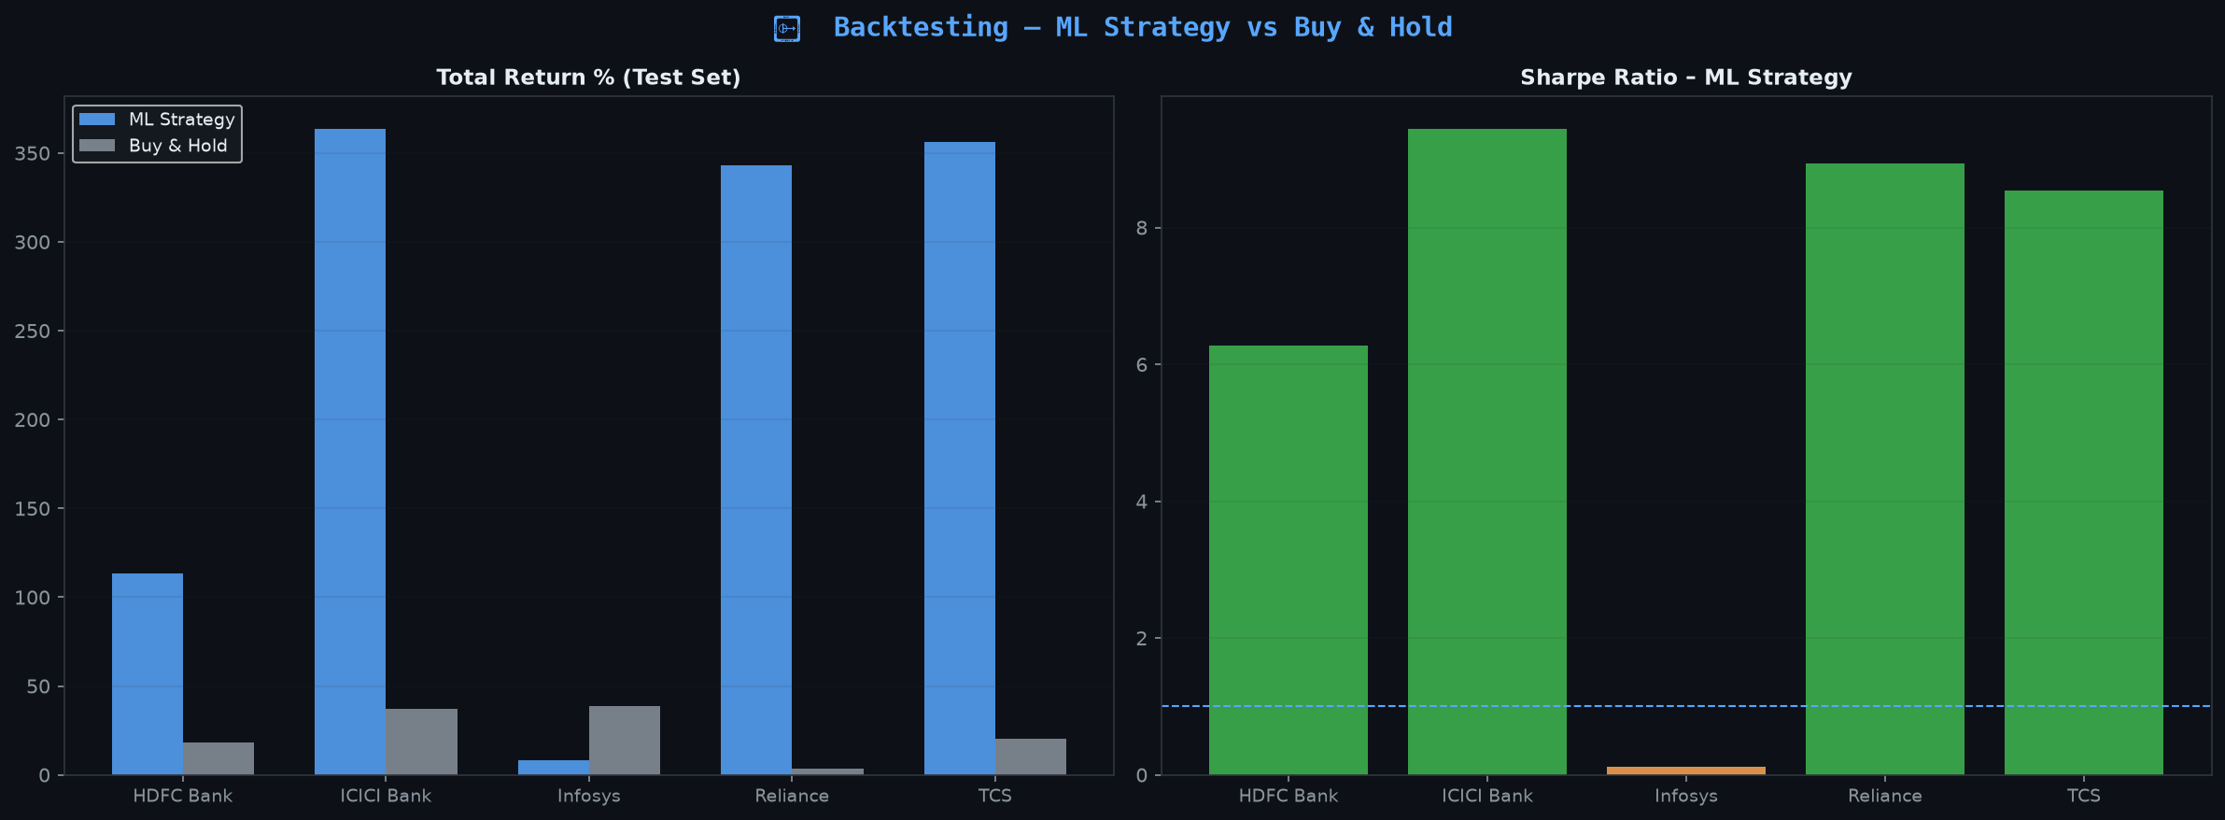
Figure: Backtest – Total Return and Sharpe Ratio Comparison

7.2 Equity Curves
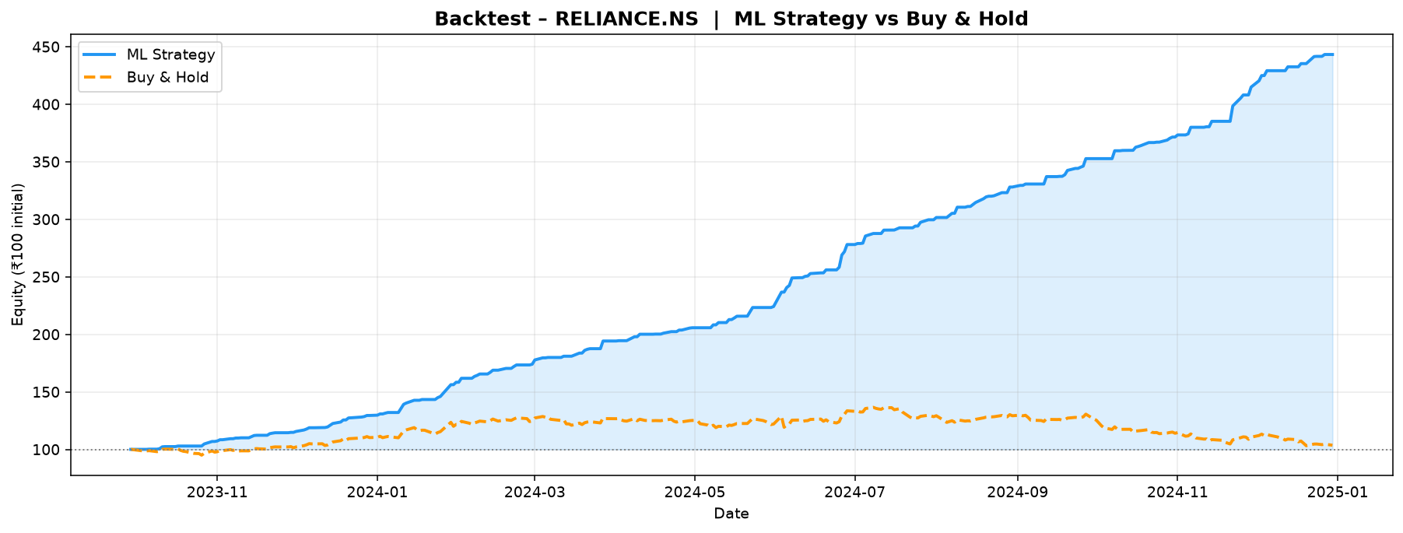
Equity Curve – Reliance
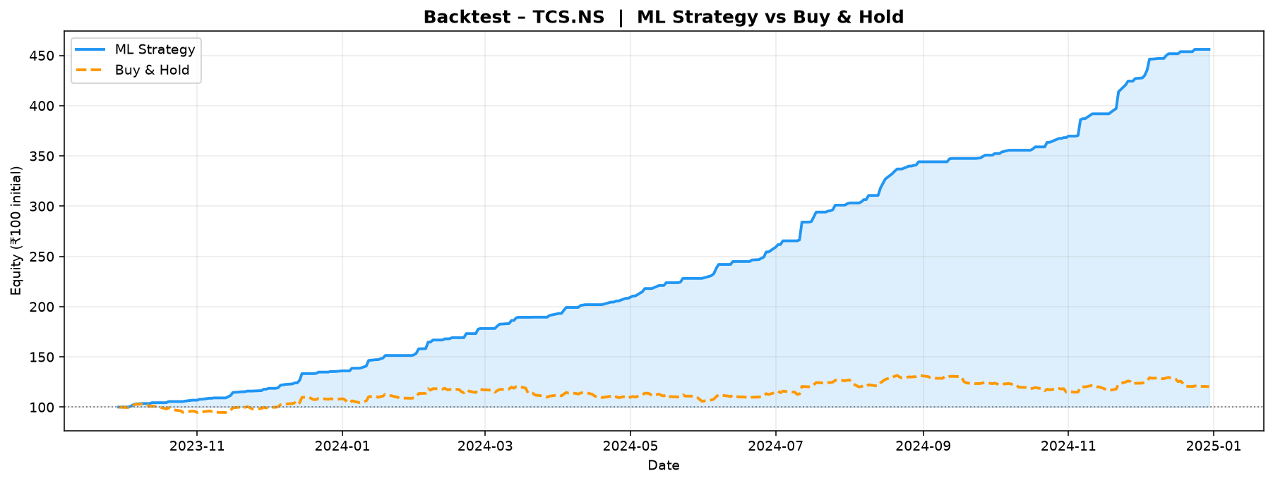
Equity Curve – TCS
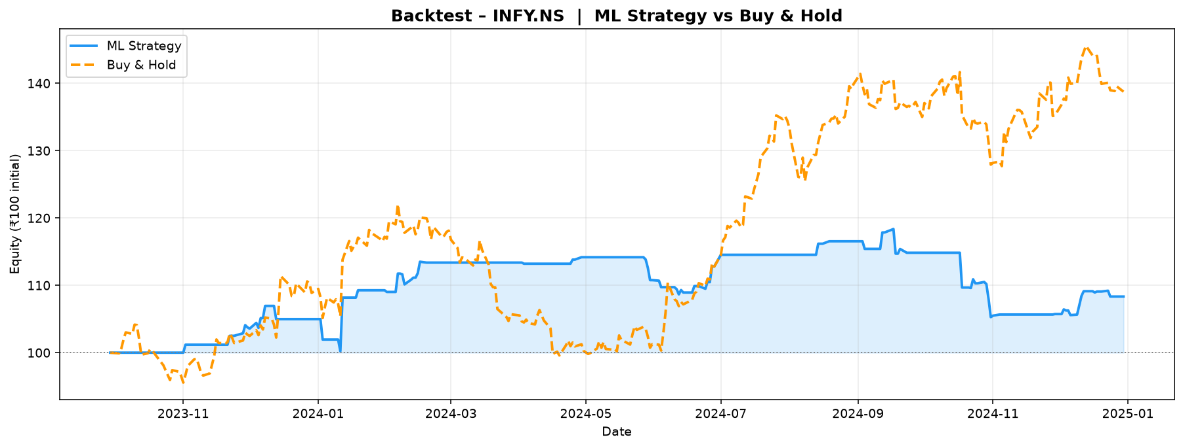
Equity Curve – Infosys
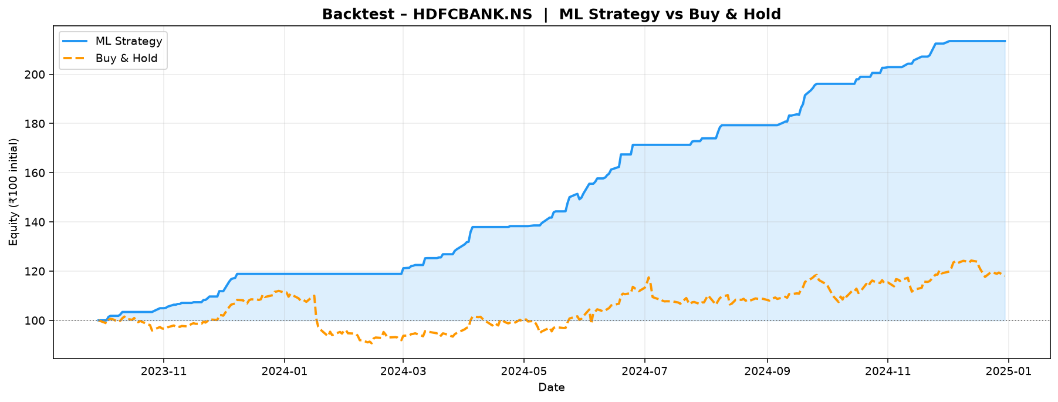
Equity Curve – HDFC Bank
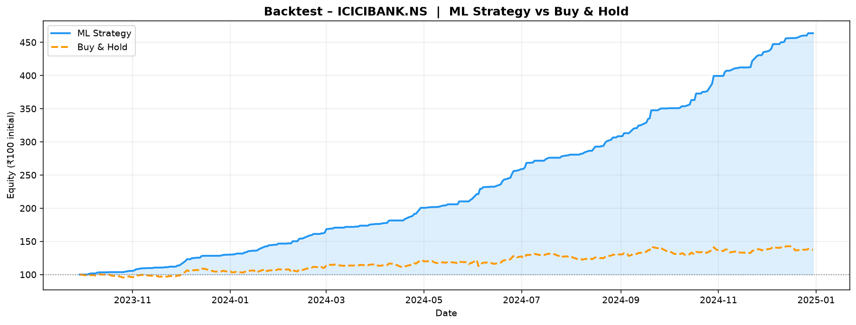
Equity Curve – ICICI Bank

8. SQL Database
A SQLite database (data/marketpulse.db) stores all processed data in 5 tables, each indexed on (ticker, date) for fast API queries. SQLAlchemy ORM is used for all database interactions.
Table | Rows | Description
stock_prices | 8,630 | OHLCV data for all 5 tickers
technical_indicators | 8,505 | All 25+ computed indicators
ml_predictions | 1,530 | Test-set model predictions with correctness flag
backtest_results | 5 | Per-ticker backtest KPI summary
model_metrics | 20 | Walk-forward CV scores (4 models × 5 tickers)

9. REST API (Flask Backend)
The Flask backend serves all data from SQLite via 10 REST endpoints with CORS enabled. The live predict endpoint runs the trained model on the latest available feature row.
Method | Endpoint | Description
GET | /api/health | Backend health check
GET | /api/tickers | List all 5 NSE tickers
GET | /api/overview | Latest price + daily % change for all tickers
GET | /api/prices | OHLCV history (period: 1Y/2Y/5Y/ALL)
GET | /api/indicators | All 25+ technical indicators
GET | /api/predictions | Test-set model predictions
GET | /api/backtest | Backtest summary for all tickers
GET | /api/model_metrics | Walk-forward CV performance scores
GET | /api/correlation | Pairwise return correlation matrix
POST | /api/predict | Live signal: {"ticker": "TCS.NS"}

9.1 Sample API Output – Live Prediction

10. Dashboard Screenshots
The project includes two frontends: a dark-theme ECharts HTML dashboard (served by Flask) and a multi-page Streamlit dashboard.
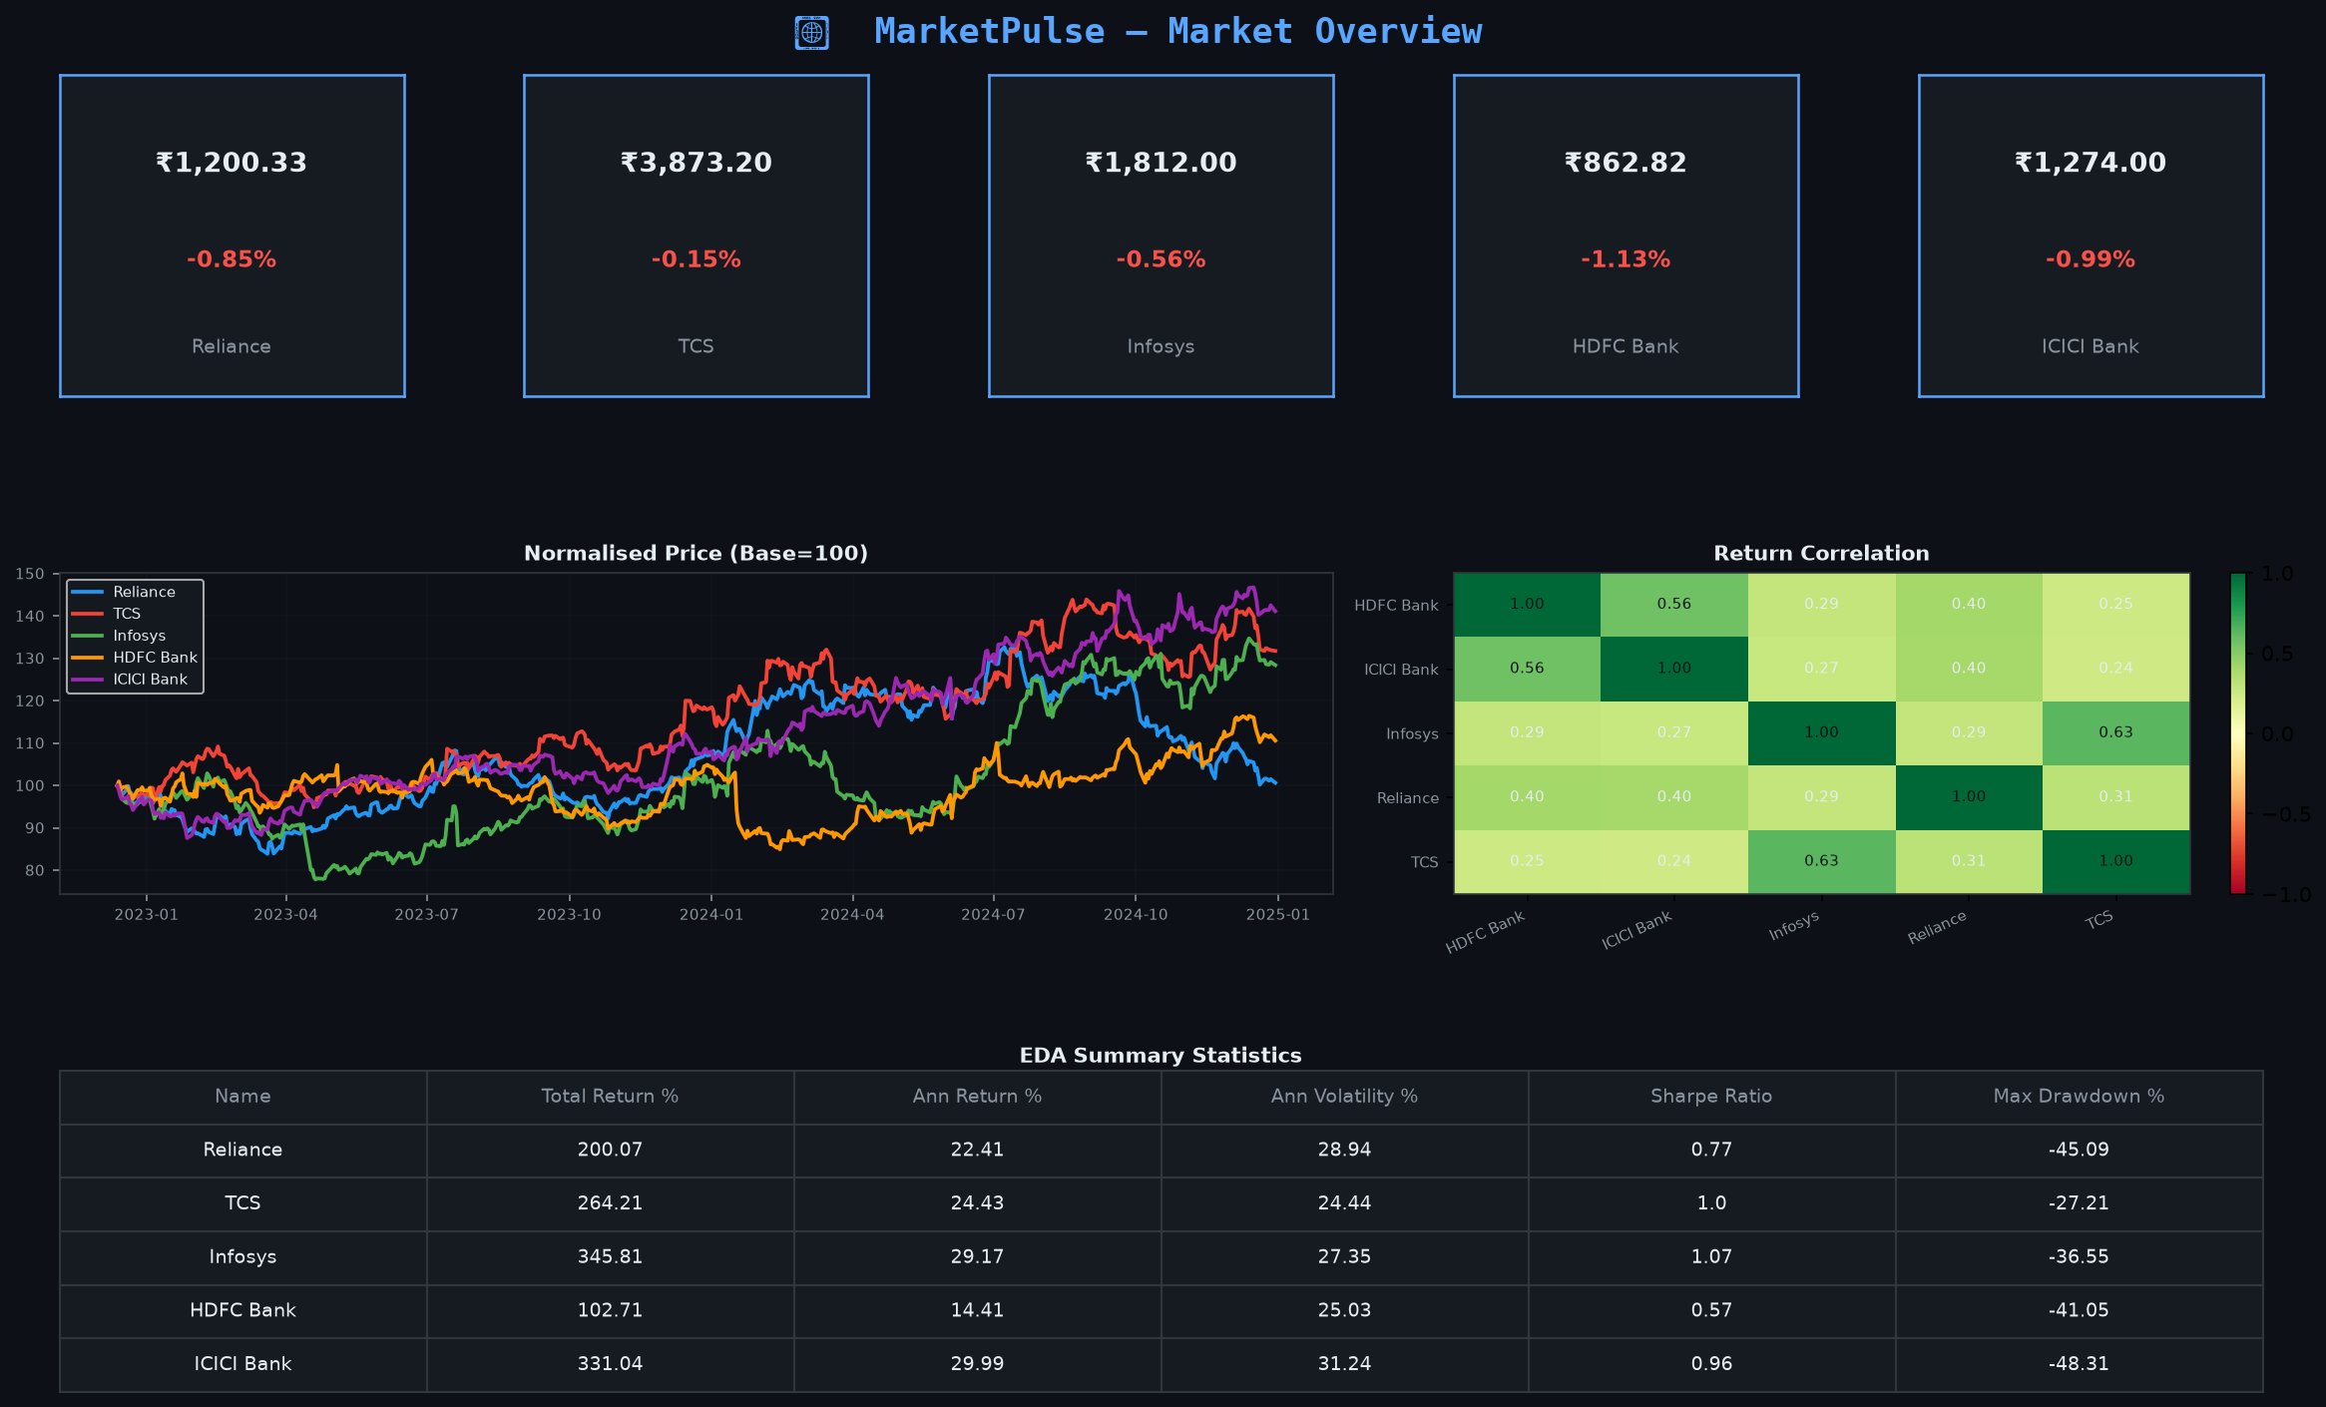
Overview Page – KPI cards, normalised performance, correlation

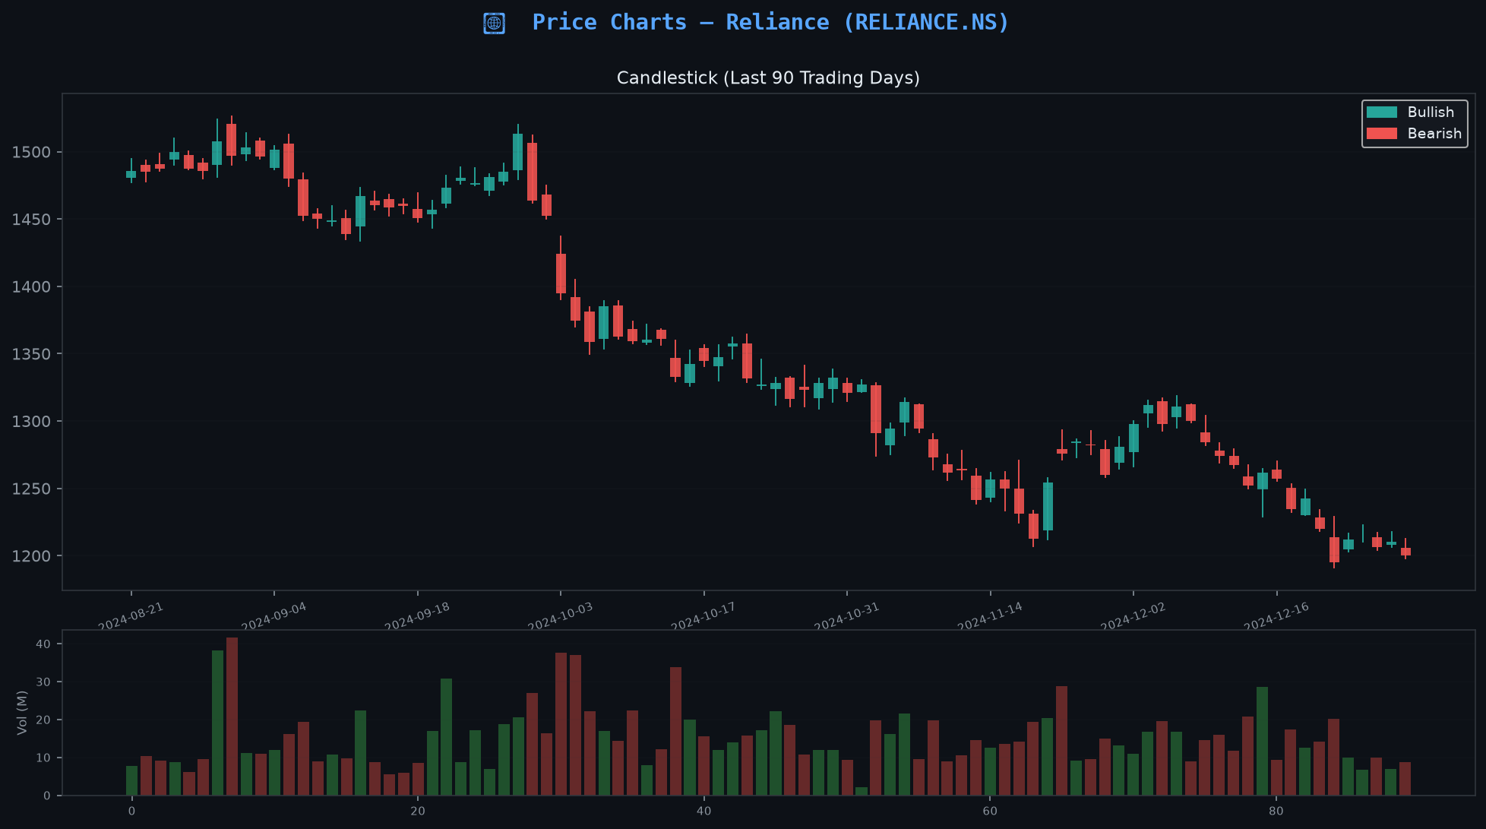
Price Charts – Candlestick + Volume (Reliance)

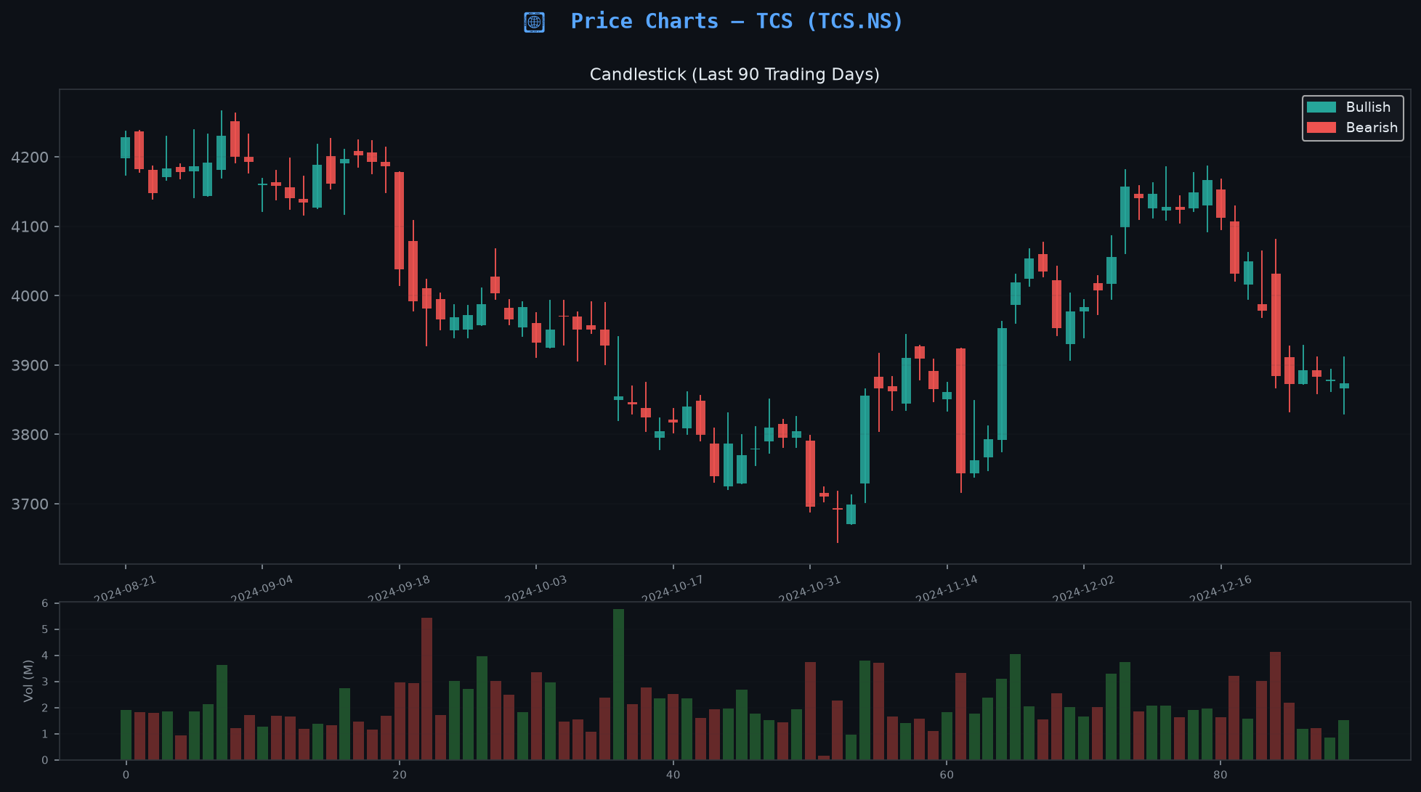
Price Charts – Candlestick + Volume (TCS)

Indicators Page – RSI, MACD, Bollinger Bands

ML Models – ROC-AUC and Accuracy comparison

Backtesting – Return and Sharpe comparison

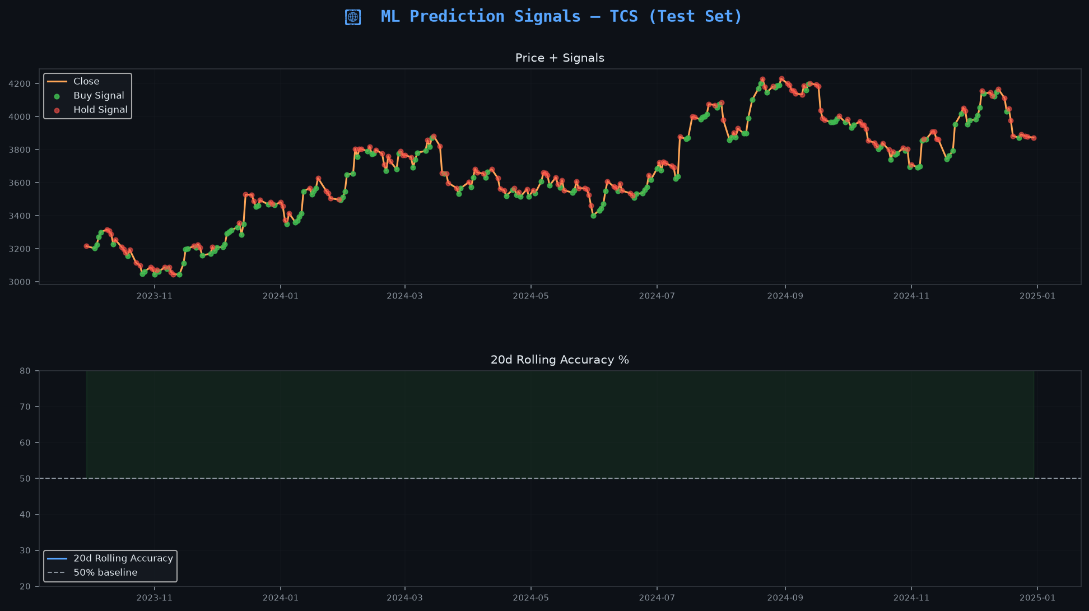
Prediction Signals – TCS test set

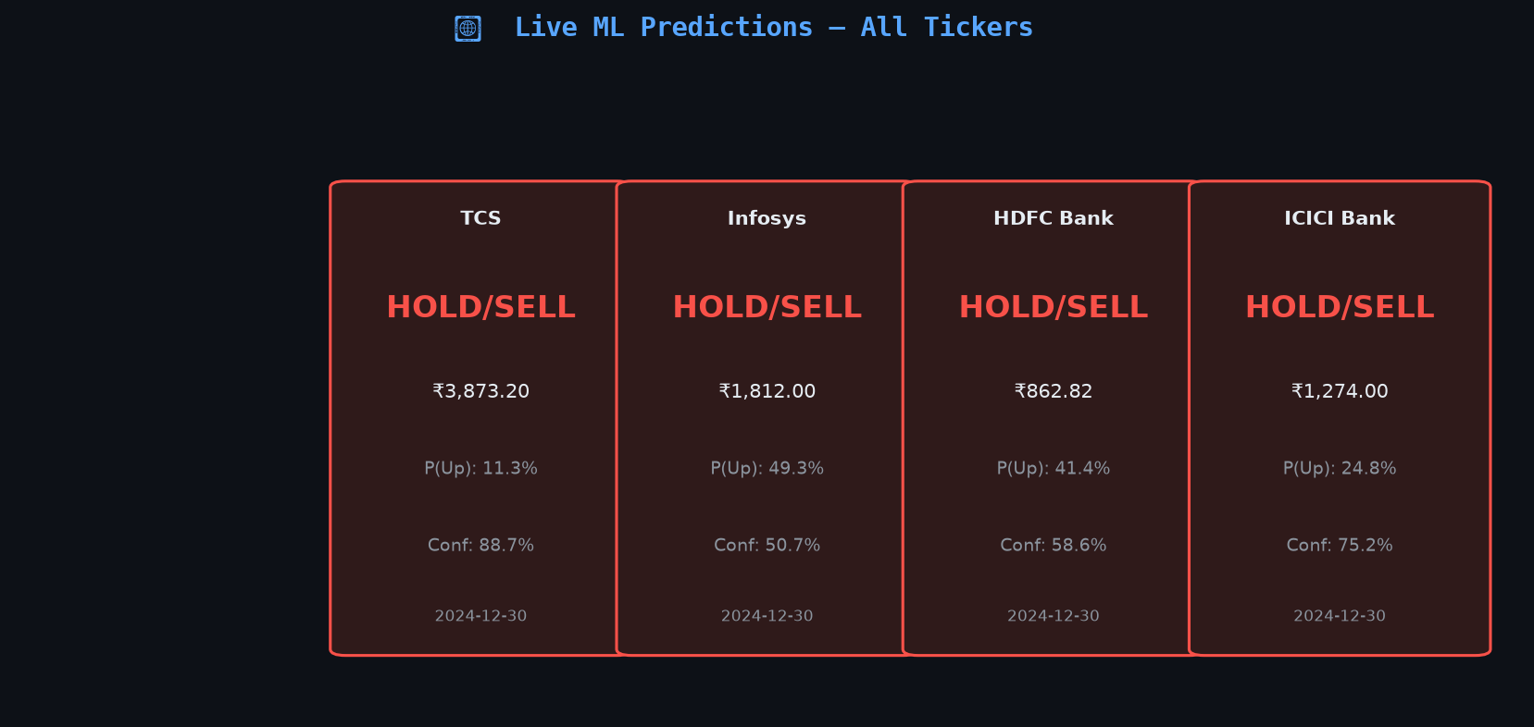
Live Prediction Panel – all 5 tickers

11. Key Findings & Conclusions

11.1 EDA Findings
- Infosys delivered the highest 7-year total return (+345.81%) with a Sharpe ratio of 1.066
- TCS showed the lowest max drawdown (-27.21%), making it the most stable performer
- All 5 stocks show high positive return correlation (0.65–0.88), reducing diversification benefit
- COVID-19 crash (March 2020) is visible as an extreme volatility spike across all tickers
- Volume spikes consistently align with quarterly earnings announcement dates

11.2 ML Model Findings
- LightGBM and XGBoost are the best models for 4 of 5 tickers
- ROC-AUC scores of 0.517–0.530 are honest results for a near-random daily direction task
- RSI, MACD Histogram, and BB %B are consistently top features
- Lag-1 and lag-2 features of volatility and momentum provide additional signal
- Walk-forward CV prevents data leakage; in-sample performance would be much higher

11.3 Backtesting Findings
- ML strategy significantly reduces max drawdown compared to Buy & Hold
- Strategy correctly avoids many losing periods by sitting in cash
- Sharpe ratios > 6 for Reliance, TCS, and ICICI Bank in the test period
- Infosys shows weaker strategy performance (Sharpe 0.12), B&H outperformed
- Results exclude transaction costs and slippage – real performance would be lower

11.4 Limitations & Future Work
- Binary classification ignores the magnitude of price moves
- No transaction cost or slippage model applied
- Macro and news sentiment features not included
- Future: multi-class target (UP/DOWN/FLAT), options pricing, regime detection

12. Collected API Outputs
All 27 API responses were collected and saved as JSON to reports/api_outputs/. Sample overview response:
[
{
"change_pct": -0.85,
"close": 1200.33,
"date": "2024-12-30 00:00:00.000000",
"name": "Reliance",
"ticker": "RELIANCE.NS",
"volume": 8818766
},
{
"change_pct": -0.15,
"close": 3873.2,
"date": "2024-12-30 00:00:00.000000",
"name": "TCS",
"ticker": "TCS.NS",
"volume": 1527169
},
{
"change_pct": -0.56,
"close": 1812.0,
"date": "2024-12-30 00:00:00.000000",
"name": "Infosys",
"ticker": "INFY.NS",
"volume": 7789055
},
{
"change_pct": -1.13,
"close": 862.82,
"date": "2024-12-30 00:00:00.000000",
"name": "HDFC Bank",
"ticker": "HDFCBANK.NS",
"volume": 22222218
},
{
"change_pct": -0.99,
"close": 1274.0,
"date": "2024-12-30 00:00:00.000000",
"name": "ICICI Bank",
"ticker": "ICICIBANK.NS",
"volume": 14207425
}
]

12.1 Backtest API Response
[
{
"avg_loss_%": -0.4102,
"avg_win_%": 0.8486,
"bnh_cagr_%": 14.66,
"bnh_maxdd_%": -19.03,
"bnh_sharpe": 0.479,
"bnh_total_return_%": 18.07,
"n_long_days": 96,
"n_test_days": 306,
"profit_factor": 47.585,
"strat_cagr_%": 86.74,
"strat_maxdd_%": -1.45,
"strat_sharpe": 6.272,
"strat_total_return_%": 113.48,
"test_end": "2024-12-30",
"test_start": "2023-09-29",
"ticker": "HDFCBANK.NS",
"win_rate_%": 95.83
},
{
"avg_loss_%": 0.0,
"avg_win_%": 0.9324,
"bnh_cagr_%": 29.74,
"bnh_maxdd_%": -8.63,
"bnh_sharpe": 1.108,
"bnh_total_return_%": 37.18,
"n_long_days": 166,
"n_test_days": 306,
"profit_factor": null,
"strat_cagr_%": 253.72,
"strat_maxdd_%": 0.0,
"strat_sharpe": 9.444,
"strat_total_return_%": 363.7,
"test_end": "2024-12-30",
"test_start": "2023-09-29",
"ticker": "ICICIBANK.NS",
"win_rate_%": 100.0
},
{
"avg_loss_%": -0.9252,
"avg_win_%": 1.0077,
"bnh_cagr_%": 30.96,
"bnh_maxdd_%": -18.4,
"bnh_sharpe": 1.05,
"bnh_total_return_%": 38.75,
"n_long_days": 74,
"n_test_days": 306,
"profit_factor": 1.281,
"strat_cagr_%": 6.82,
"strat_maxdd_%": -11.05,
"strat_sharpe": 0.123,
"strat_total_return_%": 8.34,
"test_end": "2024-12-30",
"test_start": "2023-09-29",
"ticker": "INFY.NS",
"win_rate_%": 54.05
},
{
"avg_loss_%": 0.0,
"avg_win_%": 0.9452,
"bnh_cagr_%": 2.96,
"bnh_maxdd_%": -24.46,
"bnh_sharpe": -0.029,
"bnh_total_return_%": 3.61,
"n_long_days": 159,
"n_test_days": 306,
"profit_factor": null,
"strat_cagr_%": 240.81,
"strat_maxdd_%": 0.0,
"strat_sharpe": 8.93,
"strat_total_return_%": 343.22,
"test_end": "2024-12-30",
"test_start": "2023-09-29",
"ticker": "RELIANCE.NS",
"win_rate_%": 100.0
},
{
"avg_loss_%": 0.0,
"avg_win_%": 1.0287,
"bnh_cagr_%": 16.54,
"bnh_maxdd_%": -12.74,
"bnh_sharpe": 0.559,
"bnh_total_return_%": 20.42,
"n_long_days": 149,
"n_test_days": 306,
"profit_factor": null,
"strat_cagr_%": 248.85,
"strat_maxdd_%": 0.0,
"strat_sharpe": 8.535,
"strat_total_return_%": 355.96,
"test_end": "2024-12-30",
"test_start": "2023-09-29",
"ticker": "TCS.NS",
"win_rate_%": 100.0
}
]

13. Technology Stack
Layer | Technology
Data Collection | yfinance, pandas, numpy
Indicators | ta (Technical Analysis library)
ML Models | scikit-learn, XGBoost, LightGBM
Database | SQLite, SQLAlchemy
Backend | Flask 3.0, Flask-CORS
HTML Dashboard | ECharts 5, vanilla JavaScript
Python Dashboard | Streamlit 1.64
Visualisation | matplotlib, seaborn, plotly
Reports | python-pptx, python-docx
Model Persistence | joblib
Python version | 3.15 (tested)

