# Annexure3b- Complete filing

# INVENTION DISCLOSURE FORM

Details of Invention for better understanding:

**1. TITLE:** AI-Driven Personalized Financial Portfolio Management System

**2. INTERNAL INVENTOR(S)/ STUDENT(S):** All fields in this column are mandatory to be filled

|  |  |
| --- | --- |
| A. Full name | Himanshi Chaudhari |
| ­­­­­Mobile Number | 6386866152 |
| Email (personal) | himanshi.12349@gmail.com |
| UID/Registration number | 12318164 |
| Address of Internal Inventors | Lovely Professional University, Punjab-144411, India |
| Signature (Mandatory) |  |

|  |  |
| --- | --- |
| A. Full name | Srabani Gorai |
| ­­­­­Mobile Number | 9691419986 |
| Email (personal) | Srabanigorai145@gmail.com |
| UID/Registration number | 12319615 |
| Address of Internal Inventors | Lovely Professional University, Punjab-144411, India |
| Signature (Mandatory) |  |

**3. DESCRIPTION OF THE INVENTION:**

The invention presents an AI-driven portfolio management system that offers real-time, customized investment strategies and dynamic visualizations. By utilizing machine learning models, the system continuously analyzes financial data, market trends, economic indicators, and sentiment from various sources to identify optimal investment opportunities and suggest portfolio adjustments aligned with user preferences.

**Purpose of the Invention**  
The AI-Driven Personalized Financial Portfolio Management System is developed to empower users with a data-centric, highly adaptable investment tool that optimizes their financial portfolios in real-time. Its primary purpose is to analyze and process vast streams of financial information and provide personalized, actionable investment strategies. This system simplifies the traditionally complex process of portfolio management by offering recommendations that align with each user's unique financial goals, risk tolerance, and investment preferences. By doing so, it equips users to make informed investment decisions with a clear path to achieving targeted financial outcomes.

**Technical Workings of the Invention**  
The invention operates on a robust multi-layered AI and machine learning framework that continuously integrates multiple data inputs, including historical financial records, real-time market trends, economic indicators, and sentiment analysis. The system utilizes predictive modeling to assess and forecast investment opportunities, taking into account shifts in market conditions and economic factors. Sentiment analysis is embedded to process data from news articles, social media trends, and economic reports, allowing the system to detect market sentiment and anticipate its impact on short-term asset performance. The system dynamically synthesizes all these inputs to provide strategic recommendations that are adaptable to the user’s evolving financial profile and to market fluctuations, ensuring that each investment action remains relevant and timely.

**Unique Attributes of the Invention**

1. **Tailored Investment Recommendations**: This system uses machine learning to generate strategies customized for each user, factoring in their specific risk tolerance, preferred investment assets, and long-term financial objectives. Unlike one-size-fits-all solutions, this approach delivers unique, user-specific insights designed to support individual growth and asset protection goals.
2. **Real-Time Interactive Visualizations**: The invention offers an interactive user interface with real-time visual representations, such as graphs, performance charts, and dashboards, which bring financial data to life in an accessible and intuitive format. This feature enables users to grasp complex information instantly, tracking portfolio performance and assessing the impact of recommended actions effectively.
3. **Predictive Scenario Analysis**: Integrated within the system is a scenario analysis tool, allowing users to simulate potential outcomes based on different investment scenarios and market conditions. This predictive feature enhances the system’s value by offering foresight, helping users understand potential risks and rewards associated with their investment decisions.
4. **Adaptive AI Engine**: The system’s adaptive AI engine is built to respond to both market dynamics and changes in user preferences, updating its recommendations in real-time to align with the most recent data. This feature ensures that the investment strategies remain optimal, regardless of market stability or volatility, and adjust seamlessly to meet the user’s evolving financial needs.

Through this system, the AI-Driven Personalized Financial Portfolio Management System delivers an advanced, accessible, and tailored approach to investment management. By merging sophisticated AI technology with an intuitive, user-friendly interface, this system provides a cutting-edge solution for managing financial portfolios, designed to enhance users’ ability to make informed investment choices with precision and adaptability.

1. **PROBLEM ADDRESSED BY THE INVENTION:**

Traditional portfolio management is often limited by its dependence on historical data, which can only provide a partial view of future market trends. Human biases and the manual, time-intensive evaluation processes further constrain its effectiveness, potentially leading to suboptimal investment decisions. These limitations can hinder an investor's ability to respond quickly to market changes, leaving portfolios vulnerable to fluctuating economic conditions.

The AI-Driven Personalized Financial Portfolio Management System overcomes these challenges by leveraging AI to automate and enhance data analysis. Through real-time data integration and continuous monitoring of financial trends, market conditions, and sentiment analysis, this system generates personalized insights without the biases inherent in manual processes. By providing dynamic, data-driven recommendations that adjust to current market conditions, the system optimizes financial decision-making and helps minimize risk, allowing users to make well-informed investment choices in a timely manner.

1. **OBJECTIVE OF THE INVENTION :**

* To create a personalized AI-driven financial portfolio management system that provides real-time, customized investment recommendations based on individual user preferences and current market conditions, enabling goal-aligned strategies.
* To enhance decision-making by allowing users to visualize risk and return metrics through dynamic, interactive visualizations, helping them understand portfolio performance and simulate hypothetical investment scenarios.
* To empower users with the tools and insights needed to make informed financial decisions, promoting clarity and confidence in managing investments.

**C. STATE OF THE ART/ RESEARCH GAP/NOVELTY:** Describe your invention fulfil the research gap?

|  |  |  |  |  |
| --- | --- | --- | --- | --- |
| Sr. No. | Patent I’d | Abstract | Research Gap | Novelty |
|  | US20050144110A1 | An automated retirement plan manager oversees employee assets, executing trades based on portfolio recommendations from an advisor. The advisor calculates each participant’s human capital to suggest an allocation, adjusting for age to shift to a conservative portfolio when needed. | Existing systems lack adaptive, real-time personalization and visualization tools | Real-time, AI-driven personalized strategy recommendations and dynamic visualizations for user-defined investment goals |

**D. DETAILED DESCRIPTION:**

The invention utilizes advanced machine learning algorithms to continuously analyze a vast array of financial data, market trends, and sentiment indicators from multiple sources, including real-time feeds and historical records. This AI-driven approach enables the system to provide tailored, dynamic investment recommendations that evolve with current market conditions. The system architecture is organized into several core modules, each with a specific function that collectively enables seamless, data-driven portfolio management.

* **User Input Module**: This module is responsible for gathering user-defined parameters, such as risk tolerance, financial goals, preferred asset classes, and investment timelines. By capturing these individualized inputs, the module ensures that the system's recommendations align with each user’s unique preferences and financial objectives. This personalized input serves as the foundation for strategy generation and portfolio recommendations.
* **Data Collection and Preprocessing Module**: This module aggregates data from various financial sources, including stock exchanges, economic reports, and sentiment indicators. The data is then preprocessed to ensure consistency, accuracy, and relevance before it is analyzed. Preprocessing includes tasks such as data cleansing, normalization, and feature extraction, which prepare the information for subsequent analysis by the AI model, ensuring that the insights generated are both reliable and actionable.
* **AI Model for Strategy Generation**: The core of the system lies in this module, which employs machine learning algorithms to analyze the processed data and predict asset performance under different market conditions. By assessing trends, historical patterns, and sentiment shifts, the model can generate investment strategies that anticipate market movements and adapt to changing conditions, delivering recommendations that are both data-driven and proactive.
* **Portfolio Optimization Module**: This module focuses on recommending diversified asset allocations based on user preferences and the strategies generated by the AI model. It balances risk and return by suggesting optimal distributions across various asset classes, ensuring that the portfolio aligns with both the user's risk profile and financial objectives. This module enables users to achieve a balanced investment approach that maximizes potential gains while minimizing exposure to unnecessary risks.
* **Visualization and Scenario Analysis Module**: The final module provides users with real-time visualizations of their portfolio’s performance, using interactive charts and graphs that make complex financial data accessible and understandable. Additionally, this module includes scenario testing features, allowing users to simulate different market scenarios and view potential outcomes. By visualizing potential risks and returns, users can make more informed decisions, backed by a clear understanding of how various strategies may perform under different conditions.

Together, these modules create a comprehensive, AI-driven system that delivers an adaptive, user-centric approach to portfolio management, offering personalized recommendations, dynamic visual insights, and robust scenario analysis to guide users in making strategic financial decisions.

**E. RESULTS AND ADVANTAGES:**

* **Results**: Increased accuracy in portfolio recommendations and adaptive rebalancing based on real-time data.
* **Advantages**: Real-time, personalized investment strategies that enhance user engagement and informed decision-making compared to traditional methods.

**F. EXPANSION:**

The system’s adaptability is driven by several key variables that enable comprehensive customization for a wide range of investor profiles. User-defined investment preferences, such as risk tolerance, return expectations, asset allocation preferences, and investment goals, form the cornerstone of the personalized recommendations provided by the system. These parameters allow the AI algorithms to tailor investment strategies based on the individual’s financial situation and objectives. By factoring in user preferences, the system ensures that the strategies align with both short-term and long-term goals, offering optimal asset allocations and personalized recommendations for maximizing returns while managing risks.

In addition to user preferences, other crucial variables such as investment time horizon, sector interests, and market conditions are incorporated into the system’s decision-making process. Time horizon plays a vital role in determining the suitable investment strategies for different phases of an investor’s life, whether it is for short-term growth or long-term wealth accumulation. Sector interests, such as a preference for technology, healthcare, or sustainable investments, enable users to focus on specific industries that align with their personal values or strategic vision. Together, these variables help the system generate highly specific, dynamic strategies that can evolve as market conditions change, ensuring continuous alignment with the investor’s objectives and evolving financial landscape.

**G. WORKING PROTOTYPE/ FORMULATION/ DESIGN/COMPOSITION:**

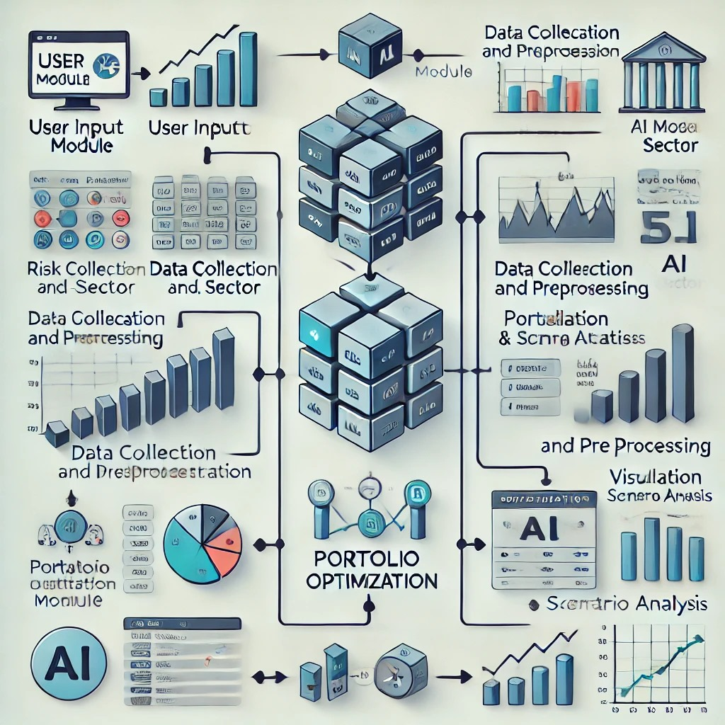

**G. EXISTING DATA:** Any clinical or comparative data necessary enough to support your invention. (Comparative)

**4. USE AND DISCLOSURE (IMPORTANT):** Please answer the following questions:

|  |  |  |
| --- | --- | --- |
| 1. Have you described or shown your invention/ design to anyone or in any conference? | YES ( ) | NO (✓) |
| 1. Have you made any attempts to commercialize your invention (for example, have you approached any companies about purchasing or manufacturing your invention)? | YES ( ) | NO (✓) |
| 1. Has your invention been described in any printed publication, or any other form of media, such as the Internet? | YES ( ) | NO (✓) |
| 1. Do you have any collaboration with any other institute or organization on the same? Provide name and other details. | YES ( ) | NO (✓) |
| 1. Name of Regulatory body or any other approvals if required. | YES ( ) | NO (✓) |

1. Provide links and dates for such actions if the information has been made public (Google, research papers, YouTube videos, etc.) before sharing with us.:

* Google Patents - <https://patents.google.com/patent/US20050144110A1/en?q=(AI-Driven+Personalized+Financial+Portfolio+Management+System+Real-Time+Strategy+Recommendations+and+Visualization+Tools)&oq=AI-Driven+Personalized+Financial+Portfolio+Management+System+with+Real-Time+Strategy+Recommendations+and+Visualization+Tools>
* LeewayHertz - <https://www.leewayhertz.com/ai-for-portfolio-management/>
* Research Gates - <https://www.researchgate.net/publication/380202691_Personalized_Financial_Recommendations_Real-Time_AI-ML_Analytics_in_Wealth_Management>

6. Provide the terms and conditions of the MOU also if the work is done in collaboration within or outside university (Any Industry, other Universities, or any other entity). : **N/A**

7. Potential Chances of Commercialization. : **N/A**

8. List of companies which can be contacted for commercialization along with the website link. :

* Coinbase - <https://www.coinbase.com/>
* Zerodha - <https://zerodha.com/>
* Groww - <https://groww.in/>
* Upstox - <https://upstox.com/>
* Motilal Oswal - <https://www.motilaloswal.com/>
* Kotak Securities - <https://www.kotaksecurities.com/>
* Reliance Securities - <https://www.reliancesmartmoney.com/>
* HDFC Securities - <https://www.hdfcsec.com/>
* Paytm Money - <https://www.paytmmoney.com/>
* SBICAP Securities - <https://www.sbisecurities.in/>

9. Any basic patent which has been used and we need to pay royalty to them. : **N/A**

10**. FILING OPTIONS:** Please indicate the level of your work which can be considered for provisional/ complete/ PCT filings (Mandatory to mention).: This invention is suitable for provisional patent filing.

11. **KEYWORDS:**

* **AI-driven portfolio management**
* **personalized investment strategies**
* **financial data analysis**
* **real-time investment insights**
* **portfolio optimization**
* **dynamic visualizations.**
* **Machine learning models**
* **Predictive analytics**
* **Risk assessment**
* **Market sentiment analysis**
* **Financial forecasting**
* **Data-driven recommendations**
* **Adaptive AI algorithms**
* **Investment decision support**
* **Real-time financial analytics**
* **Diversified asset allocation**
* **Portfolio rebalancing**
* **Investment simulation tools**
* **Scenario analysis**
* **Financial market trends**
* **Automated investment strategies**
* **AI-based financial advisor**
* **Investor risk tolerance**
* **Quantitative financial modeling**
* **Interactive financial dashboards**
* **Smart investment optimization**
* **Economic indicator analysis**
* **Behavioral finance modeling**
* **Sentiment-driven trading signals**
* **Real-time portfolio tracking**
* **Customizable investment goals**

**NO OBJECTION CERTIFICATE**

This is to certify that I (Name of the external person) have no financial assistance in filing any patent form from Lovely Professional University.

We have no objection if Lovely Professional University files any patent with the name of our employee (name of the external person) as co-inventor with (Names of LPU faculty/Staff and all co-inventors) having title as per the patent idea request file (LPU Idea Request I’D….).

Further, our institution will not raise any objections later concerning the filing and commercialization of the said patent.

(Authorised Signatory)