Scenario: SecureBank
Business Intelligence Solution Report

Assessment 2: Individual

Himanshi Sachdeva (224850909)

MIS781 Business Intelligence and Database

Table of content
Contents
Table of Contents 1
1. Introduction 1
1.1 Objectives of your BI Dashboards 2
1.2 Benefits/Advantages of your BI Dashboards 2
1.3 Assumptions 3
1.4 Business Rules and Variable Descriptions 3
2. BI Dashboards 5
2.1 Dashboard 1: For Phishing Campaign Manager 5
2.2 Dashboard 2: For HR Manager 5
2.3 Dashboard 3: For IT Security Manager 5
3. Recommendations 15
4. References 15
5. Appendix (Certificate of Completion for Power BI & Dataset) 16

- Introduction
In the digital age, cyberattacks such as phishing remain one of the most prevalent and damaging threats to organizational security. Phishing attacks exploit human vulnerabilities, making employee behavior a critical component in any cybersecurity strategy. To address this challenge, SecureBank, a major financial institution, initiated simulated phishing campaigns across its workforce. The aim was to assess employee awareness, gauge training effectiveness, and track IT response actions in order to proactively strengthen its security posture.
This business intelligence (BI) report outlines a data-driven solution designed to support three key stakeholders within SecureBank: the Phishing Campaign Manager, the Human Resources (HR) Manager, and the IT Security Team. Each stakeholder plays a distinct role in managing phishing risk—whether it's monitoring simulation results, enforcing training compliance, or coordinating timely incident responses.

Objectives of the BI Dashboards

This BI solution comprises three tailored dashboards designed to address the distinct needs of SecureBank’s operational stakeholders. Each dashboard transforms complex phishing simulation data into actionable insights, with the ultimate goal of minimizing human vulnerabilities and enhancing security responsiveness.

Phishing Campaign Manager Dashboard
The objective of the Phishing Campaign Manager dashboard is to provide a comprehensive overview of employee engagement with simulated phishing campaigns. This dashboard helps the campaign manager to:
- Track overall exposure by monitoring who clicked phishing links and entered credentials
- Evaluate the effectiveness of each campaign over time
- Identify departments that are consistently at higher risk
- Understand employee reporting behavior to assess awareness and responsiveness
- Use behavioral patterns to design more targeted and realistic future simulations
By doing so, the dashboard supports the development of smarter, data-driven phishing campaigns that improve training relevance and reduce successful phishing attempts.

HR Manager Dashboard
The HR Manager dashboard is designed to monitor employee readiness, compliance with security training, and behavioral risk across departments and job roles. The key objectives of this dashboard are to:
- Evaluate phishing awareness training completion rates across teams
- Identify job titles and departments with higher risk based on click and credential entry behavior
- Detect repeat offenders to enable focused retraining or intervention
- Assess whether training completion correlates with safer behavior in phishing simulations
This dashboard empowers HR to take a proactive role in shaping a security-conscious workforce by aligning training strategy with observed behaviours and risks.

IT Security Team Dashboard
The IT Security Team dashboard focuses on managing and monitoring responses to phishing incidents. It provides visibility into how the security team reacts to threats, enabling operational efficiency and accountability. Its objectives include:
- Track the volume and timing of IT responses to phishing incidents (e.g., password resets, training enforcement)
- Analyse action trends by type and by IT administrator
- Monitor the time lag between phishing email delivery and IT action
- Provide a detailed incident log for investigation, reporting, or audits
- Enable filtering and deep dives by date, department, action type, or admin
Through this dashboard, the IT team can optimize its response workflow, ensure timely intervention, and maintain high standards in phishing incident management.

Benefits/Advantages of the BI Dashboards
The business intelligence solution developed for SecureBank offers several critical advantages by enabling stakeholders to access meaningful insights that guide proactive security decision-making. The following are the four most impactful benefits of the dashboards:
Stakeholder-Specific Insights for Targeted Action
Each dashboard is custom-designed to meet the information needs of a specific role—Phishing Campaign Manager, HR Manager, and IT Security Team. This ensures that each stakeholder receives relevant, role-appropriate insights that can directly inform policy, training, or incident response strategies.

Proactive Identification of High-Risk Behavior
By tracking metrics such as click-throughs, credential entries, and repeat offenders, the dashboards help identify individuals, job roles, or departments that exhibit risky behavior. This enables timely intervention, targeted training, and resource allocation before vulnerabilities escalate into actual breaches.

Clear Linkage Between Training and Behavioral Outcomes
The dashboards integrate training completion data with phishing simulation responses, enabling HR to evaluate whether training translates into safer behavior. This supports continuous improvement of training programs and ensures they are data-informed rather than assumption-driven.

Enhanced IT Response Monitoring and Accountability
The IT Security Team dashboard enables real-time monitoring of responses to phishing incidents, including time-to-response, action types, and admin workload. This enhances operational oversight, supports resource balancing, and strengthens compliance with security protocols.

Assumptions
The dashboards and analyses presented in this report are based on a synthetic dataset generated to reflect realistic phishing simulation scenarios within a financial institution. To ensure consistency, usability, and analytical relevance, the following assumptions were made during the design and development of the BI solution:

- Each Employee belongs to one Department and has one Job Title
- Each Phishing Simulation is Independent
- Training Status is Updated Per Simulation
- Security actions are logged only for simulations where users interacted with phishing emails.
- Dataset Reflects a Three-Month Simulation Window
- Each employee participates in multiple phishing simulations

  - Description of business rules and variables used in this report

Attribute | Data Type | Description | Business Rule
EmployeeID | Integer | Unique identifier for each employee | - Unique value  - Not null
EmployeeName | String | Full name of the employee | - Used for display only  - Not used in join relationships  - Not null
Department | String | Department to which the employee belongs | - Must match controlled list of departments  - Not null
JobTitle | String | Role of the employee | - Must match job title catalogue  - Not null
Email | String | Work email address of the employee | - Must be valid and unique  - Not null
Salary | Integer | Annual salary of the employee | - Must be a positive integer  - May be used for HR segmentation or salary-risk trends  - Not null
DepartmentHead | String | Name of the person managing the department | - Used for HR reporting only  - optional in visualisations  - Not null
PhishingID | Integer | Unique ID for each phishing simulation event | - Must be unique and linkable to EmployeeID  - Not null
EmailSentDate | Date | Date phishing email was sent | - Must be within simulation period  - Not null
ClickedLink | Boolean | Whether the employee clicked the phishing link | - TRUE/FALSE only  - Not null
EnteredCredentials | Boolean | Whether the employee entered login credentials | - TRUE/FALSE only  - TRUE only if ClickedLink = TRUE  - Not null
ReportedPhishing | Boolean | Whether the employee reported the phishing email | - TRUE/FALSE only  - Can occur independently  - Not null
TrainingStatus | String | Training completion status at time of simulation | - Values must be either “Completed” or “Pending”  - Not null
SecurityActionID | Integer | Unique ID for IT security action | - Must be unique  - Not null
ActionTaken | String | Type of IT action taken | - Must be one of: “Password Reset”, “Security Training”, “No Action”  - Not null
ActionDate | Date | Date on which the IT action was taken | - Must be ≥ EmailSentDate  - Not null
ITAdmin | String | Name of the IT administrator performing the action | - Must match predefined list of IT admins  - Not null

BI Dashboards (Screenshots from Power BI; 3 BI Dashboards are required)

Dashboard 1: For Phishing Campaign Manager
This dashboard is designed to support the Phishing Campaign Manager in monitoring employee engagement with simulated phishing attacks and evaluating the effectiveness of awareness efforts. By visualizing phishing behavior across departments and over time, the dashboard provides valuable insights to design smarter, more targeted campaigns that reduce organizational exposure to phishing threats.
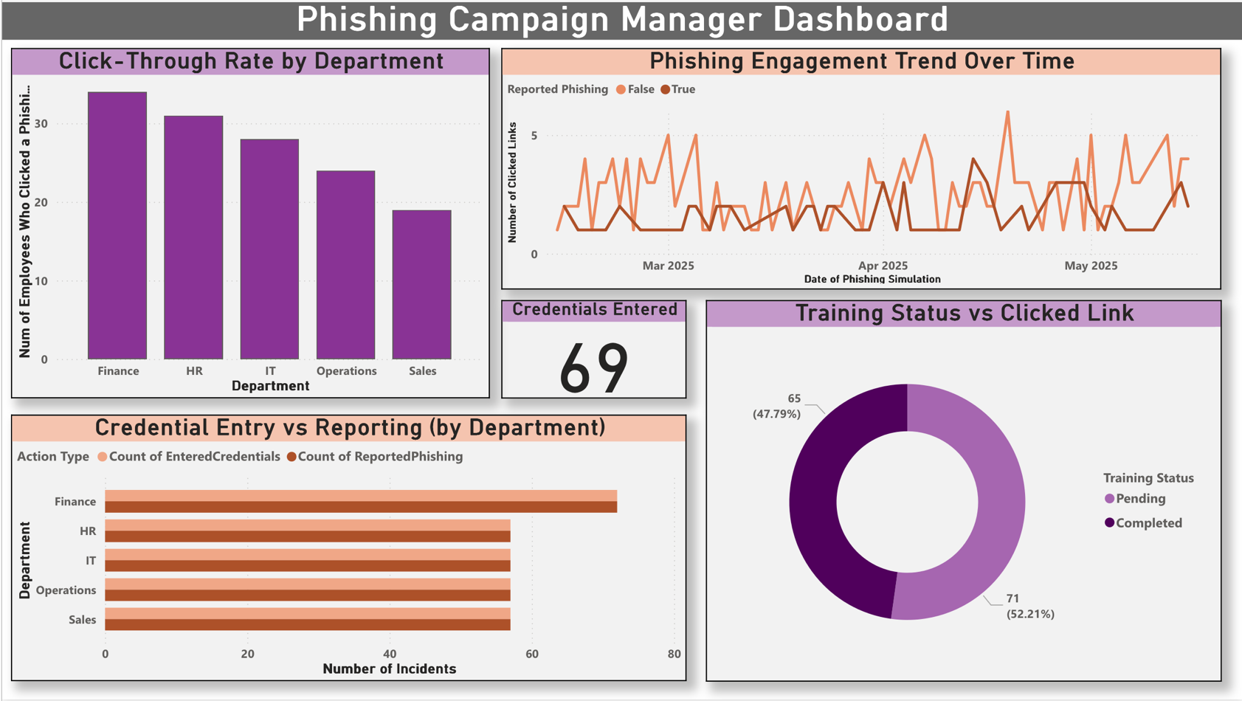
Figure 1. Phishing Campaign Manager Dashboard

Key Visualizations and Insights
1. Click-Through Rate by Department (Bar Chart)
This visual highlights which departments have the highest number of employees clicking phishing links. Finance and HR lead in click volume, suggesting a need for targeted training in those teams. The chart helps identify high-risk groups, making it easier for the campaign manager to prioritize interventions and fine-tune phishing scenarios to department specific contexts.
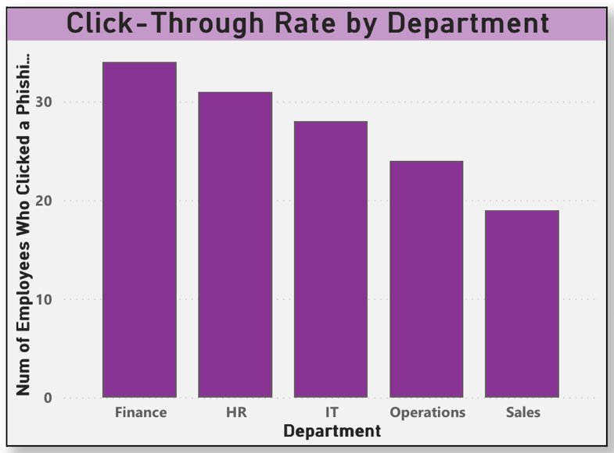
Figure 1 HR Manager Dashboard)

2. Phishing Engagement Trend Over Time (Line Chart)
This time series tracks the volume of phishing link clicks across the simulation period. Peaks in engagement indicate periods when specific phishing emails were more effective, or employee vigilance was lower. This allows campaign managers to review and refine the timing, messaging, and content of future phishing simulations.
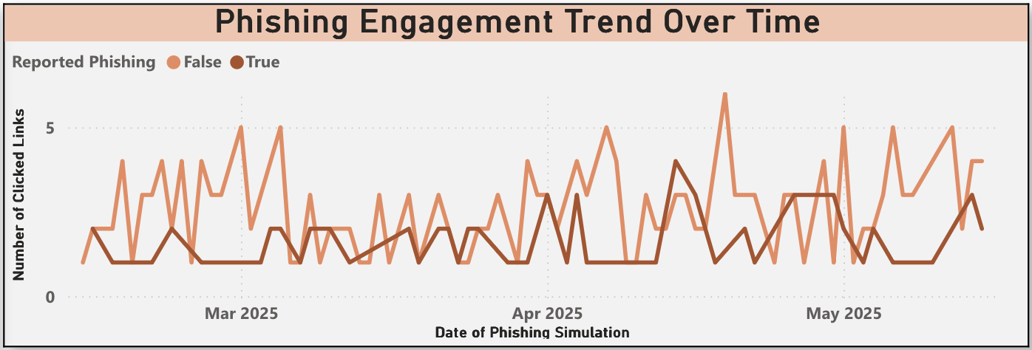

3. Credential Entry vs Reporting by Department (Stacked Bar Chart)
This comparison shows, for each department, how many employees entered credentials versus how many reported the phishing attempt. A high number of credential entries paired with low reporting (as seen in Finance) highlights a behavioral risk that requires immediate corrective action. The manager can use this to assess both the awareness level and the willingness of employees to report threats.
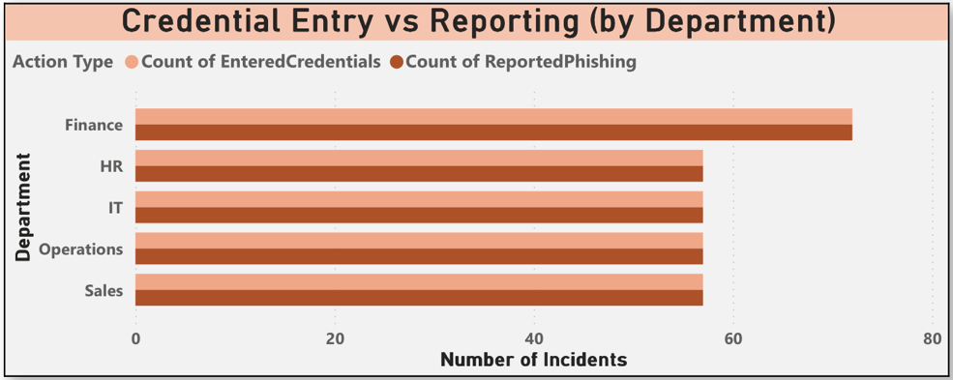

4. Training Status vs Clicked Link (Donut Chart)
This chart evaluates the relationship between training completion and phishing link clicks. The relatively even split between clicks from ‘Completed’ and ‘Pending’ training status suggests that training, while present, may not be sufficiently effective or recent. This could inform follow-up micro-training or gamified reinforcement campaigns.
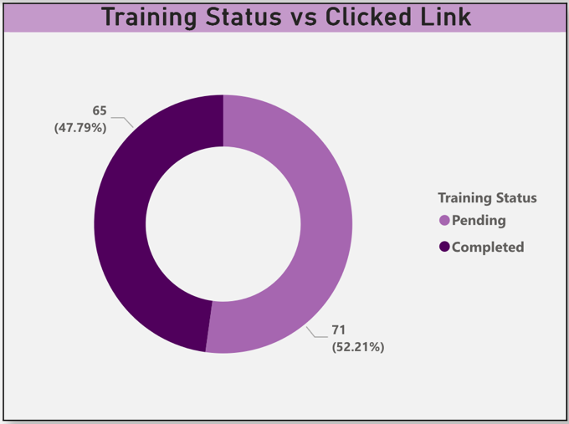

5. KPI Card: Credentials Entered
The KPI card shows a total of 69 credential entries across simulations. This is a critical risk indicator as these entries represent the highest level of potential damage in real-world phishing scenarios. Campaign managers can use this number to track reductions over time as training and simulations mature.
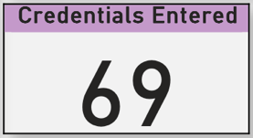

Summary of Usefulness
This dashboard allows the Phishing Campaign Manager to:
- Measure employee susceptibility across departments
- Track simulation performance over time
- Correlate engagement with training outcomes
- Identify critical risk areas requiring focused attention
By leveraging these insights, the campaign manager can tailor future phishing emails, improve the design of training materials, and reduce successful phishing interactions across SecureBank.

Dashboard 2: For HR Manager
The HR Manager dashboard is designed to assess employee readiness, compliance with security training, and behavioral risk across departments and job roles. It provides comprehensive visibility into how employee actions align with their training status, enabling HR to make informed decisions about awareness programs and targeted interventions.
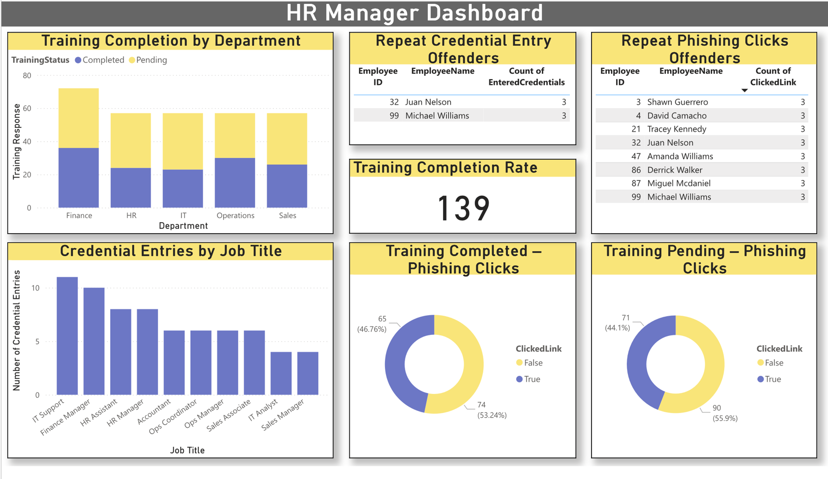
Figure 2. HR Manager Dashboard

Key Visualizations and Insights
1. Training Completion by Department (Stacked Column Chart)
This chart displays the number of employees who have completed or are pending phishing awareness training, segmented by department. Finance shows relatively higher completion, while other departments exhibit a larger proportion of pending statuses. This helps HR prioritize follow-up actions in specific teams where training uptake is lower.
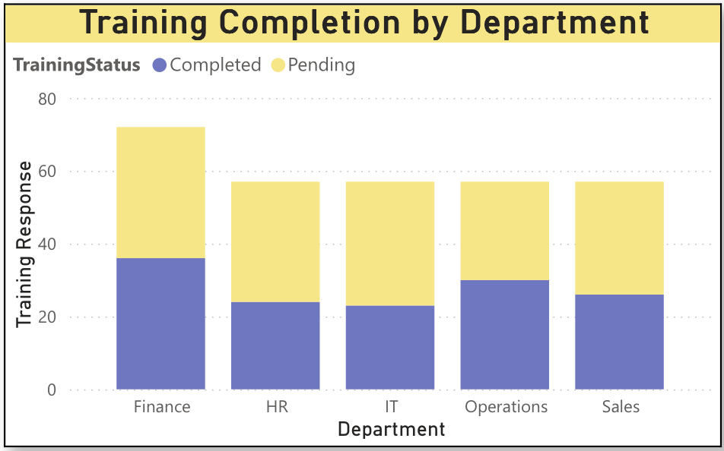
2. Repeat Credential Entry Offenders (Table)
This table highlights employees who entered credentials in phishing simulations more than once. Repeat offenses by the same individuals flag potential behavioral risks and provide a clear basis for individual-level coaching, retraining, or disciplinary follow-up.
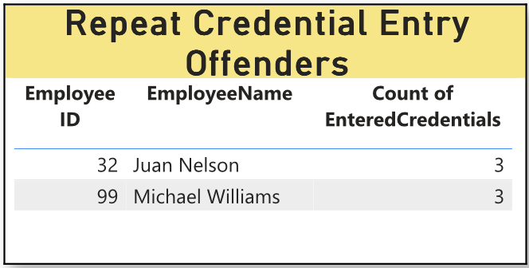

3. Repeat Phishing Click Offenders (Table)
Similar to the previous visual, this table identifies employees who repeatedly clicked phishing links. These individuals are at elevated risk and may not fully grasp the training content or be actively engaged, making them ideal candidates for refresher training or personalized security guidance.
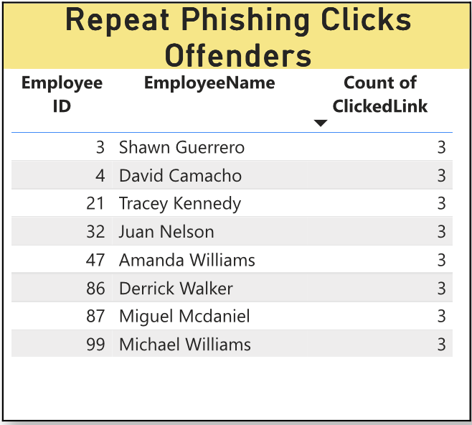

4. Credential Entries by Job Title (Bar Chart)
This chart allows HR to identify job roles most likely to submit credentials during phishing attempts. Roles like IT Support, HR Assistant, and Finance Manager show a higher frequency of credential entry. These insights inform role-specific training design, especially for positions with elevated access or sensitive data responsibilities.
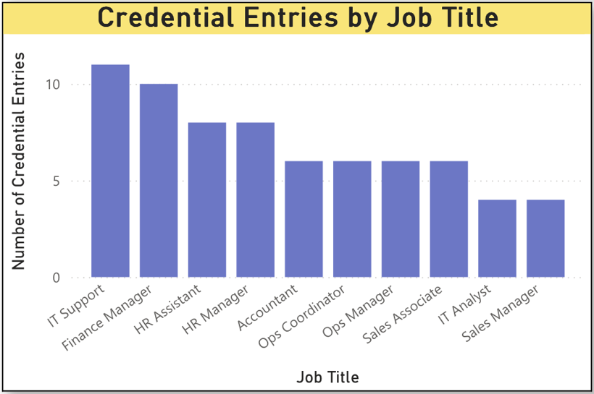

5. Training Completion (KPI Card)
This KPI displays the total number of training responses (completed and pending), serving as a quick benchmark of overall training engagement. When tracked over time, it can help HR measure campaign reach and training compliance across the organization.
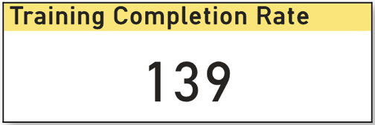

6. Phishing Clicks by Training Status (Donut Charts)
These side-by-side donut charts compare click behavior among employees who have completed training versus those who have not. While both groups show significant click activity, the pending group has a higher percentage of phishing link clicks, reinforcing the importance of timely training delivery and completion tracking.
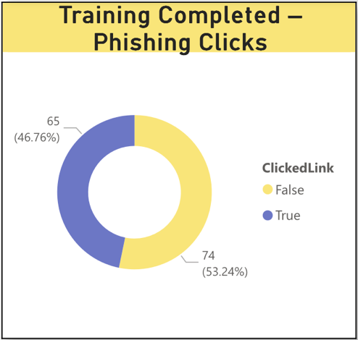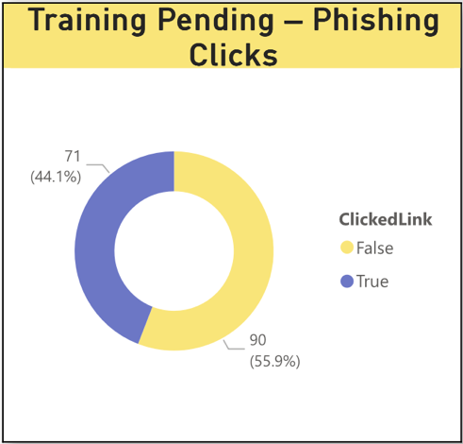

Summary of Usefulness
The HR Manager dashboard supports the following actions:
- Monitor and improve phishing training participation
- Identify individuals and job roles at greatest behavioral risk
- Correlate training outcomes with real behavior in simulations
- Tailor awareness campaigns by department or job function
Ultimately, this dashboard empowers HR to take a proactive, evidence-based approach to building a more cyber-aware workforce, enhancing SecureBank’s human-layer security posture.

Dashboard 3: For IT Security Manager
The IT Security Team dashboard is designed to support operational efficiency and accountability in response to phishing incidents. It provides real-time visibility into the volume, type, and timeliness of IT actions taken after employee interactions with phishing simulations. With a focus on responsiveness and workload distribution, this dashboard allows IT leadership to improve coordination, reduce response time, and ensure that high-risk incidents are promptly addressed.
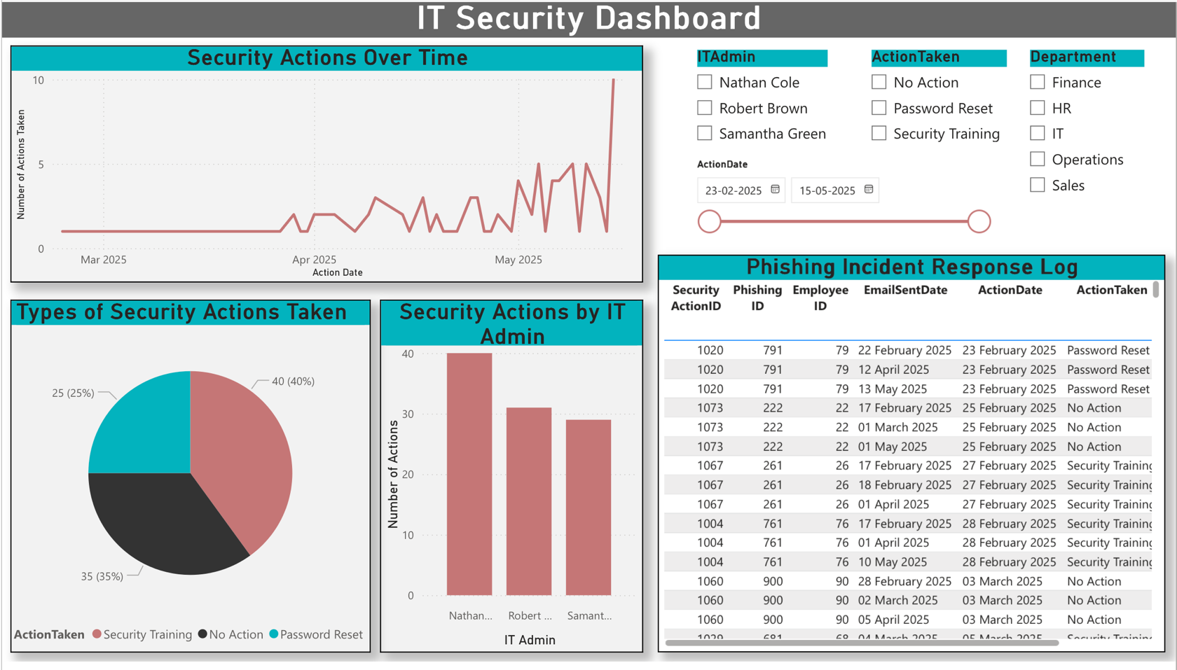
Figure 3. IT Security Team Dashboard

Key Visualizations and Insights
1. Security Actions Over Time (Line Chart)
This chart shows how IT interventions have varied over the simulation period. The upward trend reflects either an increase in phishing events or more active response efforts by the IT team. Spikes may correlate with periods of high phishing engagement, helping the team plan for resource allocation and evaluate if automation or escalated response protocols are needed.
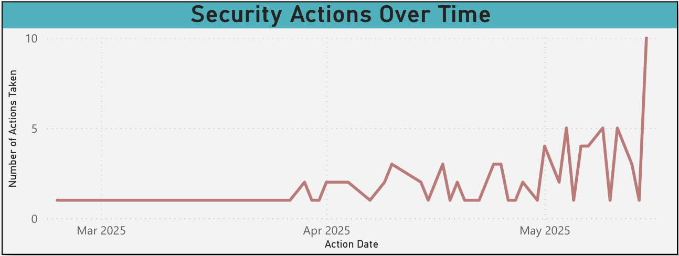
2. Types of Security Actions Taken (Pie Chart)
This visual shows the distribution of IT actions: Password Resets, Security Training, and No Action. The dominance of Password Resets and Training suggests that IT is actively mitigating threats. However, the portion of No Action indicates opportunities for improving trigger rules or follow-up mechanisms. It also helps assess policy consistency.
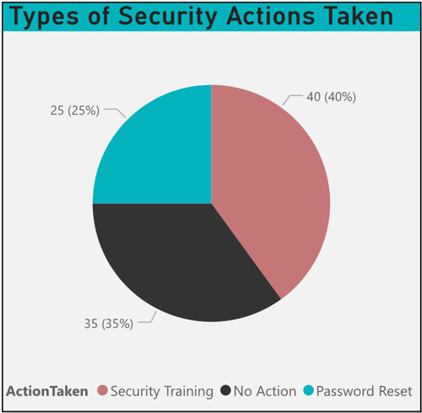

3. Security Actions by IT Admin (Bar Chart)
This chart displays the number of actions performed by each IT administrator. Nathan Cole leads in intervention volume, followed by Robert Brown and Samantha Green. This helps identify workload distribution, potential bottlenecks, and training needs across the IT support team.
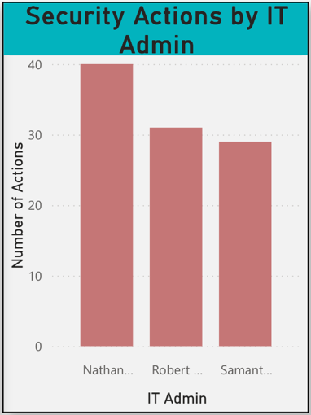
4. Phishing Incident Response Log (Table)
The table provides a detailed record of each phishing incident and the corresponding IT response. It includes fields such as PhishingID, EmailSentDate, ActionTaken, and ActionDate, allowing for audit, traceability, and performance evaluation. Combined with slicers, it enables dynamic filtering by IT Admin, Department, Action Type, and Date.
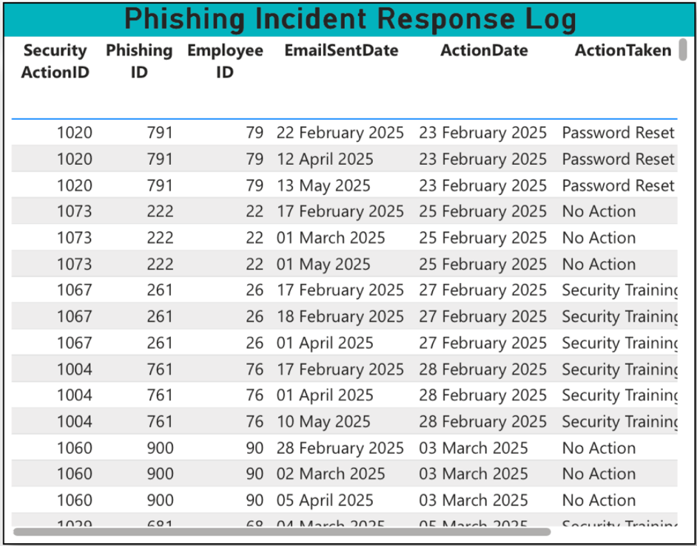
5. Slicers for Interactive Analysis
The inclusion of slicers enhances interactivity and allows the user to explore incident trends by specific IT Admins, departments, action types, or simulation dates. This makes the dashboard more versatile and user-driven, supporting both high-level summaries and detailed reviews.
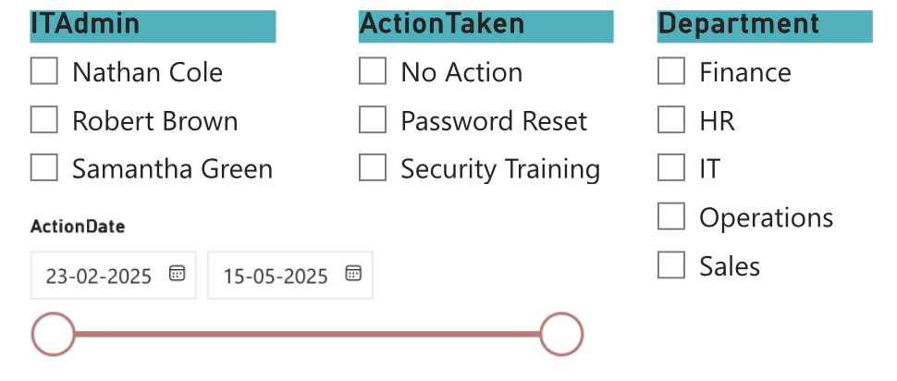

Summary of Usefulness
This dashboard enables the IT Security Team to:
- Monitor operational performance in phishing incident response
- Ensure timely mitigation of credential risks or unreported phishing clicks
- Balance workloads across IT personnel
- Maintain an auditable trail of actions taken for future compliance or investigation
By using this dashboard, SecureBank’s IT team can not only detect but also respond to phishing threats with speed, precision, and accountability, contributing to a more resilient cybersecurity framework.

- Recommendations (at least 3 recommendations for 3 BI Dashboards)
Based on the findings from the three BI dashboards developed for SecureBank, the following recommendations are proposed to improve phishing awareness, training effectiveness, and IT response capability across the organization.
Recommendation 1: Launch Department-Specific Refresher Campaigns (Phishing Campaign Manager Dashboard)
The Phishing Campaign Manager dashboard revealed that departments such as Finance and HR exhibit higher click-through and credential entry rates, paired with lower phishing reporting behaviour.
Action:
Launch tailored phishing awareness refreshers for these high-risk departments. Customize phishing scenarios to resemble actual business processes relevant to their roles (e.g., payroll alerts for Finance).
Justification:
Generic training may not resonate with contextual threats. Department-specific simulations will improve realism and effectiveness, thereby reducing susceptibility and enhancing reporting behaviour.
Recommendation 2: Prioritize Role-Based Micro-Training for High-Risk Job Titles (HR Manager Dashboard)
The HR dashboard identified job roles like IT Support, Finance Manager, and HR Assistant as more likely to enter credentials during phishing simulations, even among those who completed training.
Action:
Design and deploy short, role-specific micro-learning modules that highlight real-world phishing risks tailored to each job function. Reinforce these with brief, interactive quizzes or simulation follow-ups.
Justification:
One-size-fits-all training isn't sufficient. High-risk roles require more nuanced, engaging content that reflects the specific threats they are likely to encounter in their workflow.
Recommendation 3: Improve Incident Response SLA Tracking and IT Resource Balancing (IT Security Team Dashboard)
The IT Security dashboard indicates variable response times and uneven distribution of actions among IT administrators, with one admin (e.g., Nathan Cole) handling a significantly higher volume.
Action:
Implement SLA targets for phishing response time and automate alerts for delayed actions. Evaluate team workloads and consider redistributing tasks or cross-training admins to ensure balanced intervention capacity.
Justification:
Consistent and timely responses to phishing threats are critical to minimize risk. Establishing clear performance benchmarks and balancing workloads will improve both speed and accountability in the IT security function.

References
- OpenAI. (2025). Synthetic dataset generated using ChatGPT for phishing simulation analysis.
- Microsoft. (n.d.). Dashboard design tips. Microsoft Learn. https://learn.microsoft.com/en-us/power-bi/create-reports/service-dashboards-design-tips
- Yeoh, W., Talburt, J. R., & Zhou, Y. (2014). Information quality and governance for business intelligence. IGI Global.
- Power, D. J. (2007). DSS 2.0: Supporting decision making with new technologies (1st ed.). IGI Global.

Appendix (& Dataset)

Appendix A: Certificate of Completion for Power BI

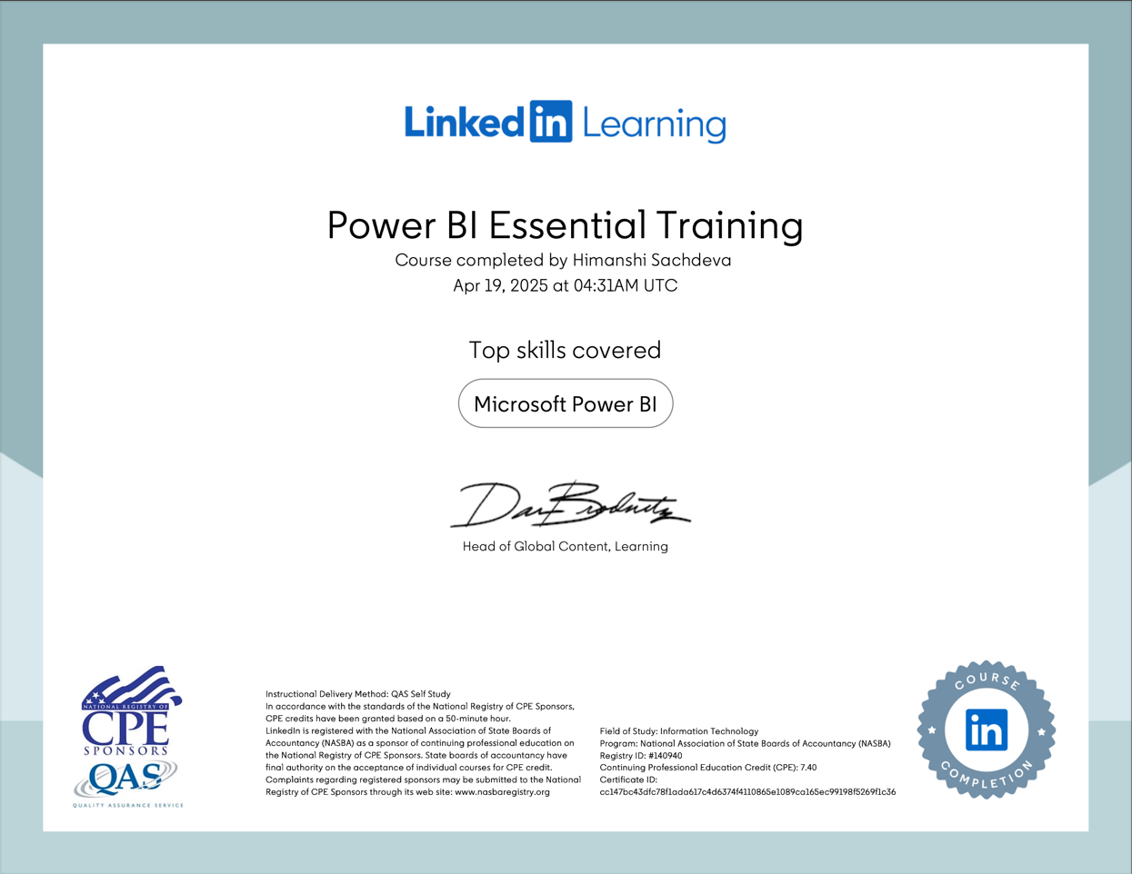
Figure 4. Power BI Essential Training - Course Completion Certificate

Appendix B: Dataset Sample showing first 5 rows

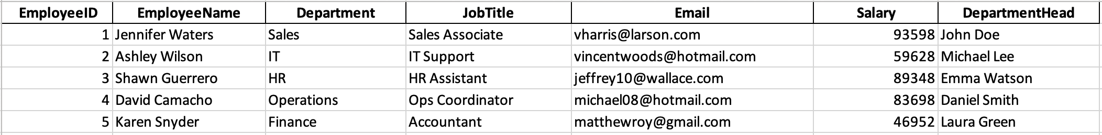
Figure 5. HR Manager Dataset

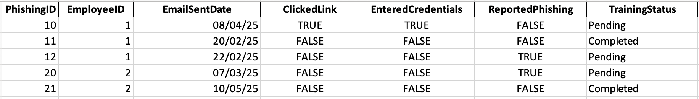
Figure 6. Phishing Campaign Dataset

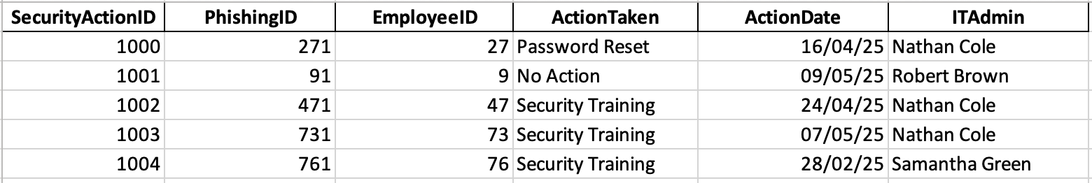
Figure 7. IT Security Dataset

