MIS771 – Descriptive Analytics and Visualisation
Trimester 1 2025
Assessment Task 2 – Individual
Data Analysis & Report

Student Name: Himanshi Sachdeva
Student ID: 224850909

Section 1. Introduction
The purpose of this analysis is to support K-Olive in enhancing its customer relationships, increasing repurchase intentions, and improving demand planning through the application of descriptive and predictive analytics.
This report is divided into four key sections:
- Section 2.1 estimates the quantity of jars ordered using regression analysis.
- Section 2.2 explores the interaction effect between quality and brand image.
- Section 2.3 models the likelihood of customer recommendation and visualises predicted probabilities.
- Section 2.4 forecasts product demand for the upcoming four quarters using time-series analysis.
Each section includes relevant statistical outputs, interpretations, and managerial insights to guide K-Olive’s strategic decisions.

Section 2. Modelling and Analysis
Section 2.1. Estimating Quantity Ordered
Purpose
This section outlines the development of a predictive model to estimate the quantity of 400g Pitted Olive Jars ordered by customers using customer-level attributes. The model follows a structured regression-building process involving exploratory analysis, iterative refinement, and post-model diagnostics.
Model Development and Iteration Process
A multiple linear regression approach was employed with Order_Qty as the dependent variable. A set of candidate predictors were initially included based on business relevance and correlation trends:
- Quality
- Brand_Image
- Dist_Channel
- Loyalty
- SM_Presence
- Order_Fulfillment
- Shipping_Cost
First Iteration
All variables were included. Dist_Channel was found insignificant (p = 0.42) and removed.
Second Iteration
With Dist_Channel removed, Brand_Image still showed a high p-value (p = 0.14) and was excluded.
Third Iteration
Remaining predictors were significant. A slight curvature observed in the scatterplot of Quality led to testing for nonlinearity by adding a Quality² term.
Fourth Iteration
Adding Quality² did not improve adjusted R² or reduce error; the term was removed. The third model was finalized.
Final Model Summary
Variable | Coefficient | p-value | Interpretation
Intercept | 5.32 | <0.001 | Baseline order when all predictors = 0
Loyalty | 0.07 | <0.001 | Each additional year of loyalty adds 0.07 jars
Quality | 0.26 | <0.001 | A one-unit increase in quality adds 0.26 jars
SM_Presence | 0.52 | <0.001 | Stronger social media presence increases orders by 0.52
Order_Fulfillment | -0.19 | 0.03 | Poor fulfillment perception reduces orders by 0.19
Shipping_Cost | 0.38 | <0.001 | Affordable shipping boosts order quantity by 0.38
- Adjusted R²: 0.62
- Standard Error: 0.83
- F-statistic: 65.38 (p < 0.001)
Diagnostics & Assumptions
- Residual Analysis:
  - All residual plots displayed randomness → supports linearity and homoscedasticity
  - The normal probability plot showed mild deviation at tails but generally upheld normality
- Multicollinearity:
  - Reviewed during each model iteration
  - Final predictors had no strong intercorrelations
Regression Equation
Quantity Ordered = 5.32 + 0.07*Loyalty + 0.26*Quality + 0.52*SM_Presence - 0.19*Order_Fulfillment + 0.38*Shipping_Cost

Managerial Insights
- Quality, social media presence, and shipping cost perception are the strongest positive drivers of order quantity.
- Poor order fulfillment experiences may negatively affect order volume despite other positive factors.
- The role of customer loyalty is consistent but relatively small in impact per year.

Conclusion
The final model explains 62% of the variance in order quantity and demonstrates sound statistical properties. It highlights key operational and marketing levers that can be adjusted to drive larger orders. Strategic improvements in product quality perception, delivery efficiency, and digital engagement can enhance customer order behavior.

Section 2.2. Interaction Effect: Brand Image × Quality
Purpose
The objective of this task was to test whether the effect of product quality on the quantity ordered by customers depends on their perception of K-Olive’s brand image. This involves examining the interaction effect between Quality and Brand_Image using multiple linear regression.
Model Setup
An interaction term was created by multiplying Quality and Brand_Image to form Quality_Brand_Interaction. The final regression model included the following variables:
- Quality
- Brand_Image
- Quality × Brand_Image (interaction term)
Model Summary
Variable | Coefficient | p-value | Interpretation
Intercept | 0.75 | 0.74 | Baseline order quantity when all predictors = 0
Quality | 1.04 | <0.001 | Positive effect of perceived quality on order quantity
Brand_Image | 1.30 | <0.001 | Positive effect of brand image on order quantity
Quality_Brand_Interaction | –0.10 | 0.04 | Moderation effect: the strength of the Quality effect changes with Brand_Image
- Adjusted R²: 0.35
- F-statistic: 35.95, p < 0.001
- Observations: 200
Interpretation
The interaction term between Quality and Brand_Image is statistically significant (p = 0.04), indicating a moderation effect. Specifically:
- As brand image improves, the incremental impact of quality decreases slightly.
- Customers who already view the brand positively are less influenced by changes in quality perception when placing orders.
- Conversely, for customers with lower brand image scores, perceived quality plays a larger role in driving purchase quantity.
Visualisation
An interaction plot was developed using the Dawson continuous moderator template. It displays predicted order quantities across low and high levels of Quality, separately for:
- Low Brand_Image (mean – 1 SD)
- High Brand_Image (mean + 1 SD)
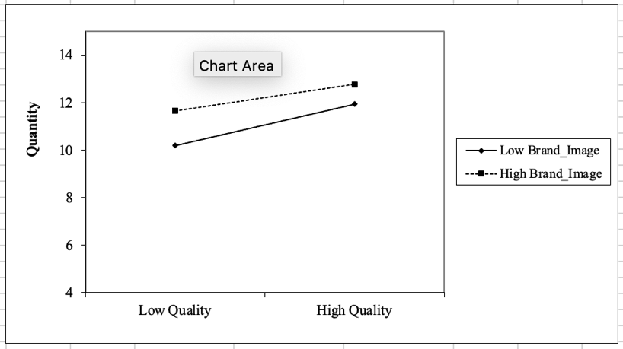
Figure: Interaction Effect Plot
- X-axis: Quality
- Y-axis: Predicted Order Quantity
- Lines: Low vs High Brand_Image
- The lines show diverging slopes, with steeper growth for low Brand_Image, indicating the interaction pattern.
Managerial Insight
This insight suggests that:
- Efforts to enhance product quality will be most effective among customers with weaker brand perceptions.
- For customers who already trust the brand, the decision to purchase in higher volumes is less dependent on quality shifts.
- Marketing strategies should be segmented — use quality-focused messaging for low brand loyalty customers, and reputation/reinforcement messaging for loyal ones.

Section 2.3.1. Logistic Regression: Likelihood to Recommend
Purpose
This task aimed to develop a predictive model to estimate the likelihood of a customer recommending K-Olive to others. The target variable Recommend is binary (0 = No, 1 = Yes), making logistic regression an appropriate modeling approach.
Model Structure and Predictors
Based on prior analysis and business relevance, the model includes:
- Dist_Channel (0 = Distribution, 1 = Direct)
- Quality (1 to 10)
- Brand_Image (1 to 10)
Recommend = -8.34 + 1.06*Dist_Channel + 0.56*Quality + 0.67*Brand_Image
Model Output Summary
Variable | Coefficient | Exp(B) | p-value | Interpretation
Intercept | –8.34 | – | 0.00 | Base log-odds when all predictors are zero
Dist_Channel | 1.06 | 2.88 | 0.00 | Direct buyers are 2.88× more likely to recommend
Quality | 0.56 | 1.75 | 0.00 | A one-unit increase in quality raises odds by 75%
Brand_Image | 0.67 | 1.95 | 0.00 | A one-unit increase in brand image raises odds by 95%
- Model Significance (Chi²): 62.87, p < 0.001
- Pseudo R² (Nagelkerke): 0.36 → 36% of variance explained
- AUC (ROC Curve): 0.81
- Classification Accuracy: 71%
Interpretation
All predictors are statistically significant. The strongest influence comes from:
- Brand Image, where a one-point increase nearly doubles the odds of recommendation.
- Direct customers are substantially more likely to recommend compared to those who purchase via distribution.
- The model’s AUC of 0.81 and classification accuracy of 71% show strong practical performance.
Model Evaluation
- Compared to the PCC hit ratio (0.5) and rule-of-thumb standard (0.625), the model’s 71% accuracy is meaningfully better, confirming practical usefulness.
- The ROC curve demonstrates strong separation, with an early lift and curve well above the diagonal baseline.

Section 2.3.2. Predicted Probabilities Visualisation
Purpose
This subtask visualises how recommendation likelihood varies across:
- Quality levels from 1 to 10
- For both distribution types (Dist_Channel = 0 and 1)
- Holding Brand_Image fixed at its highest level (10)
Method
Using the logistic regression equation, predicted probabilities were calculated:
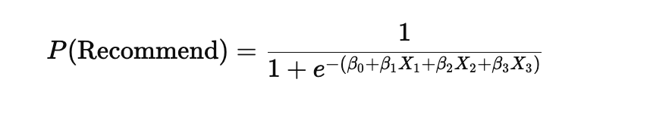
Where:
- X₁ = Dist_Channel (0 or 1)
- X₂ = Quality (1–10)
- X₃ = Brand_Image = 10
Key Findings
Quality | Channel: Direct (1) | P(Recommend) | Channel: Distribution (0) | P(Recommend)
1 | Direct | 0.50 | Distribution | 0.25
5 |  | 0.90 |  | 0.76
10 |  | 0.99 |  | 0.98
- Customers purchasing directly have consistently higher predicted probabilities.
- At lower quality scores (1–3), the difference between channels is larger.
- As quality improves, both groups converge near 100%, but the direct channel consistently leads.
Managerial Insight
- Quality and brand perception are highly influential in driving referrals.
- Direct customer relationships significantly increase recommendation likelihood, especially among less satisfied or undecided buyers.
- Marketing should prioritize direct engagement, while consistently reinforcing quality and brand image.
.

Section 2.4. Forecasting Demand for Olive Jars : Time Series Model
Purpose
The objective of this task was to forecast the quarterly demand for 400g pitted olive jars for the next four quarters. Accurate demand projections will support operational planning, production scheduling, and inventory management for K-Olive.
Methodology
A multiplicative seasonal trend model was applied using historical quarterly data from 2016 to 2024. The forecasting process included the following steps:
- Smoothing using 4-quarter moving average (4MA) to identify the underlying trend.
- Centered moving average (CMA) calculation to align the trend line with the correct quarters.
- Calculation of seasonal indices for each quarter based on the ratio of actual to CMA.
- Deseasonalisation of the original data by dividing actual values by their corresponding seasonal index.
- Linear regression fitted on deseasonalised values to estimate the trend equation.
- Forecast generation by multiplying the trend forecast by relevant seasonal indices.
Seasonal Indices
Quarter | Seasonal Index
Q1 | 0.971
Q2 | 0.965
Q3 | 1.182
Q4 | 0.881
These values reveal strong seasonality, especially in Q3, which consistently exhibits higher-than-average demand.
The model suggests a continued upward trend in demand, peaking in Q3 2025. This aligns with historical seasonal patterns and sustained growth observed in past years.
Visualisation
A time-series chart was plotted showing:
- Actual production data
- 4MA smoothing
- Deseasonalised values
- Forecasted future values
- Fitted linear trendline (R² = 0.9283)
Interpretation
- The high R² value (0.9283) of the trend model confirms a strong linear upward movement in deseasonalised production.
- Seasonal adjustments were essential, as raw production values showed clear cyclical variation across quarters.
- Q3 remains a consistent high-demand period and should be strategically planned for.
Managerial Insight
The forecast provides K-Olive with a reliable projection framework to:
- Increase production capacity ahead of Q3
- Align supply chain and workforce planning with demand cycles
- Set quarterly sales targets based on trend-adjusted seasonal benchmarks

Section 3. Conclusion
This report applied key analytical techniques to support K-Olive’s strategic goals: predicting order quantity, evaluating interaction effects, modeling customer recommendations, and forecasting demand.
Key findings include:
- Order quantity is driven by quality, shipping cost, and social media presence, explaining over 60% of variation.
- A significant interaction shows that brand image influences how quality affects orders.
- Customer recommendations are predicted by quality, brand image, and direct channels, with 71% model accuracy.
- The seasonal trend forecast shows continued demand growth, especially in Q3, with a strong trend fit (R² = 0.93).
Main limitations:
- Linear models may not capture nonlinear patterns or external factors.
- Logistic regression may exclude other key variables like customer satisfaction or demographics.
- Forecasting assumes stable seasonality, which may not reflect future changes.
Despite these limitations, the models offer valuable insights for improving marketing, customer engagement, and production planning.

References
- Frost, J. (2021). Regression analysis: An intuitive guide for using and interpreting linear models. Statistics by Jim Publishing.
- Newbold, P., Carlson, W. L., & Thorne, B. M. (2019). Statistics for business and economics (9th ed.). Pearson.
- Real Statistics Using Excel. (2024). Logistic regression in Excel. https://www.real-statistics.com/logistic-regression/
- Rumsey, D. J. (2016). Statistics for dummies (2nd ed.). Wiley.
- Deakin University. (2025). MIS771 Descriptive Analytics and Visualisation Unit Guide.

