MIS784 – Assignment 1 – T3, 2024
Student Name: Himanshi Sachdeva (Shyna)
Student ID: 224850909
Query Appendix
QUESTION 1
Best-selling Product
SELECT StockCode, Description,
SUM(Quantity) AS TotalQuantity,
FROM `genial-moon-441804-t5.Assignment1.MarketCo`
GROUP BY StockCode, Description
ORDER BY TotalQuantity DESC LIMIT 1

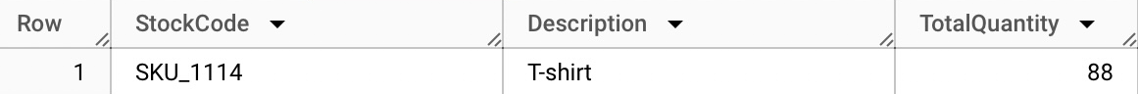

Highest Return Rate
SELECT StockCode, Description,
SUM(CASE WHEN ReturnStatus = "Returned" THEN Quantity ELSE 0 END) AS TotalReturns,
SUM(Quantity) As TotalTransactions,
SUM(CASE WHEN ReturnStatus = "Returned" THEN Quantity ELSE 0 END)/SUM(Quantity) AS ReturnRate
FROM `genial-moon-441804-t5.Assignment1.MarketCo`
GROUP BY StockCode, Description
ORDER BY ReturnRate DESC, TotalReturns DESC LIMIT 1

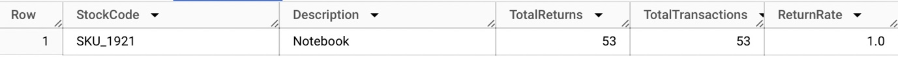
Most Applied Discounts
SELECT StockCode, Description,
SUM(Discount*Quantity*UnitPrice)/SUM(Quantity*UnitPrice) AS TotalDiscount
FROM `genial-moon-441804-t5.Assignment1.MarketCo`
GROUP BY StockCode, Description
ORDER BY TotalDiscount DESC
LIMIT 1

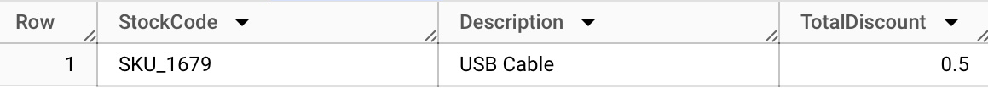

QUESTION 2
Number of unique customers who have made at least one purchase for each sales channel
SELECT SalesChannel,
COUNT(DISTINCT UserID) AS UniqueCustomers
FROM `genial-moon-441804-t5.Assignment1.MarketCo`
GROUP BY SalesChannel
ORDER BY UniqueCustomers DESC
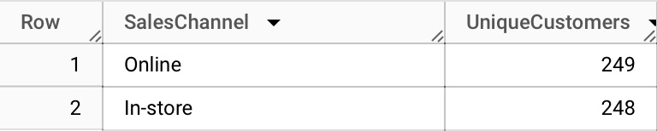
QUESTION 3
RFM Value scores
SELECT UserID,
DATE_DIFF(CURRENT_DATE(),MAX(InvoiceDate), DAY) AS recency_score,
COUNT(DISTINCT InvoiceNo) AS frequency_score,
SUM((Quantity*UnitPrice)-(Quantity*UnitPrice*Discount)) AS monetary_score
FROM `genial-moon-441804-t5.Assignment1.MarketCo`
GROUP BY UserID
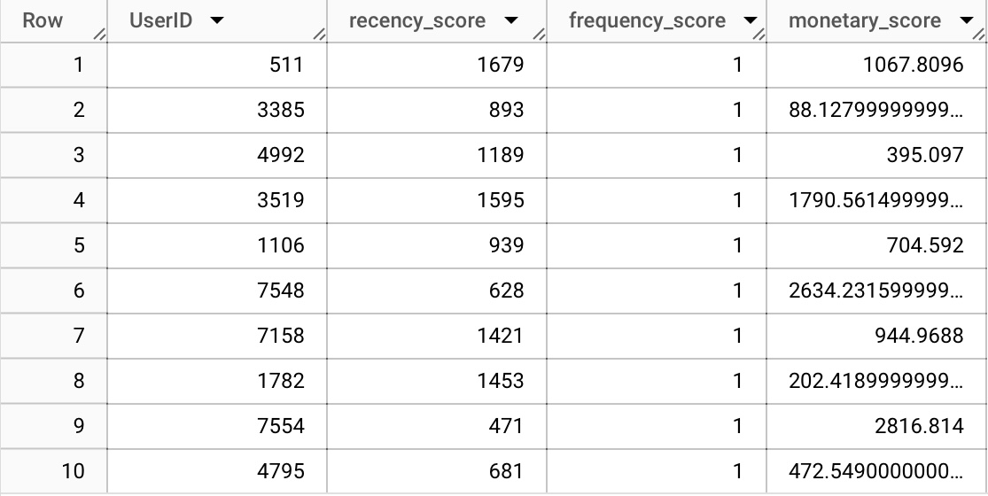

QUESTION 4
Segment customers into five groups for Recency, Frequency and Monetary value
WITH rfm_scores AS (
SELECT UserID,
DATE_DIFF(CURRENT_DATE(),MAX(InvoiceDate), DAY) AS recency_score,
COUNT(DISTINCT InvoiceNo) AS frequency_score,
SUM((Quantity*UnitPrice)-(Quantity*UnitPrice*Discount)) AS monetary_score
FROM `genial-moon-441804-t5.Assignment1.MarketCo`
GROUP BY UserID),
rfm_quintiles AS(
SELECT UserID, rfm_scores.recency_score, rfm_scores.frequency_score, rfm_scores.monetary_score,
NTILE(5) OVER (ORDER BY recency_score) AS recency_quintile,
NTILE(5) OVER (ORDER BY frequency_score DESC) AS frequency_quintile,
NTILE(5) OVER (ORDER BY monetary_score DESC) AS monetary_quintile
FROM rfm_scores
)
SELECT UserID, recency_score, frequency_score, monetary_score, recency_quintile, frequency_quintile, monetary_quintile,
CONCAT(recency_quintile, frequency_quintile, monetary_quintile) AS rfm_cell
FROM rfm_quintiles
ORDER BY rfm_cell DESC
