Adaptive Reader: Wearable Technology for Enhanced Visual and Cognitive Support
(PH4052D)
A Thesis
Submitted in Partial Fulfillment of the
Requirements for the Degree of
Bachelor of Technology in
Engineering Physics
By
Authors
A. AMARESHAWAR REDDY Roll No.: B210943EP
HIMANSHOO JAIN Roll No.: B211293EP
SHAMEEM V P Roll No.: B210937EP
Under the supervision of
Dr. Biswajit Mandal

Department of Physics
NATIONAL INSTITUTE OF TECHNOLOGY CALICUT
May 2025

© AUTHOR, (2023)

NIT Calicut has the sole ownership of Patents and Software Copyrights resulting out of this Thesis work. NIT Calicut has the royalty-free permission to reproduce and distribute copies of this Thesis for teaching and research as well as for dissemination of teaching and research in other academic institutions.

Acknowledgments

We would like to express our sincere gratitude to Dr. Biswajit Mandal for his invaluable guidance and unwavering support. His invaluable feedback and expertise were pivotal in shaping the direction and quality of our work.
We are also deeply grateful to the dedicated faculty members of the Physics Department for their encouragement and support. Their collective wisdom has been instrumental in enriching our academic and research journey.
Finally, we extend our gratitude to our teammates for their collaboration, enthusiasm, and commitment, which have been the key to this project’s success. This achievement would not have been possible without everyone’s collective effort.

Declaration

We declare that this report titled “Adaptive Reader: Wearable Technology for Enhanced Visual and Cognitive Support” submitted in partial fulfillment of degree of B Tech in Engineering Physics is a record of original work carried out by us under the supervision of Dr. Biswajit Mandal, and has not formed the basis for the award of any other degree or diploma, in this or any other Institution or University. In keeping with ethical practice of reporting scientific information, due-acknowledgements have been made where the findings of others have been cited.

A Amareshwar Reddy - B210943EP
Himanshoo Jain – B211293EP
Shameem V P B210937EP

National Institute of Technology, Calicut
Date: 01/05/25


Certificate

This is to certify that this report titled “Adaptive Reader: Wearable Technology for Enhanced Visual and Cognitive Support” is a bona fide record of project done by A Amareshwar Reddy (B210943EP), Himanshoo Jain (B211293EP), Shameem V P (B210937EP) under my supervision, in partial fulfillment of the requirements for the award of degree of Bachelor of Technology in Engineering physics from National Institute of technology Calicut, and this work has not been submitted elsewhere for the award of degree.

Supervisor
Dr. Biswajit Mandal
Department of Physics,
NIT Calicut

Signature of faculty advisor Signature of the head of department

Place: NIT Calicut
Date: 01/05/2025

Project Evaluation

This is to certify that Mr. A. AMARESHAWAR REDDY (B210943EP), Mr. HIMANSHOO JAIN (B211293EP), Mr. SHAMEEM V P (B210937EP) has successfully defended the Thesis entitled Adaptive Reader: Wearable Technology for Enhanced Visual and Cognitive Support on 01/05/2002

The committee recommends the candidate for the award of the degree of
Bachelor of Technology in Engineering Physics.

Signature of External Examiner Signature of Internal Examiner

Abstract
Text is a crucial mode of communication in everyday life, yet accessing it remains difficult for visually impaired people, particularly in areas where native scripts predominate. Current assistive devices are frequently hampered by high costs and a reliance on global languages. This article describes the creation of the Adaptive Reader, a wearable gadget intended to alleviate these restrictions.
The Adaptive Reader integrates Optical Character Recognition (OCR) with Text-to-Speech (TTS) technology, utilizing a Raspberry Pi microcontroller and an embedded camera. The system includes OpenCV for preprocessing and Tesseract for multilingual text recognition. By addressing critical gaps in current assistive technologies, the Adaptive Reader makes textual information more inclusive and accessible to a broader audience. Through its user-friendly design it aims to improve the quality of life for visually impaired individuals in various linguistic and cultural contexts.

Contents
List of Tables iv
List of Figures v
Introduction 1
1.1. Background and motivation 1
1.2. Neural Network 2
1.3. Text Detection (Supervised Learning) 3
1.4. Text Recognition (Sequence Model) 3
1.5. Computer Vision 3
1.6. Optical Character Recognition (OCR) 4
System Components 6
2.1. Raspberry pi 6
2.2. Raspberry Pi Camera 7
Schematics and System Integration 9
3.1. Schematic 9
9
3.2. Process Steps 10
3.2.1. Image Capture & Initial Setup 10
3.2.2. Fingertip Detection Algorithm 10
3.2.3. Text Extraction Using OCR 11
3.2.4. Text-to-Speech (TTS) 12
3.2.5. Continuous Operation and Real-Time Feedback 13
3.3. Adaptive Reader App 13
Device CAD Model 16
Prototyping 18
5.1. 3D Printing 18
Conclusions, Limitations and Scope for future works 21
6.1. Conclusion 21
6.2. Limitations and Scope for Future Works 21
Bibliography 22
Appendix A: Python Script 23
Appendix B: React Script 30
Enivironment and sustainability…………………………………………………………………………………………………………….41
Engineering and society……………………………………………………………………………………………………………………….42
list of modern tools, instruments and softwares used…………………………………………………………………………..43

List of Tables
Table 2. 1. Technical specification of Raspberry Pi 8
Table 2. 2 Technical Specifications of Camera Module 9

List of Figures
Fig. 1. 1 Neural Network Model 2
Fig. 1. 2 OCR text recognition 4

Fig. 2. 1 Raspberry Pi 4 Model B 7
Fig. 2. 2 Raspberry Pi camera Module 3 8

Fig. 3. 1 System Working Schematic 11
Fig. 3. 2 App UI 17
Fig. 3. 3 App UI 17

Fig. 4. 1 17
Fig. 4. 2 17
Fig. 4. 3 18

Fig. 5. 1 20
Fig. 5. 2 20
Fig. 5. 3 20
Fig. 5. 4 20
Fig. 5. 5 20
Fig. 5. 7 21
Fig. 5. 6 21

Chapter 1

Introduction

Background and motivation
Access to both printed and digital text is crucial in daily life, influencing education, employment, autonomy, and social integration. Visually impaired individuals have significant obstacles in accessing textual content, particularly in resource-limited contexts or for languages that lack representation in mainstream assistive technology. Current devices, although beneficial, often exhibit constraints such as elevated costs and a predominant focus on English or a limited selection of global languages, resulting in the marginalization of regional languages.
The Adaptive Reader addresses this issue by incorporating compact embedded devices with contemporary text recognition technologies, such as Optical Character Recognition (OCR) and Text-to-Speech (TTS) engines. It is a wearable, finger-mounted device that enables users to explore text through natural finger movements while providing real-time aural feedback. The Adaptive Reader makes practical accessibility through image processing techniques that guarantee readability across diverse alignment configurations. This device enhances users' capacity to interact with written material autonomously across diverse situations by offering an affordable, portable, multilingual instrument.

Neural Network
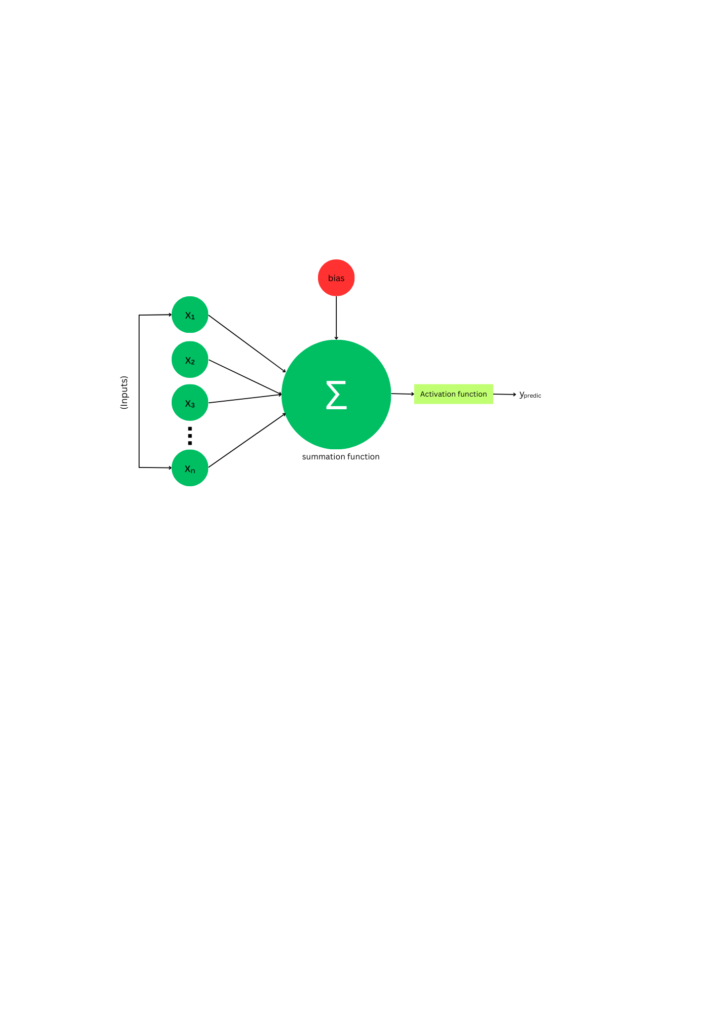
A neural network is a machine learning model inspired from the human brain. It consists of an input layer, one or more hidden layers, and an output layer. Each node processes data using weights and thresholds, passing it to the next layer if the output exceeds the threshold.

Neural networks learn from training data and improve with experience, making them effective for tasks like speech recognition, image analysis, and text classification. There are several types of neural networks:
- Feedforward Neural Network (FNN): A simple neural network where data flows unidirectionally from input to output without cycles or feedback loops. It is commonly used for binary or multiclass classification. For a binary classification task the output layer often uses a sigmoid activation to produce probabilities: $y=σ(w_{out}^{T} a_{hidden}+b_{out})$, where $a_{hidden}$ is the activation vector from the final hidden layer.
Fig. 1. 1 Neural Network Model
- Convolutional Neural Network (CNN): This model is designed for grid like data structures such as images. CNNs use convolutional layers to extract spatial features, making them ideal for image recognition, classification, and computer vision applications.
- Recurrent Neural Network (RNN): A neural network with cyclic connections, allowing it to retain information about previous inputs. It processes sequential data by maintaining a hidden state $h_{t}∈R^{d}$ at time step t. The state evolves as:
$$h_{t}=σ(W_{h} h_{t-1}+W_{x} x_{t}+b)$$
Where $W_{h}$ and $W_{x}$ are recurrent and input weight matrices, respectively. RNNs are suited for sequential tasks like natural language processing, speech recognition, and time-series analysis.
- Long Short-Term Memory (LSTM): A type of RNN that incorporates memory gates to address vanishing and exploding gradient problems. An LSTM cell at timestep t computes:
$$f_{t}=σ\left(W_{f}\left[h_{t-1}, x_{t}\right]+b_{f}\right) \left(forget gate\right), \\ i_{t}=σ (W_{i}\left[h_{t-1}, x_{t}\right]+b_{i} \left(input gate\right)$$
$$o_{t}=σW_{i}\left[h_{t-1}, x_{t}\right]+b_{o} (output gate)$$
LSTMs effectively capture long-term dependencies, excelling in sequential data tasks like text generation, speech processing, and OCR.

Text Detection (Supervised Learning)
Text detection is a supervised task where a model learns a mapping $f :I→B$ from an input image I to a set of bounding boxes $B=\{\left(xi,yi,wi,hi\right)\}$ localizing text regions. EAST employs a CNN with feature pyramids to predict rotated boxes via direct regression, optimizing multi-scale feature fusion. CRAFT generates character-level region maps and affinity scores to link adjacent characters into coherent text instances. The loss function combines classification loss (cross-entropy for text/non-text classification) and localization loss $L=L_{cls}+L_{loc}$ensuring joint optimization of detection accuracy and spatial precision.

Text Recognition (Sequence Model)
Once the text regions are extracted, the next step is to recognize the characters. The task involves predicting a character sequence $y=\{y1,...,yn\}$ where each$yi ∈ Σ$ (alphabet) from a cropped image $x∈R^{H×R}$. A standard architecture employs a CNN to extract hierarchical spatial features, followed by an RNN/LSTM to model temporal dependencies in the feature sequence. $L_{CTC}\left(x,y\right)= -logp(y|x)$ eliminates alignment requirements by marginalizing over permissible input-output alignments during training. Advanced variants include CRNNs, which unify convolutional and recurrent layers for end-to-end sequence learning, and Transformer-based models with self-attention mechanisms, offering enhanced flexibility for variable-length sequences by dynamically weighting contextual dependencies. Both architectures optimize feature extraction and sequential modeling while addressing alignment challenges in structured outputs.

Computer Vision
Computer Vision (CV) is a field of artificial intelligence (AI) that enables computers and systems to interpret, analyze, and understand visual data from the world—just like humans do. It involves processing and interpreting images, videos, and other visual inputs to perform tasks such as object detection, image classification, facial recognition, and scene reconstruction.
At its core, CV involves transforming raw pixel data into structured representations using techniques from linear algebra, calculus, and statistical learning. Let $I∈R^{H×W×C }$represent a digital image, where H and W denote height and width in pixels, and C curresponds to color channels. Early vision task, such as edge detection build on neurophysiological insights from 1959 cat experiments, where biological system prioritize low-level featuring like edges. Mathematically edges are detected using gradient operators like the Soble filter, which computes partial derivative $G_{x} and G_{y}$ via convolution:
$$G_{x}= \left(\begin{matrix}-1 & 0 & 1 \\ -2 & 0 & 2 \\ -1 & 0 & 1\end{matrix}\right)*I, G_{y}=\left(\begin{matrix}-1 & -2 & -1 \\ 0 & 0 & 0 \\ 1 & 2 & 1\end{matrix}\right)*I$$
yielding edge magnitude $|| ∇ ||=√(G_{x}^{2}+G_{y}^{2})$.
In the 1960s, AI emerged as an academic field of study and it also marked the beginning of the AI quest to solve the human vision problem.1974 saw the introduction of optical character recognition (OCR) technology, which could recognize text printed in any font or typeface. Similarly, intelligent character recognition (ICR) could decipher hand-written text that is using neural networks. Since then, OCR and ICR have found their way into document and invoice processing, vehicle plate recognition, mobile payments, machine conversion and other common applications.

Optical Character Recognition (OCR)
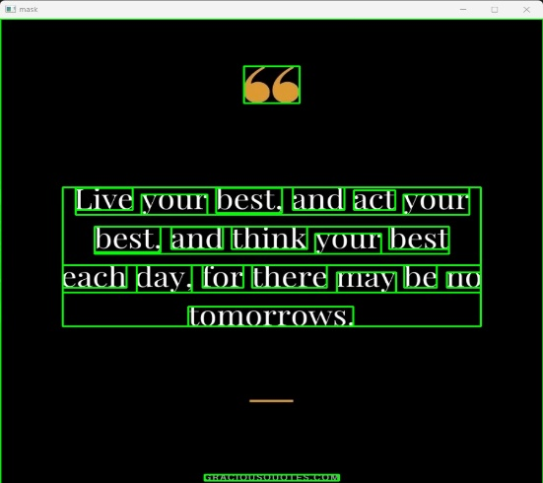
Optical Character Recognition (OCR) is a computational pipeline that transforms rasterized textual data—encoded in images, scanned documents, or handwritten inputs—into machine-encoded text through a hierarchical integration of image processing, pattern recognition, and machine learning. Input image $I∈R^{H×W×C }$ undergo preprocessing to isolate text regions. Initial preprocessing employs Gaussian filtering for noise suppression, followed by Otsu’s method for adaptive binarization, which maximizes inter-class variance to separate foreground (text) from background:
Fig. 1. 2 OCR text recognition

$$σ^{2}\left(t\right)=ω_{0}\left(t\right)ω_{1}\left(t\right){\left[μ_{0}\left(t\right)- μ_{1}\left(t\right)\right]}^{2}$$
Where $ω_{1}and ω_{1}$ are class probabilities and $μ_{0} and μ_{1}$ are mean intensities for threshold t. Geometric corrections, such as affine transformations, rectify skew and perspective distortion using homography matrices.
Text localization leverages Maximally Stable Extremal Regions (MSER) or Contour Detection to identify bounding regions of characters or lines. For segmentation, Connected Component Analysis (CCA) or Projection Profiling partitions text into individual glyphs. Horizontal and vertical projections, defined as:
$$P_{x}\left(i\right)= \sum_{j=1}^{w}{I_{binary}\left(i,j\right) , } P_{y}\left(j\right)= \sum_{i=1}^{h}{I_{binary}\left(i,j\right) , }$$
identify line and character boundaries by detecting minima in the projection histograms.
The recognition stage employs machine learning architectures to map segmented glyphs to Unicode characters. Traditional OCR systems, such as early iterations of Tesseract, utilized Histogram of Oriented Gradients (HOG) features with Support Vector Machines (SVM) classifiers. Modern systems, like Tesseract 4.0+, adopt Long Short-Term Memory (LSTM) networks with Connectionist Temporal Classification (CTC) loss for sequence modeling, optimizing:
$$L_{CTC}= -log⁡(\prod_{π∈B}{p\left(π\right|x)}$$
Where $π$ denotes alignments between input sequences $x$ and target labels $y$, $B$ is a function collapsing repeated tokens. For handwritten text, Convolutional Recurrent Neural Networks (CRNNs) integrate ResNet-50-based feature extractors with bidirectional LSTMs to capture spatial-temporal dependencies.
Post-processing applies Natural Language Processing (NLP) techniques, such as n-gram language models or Transformer-based contextual embeddings, to correct errors via lexical constraints. For example, beam search decoding with a trigram model selects the optimal sequence $\hat{y}$by maximizing:
$$P\left(y | x\right)= \prod_{i=1}^{n}{P\left(y_{i} | x\right).P\left(y_{i} | y_{i-1},y_{i-2}\right)}$$
OCR performance is evaluated using Character Error Rate (CER) and Word Error Rate (WER), defined as:
$$CER=\frac{S+D+I}{N}, WER= \frac{S_{w}+D_{w}+I_{w}}{N_{w}}$$
Where. $S, D, I$ denotes substitutions, deletions and insertions, and $N$ is total number of charecters.

Chapter 2

System Components

The list of hardware required for the model prototyping are
- Raspberry Pi
- Camera
- Power Supply (5V, 3A) for Raspberry Pi

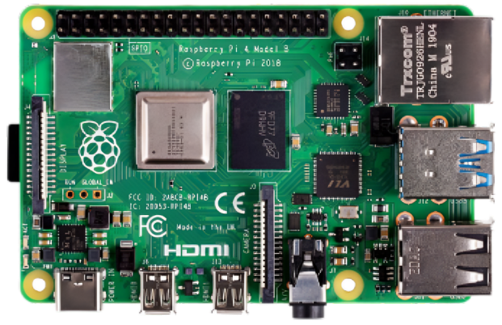
Raspberry pi
The Raspberry Pi 4 Model B is a single-board computer (SBC) built around the Broadcom BCM2711 system-on-chip (SoC), featuring a 64-bit quad-core ARM Cortex-A72 microarchitecture (ARMv8-A ISA) clocked at 1.5 GHz (overclockable to 2.1 GHz). The CPU integrates 32 KB L1 instruction/data caches per core and a shared 1 MB L2 cache, enabling parallelized task execution for embedded workloads. The SoC incorporates a Broadcom VideoCore VI GPU with support for OpenGL ES 3.1, Vulkan 1.0, and hardware-accelerated 4Kp60 H.265/HEVC video decoding via its unified shader array (clocked at 500 MHz). The board operates within a 5V/3A power envelope (15W max) and measures 85.6 mm × 56.5 mm × 17 mm (45 g mass). Software compatibility spans Raspberry Pi OS (Debian-based, 32/64-bit kernel), Ubuntu Core 22.04 LTS, and real-time operating systems (RTOS), leveraging ARMv8-A optimizations for edge computing, IoT gateways, and embedded control systems.
Fig. 2. 1 Raspberry Pi 4 Model B

Table 2. 1. Technical specification of Raspberry Pi
Model | BCM 2837
Clock Speed | 1.5 GHz
RAM | 4 GB
GPU | Broadcom VideoCore IV
Ethernet | 10/ 100 Mbps Ethernet port
Wi-Fi | 2.4 GHz built-in
Bluetooth | Bluetooth 4.1
Power Supply | 5V via Micro-USB or GPIO pins
Audio | 3.5mm audio jack

Raspberry Pi Camera
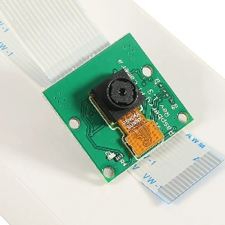
Raspberry Pi Camera Module is a low-power, high-resolution imaging system designed for integration with Raspberry Pi single-board computers via a MIPI CSI-2 (Camera Serial Interface-2) interface, leveraging Sony IMX219PQ or IMX477R CMOS sensors. The IMX219 sensor features a 1/4" optical format with 1.12 µm pixels and a dynamic range of ~70 dB, while the IMX477R employs a larger 1/2.3" sensor with 1.55 µm pixels for enhanced low-light sensitivity. The module captures still images at resolutions up to 3280 × 2464 pixels and records 1080p video at 30 fps through a fixed-focus lens with an f/2.0 aperture and 62.2° diagonal field of view. Data transmission is facilitated via a 2-lane CSI-2 interface, achieving a per-lane data rate of approximately 1.49 Gbps for 1080p30 video.
Fig. 2. 2 Raspberry Pi camera Module 3

Table 2. 2 Technical Specifications of Camera Module
Model | Raspberry Pi camera V3
Resolution | 12 MP
Image Sensor | Sony IMX708
Dimensions (mm) | 25 * 23 * 9
Weight (g) | 3

Chapter 3

Schematics and System Integration

Schematic

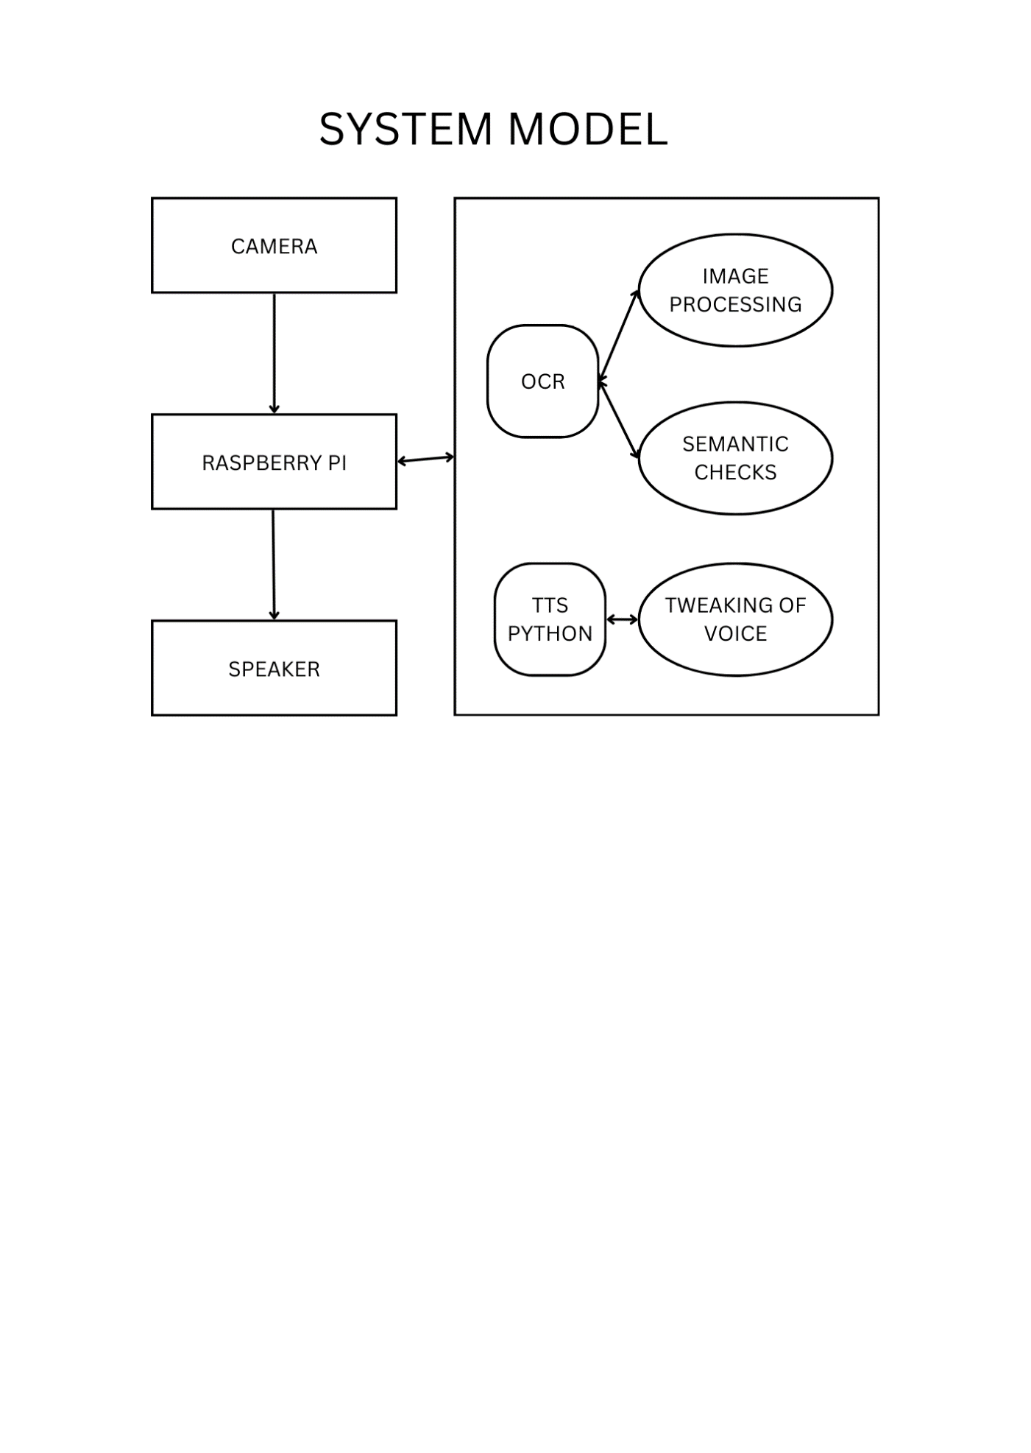

Fig. 3. 1 System Working Schematic

Process Steps

Image Capture & Initial Setup
The camera module is initialized via the Picamera2 library on Raspberry Pi, configuring the sensor with picam2.create_preview_configuration(main={"size":(640,480)}) to set resolution to 640×480 pixels, balancing computational load and clarity. Autofocus (AfMode: 2) and frame duration constraints optimize focus stability and exposure control. Frames are captured in a continuous loop using picam2.capture_array(), then converted from RGB to BGR via cv2.cvtColor() to align with OpenCV’s BGR-native processing pipeline, ensuring compatibility for downstream image operations.
The camera module is initialized via the Picamera2 library, configuring the sensor with picam2.create_preview_configuration(main={"size": (640,480)}) to set a resolution of 640×480 pixels, optimizing performance and image fidelity. Autofocus is enabled using AfMode.Continuous (mode 2) for dynamic focus adjustment, while frame duration constraints regulate exposure timing to ensure consistent capture rates under varying lighting conditions.

Fingertip Detection Algorithm
The main goal here is to detect the user's fingertip in the live camera feed. The captured image is converted to HSV (Hue, Saturation, Value) color space using hsv = cv2.cvtColor(image, cv2.COLOR_BGR2HSV). HSV color space is often more robust to lighting variations compared to RGB color space.
The formulas for converting RGB to HSV are as follows:
$$Δ=\max\left(R,G,B\right)-\min\left(R,G,B\right)$$
$$60×(G-B)/Δ + 0 , if max = R$$
Hue (H) = $60 × (B - R)Δ + 120 ,if max = G$
$$60 ×(R - G)Δ + 240 ,if max = B$$
$$S=\text{Δ}/max\left(R,G,B\right) \\ V=max\left(R,G,B\right)$$
Where max () and min () return the maximum and minimum values of R, G, and B respectively. The angle for Hue is adjusted depending on which of the RGB channels is dominant. The process involved are:
- Thresholding to Identify Skin Regions:
skin tone detection is implemented by thresholding the image in HSV color space using cv2.inRange(), which generates a binary mask isolating pixels within empirically defined skin tone bounds. The lower HSV threshold, $\left[0,20,70\right]$ captures darker skin tones under low illumination, while the upper threshold $\left[20, 255, 255\right]$ accounts for higher saturation and brightness variations. Pixels within this range are assigned a value of 255 (foreground), producing a mask that highlights skin regions for subsequent processing. This method leverages the chromatic separation of skin tones in HSV to mitigate luminance variability.
- Gaussian Blurring:
The mask is then blurred using mask = cv2.GaussianBlur(mask, (5, 5), 0) to smooth out noise and reduce sharp edges that may cause false positives in the detection process.
$$G\left(x,y\right)=\frac{1}{2πσ^{2}}\exp\left(-\frac{x^{2}+y^{2}}{2σ^{2}}\right)$$
Where x and y are the pixel coordinates, and sigma (σ) is the standard deviation controlling the spread of the Gaussian function.
Convolution of the image I (x, y) with the Gaussian kernel G (x, y) in:
$$I_{\text{blurred}}\left(x,y\right) = \sum_{i=-k}^{k}{\sum_{j=-k}^{k}{ I\left(x+i,y+j\right) ⋅ G\left(i,j\right)}}$$
- Dilation(cv2.dilate(mask, np.ones((3, 3), np.uint8), iterations=2)) is applied to expand the regions of skin detected by the mask. This helps merge fragmented regions and ensures better fingertip localization.
$$\left(A⊕B\right)\left(x,y\right)=\max_{\left(x^{'},y^{'}\right)∈B}{A}\left(x+x^{'},y+y^{'}\right)$$
Where AAA is the binary image, BBB is the structuring element, and ⊕ denotes the dilation operation.
- Contour Detection:
Contours are detected using contours, _ = cv2.findContours(mask, cv2.RETR_TREE, cv2.CHAIN_APPROX_SIMPLE).It is then filtered based on their area (cv2.contourArea(c) > 500), ensuring that only sufficiently large contours (likely to be the hand) are considered.
The contour area is calculated using the shoelace formula (also known as the surveyor's formula) for a polygon:
$$\text{Threshold}\left(x,y\right)=\frac{1}{n}\sum_{\left(i,j\right)∈\text{window}}{I\left(i,j\right)}-C$$

- Fingertip Localization
From the detected contours, the largest one is assumed to be the hand, and the fingertip is located at the minimum y-coordinate (topmost part of the hand)

Text Extraction Using OCR
The text extraction phase uses Tesseract OCR to recognize text in the image. Here’s a detailed breakdown of the OCR process:
- Grayscale Conversion
The input image is converted to grayscale using cv2.cvtColor(image, cv2.COLOR_BGR2GRAY) to project the 3-channel BGR pixel values into a single-channel luminance space, reducing spatial dimensionality. The grayscale transformation follows the ITU-R BT.601 standard: $y=0.299R+0.587G+0.114B$
- Gaussian Blurring
A second Gaussian Blur is applied (gray = cv2.GaussianBlur(gray, (3, 3), 0)) to smooth the image further, which helps reduce noise and improve OCR accuracy.
- Adaptive Thresholding
Adaptive thresholding is applied to create a binary image (thresh = cv2.adaptiveThreshold(...)) where text is black and the background is white, making it easier for Tesseract to distinguish the text. The thresholding method used is Gaussian adaptive thresholding, which is particularly useful for images with varying lighting conditions.
- Tesseract Configuration
The text extraction pipeline employs pytesseract.image_to_data() with --psm 6 to configure the OCR engine’s page segmentation mode, enforcing a single uniform text block assumption and disabling adaptive layout analysis. The output_type=Output.DICT parameter structures the OCR output as a dictionary containing spatial metadata (bounding box coordinates: left, top, width, height), recognized text strings, and confidence quantiles (conf) for each detected word.
- Distance Calculation
For each word detected by Tesseract, the bounding box coordinates (left, top, width, height) are used to calculate the center of the word (word_center).
$$d=\sqrt{{\left(x_{1}-x_{2}\right)}^{2}+{\left(y_{1}-y_{2}\right)}^{2}}$$
The Euclidean distance between the fingertip and the center of each word’s bounding box is calculated to determine which word is closest to the fingertip:
$$x_{\text{center}}=\frac{2x_{1}+x_{2}}{2}$$
$$y_{\text{center}}=\frac{2y_{1}+y_{2}}{2}$$

Word Highlighting
The bounding box of the closest word is drawn on the image using cv2.rectangle(image, (box[0], box[1]), (box[2], box[3]), (0, 255, 0), 2).
$$\text{Box}=\left(x,y,x+\text{width}, y+\text{height}\right)$$

Text-to-Speech (TTS)
The text-to-speech (TTS) pipeline leverages the Festival synthesis engine, invoked via subprocess.run(["festival", "--tts"], input=text, text=True), which streams UTF-8 text through Festival’s default voice pipeline using inter-process communication. Thread safety is enforced via a mutex lock (tts_lock) to serialize access to the TTS resource, preventing race conditions during concurrent audio rendering. Asynchronous execution is achieved by releasing a daemon thread (threading.Thread(target=speak, daemon=True)), decoupling TTS processing from the main video loop to maintain real-time frame throughput. This threading model mitigates blocking I/O latency, ensuring uninterrupted video capture and OCR inference while audio synthesis operates in parallel, constrained only by the Python Global Interpreter Lock (GIL) during thread context switches

Continuous Operation and Real-Time Feedback
The system runs continuously in a loop:
- Frame Capture: A new frame is captured at every iteration.
- Fingertip Detection and OCR: The fingertip is detected, and the closest word is identified and extracted.
- Text-to-Speech: If new text is detected and different from the previous text, it is spoken aloud.

Adaptive Reader App

The primary function of this app is to communicate with the raspberry pi and give commands to start and stop the program. The app uses react native to give the user a mobile interface for controlling the adaptive reader. This is primarily achieved using react as the core library. The backend is done using raspberry pi hosting a server implemented by api end points, while using http protocols for communication.
We start by setting a Boolean variable “isRunning” this contains the information about whether the program is running or not. It is initially set to false and is toggled when the button is pressed.
const [isRunning, setIsRunning] = useState(false);

Then we set the Raspberry pi’s ip address as a constant “raspberryPiIp”. This is later used to communicate with the pi.
const RASPBERRY_PI_IP= "192.168.1.100"

We then define a function “sendCommand” that uses fetch api to send POST requests to the pi server at port 5000 which enables the user to start and stop the program at will.
const sendCommand = async (command) => {
try {
await fetch(`http://${RASPBERRY_PI_IP}:5000/${command}`);
} catch (error) {
console.error('Network request failed', error);
}
};

The user can change the state of the program using the button provided whose label also changes dynamically between start and stop based on the current state of the program. Also changes its color based on the state of the program, green when the program is stopped and red when its running.
<TouchableOpacity
style={[
styles.button,
{ backgroundColor: isRunning ? '#f44336' : '#4CAF50' },
]}
onPress={handleButtonPress}
>
<Text style={styles.buttonText}>
{isRunning ? 'Stop' : 'Start'}
</Text>
</TouchableOpacity>

We also have a dropdown list to select the language of the ocr between hindi and English. This will update the ocr as to which language it needs to detect.
<Picker
selectedValue={language}
style={styles.picker}
dropdownIconColor="#fff"
onValueChange={(itemValue) => setLanguage(itemValue)}
>
<Picker.Item label="English" value="english" />
<Picker.Item label="Hindi" value="hindi" />
</Picker>

We also use try and catch for the error handling purposes, so if there is no response from pi it will send an alert showing “Network request failed…”
try {
await fetch(`http://${RASPBERRY_PI_IP}:5000/${command}`);
} catch (error) {
console.error('Network request failed', error);
}

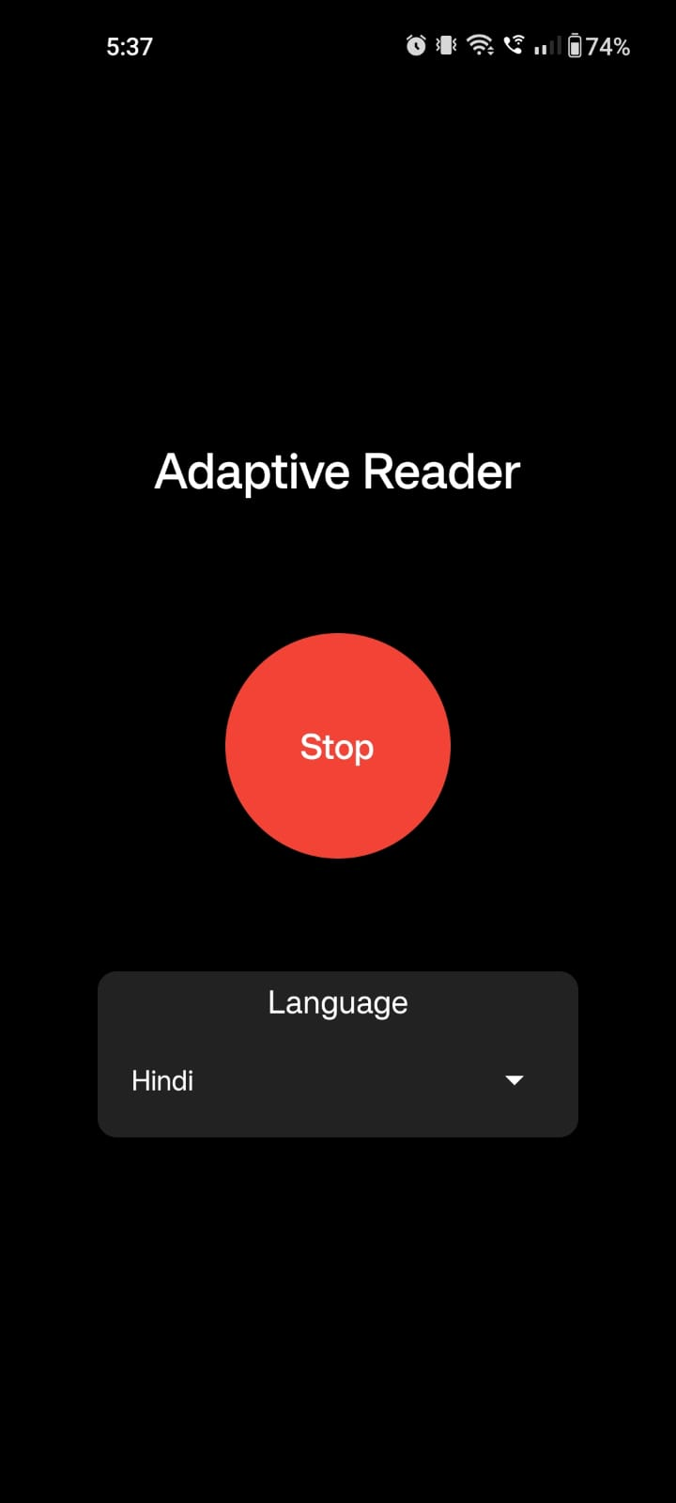
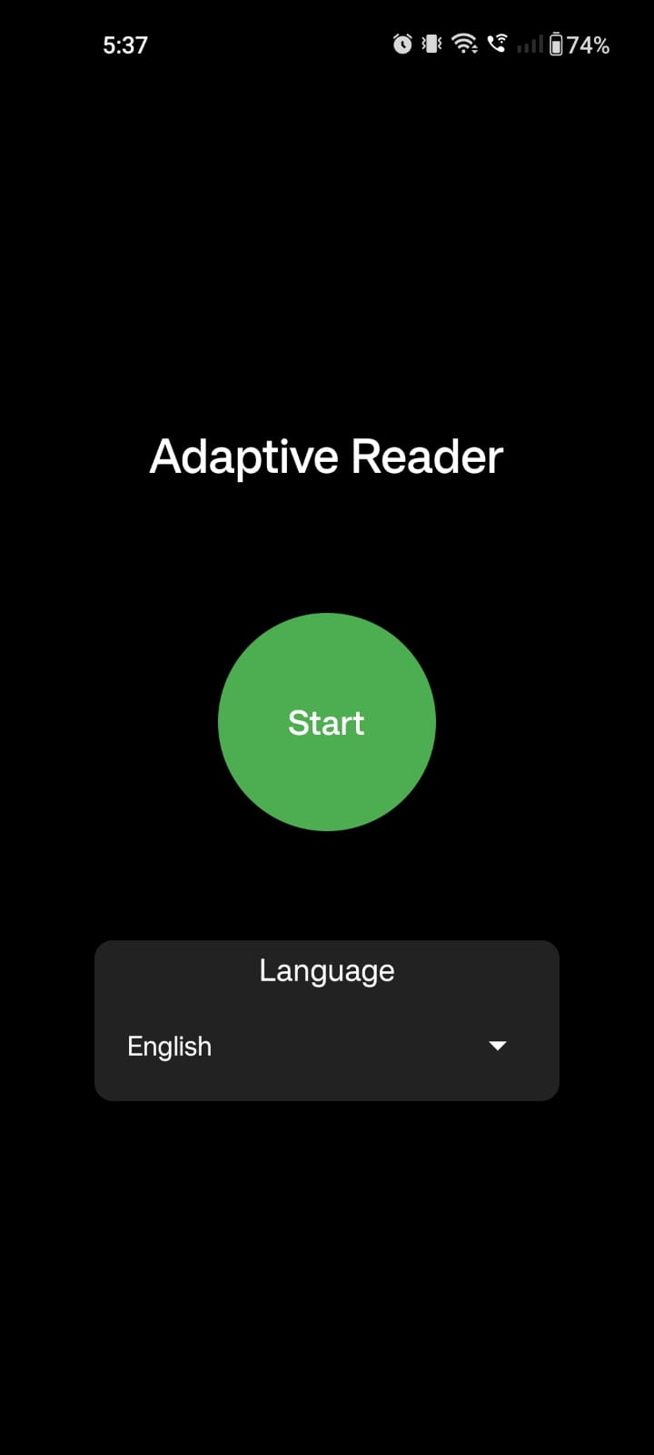
Fig. 3. 2 App UI
Fig. 3. 3 App UI

Fig. 3. 4 App UI

I

Chapter 4

Device CAD Model

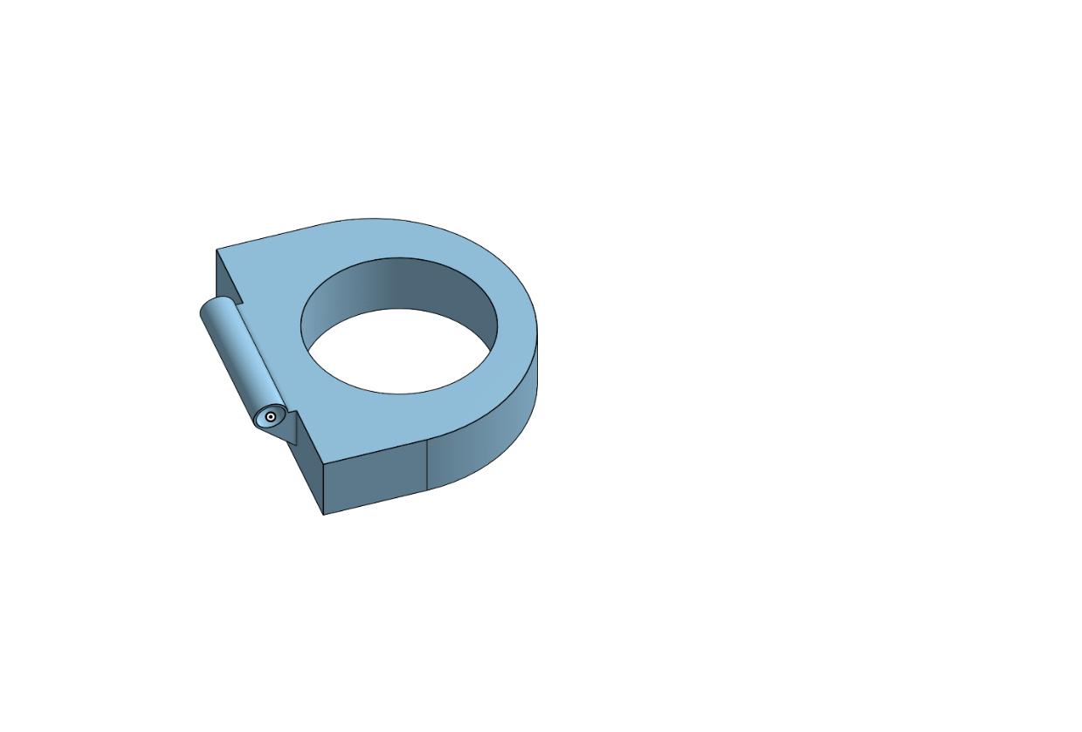
The device has been divided into 3 parts for the simplicity of making the 3D version of it.
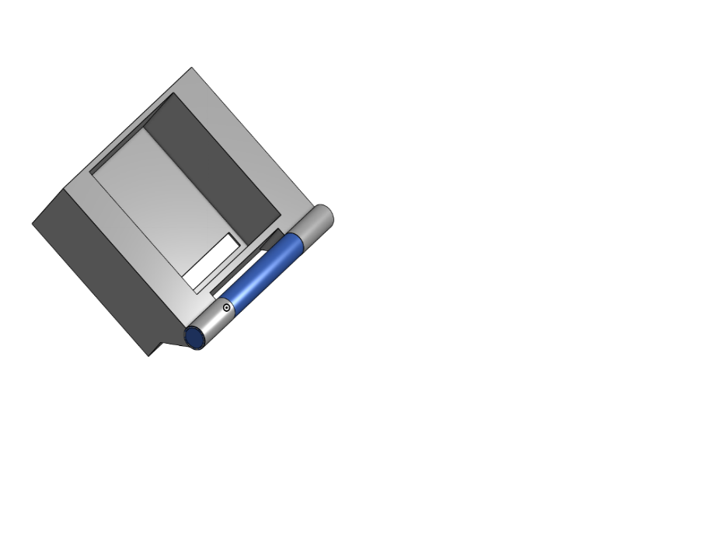
The Ring part (Fig. 1) will be placed on the finger, The Solid groove (Fig. 2) with an extruded(rectangular) based on camera dimension for a steady fit with proper cutout for the connector and power cable, and the last is the hinge with the purpose of best viewing angle for camera depending on the different hand structures.

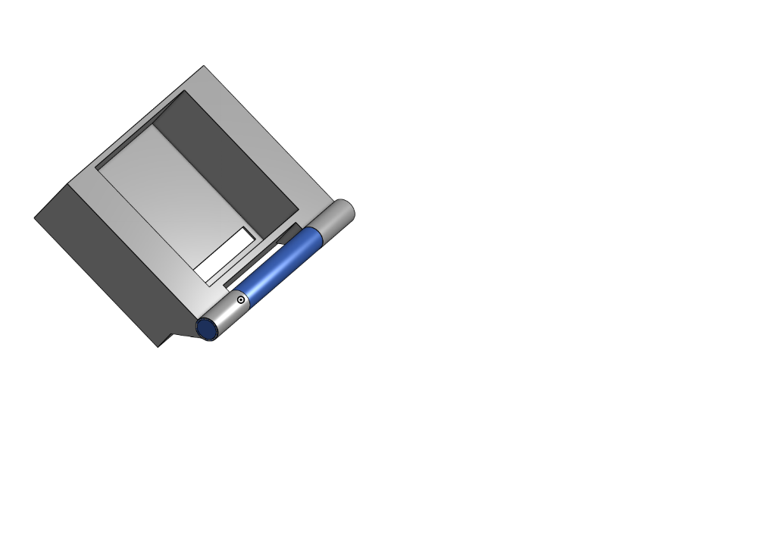

Fig. 4. 1

Considering the average human hand measurements, The Ring cutout is 0.9in diameter and with outer ring so won't be painful in the hands, more 0.5in is to make more room for the hinge rotation the other solid is 0.985in x 1.5in, and both blocks are of depth 0.35in. The inside ring of the hinge has a diameter of 0.121in and the rotating cylinder has a diameter of 0.12in.
Fig. 4. 2

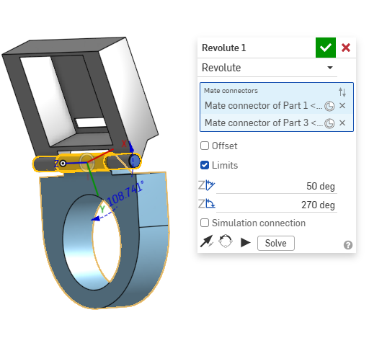
As shown in the figure, considering the hinge support (triangular prism) over the
The sides of both blocks have been given 220 deg rotation (50 to 270) for the support of the best viewing angle depending on an individual.
Fig. 4. 3

Chapter 5

Prototyping

3D Printing

Polylactic Acid (PLA), a biodegradable thermoplastic derived from renewable resources, was chosen for 3D printing a custom camera mount assembly due to its ideal balance of durability, affordability, and eco-friendly properties. The components—including a 0.9-inch-diameter support ring, a camera holder with a precisely sized rectangular slot for cable routing, and a hinge mechanism featuring a 0.12-inch rotating pin—were designed using CAD software and exported as an industry-standard STL file. Fabrication was completed using a fused deposition modeling (FDM) printer equipped with a 0.4 mm nozzle, optimized with a nozzle temperature of 210°C and a layer height of 0.2 mm to ensure strong layer adhesion and dimensional accuracy. Post-processing involved manual sanding: coarse 220-grit paper removed visible layer lines and burrs, while finer 600-grit paper achieved a smooth, functional finish. The final assembly performed reliably, with the hinge rotating smoothly without binding and the cable slot maintaining a secure fit during stress tests. Minor iterative adjustments during printing highlighted PLA’s adaptability for rapid prototyping, while its low material cost and ease of modification underscored its practicality. This project demonstrates PLA’s effectiveness in producing lightweight, functional prototypes that meet both mechanical and sustainability requirements for custom hardware solutions.
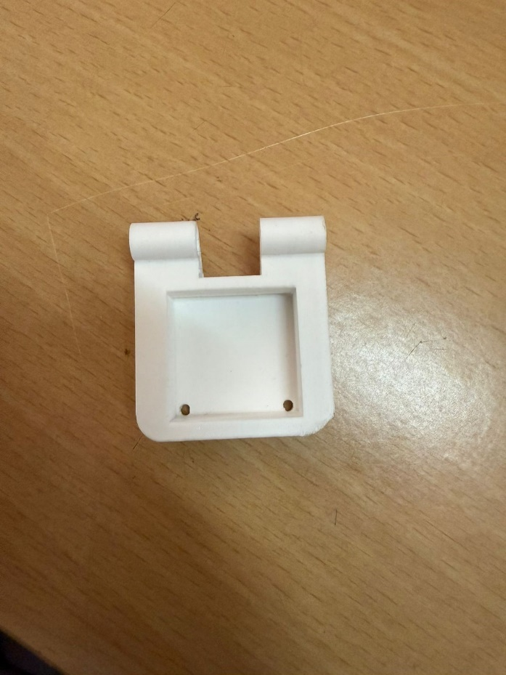
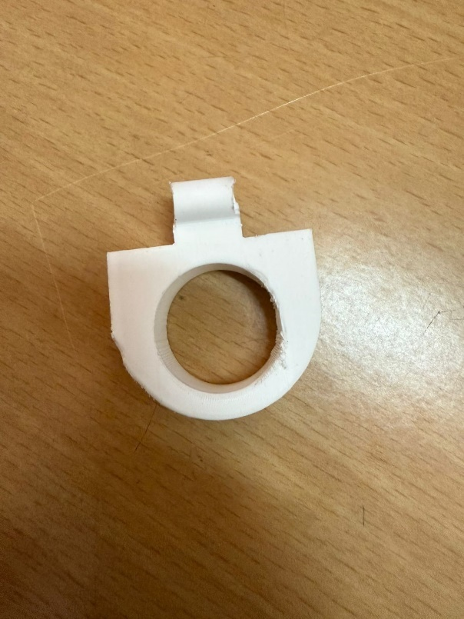
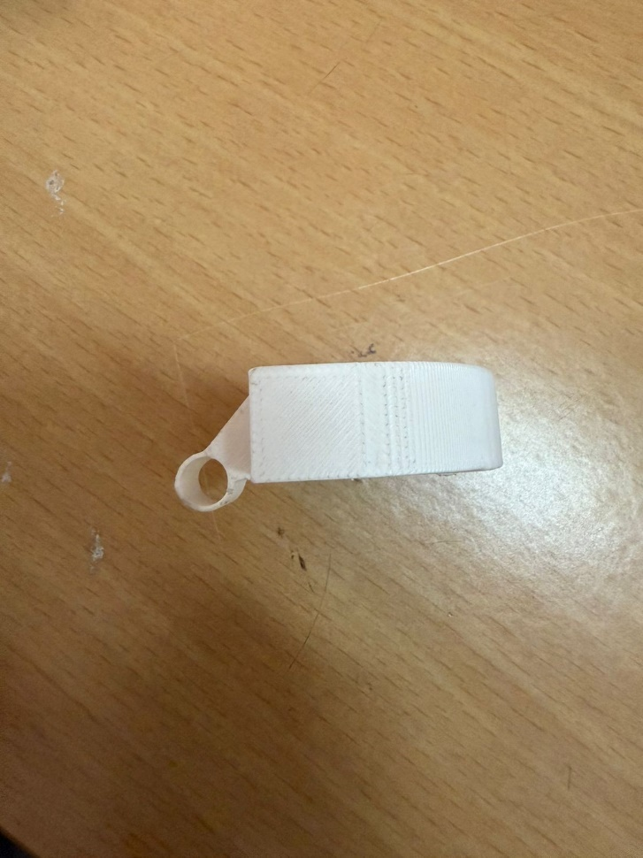
Fig. 5. 3
Fig. 5. 1
Fig. 5. 2

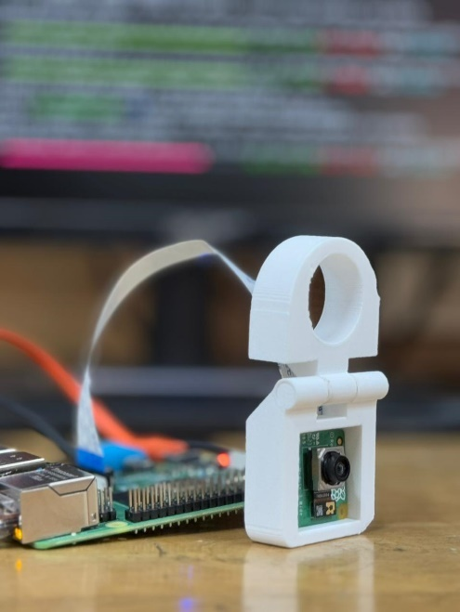
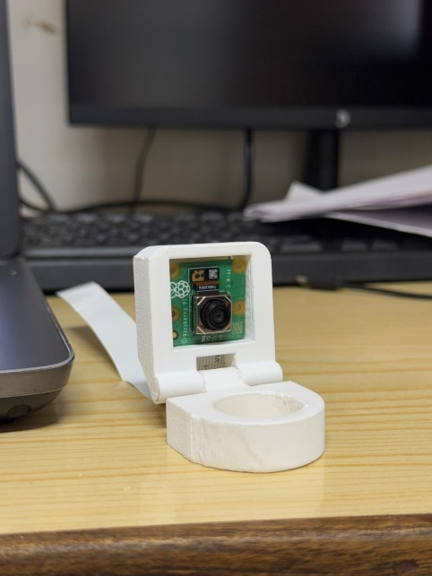

Fig. 5. 4
Fig. 5. 5

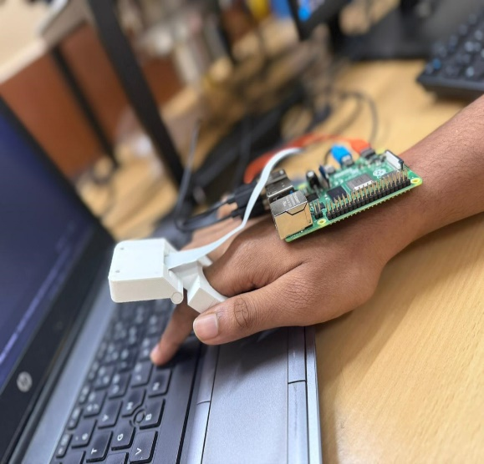
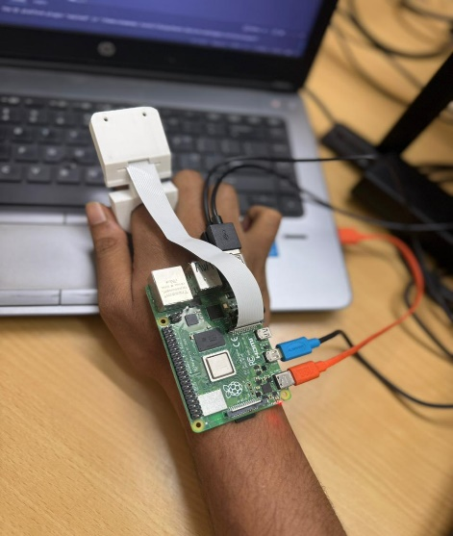

Fig. 5. 7
Fig. 5. 6

Chapter 6

Conclusions, Limitations and Scope for future works

Conclusion
Visual and cognitive aid tools may be useful as technology gets better. Machine learning, edge computing, and natural language processing could all be used to make the Adaptive Reader better. As the study goes on, the next generation of wearable tech might have Deep Learning built in, which makes it easier to recognize things, threats, and emotions in real-time. Voice instructions for controlling devices make the user experience better by recognizing and responding to spoken words. The Adaptive Reader sets the bar for future improvements because it is a cheap and easy-to-use option for people having low vision. The goal of this effort is to make assistive technology more common, which will make disabled people more independent.

Limitations and Scope for Future Works
The biggest limitation we faced when working on the adaptive reader was that the processing power of Raspberry Pi 4 was low. Upgrading to a Raspberry Pi 5 should provide ample processing power for all the processes. Providing the correct power supply was also another hinderence when it comes to making the device as portable as possible.
A self learning model can also be implemented within the adaptive reader to make it more reliable and quicker. Expanding access to a diverse range of languages, combined with integrated text-to-speech (TTS) translation tools, ensures a more inclusive and user-centric experience. The mounting mechanism should be prioritized to be neat and simple ensuring comfort for long-term user satisfaction.

Bibliography
- A. Rosebrock, Practical Python and OpenCV: An Introductory, Example-Driven Guide to Image Processing and Computer Vision, 4th ed., PyImageSearch, 2021.
- C. M. Bishop, Pattern Recognition and Machine Learning. New York, NY, USA: Springer, 2006.
- FingerReader: A Wearable Device to Explore Printed Text on the Go, Roy Shilkrot, Jochen Huber, Meng Ee Wong, Pattie Maes, Suranga Chandima Nanayakkara, Proceedings of the 33rd Annual ACM Conference on Human Factors in Computing Systems (CHI '15), 2014
- Picamera2 Library, "Picamera2 Documentation," Raspberry Pi Ltd., 2023. https://github.com/raspberrypi/picamera2
- YOLOv3: An Incremental Improvement, J. Redmon, A. Farhadi, arXiv preprint arXiv:1804.02767, 2018.
- Comprehensive resource on neural networks (CNNs, RNNs, LSTMs) relevant to your text recognition pipeline. I. Goodfellow, Y. Bengio, and A. Courville,Deep Learning. MIT Press, 2016

Appendix A: Python Script

import cv2
import numpy as np
import subprocess
import logging
import argparse
from picamera2 import Picamera2
import pytesseract as pt
import threading
import time
from collections import deque
from datetime import datetime
import signal
import sys

#Configuration Classes
class AppConfig:
def __init__(self):
self.hsv_lower = np.array([0, 20, 70], dtype=np.uint8)
self.hsv_upper = np.array([20, 255, 255], dtype=np.uint8)
self.min_contour_area = 500
self.ocr_config = '--psm 6'
self.tts_command = ["festival", "--tts"]
self.frame_size = (640, 480)
self.history_size = 10
self.fps_window = 5

class PerformanceMetrics:
def __init__(self):
self.frame_times = deque(maxlen=100)
self.fps = 0
self.processing_time = 0
self.ocr_time = 0

# Global Variables
previous_text = "" //storing previous text
speaking = False
tts_lock = threading.Lock()
history = deque(maxlen=AppConfig().history_size)
shutdown_flag = False

# Logging Setup
def setup_logging():
logger = logging.getLogger()
logger.setLevel(logging.DEBUG)
handler = logging.StreamHandler()
handler.setFormatter(logging.Formatter(
'%(asctime)s - %(levelname)s - %(message)s'))
logger.addHandler(handler)
logging.info("Logging system initialized")

#Signal Handling
def signal_handler(sig, frame):
global shutdown_flag
logging.warning("Shutdown signal received")
shutdown_flag = True
sys.exit(0)

signal.signal(signal.SIGINT, signal_handler)

# Text Validation
def load_dictionary(file_path='/usr/share/dict/words'):
try:
with open(file_path, 'r') as f:
return set(word.strip().lower() for word in f)
except FileNotFoundError:
logging.warning("Dictionary file not found, using empty set")
return set()

english_words = load_dictionary()

# Utility Functions
def calculate_fps(metrics):
if len(metrics.frame_times) > 1:
metrics.fps = len(metrics.frame_times) / \
(metrics.frame_times[-1] - metrics.frame_times[0])
return metrics.fps

def draw_performance_stats(frame, metrics):
cv2.putText(frame, f"FPS: {metrics.fps:.1f}", (10, 60),
cv2.FONT_HERSHEY_SIMPLEX, 0.5, (0, 255, 255), 1)
cv2.putText(frame, f"Proc: {metrics.processing_time:.1f}ms", (10, 80),
cv2.FONT_HERSHEY_SIMPLEX, 0.5, (0, 255, 255), 1)
cv2.putText(frame, f"OCR: {metrics.ocr_time:.1f}ms", (10, 100),
cv2.FONT_HERSHEY_SIMPLEX, 0.5, (0, 255, 255), 1)

# Core Functionality
def speak(text):
global speaking
with tts_lock:
speaking = True
try:
logging.info(f"Speaking text: {text}")
subprocess.run(AppConfig().tts_command,
input=text, text=True, check=True)
history.append((datetime.now().strftime("%H:%M:%S"), text))
except subprocess.CalledProcessError as e:
logging.error(f"TTS failed: {str(e)}")
finally:
speaking = False

def detect_fingertip(image, config):
start_time = time.time()
hsv = cv2.cvtColor(image, cv2.COLOR_BGR2HSV)
mask = cv2.inRange(hsv, config.hsv_lower, config.hsv_upper)
mask = cv2.GaussianBlur(mask, (5, 5), 0)
mask = cv2.dilate(mask, np.ones((3, 3), np.uint8), iterations=2)

//contour detection
contours, _ = cv2.findContours(mask, cv2.RETR_TREE, cv2.CHAIN_APPROX_SIMPLE)
contours = [c for c in contours if cv2.contourArea(c) > config.min_contour_area]

if not contours:
return image, None, time.time() - start_time

hand_contour = max(contours, key=cv2.contourArea)
fingertip = tuple(hand_contour[hand_contour[:, :, 1].argmin()][0])
cv2.circle(image, fingertip, 10, (255, 0, 0), -1)
return image, fingertip, time.time() - start_time

//finger tip extraction
def extract_text_near_fingertip(image, fingertip, config, metrics):
if fingertip is None:
return "No fingertip detected.", None, 0

start_time = time.time()
x, y = fingertip
gray = cv2.cvtColor(image, cv2.COLOR_BGR2GRAY)
gray = cv2.medianBlur(gray, 3)
thresh = cv2.adaptiveThreshold(gray, 255, cv2.ADAPTIVE_THRESH_GAUSSIAN_C,
cv2.THRESH_BINARY, 11, 7)

try:
ocr_start = time.time()
data = pt.image_to_data(thresh, lang='eng',
config=config.ocr_config, output_type=pt.Output.DICT)
metrics.ocr_time = (time.time() - ocr_start) * 1000
except Exception as e:
logging.error(f"OCR failed: {str(e)}")
return "OCR Error", None, 0

closest_word = ""
min_distance = float("inf")
best_bbox = None

for i, conf in enumerate(data['conf']):
if int(conf) > 60:
word = data['text'][i].strip()
if word and word.lower() in english_words:
word_x1 = data['left'][i]
word_x2 = word_x1 + data['width'][i]
word_y1 = data['top'][i]
word_y2 = word_y1 + data['height'][i]

word_center = ((word_x1 + word_x2) // 2, (word_y1 + word_y2) // 2)
distance = np.sqrt((word_center[0] - x) ** 2 + (word_center[1] - y) ** 2)

if distance < min_distance:
min_distance = distance
closest_word = word
best_bbox = (word_x1, word_y1, word_x2, word_y2)

proc_time = (time.time() - start_time) * 1000
return closest_word, best_bbox, proc_time

#Camera Initialization
def initialize_camera(config):
picam2 = Picamera2()
picam2.configure(picam2.create_preview_configuration(main={"size": config.frame_size}))
picam2.set_controls({"AfMode": 2, "AfTrigger": 1,
"FrameDurationLimits": (300000, 400000)})
picam2.start()
return picam2

# Main Loop
def main_loop(config, metrics):
global previous_text, shutdown_flag
picam2 = initialize_camera(config)

while not shutdown_flag:
frame_start = time.time()
frame = picam2.capture_array()

if frame is None:
logging.warning("Empty frame received")
continue

frame = cv2.cvtColor(frame, cv2.COLOR_RGB2BGR)
processed, fingertip, detect_time = detect_fingertip(frame, config)
text, bbox, proc_time = extract_text_near_fingertip(
processed, fingertip, config, metrics)

metrics.processing_time = (detect_time + proc_time) * 1000
metrics.frame_times.append(frame_start)
calculate_fps(metrics)

if bbox:
cv2.putText(processed, f"Text: {text.strip()}", (10, 30),
cv2.FONT_HERSHEY_SIMPLEX, 0.7, (0, 255, 255), 2)
draw_performance_stats(processed, metrics)

cv2.imshow("Enhanced Fingertip Reader", processed)

valid_text = text.strip() and text != previous_text
if valid_text and not speaking and text.lower() in english_words:
previous_text = text
threading.Thread(target=speak, args=(text,), daemon=True).start()

key = cv2.waitKey(1) & 0xFF
if key == ord('q'):
break
elif key == ord('h'):
logging.info("Help requested - showing history")
print("\nSpeech History:")
for timestamp, phrase in history:
print(f"{timestamp}: {phrase}")

cv2.destroyAllWindows()
picam2.stop()
logging.info("Application shutdown complete")

# Main Execution
if __name__ == "__main__":
setup_logging()
parser = argparse.ArgumentParser()
parser.add_argument("--debug", action="store_true", help="Enable debug mode")
args = parser.parse_args()

if args.debug:
logging.getLogger().setLevel(logging.DEBUG)
logging.info("Debug mode enabled")

config = AppConfig()
metrics = PerformanceMetrics()

try:
main_loop(config, metrics)
except Exception as e:
logging.critical(f"Critical error: {str(e)}", exc_info=True)
sys.exit(1)

Appendix B: React Script
import React, { useState, useEffect, useRef } from 'react';
import {
View,
Text,
TouchableOpacity,
StyleSheet,
Animated,
Easing,
ScrollView,
Dimensions
} from 'react-native';
import { Picker } from '@react-native-picker/picker';
import Icon from 'react-native-vector-icons/MaterialIcons';
import LinearGradient from 'react-native-linear-gradient';

const { width, height } = Dimensions.get('window');
const RASPBERRY_PI_IP = "192.168.1.100";

const App = () => {
const [isRunning, setIsRunning] = useState(false);
const [language, setLanguage] = useState('english');
const [selectedMode, setSelectedMode] = useState('word');
const [connectionStatus, setConnectionStatus] = useState('connecting');
const [settingsVisible, setSettingsVisible] = useState(false);
const [lastWords, setLastWords] = useState([]);
const scaleAnim = useRef(new Animated.Value(1)).current;
const slideAnim = useRef(new Animated.Value(height)).current;

const animateButton = () => {
Animated.sequence([
Animated.timing(scaleAnim, {
toValue: 0.95,
duration: 100,
easing: Easing.ease,
useNativeDriver: true
}),
Animated.spring(scaleAnim, {
toValue: 1,
friction: 3,
useNativeDriver: true
})
]).start();
};

const toggleSettings = () => {
Animated.timing(slideAnim, {
toValue: settingsVisible ? height : height * 0.3,
duration: 300,
easing: Easing.ease,
useNativeDriver: true
}).start();
setSettingsVisible(!settingsVisible);
};

const sendCommand = async (command) => {
try {
const response = await fetch(`http://${RASPBERRY_PI_IP}:5000/${command}`);
setConnectionStatus(response.ok ? 'connected' : 'error');
} catch (error) {
setConnectionStatus('error');
console.error('Network request failed', error);
}
};

const handleButtonPress = () => {
animateButton();
const command = isRunning ? 'stop' : 'start';
sendCommand(command);
setIsRunning(!isRunning);

if (!isRunning) {
setLastWords(prev => [...prev, `Session started: ${new Date().toLocaleTimeString()}`]);
}
};

const ConnectionIndicator = () => (
<View style={styles.connectionContainer}>
<Icon
name={connectionStatus === 'connected' ? 'wifi' : 'wifi-off'}
size={20}
color={connectionStatus === 'connected' ? '#4CAF50' : '#f44336'}
/>
<Text style={styles.connectionText}>
{connectionStatus.charAt(0).toUpperCase() + connectionStatus.slice(1)}
</Text>
</View>
);

const ModeSelector = () => (
<View style={styles.modeContainer}>
<TouchableOpacity
style={[styles.modeButton, selectedMode === 'word' && styles.activeMode]}
onPress={() => setSelectedMode('word')}
>
<Text style={styles.modeText}>Word Mode</Text>
</TouchableOpacity>
<TouchableOpacity
style={[styles.modeButton, selectedMode === 'paragraph' && styles.activeMode]}
onPress={() => setSelectedMode('paragraph')}
>
<Text style={styles.modeText}>Paragraph Mode</Text>
</TouchableOpacity>
</View>
);

const HistoryCard = () => (
<View style={styles.historyContainer}>
<Text style={styles.historyTitle}>Recent Activity</Text>
<ScrollView>
{lastWords.slice(-5).map((entry, index) => (
<View key={index} style={styles.historyItem}>
<Icon name="history" size={16} color="#888" />
<Text style={styles.historyText}>{entry}</Text>
</View>
))}
</ScrollView>
</View>
);

const SettingsPanel = () => (
<Animated.View style={[styles.settingsPanel, { transform: [{ translateY: slideAnim }] }]}>
<Text style={styles.settingsTitle}>Settings</Text>
<View style={styles.settingItem}>
<Text style={styles.settingLabel}>Language Preference</Text>
<Picker
selectedValue={language}
style={styles.picker}
onValueChange={setLanguage}
>
<Picker.Item label="English" value="english" />
<Picker.Item label="Hindi" value="hindi" />
<Picker.Item label="Spanish" value="spanish" />
<Picker.Item label="French" value="french" />
</Picker>
</View>
<View style={styles.settingItem}>
<Text style={styles.settingLabel}>Text Size</Text>
<View style={styles.sizeControls}>
<TouchableOpacity style={styles.sizeButton}>
<Text style={styles.sizeText}>A-</Text>
</TouchableOpacity>
<TouchableOpacity style={styles.sizeButton}>
<Text style={styles.sizeText}>A+</Text>
</TouchableOpacity>
</View>
</View>
</Animated.View>
);

return (
<LinearGradient
colors={['#1a1a1a', '#2d2d2d']}
style={styles.container}
>
<View style={styles.header}>
<Text style={styles.title}>Adaptive Reader</Text>
<TouchableOpacity onPress={toggleSettings}>
<Icon name="settings" size={28} color="#fff" />
</TouchableOpacity>
</View>

<ConnectionIndicator />
<ModeSelector />

<Animated.View style={{ transform: [{ scale: scaleAnim }] }}>
<LinearGradient
colors={isRunning ? ['#f44336', '#d32f2f'] : ['#4CAF50', '#388E3C']}
style={styles.gradientButton}
>
<TouchableOpacity
style={styles.button}
onPress={handleButtonPress}
activeOpacity={0.9}
>
<Icon
name={isRunning ? 'stop-circle' : 'play-circle-filled'}
size={60}
color="#fff"
/>
<Text style={styles.buttonText}>
{isRunning ? 'Stop Reading' : 'Start Reading'}
</Text>
</TouchableOpacity>
</LinearGradient>
</Animated.View>

<HistoryCard />
<SettingsPanel />

<View style={styles.footer}>
<Text style={styles.footerText}>Powered by Raspberry Pi</Text>
<Icon name="computer" size={18} color="#666" />
</View>
</LinearGradient>
);
};

const styles = StyleSheet.create({
container: {
flex: 1,
padding: 25,
paddingTop: height * 0.05,
},
header: {
flexDirection: 'row',
justifyContent: 'space-between',
alignItems: 'center',
marginBottom: 30,
},
title: {
fontSize: 28,
color: '#fff',
fontWeight: '700',
letterSpacing: 1.2,
},
gradientButton: {
width: width * 0.7,
height: width * 0.7,
borderRadius: width * 0.35,
alignSelf: 'center',
marginVertical: 25,
elevation: 8,
shadowColor: '#000',
shadowOffset: { width: 0, height: 4 },
shadowOpacity: 0.3,
shadowRadius: 4,
},
button: {
flex: 1,
justifyContent: 'center',
alignItems: 'center',
},
buttonText: {
color: '#fff',
fontSize: 18,
marginTop: 10,
fontWeight: '600',
},
connectionContainer: {
flexDirection: 'row',
alignItems: 'center',
justifyContent: 'center',
marginBottom: 20,
},
connectionText: {
color: '#fff',
marginLeft: 8,
fontSize: 14,
},
modeContainer: {
flexDirection: 'row',
justifyContent: 'center',
marginBottom: 25,
},
modeButton: {
paddingVertical: 10,
paddingHorizontal: 20,
marginHorizontal: 8,
borderRadius: 25,
backgroundColor: '#333',
},
activeMode: {
backgroundColor: '#4CAF50',
},
modeText: {
color: '#fff',
fontSize: 14,
fontWeight: '500',
},
historyContainer: {
backgroundColor: '#2a2a2a',
borderRadius: 15,
padding: 15,
marginTop: 20,
maxHeight: height * 0.2,
},
historyTitle: {
color: '#fff',
fontSize: 16,
fontWeight: '600',
marginBottom: 10,
},
historyItem: {
flexDirection: 'row',
alignItems: 'center',
marginBottom: 8,
},
historyText: {
color: '#888',
marginLeft: 8,
fontSize: 14,
},
settingsPanel: {
position: 'absolute',
bottom: 0,
left: 0,
right: 0,
backgroundColor: '#252525',
borderTopLeftRadius: 25,
borderTopRightRadius: 25,
padding: 25,
},
settingsTitle: {
color: '#fff',
fontSize: 20,
fontWeight: '600',
marginBottom: 20,
textAlign: 'center',
},
settingItem: {
marginBottom: 25,
},
settingLabel: {
color: '#fff',
fontSize: 16,
marginBottom: 10,
},
picker: {
backgroundColor: '#333',
borderRadius: 10,
color: '#fff',
},
sizeControls: {
flexDirection: 'row',
justifyContent: 'space-between',
},
sizeButton: {
backgroundColor: '#333',
padding: 12,
borderRadius: 8,
width: '48%',
alignItems: 'center',
},
sizeText: {
color: '#fff',
fontSize: 18,
fontWeight: 'bold',
},
footer: {
position: 'absolute',
bottom: 20,
alignSelf: 'center',
flexDirection: 'row',
alignItems: 'center',
},
footerText: {
color: '#666',
marginRight: 8,
fontSize: 12,
},
});

export default App;

Environment and sustainability
The Finger Reader Project is an assistive technology designed to help partially blind individuals read printed text while prioritizing environmental sustainability. Built with a Raspberry Pi, an energy-efficient camera, and a 3D-printed casing made from biodegradable PLA (derived from corn starch), the device minimizes ecological impact through low power consumption and reduced plastic waste. Its modular design allows users to replace or upgrade components, extending its lifespan and curbing electronic waste. Local sourcing of materials and recyclable packaging during development further lowered its carbon footprint, demonstrating a commitment to eco-conscious practices from prototype to production.

By emphasizing durability and repairability, the project challenges the disposable nature of consumer electronics, promoting a circular economy where devices are maintained rather than discarded. This approach not only reduces environmental harm but also enhances accessibility by lowering long-term costs for users. The Finger Reader exemplifies how technology can address social needs without compromising planetary health, setting a precedent for ethical innovation. It proves that assistive tools can harmonize inclusivity, functionality, and sustainability, inspiring a future where tech advancements prioritize both people and the environment.

Engineer and Society
The Finger Reader project is a socially transformative innovation aimed at empowering individuals with visual impairments by enabling them to read printed text independently. In a world where access to information remains a key determinant of opportunity, this device directly addresses the challenges faced by millions of partially blind and low-vision individuals in accessing printed content. By bridging the gap between the physical world and digital accessibility, the project contributes significantly to the ideals of inclusive technology.
Existing solutions such as Braille books or expensive commercial screen readers are either limited in scope or inaccessible due to cost. In contrast, the Finger Reader is a low-cost, portable, and user-friendly alternative that has the potential to improve daily life activities. Its affordability and open-ended design allow for mass adoption in underserved regions, making the technology particularly impactful in low-resource settings.
The project stands as a practical demonstration of how interdisciplinary knowledge can be harnessed to solve real-world problems. It integrates concepts from optics (camera focus and lens behavior), image processing (text detection and recognition), embedded systems (real-time control using Raspberry Pi), and human-centered design. The device’s image-to-speech pipeline reflects the practical implementation of signal processing and machine learning techniques.

List of Modern Tools, Instruments and Software used

Hardware Tools and Instruments
- Raspberry Pi (Model 4B)
– Used as the core processing unit for running image processing and control algorithms.
- Raspberry Pi Camera Module 3 Wide
– Autofocus camera module for capturing high-resolution images of text.
- 3D Printer (FDM type)
– Used to fabricate the device casing using PLA, a biodegradable plastic.

Software and Programming Tools
- Raspberry Pi OS (64-bit)
– Operating system used to run the application on the Raspberry Pi.
- Python
– Main programming language used for camera interfacing, image processing, and speech output.
- Tesseract OCR
– Open-source Optical Character Recognition engine for converting images of text to machine-readable text.
- Festival TTS / pyttsx3 / gTTS
– Python-based Text-to-Speech (TTS) libraries used to vocalize the recognized text.
- OpenCV
– Computer vision library for image enhancement, pre-processing, and ROI detection.
- Git and GitHub
– Version control and collaboration tools used for managing code and tracking changes.
- 3D Modeling Software (SolidWorks)
– Used for designing the enclosure of the device before 3D printing.

