Applied Discrete Modelling

Kanishk Kashayap, XxX Himanshoo, Atif Usman

Assignment- 5 Quality Tester

**System Specification:**

A quality tester is fed by material flows from two different sources. Only one of the two sources can be active, either *source 0* or *source 1*. The probability to switch from source 0 to source1 in one step is 0.4. The one step transition probability from source 1 to source 0 is 0.3. At the beginning of the simulation source 0 is active.

Assuming, that in each time step, one item is produced, the probability for the item to test OK is 0.9 for source 0 and 0.95 for source 1.

**Implementation:**

Obtain or build a tool that is able to solve the Evaluation and Decoding problem for HMM. (e.g.

MatLab, C, Excel…)

**Tasks and Questions:**

Specify and draw the HMM representing the system.

Use your program to answer the following questions:

* What is the most likely sequence of wafer test results in the first three steps of our observation?
* What is the probability of testing three defective wafers in a row (trace: *defective, defective, defective*) in the first three steps of our observation?
* What is the probability of the trace (*defective, defective, defective)* when starting in steady state?
* What is the most likely path that led to testing three wafers OK in a row (trace: *OK, OK, OK*) in the first three steps of our observation?
* What is the most likely path for the trace *(OK, OK, OK)* when starting in steady state?

**Task 01: Specify and draw the HMM representing the system.**

Sol: HMM for the given system:

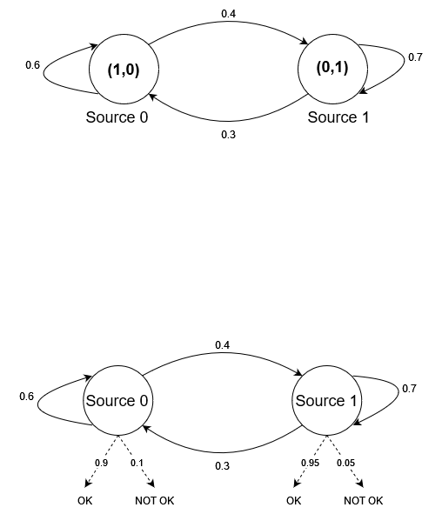

**Task 02:**

**2.1 What is the most likely sequence of wafer test results in the first three steps of our observation?**

Most likely sequence of wafer test results in the first three steps:

OK

OK

OK

With probability: 0.76005

**2.2 What is the probability of testing three defective wafers in a row (trace: *defective, defective, defective*) in the first three steps of our observation?**

Probability for trace(defective, defective, defective) in first 3 steps: 0.00065

**2.3 What is the probability of the trace (*defective, defective, defective)* when starting in steady state?**

Probability for trace(defective, defective, defective) in steady state: 0.000475

**2.4 What is the most likely path that led to testing three wafers OK in a row (trace: *OK, OK, OK*) in the first three steps of our observation?**

Most likely source path for testing three wafers OK in a row (trace: OK, OK, OK) in first 3 steps: [0 0 0]

**2.5 What is the most likely path for the trace *(OK, OK, OK)* when starting in steady state?**

Most likely source path for testing three wafers OK in a row (trace: OK, OK, OK) in steady state: [1 0 0]