SECURENOVA AI
PROJECT 1 — THREAT MODEL THE AI IDENTITY SYSTEM
Threat Modelling • STRIDE • Attack Trees • MITRE ATLAS • Risk Register
Document Type | Project Evidence & Results Report
Project | Project 1 — Threat Model the AI Identity System
Scope | SecureNova AI identity flows and trust boundaries
Evidence Set | P1-S1 through P1-S8
Status | Completed — evidence captured in project workflow

Prepared from the Project 1 assignment instructions and the actual evidence outputs supplied for the SecureNova AI capstone.

1. Problem Statement and Project Instructions
Project purpose. Project 1 establishes the threat-model foundation for the SecureNova AI identity system. The project requires enumeration of identity types, analysis of identity flows using STRIDE, creation of three attack trees, MITRE ATLAS mapping, and a risk-ranked register with ownership.
Assignment requirements (as provided).
- Threat Modelling: Enumerate all identity types in the SecureNova AI platform — human users, AI agent, OAuth M2M client, LLM API key, RAG pipeline service identity, MCP server identity. For each, document the authentication mechanism and privilege level.
- STRIDE Matrix: Apply all six STRIDE categories to every identity flow in the system. Build the complete data-flow diagram in OWASP Threat Dragon. Identify trust boundaries between the user layer, agent layer, and internal API layer.
- Attack Trees: Build three attack trees in draw.io: (1) LLM API key exfiltration via prompt injection, (2) agent identity spoofing to gain elevated API scope, (3) RAG chunk poisoning to manipulate agent behavior. Score each threat: Likelihood × Impact = Risk Score.
- MITRE ATLAS Mapping: Map each attack tree to the closest MITRE ATLAS technique. Record the AML.TXXXX Technique ID for each attack path. Produce the final risk-ranked register with owner assigned to each threat.
Required evidence screenshots.
- P1-S1 — OWASP Threat Dragon open with the complete data-flow diagram and trust boundaries labelled.
- P1-S2 — Threat Dragon threat panel showing at least three STRIDE threats for one identity flow.
- P1-S3 — draw.io Attack Tree 1: LLM API Key Exfiltration via Prompt Injection.
- P1-S4 — draw.io Attack Tree 2: Agent Identity Spoofing.
- P1-S5 — draw.io Attack Tree 3: RAG Chunk Poisoning.
- P1-S6 — STRIDE threat matrix fully populated across all six categories.
- P1-S7 — Risk register with threats scored/ranked and owners assigned; at least 10 rows visible.
- P1-S8 — MITRE ATLAS technique page for one mapped attack tree.

2. Project 1 Results at a Glance
The supplied evidence set demonstrates that the requested threat-model artefacts were produced for the SecureNova AI identity system. The data-flow diagram identifies the major identity components and trust boundaries; the STRIDE matrix covers the six STRIDE categories; three attack trees model the requested attack paths; the risk register contains ranked threats with owners and MITRE ATLAS IDs; and the MITRE ATLAS evidence page shows AML.T0051 — LLM Prompt Injection.
Evidence | Requirement | Observed output | Status
P1-S1 | Identity data-flow & trust boundaries | Complete SecureNova AI identity data-flow diagram received | Completed
P1-S2 | Threat Dragon STRIDE threats | 3 STRIDE threats visible in Threat Dragon | Completed
P1-S3 | Attack Tree 1 | LLM API Key Exfiltration via Prompt Injection | Completed
P1-S4 | Attack Tree 2 | Agent Identity Spoofing to Gain Elevated API Scope | Completed
P1-S5 | Attack Tree 3 | RAG Chunk Poisoning to Manipulate Agent Behavior | Completed
P1-S6 | STRIDE matrix | All six STRIDE categories populated across identity flows | Completed
P1-S7 | Risk register | 12 visible risk-ranked rows with likelihood, impact, risk score, rank, owner and ATLAS ID | Completed
P1-S8 | MITRE ATLAS mapping | AML.T0051 — LLM Prompt Injection page captured | Completed

3. Threat Model — Identity Types and Flows
The supplied SecureNova AI data-flow diagram shows a human user, Auth0 identity provider, AI customer-service agent, LLM service, RAG knowledge pipeline, internal REST APIs, MCP tool server, and knowledge base. The agent trust boundary, user/external boundary, and internal services boundary are visibly distinguished.
Identity | Authentication mechanism shown/used | Privilege level / role | Boundary
Human User | Auth0 / OIDC authorization flow shown in diagram | User-level access to request AI service actions | User / external boundary
AI Customer Service Agent | OAuth access token / agent identity context | Acts on behalf of authenticated user; security-relevant identity | AI Agent Trust Boundary
OAuth M2M Client | OAuth client credentials / client identity | Machine-to-machine access to APIs and services | AI Agent Trust Boundary
LLM API Key | API credential used to access LLM service | Credential-level privilege for LLM service access | AI Agent Trust Boundary
RAG Pipeline Service Identity | Service identity for retrieval and knowledge access | Retrieval access to knowledge pipeline / knowledge base | Internal Services Boundary
MCP Server Identity | Service identity for MCP tool execution | Tool-invocation capability, including potentially privileged actions | Internal Services Boundary

4. STRIDE Analysis
The supplied STRIDE matrix applies Spoofing, Tampering, Repudiation, Information Disclosure, Denial of Service, and Elevation of Privilege across the documented identity flows. The matrix contains 10 visible flow/component rows and assigns risk levels including High and Critical.
Identity Flow | S | T | R | I | D | E | Risk
Human User → Auth0 | Stolen credentials / token manipulation | Authentication request modification | Disputed authentication | ID/access token exposure | Login flooding | Attempt to obtain admin privileges | High
Auth0 → Human User | Forged token presented as Auth0 token | Token claims modified | Invalid token issuance disputed | Token contents exposed | Token service disrupted | Token scope manipulated | High
Human User → AI Agent | Attacker impersonates legitimate user | Prompt/request modified | Malicious request disputed | Agent reveals sensitive data | Request flooding | Prompt attempts admin behavior | High
Auth0 → AI Agent | Forged agent authentication token | OAuth claims/scopes modified | Agent denies token use | Access token exposed | Token endpoint abused | Unauthorized privileged scope obtained | Critical
AI Agent → Internal REST APIs | Spoofed AI agent identity | API request/parameters modified | Agent denies API operation | Unauthorized API data returned | Excessive API calls | Agent invokes admin API | Critical
AI Agent → RAG Pipeline | Spoofed RAG service identity | Retrieval query/context modified | Retrieval activity disputed | Sensitive knowledge retrieved | Retrieval service overwhelmed | Restricted knowledge accessed | High
RAG Pipeline → Knowledge Base | Unauthorized service identity | Knowledge chunks poisoned/modified | Malicious modification disputed | Restricted knowledge exposed | Knowledge base flooded | Unauthorized write access | Critical
RAG Pipeline → AI Agent | Forged retrieval response | Retrieved context manipulated | Malicious context origin disputed | Sensitive RAG content exposed | Content disrupts agent | Poisoned context causes privileged action | Critical
AI Agent → LLM Service | Spoofed agent/client identity | Prompt/context modified | Agent denies malicious prompt | LLM API key/system context exposed | Excessive LLM requests | Prompt injection causes privileged behavior | Critical
AI Agent → MCP Tool Server | Spoofed MCP/agent identity | Tool parameters modified | Tool invocation disputed | Tool response exposes sensitive data | MCP tool repeatedly invoked | Agent invokes unauthorized privileged tool | Critical

5. Attack Trees

5.1 Attack Tree 1 — LLM API Key Exfiltration via Prompt Injection
The evidence models an attacker gaining access to an agent execution context, embedding malicious instructions in RAG content or context, causing the credential to enter prompt/context, generating credential-shaped output or sending it to an attacker-controlled destination, and ultimately obtaining the credential.
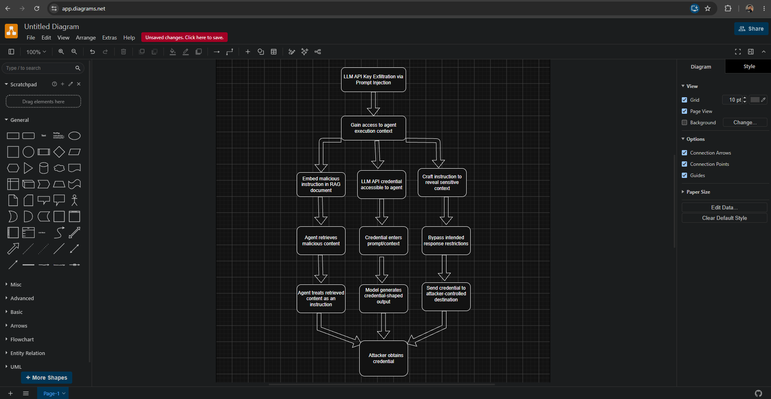
P1-S3 AttackTree LLM API Key Exfiltration

5.2 Attack Tree 2 — Agent Identity Spoofing to Gain Elevated API Scope
The evidence models obtaining or forging a trusted agent identity, bypassing inadequate identity validation, replaying or presenting forged identity material, causing a receiving agent to accept the message, obtaining elevated API scope, executing a privileged API action, and reaching unauthorized privileged access.
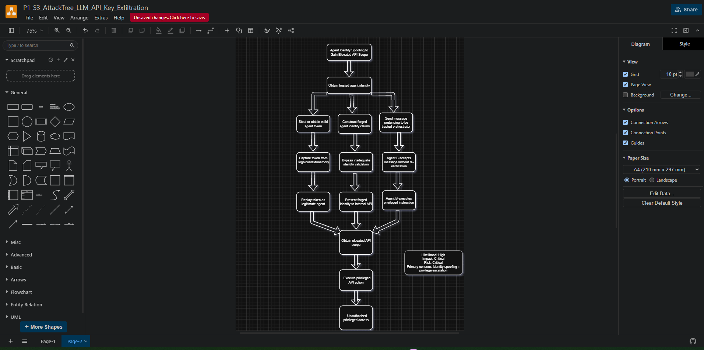
P1-S4 AttackTree Agent Identity Spoofing

5.3 Attack Tree 3 — RAG Chunk Poisoning to Manipulate Agent Behavior
The evidence models malicious knowledge-base content being inserted or modified, the RAG pipeline retrieving the poisoned chunk, the agent interpreting retrieved text as trusted context, changing intended behavior, invoking an unauthorized action/tool, and resulting in unauthorized action execution.
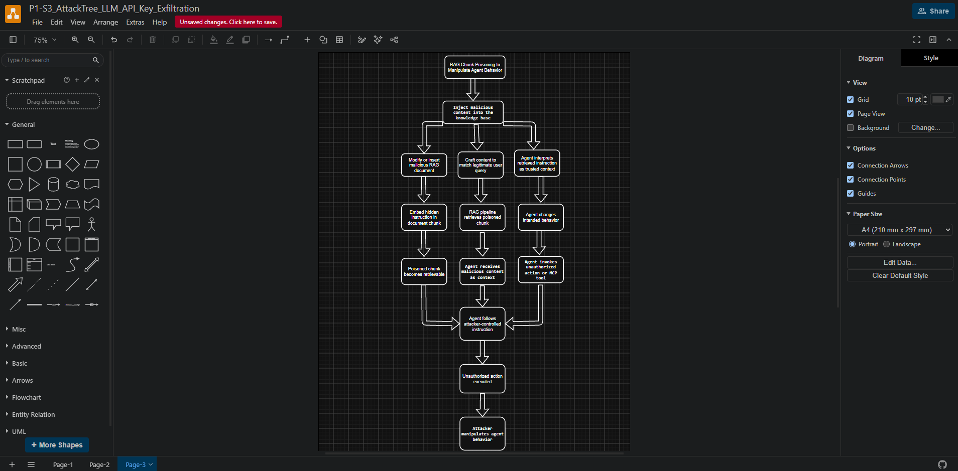
P1-S5 AttackTree RAG Chunk Poisoning

6. Risk-Ranked Register
The supplied Risk Register shows 12 visible rows, ranked by Risk Score = Likelihood × Impact. The highest-ranked entries are Critical, with owners assigned and MITRE ATLAS IDs recorded.
ID | Identity Flow / Component | Threat | Likelihood | Impact | Risk Score | Level | Rank | Owner | MITRE ATLAS
R-01 | AI Agent → Internal REST APIs | Agent identity spoofing / unauthorized API scope | 5 | 5 | 25 | Critical | 1 | IAM Security Lead | AML.T0073
R-02 | AI Agent → LLM Service | LLM API credential exposure through prompt injection | 5 | 5 | 25 | Critical | 2 | AI Security Lead | AML.T0051
R-03 | RAG Pipeline → AI Agent | RAG chunk poisoning manipulates agent behavior | 4 | 5 | 20 | Critical | 3 | RAG Security Engineer | AML.T0070
R-04 | AI Agent → MCP Tool Server | Unauthorized privileged MCP tool invocation | 4 | 5 | 20 | Critical | 4 | Platform Security Lead | AML.T0073
R-05 | Auth0 → AI Agent | Forged OAuth token / manipulated privileged scope | 4 | 5 | 20 | Critical | 5 | IAM Engineer | AML.T0015
R-06 | Human User → AI Agent | Prompt-based privilege elevation | 4 | 4 | 16 | High | 6 | AI Security Lead | AML.T0051
R-07 | RAG Pipeline → Knowledge Base | Unauthorized modification of knowledge chunks | 3 | 5 | 15 | High | 7 | RAG Security Engineer | AML.T0070
R-08 | AI Agent → RAG Pipeline | Spoofed RAG service identity / unauthorized retrieval | 3 | 4 | 12 | High | 8 | Data Security Lead | AML.T0073
R-09 | Human User → Auth0 | Credential theft / user impersonation | 3 | 4 | 12 | High | 9 | IAM Security Lead | AML.T0015
R-10 | AI Agent → LLM Service | Excessive LLM requests cause service/quota exhaustion | 3 | 4 | 12 | High | 10 | AI Platform Engineer | AML.T0049
R-11 | Auth0 → Human User | Token disclosure or claim manipulation | 2 | 4 | 8 | Medium | 11 | IAM Engineer | AML.T0015
R-12 | AI Agent → MCP Tool Server | MCP request tampering / replay | 2 | 4 | 8 | Medium | 12 | Platform Security Lead | AML.T0049

7. Evidence Gallery
The following screenshots are the actual supplied project evidence and are included for traceability. Each image corresponds to one of the eight required Project 1 evidence items.

P1-S1 — OWASP Threat Dragon data-flow diagram
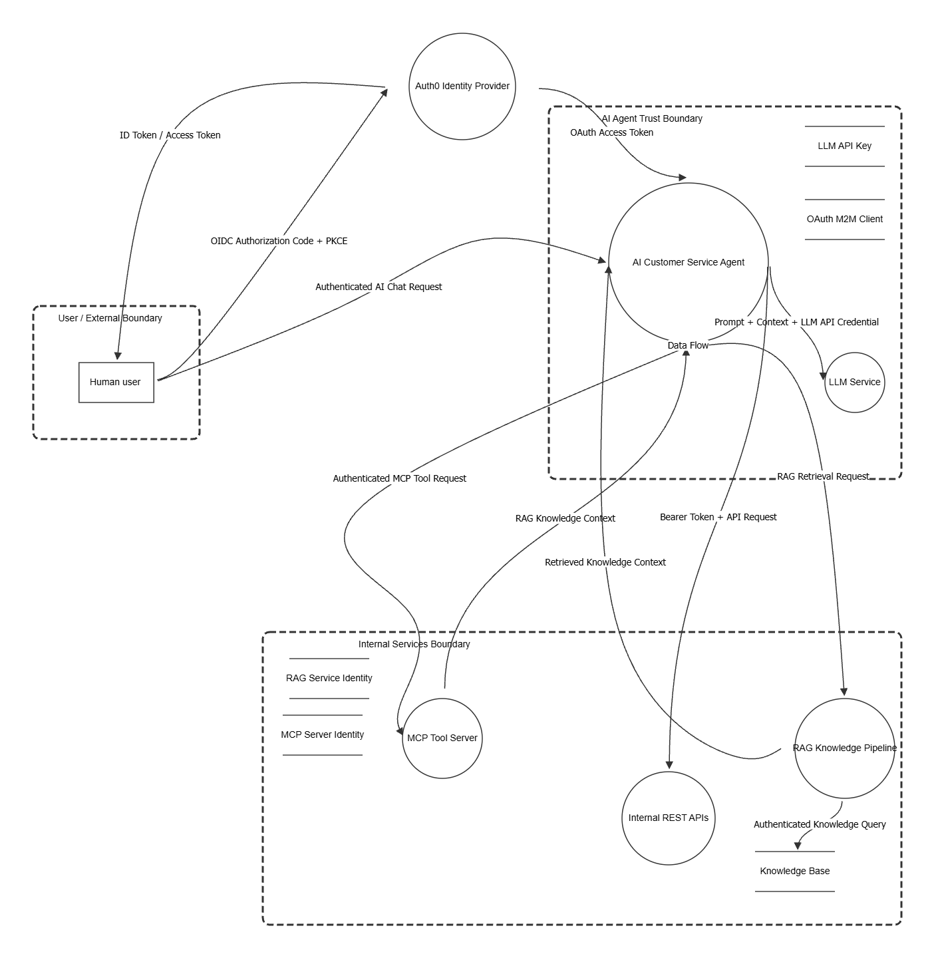
P1-S1 — OWASP Threat Dragon data-flow diagram

P1-S2 — Threat Dragon STRIDE threat panel
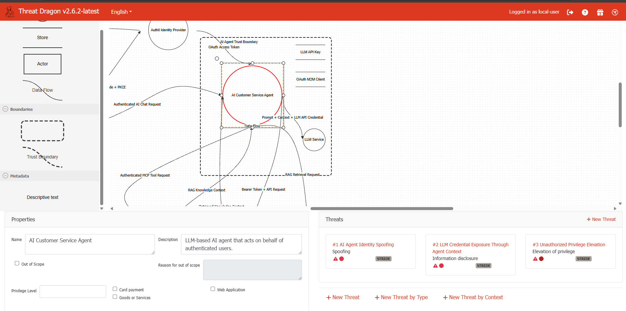
P1-S2 — Threat Dragon STRIDE threat panel

P1-S3 — Attack Tree 1: LLM API Key Exfiltration

P1-S3 — Attack Tree 1: LLM API Key Exfiltration

P1-S4 — Attack Tree 2: Agent Identity Spoofing

P1-S4 — Attack Tree 2: Agent Identity Spoofing

P1-S5 — Attack Tree 3: RAG Chunk Poisoning

P1-S5 — Attack Tree 3: RAG Chunk Poisoning

P1-S6 — STRIDE Threat Matrix
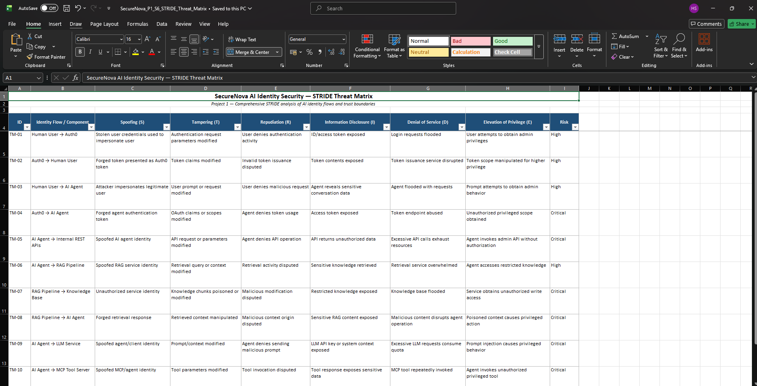
P1-S6 — STRIDE Threat Matrix

P1-S7 — Risk Register
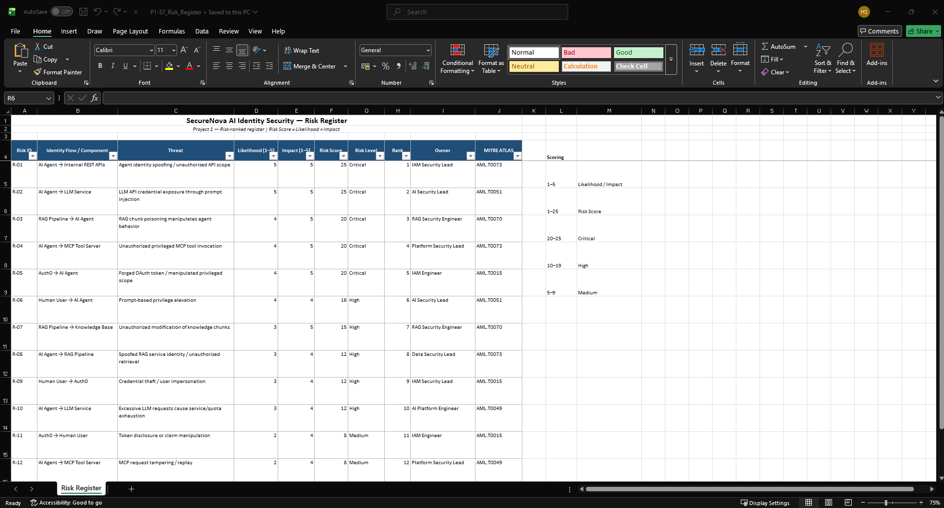
P1-S7 — Risk Register

P1-S8 — MITRE ATLAS AML.T0051
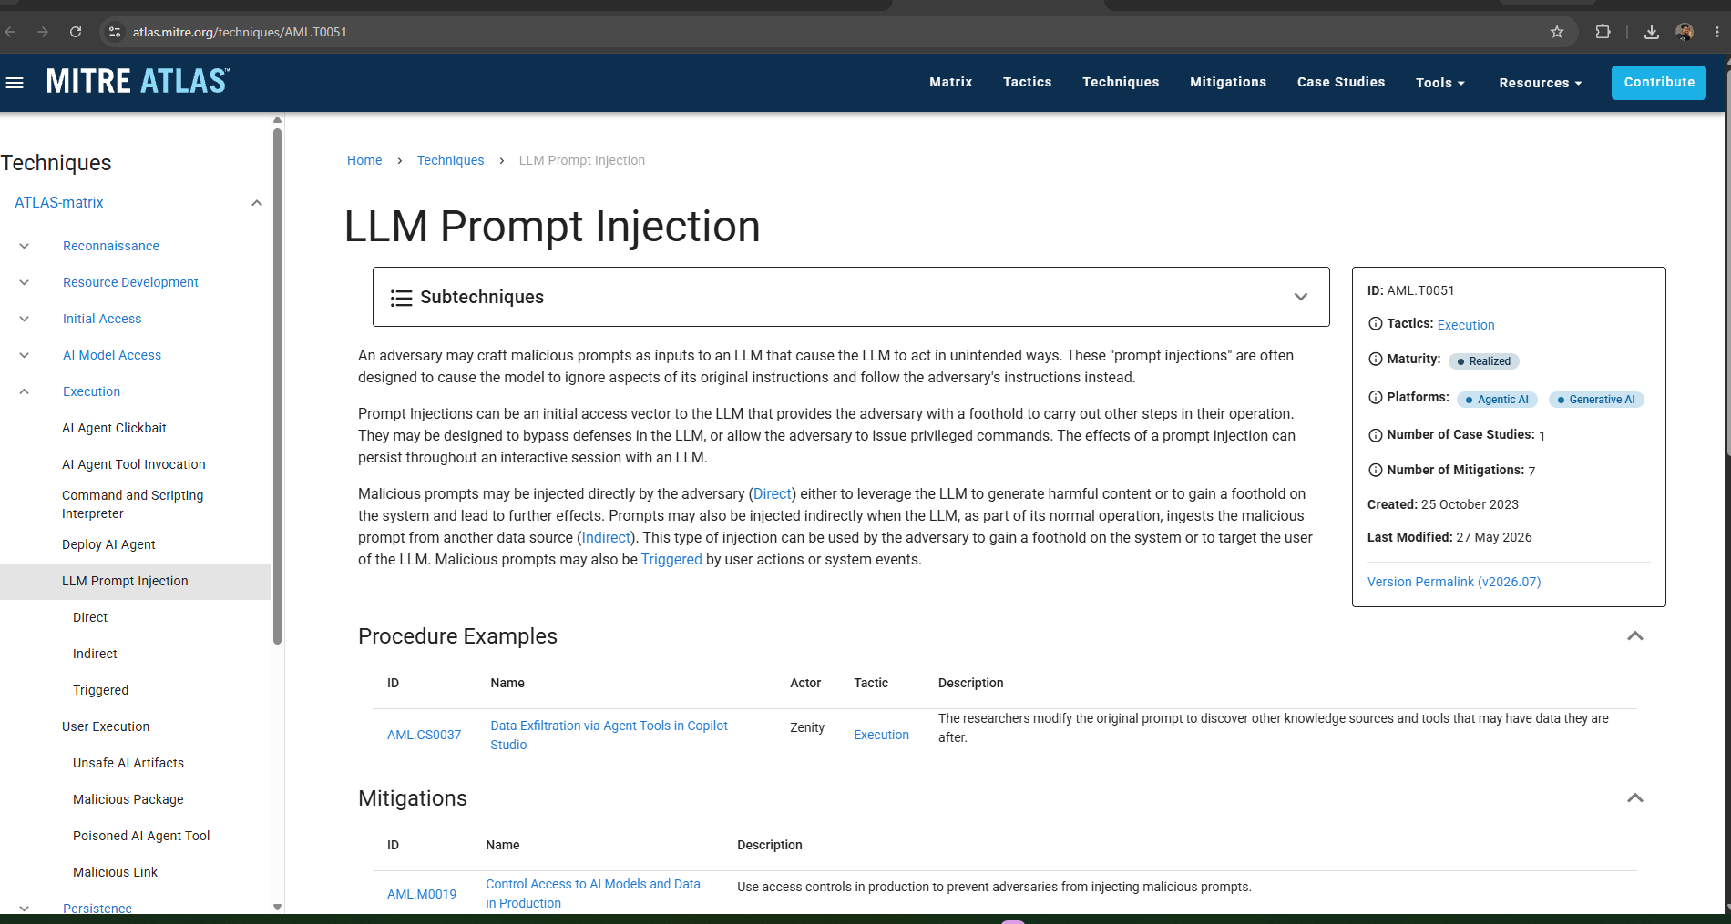
P1-S8 — MITRE ATLAS AML.T0051

8. Project 1 Conclusion
Project 1 establishes the documented identity threat model for SecureNova AI. The supplied evidence covers the requested identity components and trust boundaries, six-category STRIDE analysis, three attack trees, MITRE ATLAS mapping, and a risk-ranked register with owners. The evidence set therefore provides the threat-model foundation used by the later red-team, blue-team, and policy/compliance work.
Evidence note. This report records the supplied project outputs as evidence. It does not infer missing artefacts or substitute external results for the screenshots and files provided.

