SECURENOVA AI
PROJECT 2 — AUTH0 IMPLEMENTATION
Build and Secure the Auth0-Backed AI Application
Document Type | Project Evidence & Results Report
Project | Project 2 — Build and Secure the Auth0-Backed AI Application
Scope | Auth0 tenant, OAuth/PKCE, MFA, attack protection, credential rotation, Actions and SSO
Evidence Set | P2-S1 through P2-S8 + supplementary SSO evidence
Status | Completed — evidence captured in project workflow
Prepared From | Project 2 assignment instructions and supplied project outputs

Report style note: This report intentionally keeps theory brief and focuses on the practical configuration, observed output, and evidence used for the Project 2 submission.

1. Problem Statement and Project Instructions
Project 2 builds and secures the SecureNova AI application using Auth0. The work covers tenant setup, OAuth 2.0 + PKCE, MFA and attack protection, short-lived M2M credentials, Auth0 Actions, and SSO.
- 1. Auth0 Tenant Setup: create a free Auth0 developer tenant; register a Regular Web Application for the AI chat service and a Machine-to-Machine application for the AI agent; configure callback URLs, grant types, and CORS origins.
- 2. OAuth 2.0 + PKCE: implement Authorization Code + PKCE; define read:ai-data and write:admin scopes; reject unauthorized admin access; decode and verify JWT claims including RS256, aud, iss, exp, and scope.
- 3. MFA and Attack Protection: enable TOTP-based MFA; configure Brute-Force Protection and Suspicious IP Throttling; capture the MFA enrolment/challenge flow.
- 4. Credential Rotation: obtain a short-lived M2M token, call /chat successfully, wait for expiry, and replay the token to confirm rejection.
- 5. Auth0 Actions and SSO: add agent_id as a custom claim and deploy the post-login Action; enable SSO and confirm an existing Auth0 session is accepted by a second registered client.

2. Results at a Glance
Evidence | Requirement | Observed Output | Status
P2-S1 | Auth0 Applications | Both the Regular Web Application and Machine-to-Machine application are registered and visible. | Completed
P2-S2 | Auth0 API Permissions | SecureNova AI API shows the required read:ai-data and write:admin permissions. | Completed
P2-S3 | JWT Verification | Decoded JWT shows RS256 and the required aud, iss, exp, scope, and agent_id claims. | Completed
P2-S4 | Universal Login Branding | Auth0 Universal Login page shows the custom SecureNova AI / Himanshu Labs branding. | Completed
P2-S5 | MFA / TOTP Challenge | Auth0 MFA challenge flow is visible in the browser. | Completed
P2-S6 | Auth0 Post-Login Action | Action code adds agent_id to the ID token and access token. | Completed
P2-S7 | Attack Protection | Suspicious IP Throttling and Brute-force Protection are enabled. | Completed
P2-S8 | Credential Rotation | M2M token lifetime is 60 seconds; first /chat request returns 200 and replay after expiry returns 401. | Completed
P2-S9 | SSO Verification (supplementary evidence) | A second registered client accepts the existing Auth0 session without re-authentication. | Demonstrated

3. Practical Implementation Results

3.1 Auth0 Tenant and Applications
Auth0 shows both SecureNova AI Agent M2M and SecureNova AI Chat Web App in the Applications list. The M2M application is a Machine-to-Machine application and the chat client is a Regular Web Application.

3.2 API Permissions
SecureNova AI API contains the two required permissions: read:ai-data (Read AI data) and write:admin (Admin write access).

3.3 JWT Verification
The decoded token shows alg = RS256 and includes agent_id, iss, aud, exp, scope and permissions. The displayed scope includes openid profile email read:ai-data.

3.4 Universal Login Branding
The Auth0 Universal Login screen is branded for the SecureNova AI application and shows the custom tenant/application presentation.

3.5 MFA and Attack Protection
The browser shows the Auth0 Guardian identity verification/MFA challenge. The Attack Protection dashboard shows Suspicious IP Throttling = Enabled and Brute-force Protection = Enabled.

3.6 Auth0 Post-Login Action
The Action named Add Agent ID Claim sets agent_id from event.client.client_id and writes the claim to both the ID token and access token.

3.7 Credential Rotation
The M2M test reports a 60-second token lifetime. The first /chat call returns HTTP 200 and replay after expiry returns HTTP 401 with an Invalid or expired access token response; the script reports success.

3.8 SSO Verification
The supplementary SSO evidence shows “SSO authentication successful” and explicitly states that the second client accepted the existing Auth0 session.

P2-S1 — Auth0 Applications: SecureNova AI Agent M2M and SecureNova AI Chat Web App are registered.
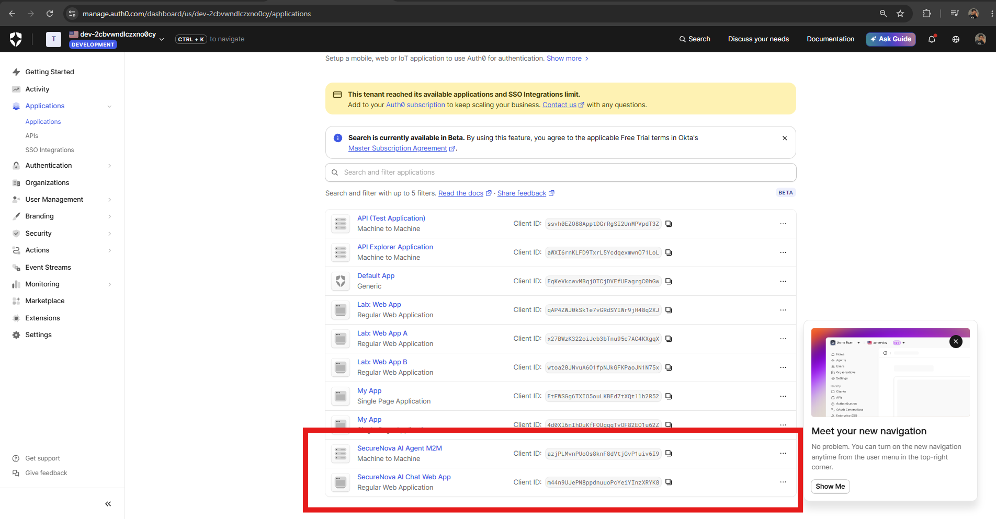
P2-S1 — Auth0 Applications: SecureNova AI Agent M2M and SecureNova AI Chat Web App are registered.

P2-S2 — Auth0 API Permissions: read:ai-data and write:admin are visible.
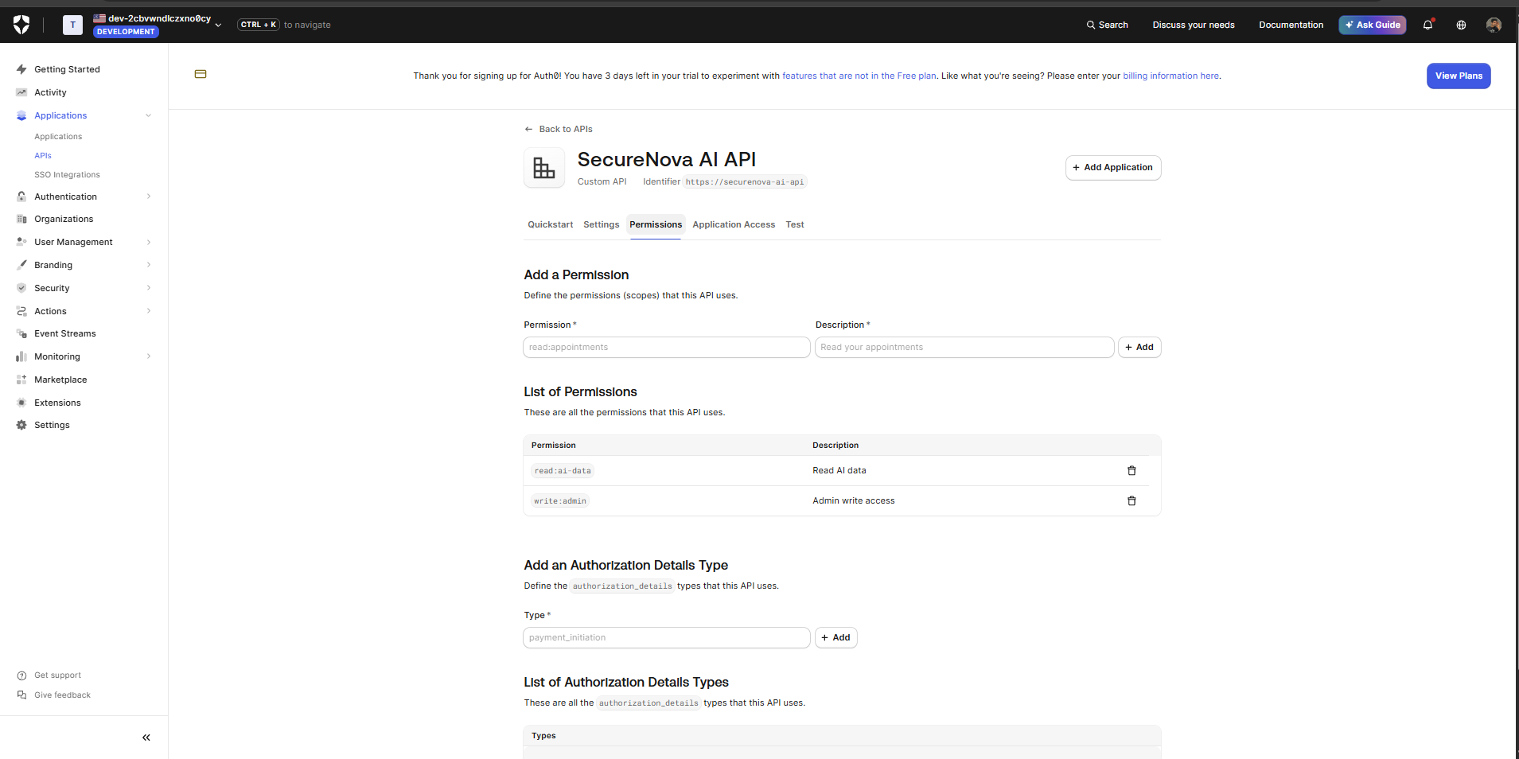
P2-S2 — Auth0 API Permissions: read:ai-data and write:admin are visible.

P2-S3 — jwt.io decoded token: RS256 plus agent_id, aud, iss, exp, scope and permissions are visible.
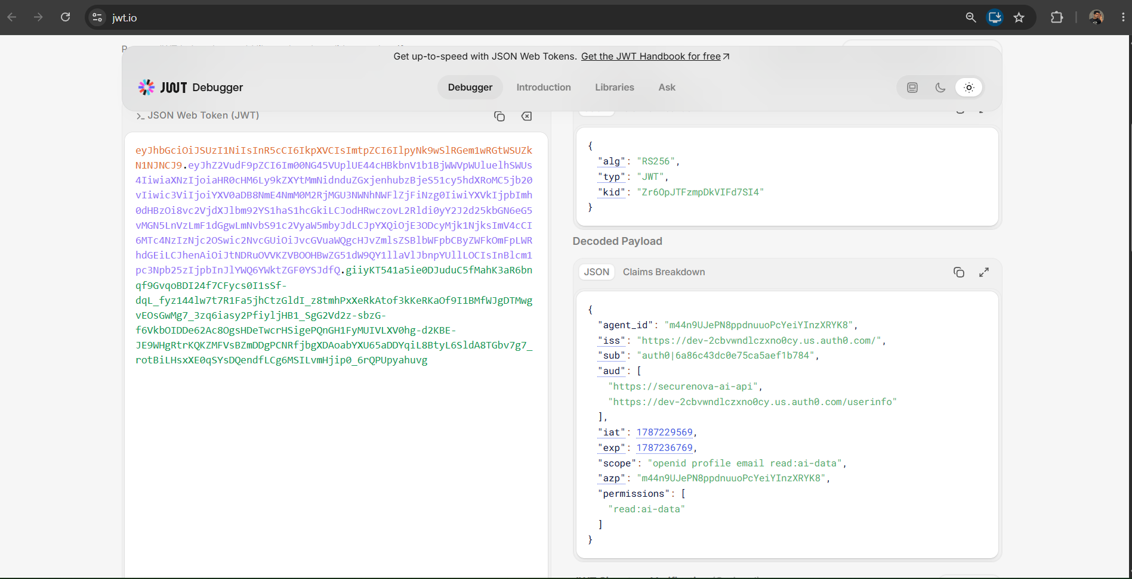
P2-S3 — jwt.io decoded token: RS256 plus agent_id, aud, iss, exp, scope and permissions are visible.

P2-S4 — Auth0 Universal Login with SecureNova AI branding.
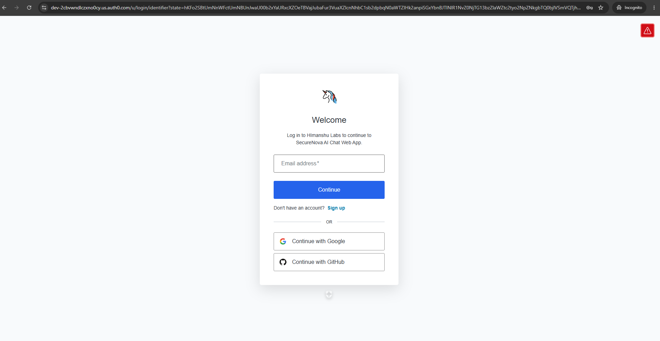
P2-S4 — Auth0 Universal Login with SecureNova AI branding.

P2-S5 — Auth0 MFA / identity verification challenge screen.
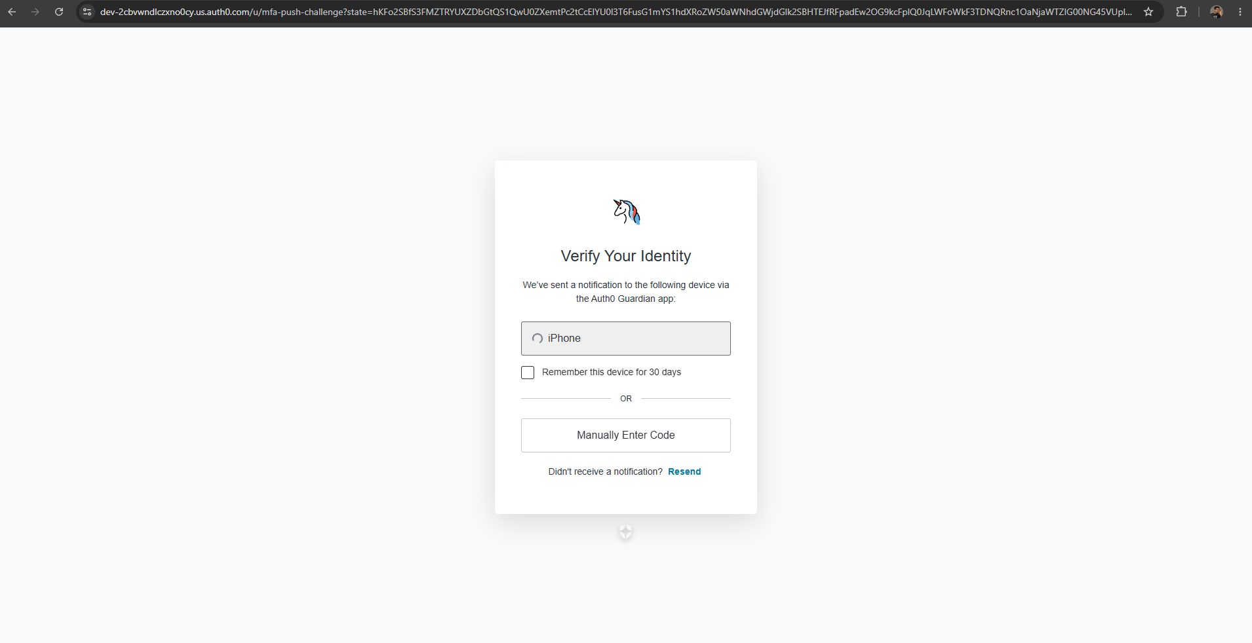
P2-S5 — Auth0 MFA / identity verification challenge screen.

P2-S6 — Auth0 Action editor showing agent_id custom-claim code.
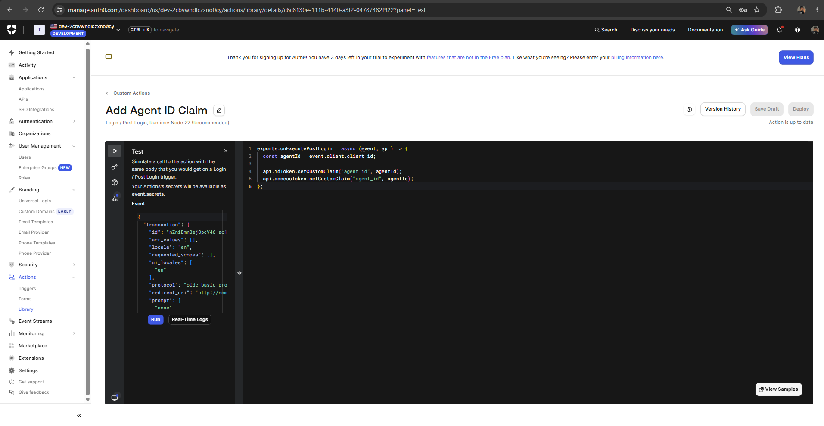
P2-S6 — Auth0 Action editor showing agent_id custom-claim code.

P2-S7 — Auth0 Attack Protection: Suspicious IP Throttling and Brute-force Protection enabled.
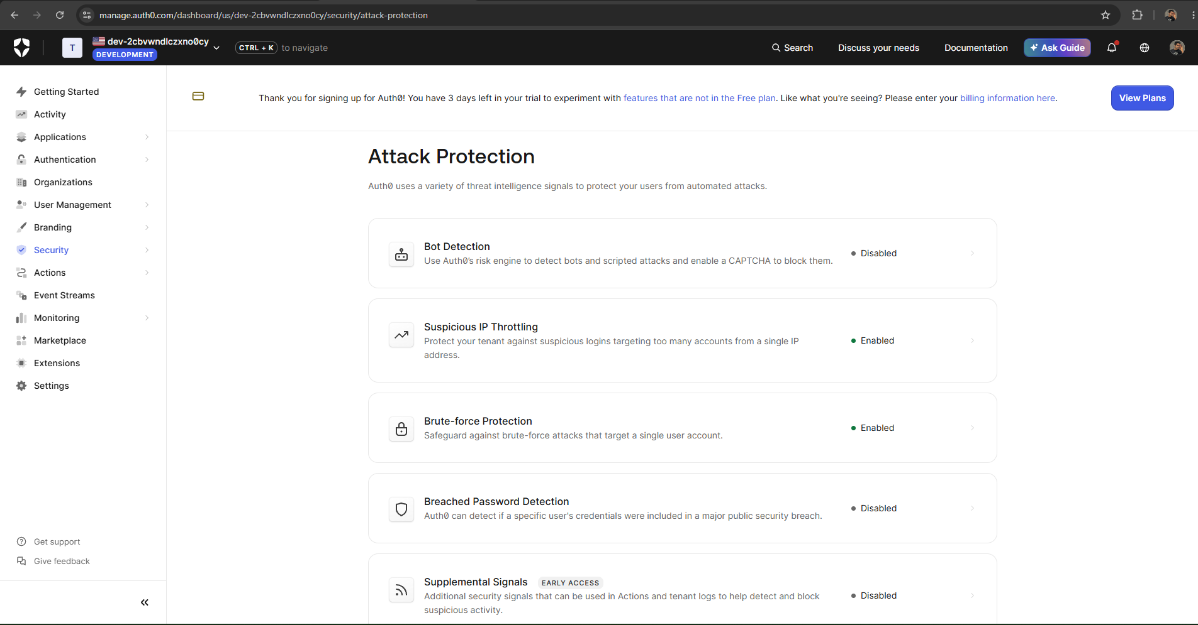
P2-S7 — Auth0 Attack Protection: Suspicious IP Throttling and Brute-force Protection enabled.

P2-S8 — Credential rotation terminal: first request HTTP 200, replay after expiry HTTP 401.
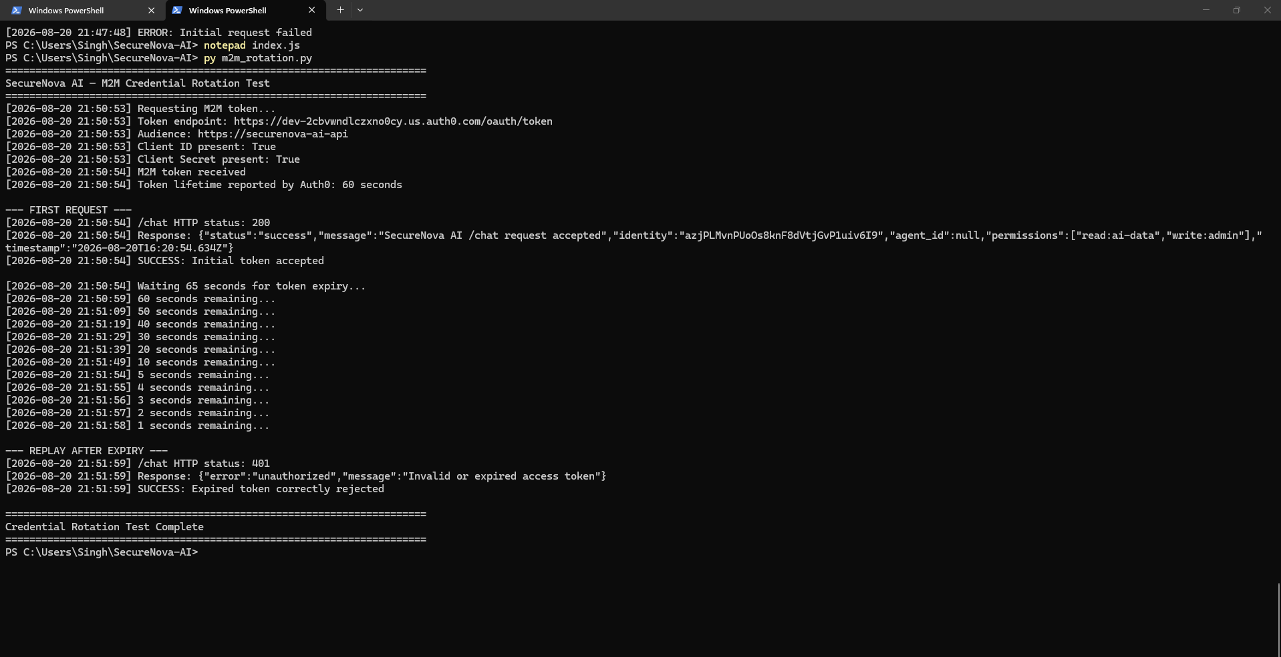
P2-S8 — Credential rotation terminal: first request HTTP 200, replay after expiry HTTP 401.

P2-S9 (supplementary) — SSO verification: second client accepted the existing Auth0 session.
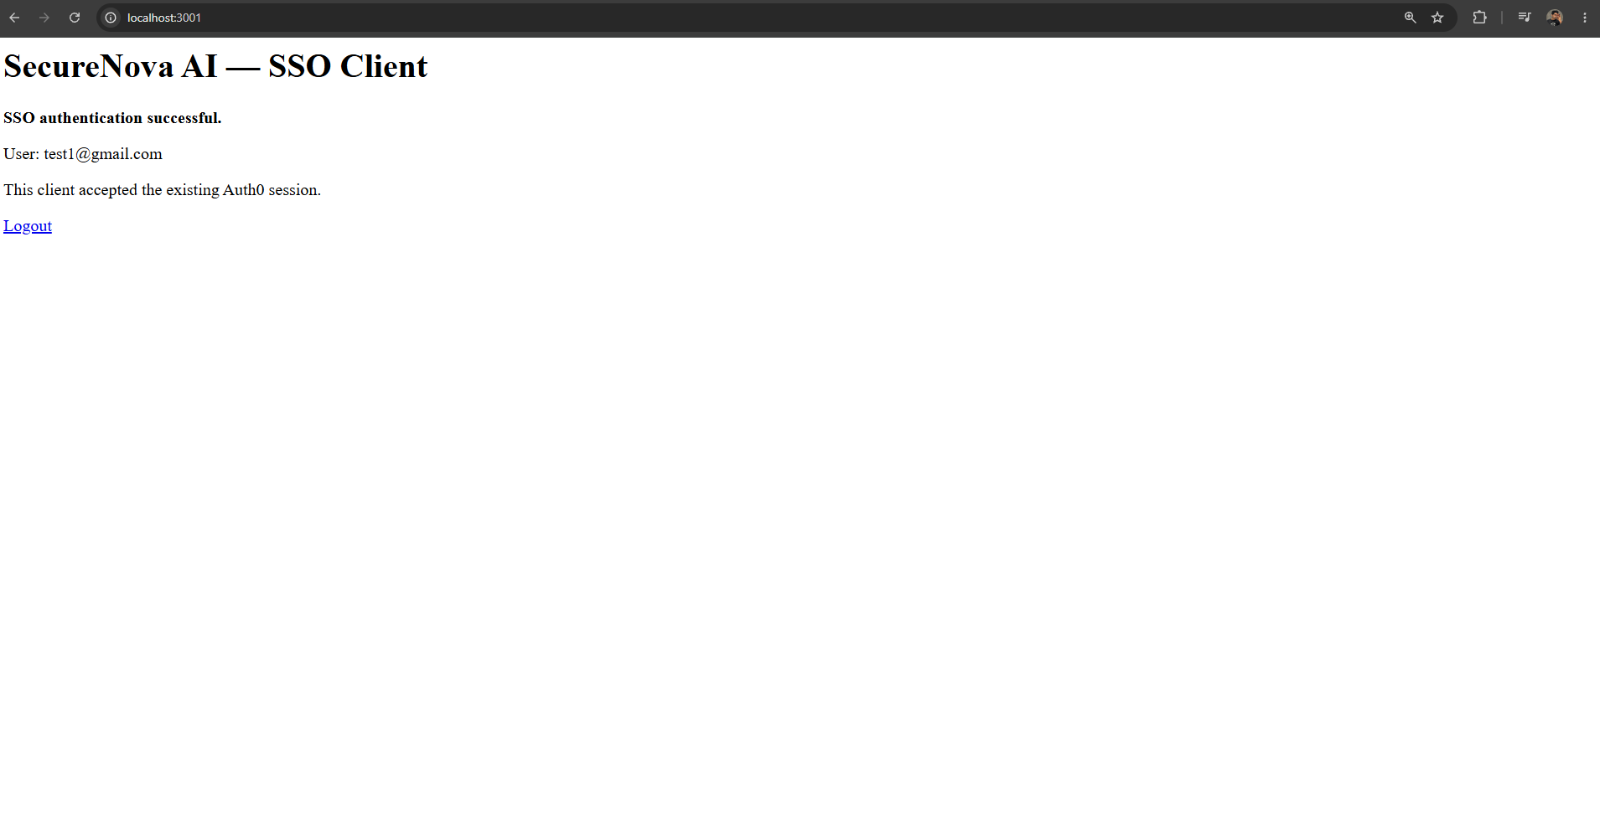
P2-S9 (supplementary) — SSO verification: second client accepted the existing Auth0 session.

4. Project 2 Conclusion
Project 2 produced the requested Auth0-backed security implementation evidence. The supplied outputs demonstrate the tenant applications, API permissions, JWT verification view, branded Universal Login, MFA challenge, post-login agent_id Action, Attack Protection settings, short-lived M2M credential rejection after expiry, and supplementary SSO verification.

