**ARTIFICIAL NEURAL NETWORK**

**MODEL FOR MACHINING OF**

**COMPOSITE MATERIALS**

**NAME :** HIMANSHU LAHARE

**ROLL No.** : 224103414

MTech, Machine Design

1

# Introduction

## Background

Since machining processes are non-linear and time-dependent, it is difficult for classical identification methods to provide accurate models. To address this difficulty, non-classical methods such as artificial neural networks (ANNs) are used. The ANNs are robust models having properties of universal approximation, parallel distributed processing, learning, and adaptive behaviour and can be applied to multivariate systems. ANNs give a kind of implicit relationship between inputs and outputs by learning from a data set representing the behaviour of a system.

In the last years, modelling using artificial neural networks (ANNs) have been extensively used and investigated in machining (Liu and Altintas [1]; Lin and Ting [2]; Das et al. [3]; Choudhury et al. [4]; Briceno et al. [5]; Oktem et al. [6]; Tsai et al. [7]; and Suresh et al. [8], among others), and in other materials processing technologies (Zhecheva et al. [9]; Altinkok and Koker [10]). In particular, the ANNs have been used in machining processes such as milling, turning, and drilling. Liu and Altintas [1] developed a feed-forward neural network algorithm (MLFF N-Network) using cutting speed, feedrate, and measured cutting forces as input parameters to get on-line monitoring of flank wear in turning. Lin and Ting [2] used a back propagation neural network (BPNN) with sample and batch mode, and observed a faster convergence to minimal error in the case of the sample mode.

A literature survey of ANN applications shows that only a small number of works is devoted to orthogonal cutting and all of them are not applied to polymeric composite materials. Modelling of orthogonal cutting of composite materials is implemented in this work. By definition, the cutting is orthogonal when the tool has a position angle of 90 and an inclination angle of 0 , enabling this way a bi-dimensional representation of the plane deformation of the chip as referred by Childs et al. [11].

To explain this phenomenon, the physical-mathematical model of approximation of Merchant has been used to obtain the vector analysis of cutting forces and stresses of the machining process. However, for some applications such as in composite materials machining processes, the Merchant model is not satisfactory. Furthermore some machining parameters assume discrete values, making the use of polynomial approximations inappropriate. The proposed alternative is to use an approximation model based on ANN. The objective of this work is to develop an ANN model based on evolutionary learning, applied to polymeric composite materials machining.

## Problem Definition

In the present work, a set of experimental results in turning of polyetheretherketone (PEEK) composite materials has been obtained considering as process parameters the cutting speed, feedrate, type of insert of the tool, and type of workpiece material. Then, a set of these experimental results is used in the learning algorithm of ANNs to establish the relationship between the referred input parameters and the output machining parameters such as cutting force, feed force, and chip thickness after cutting. The optimal ANN is tested after the learning process using another set of experimental data.

The reason for choosing these parameters is that they are quantities which may easily be measured in the experiment, or derived using simple formulae. Hence, the user should readily be able to predict the life under a different set of experimental conditions from the trained network, without further calculation. A single hidden layer of neurons is used between the input layer and the output layer.

In order to sufficiently train the network arrays of input and output, a considerable number of data pairs is considered. Two materials are used in the experimental procedure: (1)unreinforced polyetheretherketone (PEEK) and (2) reinforced polyetheretherketone with 30(PEEK GF 30) . The orthogonal cutting tests were carried out in extruded workpieces using a polycrystalline (PCD) insert tool and cemented carbide (K20) tool.Then, in the experimental tests, the following values were considered for cutting parameters: cutting speed: 80, 160, 320, 500 [m/min],feedrate: 0.05, 0.10,0.15,0.20,0.30 [mm/rev].

Figure 1 shows the topology of the ANN together with the input and output parameters. Two sigmoid activation functions are used in hidden and output layers. The relative error determined by comparing experimental and numerical results is used to monitor the learning process as an optimization process. The objective is to obtain the completeness of modelling of the machining process.

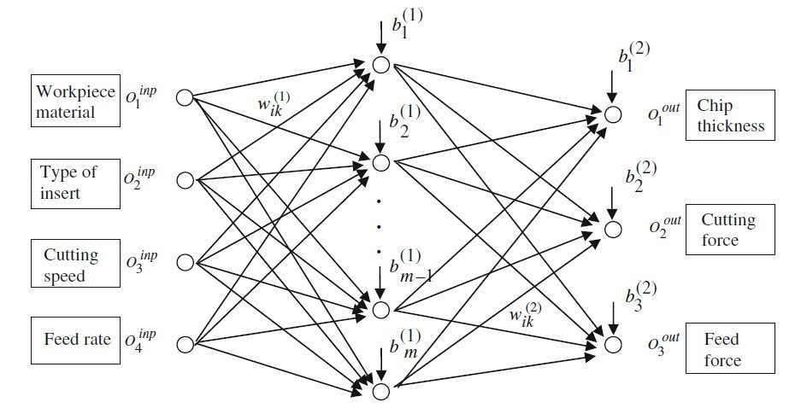

Figure 1: Topology of artificial neural network

# Methodology

## Selection of training and test data

There are total 67 experiments which were conducted for finding the output parameters of the specimen for the above mentioned inputs. Then the data was randomized and the randomized data was split into training and test sets. A typical 80-20 split was used, where 80% of the data was used for training and the rest 20% for testing. This yielded 54 patterns for training and 13 for testing. Then the model was trained for these 54 training patterns.

## Training of network

The training of the ANN model was done using backpropagation algorithm and the weight values between the input layer and hidden layer and the hidden layer and output layer were updated by using the following equation:

*Wij*(*t*) = −*η*∆*Wij*(*t*) + *α*∆*Wij*(*t*− 1)

where *η* is the learning rate which controls how fast the network learns in each iteration and *α* is the momentum coefficient, which is used to avoid local minima and to speed up the learning. Here ‘t’ is the iteration counter, which represents the current iteration.

## Selection of number of hidden neurons

To find the optimum number of hidden neurons, a trial and error procedure was used. The number of hidden neurons (L) was varied from 2 to 8 and the mean squared training error and the mean squared test error was computed for each value of L. The observations for a particular test run of the ANN code yields the following results:

**fixing the number of hidden neurons to 5; the training and testing**

**errors for different learning rates are:**

|  |  |  |
| --- | --- | --- |
| **learning rate** | **training error** | **testing error** |
| 0.2 | 0.00944 | 0.0176 |
| 0.4 | 0.00345 | 0.0038 |
| 0.6 | 0.00279 | 0.0032 |
| 0.8 | 0.00218 | 0.0029 |

**fixing the learning rate to 0.4;the training and testing errors for**

**different number of hidden neurons are:**

|  |  |  |
| --- | --- | --- |
| **Number of hidden neurons** | **training error** | **testing error** |
| 2 | 0.0176 | 0.0224 |
| 3 | 0.0145 | 0.0138 |
| 4 | 0.00449 | 0.0082 |
| 5 | 0.00378 | 0.0064 |

# Result

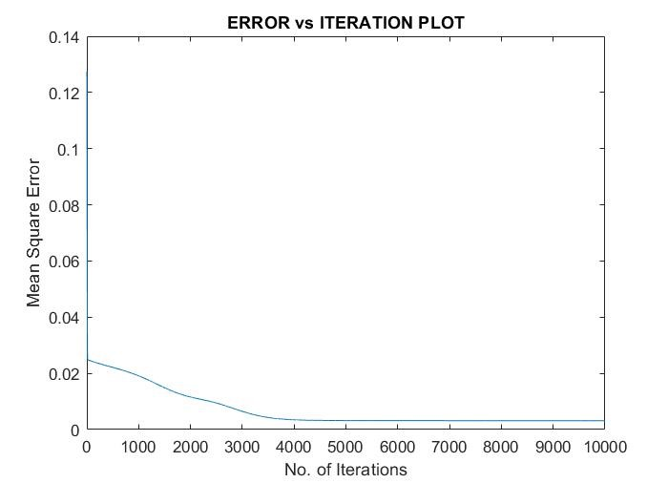

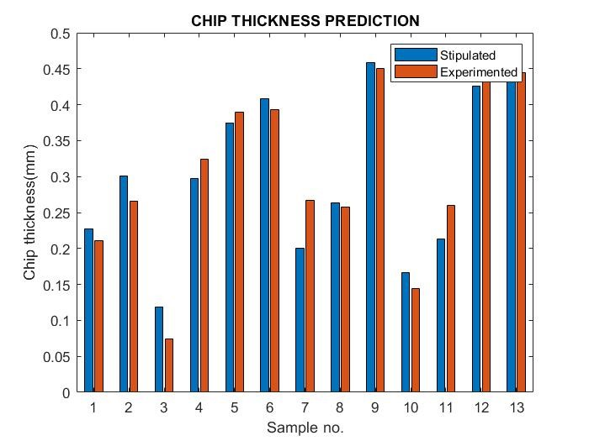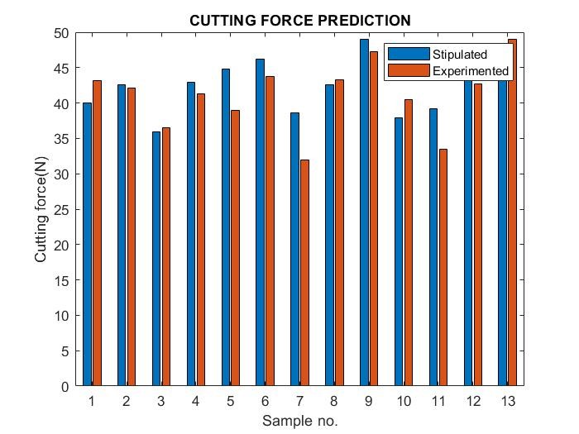

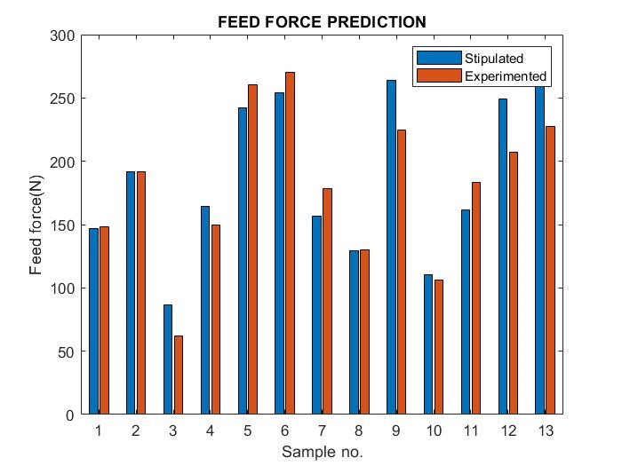

# Conclusion

In this paper, an artificial neural network (ANN) aiming for the efficient modelling of a set of machining conditions in orthogonal cutting of PEEK composite materials is presented. The proposed ANN is based on input, hidden, and output layers. The input parameters are cutting speed, feedrate, type of insert of the tool, and type of workpiece material. The output parameters are cutting force, feed force, and the chip thickness after cutting. Two sigmoid functions in hidden and output layers are used.. The mean relative error between experimental and numerical results was used to monitor the learning process.

To illustrate the computational methodology, a set of experimental results is considered and the numerical results obtained from supervised learning are presented. Then, using a different set of experimental results, the obtained solution for ANN is tested aiming to demonstrate the performance of the learning process.