DSA NOTES OF CODE WITH HARRY

INDEX
VIDEO:01 INTRO 3
Runtime complexity diagram. 3
VIDEO:02 ASYMPTOTIC NOTATIOIN 3
BIG-OH 3
BIG-Ω 4
BIG-θ 4
VIDEO:05 HOW TO CALCULATE RUNTIME COMPLEXITY OF CODE/PROGRAM 4

VIDEO:01 INTRO

Runtime complexity diagram.
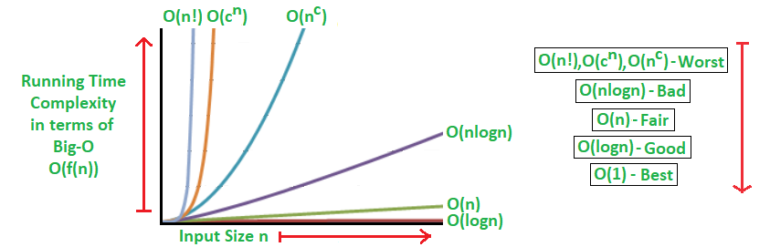

- We convert constant time into “1”
  - Algo 1 = 33
in this equation, we consider 33 as 1, because it’s taking constant time.
  - O(1)
- We took highest order term of the polynomia/equation.
  - Algo 1 = k₁n² + k₂n + k₃
in this equation, we will took k1n2 termp only, and remove constant term.
  - O(n²)
________________________________________________________________________________

VIDEO:02 ASYMPTOTIC NOTATIOIN

BIG-OH
- An algorithm with a running time of f(n) is equivalent to O(g(n)) if and only if there are constants c and n0 such that the below expression is satisfied.

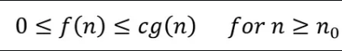

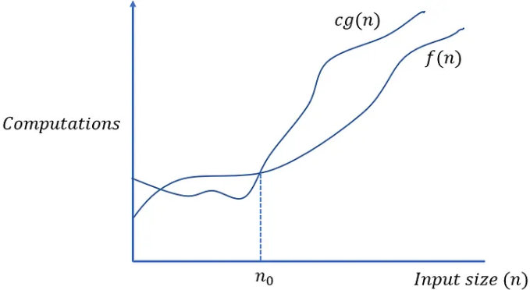

BIG-Ω
- An algorithm with a running time of f(n) is equivalent to Ω(g(n)) if and only if there are constants c and n0 such that the below expression is satisfied.

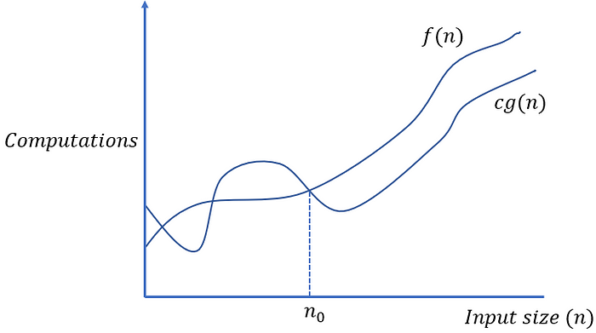

BIG-θ
- Big-Theta notation is described mathematically as follows (a combination of the previous notations).

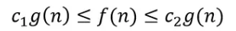

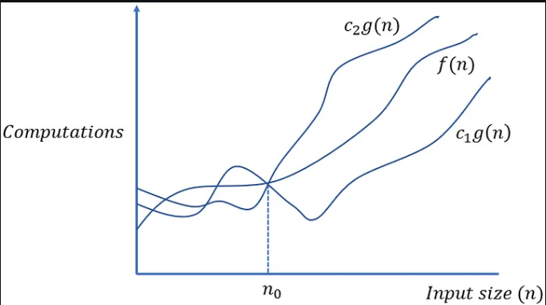

26/08/24

VIDEO:05 HOW TO CALCULATE RUNTIME COMPLEXITY OF CODE/PROGRAM
- Remove None dominating term.
- Remove constant term.
- Breake the code into fregments.
  - For example
    - time = k₂n + k₃
    - so the ans is
      - O(n)

28/08/24

VIDEO:06 ARRAY AND ABSTRACT DATA TYPE

What is ADT (abtract data type)?
- Abstract Data type (ADT) is a type (or class) for objects whose behavior is defined by a set of values and a set of operations. The definition of ADT only mentions what operations are to be performed but not how these operations will be implemented. It does not specify how data will be organized in memory and what algorithms will be used for implementing the operations. It is called “abstract” because it gives an implementation-independent view.
- The process of providing only the essentials and hiding the details is known as abstraction.

