PREDICTIVE ANALYTICS
PROJECT REPORT
(Project Semester August–December 2026)

Video Game Sales Analysis and Prediction Using Python and Machine Learning

Submitted by

Himanshu Singh
Registration No. 12411444
Programme and Section: B.Tech (Computer Science & Engineering), Section K2P24NK
Course Code: INT234

Under the Guidance of

Dr. Mrinalini Rana (U.Id: 22138)

Discipline of CSE/IT

Lovely School of Computer Science and Engineering

Lovely Professional University, Phagwara

DECLARATION
I, Himanshu Singh, student of B.Tech (Computer Science & Engineering) under CSE/IT Discipline at Lovely Professional University, Punjab, hereby declare that all the information furnished in this project report is based on my own intensive work and is genuine.
The project titled “Video Game Sales Analysis and Prediction Using Python and Machine Learning” has been carried out using the publicly available Video Games Sales (1980–2024) dataset. All external tools, libraries and references used in the work have been duly acknowledged.

Date: 31 / 10 / 2026

Registration No. 12411444
Name of the student: Himanshu Singh
Signature: ____________________
CERTIFICATE
This is to certify that Himanshu Singh bearing Registration no. 12411444 has completed INT234 project titled, “Video Game Sales Analysis and Prediction Using Python and Machine Learning” under my guidance and supervision. To the best of my knowledge, the present work is the result of his original development, effort and study.

Signature and Name of the Supervisor: Dr. Mrinalini Rana (U.Id: 22138)
Designation of the Supervisor
School of Computer Science and Engineering
Lovely Professional University
Phagwara, Punjab.
Date: 31 / 10 / 2026
ACKNOWLEDGEMENT
I would like to express my sincere gratitude to my faculty coordinator, Dr. Mrinalini Rana, for the continuous guidance, constructive feedback and encouragement provided throughout this project. Their suggestions on structuring the analysis, validating the results and presenting the findings helped me improve the quality of this work.
I am thankful to the Lovely School of Computer Science and Engineering and Lovely Professional University, Phagwara, for providing the academic environment, learning resources and computing facilities required to complete this project.
I also acknowledge the open-source community behind Python, pandas, NumPy, Matplotlib, Seaborn and scikit-learn, whose well-documented libraries made the data cleaning, visualization and machine learning workflow possible, and the creators of the publicly available Video Games Sales (1980–2024) dataset for making the data accessible for learning and research.
Finally, I thank my family and friends for their motivation and support during the course of this work.

Himanshu Singh
Registration No. 12411444
TABLE OF CONTENTS
1. Introduction 1
1.1 Background 1
1.2 Problem Statement 1
1.3 Objectives 1
1.4 Scope of the Project 2
1.5 Tools and Technologies 3
1.6 Methodology Overview 3
1.7 Organisation of the Report 3
2. Source of Dataset 5
2.1 Origin of the Data 5
2.2 Description of Attributes 6
2.3 Coverage and Characteristics 6
2.4 Regional Definitions 6
2.5 Limitations of the Source 7
2.6 Files Used and Generated 7
3. EDA Process 8
3.1 Loading and Initial Inspection 8
3.2 Missing Values and Duplicates 9
3.3 Data Cleaning Steps 11
3.4 Feature Engineering 13
3.5 First Descriptive Insights 13
3.6 Data-Quality Observations 15
4. Analysis on Dataset 16
4.1 Analysis 1: Distribution of Games by Genre 16
4.2 Analysis 2: Recorded Sales by Region 18
4.3 Analysis 3: Average Sales by Genre 19
4.4 Analysis 4: Release Trends by Year and Decade 21
4.5 Analysis 5: Critic Score and Sales 22
4.6 Analysis 6: Average Sales by Platform 24
4.7 Analysis 7: Distribution of Total Sales 26
4.8 Analysis 8: Correlation Between Regional Sales 28
4.9 Analysis 9: Classifying High-Selling and Low-Selling Games with Machine Learning 29
5. Conclusion 34
5.1 Summary of the Work 34
5.2 Key Findings 34
5.3 Recommendations 35
5.4 Limitations 35
5.5 Project Deliverables and Public Availability 36
5.6 Learning Outcomes 37
6. Future Scope 38
7. References 39

LIST OF FIGURES
Figure 1: Overall methodology of the project 3
Figure 2: Output of df.info() and df.head() for the raw dataset 8
Figure 3: Last five records and summary statistics of numeric columns 9
Figure 4: Summary statistics including text columns 9
Figure 5: Missing values before cleaning, duplicate count and shape after cleaning 10
Figure 6: Missing values and summary statistics after cleaning 12
Figure 7: Percentage of missing values per column after cleaning 12
Figure 8: Most common genres and platforms in the cleaned dataset 13
Figure 9: Top 10 games by sales and classification model output 14
Figure 10: Top 10 genres by number of games 17
Figure 11: Recorded sales by region 19
Figure 12: Top 10 genres by average sales 20
Figure 13: Number of games released by year 22
Figure 14: Games released by decade 22
Figure 15: Critic score and total sales (symlog scale) 24
Figure 16: Average sales by critic score category 24
Figure 17: Top 10 platforms by average sales 26
Figure 18: Distribution of recorded total sales 27
Figure 19: Correlation between regional sales 29
Figure 20: Decision Tree classifier (first three levels of the tree) 33
Figure 21: Random Forest feature importance (top 20 features) 33
Figure 22: GitHub repository of the project (Preditive_Analysis_CA2) 36
Figure 23: Commit activity of the repository (GitHub Insights) 37
Figure 24: LinkedIn post summarising the project 37

LIST OF TABLES
Table 1: Tools and libraries used in the project 3
Table 2: Attributes of the raw dataset (64,016 records) 6
Table 3: Data files used and produced by the project 7
Table 4: Missing values in the raw dataset 10
Table 5: Data cleaning operations applied to the raw dataset 11
Table 6: Engineered features 13
Table 7: Top 10 records by recorded total sales (millions of units) 14
Table 8: Ten most frequent genres 17
Table 9: Recorded sales by region (millions of units) 18
Table 10: Top 10 genres by average total sales (games with recorded sales only) 20
Table 11: Games released by decade 21
Table 12: Sales by critic-score category (games with both values) 23
Table 13: Top 10 platforms by average total sales 25
Table 14: Descriptive statistics of total sales (millions of units, n = 18,922) 27
Table 15: Pearson correlation matrix of regional sales 28
Table 16: Classification models and hyper-parameters 30
Table 17: Classification performance on the test set (sorted by macro F1) 31
Table 18: Confusion matrix of the Random Forest classifier on the test set 32

1. Introduction

1.1 Background
The global video game industry has grown from a niche pastime in the early 1980s into one of the largest entertainment sectors in the world. Hardware generations from the Atari 2600 and Nintendo Entertainment System (NES) to the PlayStation 5 and Nintendo Switch have repeatedly changed how games are built, distributed and consumed. For publishers, developers and analysts, understanding which genres, platforms and release strategies are associated with commercial success is a data-driven question that can influence budgeting, marketing and release planning.
Data science provides a systematic way of answering such questions. By combining data cleaning, exploratory data analysis (EDA), visualization and predictive modelling, large collections of historical sales records can be converted into evidence about market behaviour. This project applies that workflow to a dataset of 64,016 video game records released between 1980 and 2024, using the Python data-science ecosystem.

1.2 Problem Statement
Public video-game sales data is large but incomplete and noisy. Sales figures are missing for most titles, critic scores are available for only a small fraction of games, regional columns are sparsely populated and several categorical fields are inconsistent. The problem addressed in this project is two-fold:
- to clean, validate and explore the raw dataset so that reliable insights about genres, platforms, regions, release trends and critic reception can be drawn; and
- to classify games as high-selling or low-selling (total sales above or below the median of 0.12 million units) from a small set of descriptive features—critic score, release year, platform and genre—and to compare several classification algorithms on a held-out test set.

1.3 Objectives
- To load, inspect and profile the raw Video Games Sales (1980–2024) dataset and quantify its data-quality issues.
- To clean the dataset: standardise text, parse dates, validate numeric ranges and handle missing values and duplicates in a transparent, documented way.
- To engineer additional features such as release year, release decade, critic-score category, regional sales sum and North American sales share.
- To perform exploratory analysis and produce ten publication-quality visualizations covering genres, regions, platforms, release trends, critic score and sales distribution.
- To build a reusable scikit-learn preprocessing pipeline and compare Logistic Regression, K-Nearest Neighbours (KNN), Decision Tree and Random Forest classifiers using accuracy, precision, recall, macro F1 and the confusion matrix.
- To discuss the limitations imposed by missing data and to suggest improvements for future work.
Within these objectives, five dataset-specific questions are investigated in Chapter 4:
- Question 1 (Analysis 1): Which genres have the largest number of games?
- Question 2 (Analysis 2): Which region contributes most to recorded sales?
- Question 3 (Analyses 3 and 6): Which genres and platforms achieve the highest average sales per game?
- Question 4 (Analysis 4): How has the number of game releases changed over the years and decades?
- Question 5 (Analysis 5): Are higher critic scores associated with higher sales?
In addition, Analysis 7 studies the distribution of total sales, Analysis 8 the correlation between regional markets and Analysis 9 the classification of games into high-selling and low-selling titles with four machine-learning models.

1.4 Scope of the Project
The project covers the complete analytical life cycle on a single tabular dataset: data acquisition, cleaning, feature engineering, EDA, visualization, supervised classification modelling and interpretation. It is an academic project: models are trained on a single random train/test split with fixed hyper-parameters, and the results are intended to demonstrate methodology and to give a realistic baseline rather than a production forecasting system. Deployment, text mining of titles and time-series forecasting are outside the present scope and are listed under future scope (Chapter 6).

1.5 Tools and Technologies
The entire work is implemented in Python. Table 1 summarises the tools used and their role in the project.
Table 1: Tools and libraries used in the project
Tool / Library | Purpose in this project
Python 3 | Programming language for the complete workflow
pandas | Data loading, cleaning, date parsing, grouping, aggregation and CSV export
NumPy | Numerical operations, handling of missing values (NaN) and the median sales threshold
Matplotlib | Creation and export of figures (bar, line, scatter and histogram plots)
Seaborn | Statistical plots, colour palettes, histogram with KDE and correlation heat map
scikit-learn | Imputation, scaling, one-hot encoding, pipelines, train/test split, classifiers and metrics
Jupyter Notebook / VS Code | Interactive development and execution of the analysis
Git and GitHub | Version control and public hosting of code, data and figures

1.6 Methodology Overview
The work follows the standard data-science pipeline shown in Figure 1. The raw dataset is first profiled and cleaned; new features are derived; exploratory analysis is performed with ten visualizations; and finally the cleaned data is passed through a preprocessing pipeline into four classification models whose performance is compared on unseen data.
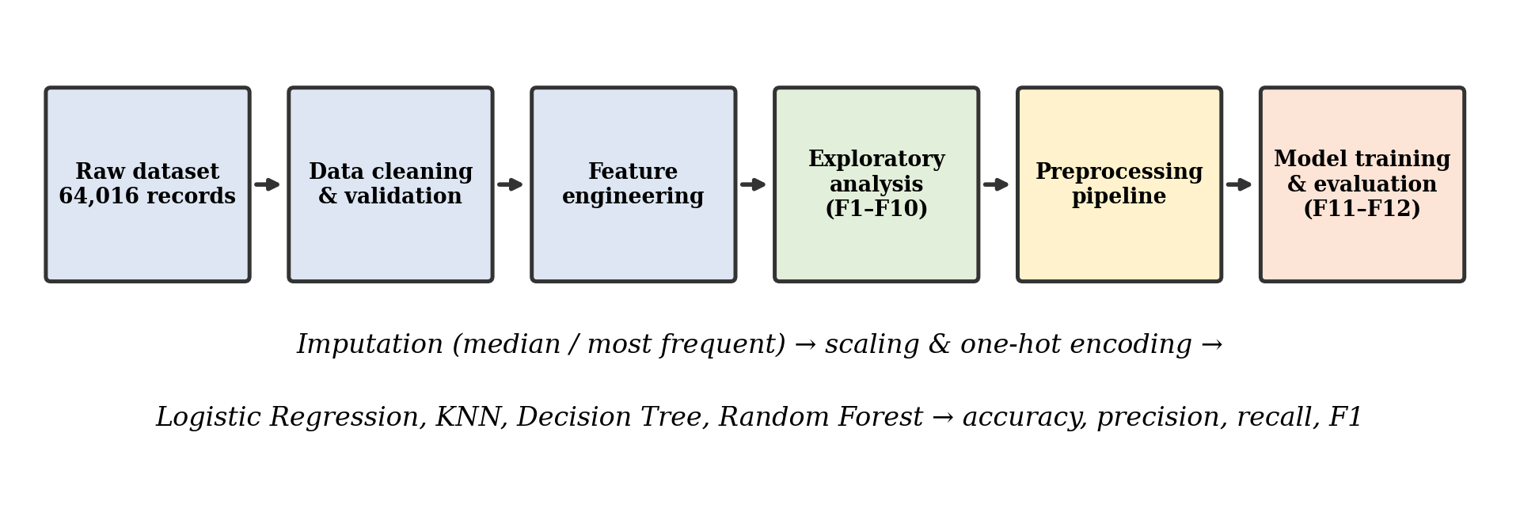
Figure 1: Overall methodology of the project

1.7 Organisation of the Report
Chapter 2 describes the source and structure of the dataset. Chapter 3 documents the EDA and cleaning process. Chapter 4 presents nine individual analyses, each with an introduction, general description, specific requirements/functions/formulas, results and visualization. Chapter 5 concludes the work, Chapter 6 outlines future scope and Chapter 7 lists the references.

2. Source of Dataset

2.1 Origin of the Data
The data used in this project is the publicly available Video Games Sales (1980–2024) dataset, obtained as a CSV file (Video Games Sales (1980-2024) - Raw.csv). The structure of the file—box-art image paths of the form /games/boxart/…, the PAL region and a last_update field—indicates that it is a compiled snapshot of online video-game sales tracking data in which sales are expressed in millions of units. The dataset was obtained from Kaggle, where it is available as an input file of the public notebook Video Games Sales EDA (https://www.kaggle.com/code/bhushandivekar/video-games-sales-eda). The sales figures follow the structure of VGChartz-based Kaggle video-game sales data (for example the Kaggle dataset Video Game Sales 2024 by asaniczka). In this project the file is stored locally as Video Games Sales (1980-2024) - Raw.csv and was downloaded on 28 / 10 / 2026 (see Reference [12]).
The raw file contains 64,016 rows and 14 columns, with about 6.8 MB of memory usage once loaded into pandas. Each row represents one game released on one platform; the same title can therefore appear several times (for example, Grand Theft Auto V appears separately for PS3, PS4 and Xbox 360).

2.2 Description of Attributes
Table 2 lists every attribute of the raw dataset with its data type and the number of non-null values reported by df.info() (Figure 2 in Chapter 3).
Table 2: Attributes of the raw dataset (64,016 records)
Column | Type | Non-null | Description
img | text | 64,016 | Relative path of the game’s box-art image
title | text | 64,016 | Name of the game
console | text | 64,016 | Platform on which the game was released (81 distinct values)
genre | text | 64,016 | Genre of the game (20 distinct values)
publisher | text | 64,016 | Publishing company
developer | text | 63,999 | Development studio (17 missing)
critic_score | float | 6,678 | Average critic review score on a 1–10 scale
total_sales | float | 18,922 | Worldwide sales in millions of units
na_sales | float | 12,637 | Sales in North America (millions)
jp_sales | float | 6,726 | Sales in Japan (millions)
pal_sales | float | 12,824 | Sales in PAL regions – Europe, Africa, Australia (millions)
other_sales | float | 15,128 | Sales in the rest of the world (millions)
release_date | text | 56,965 | Release date in DD-MM-YYYY format
last_update | text | 17,879 | Date on which the record was last updated

2.3 Coverage and Characteristics
- Time span: release dates in the cleaned data range from 1980 to 2024, with a median release year of 2008 and a mean of about 2006. The raw file also contains 67 records dated before 1980 (the earliest in 1971); these were set to missing during cleaning (Section 3.3).
- Diversity: 39,798 unique titles, 81 platforms, 20 genres and 3,383 distinct publisher values (including the placeholder “Unknown”).
- Most frequent platforms: PC (12,617 records), PS2 (3,565), DS (3,288), PS4 (2,878) and PS (2,707).
- Sparse numeric fields: only 29.6% of the records have a recorded total sales value and only 10.4% have a critic score.

2.4 Regional Definitions
Sales are split into four regional columns. na_sales covers North America (United States and Canada), jp_sales covers Japan, pal_sales covers the PAL territories (mainly Europe and Australia) and other_sales covers all remaining markets. For a record where all four regional values are present, the total should equal their sum, a relationship that is used later in the cleaning step and in the correlation analysis.

2.5 Limitations of the Source
- Sales figures are estimates compiled by VGChartz from public tracking, not audited publisher accounts, and digital-only sales are often under-represented.
- Sales and critic scores are missing for the majority of records, so any analysis of sales is restricted to a minority subset of games that are likely to be better known and more commercially successful.
- Regional columns are filled for different subsets of games (for example only 6,726 records have Japan sales), which makes totals across regions not strictly comparable.
- The genre field contains broad catch-all categories such as “Misc”, and 8,842 records have an unknown publisher.

2.6 Files Used and Generated
Besides the raw input, the project script generates cleaned and feature-enriched versions of the data, twelve figures, a classification-results table and confusion matrices, as listed in Table 3.
Table 3: Data files used and produced by the project
File | Description
Video Games Sales (1980-2024) - Raw.csv | Original dataset (64,016 × 14)
Video_Games_Sales_Cleaned.csv | Cleaned dataset after text, date and numeric validation
Video_Games_Sales_Featured.csv | Cleaned dataset with five engineered features (64,016 × 19)
Classification_Model_Evaluation_Results.csv | Accuracy, macro precision, recall and F1 of the four classifiers
*_Confusion_Matrix.csv | Confusion matrix of each of the four classifiers (four files)
F1 – F12 (.png) | Twelve visualizations (ten exploratory charts, a decision-tree plot and a feature-importance chart) exported at 300 dpi
Project.py / Video_Games_Notebook.ipynb | Complete Python script and notebook of the analysis

3. EDA Process
Exploratory data analysis was carried out in a fixed order: inspect the structure, quantify missing values and duplicates, clean and validate each column type, engineer features and finally summarise the cleaned data. Every step is implemented in Project.py and its console output is reproduced below.

3.1 Loading and Initial Inspection
The dataset was read with pd.read_csv(). The methods df.info(), df.head(), df.tail(), df.describe() and df.describe(include="all") were used to understand the structure. Figure 2 shows that the file has 64,016 entries and 14 columns of type float64 (6) and text (8), and displays the first five rows.
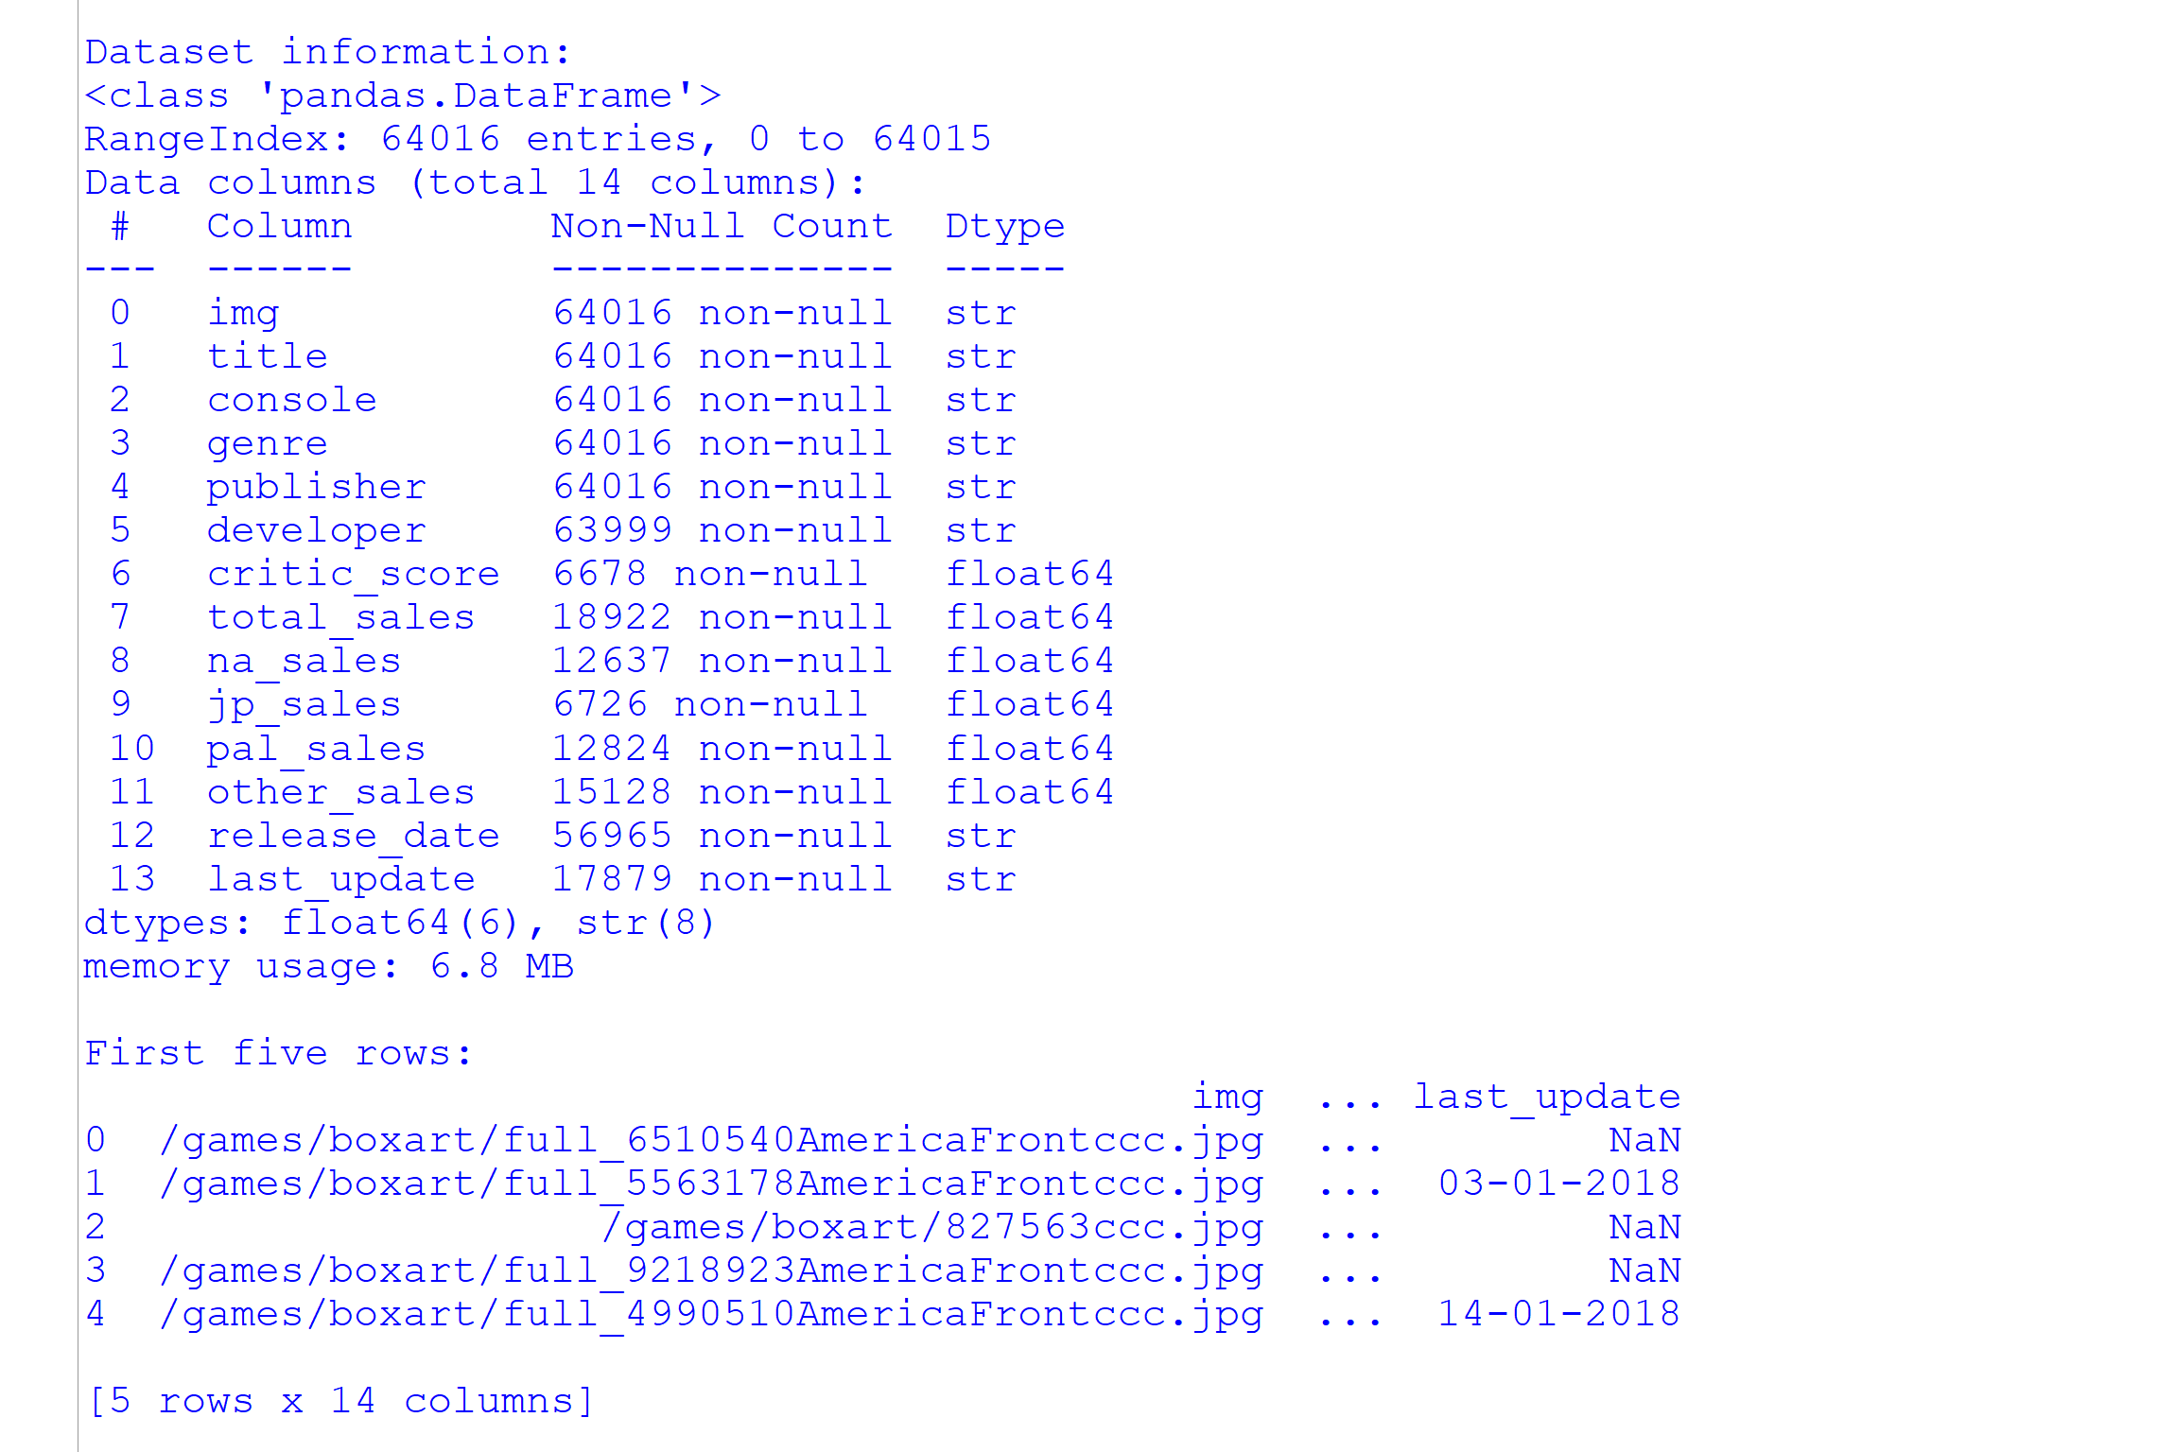
Figure 2: Output of df.info() and df.head() for the raw dataset
The last five records and the numeric summary are shown in Figure 3. Among the 18,922 games with sales, the mean total sales is 0.349 million units but the maximum is 20.32 million, a first sign of a heavily right-skewed distribution. Critic scores (6,678 values) average 7.22 with a standard deviation of 1.46 and span the full 1–10 range.
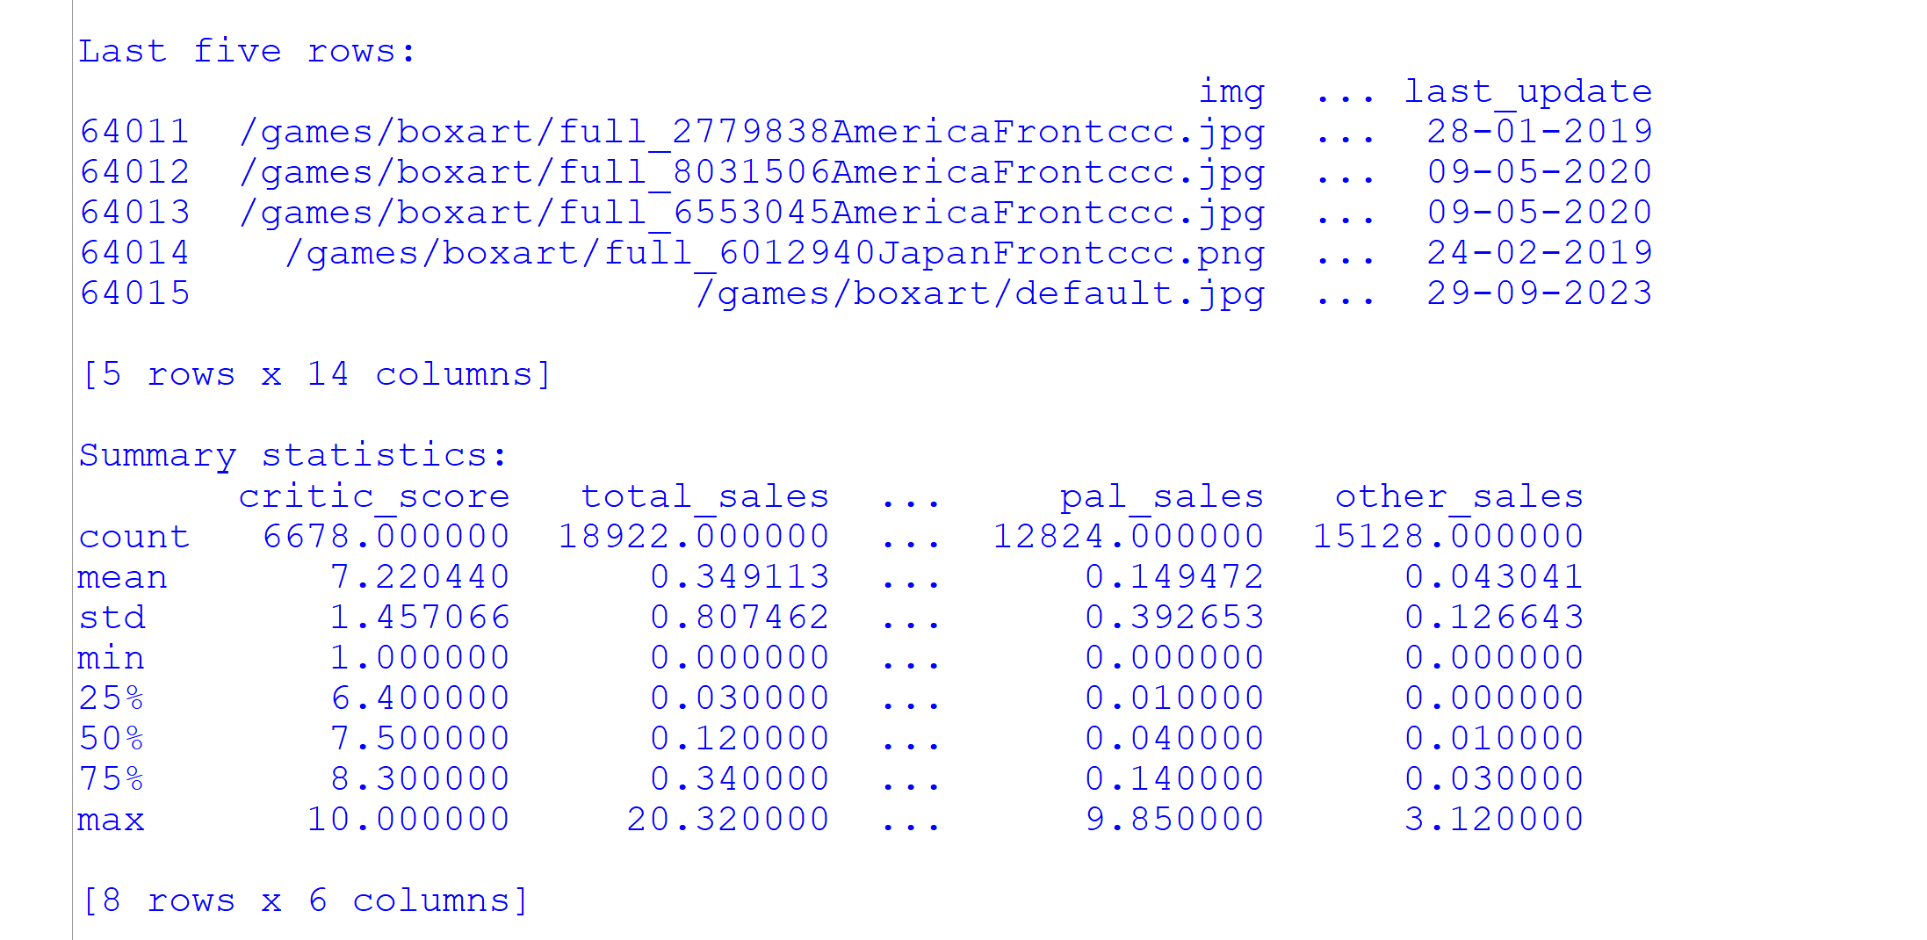
Figure 3: Last five records and summary statistics of numeric columns
Including text columns in the summary (Figure 4) shows that the most common image path is the placeholder /games/boxart/default.jpg, used by 7,810 records, and that the last_update field contains 1,545 unique dates with 06-01-2018 occurring most often (165 times).
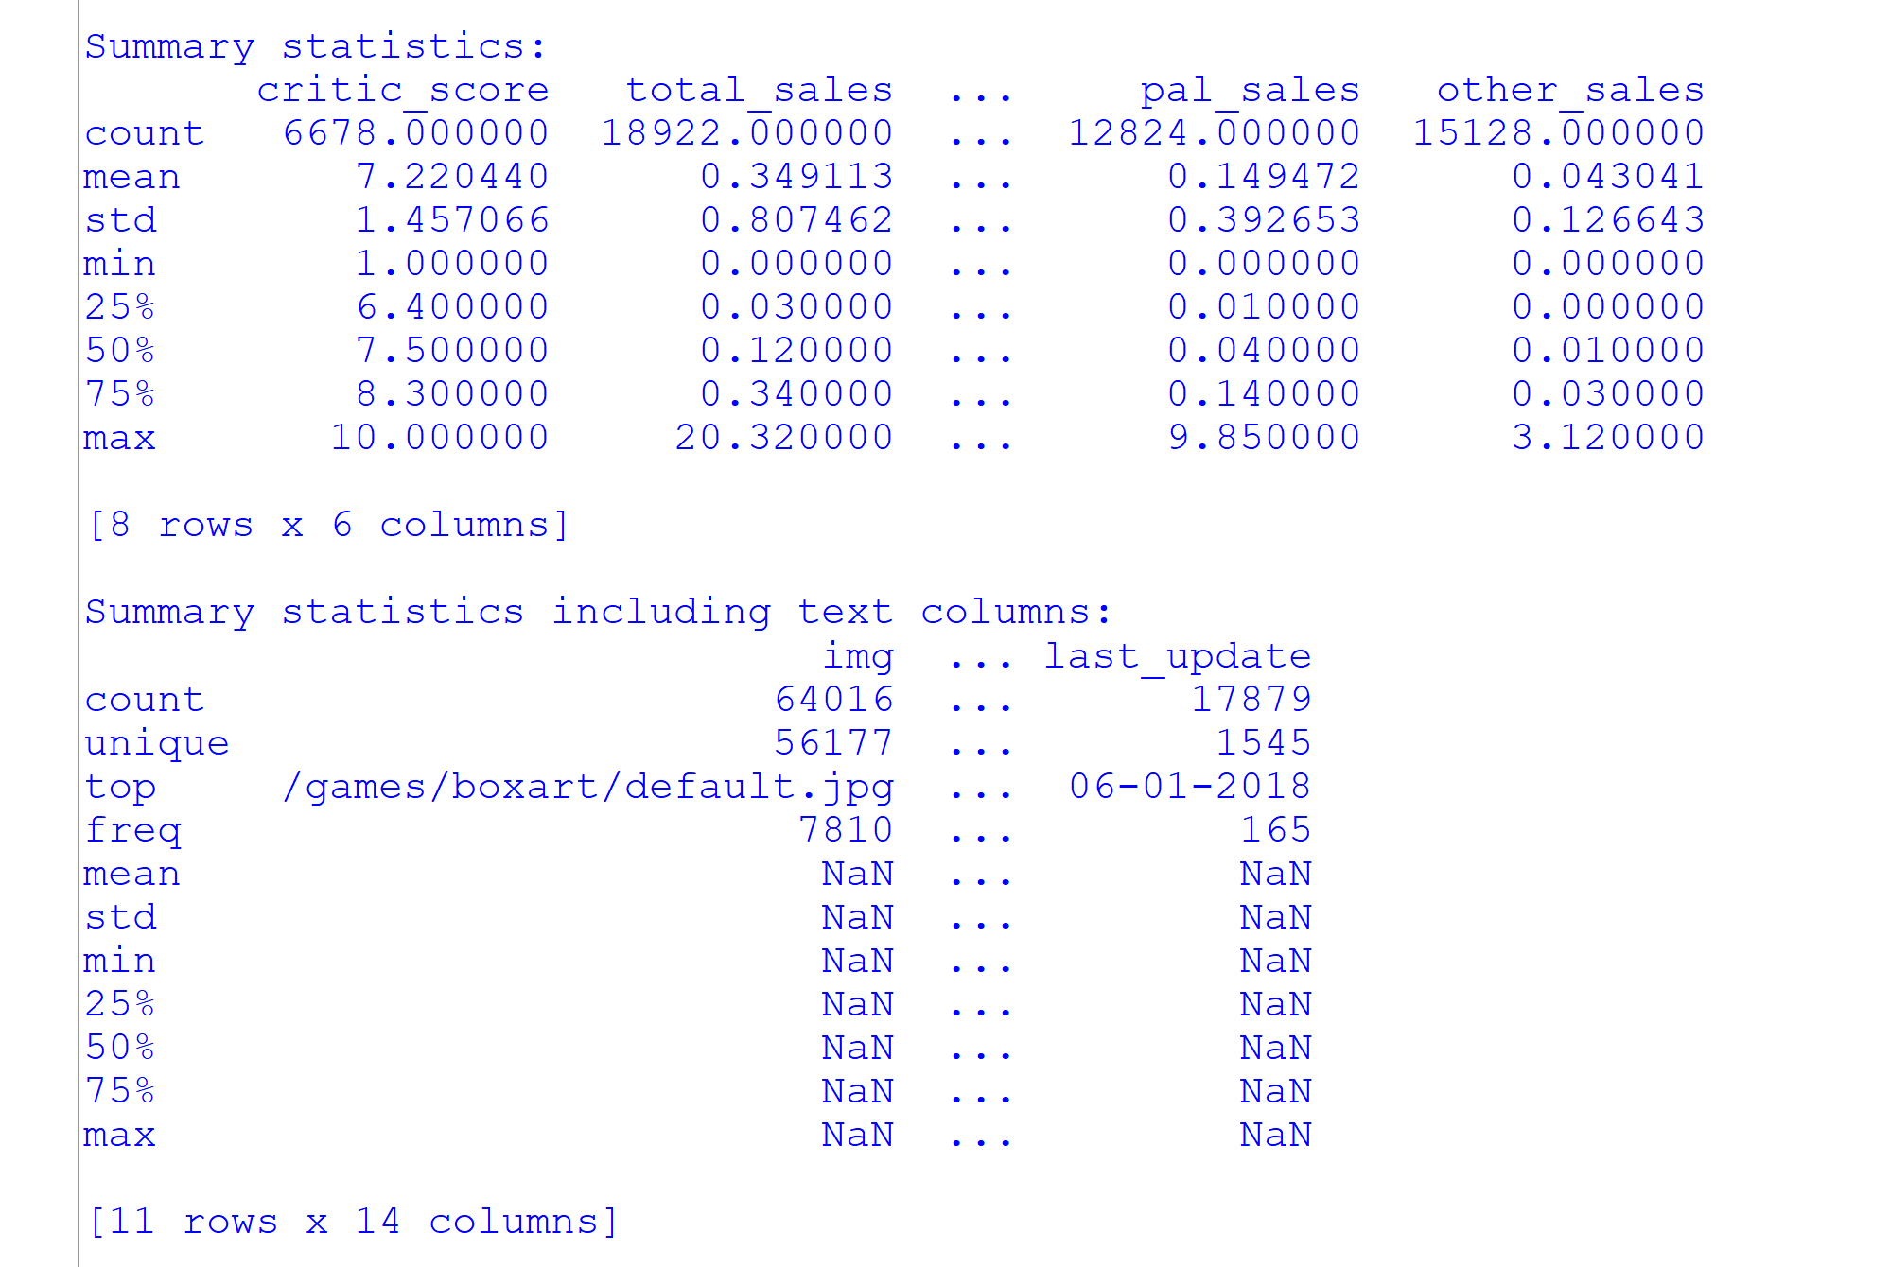
Figure 4: Summary statistics including text columns

3.2 Missing Values and Duplicates
Counting missing values with df.isna().sum() shows that the dataset is dominated by gaps in the numeric columns (Figure 5, Table 4). Text columns are almost complete: only 17 developer values are missing. In contrast, critic scores are missing in 89.57% of the rows and total sales in 70.44%. The regional columns are even sparser, with Japan missing for 89.49% of records. The check df.duplicated().sum() returned 0 exact duplicate rows.
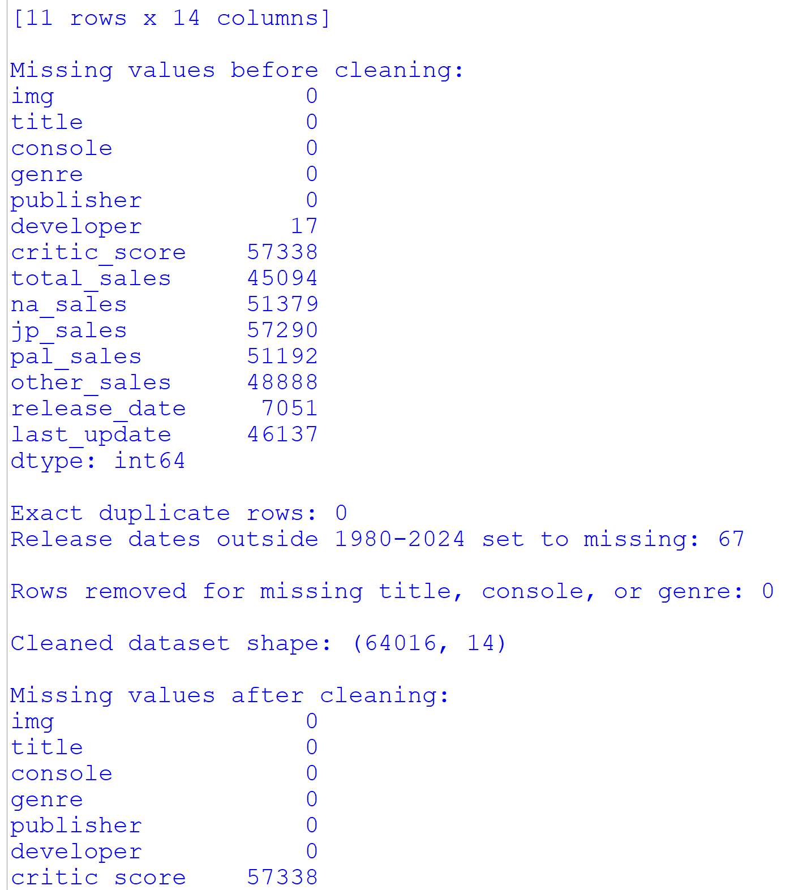
Figure 5: Missing values before cleaning, duplicate count and shape after cleaning
Table 4: Missing values in the raw dataset
Column | Missing | Missing (%) | Column | Missing | Missing (%)
img / title / console / genre / publisher | 0 | 0.00 | jp_sales | 57,290 | 89.49
developer | 17 | 0.03 | pal_sales | 51,192 | 79.97
critic_score | 57,338 | 89.57 | other_sales | 48,888 | 76.37
total_sales | 45,094 | 70.44 | release_date | 7,051 | 11.01
na_sales | 51,379 | 80.26 | last_update | 46,137 | 72.07

Because most missing values are structural (a score or a sales estimate simply was never recorded for that game), deleting all incomplete rows would discard almost the entire dataset. The cleaning strategy therefore keeps rows wherever possible, marks gaps explicitly, and handles missing values only at the stage where a specific analysis or model needs them.

3.3 Data Cleaning Steps
The cleaning operations, their implementation and the reasoning behind each are summarised in Table 5.
Table 5: Data cleaning operations applied to the raw dataset
Step | Implementation | Reason / outcome
1. Text standardisation | astype("string"), str.strip(); empty strings replaced with missing | Removes stray whitespace and prevents the same category being counted twice
2. Unknown publisher/developer | fillna("Unknown") | Keeps 17 developer gaps (and publisher gaps) as an explicit category instead of NaN; 8,842 records have publisher “Unknown”
3. Date parsing | pd.to_datetime(format="%d-%m-%Y", errors="coerce") | Converts release_date and last_update to datetime; no value failed to parse
4. Date range check | Release years outside 1980–2024 set to NaT | 67 invalid release dates were set to missing
5. Numeric coercion | pd.to_numeric(errors="coerce") | Guarantees numeric type for scores and sales
6. Negative sales | Values < 0 set to NaN | No negative sales were found
7. Critic score range | Scores < 1 or > 10 set to NaN | No out-of-range scores were found
8. Total sales recovery | If total is missing and all four regions exist, total = sum of regions | No such row existed, confirming internal consistency
9. Duplicates & key fields | drop_duplicates(); dropna(subset=[title, console, genre]) | 0 duplicate rows and 0 rows with missing key fields were removed

The cleaned dataset has the same shape as the raw data, (64,016, 14), because no row needed to be removed. The data was already structurally sound; the main cleaning effort was therefore standardising types and documenting gaps rather than deleting records. Figure 6 shows the missing-value counts and summary statistics after cleaning: the developer column now has zero missing values, while the release_date column has 7,118 missing values (7,051 original plus the 67 invalid dates). Figure 7 visualises the share of missing values in every column.
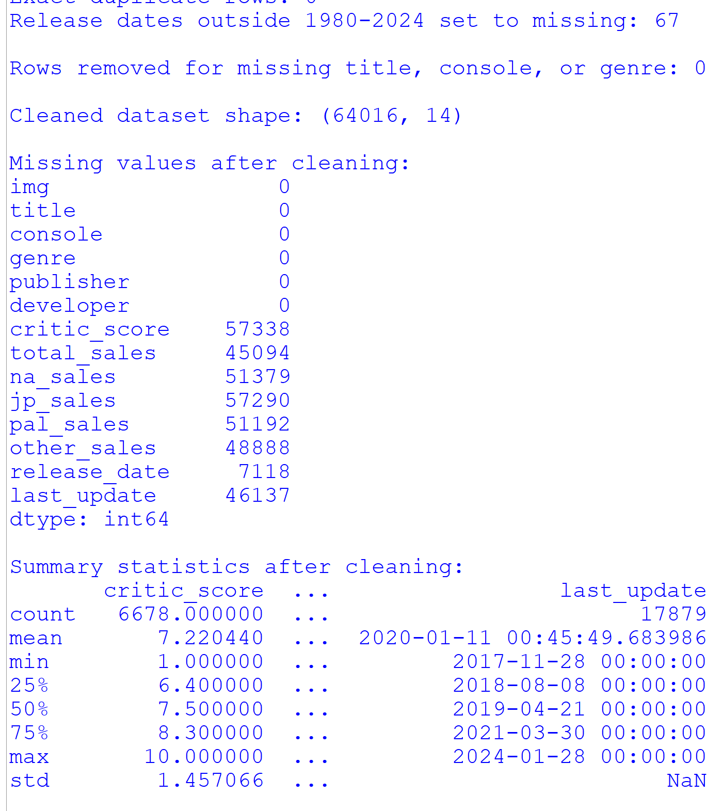
Figure 6: Missing values and summary statistics after cleaning
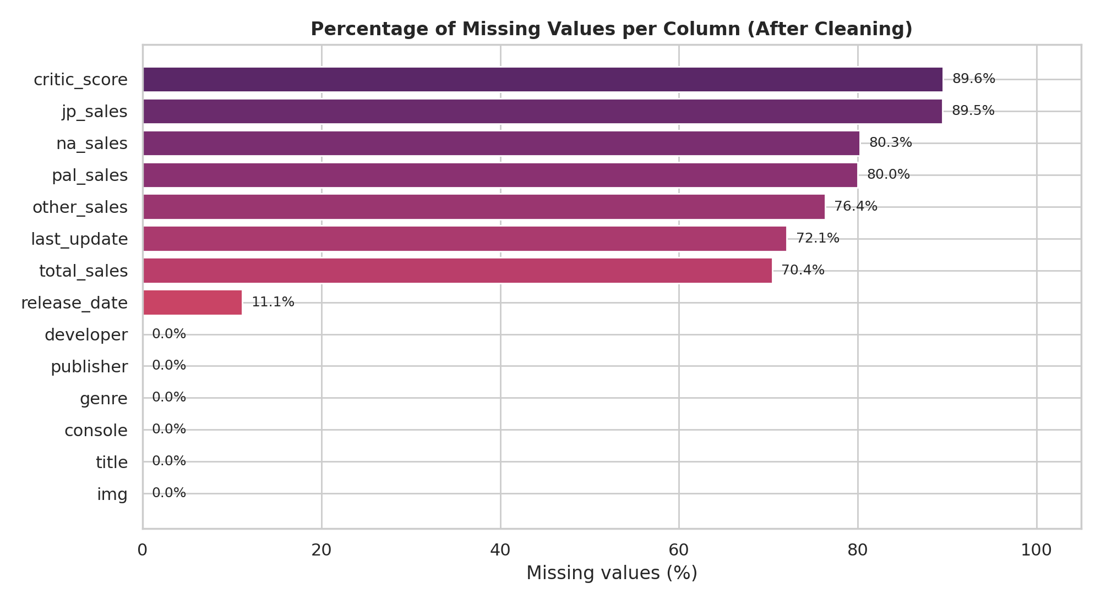
Figure 7: Percentage of missing values per column after cleaning

3.4 Feature Engineering
Five new columns were derived from the cleaned data. They enrich the analysis and are saved in Video_Games_Sales_Featured.csv, which therefore has 19 columns.
Table 6: Engineered features
Feature | Derivation | Purpose
release_year | release_date.dt.year | Time-trend analysis and a model input
release_decade | (release_year // 10) × 10 | Grouping releases into 1980s … 2020s
critic_score_category | pd.cut(critic_score, [0, 4, 7, 10]) → Low / Average / High | Compare sales across review-quality groups
regional_sales_sum | Row-wise sum of the four regional columns (min_count = 1) | Consistency check of totals
na_sales_share | na_sales / regional_sales_sum | Share of a game’s sales that comes from North America (mean ≈ 0.65 where available)

3.5 First Descriptive Insights
Frequency counts of genres and platforms were produced before any plotting (Figure 8). “Misc” (9,304), Action (8,557) and Adventure (6,260) are the most frequent genres, while PC dominates the platform list with 12,617 records, almost four times the next platform (PS2, 3,565).
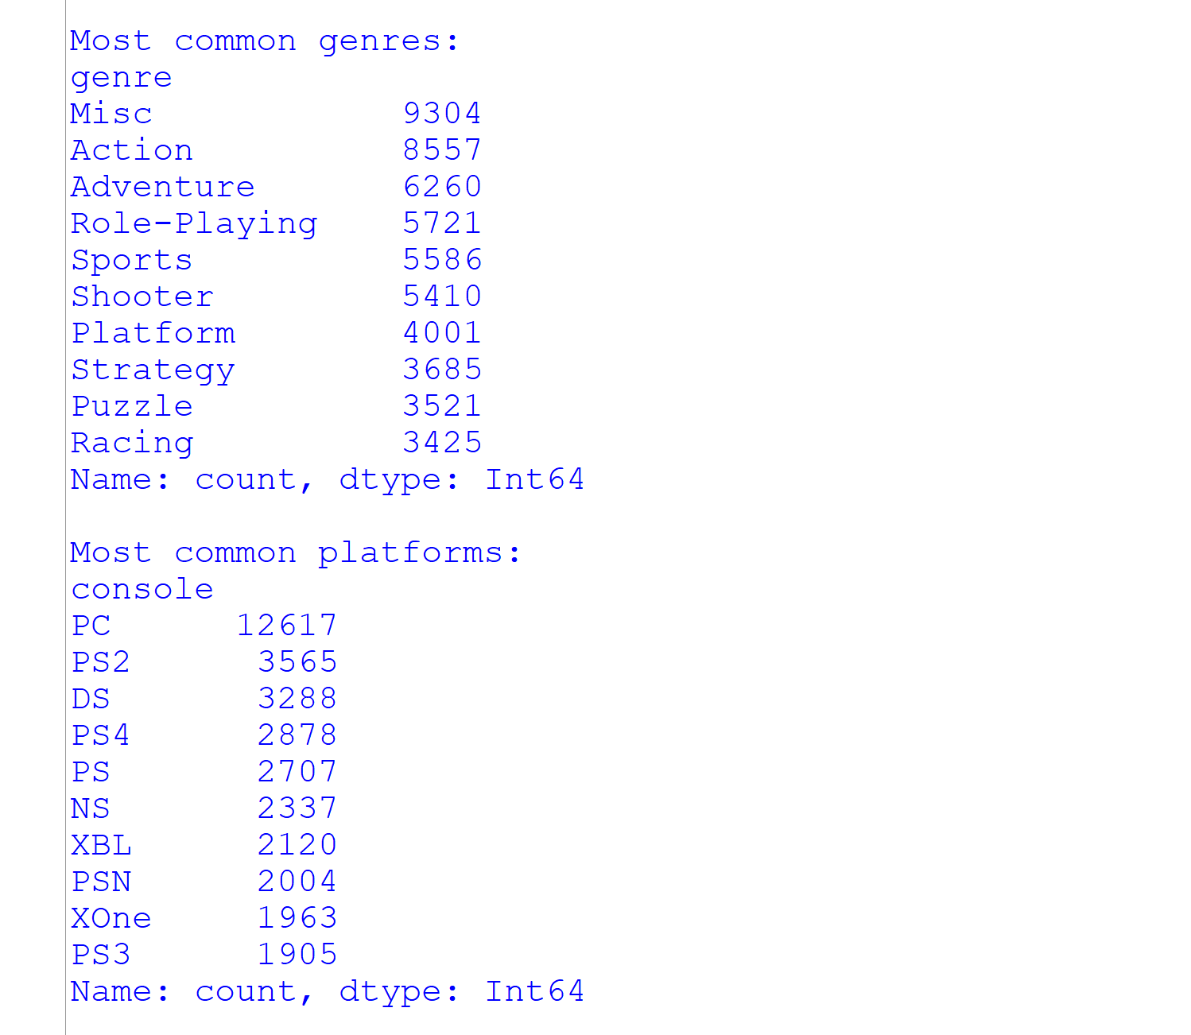
Figure 8: Most common genres and platforms in the cleaned dataset
Sorting by total sales shows that the best-selling records are dominated by a few franchises (Table 7, Figure 9). Grand Theft Auto V occupies three of the top four places (PS3 with 20.32 million, PS4 with 19.39 million and Xbox 360 with 15.86 million units), and the Call of Duty series appears five times in the top ten.
Table 7: Top 10 records by recorded total sales (millions of units)
Rank | Title | Platform | Total sales
1 | Grand Theft Auto V | PS3 | 20.32
2 | Grand Theft Auto V | PS4 | 19.39
3 | Grand Theft Auto: Vice City | PS2 | 16.15
4 | Grand Theft Auto V | X360 | 15.86
5 | Call of Duty: Black Ops 3 | PS4 | 15.09
6 | Call of Duty: Modern Warfare 3 | X360 | 14.82
7 | Call of Duty: Black Ops | X360 | 14.74
8 | Red Dead Redemption 2 | PS4 | 13.94
9 | Call of Duty: Black Ops II | X360 | 13.86
10 | Call of Duty: Black Ops II | PS3 | 13.80

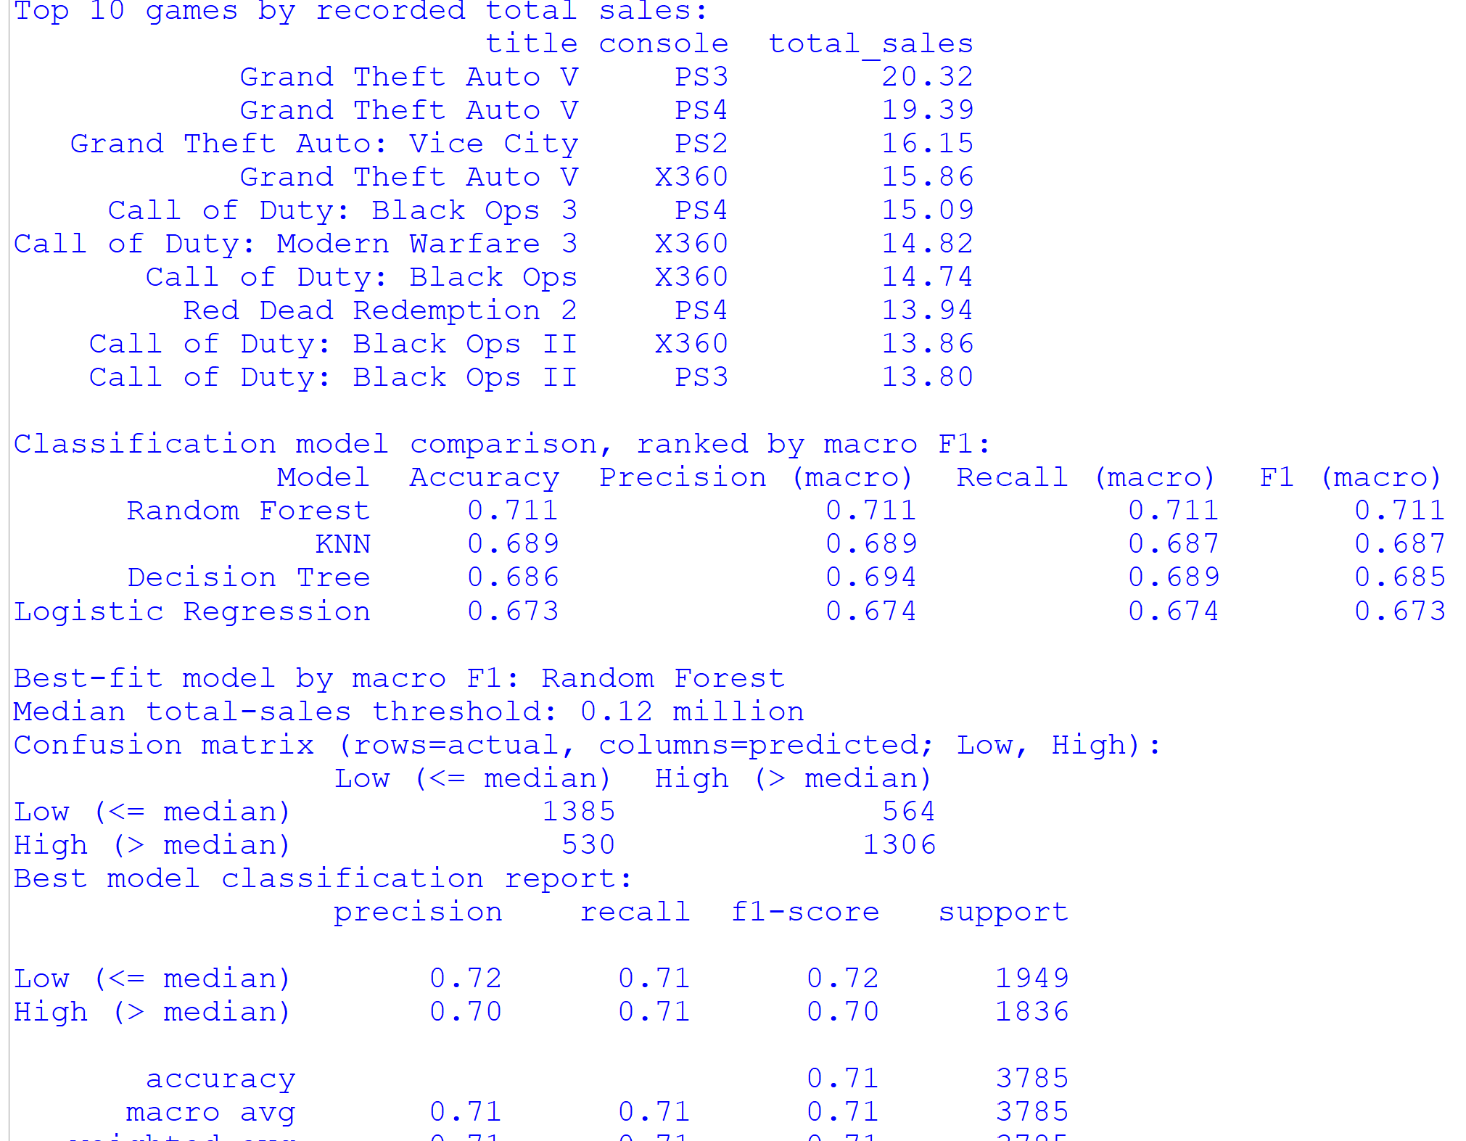
Figure 9: Top 10 games by sales and classification model output

3.6 Data-Quality Observations
- The dataset is clean in terms of structure (no duplicates, valid ranges) but sparse in content: 70.44% of total sales are missing.
- Missingness is not random. Games with recorded sales and critic scores tend to be the more prominent releases, so conclusions apply mainly to this better-documented subset.
- Catch-all categories (“Misc”, “Unknown” publisher) limit the interpretability of some groupings.
- Several category averages rest on very few games and must be interpreted with caution; this is highlighted in the relevant analyses in Chapter 4.

4. Analysis on Dataset
This chapter presents nine analyses. Each analysis follows the same five-part structure: (i) introduction, (ii) general description, (iii) specific requirements, functions and formulas, (iv) analysis results and (v) visualization. The first eight analyses are exploratory (Figures 10–19); the ninth is the predictive model comparison (Figure 20). Sales values are in millions of units unless stated otherwise.

4.1 Analysis 1: Distribution of Games by Genre

4.1.1 Introduction
A genre describes the gameplay style of a title, such as Action, Sports or Role-Playing. Counting how many games belong to each genre shows where developers and publishers concentrate their output and which genres are most crowded.

4.1.2 General Description
The analysis counts the number of records per genre in the cleaned dataset and displays the ten most frequent genres as a horizontal bar chart. Only the genre column is needed, and it has no missing values, so all 64,016 records are included. The count measures the supply of games, not their commercial success; success is examined in later analyses.

4.1.3 Specific Requirements, Functions and Formulas
- Column required: genre (text, complete).
- Functions: Series.value_counts() to count, head(10) to select the top ten, sort_values() to order bars, plt.barh() to draw and sns.color_palette("viridis") for colours.
Share of genre g (%) = (n_{g} / N) × 100, where N = 64,016
genre_counts = df["genre"].value_counts().head(10).sort_values()
plt.barh(genre_counts.index, genre_counts.values,
color=sns.color_palette("viridis", len(genre_counts)))

4.1.4 Analysis Results
Table 8 gives the counts and shares. “Misc” is the largest category with 9,304 games (14.5%), followed by Action (8,557; 13.4%) and Adventure (6,260; 9.8%). The top three categories together cover more than one third of the dataset. Role-Playing, Sports and Shooter each have between 5,400 and 5,700 titles. Because “Misc” is a catch-all label, its leading position partly reflects classification practice rather than a real gameplay genre.
Table 8: Ten most frequent genres
Rank | Genre | Games | Share of dataset
1 | Misc | 9,304 | 14.5%
2 | Action | 8,557 | 13.4%
3 | Adventure | 6,260 | 9.8%
4 | Role-Playing | 5,721 | 8.9%
5 | Sports | 5,586 | 8.7%
6 | Shooter | 5,410 | 8.5%
7 | Platform | 4,001 | 6.3%
8 | Strategy | 3,685 | 5.8%
9 | Puzzle | 3,521 | 5.5%
10 | Racing | 3,425 | 5.4%

4.1.5 Visualization
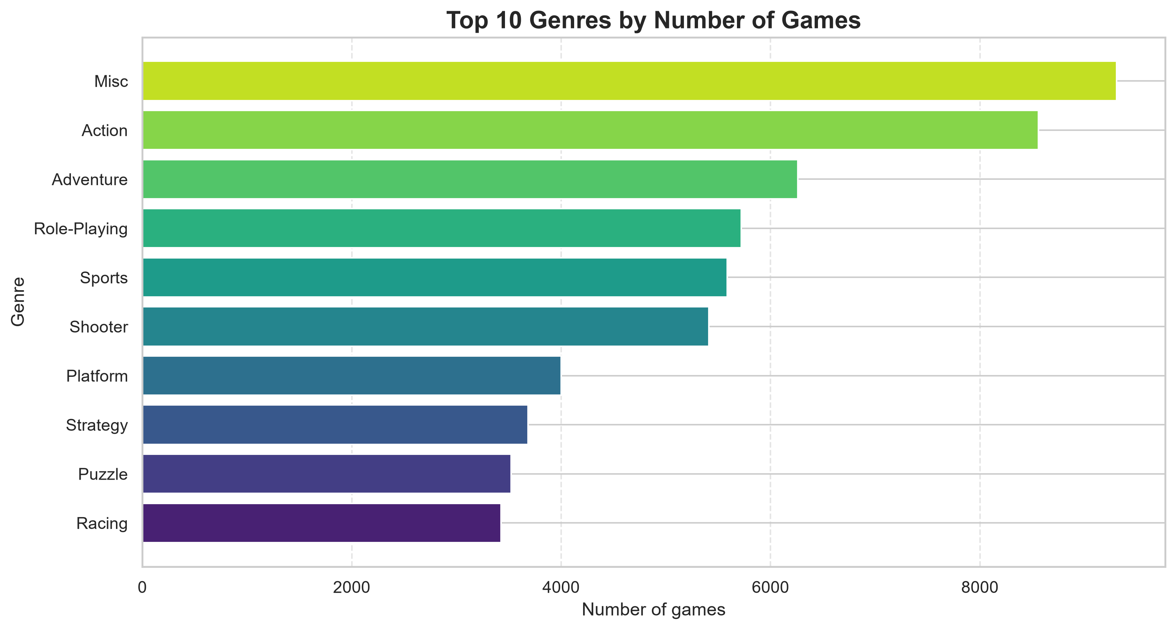
Figure 10: Top 10 genres by number of games

4.2 Analysis 2: Recorded Sales by Region

4.2.1 Introduction
Video game demand differs strongly across the world. Comparing the four sales regions shows which market contributes most to the sales recorded in the dataset.

4.2.2 General Description
The sales values in na_sales, jp_sales, pal_sales and other_sales are summed over all games for which a value is recorded, ignoring missing entries. The totals are then sorted and drawn as a column chart. Because the number of games with a recorded value differs between regions (Table 2), the totals describe recorded sales, not complete regional markets.

4.2.3 Specific Requirements, Functions and Formulas
- Columns required: na_sales, jp_sales, pal_sales, other_sales.
- Functions: df[region_columns].sum() (NaN values are skipped), sort_values(ascending=False) and plt.bar().
Regional total R_{r} = Σ_{i=1..n} s_{i,r} (sum over non-missing values only)
Regional share (%) = R_{r} / (R_{NA} + R_{JP} + R_{PAL} + R_{Other}) × 100
region_columns = ["na_sales", "jp_sales", "pal_sales", "other_sales"]
regional_sales = df[region_columns].sum().sort_values(ascending=False)

4.2.4 Analysis Results
North America is by far the largest region with about 3,345.5 million recorded units, which is 50.7% of the four-region total of 6,601.4 million. PAL territories follow with 1,916.8 million (29.0%). Japan (687.9 million; 10.4%) and the rest of the world (651.1 million; 9.9%) are of similar and much smaller size. Japan’s low figure should be read with care: only 6,726 games have a Japan sales value, compared with about 12,600–15,100 for the other regions.
Table 9: Recorded sales by region (millions of units)
Region | Games with value | Total recorded sales | Share
North America (na_sales) | 12,637 | 3,345.52 | 50.7%
PAL (pal_sales) | 12,824 | 1,916.83 | 29.0%
Japan (jp_sales) | 6,726 | 687.94 | 10.4%
Other (other_sales) | 15,128 | 651.12 | 9.9%
All regions | – | 6,601.41 | 100%

4.2.5 Visualization
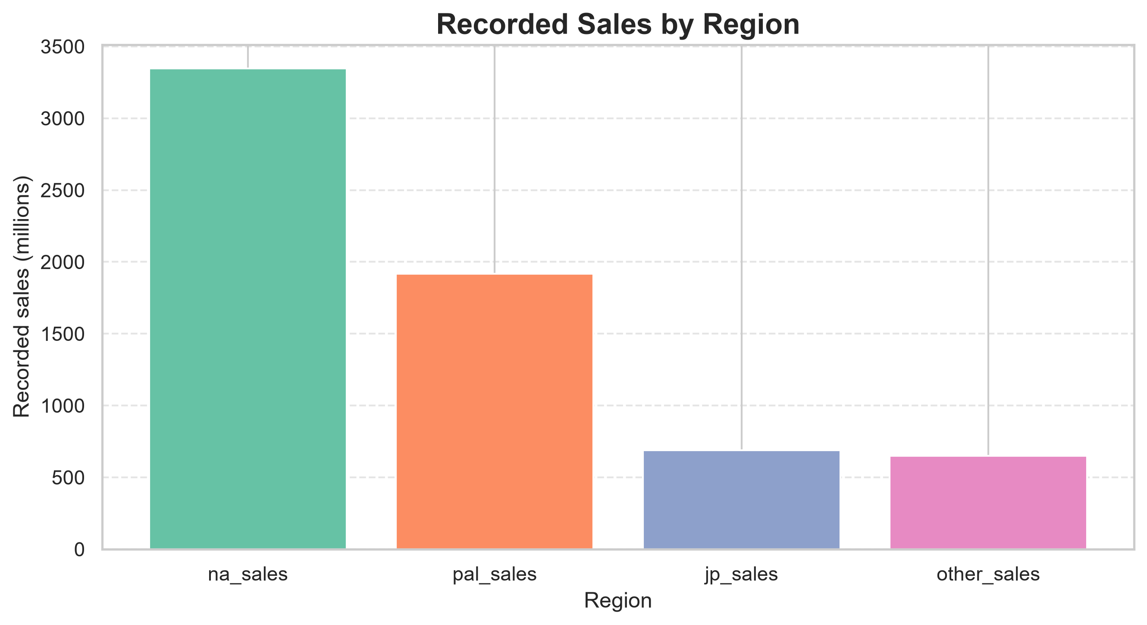
Figure 11: Recorded sales by region

4.3 Analysis 3: Average Sales by Genre

4.3.1 Introduction
Genre frequency (Analysis 1) says how many games exist; average sales say how well a typical game of that genre sells. This analysis identifies the genres whose titles achieve the highest mean sales.

4.3.2 General Description
Rows with missing total sales are removed, the remaining games are grouped by genre, the mean of total_sales is calculated for each group and the ten highest means are plotted. The result is sensitive to group size and to a few blockbuster titles, so the number of games behind each mean is reported alongside it.

4.3.3 Specific Requirements, Functions and Formulas
- Columns required: genre, total_sales (non-missing).
- Functions: dropna(subset=["total_sales"]), groupby("genre")["total_sales"].mean(), sort_values(), head(10).
Mean sales of genre g: x̄_{g} = (1 / n_{g}) Σ_{i ∈ g} total_sales_{i}
avg_by_genre = (df.dropna(subset=["total_sales"])
.groupby("genre")["total_sales"].mean()
.sort_values(ascending=False).head(10))

4.3.4 Analysis Results
The highest average belongs to Sandbox (1.89 million), but this value is based on a single game with recorded sales and therefore says nothing general about the genre. The first reliable result is Shooter with 0.670 million units per game across 1,485 titles, followed by Action-Adventure (0.563; 264 titles) and Sports (0.457; 2,597 titles). Action, the second most frequent genre by count, averages only 0.397. In total recorded sales, the leading genres are Sports (1,187.5 million), Action (1,125.9 million) and Shooter (995.5 million). Shooters therefore combine a high average with a large volume, which is consistent with a hit-driven market dominated by franchises such as Call of Duty.
Table 10: Top 10 genres by average total sales (games with recorded sales only)
Genre | Average sales (millions) | Games with sales
Sandbox | 1.890 | 1
Shooter | 0.670 | 1,485
Action-Adventure | 0.563 | 264
Sports | 0.457 | 2,597
Action | 0.397 | 2,839
Fighting | 0.392 | 871
Racing | 0.367 | 1,431
Platform | 0.367 | 951
Music | 0.352 | 147
MMO | 0.310 | 30

4.3.5 Visualization
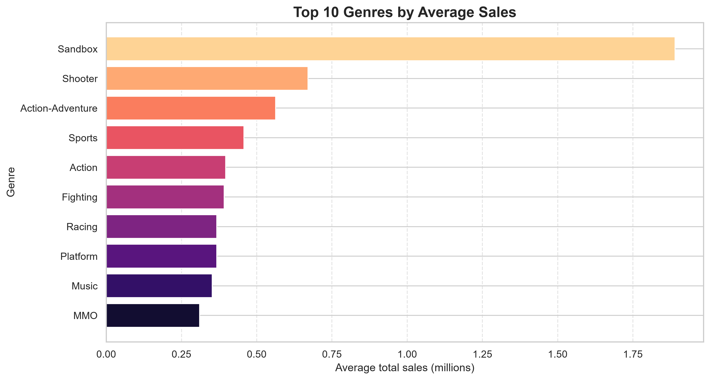
Figure 12: Top 10 genres by average sales

4.4 Analysis 4: Release Trends by Year and Decade

4.4.1 Introduction
Examining the number of games released over time reveals how the industry grew, when platform generations peaked and how complete the dataset is for different periods.

4.4.2 General Description
Release years were derived from the parsed release_date column. Games with an unknown or invalid date (7,118 records) are excluded from this analysis, leaving 56,898 games. A line-and-area chart shows releases per year (1980–2024) and a bar chart aggregates them by decade.

4.4.3 Specific Requirements, Functions and Formulas
- Columns required: release_date → release_year and release_decade (engineered).
- Functions: dt.year, integer division for decades, groupby().size(), plt.plot(), plt.fill_between() and plt.bar().
release_decade = ⌊ release_year / 10 ⌋ × 10
df["release_year"] = df["release_date"].dt.year
df["release_decade"] = (df["release_year"] // 10 * 10).astype("Int64")
games_by_year = (df.dropna(subset=["release_year"])
.groupby("release_year").size())

4.4.4 Analysis Results
Releases grew slowly through the 1980s, accelerated in the 1990s and peaked in the late 2000s: 2009 is the busiest year with 4,360 games, and a second smaller peak of roughly 2,900 games appears around 2014. The 2000s (21,812 games) and 2010s (20,610 games) together account for about three quarters of all dated records. After 2020 the counts fall sharply. This fall most likely reflects the way the data was collected—recent releases and digital-only titles are added with a delay and the 2020s decade is incomplete—rather than a real collapse in game production, so the right-hand part of the curve should not be over-interpreted.
Table 11: Games released by decade
Decade | Games | Share of dated records
1980s | 1,949 | 3.4%
1990s | 10,355 | 18.2%
2000s | 21,812 | 38.3%
2010s | 20,610 | 36.2%
2020s (to 2024) | 2,172 | 3.8%
Total | 56,898 | 100%

4.4.5 Visualization
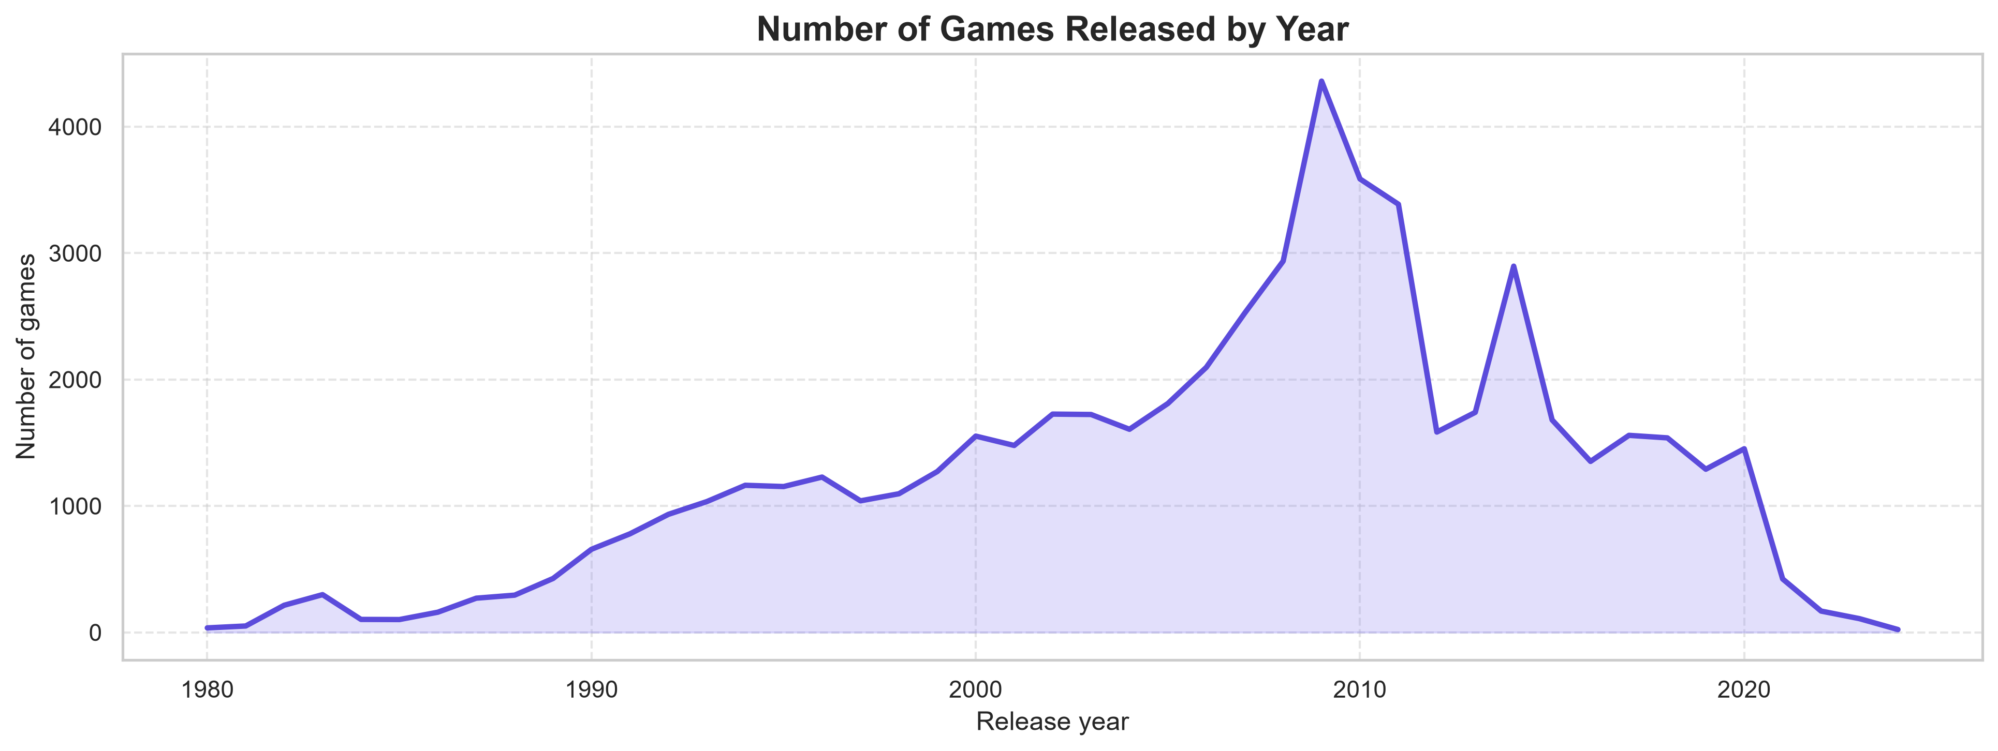
Figure 13: Number of games released by year
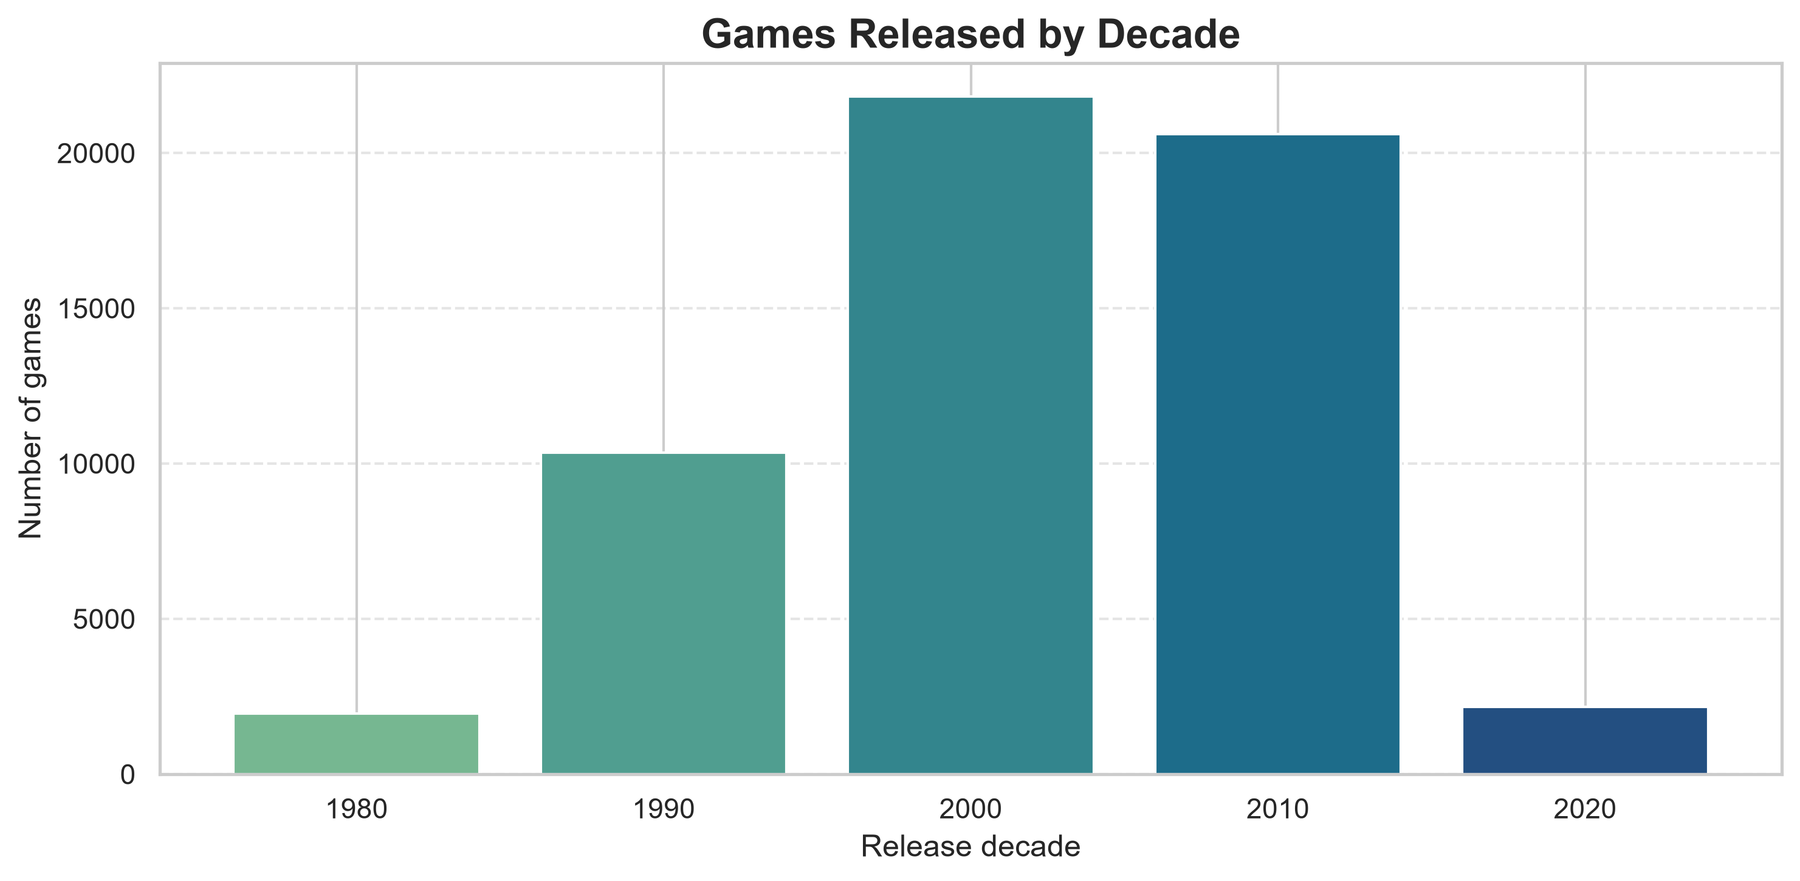
Figure 14: Games released by decade

4.5 Analysis 5: Critic Score and Sales

4.5.1 Introduction
Critic reviews are often assumed to influence purchase decisions. This analysis tests whether higher critic scores are associated with higher sales in the dataset, using both a scatter plot and a categorical comparison.

4.5.2 General Description
Only games with both a critic score and total sales can be used. This is a small subset: 4,126 games out of 64,016 (6.4%). Two views are produced. First, a scatter plot of critic score against total sales is drawn with a symmetric-log (symlog) y-axis, because sales range from near zero to over 20 million and a linear axis would compress almost all points at the bottom. Second, critic scores are grouped into three categories—Low (up to 4), Average (above 4 up to 7) and High (above 7)—and the mean sales of each category is compared.

4.5.3 Specific Requirements, Functions and Formulas
- Columns required: critic_score, total_sales and the engineered critic_score_category.
- Functions: pd.cut() with bins [0, 4, 7, 10], groupby(..., observed=False).mean(), plt.scatter() with a colour map, plt.yscale("symlog").
Pearson correlation r = Σ (x_{i} − x̄)(y_{i} − ȳ) / √[ Σ (x_{i} − x̄)² · Σ (y_{i} − ȳ)² ]
df["critic_score_category"] = pd.cut(
df["critic_score"], bins=[0, 4, 7, 10],
labels=["Low", "Average", "High"])
df.groupby("critic_score_category", observed=False)["total_sales"].mean()

4.5.4 Analysis Results
The scatter plot (Figure 15) shows a clear but loose upward pattern: the best-selling games almost all have scores above 7, while low-scored games rarely exceed one million units. The Pearson correlation between critic score and total sales on the 4,126 paired records is about r = 0.28, a weak-to-moderate positive linear relationship. The category comparison (Figure 16, Table 12) reinforces the pattern: games rated High sell on average 1.00 million units, about four times the average of Low-rated games (0.24 million) and about 2.4 times that of Average games (0.41 million). The medians show the same order (0.46, 0.21 and 0.12 million) but are much smaller than the means, again indicating a few very large hits. Note that the relationship is an association; popular games may be reviewed more and sold more for reasons unrelated to review quality (for example marketing budget and franchise recognition).
Table 12: Sales by critic-score category (games with both values)
Category | Score range | Games | Mean sales | Median sales
Low | ≤ 4 | 174 | 0.244 | 0.12
Average | > 4 to 7 | 1,625 | 0.411 | 0.21
High | > 7 to 10 | 2,327 | 1.002 | 0.46

4.5.5 Visualization
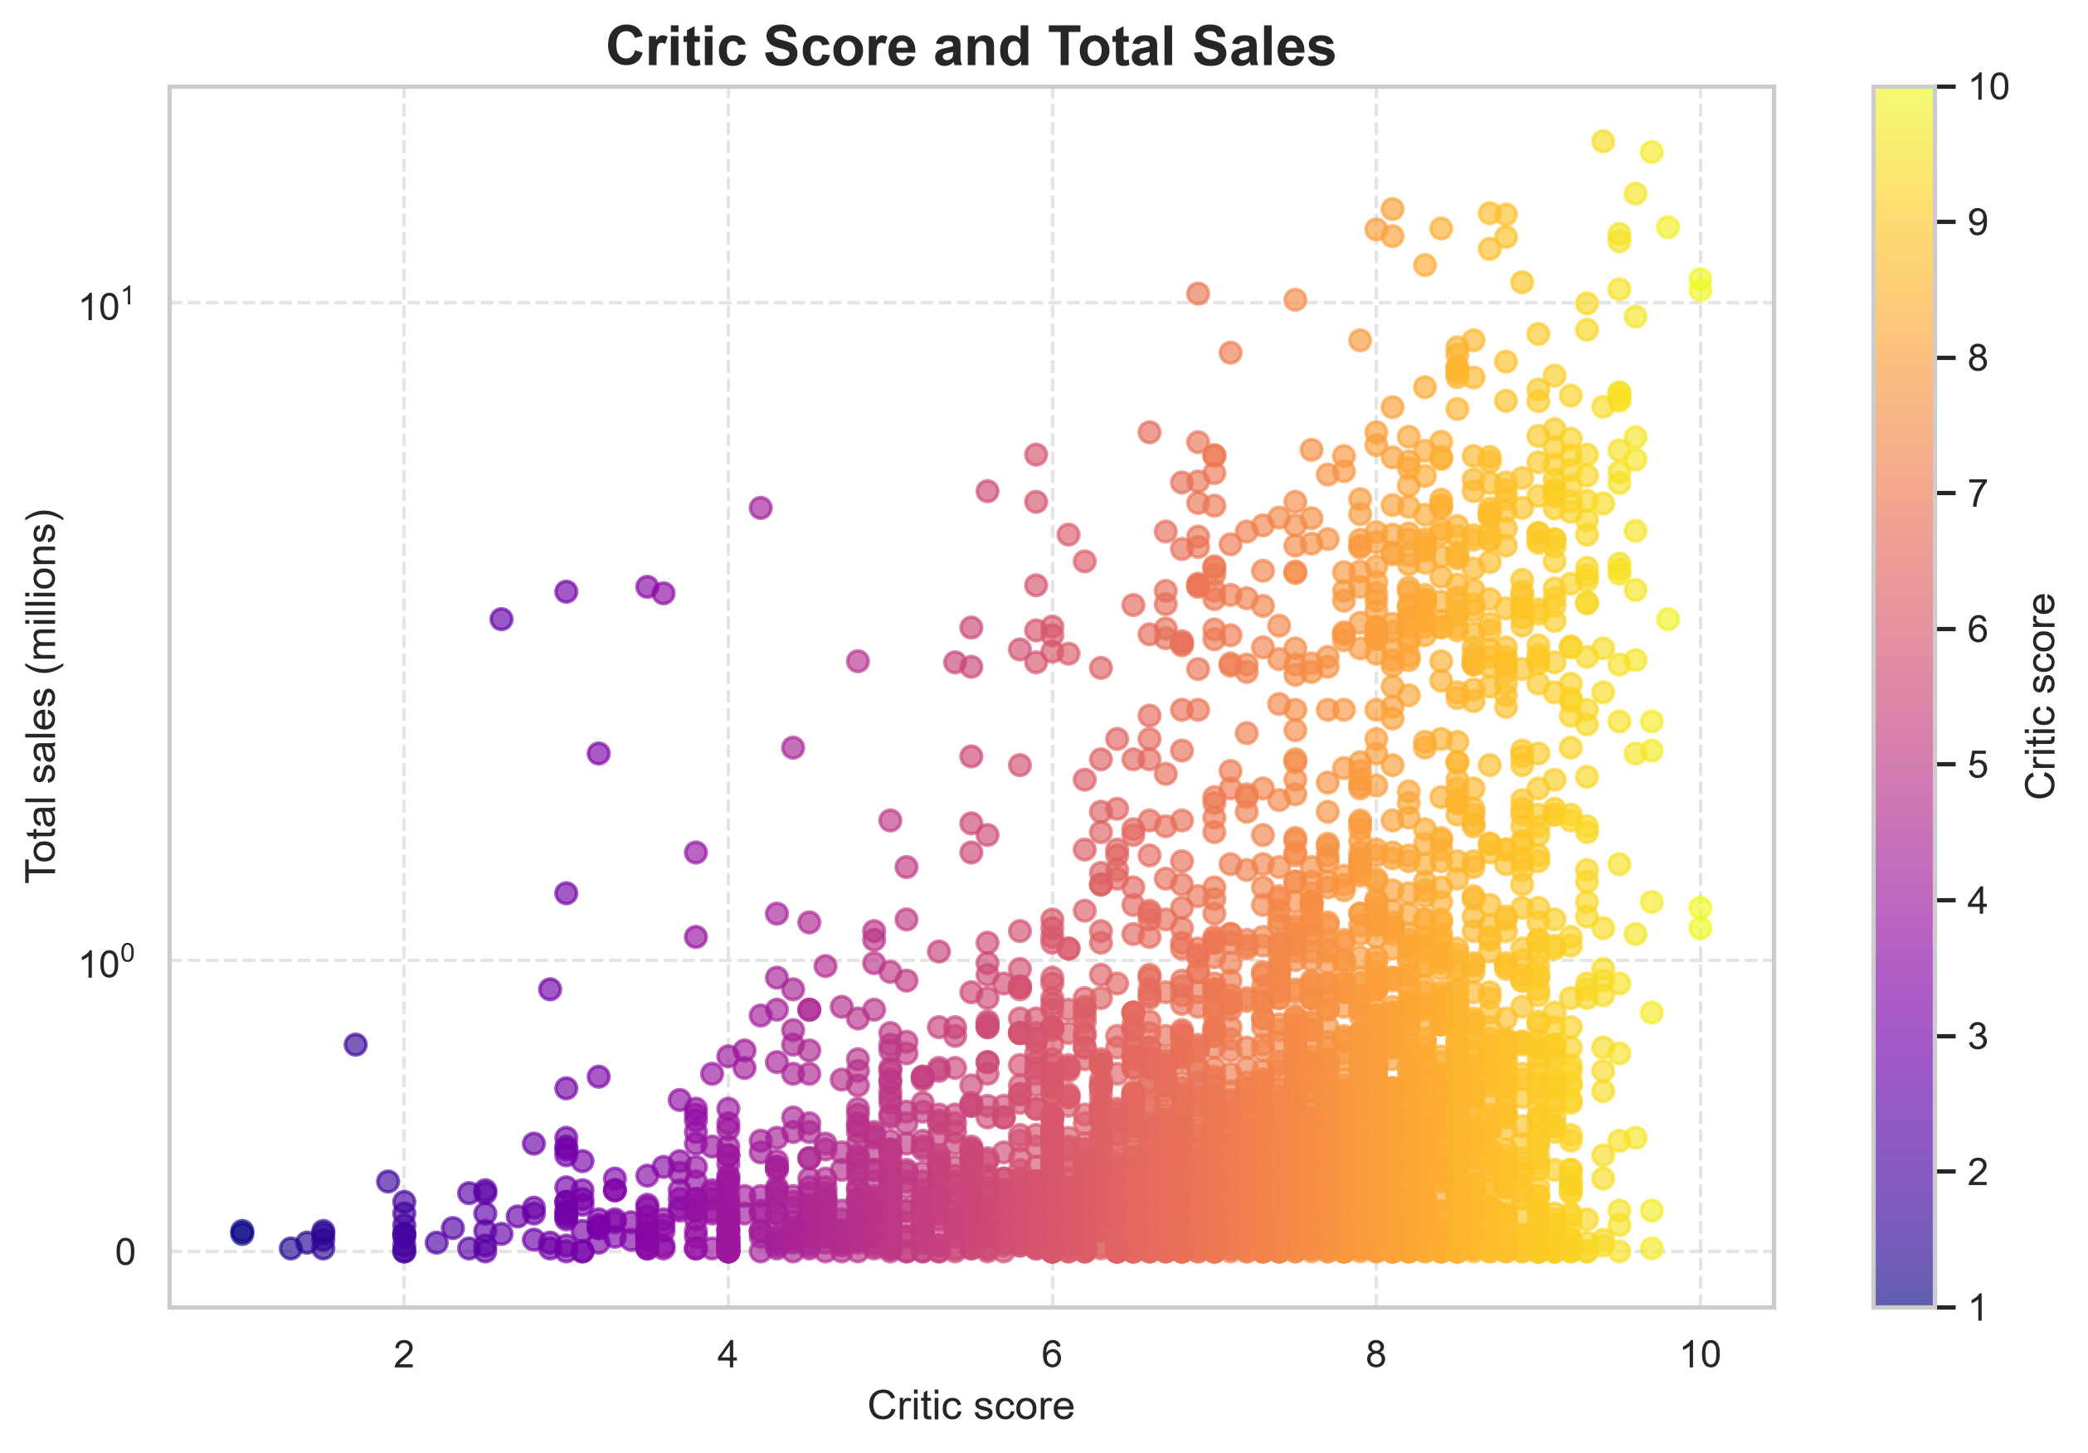
Figure 15: Critic score and total sales (symlog scale)
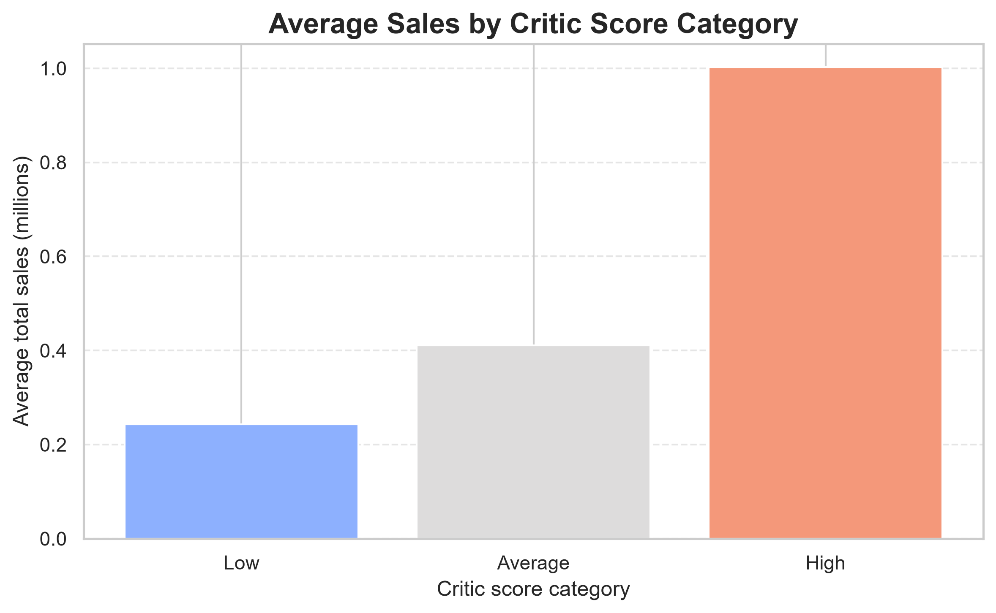
Figure 16: Average sales by critic score category

4.6 Analysis 6: Average Sales by Platform

4.6.1 Introduction
Platforms differ in installed base, software libraries and life span. This analysis asks which platforms produce the highest average sales per game.

4.6.2 General Description
Games with recorded sales are grouped by console, the mean total sales per platform is computed and the ten highest averages are displayed. As in Analysis 3, the number of games behind each average determines how reliable it is.

4.6.3 Specific Requirements, Functions and Formulas
- Columns required: console, total_sales (non-missing).
- Functions: groupby("console")["total_sales"].mean(), sort_values(), head(10), plt.barh() with the “rocket” palette.
Mean sales of platform p: x̄_{p} = (1 / n_{p}) Σ_{i ∈ p} total_sales_{i}
platform_sales = (df.dropna(subset=["total_sales"])
.groupby("console")["total_sales"].mean()
.sort_values(ascending=False).head(10))

4.6.4 Analysis Results
The Game Boy Color (GBC, 1.45 million) and NES (1.00 million) lead the ranking, but they rest on only 3 and 48 games respectively, so they are better described as platforms with a few famous titles than as strong averages. Among platforms with large catalogues the leaders are Xbox 360 (0.660 million, 1,302 games), PS3 (0.623 million, 1,348 games) and PS4 (0.595 million, 908 games). Modern console generations therefore deliver the highest typical sales per title, whereas PS2 (2,126 games) and PS (1,130 games) average about 0.48 million. By cumulative sales the order is PS2 (1,027.8 million), Xbox 360 (859.8 million), PS3 (839.7 million), PS (546.3 million) and PS4 (539.9 million).
Table 13: Top 10 platforms by average total sales
Platform | Average sales (millions) | Games with sales
GBC | 1.447 | 3
NES | 0.999 | 48
GEN (Sega Genesis) | 0.697 | 27
X360 | 0.660 | 1,302
PS3 | 0.623 | 1,348
2600 | 0.600 | 126
PS4 | 0.595 | 908
XOne | 0.513 | 524
PS2 | 0.483 | 2,126
PS | 0.483 | 1,130

4.6.5 Visualization
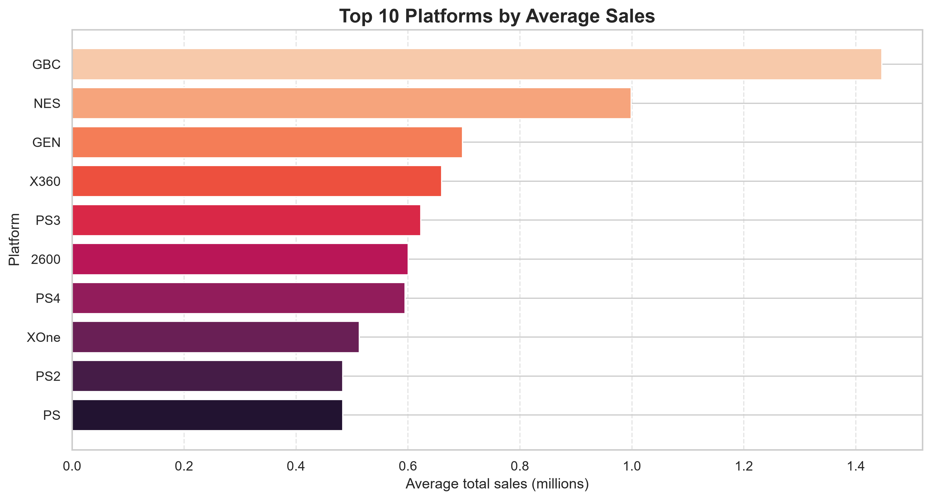
Figure 17: Top 10 platforms by average sales

4.7 Analysis 7: Distribution of Total Sales

4.7.1 Introduction
Before modelling, it is important to understand the shape of the target. The distribution of total sales shows how concentrated sales are among a few titles and why the median (0.12 million units) is a sensible threshold for separating high-selling from low-selling games in Analysis 9.

4.7.2 General Description
A histogram with 40 bins and a kernel density estimate (KDE) curve is drawn for all 18,922 recorded total-sales values. A symmetric-log x-axis is used so that the long right tail remains visible.

4.7.3 Specific Requirements, Functions and Formulas
- Column required: total_sales (non-missing).
- Functions: sns.histplot(bins=40, kde=True), plt.xscale("symlog"), Series.describe() and quantile().
Skewness = (1/n) Σ (x_{i} − x̄)³ / s³
sns.histplot(df["total_sales"].dropna(), bins=40, kde=True)
plt.xscale("symlog")

4.7.4 Analysis Results
The distribution is extremely right-skewed. The median game sells only 0.12 million units while the mean is 0.349 million, almost three times larger, and the standard deviation (0.807) is more than twice the mean. A quarter of the games sell 0.03 million or less, 90% sell less than 0.83 million, and only 1% exceed 3.54 million. At the top, 1,505 games (8.0%) sold at least one million copies and just 91 games sold five million or more, with a maximum of 20.32 million. About 1,352 games show a recorded value of 0.00, which most likely corresponds to very small sales rounded down to zero in the source. This shape has two consequences for modelling: a regression model judged by squared error would be dominated by the few blockbuster titles, and it is hard to explain the variance without information that identifies hits (for example franchise, marketing or publisher strength). For this reason Analysis 9 predicts whether a game sells more or less than the median instead of the exact number of units.
Table 14: Descriptive statistics of total sales (millions of units, n = 18,922)
Statistic | Value | Statistic | Value
Mean | 0.349 | 75th percentile | 0.34
Standard deviation | 0.807 | 90th percentile | 0.83
Minimum | 0.00 | 99th percentile | 3.54
25th percentile | 0.03 | Maximum | 20.32
Median (50th) | 0.12 | Games ≥ 1 million | 1,505

4.7.5 Visualization
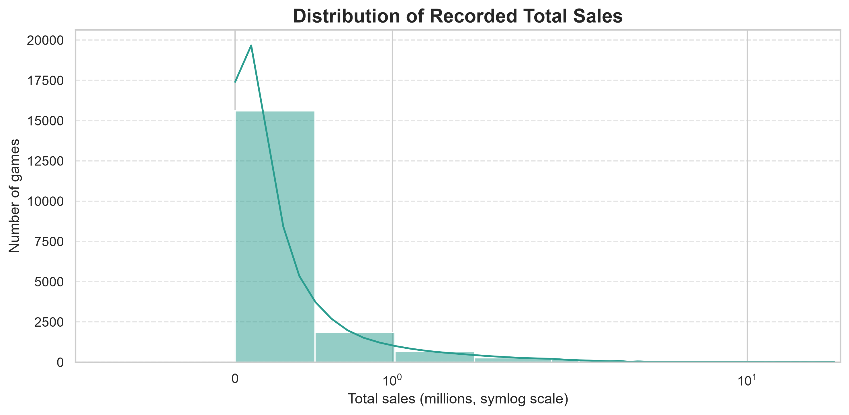
Figure 18: Distribution of recorded total sales

4.8 Analysis 8: Correlation Between Regional Sales

4.8.1 Introduction
If a game that sells well in one region also tends to sell well elsewhere, regional sales will be positively correlated. A correlation analysis quantifies how similar the four regional markets are in their taste.

4.8.2 General Description
The Pearson correlation coefficient is computed for every pair of regional sales columns using pandas’ pairwise-complete handling of missing values and displayed as an annotated heat map with values between 0 and 1.

4.8.3 Specific Requirements, Functions and Formulas
- Columns required: na_sales, jp_sales, pal_sales, other_sales.
- Functions: DataFrame.corr() and sns.heatmap(annot=True, fmt=".2f", cmap="YlGnBu").
r_{xy} = cov(X, Y) / (σ_{X} σ_{Y}), −1 ≤ r_{xy} ≤ 1
sns.heatmap(df[region_columns].corr(), annot=True, cmap="YlGnBu",
fmt=".2f", linewidths=0.5, square=True)

4.8.4 Analysis Results
Three of the four markets are strongly related: PAL and Other sales have the highest correlation (0.82), and North America correlates at 0.68 with PAL and 0.69 with Other. Japan is the clear exception, with correlations of only 0.07 (North America), 0.13 (PAL) and 0.08 (Other). Japanese buyers therefore appear to favour a different set of titles than the other regions, whose sales are driven largely by the same global franchises; this is consistent with a distinct local market preference. For modelling, this suggests that a model trained on global totals will mainly learn Western market behaviour.
Table 15: Pearson correlation matrix of regional sales
 | na_sales | jp_sales | pal_sales | other_sales
na_sales | 1.00 | 0.07 | 0.68 | 0.69
jp_sales | 0.07 | 1.00 | 0.13 | 0.08
pal_sales | 0.68 | 0.13 | 1.00 | 0.82
other_sales | 0.69 | 0.08 | 0.82 | 1.00

4.8.5 Visualization
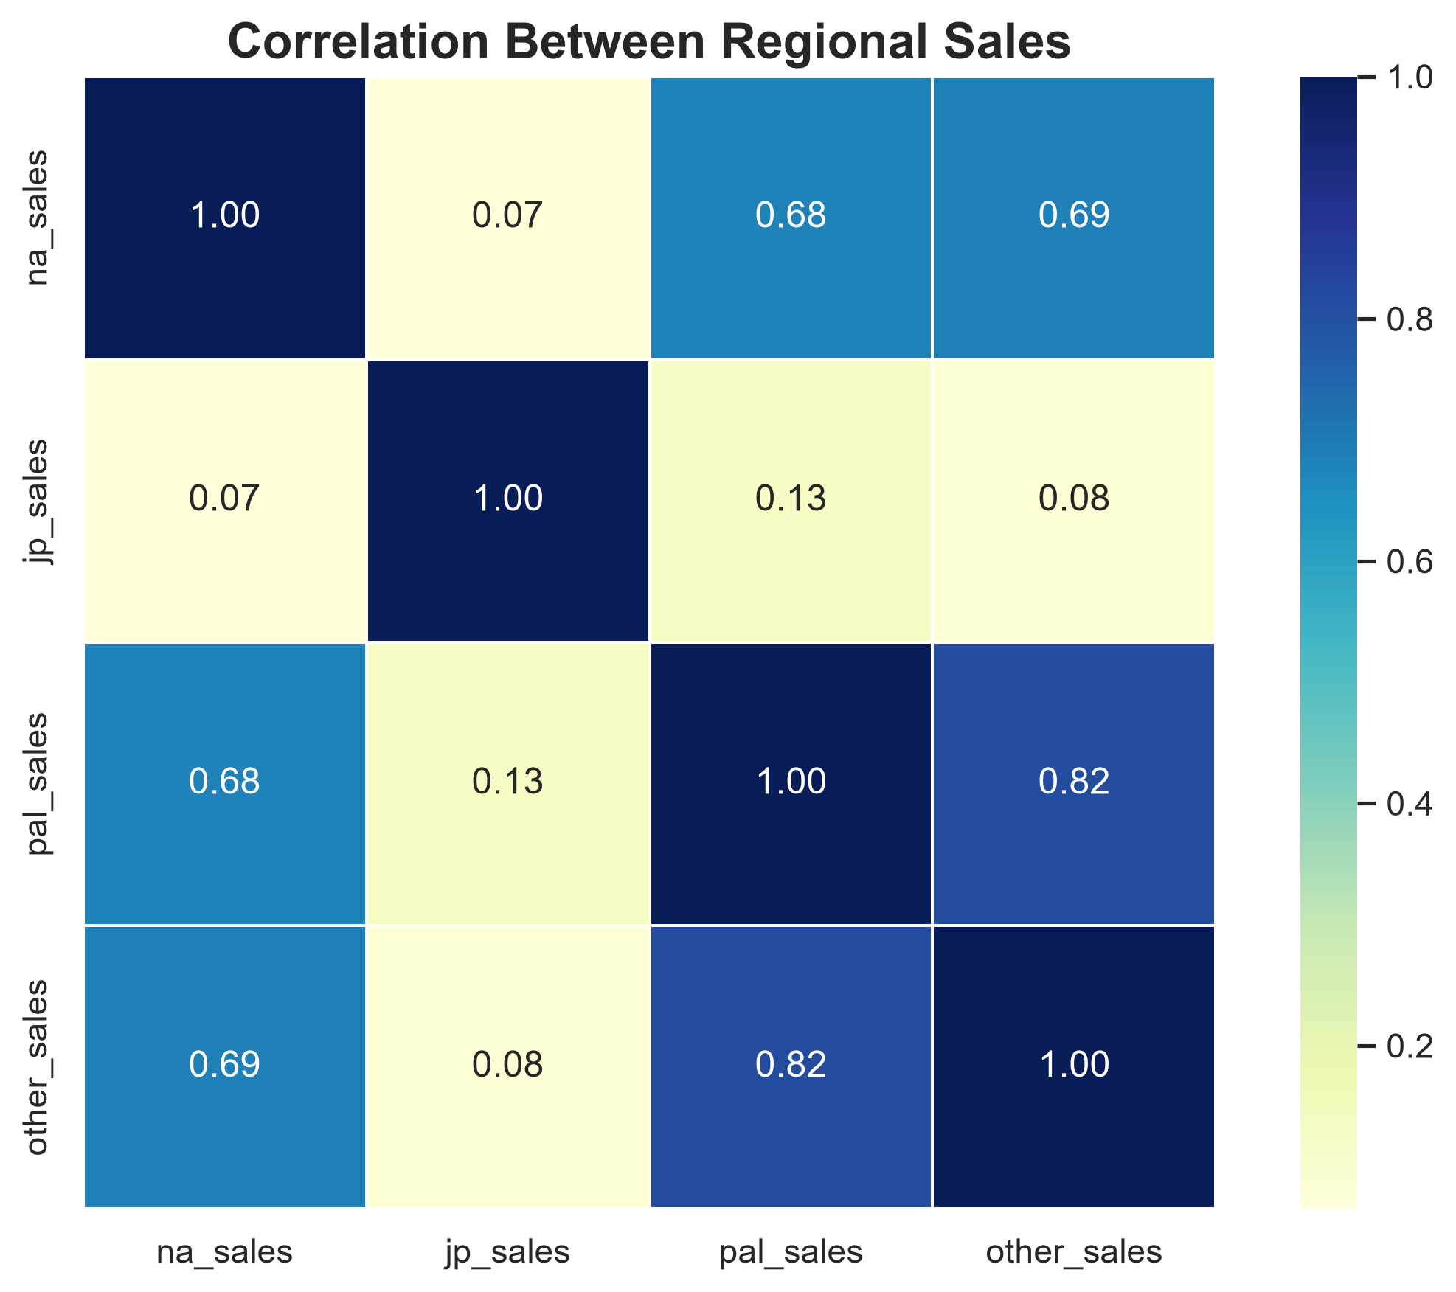
Figure 19: Correlation between regional sales

4.9 Analysis 9: Classifying High-Selling and Low-Selling Games with Machine Learning

4.9.1 Introduction
The final analysis moves from description to prediction. Because total sales are extremely skewed (Analysis 7) and an initial regression attempt on the exact number of units explained only about 21% of the variance (R² ≈ 0.21), the task is reformulated as a binary classification: will a game sell more than the median (0.12 million units) or not? The goal is to find out which of four common classification algorithms performs best.

4.9.2 General Description
The target is sales_category, derived from total_sales: a game is High (1) if its total sales are above the median of 0.12 million units and Low (0) otherwise. This split gives almost balanced classes (9,742 Low and 9,180 High games). The features are critic_score and release_year (numeric) and console and genre (categorical). Only the 18,922 games with a recorded total sales value are used. Of these, 4,126 (21.8%) have a critic score and 18,821 (99.5%) have a release year, so missing critic scores are imputed and the model effectively relies on platform, genre and year for most records. The data is split randomly into 80% training (15,137 games) and 20% test (3,785 games) with random_state = 42 and stratify = y, so both sets keep the same class proportions (test set: 1,949 Low and 1,836 High games). All preprocessing is placed inside a scikit-learn Pipeline, so that imputation values, scaling parameters and encoding categories are learnt from the training data only, which prevents data leakage into the test set.

4.9.3 Specific Requirements, Functions and Formulas
Preprocessing. Numeric features are imputed with the median and standardised; categorical features are imputed with the most frequent value and one-hot encoded (unseen categories are ignored at prediction time). The target is created with (total_sales > median).astype(int).
Standardisation: z = (x − μ) / σ
numeric_preprocessor = Pipeline([
("imputer", SimpleImputer(strategy="median")),
("scaler", StandardScaler())])
categorical_preprocessor = Pipeline([
("imputer", SimpleImputer(strategy="most_frequent")),
("onehot", OneHotEncoder(handle_unknown="ignore"))])
preprocessor = ColumnTransformer([
("numeric", numeric_preprocessor, numeric_features),
("categorical", categorical_preprocessor, categorical_features)])

Algorithms. Table 16 lists the four classifiers and their settings. Logistic Regression estimates the probability of the High class with a logistic (sigmoid) function; KNN assigns the majority class among the k most similar training games; the Decision Tree recursively splits the data to make the classes purer (Gini impurity); and the Random Forest takes a majority vote of many such trees built on bootstrap samples. Because the classes are almost balanced, class_weight = "balanced" is used for Logistic Regression, Decision Tree and Random Forest.
Table 16: Classification models and hyper-parameters
Model | Principle | Settings
Logistic Regression | Linear model with a sigmoid output giving the probability of the High class | max_iter = 2000, class_weight = balanced
KNN | Majority class among the nearest neighbours in feature space | n_neighbors = 5 (Euclidean distance)
Decision Tree | Recursive binary splits minimising Gini impurity | max_depth = 12, class_weight = balanced, random_state = 42
Random Forest | Ensemble of bootstrap-trained trees, majority vote | n_estimators = 100, max_depth = 15, class_weight = balanced, random_state = 42

Logistic regression: P(High | x) = 1 / (1 + e^−(β0 + β1x1 + … + βpxp))
Classification rule (KNN): predicted class = majority class of the k nearest training games
Evaluation metrics. The models are compared on the test set with four standard classification metrics, which are computed from the confusion matrix (TP, TN, FP and FN are the true/false positives and negatives):
Accuracy = (TP + TN) / (TP + TN + FP + FN)
Precision = TP / (TP + FP) Recall = TP / (TP + FN)
F1 = 2 × Precision × Recall / (Precision + Recall)
Accuracy is the share of correctly classified games. Precision is the share of games predicted as a class that really belong to it, and recall is the share of games of a class that were found. F1 combines both. “Macro” values are the unweighted averages over the two classes, so Low and High count equally; the best-fit model is chosen by the highest macro F1.

4.9.4 Analysis Results
Table 17 shows the performance of the four classifiers on the test set of 3,785 games (1,949 Low and 1,836 High). Random Forest is the best-fit model: it has the highest accuracy (0.711) and the highest macro F1 (0.711), and it also leads in macro precision and macro recall. KNN follows with a macro F1 of 0.687 and the Decision Tree with 0.685, while Logistic Regression is lowest with 0.673, which shows that a purely linear relationship between the features and the sales class is too simple. For comparison, always predicting the larger test class (Low) would give an accuracy of only 51.5%, so Random Forest classifies about 71 of every 100 games correctly.
Table 17: Classification performance on the test set (sorted by macro F1)
Model | Accuracy | Precision (macro) | Recall (macro) | F1 (macro)
Random Forest | 0.711 | 0.711 | 0.711 | 0.711
KNN | 0.689 | 0.689 | 0.687 | 0.687
Decision Tree | 0.686 | 0.694 | 0.689 | 0.685
Logistic Regression | 0.673 | 0.674 | 0.674 | 0.673

The confusion matrix of the Random Forest (Table 18) shows that the errors are balanced. Of the 1,949 Low-selling games, 1,385 were identified correctly (recall 0.71), and of the 1,836 High-selling games, 1,306 were identified correctly (recall 0.71). 564 Low games were wrongly predicted as High and 530 High games as Low, so 1,094 of the 3,785 games (28.9%) were misclassified. The class-wise precision is 0.72 for Low and 0.70 for High, with F1-scores of 0.72 and 0.70.
Table 18: Confusion matrix of the Random Forest classifier on the test set
Actual \ Predicted | Low (≤ median) | High (> median)
Low (≤ median) | 1,385 | 564
High (> median) | 530 | 1,306

Figure 20 shows the first levels of the Decision Tree. The root split uses the critic score: the 1,630 training games with a known score above about 7.3 form a branch in which roughly 82% of the (class-weighted) games are High-selling. For the other 13,507 games the next question is whether the platform is PC, and PC games fall overwhelmingly into the Low class (about nine in ten of the 1,054 PC games in that node). Further down the tree, release year, the consoles PS2 and GBA and the genres Shooter and Adventure are used. Figure 21 shows the Random Forest feature importance: the critic score (about 0.27) and the release year (about 0.23) are the two most important features, followed by the PC platform (about 0.12), while every individual genre and the other consoles contribute less than 0.04. The weight of the PC platform reflects the data: only about 14% of PC games with recorded sales are High-selling, compared with 63–68% of PS2, Xbox 360 and PS3 games. Because about 78% of the games have no critic score and the median had to be imputed, the critic score mainly separates the minority of games with a known high score from the rest.
An accuracy of about 71% is clearly better than guessing but far from perfect. The reasons are visible in the earlier analyses: the available features contain no information on franchise, publisher or marketing, most critic scores are imputed, and the target is available only for a non-random 30% of all games. The differences between KNN, the Decision Tree and Logistic Regression are small (0.01–0.02 in macro F1) and come from a single train/test split, so only the lead of the Random Forest should be regarded as reasonably clear; cross-validation would be needed to rank the other three reliably. Note: the values above are taken from the saved file Classification_Model_Evaluation_Results.csv; re-running the script with a different library version can change the third decimal place.

4.9.5 Visualization
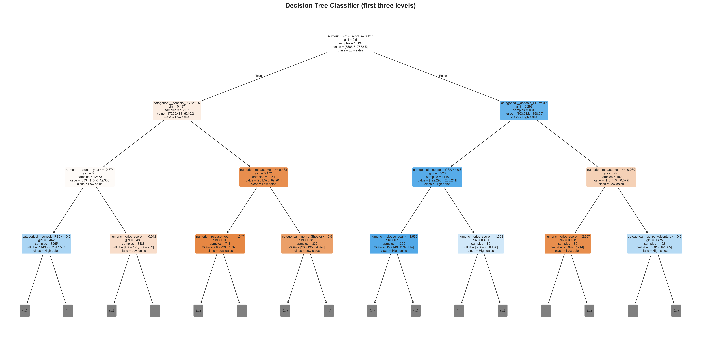
Figure 20: Decision Tree classifier (first three levels of the tree)
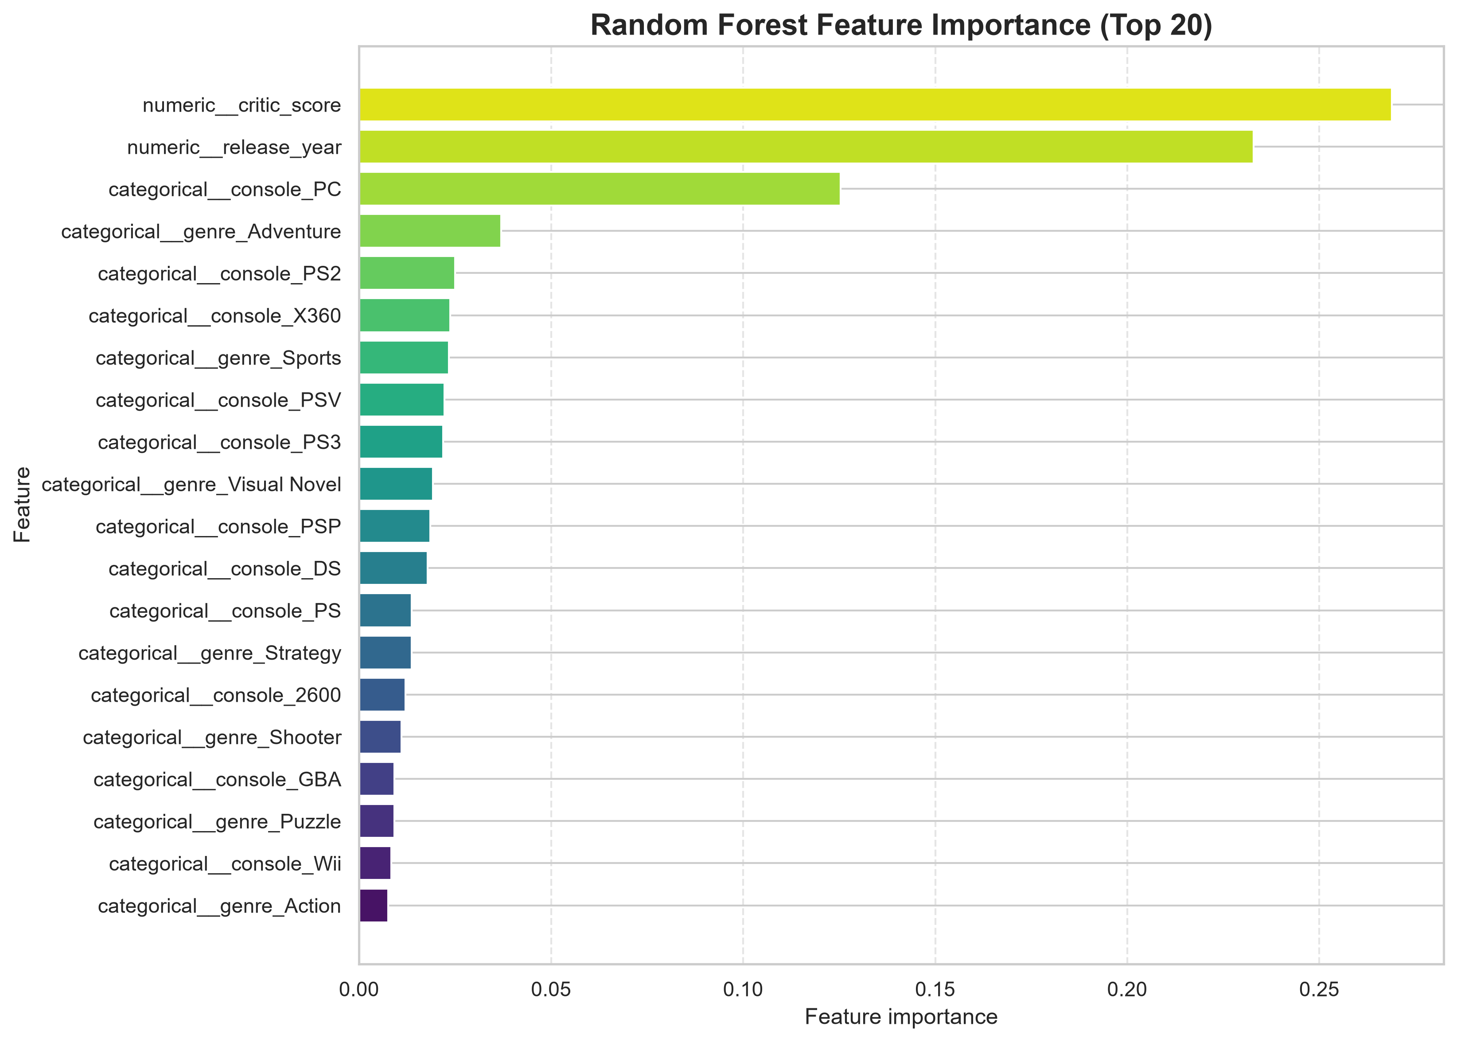
Figure 21: Random Forest feature importance (top 20 features)

5. Conclusion

5.1 Summary of the Work
This project analysed 64,016 video game records from 1980 to 2024 using Python. The raw data was profiled, validated and cleaned; five features were engineered; ten exploratory visualizations and two model-interpretation charts were produced; and four classification algorithms were compared for predicting whether a game is high-selling or low-selling. The entire workflow is reproducible from a single script and is published, together with the data and figures, in a public GitHub repository.

5.2 Key Findings
- Data quality. The dataset has no duplicates and no invalid scores or negative sales, but is highly incomplete: 70.44% of total sales and 89.57% of critic scores are missing. Conclusions therefore apply mainly to the minority of games with recorded values.
- Genres. “Misc” (9,304), Action (8,557) and Adventure (6,260) are the most numerous genres, but Shooter has the highest reliable average sales (0.670 million per game), and Sports, Action and Shooter generate the largest total sales.
- Regions. North America accounts for about 51% of recorded sales and PAL for 29%. Japan behaves differently from other regions, with correlations of only 0.07–0.13 with them, while PAL, Other and North America are strongly correlated (0.68–0.82).
- Time trend. Releases peaked in 2009 with 4,360 games; the 2000s and 2010s hold about three quarters of the dated records. The decline after 2020 mainly reflects incomplete recent data.
- Critic reception. Higher critic scores go with higher sales (r ≈ 0.28). High-rated games average 1.00 million units, about four times the 0.24 million of low-rated games.
- Platforms. Among platforms with large catalogues, Xbox 360, PS3 and PS4 have the highest average sales per game (0.59–0.66 million); the averages of GBC and NES (platforms) and of Sandbox (genre) rest on very few titles.
- Sales distribution. Sales are extremely right-skewed: median 0.12 million, mean 0.349 million, maximum 20.32 million. A handful of franchises such as Grand Theft Auto and Call of Duty dominate the top of the market.
- Prediction. Random Forest was the best classifier of high-selling versus low-selling games (accuracy 0.711, macro F1 0.711), ahead of KNN (0.687), the Decision Tree (0.685) and Logistic Regression (0.673). Critic score, release year and the PC platform are the most important features. Predictive power is real but modest.

5.3 Recommendations
Based on the findings of Chapter 4, the following recommendations are made for publishers, developers and analysts. They are based on associations in the recorded data and should be read together with the limitations in Section 5.4.
- Invest in quality and reception. Games with a High critic score (above 7) average 1.00 million units against 0.24 million for Low-rated games, so quality assurance, polish and review readiness are worth prioritising for titles with large budgets.
- Favour proven high-volume genres. Shooter (0.670 million per game), Action-Adventure (0.563) and Sports (0.457) combine high averages with large recorded totals. Newcomers should expect strong competition, since these genres are dominated by a few franchises.
- Plan for North America and PAL first. These regions account for about 51% and 29% of recorded sales, so release schedules, marketing budgets and localisation should be planned around them.
- Treat Japan as a separate market. Japanese sales correlate only 0.07–0.13 with other regions, so titles aimed at Japan need their own genre mix, localisation and marketing instead of a global copy of the Western plan.
- Choose current-generation platforms. Xbox 360, PS3, PS4 and Xbox One have average sales of about 0.51–0.66 million per title, higher than PS2 and PS (about 0.48 million), which favours platforms with an active installed base.
- Use the prediction model only as a baseline. The Random Forest classifier labels about 71% of games correctly (macro F1 0.711), which is useful for rough screening of high- versus low-selling titles but not for budget decisions. Franchise, publisher strength, marketing spend and price should be added and cross-validation used before relying on it (Chapter 6).
- Improve data collection. Sales are recorded for only 30% of titles and critic scores for about 10%. Complete records, especially for recent and digital-only releases, would make future trend analysis, including the apparent fall after 2020, more reliable.

5.4 Limitations
- Missing target values. Models were trained only on the 29.6% of games with recorded total sales, which is not a random sample of the market.
- Imputation. About 78% of the modelled games had no critic score, so the median was imputed; the feature therefore contributes little for most records.
- Limited features. Publisher, developer, franchise, marketing, price and user reviews were not used as predictors although they are likely to matter.
- Evaluation design. A single 80/20 stratified random split and fixed hyper-parameters were used; no cross-validation or tuning was performed, and the median threshold was computed on all games with recorded sales before the split. Results can vary slightly between runs and library versions.
- Small groups. Averages for Sandbox (one game), GBC (three games) and some other categories are statistically unreliable.

5.5 Project Deliverables and Public Availability
The complete project—script, notebook, raw/cleaned/featured datasets, classification results, confusion matrices and all twelve figures—is hosted in the public GitHub repository Himanshu-56-design/Preditive_Analysis_CA2 (Figure 22), available at https://github.com/Himanshu-56-design/Preditive_Analysis_CA2. The repository contains 23 commits, all made within a single week as shown in the commit-activity graph (Figure 23). A summary of the work was also shared as a LinkedIn post (Figure 24; https://lnkd.in/p/gUUVf4JF) to communicate the results to a wider audience.

Github - https://github.com/Himanshu-56-design/Preditive_Analysis_CA2
Linkedin - https://lnkd.in/p/gUUVf4JF

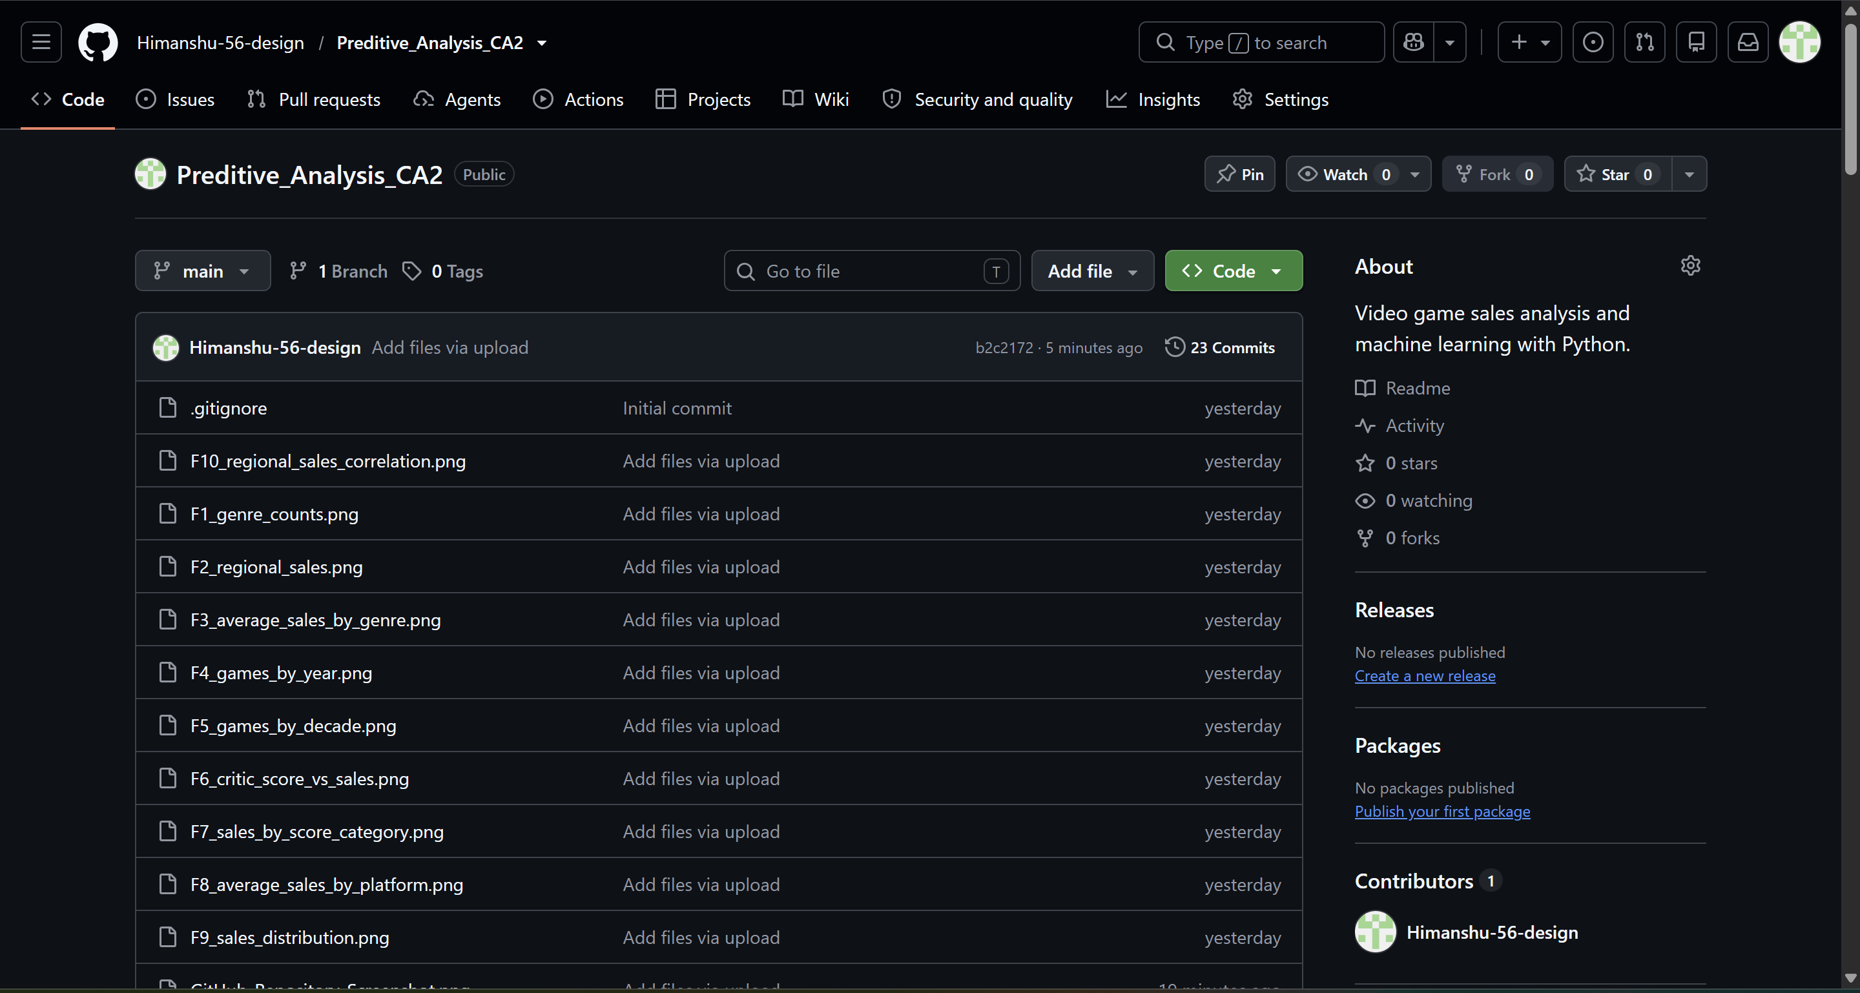
Figure 22: GitHub repository of the project (Preditive_Analysis_CA2)
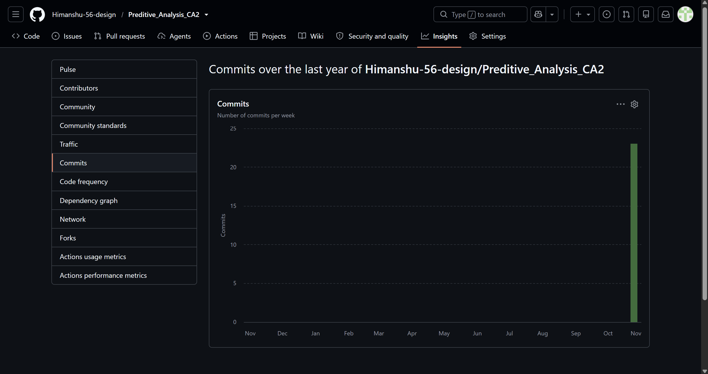
Figure 23: Commit activity of the repository (GitHub Insights)
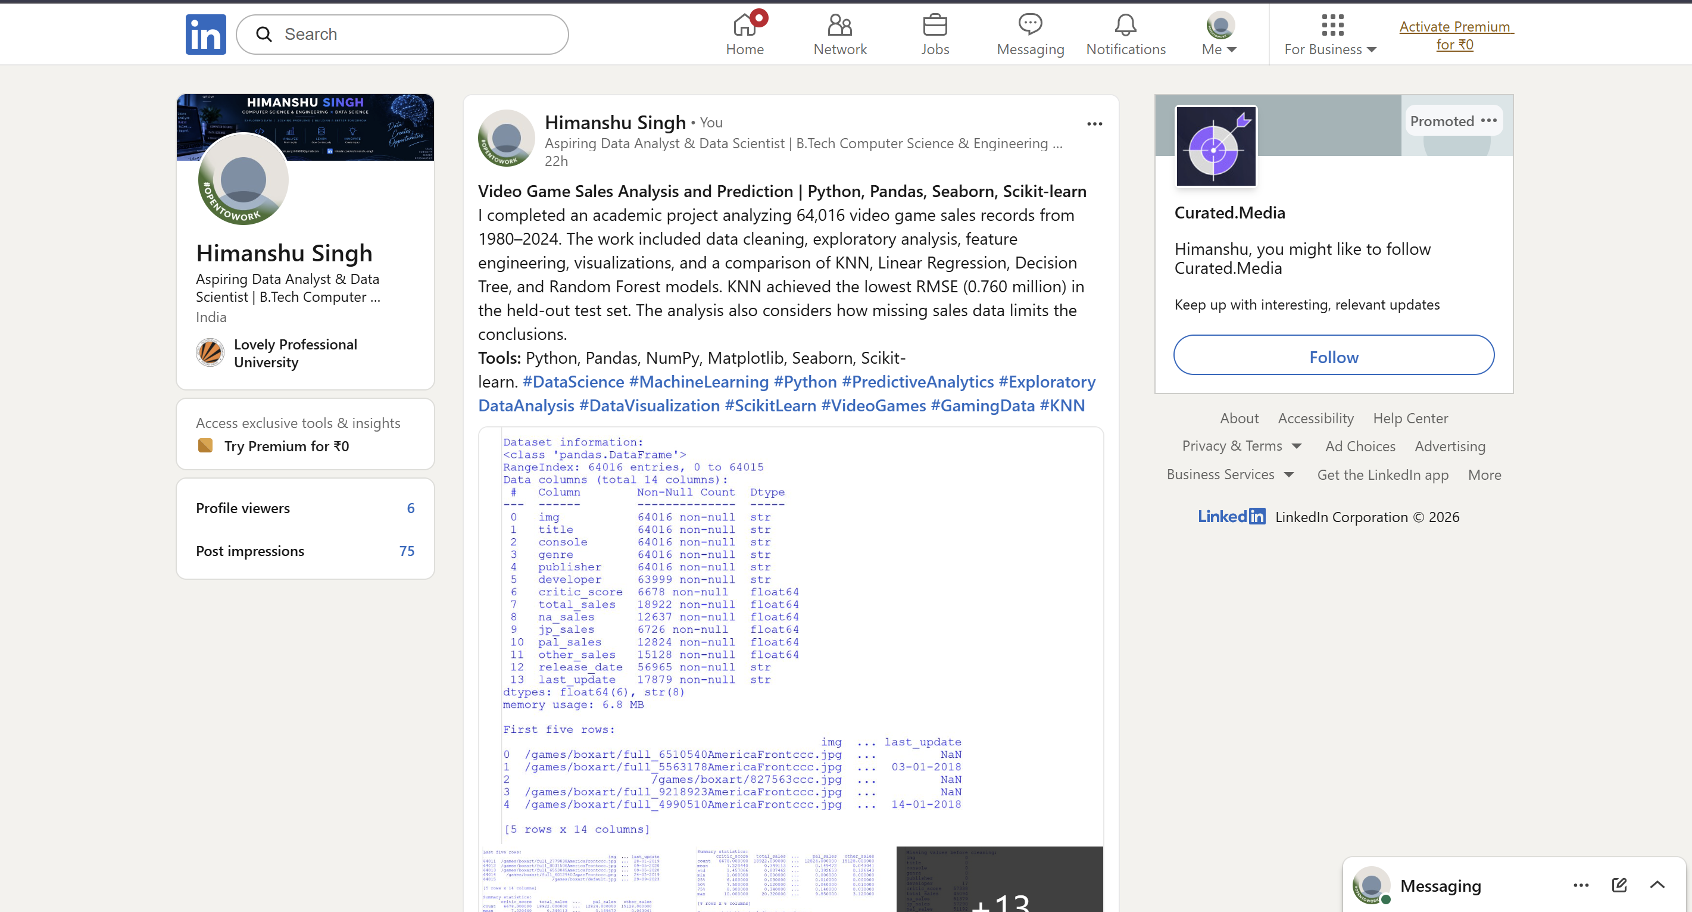
Figure 24: LinkedIn post summarising the project

5.6 Learning Outcomes
Through this project the following skills were practised: structured data profiling and documentation of cleaning decisions; feature engineering; choosing suitable chart types and scales for skewed data (symlog axes); building leak-free preprocessing pipelines; comparing models with appropriate metrics; and communicating technical results honestly, including their limitations.

6. Future Scope
The present work provides a baseline that can be extended in several directions:
- Better target handling. Apply a logarithmic transformation (log(1 + sales)) to the skewed target and evaluate with metrics such as RMSLE or median absolute error so that the model is not dominated by a few blockbusters.
- Stronger algorithms and tuning. Evaluate gradient boosting methods (XGBoost, LightGBM, CatBoost), and use k-fold cross-validation with GridSearchCV or RandomizedSearchCV to tune k, tree depth and forest size. Pruning or a smaller depth would reduce the Decision Tree’s overfitting.
- Richer features. Add publisher and developer statistics (for example average past sales), franchise or sequel indicators, release month/season, platform generation, user scores and text features derived from game titles using TF-IDF or embeddings.
- Missing-data strategies. Use model-based imputation (KNN or iterative imputation) for critic scores, add “missing” indicator variables, and build a two-stage model that first predicts whether sales will be recorded.
- Finer classification. Replace the median split by a “hit” definition (for example more than one million units) or by several sales classes, and evaluate with ROC-AUC and precision–recall curves in addition to the metrics used here.
- Time-aware validation and forecasting. Replace the random split with a chronological split (train on older games, test on newer ones) and apply time-series methods to forecast platform- or genre-level sales.
- Regional models. Build separate models for North America, PAL and Japan, given the low correlation of Japan with other regions.
- Deployment and dashboards. Package the best pipeline with joblib, expose it through a Streamlit or Flask web application and create an interactive Power BI or Plotly dashboard for non-technical users.

7. References
- McKinney, W. (2010). Data structures for statistical computing in Python. Proceedings of the 9th Python in Science Conference, 56–61.
- Harris, C. R., Millman, K. J., van der Walt, S. J., et al. (2020). Array programming with NumPy. Nature, 585, 357–362.
- Hunter, J. D. (2007). Matplotlib: A 2D graphics environment. Computing in Science & Engineering, 9(3), 90–95.
- Waskom, M. L. (2021). seaborn: statistical data visualization. Journal of Open Source Software, 6(60), 3021.
- Pedregosa, F., Varoquaux, G., Gramfort, A., et al. (2011). Scikit-learn: Machine learning in Python. Journal of Machine Learning Research, 12, 2825–2830.
- Breiman, L. (2001). Random forests. Machine Learning, 45(1), 5–32.
- Cover, T., & Hart, P. (1967). Nearest neighbor pattern classification. IEEE Transactions on Information Theory, 13(1), 21–27.
- Breiman, L., Friedman, J., Olshen, R., & Stone, C. (1984). Classification and Regression Trees. Wadsworth.
- Hastie, T., Tibshirani, R., & Friedman, J. (2009). The Elements of Statistical Learning (2nd ed.). Springer.
- James, G., Witten, D., Hastie, T., & Tibshirani, R. (2021). An Introduction to Statistical Learning (2nd ed.). Springer.
- Tukey, J. W. (1977). Exploratory Data Analysis. Addison-Wesley.
- Divekar, B. (n.d.). Video Games Sales EDA [Kaggle notebook and input dataset: Video Games Sales (1980-2024) - Raw.csv]. Kaggle. https://www.kaggle.com/code/bhushandivekar/video-games-sales-eda. Accessed on 28/10/2026.
- scikit-learn developers. scikit-learn User Guide and API reference. https://scikit-learn.org/stable/user_guide.html
- pandas development team. pandas documentation. https://pandas.pydata.org/docs/
- Singh, H. (2026). Preditive_Analysis_CA2: Video game sales analysis and machine learning with Python [Source code repository]. GitHub. https://github.com/Himanshu-56-design/Preditive_Analysis_CA2
- Singh, H. (2026). Video Game Sales Analysis and Prediction | Python, Pandas, Seaborn, Scikit-learn [LinkedIn post]. LinkedIn. https://lnkd.in/p/gUUVf4JF

