IBM SkillsBuild | BharatCares (CSRBOX)

PEOPLE SIGNALS: IBM HR ANALYTICS PLATFORM
A 5-Level Business Intelligence Decision System for Employee Attrition, Tenure Velocity, and Retention Planning

Prepared By | Himanshu Pathak
Domain | Data Analytics with AI
Internship | IBM SkillsBuild Data Analytics with AI Internship 2026
Date | 22 September 2026

PROJECT SCOPE
A production-oriented Streamlit platform that connects descriptive workforce analytics, supervised learning, employee segmentation, and evidence-linked HR actions.

Certificate of Originality & Acknowledgments
I, Himanshu Pathak, declare that this capstone report and the accompanying People Signals: IBM HR Analytics Platform were prepared as part of the IBM SkillsBuild Data Analytics with AI Internship 2026. The analysis, documentation, visual design, and implementation decisions are presented for academic and professional learning purposes. External datasets and open-source libraries are acknowledged in the references section.
I understand that the employee-level risk outputs in this project are analytical prioritisation signals only. They must not be used as automated employment decisions and should be reviewed with appropriate human, ethical, privacy, and organisational safeguards.

Signature: | Date:
Himanshu Pathak | 22 September 2026

Acknowledgments
I sincerely thank IBM SkillsBuild for the structured learning environment and practical orientation toward data analytics with AI. I am grateful to BharatCares and CSRBOX for facilitating the internship experience and to mentors Kartik Hooda and Himanshu Souda for their guidance, feedback, and encouragement. I also acknowledge the maintainers and contributors of Python, pandas, Streamlit, Plotly, scikit-learn, KaggleHub, ReportLab, and python-docx, whose open-source work made this capstone possible.
DOCUMENT NOTE
This report is intentionally written as a complete capstone artifact. Bracketed screenshot boxes are reserved for final dashboard captures from the running application.

Executive Summary & 5-Level BI Hierarchy Synthesis
People Signals: IBM HR Analytics Platform turns 1,470 employee records into a decision surface for retention, mobility, and workforce planning. The baseline workforce view shows a 16.1% attrition rate and average monthly income of $6,503. The system progresses from descriptive KPIs to lifecycle trends, diagnostic drivers, model-led risk and employee segments, and finally to strategic actions that are tied to measured evidence.

Headline findings
- OverTime is a material retention lever: the observed attrition rate reaches 30.5% for the highest overtime group.
- Sales Representative turnover is 39.8%, making role-specific coaching and career-path interventions a priority.
- Early tenure is a clear lifecycle pressure point: the 0-1 year bucket records 34.9% attrition.
- The platform uses an optimal classification threshold of 0.220 so risk review reflects the cost of missing at-risk employees rather than relying on the default 0.50 cutoff.

5-level synthesis
Level | Business question | Decision output
1 / KPIs | What is happening? | Scale, attrition, income, departments, and roles.
2 / Trends | Direction kya hai? | Chronological tenure lifecycle and income progression.
3 / Drivers | Why is it happening? | Work design, role, distance, marital status, and experience diagnostics.
4 / Risks | Who needs attention? | Permutation importance, thresholded risk scores, and KMeans segments.
5 / Actions | What should HR do? | Prioritised interventions with measurable follow-through.

Dataset Architecture, Schema & Data Quality Audit
The source is the Kaggle IBM HR Analytics Employee Attrition & Performance dataset. It contains 1,470 rows and 35 source attributes. The application downloads the dataset through KaggleHub inside the same single-file Streamlit app, then applies deterministic preparation before analysis and modelling.

Analytical schema
Attribute family | Representative fields | Analytical role
Work context | Department, JobRole, BusinessTravel, OverTime | Driver diagnostics and action design.
Tenure and mobility | YearsAtCompany, YearsInCurrentRole, YearsSinceLastPromotion, YearsWithCurrManager | Lifecycle trends and career progression.
Experience | JobSatisfaction, WorkLifeBalance, EnvironmentSatisfaction, JobInvolvement | Employee experience distributions and clustering.
Compensation | MonthlyIncome, MonthlyRate, PercentSalaryHike, StockOptionLevel | Income regression and opportunity analysis.
Personal context | Age, Gender, MaritalStatus, DistanceFromHome | Fairness-aware descriptive segmentation.
Targets | Attrition, MonthlyIncome | Classification and regression outcomes.

Data hygiene audit
Audit check | Result | Decision
Rows and duplicates | 1,470 rows; zero duplicate records | Retain all unique employee records.
Constants | EmployeeCount=1, StandardHours=80, Over18='Y' | Drop at load time because they carry no variance.
Identifier | EmployeeNumber | Drop because it is an ID with no predictive meaning.
Tenure normalization | Five ordered buckets | 0-1, 2-3, 4-5, 6-10, 11+ in chronological order.
Leakage control | Targets excluded from feature frames | Prevent Attrition and MonthlyIncome from entering their own models.

Analytical Deep-Dive & Findings

Tenure-based lifecycle attrition
The tenure chart treats YearsAtCompany as the time axis because this dataset contains no calendar event dates. The bucket order is explicitly categorical and chronological: 0-1, 2-3, 4-5, 6-10, and 11+. This prevents the misleading alphabetical sequence in which 11+ appears before 2-3. The highest observed early-tenure rate is 34.9%, supporting structured onboarding and manager touchpoints during the first year.

Driver diagnostics
Signal | Observed result | Interpretation
OverTime | 30.5% attrition in the highest group | Workload and recovery time deserve a policy response.
JobRole | 39.8% Sales Representative turnover | Role-specific coaching and progression are warranted.
MaritalStatus | 25.5% Single attrition | Use as a context signal, not a causal or individual decision rule.
DistanceFromHome | 20.7% for >16 km | Commute burden may amplify retention pressure.

Machine learning integration
The attrition workflow uses a stratified Random Forest classifier with balanced class weights. Its validation ROC-AUC is 0.778 and the threshold-selected F1 is 0.522 at an optimal threshold of 0.220. The model quality view also exposes precision, recall, default-threshold F1, and the confusion matrix so stakeholders can understand the trade-off between false alarms and missed at-risk employees.
The MonthlyIncome workflow uses a tuned Random Forest regressor alongside a Linear Regression baseline. The reported validation result is R² 0.945 with RMSE of $1,091. These models are decision-support components; they do not replace HR judgment, employee conversations, or governance.
METHOD LIMITATION
The dataset is a static historical snapshot. Associations should not be interpreted as causal effects, and model outputs should be monitored for drift, fairness, and changes in workforce composition.

Visual Evidence: Dashboard UI Screenshots
The following placeholders are intentionally sized and bordered for final dashboard screenshots. Insert captures from the Streamlit application at a consistent desktop viewport so the five-level hierarchy remains legible in review.

LEVEL 1 EXECUTIVE WORKFORCE KPIs

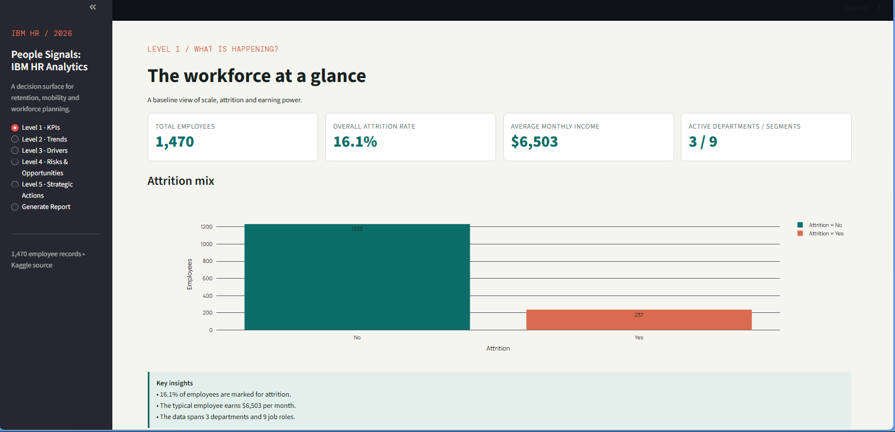

LEVEL 2 TENURE LIFECYCLE & INCOME PROGRESSION TRENDS

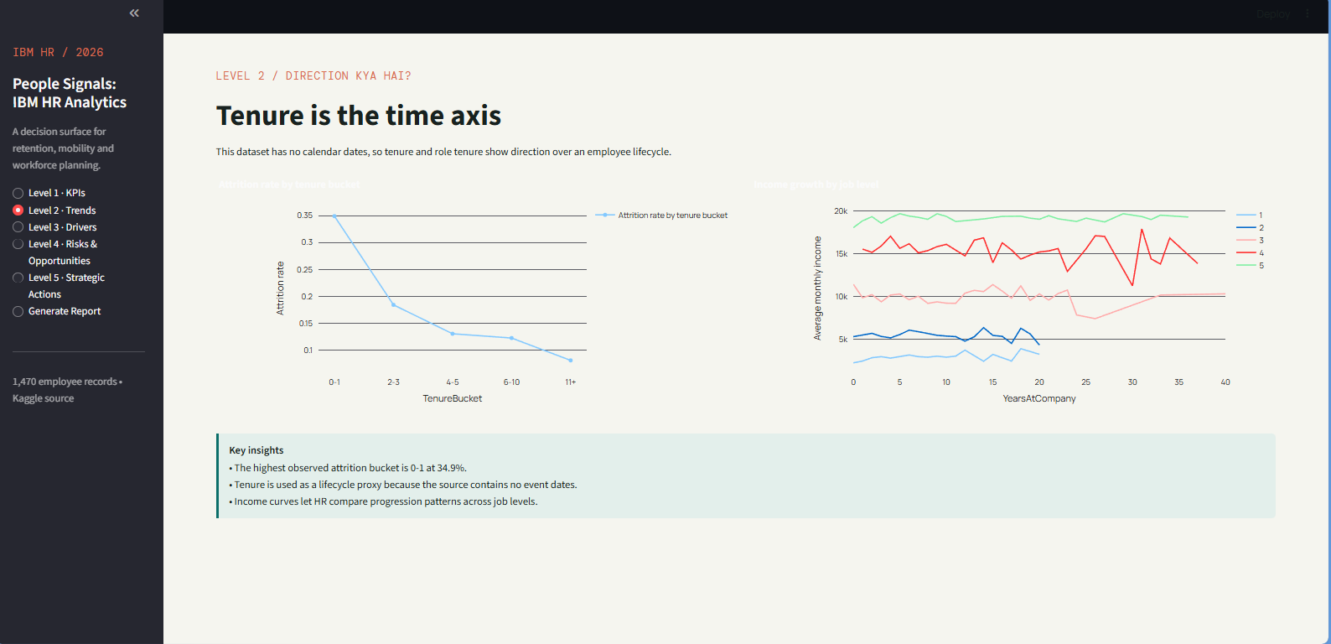

Visual Evidence: Drivers, Risks & Actions
LEVEL 3 ATTRITION DRIVERS (OVERTIME & JOB ROLES)

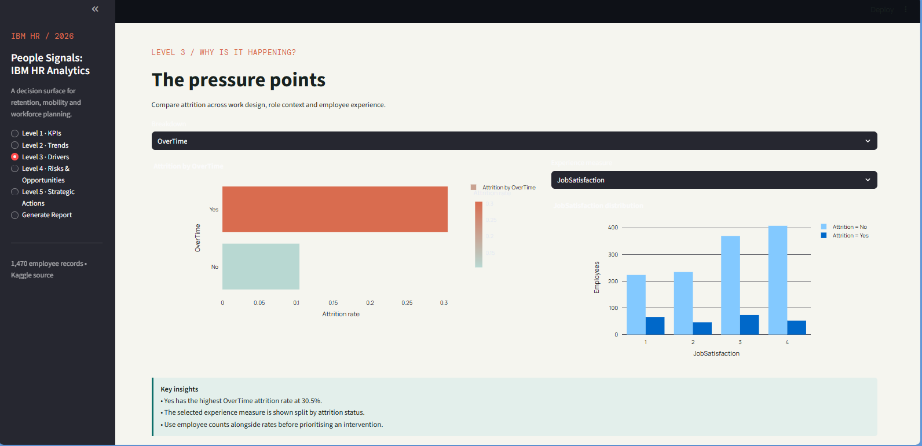

LEVEL 4 RISKS, ML PERFORMANCE

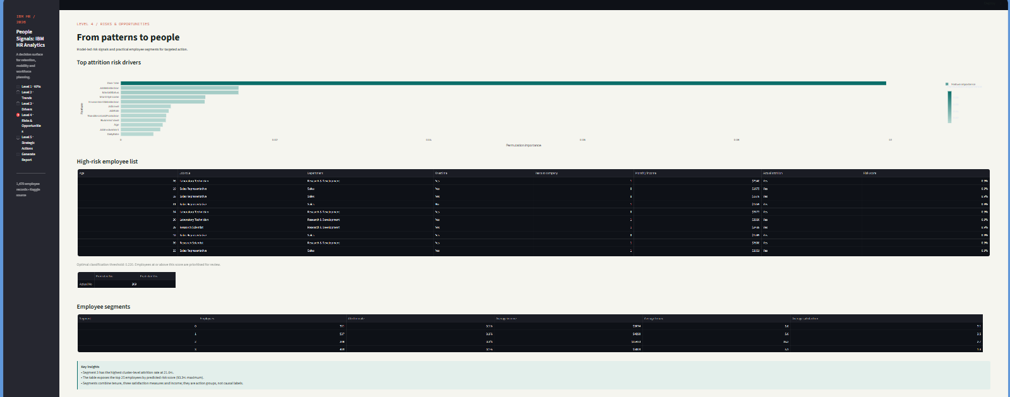

LEVEL 5 STRATEGIC ACTIONS

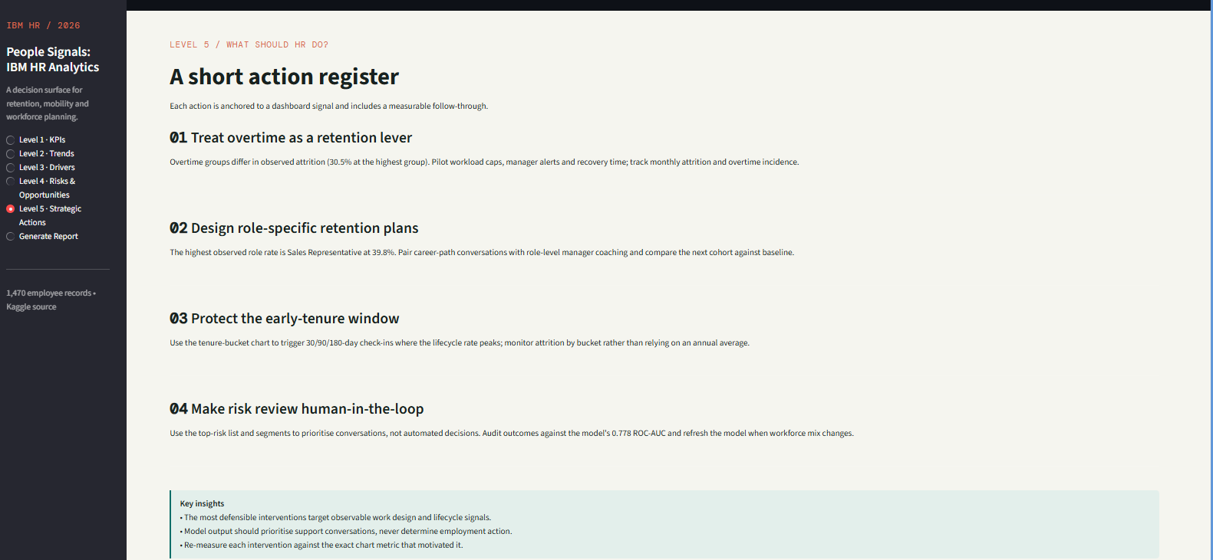

IN-APP REPORT EXPORT
The Generate Report page produces a current-state PDF containing calculated KPIs, model metrics, and methodological notes. This Word report is the manually authored capstone narrative; the PDF is the live dashboard-state export.

Strategic HR Recommendations & Prioritized Action Matrix
Initiative | Target driver | Expected HR impact | Timeline
Overtime workload caps and recovery-time alerts | 30.5% overtime-group attrition | Reduce sustained workload pressure and improve manager visibility. | 0-90 days pilot; quarterly review
Sales Representative coaching and career paths | 39.8% role turnover | Improve role confidence, progression clarity, and manager support. | 30-120 days
30/90/180-day onboarding check-ins | 34.9% early-tenure churn | Detect adjustment barriers before first-year attrition becomes irreversible. | Start immediately; monthly cohort review
Human-in-the-loop ML risk review | F1 0.522 at threshold 0.220 | Prioritise supportive conversations while protecting against automated decisions. | Design in 30 days; audit quarterly

Technical learning outcomes
- pandas: reproducible cleaning, ordered categorical variables, grouped metrics, and feature-frame construction.
- Streamlit: cached data and resource functions, multi-level navigation, Plotly integration, formatted dataframes, and PDF download flow.
- Plotly: high-contrast chart configuration, readable legends, data labels, and chronological categorical axes.
- scikit-learn: preprocessing pipelines, class-balanced modelling, GridSearchCV, cross-validation, threshold tuning, permutation importance, and KMeans.
- python-docx: structured report generation, professional styles, tables, borders, shaded callouts, screenshot placeholders, and page fields.

Formal references
1. Pavan Subhasht. IBM HR Analytics Employee Attrition & Performance Dataset. Kaggle. https://www.kaggle.com/datasets/pavansubhasht/ibm-hr-analytics-attrition-dataset
2. IBM SkillsBuild. Data Analytics with AI Internship learning resources, 2026. IBM SkillsBuild in collaboration with BharatCares / CSRBOX.
3. Pedregosa, F. et al. Scikit-learn: Machine Learning in Python. Journal of Machine Learning Research, 12, 2825-2830, 2011.
4. McKinney, W. Python for Data Analysis. O'Reilly Media.
5. Streamlit, Plotly, KaggleHub, ReportLab, and python-docx official documentation.
CONCLUSION
People Signals demonstrates how a compact, production-minded analytics application can move from workforce facts to defensible HR action. Its strongest contribution is the connection between measurable signals, transparent model trade-offs, and human-led retention planning.

