NETFLIX CONTENT STRATEGY & CATALOG ANALYTICS PLATFORM
A Business Intelligence Study on Catalog Velocity, Audience Maturity Demographics, and International Growth Whitespaces
Prepared By: Himanshu Pathak
Internship: IBM SkillsBuild Data Analytics with AI Internship 2026 (in collaboration with BharatCares / CSRBOX)
Date: 22 September 2026

Certificate of Originality
I declare that this project represents my independent analytical work on the Kaggle Netflix multi-attribute catalog dataset. The data preparation, metric definitions, visual analysis, strategic interpretation, and report generation were developed for this capstone submission. External libraries and references are acknowledged in the references section.

Acknowledgments
I acknowledge IBM SkillsBuild for the learning framework, BharatCares and CSRBOX for the internship context, mentors Kartik Hooda and Himanshu Souda for their guidance, and the open-source contributors whose tools enable reproducible data analysis.

Table of Contents
- Executive Summary
- 1. Introduction & OTT Streaming Context
- 2. Internship Framework & BI Mindset
- 3. Core KPI Framework Matrix
- 4. Dataset Architecture & Data Quality Audit
- 5. Analytical Deep-Dive & Findings
- 6. Visual Evidence Placeholders
- 7. Strategic Recommendations & Prioritized Action Matrix
- 8. Technical Learning Outcomes & References

Executive Summary
The current Kaggle snapshot contains 8,709 titles across 122 countries and 42 genres. Movies account for 70.4% of the catalog and TV shows account for 29.6%. Among TV shows, 69.5% have one season, indicating a material renewal and retention opportunity. The US and Canada remain the core mature-market portfolio, while India, South Korea, EMEA, and LATAM provide localization and whitespace opportunities.
Metrics are calculated dynamically from the downloaded source snapshot. The dataset's rating field is treated as a categorical audience maturity label, never as an IMDb-style quality score.

1. Introduction & OTT Streaming Context
Subscription streaming economics depend on a portfolio that acquires subscribers, supports ongoing engagement, and limits churn. Content acquisition must therefore be evaluated alongside renewal depth, audience breadth, regional relevance, and catalog freshness. This platform translates title-level metadata into an executive decision system for content strategy.
The analysis distinguishes catalog supply from audience quality. Genre, country, runtime, season count, release year, addition date, and maturity labels describe portfolio structure; they do not independently measure viewing hours, completion, or subscriber lifetime value.

2. Internship Framework & Business Intelligence Mindset
The project follows a five-level BI hierarchy: raw data becomes validated information; descriptive KPIs establish what exists; time trends show how the portfolio changes; driver analysis explains structural composition; risk and whitespace analysis identifies management concerns; and strategic actions convert evidence into decisions.
BI Level | Management Question | Platform Output
1. Executive Overview | What is the portfolio position? | Title count, mix, reach, diversity
2. Trends | How is content velocity changing? | Yearly trajectory and monthly seasonality
3. Drivers | What explains portfolio shape? | Genres, runtime, seasons, maturity
4. Risks & Whitespace | Where is exposure or opportunity? | Aging, churn, skew, regions
5. Actions | What should management do? | Prioritized action matrix

3. Core KPI Framework Matrix
Metric | Value | Calculation Method | Business Impact
Total Titles | 8,709 | Count of catalog rows | Portfolio scale
Movies | 6,131 (70.4%) | Movie rows / total rows | Film-led portfolio balance
TV Shows | 2,578 (29.6%) | TV rows / total rows | Episodic retention base
Global Reach | 122 | Distinct countries in country field | Localization footprint
Content Diversity | 42 | Distinct listed genres | Choice breadth

4. Dataset Architecture & Data Quality Audit
The application downloads shivamb/netflix-shows through kagglehub, identifies the CSV artifact, validates source fields, normalizes dates and numeric duration values, and derives audience and season fields without changing the source rating semantics.
Field / Check | Observed Result | Interpretation
Rows | 8807 | Source snapshot size
Columns | 12 | Multi-attribute catalog schema
Missing directors | 29.91% | Metadata completeness limitation
Missing countries | 9.44% | Geographic attribution limitation
Rating definition | Categorical maturity label | Not an IMDb score or quality metric
Duplicate rows | 0 | Validation control

5. Analytical Deep-Dive & Findings
Content velocity is measured from date_added using yearly acquisition counts and a monthly seasonality curve. Runtime analysis uses minute values for movies only. TV retention structure is measured from season counts for TV rows only, avoiding the common schema error of treating movie runtimes as TV seasons.
The current TV portfolio contains 2,578 shows, of which 69.5% are single-season. Audience maturity segmentation groups ratings into Adults (18+), Teens (13-17), Kids & Family (<13), and Not Rated. These buckets support portfolio breadth decisions without inventing a numeric quality score.

6. Visual Evidence Placeholders

LEVEL 1 EXECUTIVE OVERVIEW & KPI METRICS
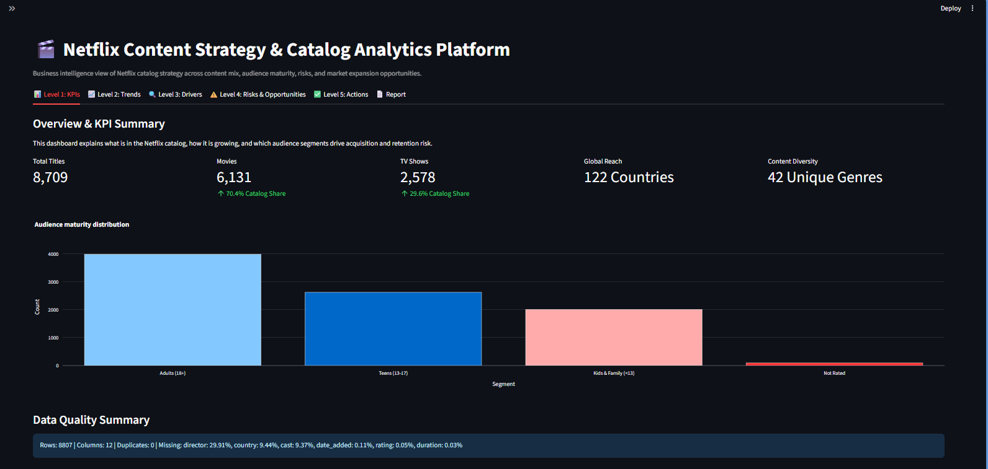

LEVEL 2 TRENDS & CONTENT VELOCITY CHARTS
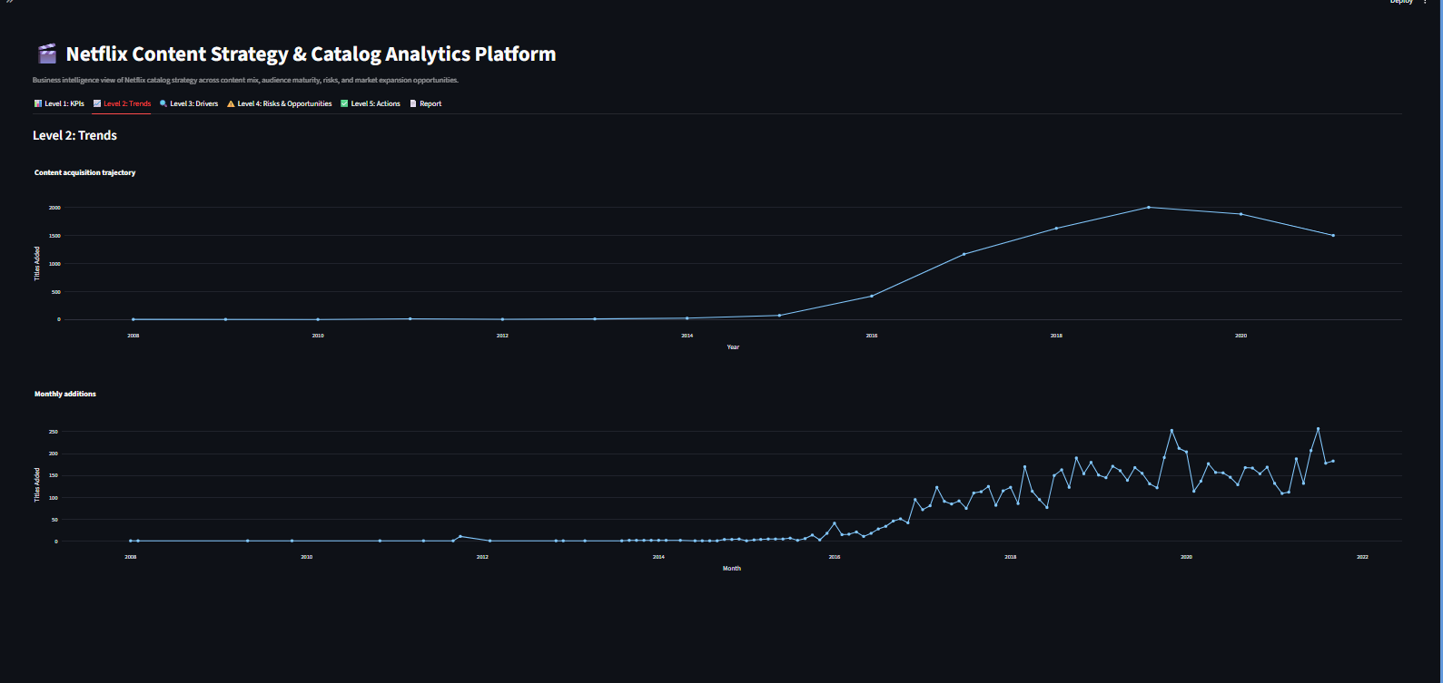

LEVEL 3 CONTENT DRIVERS & SEASON RETENTION
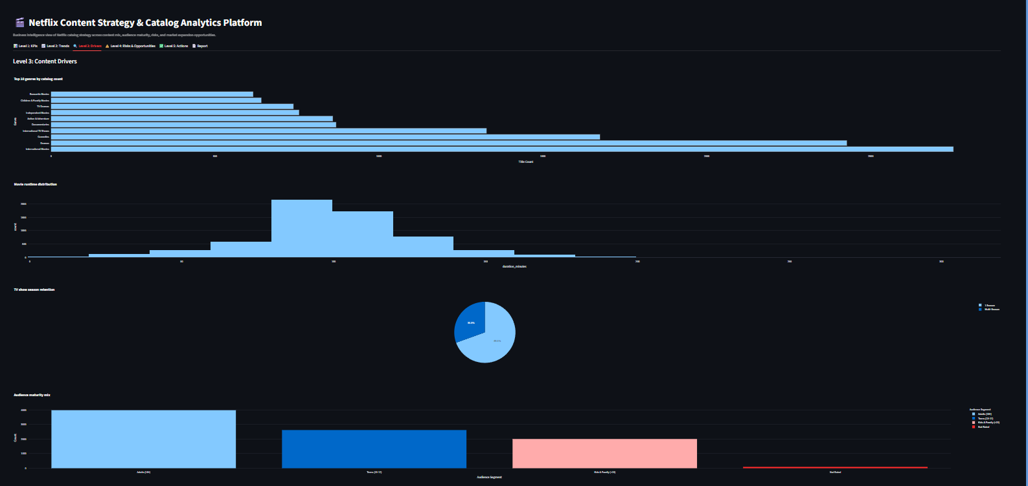

LEVEL 4 RISKS, OPPORTUNITIES
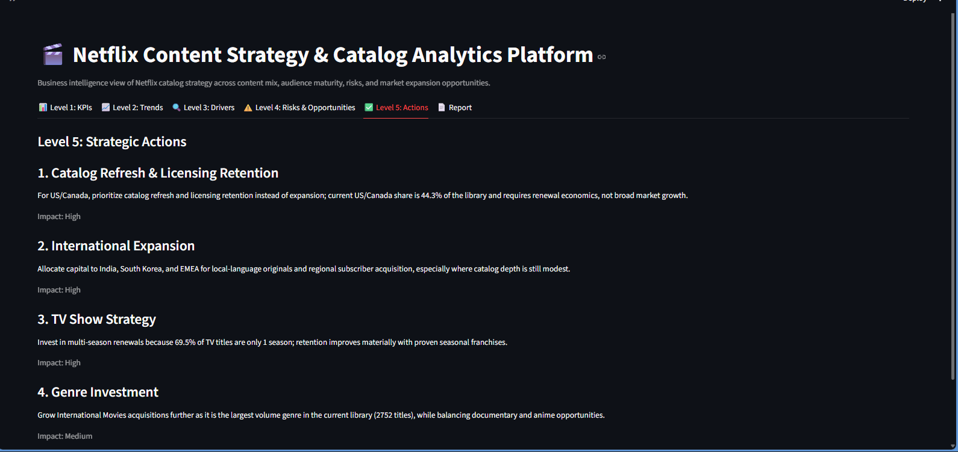
LEVEL 5 STRATEGIC ACTIONS
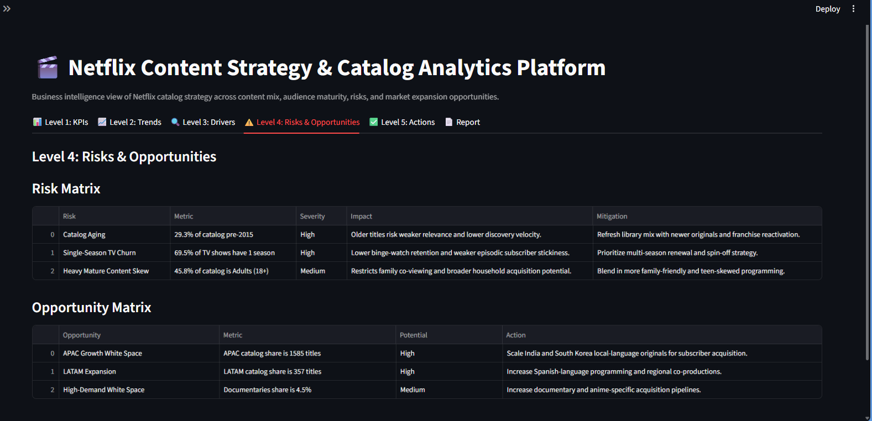

7. Strategic Recommendations & Prioritized Action Matrix
Initiative | Target Problem | Expected Business Impact | Implementation Timeline
US/Canada licensing retention | Mature-market saturation and catalog aging | Protect engagement and reduce avoidable churn | 0-6 months
India and South Korea local acquisition | APAC localization whitespace | Increase regional relevance and subscriber acquisition | 6-12 months
EMEA and LATAM expansion | Uneven international catalog depth | Broaden language and cultural coverage | 6-18 months
Multi-season renewals | Single-season TV churn exposure | Improve episodic retention and franchise value | 0-12 months

1. Catalog Refresh & Licensing Retention: For US/Canada, prioritize catalog refresh and licensing retention instead of expansion; current US/Canada share is 44.3% of the library and requires renewal economics, not broad market growth.
2. International Expansion: Allocate capital to India, South Korea, and EMEA for local-language originals and regional subscriber acquisition, especially where catalog depth is still modest.
3. TV Show Strategy: Invest in multi-season renewals because 69.5% of TV titles are only 1 season; retention improves materially with proven seasonal franchises.
4. Genre Investment: Grow International Movies acquisitions further as it is the largest volume genre in the current library (2752 titles), while balancing documentary and anime opportunities.

8. Technical Learning Outcomes & References
This project developed skills in schema validation, pandas transformation, Streamlit caching and layout, Plotly visual analytics, categorical segmentation, business recommendation design, and automated Word report generation. The implementation remains intentionally consolidated in app.py to meet the single-file capstone constraint.
References:
Kaggle Netflix Titles dataset: https://www.kaggle.com/datasets/shivamb/netflix-shows
IBM SkillsBuild Data Analytics with AI curriculum and internship materials.
Streamlit, pandas, Plotly, kagglehub, and python-docx documentation.

