Industrial Internship Report on
"Smart City Traffic Pattern Analysis and Forecasting for Junction-wise Traffic Management"
Prepared by
Himanshu Agarwal

Executive Summary
This report provides details of the Industrial Internship provided by upskill Campus and The IoT Academy in collaboration with Industrial Partner UniConverge Technologies Pvt Ltd (UCT).
This internship was focused on a project/problem statement provided by UCT. I completed the project, including this report, within the internship period.
My project was building a data-driven traffic forecasting system for a smart city. Using hourly traffic data from four city junctions, I cleaned and explored the data, engineered date-time and holiday-related features, and trained Linear Regression and Random Forest models to forecast traffic volume. After tuning, the Random Forest model consistently outperformed the baseline across all four junctions. The results, including peak-hour patterns and feature importance, were translated into practical infrastructure and traffic-management recommendations for the city.
This internship gave me a very good opportunity to get exposure to industrial, real-world problems and to design and implement a complete data science solution for one. It was an overall great learning experience.

TABLE OF CONTENTS
1 Preface 3
2 Introduction 5
2.1 About UniConverge Technologies Pvt Ltd 5
2.2 About upskill Campus 9
2.3 The IoT Academy 9
2.4 Objectives of this Internship program 11
2.5 Reference 11
2.6 Glossary 11
3 Problem Statement 12
4 Existing and Proposed solution 13
5 Proposed Design/ Model 13
5.1 High Level Diagram (if applicable) 13
5.2 Low Level Diagram (if applicable) 14
5.3 Interfaces (if applicable) 15
6 Performance Test 16
6.1 Test Plan/ Test Cases 16
6.2 Test Procedure 16
6.3 Performance Outcome 16
7 My learnings 18
8 Future work scope 18

Preface
This report summarizes my Industrial Internship in Data Science and Machine Learning, completed with upskill Campus and UniConverge Technologies Pvt. Ltd.
Internships like this play an important role in career development because they bridge the gap between classroom learning and real industry problems, giving practical, hands-on exposure that theory alone cannot provide.
My project involved analyzing and forecasting traffic patterns at four junctions of a city, as part of a larger smart-city initiative aimed at improving traffic management and helping the government plan infrastructure more effectively.
I am thankful to upskill Campus and UniConverge Technologies (UCT) for the opportunity to work on a real, industry-relevant problem statement in a structured, mentored format.
The program was planned over 4 weeks: Week 1 covered problem understanding, data collection, and setup; Week 2 covered data cleaning, feature engineering, and exploratory data analysis; Week 3 covered baseline model building and evaluation; and Week 4 covered model tuning, final comparison, and infrastructure recommendations.
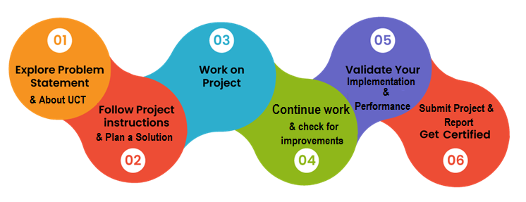
Through this internship, I learned the complete data science workflow end-to-end, from raw data to a working, evaluated forecasting model, and gained a much better understanding of how data science is applied to real infrastructure and planning problems. It significantly strengthened both my technical and documentation skills.
I would like to thank the mentors and team at upskill Campus and UniConverge Technologies Pvt. Ltd. for their guidance and support throughout this internship.
To my juniors and peers: take full advantage of the project-based structure of this internship. Don't just complete the steps, understand why each step (like using a chronological train/test split for time-series data) matters. It will help you far more than any theory-only course.

Introduction

About UniConverge Technologies Pvt Ltd
A company established in 2013 and working in Digital Transformation domain and providing Industrial solutions with prime focus on sustainability and RoI.
For developing its products and solutions it is leveraging various Cutting Edge Technologies e.g. Internet of Things (IoT), Cyber Security, Cloud computing (AWS, Azure), Machine Learning, Communication Technologies (4G/5G/LoRaWAN), Java Full Stack, Python, Front end etc.

- UCT IoT Platform ()
UCT Insight is an IOT platform designed for quick deployment of IOT applications on the same time providing valuable “insight” for your process/business. It has been built in Java for backend and ReactJS for Front end. It has support for MySQL and various NoSql Databases.
- It enables device connectivity via industry standard IoT protocols - MQTT, CoAP, HTTP, Modbus TCP, OPC UA
- It supports both cloud and on-premises deployments.
It has features to
• Build Your own dashboard
• Analytics and Reporting
• Alert and Notification
• Integration with third party application(Power BI, SAP, ERP)
• Rule Engine

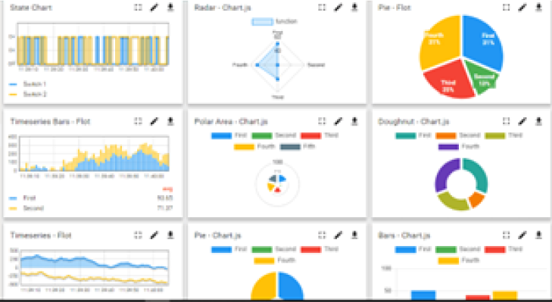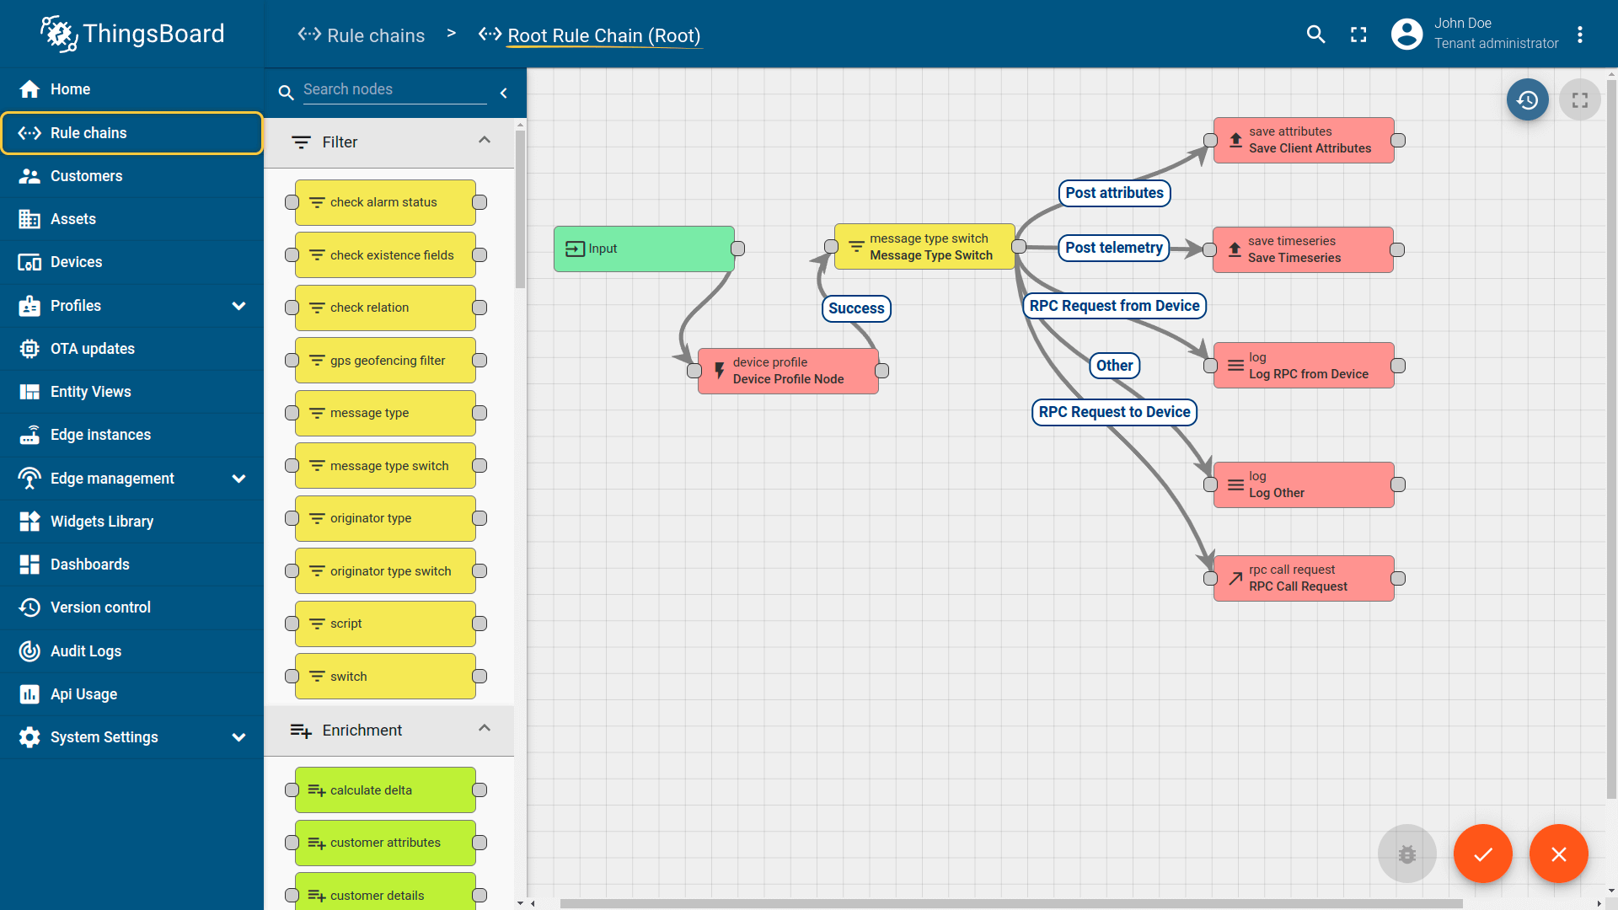

- Smart Factory Platform ()
Factory watch is a platform for smart factory needs.
It provides Users/ Factory
- with a scalable solution for their Production and asset monitoring
- OEE and predictive maintenance solution scaling up to digital twin for your assets.
- to unleased the true potential of the data that their machines are generating and helps to identify the KPIs and also improve them.
- A modular architecture that allows users to choose the service that they what to start and then can scale to more complex solutions as per their demands.
Its unique SaaS model helps users to save time, cost and money.
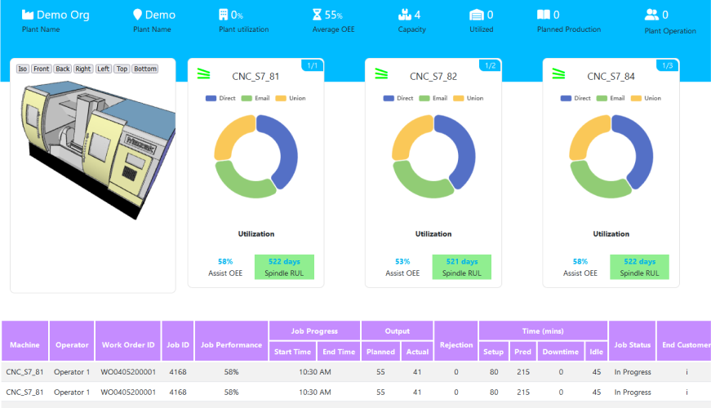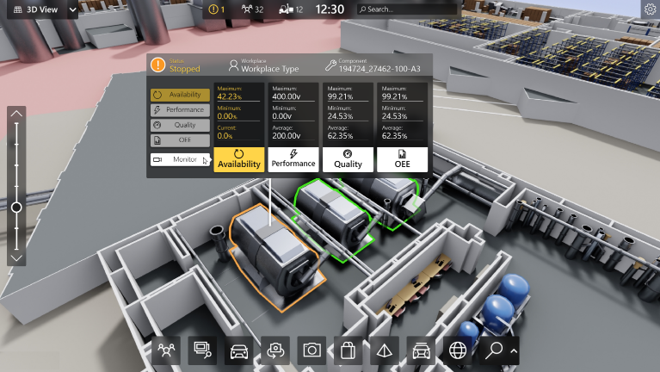

-  based Solution
UCT is one of the early adopters of LoRAWAN teschnology and providing solution in Agritech, Smart cities, Industrial Monitoring, Smart Street Light, Smart Water/ Gas/ Electricity metering solutions etc.
- Predictive Maintenance
UCT is providing Industrial Machine health monitoring and Predictive maintenance solution leveraging Embedded system, Industrial IoT and Machine Learning Technologies by finding Remaining useful life time of various Machines used in production process.
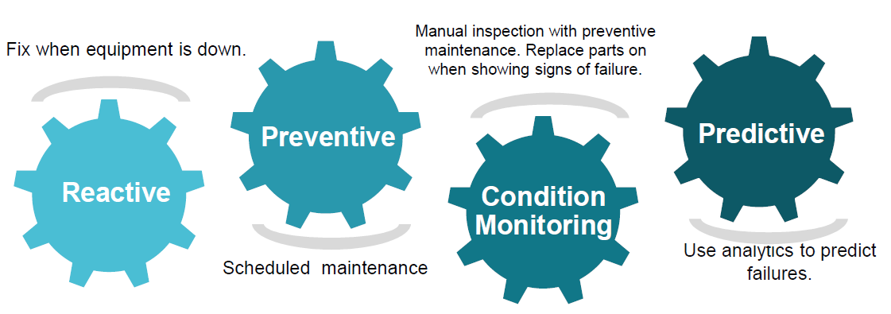

About upskill Campus (USC)
upskill Campus along with The IoT Academy and in association with Uniconverge technologies has facilitated the smooth execution of the complete internship process.
USC is a career development platform that delivers personalized executive coaching in a more affordable, scalable and measurable way.




Seeing need of upskilling in self paced manner along-with additional support services e.g. Internship, projects, interaction with Industry experts, Career growth Services
https://www.upskillcampus.com/
upSkill Campus aiming to upskill 1 million learners in next 5 year

The IoT Academy
The IoT academy is EdTech Division of UCT that is running long executive certification programs in collaboration with EICT Academy, IITK, IITR and IITG in multiple domains.

Objectives of this Internship program
The objective for this internship program was to
☛ get practical experience of working in the industry.
☛ to solve real world problems.
☛ to have improved job prospects.
☛ to have Improved understanding of our field and its applications.
☛ to have Personal growth like better communication and problem solving.

Reference
[1] scikit-learn documentation - https://scikit-learn.org
[2] pandas documentation - https://pandas.pydata.org
[3] Kaggle "Traffic Prediction Dataset" - reference schema for junction-wise hourly traffic data

Glossary
Terms | Acronym
EDA | Exploratory Data Analysis
MAE | Mean Absolute Error
RMSE | Root Mean Squared Error
RF | Random Forest
LR | Linear Regression

Problem Statement
In the assigned problem statement:
A city government is working towards becoming a smart city and wants to manage traffic more effectively at four major junctions. Traffic patterns differ significantly between normal working days, weekends, holidays, and special occasions, and the government needed a way to understand and forecast these patterns to plan infrastructure and traffic-signal timing more effectively, and to be better prepared for traffic peaks.

Existing and Proposed solution

Traditionally, traffic management at these junctions relied on fixed signal timings and manual observation, without a data-driven understanding of how traffic volume changes by hour, day of week, or holiday. This approach does not adapt to real patterns and can lead to unnecessary congestion during peak periods and under-utilized capacity during quiet periods.
My proposed solution uses historical hourly traffic data from all four junctions to build a forecasting pipeline: cleaning and feature engineering the data (hour, day of week, weekend flag, holiday flag), performing exploratory data analysis to uncover patterns, and training machine learning models (Linear Regression and Random Forest) to forecast traffic volume per junction.
The value addition is twofold: (1) a working, evaluated forecasting model that can predict traffic volume ahead of time for each junction, and (2) concrete, data-backed recommendations, peak-hour timings and feature importance, that can directly inform traffic-signal adjustments and infrastructure investment priorities.

Code submission (Github link)
https://github.com/Himanshu-Agarwal-2414/upskillCampus

Report submission (Github link)
https://github.com/Himanshu-Agarwal-2414/upskillCampus

Proposed Design/ Model

The overall design follows a standard, four-stage data science pipeline, matching the four-week internship structure: (1) Data Collection & Setup - loading and inspecting the raw hourly traffic dataset for all four junctions; (2) Data Cleaning & Feature Engineering - handling missing values/duplicates and creating hour, weekend, and holiday features; (3) Exploratory Data Analysis - visualizing traffic patterns by hour, weekday, and holiday; (4) Model Building & Evaluation - training and tuning Linear Regression and Random Forest models per junction, evaluated with MAE and RMSE, with a chronological train/test split to reflect real forecasting conditions.

High Level Diagram (if applicable)

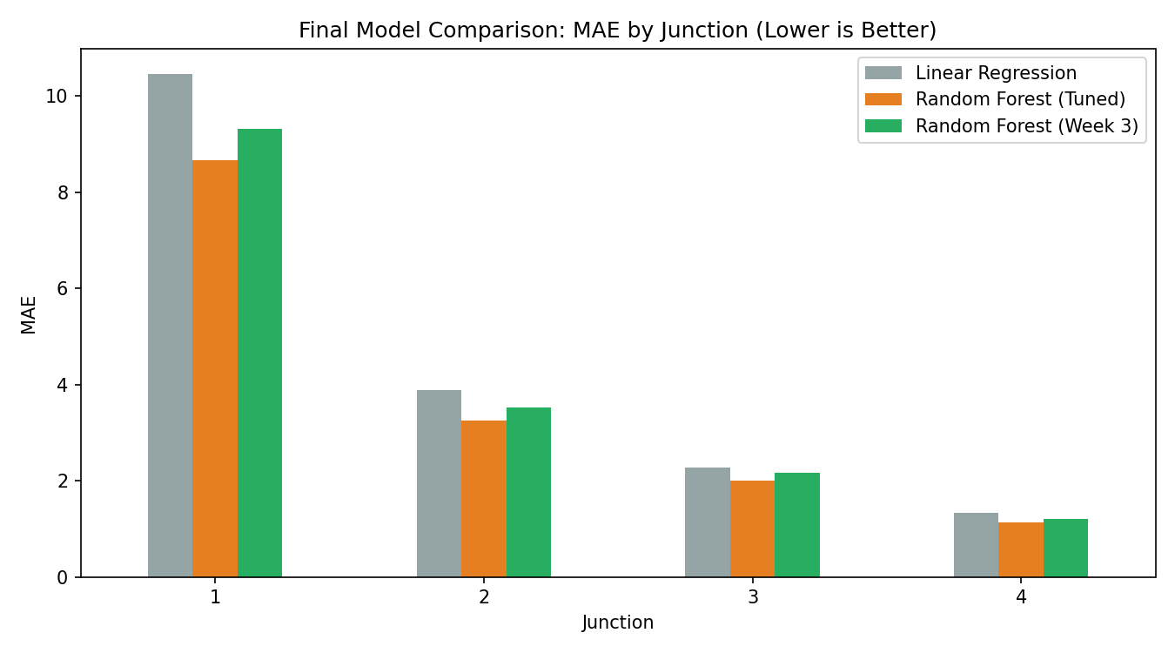

Figure 1: HIGH LEVEL DIAGRAM OF THE SYSTEM

Low Level Diagram (if applicable)
At a lower level, each junction is modeled independently. For each junction: input features (Hour, Day of Week, Month, Weekend flag, Holiday flag) are computed from the DateTime column; the data is split chronologically (85% train / 15% test); a Random Forest Regressor is trained and tuned via a small grid search validated on a held-out slice of the training period; and the final tuned model is evaluated on the untouched test set using MAE and RMSE.

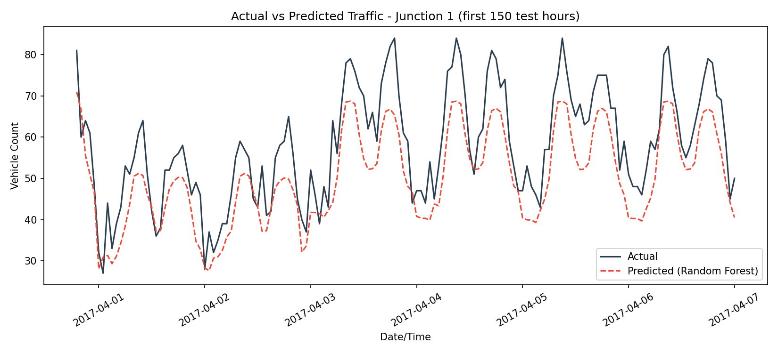

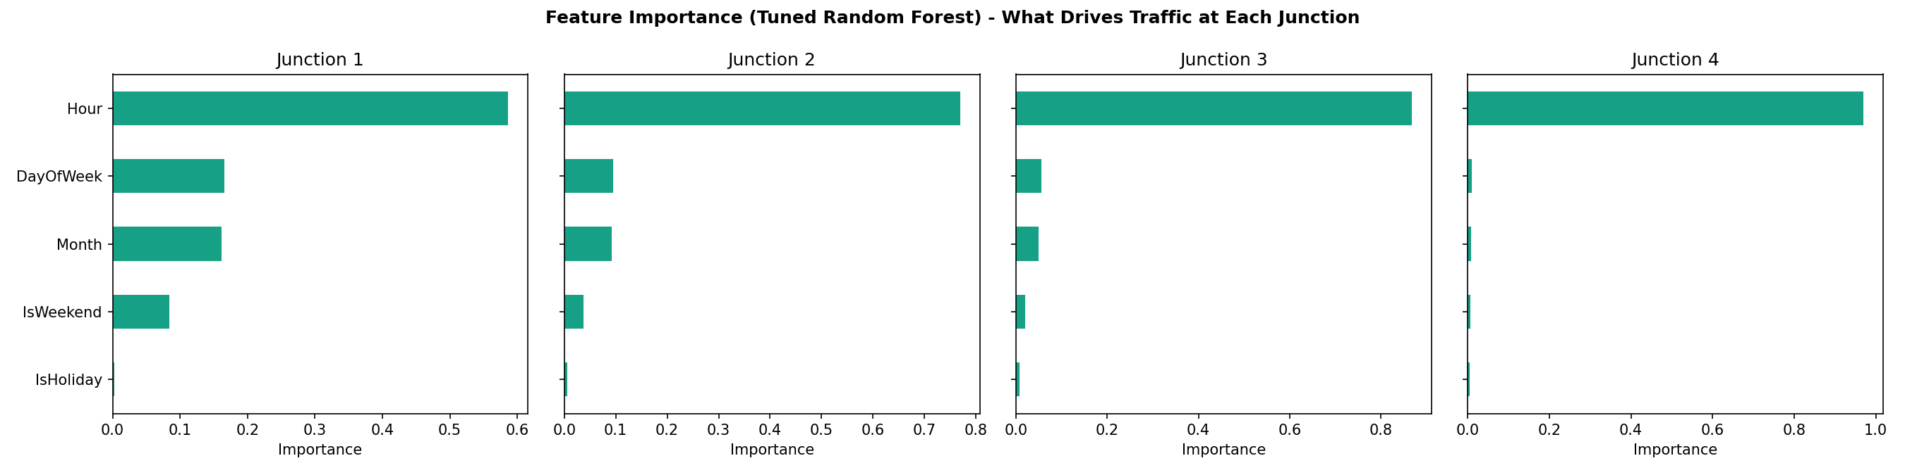

Interfaces (if applicable)
This project does not involve hardware or network interfaces. The functional interface is data-in/prediction-out: the pipeline accepts an hourly traffic CSV file (DateTime, Junction, Vehicles, ID) as input, and produces a cleaned/feature-engineered CSV, trained model objects, and forecasted traffic volumes with evaluation metrics as output.

Performance Test

For a traffic forecasting model, performance is best defined by prediction accuracy on unseen (future) data, since the model's practical value depends on how closely its forecasts match real traffic volumes.
The key constraint identified was avoiding data leakage from the future into training, since traffic data is time-ordered.
This was handled by using a chronological train/test split (train on the earliest ~85% of records, test on the most recent ~15%) instead of a random split, and by tuning hyperparameters only on a validation slice carved out of the training period, never touching the final test set until evaluation.
Test results (on the held-out chronological test set) showed the tuned Random Forest model achieved the lowest MAE and RMSE of all models tried, on every one of the four junctions, confirming it generalizes well to unseen, future-like data.
Constraints considered: forecasting accuracy (MAE, RMSE), and interpretability (feature importance) so that results could be turned into actionable recommendations for a non-technical audience such as city planners.
All identified constraints were tested directly within the available data, so no additional untested constraints remain outstanding.

Test Plan/ Test Cases
Test cases were defined per junction: for each of the 4 junctions, the trained model was evaluated on the chronologically held-out test set (the most recent ~15% of that junction's records), comparing Linear Regression, untuned Random Forest, and tuned Random Forest.

Test Procedure
For each junction: (1) train each model on the training split, (2) generate predictions on the test split, (3) compute MAE and RMSE against actual traffic counts, (4) repeat across all 4 junctions and record results in a comparison table.

Performance Outcome
The tuned Random Forest model achieved the lowest MAE and RMSE on all four junctions. Results:
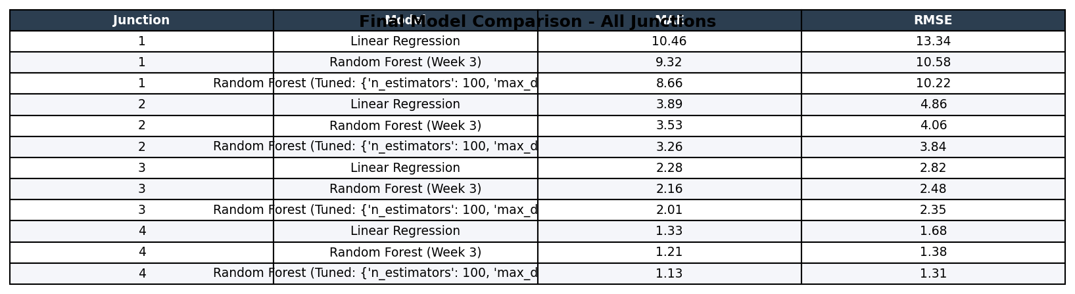

My learnings

This internship strengthened my end-to-end data science skills, from problem framing and data cleaning to model building, evaluation, and communicating results. Key takeaways include: the importance of a chronological train/test split for time-series data, how feature engineering (hour, weekend, holiday flags) can meaningfully improve model performance, how to responsibly tune hyperparameters without overfitting to the test set, and how to translate technical outputs like feature importance into clear, actionable recommendations for non-technical stakeholders. These are directly applicable to future data science roles and projects.

Future work scope

Future extensions of this project could include: incorporating weather data as an additional feature; using more advanced time-series models (e.g., ARIMA, LSTM) for comparison; building a live dashboard for real-time traffic monitoring and forecasting; and extending the model to recommend dynamic, real-time traffic-signal timing changes rather than static historical recommendations.

