SALESFORCE MARKETING CLOUD
Admin-AuditTrailMaster

Contents
Contents 2
Summary 4
1. Document Control 5
1.1 Version History 5
1.2 Purpose 5
1.3 Scope and Sources 5
2. Definitions and Acronyms 6
3. Overview 7
3.1 Purpose 7
3.2 Business Context 7
3.3 Key Benefits 7
3.4 Components 7
4. Architecture and Data Flow 8
4.1 End-to-End Flow 8
4.2 Pipeline Stages 8
4.3 Data Lineage 9
5. Automation 10
5.1 Automation Overview 10
5.2 Automation Summary 10
5.3 Schedule Configuration 11
5.4 Workflow 11
5.5 Run History and Health 12
6. Workflow Activities 13
6.1 Step 1 – Initialization and Audit Log Extraction 13
Activity 1.1 – DeleteUser (SQL Query) 13
Activity 1.2 – AuditTrailAcessLog (Data Extract) 14
Activity 1.3 – AuditTrailActivityLog (Data Extract) 15
Activity 1.4 – AuditTrailActivityLog_Temp_Clear (SQL Query) 16
6.2 Step 2 – User Extraction and SFTP Staging 18
Activity 2.1 – Extract_User (Script) 18
Activity 2.2 – SRQ_AuditTrailAccessLog (File Transfer) 21
Activity 2.3 – AuditTrailActivityLog_MCFTP (File Transfer) 22
6.3 Step 3 – Transformation and Import 23
Activity 3.1 – User_Extract_Import (SQL Query) 23
Activity 3.2 – AuditTrailAccessLog_Import_FIle (Data Copy or Import) 24
Activity 3.3 – AuditTrailActivityLog_Import_FIle (Data Copy or Import) 26
Activity 3.4 – AuditTrailActivityLog_Append (SQL Query) 28
Activity 3.5 – Email_Extract_Log_1day (SQL Query) 29
6.4 Step 4 – Consolidation and Extract 31
Activity 4.1 – Daily_User_Extract (Data Extract) 31
Activity 4.2 – AuditTrailAccessLog_Append (SQL Query) 32
Activity 4.3 – Email_Activity_Extract_1day (Data Extract) 33
6.5 Step 5 – File Delivery to SFTP 35
Activity 5.1 – Daily_User_Extract_MCFTP (File Transfer) 35
Activity 5.2 – Email_Activity_Extract_1day_MCFTP (File Transfer) 36
7. Data Extensions 37
7.1 Data Extension Inventory 37
7.2 User_Extract 37
7.2.1 Attributes 38
7.3 User_Extract_Import 39
7.4 AuditTrailAccessLog_Temp 40
7.5 AuditTrailAccessLog 41
7.6 AuditTrailActivityLog_Temp 42
7.7 AuditTrailActivityLog 43
7.8 DataView_Sent_Daily 44
7.9 Email_ActivityExtract_lastOneDay 45
8. File Delivery and Output Files 46
8.1 Delivered Files 46
8.2 Transfer and Import Settings 46
9. Quick Reference 48
9.1 Activity Quick Reference 48

Summary
Admin-AuditTrailMaster is a Salesforce Marketing Cloud (SFMC) automation that runs once a day. Its job is to collect a record of who accessed SFMC and what they did, add useful context about users and email sending, keep a running history of that information, and hand it to Splunk, the monitoring tool, so access can be reviewed and compliance expectations met. No one has to run it by hand.
The short version
Input: SFMC Audit Trail access and activity logs, the SFMC user list, and the last day of email sends.
Process: 17 activities in 5 steps, every day at 6:41 AM Eastern Time.
Output: 4 CSV files delivered to the KPMG SFTP Splunk_Prod location for Splunk, plus cumulative history kept in SFMC.

The process in five steps
Step | What happens | Result
1. Prepare and extract | The previous day’s Audit Trail access and activity logs are requested from SFMC, and the working data extensions are cleared ready for fresh data. | Two log files written to the Safehouse.
2. Collect users and stage logs | A script pulls the SFMC user list, and the two log files are moved from the Safehouse to the SFTP location. | User list ready; access and activity log files on SFTP.
3. Transform and import | The log files are imported into temporary data extensions, the activity log is appended to its master, user names are masked, and the last day of email activity is gathered. | Staged data and a growing activity history.
4. Consolidate and export | The access log is appended to its master, and the user list and email activity are written out as CSV files. | Two more files written to the Safehouse.
5. Deliver | The user and email activity files are moved to the SFTP location. | All four files available to Splunk.

Along the way, two safeguards apply: user names are reduced to first name and surname initial, and service accounts are excluded. The four delivered files are the access log, the activity log, the user list and the email activity extract.
Where to find more detail
Section 4 shows the end-to-end data flow and how each data stream travels from source to delivered file. Section 5 covers the schedule and run health. Section 6 documents every activity in order, Section 7 the data extensions, Section 8 the delivered files, and Section 9 is a one-page activity quick reference.

1. Document Control

1.1 Version History
Version | Date | Changed By | E-mail | Change
1.0 | 11/02/2026 | Megha Kurl | mkurl@kpmg.com | Created the document.

1.2 Purpose
This document is the single technical and operational reference for the Admin-AuditTrailMaster automation and the Salesforce Marketing Cloud (SFMC) components it depends on — including its 17 activities (SQL queries, data extracts, a script, file transfers and imports), the data extensions they read and write, and the files delivered to SFTP for Splunk.

1.3 Scope and Sources
The document describes the automation as configured in SFMC Automation Studio. Configuration values, external keys, record counts and run statistics were taken from screenshots of the automation (Summary, Workflow and Activity tabs), each activity, and each data extension. Where a value is truncated in the SFMC user interface, this is noted in the relevant section.
Automation | Admin-AuditTrailMaster
Environment | Production (delivery to KPMG SFTP Splunk_Prod)
Status captured | Run statistics through 10/28/2026; automation last saved 06/26/2026 2:03 PM
Time zones | Schedule: (GMT-05:00) Eastern Time (US & Canada). Audit Trail and data extract activities: (GMT-06:00) Central Standard Time.

2. Definitions and Acronyms
Term | Definition
SFMC | Salesforce Marketing Cloud.
Safehouse | The SFMC secure file area where extract files are first written before they are moved to an external location.
SFTP / KPMG SFTP Splunk_Prod | The production SFTP file location used by this automation to stage files for Splunk ingestion.
MCFTP | Suffix used in the names of File Transfer activities that move extract files to the SFTP location.
Splunk | Log and data monitoring platform that ingests the files delivered by this automation.
EID / MID | Enterprise ID and Member ID — SFMC account identifiers present in the Audit Trail activity log.
ET / CST | Eastern Time (schedule time zone) and Central Standard Time (extract time zone).

3. Overview

3.1 Purpose
Admin-AuditTrailMaster is a daily automation that extracts SFMC audit logs, user metadata and email activity; enriches and consolidates the data for monitoring and compliance; keeps cumulative history of the access and activity logs in master data extensions; and delivers the output files to SFTP for Splunk ingestion and downstream monitoring.

3.2 Business Context
SFMC records who accessed the platform and what they did. To monitor access, review administrator activity and meet compliance expectations, these records need to be collected consistently, joined with user and email activity context, and made available in the organization’s monitoring tool.
The automation runs once a day. It extracts the previous day’s Audit Trail access and activity logs, stages and imports them, appends them to long-term data extensions, prepares a masked user list and a daily email activity extract, and places four CSV files on the KPMG SFTP location where Splunk collects them.

3.3 Key Benefits
- Automated, daily collection of Audit Trail access and activity logs with no manual extraction.
- Cumulative history retained in the AuditTrailAccessLog and AuditTrailActivityLog data extensions.
- Privacy-aware user data — user names are reduced to first name and surname initial, and service accounts are excluded.
- Single delivery point — four files are published daily to one SFTP location for Splunk ingestion.

3.4 Components
Component | Type | Name | Location
Automation | Automation Studio | Admin-AuditTrailMaster | my automations > 20. Audit Trail Logs > B. Daily
SQL Query activities (6) | Query | 1.1, 1.4, 3.1, 3.4, 3.5, 4.2 | Query > 20. Audit Trail Logs > Admin-AuditTrailMaster
Data Extract activities (4) | Extract | 1.2, 1.3, 4.1, 4.3 | Automation Studio activities
Script activity (1) | SSJS | 2.1 Extract_User | Scripts > 20. Audit Trail Logs > Admin-AuditTrailMaster
File Transfer activities (4) | Transfer | 2.2, 2.3, 5.1, 5.2 | Safehouse → KPMG SFTP Splunk_Prod
Import activities (2) | Data Copy or Import | 3.2, 3.3 | KPMG SFTP Splunk_Prod → staging DEs
Data Extensions (8) | Standard DE | User_Extract, User_Extract_Import, AuditTrailAccessLog(_Temp), AuditTrailActivityLog(_Temp), DataView_Sent_Daily, Email_ActivityExtract_lastOneDay | Data Extensions > 20. Audit Trail Logs and related folders (Section 7)

4. Architecture and Data Flow

4.1 End-to-End Flow
The automation processes four data streams in parallel across five sequential steps. Audit Trail logs are extracted to the Safehouse, moved to SFTP, imported into staging data extensions and appended to master data extensions. User metadata is retrieved with a script, transformed and exported. Email activity is read from a data view, staged and exported. Files for Splunk are delivered to SFTP in Steps 2 and 5.
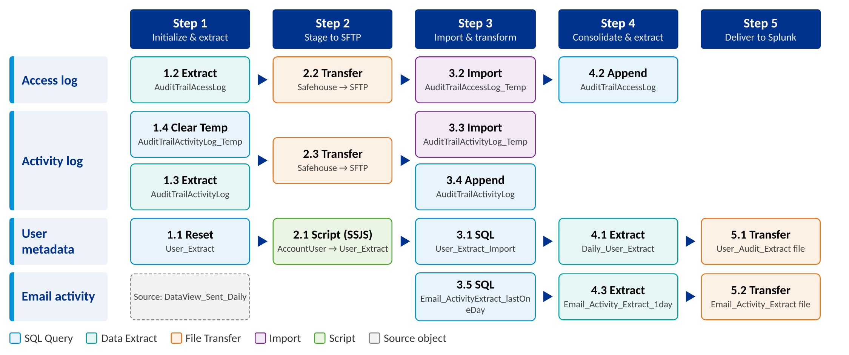
Figure 1. End-to-end data flow of the Admin-AuditTrailMaster automation

4.2 Pipeline Stages
Step | Purpose | Activities
Step 1 – Initialization and Audit Log Extraction | Initialize User_Extract, run the Audit Trail access and activity log extracts, and clear AuditTrailActivityLog_Temp for fresh data processing. | 1.1 DeleteUser, 1.2 AuditTrailAcessLog, 1.3 AuditTrailActivityLog, 1.4 AuditTrailActivityLog_Temp_Clear
Step 2 – User Extraction and SFTP Staging | Extract AccountUser data via WSProxy into User_Extract and transfer the audit log extract files from Safehouse to SFTP. | 2.1 Extract_User, 2.2 SRQ_AuditTrailAccessLog, 2.3 AuditTrailActivityLog_MCFTP
Step 3 – Transformation and Import | Transform user data, import the audit log files into temporary DEs, append activity logs, and extract daily email activity into staging DEs. | 3.1 User_Extract_Import, 3.2 AuditTrailAccessLog_Import_FIle, 3.3 AuditTrailActivityLog_Import_FIle, 3.4 AuditTrailActivityLog_Append, 3.5 Email_Extract_Log_1day
Step 4 – Consolidation and Extract | Prepare the user and email activity datasets for export and append audit access records into the final reporting data extensions. | 4.1 Daily_User_Extract, 4.2 AuditTrailAccessLog_Append, 4.3 Email_Activity_Extract_1day
Step 5 – File Delivery to SFTP | Transfer the user and email activity extract files from Safehouse to SFTP for Splunk ingestion and downstream monitoring. | 5.1 Daily_User_Extract_MCFTP, 5.2 Email_Activity_Extract_1day_MCFTP

4.3 Data Lineage
Data stream | Source | Staging | Master / output DE | Delivered file
Access log | Audit Trail Access Log (1.2) | AuditTrailAccessLog_Temp (3.2) | AuditTrailAccessLog (4.2) | AuditTrailAccessLog_*.csv (2.2)
Activity log | Audit Trail Activity Log (1.3) | AuditTrailActivityLog_Temp (1.4, 3.3) | AuditTrailActivityLog (3.4) | AuditTrailActivityLog_*.csv (2.3)
User metadata | AccountUser via WSProxy (2.1) | User_Extract (1.1, 2.1) | User_Extract_Import (3.1) | User_Audit_Extract_*.csv (4.1, 5.1)
Email activity | DataView_Sent_Daily (3.5) | — | Email_ActivityExtract_lastOneDay (3.5) | Email_Activity_Extract_*.csv (4.3, 5.2)

5. Automation

5.1 Automation Overview
The automation consolidates audit, user and email activity data and delivers it to SFTP. It contains 17 activities organized in 5 steps and is scheduled to run every day.
At a glance
Runs: Every day at 6:41 AM Eastern Time Activities: 17 in 5 steps Output: 4 CSV files on KPMG SFTP Splunk_Prod

5.2 Automation Summary
Automation Name | Admin-AuditTrailMaster
Folder Location | my automations / 20. Audit Trail Logs / B. Daily
External Key | 4d39df3a-9b30-70ae-11d3-88a9ec81eb80
Description | Extracts audit logs, user metadata, and email activity; enriches and consolidates data for monitoring and compliance, and delivers outputs to SFTP. (The description is truncated in the SFMC properties pane.)
Workflow | 17 activities in 5 steps
Status | Active

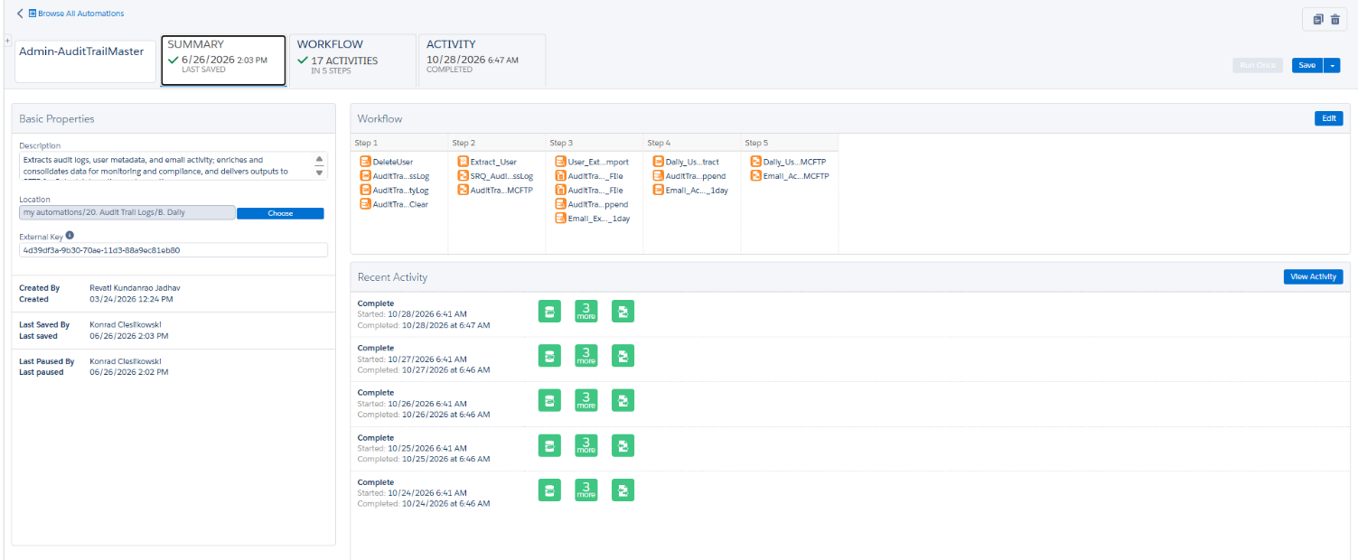
Figure 2. Automation Studio summary tab for Admin-AuditTrailMaster

5.3 Schedule Configuration
Schedule Type | Recurring Schedule
Repeat | Every 1 day
Starting | 06/26/2026, 6:41 AM
Ending | Never
Time Zone | (GMT-05:00) Eastern Time (US & Canada)
Next Run (at capture) | 10/29/2026, 6:41 AM
Status | Active

Time zones. The schedule runs on Eastern Time, while the Audit Trail and data extract activities are configured with Central Standard Time (GMT-06:00) and “Apply Time Zone: False”. Keep this in mind when comparing timestamps in the extracted files with the run time.

5.4 Workflow
The workflow contains five steps. Activities within a step run in parallel; a step starts only after the previous step has finished. Each step carries an annotation describing its role.
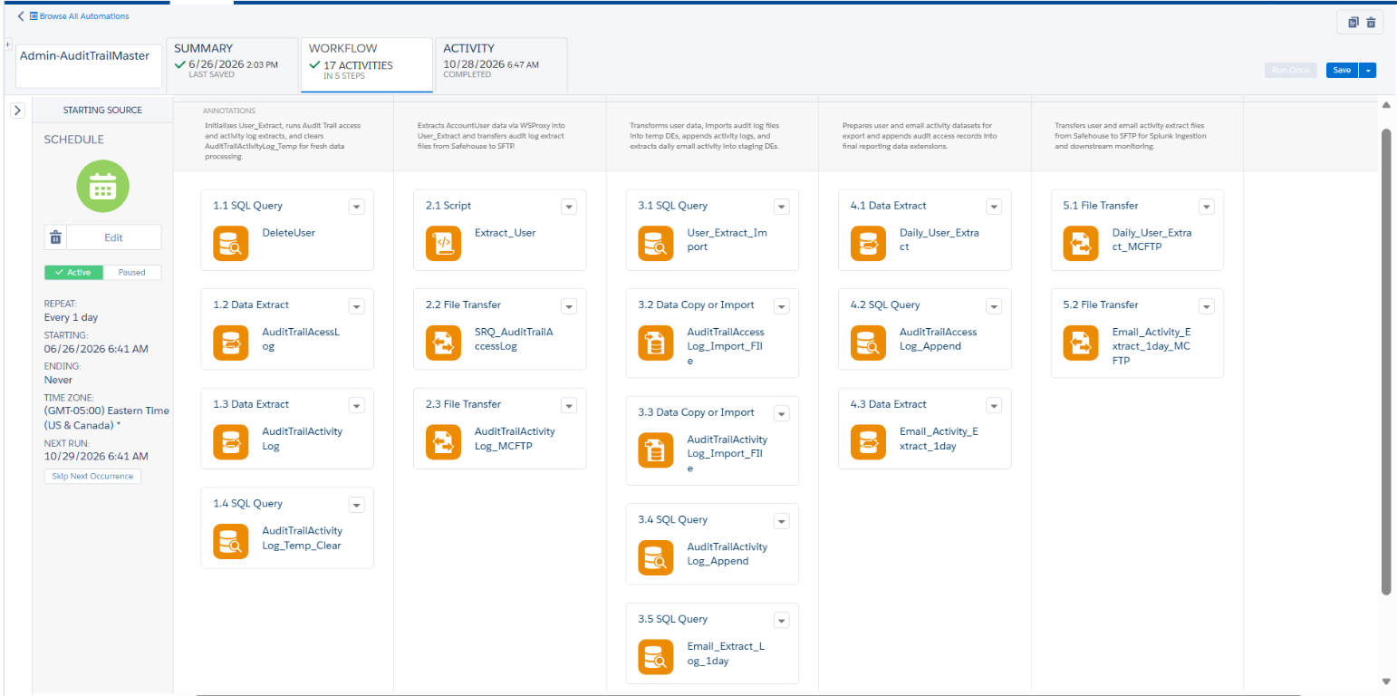
Figure 3. Automation Studio workflow for Admin-AuditTrailMaster
# | Type | Activity Name (as in SFMC) | Target / Output
1.1 | SQL Query | DeleteUser | User_Extract
1.2 | Data Extract | AuditTrailAcessLog | Safehouse file (Audit Trail Access Log)
1.3 | Data Extract | AuditTrailActivityLog | Safehouse file (Audit Trail Activity Log)
1.4 | SQL Query | AuditTrailActivityLog_Temp_Clear | AuditTrailActivityLog_Temp
2.1 | Script | Extract_User | User_Extract
2.2 | File Transfer | SRQ_AuditTrailAccessLog | KPMG SFTP Splunk_Prod
2.3 | File Transfer | AuditTrailActivityLog_MCFTP | KPMG SFTP Splunk_Prod
3.1 | SQL Query | User_Extract_Import | User_Extract_Import
3.2 | Data Copy or Import | AuditTrailAccessLog_Import_FIle | AuditTrailAccessLog_Temp
3.3 | Data Copy or Import | AuditTrailActivityLog_Import_FIle | AuditTrailActivityLog_Temp
3.4 | SQL Query | AuditTrailActivityLog_Append | AuditTrailActivityLog
3.5 | SQL Query | Email_Extract_Log_1day | Email_ActivityExtract_lastOneDay
4.1 | Data Extract | Daily_User_Extract | Safehouse file (User_Extract_Import)
4.2 | SQL Query | AuditTrailAccessLog_Append | AuditTrailAccessLog
4.3 | Data Extract | Email_Activity_Extract_1day | Safehouse file (Email_ActivityExtract_lastOneDay)
5.1 | File Transfer | Daily_User_Extract_MCFTP | KPMG SFTP Splunk_Prod
5.2 | File Transfer | Email_Activity_Extract_1day_MCFTP | KPMG SFTP Splunk_Prod

5.5 Run History and Health
The Activity tab shows the run log for the selected period (09/28/2026 – 10/28/2026) and overall health.
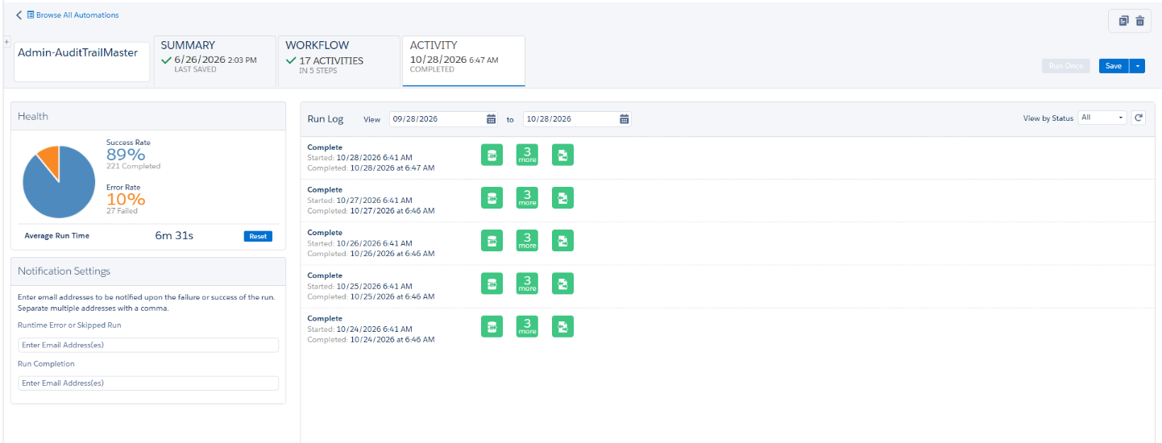
Figure 4. Automation Studio activity tab – health and run log

6. Workflow Activities
This section documents each of the 17 activities in execution order. Each activity lists its configuration, the SQL or script it runs where applicable, and the SFMC screenshots from which the values were taken.

6.1 Step 1 – Initialization and Audit Log Extraction
Role of the step: Initialize User_Extract, run the Audit Trail access and activity log extracts, and clear AuditTrailActivityLog_Temp for fresh data processing.

Activity 1.1 – DeleteUser (SQL Query)
Resets the User_Extract data extension. The query selects two null-valued columns with a condition that is never true (where 0 = 1), so it returns zero rows; combined with the Overwrite data action, every existing row in User_Extract is removed before the daily reload performed by Activity 2.1.
Activity Name | DeleteUser
Step / Position | Activity 1.1 (Step 1)
Activity Type | SQL Query Activity
External Key | C3FC6C37-2099-40DF-847B-16E187AA3EC7
Folder Location | Query
Description | —
Source | None (zero-row query)
Target Data Extension | User_Extract
Data Action | Overwrite (replaces all existing rows)

select
null as ID, null as userid
where 0 = 1

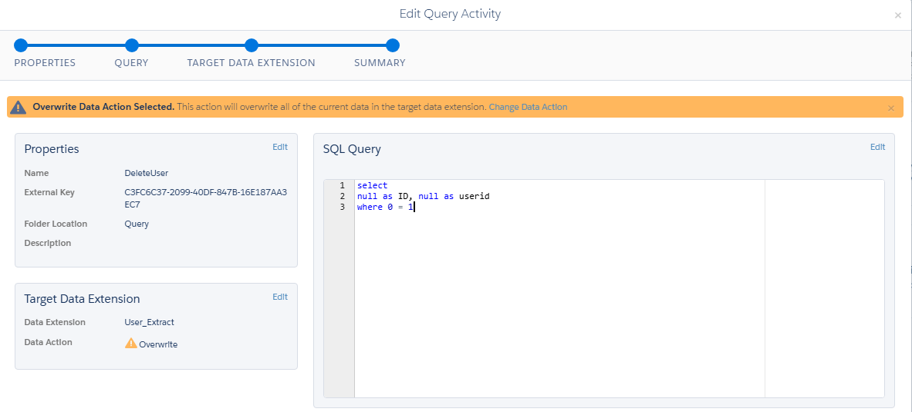
Figure 5. Activity 1.1 – DeleteUser: query activity summary

Activity 1.2 – AuditTrailAcessLog (Data Extract)
Runs the SFMC Audit Trail Access Log extract for a rolling one-day window. The output is a header-included CSV written to the account Safehouse, ready to be moved to SFTP by Activity 2.2. The activity name is spelled “AuditTrailAcessLog” in SFMC and is preserved here for traceability.
Activity Name | AuditTrailAcessLog (sic)
Step / Position | Activity 1.2 (Step 1)
Activity Type | Data Extract Activity
External Key | 23AF9D1D-1F94-462D-AC49-18761B7FD2D7
Description | —
Extract Type | Audit Trail Access Log
Date Range | Rolling Range: 1 Day
Apply Time Zone | False
Convert To ASCII | True
Include Header | True
Timezone | (GMT-06:00) Central Standard Time

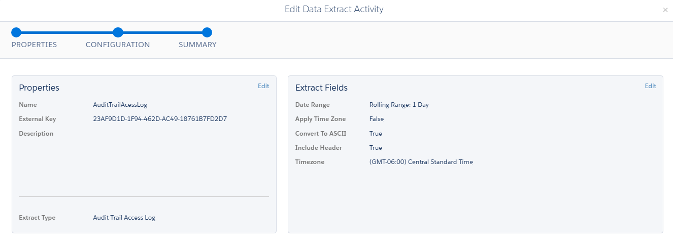
Figure 6. Activity 1.2 – AuditTrailAcessLog: data extract properties and configuration

Activity 1.3 – AuditTrailActivityLog (Data Extract)
Runs the SFMC Audit Trail Activity Log extract for a rolling one-day window, using the same configuration as Activity 1.2. The resulting file is moved to SFTP by Activity 2.3.
Activity Name | AuditTrailActivityLog
Step / Position | Activity 1.3 (Step 1)
Activity Type | Data Extract Activity
External Key | CCDA8A63-1C95-45E9-A2E2-72260A353560
Description | —
Extract Type | Audit Trail Activity Log
Date Range | Rolling Range: 1 Day
Apply Time Zone | False
Convert To ASCII | True
Include Header | True
Timezone | (GMT-06:00) Central Standard Time

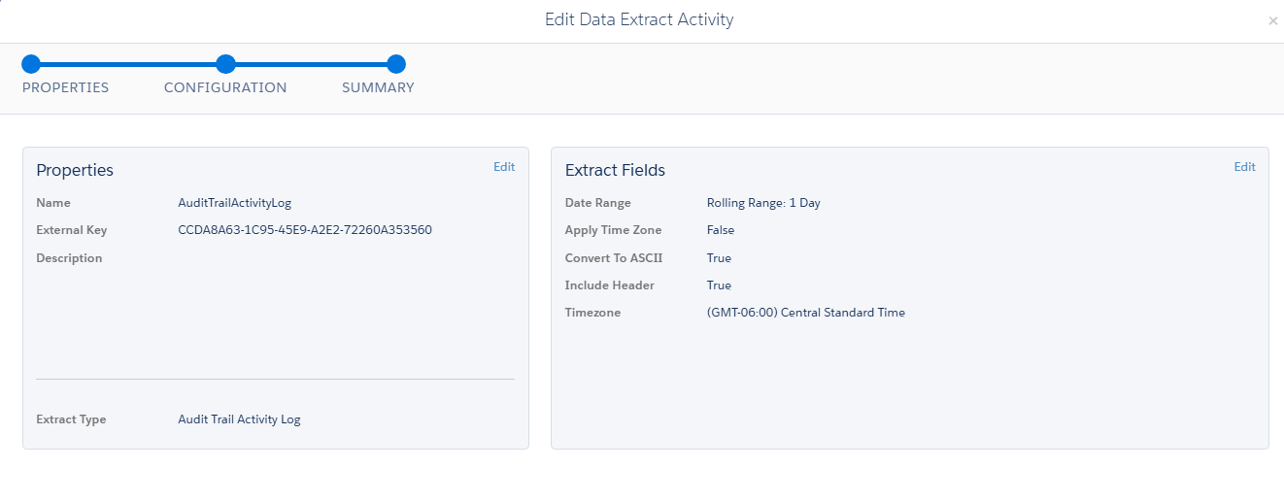
Figure 7. Activity 1.3 – AuditTrailActivityLog: data extract properties and configuration

Activity 1.4 – AuditTrailActivityLog_Temp_Clear (SQL Query)
Clears the staging data extension AuditTrailActivityLog_Temp. The query reads from the master AuditTrailActivityLog structure with a condition that is never true (1=0), returning zero rows; with the Overwrite action the staging DE is emptied so that only the current day’s file is processed.
Activity Name | AuditTrailActivityLog_Temp_Clear
Step / Position | Activity 1.4 (Step 1)
Activity Type | SQL Query Activity
External Key | a0307e60-c02a-426e-9a01-1db074cbc56b
Folder Location | Query/20. Audit Trail Logs/Admin-AuditTrailMaster
Description | —
Source | AuditTrailActivityLog (structure only; zero rows)
Target Data Extension | AuditTrailActivityLog_Temp
Data Action | Overwrite (replaces all existing rows)

select * from AuditTrailActivityLog where 1=0

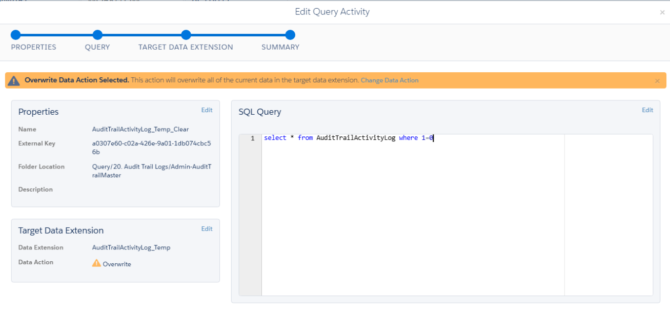
Figure 8. Activity 1.4 – AuditTrailActivityLog_Temp_Clear: query, properties and target data extension
Data extension details: Section 7.6 (AuditTrailActivityLog_Temp) and Section 7.7 (AuditTrailActivityLog).

6.2 Step 2 – User Extraction and SFTP Staging
Role of the step: Extract AccountUser data via WSProxy into User_Extract and transfer the audit log extract files from Safehouse to SFTP.

Activity 2.1 – Extract_User (Script)
A Server-Side JavaScript (SSJS) script that uses WSProxy to retrieve every AccountUser record through the SOAP API, selects the required fields, and inserts one row per user into the User_Extract data extension.
Activity Name | Extract_User
Step / Position | Activity 2.1 (Step 2)
Activity Type | Script Activity (SSJS)
External Key | 826b9ec3-7f84-448d-81d3-4058a9969b38
Folder Location | Scripts/20. Audit Trail Logs/Admin-AuditTrailMaster
Description | Retrieving user data, parsing specific fields, and then inserting that data into a Data Extension.
Core Library | Platform.Load("Core", "1.1.1")
SOAP Object Retrieved | AccountUser (via Script.Util.WSProxy)
Target Data Extension | User_Extract (via Platform.Function.InsertDE)
Error Handling | try / catch – writes “An error has occurred:” followed by the stringified exception

Processing logic
- Load the Core library (version 1.1.1) and create a WSProxy object.
- Define the column list to retrieve from the AccountUser object (ID, ActiveFlag, Email, Name, UserID, LastSuccessfulLogin, IsAPIUser, NotificationEmailAddress, IsLocked and related fields).
- Retrieve all matching AccountUser records with prox.retrieve("AccountUser", cols).
- Loop through the results and read ID, UserID, Name, ActiveFlag, LastSuccessfulLogin, NotificationEmailAddress, IsLocked, IsAPIUser, CreatedDate (formatted yyyy-MM-dd HH:mm:ss) and ModifiedDate.
- Insert each row into the User_Extract data extension; any exception is caught and written to the activity output.
Script (as displayed in SFMC)
<script runat="server">
// Load the Core library with version 1.1.1
Platform.Load("Core", "1.1.1");

try {

// Create a new WSProxy object to interact with SOAP API
var prox = new Script.Util.WSProxy();

// Define the columns to retrieve from the AccountUser object
var cols = ["ID", "ActiveFlag", "Email", "Name", "UserID", "ActiveFlag", "LastSuccessfulLogin", "IsAPIUser", "NotificationEmailAddress", "IsLocked", "IsAPIUse... // line truncated in screenshot

// Retrieve data from the "AccountUser" object using the WSProxy
var accountUsers = prox.retrieve("AccountUser", cols);

// Loop through the retrieved AccountUsers
for (var j = 0; j < accountUsers.Results.length; j++) {
var accountUser = accountUsers.Results[j];

// Extracting data from the AccountUser object
var ID = accountUser.ID;
var userId = accountUser.UserID;
var name = accountUser.Name;
var activeFlag = accountUser.ActiveFlag;
var lastSuccessfulLogin = accountUser.LastSuccessfulLogin;
var notificationEmail = accountUser.NotificationEmailAddress;
var isLocked = accountUser.IsLocked;
var isAPIUser = accountUser.IsAPIUser;
var CreatedDate = Format(accountUser.CreatedDate, "yyyy-MM-dd HH:mm:ss");
var ModifiedDate = accountUser.ModifiedDate;

// Insert data into a Data Extension named "User_Extract"
// The array defines the field names and values to insert
var rows = Platform.Function.InsertDE("User_Extract", ["ID", "userid", "name", "activeflag", "LastSuccessfulLogin", "NotificationEmailAddress", "IsLocked", ... // line truncated in screenshot
}
} catch (ex) {
// Handle any errors that occur during execution
Write("An error has occurred: " + Stringify(ex));
}
</script>

Two long lines are cut off at the right edge of the SFMC editor in the captured screenshots; they are shown here truncated with “...”. Open the activity in Automation Studio to view the full script.
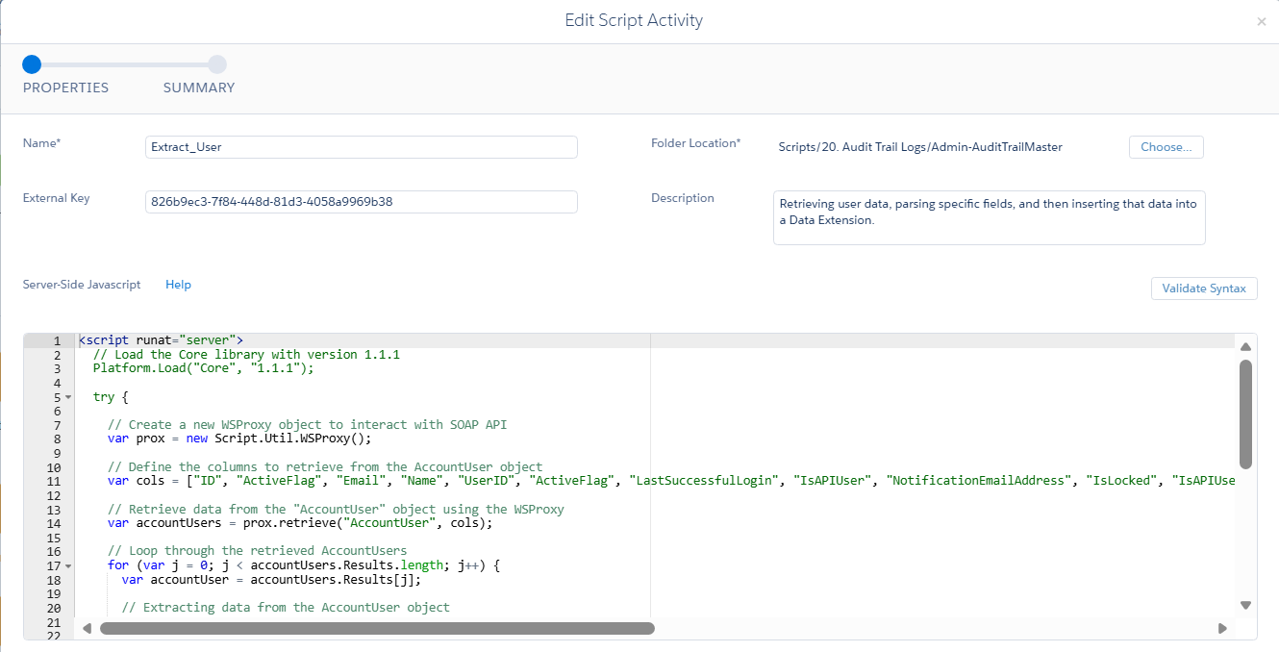
Figure 9. Activity 2.1 – Extract_User: properties and script (lines 1–22)
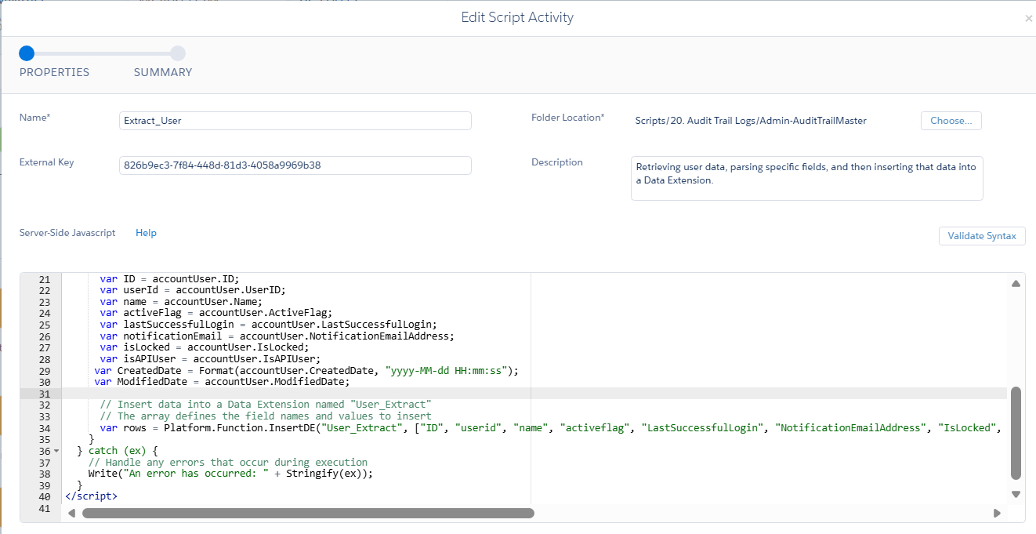
Figure 10. Activity 2.1 – Extract_User: script (lines 21–41)
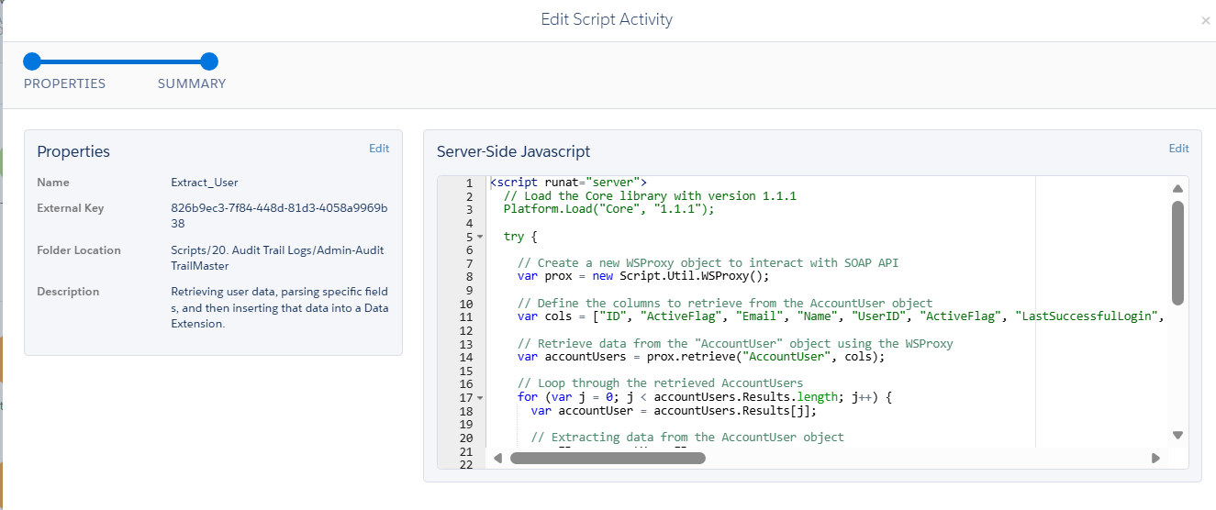
Figure 11. Activity 2.1 – Extract_User: summary tab
Target data extension: Section 7.2 (User_Extract).

Activity 2.2 – SRQ_AuditTrailAccessLog (File Transfer)
Moves the Audit Trail Access Log file produced by Activity 1.2 from the Safehouse to the production SFTP location used for Splunk ingestion.
Activity Name | SRQ_AuditTrailAccessLog
Step / Position | Activity 2.2 (Step 2)
Activity Type | File Transfer Activity
External Key | 1e688cf5-e915-4803-9e8c-913365d66186
Description | —
File Action | Move a File From Safehouse
File Naming Pattern | AuditTrailAccessLog_%%Year%%,%%Month%%,%%Day%%.csv
Destination | KPMG SFTP Splunk_Prod
Public Key | Production SSO Key

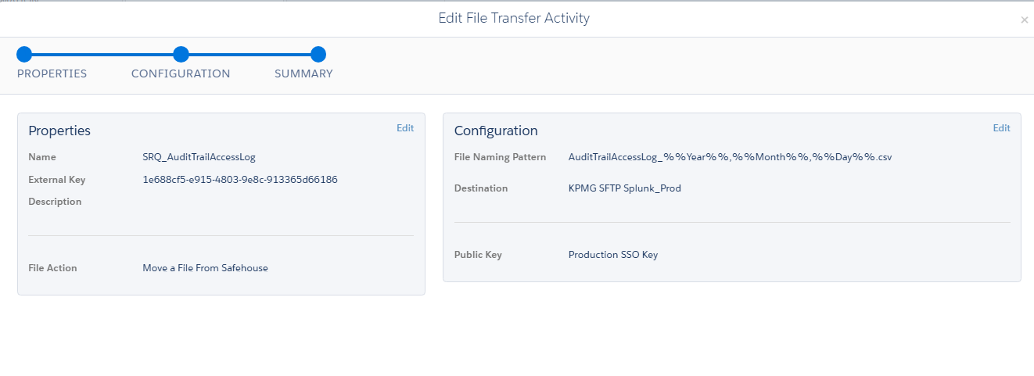
Figure 12. Activity 2.2 – SRQ_AuditTrailAccessLog: file transfer properties and configuration

Activity 2.3 – AuditTrailActivityLog_MCFTP (File Transfer)
Moves the Audit Trail Activity Log file produced by Activity 1.3 from the Safehouse to the production SFTP location.
Activity Name | AuditTrailActivityLog_MCFTP
Step / Position | Activity 2.3 (Step 2)
Activity Type | File Transfer Activity
External Key | 46527548-2fb5-4182-a02a-de6d764e6706
Description | Moving File To New location MC FTP
File Action | Move a File From Safehouse
File Naming Pattern | AuditTrailActivityLog_%%Year%%,%%Month%%,%%Day%%.csv
Destination | KPMG SFTP Splunk_Prod
Public Key | Production SSO Key

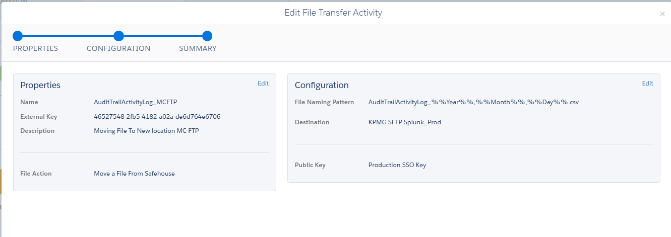
Figure 13. Activity 2.3 – AuditTrailActivityLog_MCFTP: file transfer properties and configuration

6.3 Step 3 – Transformation and Import
Role of the step: Transform user data, import the audit log files into temporary DEs, append activity logs, and extract daily email activity into staging DEs.

Activity 3.1 – User_Extract_Import (SQL Query)
Transforms User_Extract into User_Extract_Import. The query abbreviates each user’s name to the first name plus the first letter of the surname, excludes service and generic accounts, renames several columns, and stamps each row with the extract time.
Activity Name | User_Extract_Import
Step / Position | Activity 3.1 (Step 3)
Activity Type | SQL Query Activity
External Key | 933A3ACF-1A49-491B-BF96-4E8710E8DF97
Folder Location | Query/20. Audit Trail Logs/Admin-AuditTrailMaster
Description | —
Source | User_Extract
Target Data Extension | User_Extract_Import
Data Action | Overwrite (replaces all existing rows)

SELECT
CONCAT(LEFT(Name, CHARINDEX(' ', Name)), ' ', CASE
WHEN CHARINDEX(' ', Name) > 0 THEN SUBSTRING(Name, CHARINDEX(' ', Name) + 1, 1)
ELSE ''
END) AS Name,
ActiveFlag as IsActive,
LastSuccessfulLogin,
CreatedDate as UserCreatedDate,
ModifiedDate as UserModifiedDate,
ID,
FORMAT(GETDATE(), 'yyyy-MM-dd HH:mm:ss') AS ExtractDate
FROM User_Extract
WHERE (NOT (Name LIKE '%user%' OR Name LIKE '%svc%'))
/*and ActiveFlag ='True'*/

Transformation rules
- Name – first name followed by a space and the first character of the remainder of the name (the surname initial).
- Exclusions – rows whose Name contains user or svc are removed (NOT (Name LIKE '%user%' OR Name LIKE '%svc%')).
- Renamed columns – ActiveFlag → IsActive, CreatedDate → UserCreatedDate, ModifiedDate → UserModifiedDate.
- ExtractDate – current date and time formatted as yyyy-MM-dd HH:mm:ss.
- Inactive users – the filter and ActiveFlag ='True' is commented out, so inactive users are included.
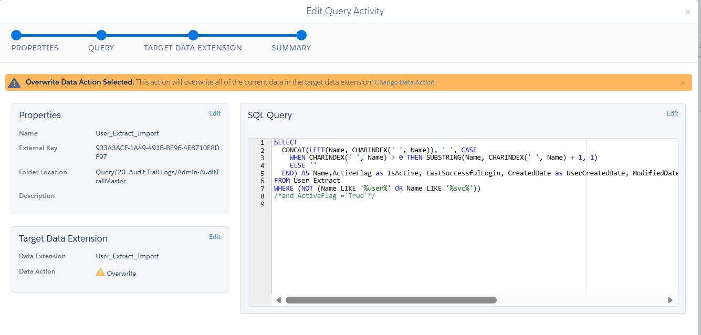
Figure 14. Activity 3.1 – User_Extract_Import: query, properties and target data extension
Data extension details: Section 7.2 (source) and Section 7.3 (target).

Activity 3.2 – AuditTrailAccessLog_Import_FIle (Data Copy or Import)
Imports the Audit Trail Access Log CSV from the SFTP location into AuditTrailAccessLog_Temp, mapping columns by header row. Rows with bad data are skipped.
Activity Name | AuditTrailAccessLog_Import_FIle (sic)
Step / Position | Activity 3.2 (Step 3)
Activity Type | Data Copy or Import Activity
External Key | AB385010-9E45-4059-83C4-B91AE507C3AC
Email Notification | sandeepjain3@kpmg.com
Description | —
Import File – Location | KPMG SFTP Splunk_Prod
Import File – Naming Pattern | AuditTrailAccessLog_%%Year%%,%%Month%%,%%Day%%.csv
Date Format | English (United States)
Delimiter | Comma
Bad Data Behavior | Skip rows with bad data
Import Options | Respect double quotes (") as a text delimiter
Advanced File Options | —
Blank File Behavior | Process blank file
Destination Data Extension | AuditTrailAccessLog_Temp
Data Action | Overwrite (replaces all existing rows)
File Mapping | Map by Header Row

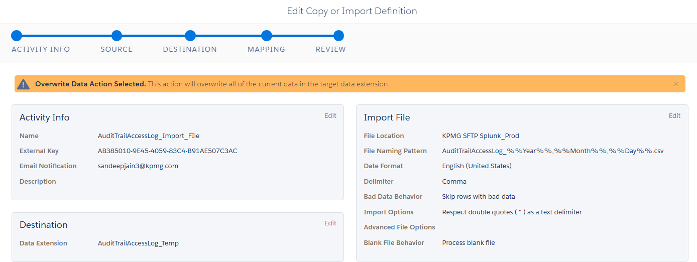
Figure 15. Activity 3.2 – AuditTrailAccessLog_Import_FIle: activity info, import file and destination
Field mapping (Map by Header Row)
Source | AuditTrailAccessLog_Temp (Data Extension) | Data Type
[Matching Header] | User | Text
[Matching Header] | UserName | Text
[Matching Header] | AccessDate | Date
[Matching Header] | FromIP | Text
[Matching Header] | SecurityEventTypeID | Text
[Matching Header] | SecurityEventType | Text
[Matching Header] | LoginStatusID | Text
[Matching Header] | LoginStatusName | Text
[Matching Header] | EventSource | Text

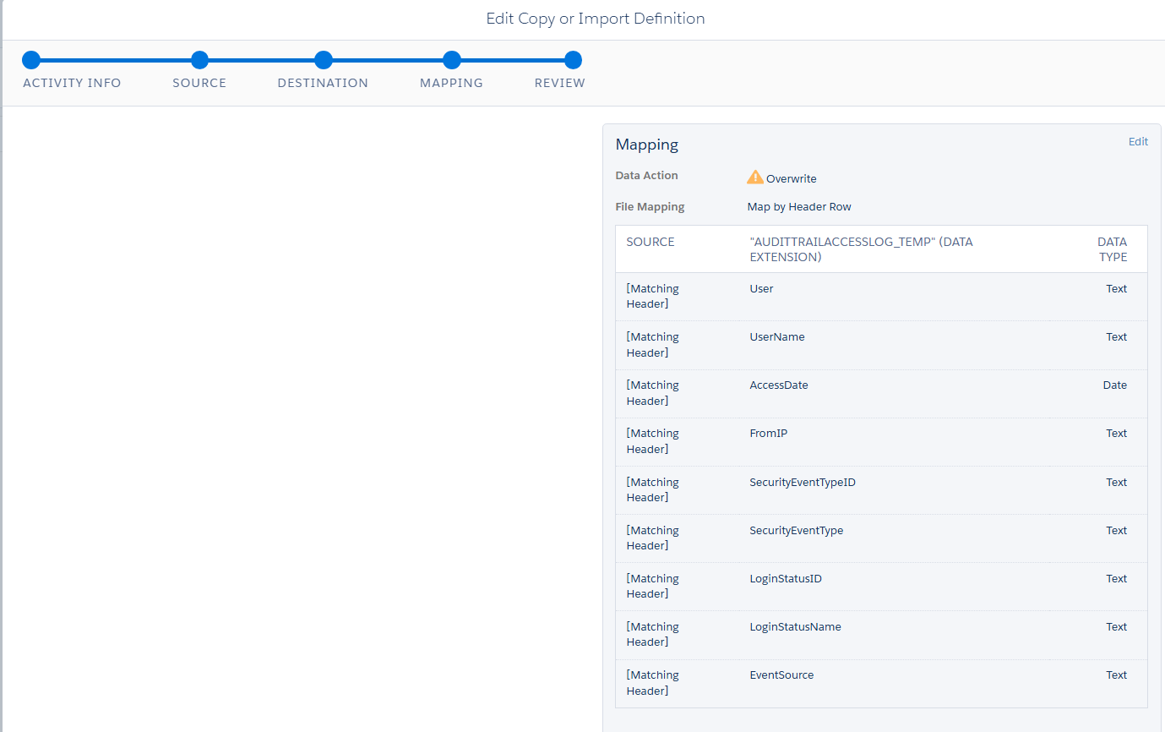
Figure 16. Activity 3.2 – AuditTrailAccessLog_Import_FIle: mapping

Activity 3.3 – AuditTrailActivityLog_Import_FIle (Data Copy or Import)
Imports the Audit Trail Activity Log CSV from the SFTP location into AuditTrailActivityLog_Temp, using the same import settings as Activity 3.2.
Activity Name | AuditTrailActivityLog_Import_FIle (sic)
Step / Position | Activity 3.3 (Step 3)
Activity Type | Data Copy or Import Activity
External Key | A59040EA-3F19-48FE-A209-F10BD6464651
Email Notification | sandeepjain3@kpmg.com
Description | —
Import File – Location | KPMG SFTP Splunk_Prod
Import File – Naming Pattern | AuditTrailActivityLog_%%Year%%,%%Month%%,%%Day%%.csv
Date Format | English (United States)
Delimiter | Comma
Bad Data Behavior | Skip rows with bad data
Import Options | Respect double quotes (") as a text delimiter
Advanced File Options | —
Blank File Behavior | Process blank file
Destination Data Extension | AuditTrailActivityLog_Temp
Data Action | Overwrite (replaces all existing rows)
File Mapping | Map by Header Row

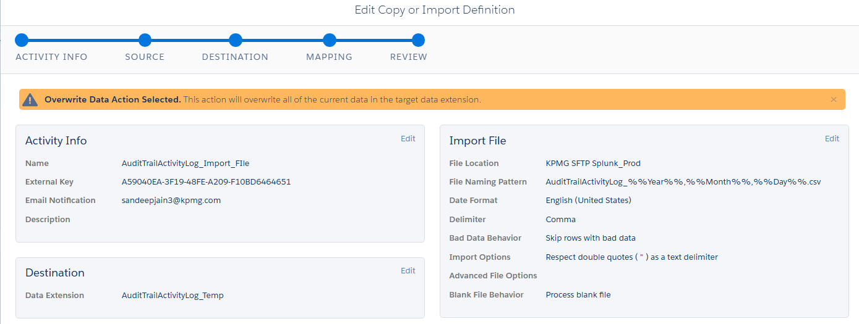
Figure 17. Activity 3.3 – AuditTrailActivityLog_Import_FIle: activity info, import file and destination
Field mapping (Map by Header Row) – the screenshot shows the first ten mapped columns; the remaining columns follow the destination data extension structure (Section 7.6).
Source | AuditTrailActivityLog_Temp (Data Extension) | Data Type
[Matching Header] | EID | Text
[Matching Header] | MID | Text
[Matching Header] | UserID | Text
[Matching Header] | EmployeeID | Text
[Matching Header] | EmployeeName | Text
[Matching Header] | ObjectTypeID | Text
[Matching Header] | ObjectTypeName | Text
[Matching Header] | OperationID | Text
[Matching Header] | OperationName | Text
[Matching Header] | ObjectID | Text
[Matching Header] | ObjectName | Text
[Matching Header] | TransactionID | Text
[Matching Header] | CreatedDate | Date

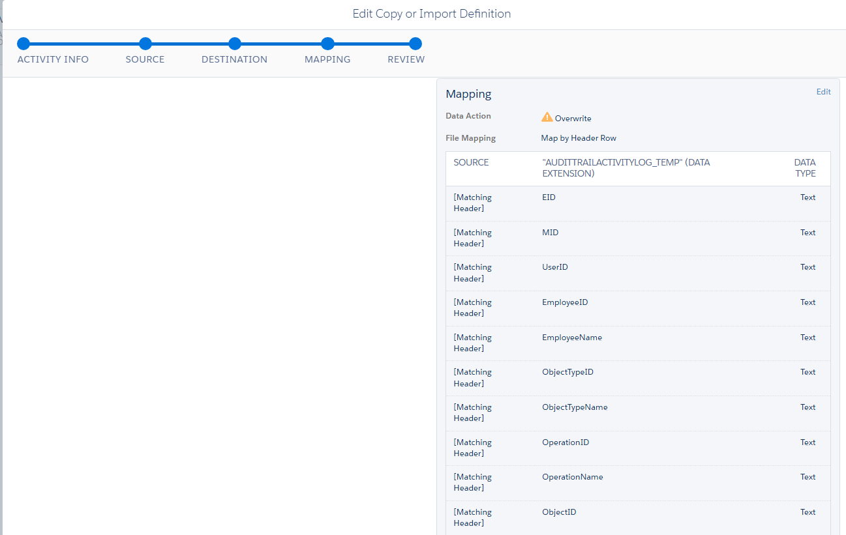
Figure 18. Activity 3.3 – AuditTrailActivityLog_Import_FIle: mapping

Activity 3.4 – AuditTrailActivityLog_Append (SQL Query)
Appends the day’s imported activity log rows from AuditTrailActivityLog_Temp to the master AuditTrailActivityLog data extension, building the cumulative history.
Activity Name | AuditTrailActivityLog_Append
Step / Position | Activity 3.4 (Step 3)
Activity Type | SQL Query Activity
External Key | 776e200b-3f68-42f6-ad9a-499e59da4d2e
Folder Location | Query/20. Audit Trail Logs/Admin-AuditTrailMaster
Description | —
Source | AuditTrailActivityLog_Temp
Target Data Extension | AuditTrailActivityLog
Data Action | Append (adds rows to existing data)

select * from AuditTrailActivityLog_Temp

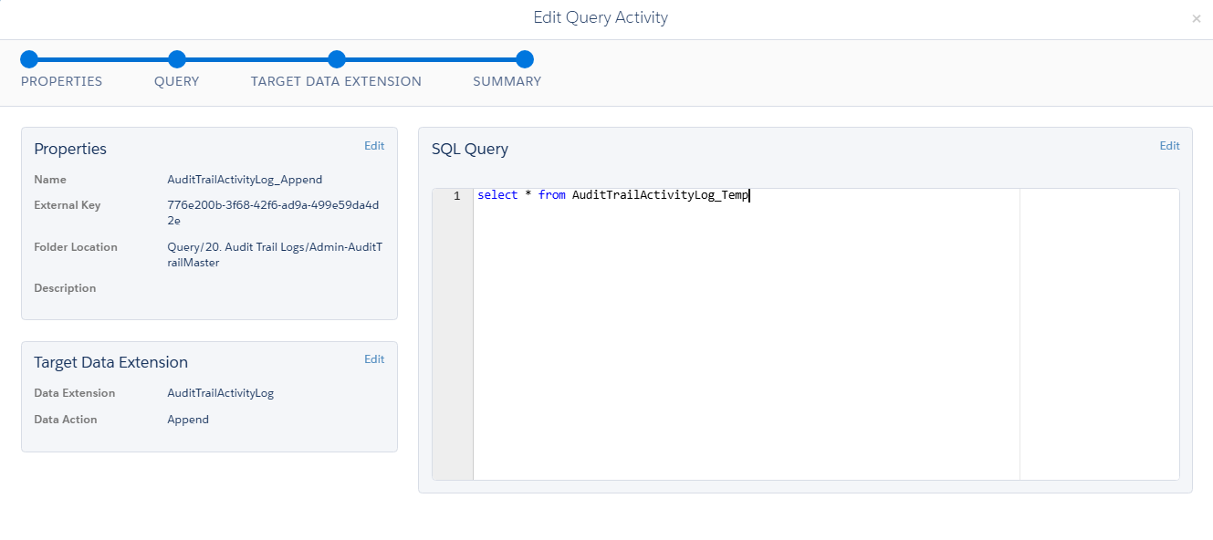
Figure 19. Activity 3.4 – AuditTrailActivityLog_Append: query, properties and target data extension
Data extension details: Section 7.6 (source) and Section 7.7 (target).

Activity 3.5 – Email_Extract_Log_1day (SQL Query)
Builds the daily email activity dataset. The query selects send and journey attributes from DataView_Sent_Daily, formats the event date as M/d/yyyy h:mm:ss tt, and overwrites Email_ActivityExtract_lastOneDay.
Activity Name | Email_Extract_Log_1day
Step / Position | Activity 3.5 (Step 3)
Activity Type | SQL Query Activity
External Key | F2984EC5-1970-464C-B9CC-0C8EC296628B
Folder Location | Query/20. Audit Trail Logs/Admin-AuditTrailMaster
Description | —
Source | DataView_Sent_Daily
Target Data Extension | Email_ActivityExtract_lastOneDay
Data Action | Overwrite (replaces all existing rows)

select
AccountID,
OYBAccountID,
JobID,
ListID,
BatchID,
SubscriberID,
FORMAT(EventDate, 'M/d/yyyy h:mm:ss tt') AS EventDate,
Domain,
TriggererSendDefinitionObjectID,
TriggeredSendCustomerKey,
VersionID_JA,
ActivityID_JA,
ActivityName_JA,
ActivityExternalKey_JA,
JourneyActivityObjectID_JA,
ActivityType_JA,
JourneyID_J,
JourneyName_J,
VersionNumber_J,
CreatedDate_J,
LastPublishedDate_J,
ModifiedDate_J,
JourneyStatus_J
FROM
DataView_Sent_Daily

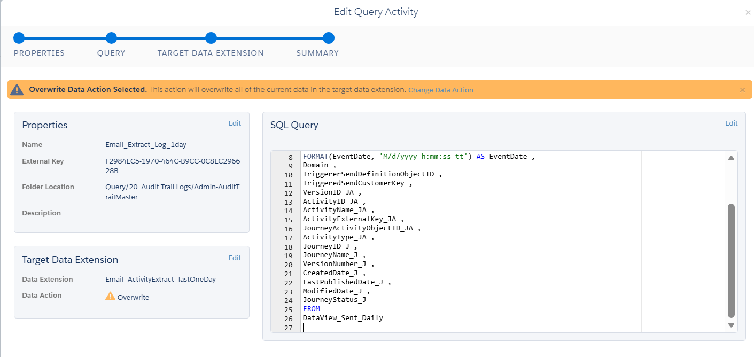
Figure 20. Activity 3.5 – Email_Extract_Log_1day: query, properties and target data extension
Data extension details: Section 7.8 (source) and Section 7.9 (target).

6.4 Step 4 – Consolidation and Extract
Role of the step: Prepare the user and email activity datasets for export and append audit access records into the final reporting data extensions.

Activity 4.1 – Daily_User_Extract (Data Extract)
Exports User_Extract_Import as a delimited file in the Safehouse. Activity 5.1 then moves it to SFTP.
Activity Name | Daily_User_Extract
Step / Position | Activity 4.1 (Step 4)
Activity Type | Data Extract Activity
External Key | 2FEF16E9-F4FC-4E09-B89C-1F65C807E2EF
Description | —
Extract Type | Data Extension Extract
DE Customer Key | 8117A595-2FD8-442B-82CF-EEDBA27B4FF9 (User_Extract_Import)
Add Selected File Encoding | false
Add Timestamp to File Name | false
Column Delimiter | ,
Convert All Dates to Selected Timezone | false
Create Tar Gz Output File | false
Has Column Headers | True
Output Format | UTF16
Text Qualified | True
Timezone | (GMT-06:00) Central Standard Time
Uses Line Feed | True

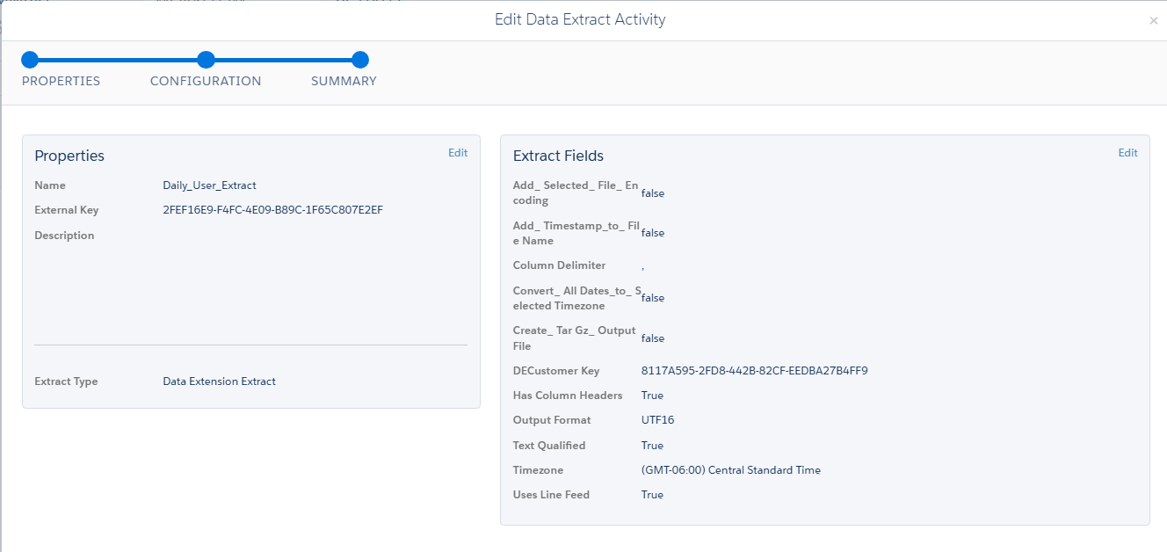
Figure 21. Activity 4.1 – Daily_User_Extract: data extract properties and configuration

Activity 4.2 – AuditTrailAccessLog_Append (SQL Query)
Appends the day’s imported access log rows from AuditTrailAccessLog_Temp to the master AuditTrailAccessLog data extension.
Activity Name | AuditTrailAccessLog_Append
Step / Position | Activity 4.2 (Step 4)
Activity Type | SQL Query Activity
External Key | 079d95b6-7cdc-4985-871d-f45b3033ca00
Folder Location | Query/20. Audit Trail Logs/Admin-AuditTrailMaster
Description | —
Source | AuditTrailAccessLog_Temp
Target Data Extension | AuditTrailAccessLog
Data Action | Append (adds rows to existing data)

select * from AuditTrailAccessLog_Temp

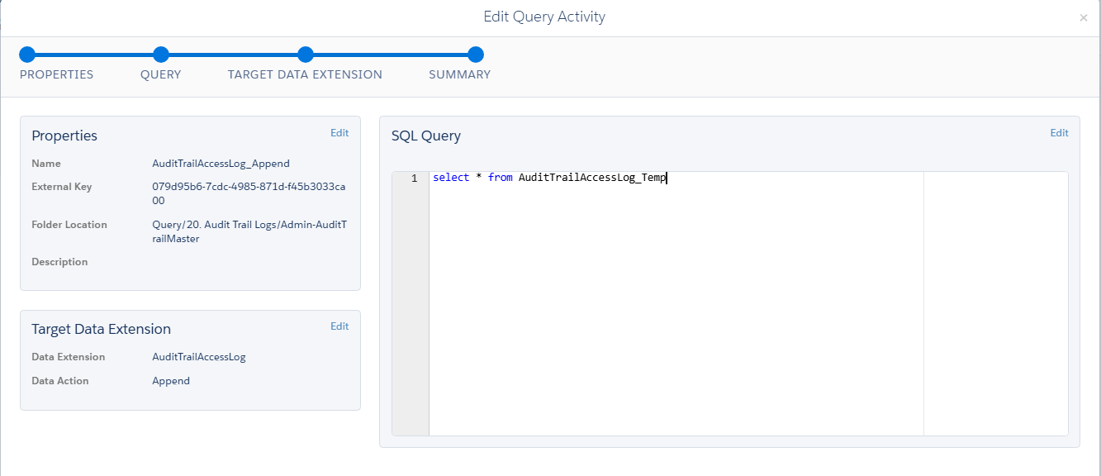
Figure 22. Activity 4.2 – AuditTrailAccessLog_Append: query, properties and target data extension
Data extension details: Section 7.4 (source) and Section 7.5 (target).

Activity 4.3 – Email_Activity_Extract_1day (Data Extract)
Exports Email_ActivityExtract_lastOneDay as a delimited file in the Safehouse. Activity 5.2 then moves it to SFTP.
Activity Name | Email_Activity_Extract_1day
Step / Position | Activity 4.3 (Step 4)
Activity Type | Data Extract Activity
External Key | FD9AADA5-6FFB-4265-9BA6-57F4E08C35A1
Description | —
Extract Type | Data Extension Extract
DE Customer Key | E53D2C55-BE4F-44B7-AE36-E62BC06C10A1 (Email_ActivityExtract_lastOneDay)
Add Selected File Encoding | false
Add Timestamp to File Name | false
Column Delimiter | ,
Convert All Dates to Selected Timezone | false
Create Tar Gz Output File | false
Has Column Headers | True
Output Format | UTF16
Text Qualified | True
Timezone | (GMT-06:00) Central Standard Time
Uses Line Feed | True

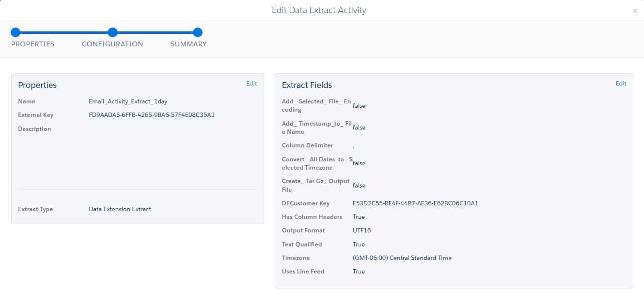
Figure 23. Activity 4.3 – Email_Activity_Extract_1day: data extract properties and configuration

6.5 Step 5 – File Delivery to SFTP
Role of the step: Transfer the user and email activity extract files from Safehouse to SFTP for Splunk ingestion and downstream monitoring.

Activity 5.1 – Daily_User_Extract_MCFTP (File Transfer)
Moves the user extract file produced by Activity 4.1 from the Safehouse to the production SFTP location.
Activity Name | Daily_User_Extract_MCFTP
Step / Position | Activity 5.1 (Step 5)
Activity Type | File Transfer Activity
External Key | e39791bf-2b2d-44ff-86e0-4f7a973d6c5b
Description | —
File Action | Move a File From Safehouse
File Naming Pattern | User_Audit_Extract_%%Year%%_%%Month%%_%%Day%%.csv
Destination | KPMG SFTP Splunk_Prod
Public Key | Production SSO Key

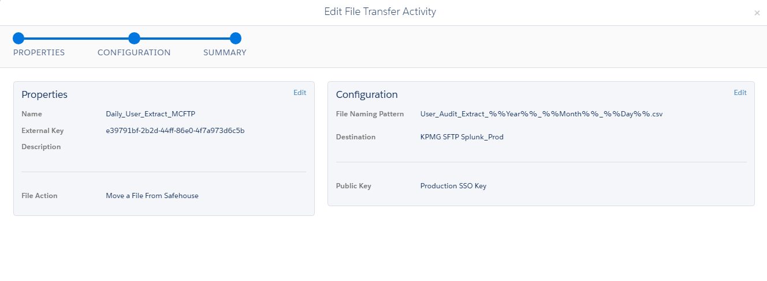
Figure 24. Activity 5.1 – Daily_User_Extract_MCFTP: file transfer properties and configuration

Activity 5.2 – Email_Activity_Extract_1day_MCFTP (File Transfer)
Moves the email activity extract file produced by Activity 4.3 from the Safehouse to the production SFTP location.
Activity Name | Email_Activity_Extract_1day_MCFTP
Step / Position | Activity 5.2 (Step 5)
Activity Type | File Transfer Activity
External Key | b8c9af8d-76b7-44a8-b687-d4fb14e6eb0b
Description | —
File Action | Move a File From Safehouse
File Naming Pattern | Email_Activity_Extract_%%Year%%, %%Month%%, %%Day%%.csv
Destination | KPMG SFTP Splunk_Prod
Public Key | Production SSO Key

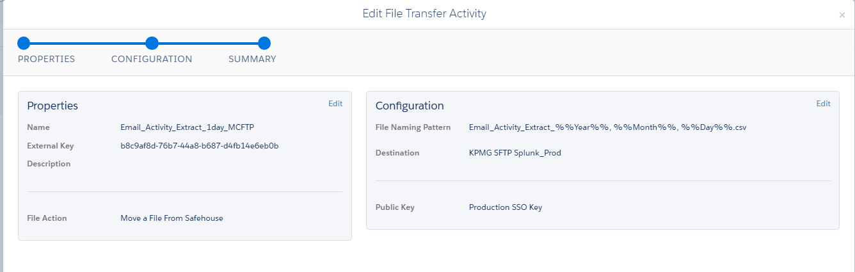
Figure 25. Activity 5.2 – Email_Activity_Extract_1day_MCFTP: file transfer properties and configuration

7. Data Extensions
This section documents the eight data extensions used by the automation — staging and master tables for the Audit Trail logs, the two user data extensions, and the email activity source and output.

7.1 Data Extension Inventory
Data Extension | Role | Records (at capture) | Last refreshed | Section
User_Extract | Staging – AccountUser snapshot | 731 | Never | 7.2
User_Extract_Import | Staging – masked user dataset for export | 570 | Never | 7.3
AuditTrailAccessLog_Temp | Staging – daily access log import | 6,728 | 10/28/2026, 8:44 AM | 7.4
AuditTrailAccessLog | Master – access log history | 6,793,301 | Never | 7.5
AuditTrailActivityLog_Temp | Staging – daily activity log import | 36,157 | 10/28/2026, 8:44 AM | 7.6
AuditTrailActivityLog | Master – activity log history | 3,566,950 | Never | 7.7
DataView_Sent_Daily | Source – daily send data | 183,346 | Never | 7.8
Email_ActivityExtract_lastOneDay | Staging – email activity for export | 183,346 | Never | 7.9

7.2 User_Extract
Staging – AccountUser snapshot. Written by 1.1 (reset) and 2.1 (load); read by 3.1.
Data Extension Name | User_Extract
Description | Extract of Users
External Key | D8B64E54-79D1-4F06-BA56-EE738574DCD2
Location | Data Extensions > 04. CRMA > DatoramaTCRM > Audit Dashboard
Type | Standard
Used for Sending / Testing | No / No (Non-Sendable)

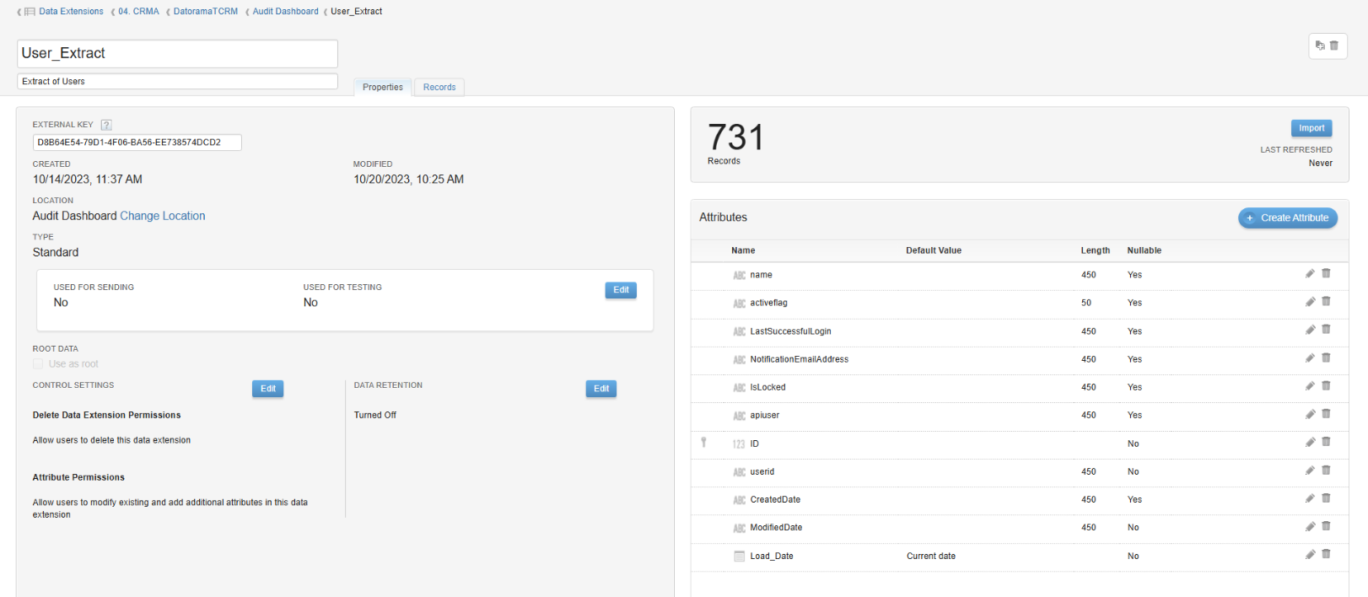
Figure 26. User_Extract data extension properties and attributes

7.2.1 Attributes
Name | Type | Length | Default Value | Nullable
name | Text | 450 | — | Yes
activeflag | Text | 50 | — | Yes
LastSuccessfulLogin | Text | 450 | — | Yes
NotificationEmailAddress | Text | 450 | — | Yes
IsLocked | Text | 450 | — | Yes
apiuser | Text | 450 | — | Yes
ID (Primary Key) | Number | — | — | No
userid | Text | 450 | — | No
CreatedDate | Text | 450 | — | Yes
ModifiedDate | Text | 450 | — | No
Load_Date | Date | — | Current date | No

7.3 User_Extract_Import

Data Extension Name | User_Extract_Import
Description | Extract of Users
External Key | 8117A595-2FD8-442B-82CF-EEDBA27B4FF9
Location | Data Extensions > 04. CRMA > DatoramaTCRM > Audit Dashboard
Type | Standard
Used for Sending / Testing | No / No (Non-Sendable)
Last Refreshed | Never
Data Retention | Turned Off

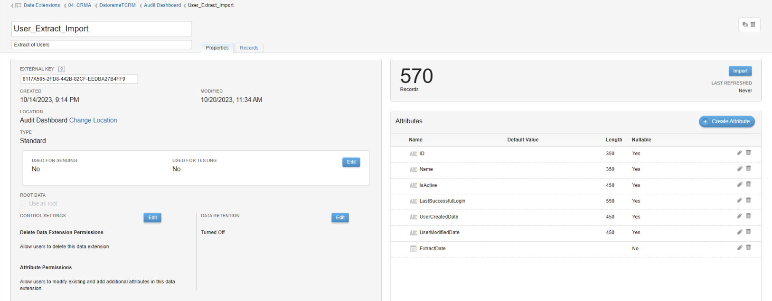
Figure 27. User_Extract_Import data extension properties and attributes

7.4 AuditTrailAccessLog_Temp
Staging – daily access log import. Written by 3.2 (Overwrite); read by 4.2.
Data Extension Name | AuditTrailAccessLog_Temp
Description | (none)
External Key | 36E0CA9F-ED25-4BB6-BED1-63DE32DCAECF
Location | Data Extensions > 20. Audit Trail Logs
Type | Standard
Used for Sending / Testing | No / No (Non-Sendable)

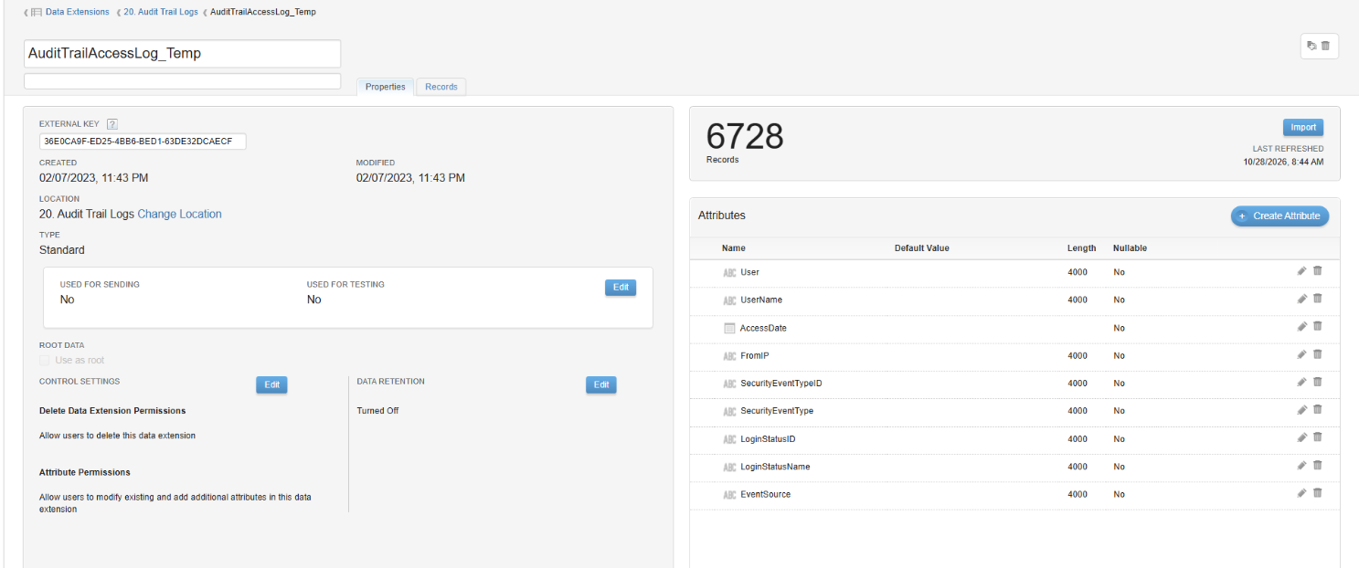
Figure 28. AuditTrailAccessLog_Temp data extension properties and attributes

7.5 AuditTrailAccessLog
Master – access log history. Appended by 4.2 (cumulative history).
Data Extension Name | AuditTrailAccessLog
Description | (none)
External Key | C3D142EF-6920-42AD-8D67-04234FC2A8C5
Location | Data Extensions > 20. Audit Trail Logs
Type | Standard
Used for Sending / Testing | No / No (Non-Sendable)
Last Refreshed | Never
Data Retention | Turned Off

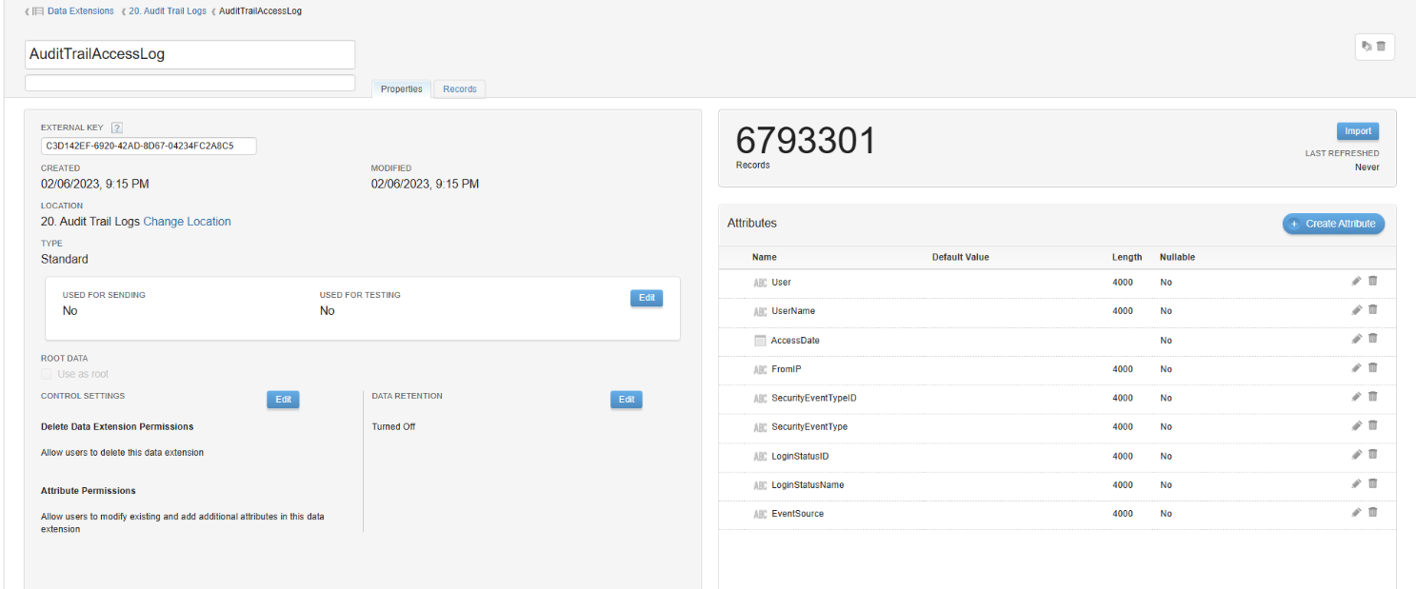
Figure 29. AuditTrailAccessLog data extension properties and attributes

7.6 AuditTrailActivityLog_Temp

Data Extension Name | AuditTrailActivityLog_Temp
Description | (none)
External Key | ADC06B94-11CD-4B6A-B89A-E4191969811D
Location | Data Extensions > 20. Audit Trail Logs
Type | Standard
Used for Sending / Testing | No / No (Non-Sendable)
Last Refreshed | 10/28/2026, 8:44 AM
Data Retention | Turned Off

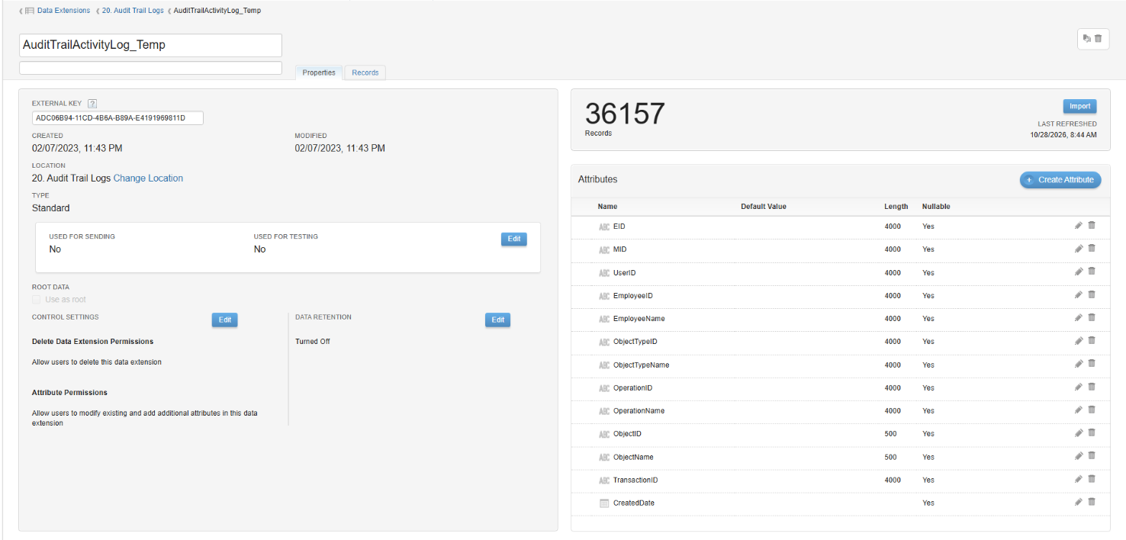
Figure 30. AuditTrailActivityLog_Temp data extension properties and attributes

7.7 AuditTrailActivityLog
Master – activity log history. Appended by 3.4 (cumulative history); schema reference for 1.4.
Data Extension Name | AuditTrailActivityLog
Description | (none)
External Key | 9E30BC4F-FB94-426D-8FF6-DC8B21E609B9
Location | Data Extensions > 20. Audit Trail Logs
Type | Standard
Used for Sending / Testing | No / No (Non-Sendable)
Last Refreshed | Never
Data Retention | Turned Off

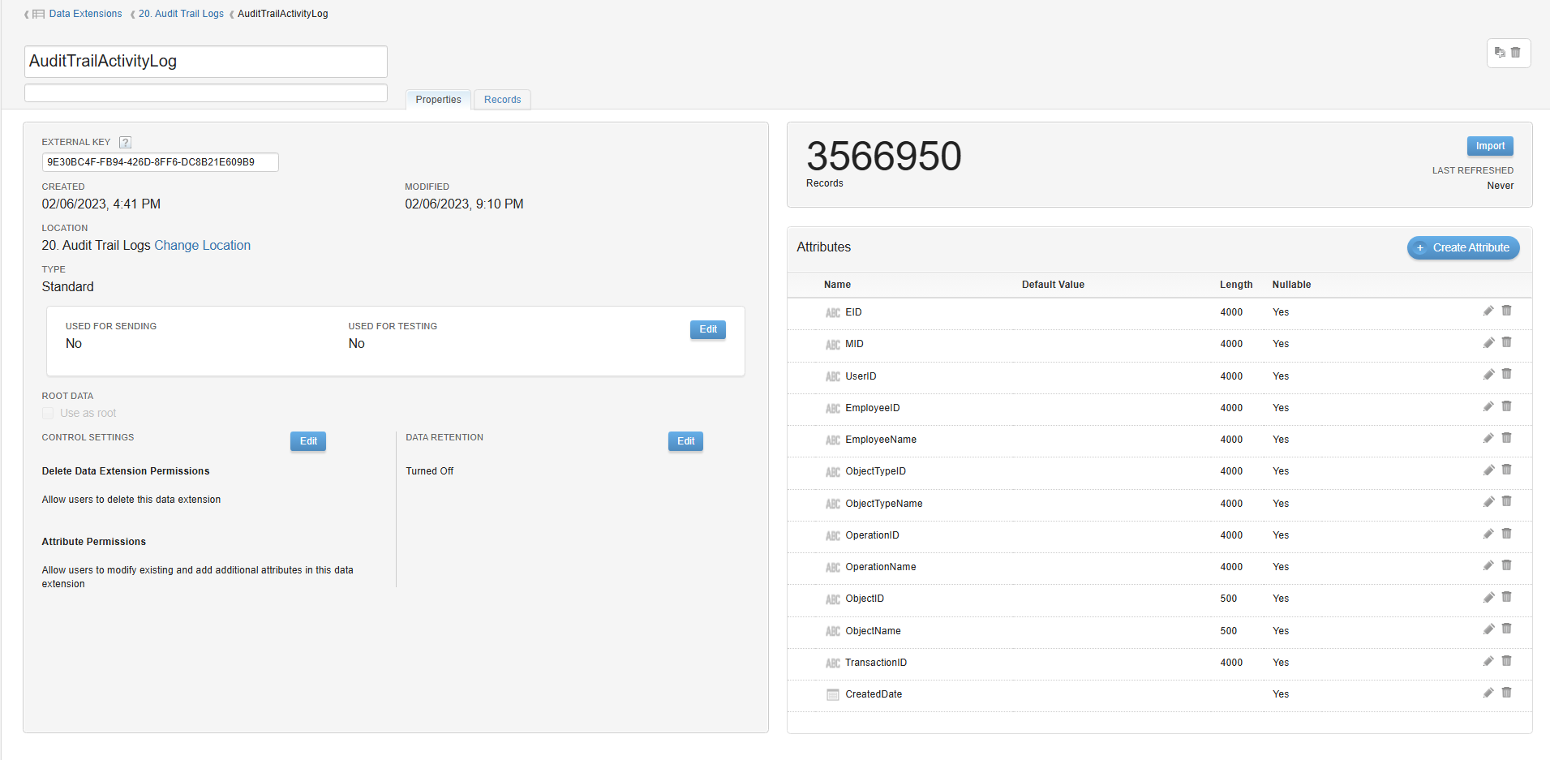
Figure 31. AuditTrailActivityLog data extension properties and attributes

7.8 DataView_Sent_Daily

Data Extension Name | DataView_Sent_Daily
Description | (none)
External Key | Not legible in the captured screenshot — see Automation Studio
Location | Data Extensions > Data_View
Type | Standard
Used for Sending / Testing | No / No (Non-Sendable)
Last Refreshed | Never
Data Retention | Delete Data: Individual Records; Retention Period: 180 days

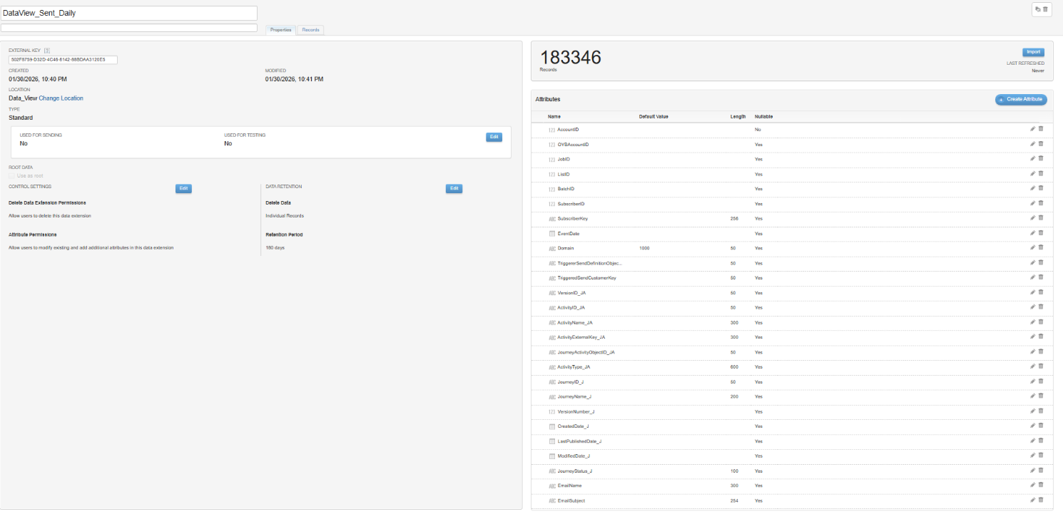
Figure 32. DataView_Sent_Daily data extension properties and attributes

7.9 Email_ActivityExtract_lastOneDay

Data Extension Name | Email_ActivityExtract_lastOneDay
Description | (none)
External Key | E53D2C55-BE4F-44B7-AE36-E62BC06C10A1
Location | Data Extensions > Russ C
Type | Standard
Used for Sending / Testing | No / No (Non-Sendable)
Last Refreshed | Never
Data Retention | Turned Off

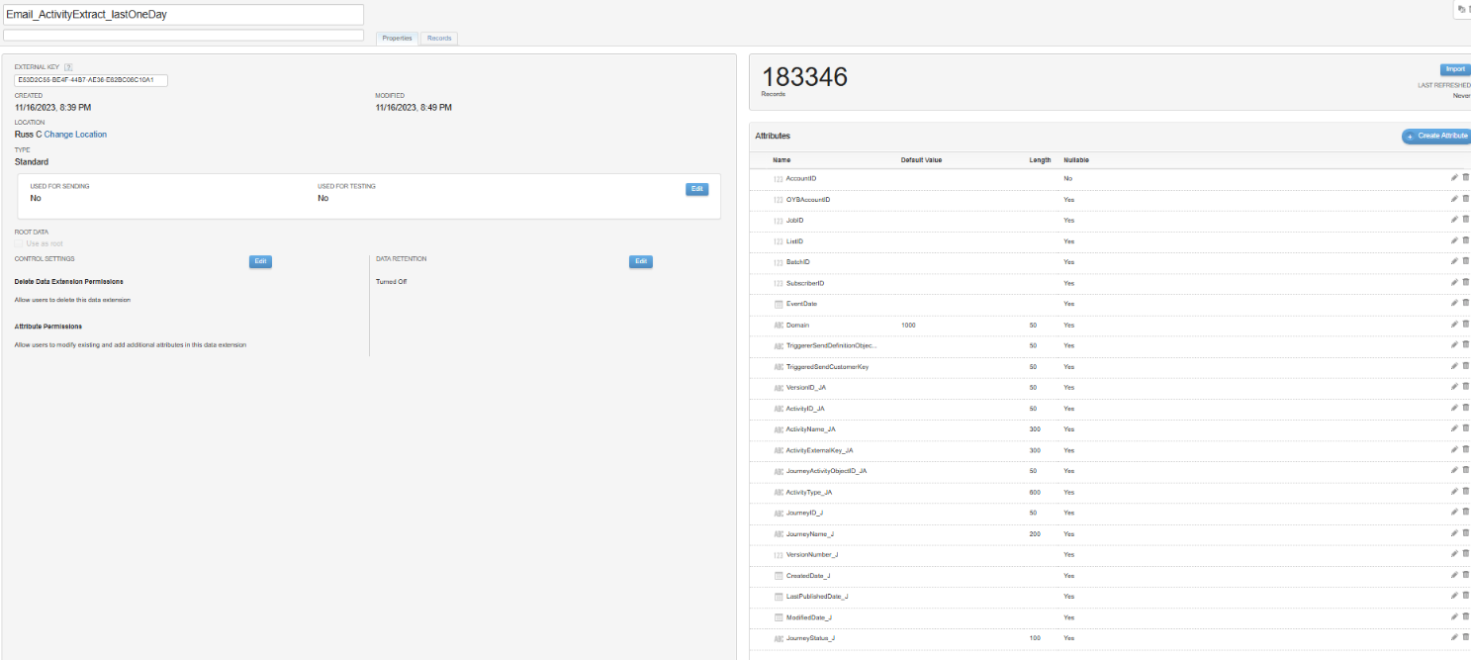
Figure 33. Email_ActivityExtract_lastOneDay data extension properties and attributes

8. File Delivery and Output Files

8.1 Delivered Files
Four files are written to the Safehouse (Data Extract activities) and then moved to the SFTP location (File Transfer activities). All transfers use the same destination and public key.
File | Naming pattern (as configured) | Created / moved by | Content
Access log | AuditTrailAccessLog_%%Year%%,%%Month%%,%%Day%%.csv | 1.2 → 2.2 | Audit Trail Access Log, rolling 1 day
Activity log | AuditTrailActivityLog_%%Year%%,%%Month%%,%%Day%%.csv | 1.3 → 2.3 | Audit Trail Activity Log, rolling 1 day
User extract | User_Audit_Extract_%%Year%%_%%Month%%_%%Day%%.csv | 4.1 → 5.1 | User_Extract_Import (masked names)
Email activity | Email_Activity_Extract_%%Year%%, %%Month%%, %%Day%%.csv | 4.3 → 5.2 | Email_ActivityExtract_lastOneDay

8.2 Transfer and Import Settings
File Action | Move a File From Safehouse
Destination | KPMG SFTP Splunk_Prod
Public Key | Production SSO Key
Import source (3.2, 3.3) | KPMG SFTP Splunk_Prod — the same access and activity log files moved by 2.2 and 2.3 are imported back into SFMC
Import behavior | Comma delimiter; English (United States) dates; skip rows with bad data; process blank file
Extract format (4.1, 4.3) | UTF-16, text qualified, column headers, line feed, comma delimiter

Naming patterns. The %%Year%%, %%Month%% and %%Day%% tokens are separated by commas (access and activity logs), underscores (user extract) or commas with spaces (email activity). Splunk input configuration must match each pattern exactly.

9. Quick Reference

9.1 Activity Quick Reference
# | Activity | Type | Target / Output | Action
1.1 | DeleteUser | SQL Query | User_Extract | Overwrite
1.2 | AuditTrailAcessLog | Data Extract | Safehouse file (Audit Trail Access Log) | Extract
1.3 | AuditTrailActivityLog | Data Extract | Safehouse file (Audit Trail Activity Log) | Extract
1.4 | AuditTrailActivityLog_Temp_Clear | SQL Query | AuditTrailActivityLog_Temp | Overwrite
2.1 | Extract_User | Script | User_Extract | Insert rows (SSJS)
2.2 | SRQ_AuditTrailAccessLog | File Transfer | KPMG SFTP Splunk_Prod | Move from Safehouse
2.3 | AuditTrailActivityLog_MCFTP | File Transfer | KPMG SFTP Splunk_Prod | Move from Safehouse
3.1 | User_Extract_Import | SQL Query | User_Extract_Import | Overwrite
3.2 | AuditTrailAccessLog_Import_FIle | Data Copy or Import | AuditTrailAccessLog_Temp | Overwrite
3.3 | AuditTrailActivityLog_Import_FIle | Data Copy or Import | AuditTrailActivityLog_Temp | Overwrite
3.4 | AuditTrailActivityLog_Append | SQL Query | AuditTrailActivityLog | Append
3.5 | Email_Extract_Log_1day | SQL Query | Email_ActivityExtract_lastOneDay | Overwrite
4.1 | Daily_User_Extract | Data Extract | Safehouse file (User_Extract_Import) | Extract
4.2 | AuditTrailAccessLog_Append | SQL Query | AuditTrailAccessLog | Append
4.3 | Email_Activity_Extract_1day | Data Extract | Safehouse file (Email_ActivityExtract_lastOneDay) | Extract
5.1 | Daily_User_Extract_MCFTP | File Transfer | KPMG SFTP Splunk_Prod | Move from Safehouse
5.2 | Email_Activity_Extract_1day_MCFTP | File Transfer | KPMG SFTP Splunk_Prod | Move from Safehouse

