Contact Sync DE Record Count Discrepancy

Table of Contents
Part 1 – Root Cause Analysis 2
1. Executive Summary 2
2. Problem Statement 2
3. Summary 3
4. Analysis Findings 3
5. Root Cause 6
6. Diagnosis and Resolution Activities 7
7. Validation Results 8
8. Impact Analysis 8
9. Preventive Actions 8
10. Final Status 9
Part 2 – Solution Approach 10
Description 10
Acceptance Criteria 10
1. Approach Principles 11
2. Proposed Approach 11
3. How the Approach Addresses the Root Causes 12
4. Changes to the Existing Automation 12
5. Monitoring and Tolerance 12
6. Validation Approach 13
7. Delivery and Rollback 13

Part 1 – Root Cause Analysis

1. Executive Summary
The number of Contact records in Marketing Cloud (SFMC) exceeds the number in Sales Cloud (Engage). On 15 October 2026 the gap was 36,279 contacts; after the contact deletion run of 29 October it was 22,351 (1.25%). A further check showed that contacts archived by the deletion process in ContactDeleteArchive_PreviouslyDeleted were also present in the synchronized Contact DE (Contact_Salesforce_5): approximately 77,070 earlier, and 1,288 Contact Orphans records at the time of this report.
The analysis shows that the contact deletion automation does not create the surplus records: it only reads Contact_Salesforce_5 and cannot add rows to a synchronized data extension. The discrepancy arises because the deletion process and the Sales Cloud synchronization operate independently and are not reconciled. A contact is selected as a Contact Orphan when it is not found in the synchronized Contact DE at the time of the run. The selection matches on _ContactKey only and does not confirm in Sales Cloud whether the contact exists, and the Contact Delete API removes the contact from All Contacts only. In addition, 816 contacts in Contact_Salesforce_5 have a _ContactKey that differs from the Salesforce ID.
All 1,288 contacts were confirmed to exist in Sales Cloud using the RetrieveSalesforceObjects function, and 1,082 of them have a LastModifiedDate in Contact_Salesforce_5 that is later than their deletion date. Salesforce Support (Case #480429426, now closed) confirmed that the records were deleted from All Contacts and were subsequently added back. All 1,288 contacts have been successfully re-added.
Resynchronization (RITM5381288) reduced the contact gap from 22,351 to 317 (0.0175%); on 13th November the gap is still 371 (0.0204%). Part 2 sets out the proposed approach: verify contacts against Sales Cloud before deletion and monitor the result, with minimal change to the existing Contact Deletion automation.

2. Problem Statement
After the contact deletion process runs, the Contact synchronized data extension and All Contacts in Marketing Cloud hold more records than Sales Cloud. Records that the automation has deleted and archived are also found in the sync DE. The business needs the out-of-sync populations identified, the root causes documented, the contact deletion safeguarded against removing valid contacts, and an agreed tolerance for future count comparisons.

3. Summary

3.1 Deletion process as implemented
- A data extract populates Contacts without Channel Addresses (orphan DE): contacts whose email address or Salesforce ID has no channel (email, SMS, mobile).
- The deletion automation compares the orphan DE with Contact_Salesforce_5 and selects ContactKeys beginning ‘003’ that are not found in the sync DE, on the basis that the Sales Cloud record no longer exists.
- Selected contacts are deleted from All Contacts using the contact key and written to ContactDeleteArchive_PreviouslyDeleted. The sync DE is not touched.

4. Analysis Findings

4.1 Record count timeline
Date | Object | SFMC | Sales Cloud | Difference | Note
15 Oct | Contacts (member firm filter) | 1,794,704 | 1,758,425 | +36,279 SFMC higher | Sales Cloud IsDeleted=false 1,758,425; IsDeleted=true 0
29 Oct (after Monthly Contact deletion) | Contacts | 1,786,121 | 1,763,770 | +22,351 (1.25%) | Resynchronization requested
After resynchronization | Contacts | 1,816,056 | 1,815,739 | +317 (0.0175%) | Post-resynchronization
13 Nov | Contacts | 1,819,169 | 1,818,798 | +371 (0.0204%) | Latest comparison

4.2 Archive records present in the sync DE
A join of ContactDeleteArchive_PreviouslyDeleted to Contact_Salesforce_5 returned approximately 77,070 contacts (ContactKey like ‘003%’). Sales Cloud validation was requested under RITM5369534 and a full refresh of the Contact sync DE was performed, after which the records were removed. The same pattern then recurred: the current check (Figure 1) returns 1,288 rows with DeleteReason Contact Orphans.
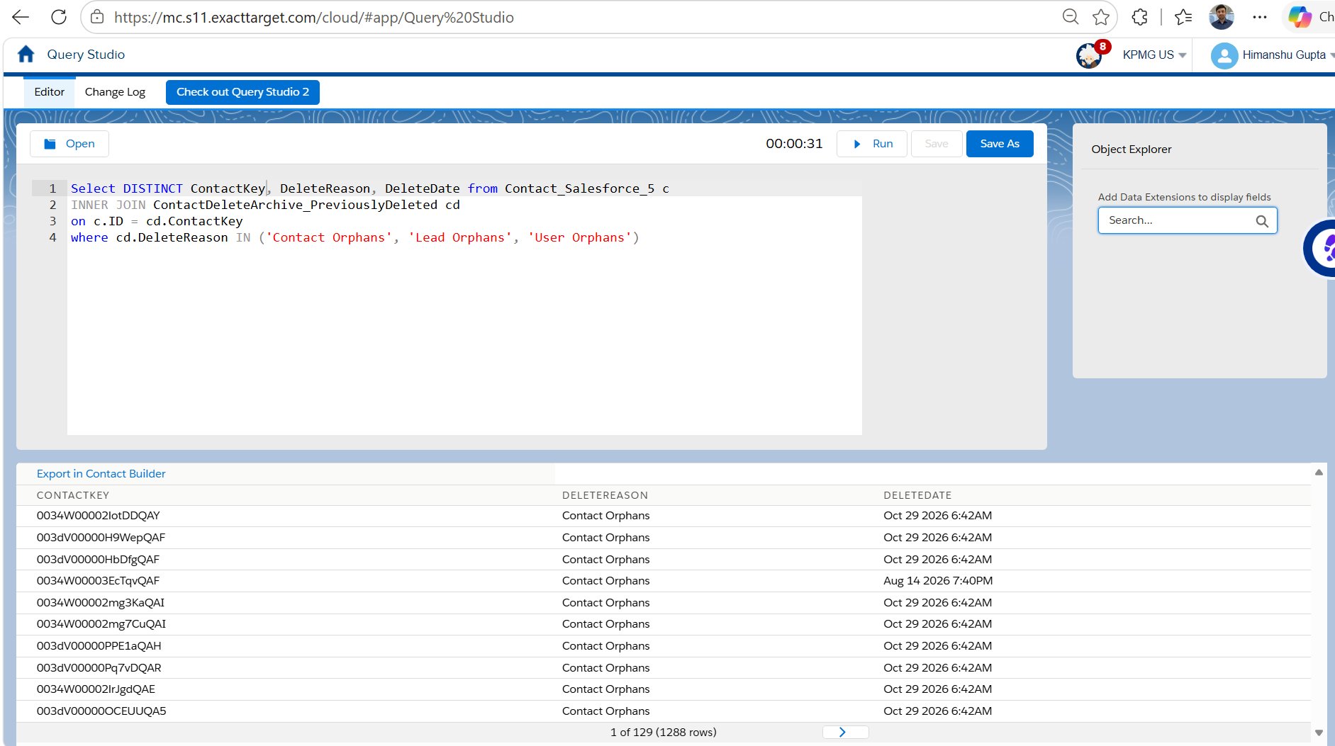
Figure 1 – ContactDeleteArchive_PreviouslyDeleted joined to Contact_Salesforce_5 (c.ID = cd.ContactKey): 1,288 rows.

4.3 Deleted contacts were re-added
The 1,288 deleted contacts were joined to Contact_Salesforce_5 (on ContactKey or Salesforce ID) and the DeleteDate was compared with the LastModifiedDate of the contact in the sync DE. 1,082 contacts have a LastModifiedDate later than the DeleteDate (Figure 2). Two examples from the result:
ContactKey | DeleteReason | DeleteDate | LastModifiedDate (sync DE)
0034W00002IWgjVQAS | Contact Orphans | Aug 14 2026 7:40 PM | Nov 11 2026 10:12 PM
003dV00000LEb5IQAT | Contact Orphans | Oct 29 2026 6:42 AM | Nov 10 2026 5:12 PM

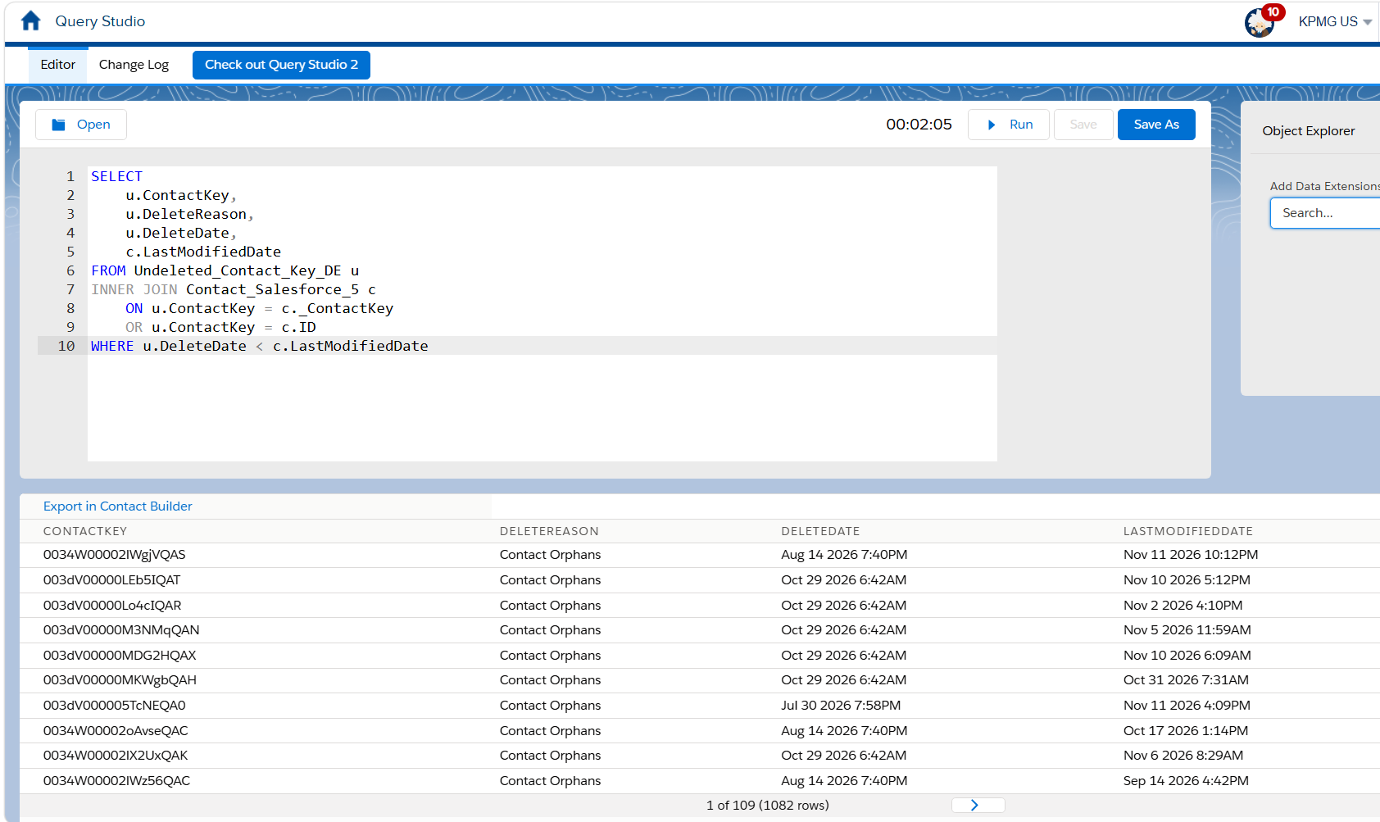
Figure 2 – Deleted contacts whose LastModifiedDate in Contact_Salesforce_5 is later than the DeleteDate: 1,082 rows.
The existence of all 1,288 contacts in Sales Cloud was verified with the RetrieveSalesforceObjects function: all 1,288 contacts exist in Sales Cloud. Salesforce Support confirmed that the records were deleted from All Contacts and were subsequently added back later, and the contacts have been successfully re-added.

4.4 Salesforce ID and ContactKey differ for some contacts
In Contact_Salesforce_5, the Salesforce ID and _ContactKey are not the same for every contact. 816 contacts have a _ContactKey (a GUID) that differs from the Salesforce ID (Figure 3). The Contact Orphans selection matches on _ContactKey only, so a Salesforce ID cannot be matched to these contacts.
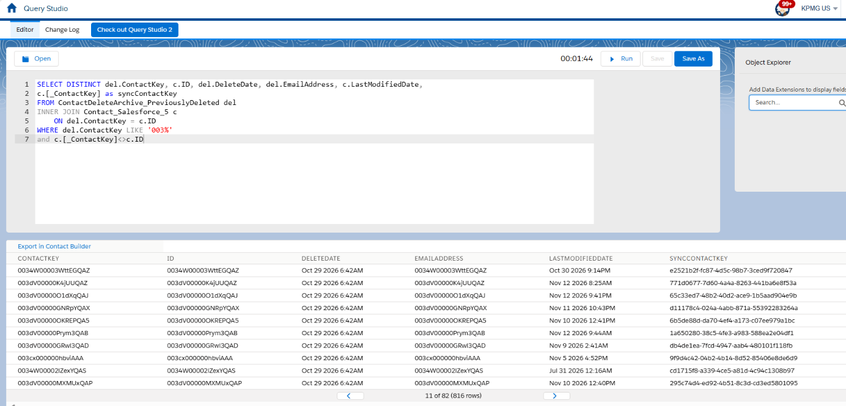
Figure 3 – Contact_Salesforce_5 where ID <> _ContactKey: 816 rows.

4.5 Key logical finding
The Contact Orphans selection is an anti-join: a contact is archived only if it is not matched in the sync DE when the automation runs. Existence in Sales Cloud is not verified. A contact that is not matched at run time is therefore deleted from All Contacts even though it exists in Sales Cloud, as happened for the 1,288 contacts. The deletion automation cannot be the process that inserted these rows into the sync DE.

4.6 Automation logic review
Step | Logic | Observation
8 – Contact Orphans | Orphan DE LEFT JOIN sync DE on ContactKey = _ContactKey; ContactKey starts ‘003’; no matching sync row | Matches on _ContactKey only (816 contacts have a different Salesforce ID and _ContactKey). No check in Sales Cloud.
Contact Delete (REST API) | Delete by contact key | Removes the contact from All Contacts and attributes only; synchronized DE rows are controlled by the Sales Cloud synchronization.

5. Root Cause
Root Cause Statement: The contact deletion automation does not add records to Contact_Salesforce_5 and is not the source of the surplus rows. The discrepancy results from the deletion process and the Sales Cloud synchronization running as unreconciled mechanisms. Contact Orphans are selected from a single point-in-time comparison with the synchronized DE, matched on _ContactKey only and without confirmation in Sales Cloud, and deletions affect All Contacts only. As a result, 1,288 contacts that exist in Sales Cloud were removed from All Contacts, contacts exist in both the Archive and the sync DE, and the drift between SFMC and Sales Cloud was not detected until counts were compared.
ID | Cause | Evidence | Status
RC-1 | Sync DE holds rows not aligned with Sales Cloud; removed only by manual full refresh/resync | 36,279 gap on 15 Oct; full refresh (RITM5369534) removed ~77,070 overlapping rows; resync (RITM5381288) cut the gap to 317 | Confirmed
RC-2 | Contact Orphan selection is not verified against Sales Cloud | All 1,288 deleted contacts exist in Sales Cloud; 1,082 have a LastModifiedDate after the DeleteDate; Salesforce Support confirmed deletion and later re-addition | Confirmed
RC-3 | Salesforce ID and _ContactKey differ for some contacts; selection matches on _ContactKey only | 816 contacts in Contact_Salesforce_5 where ID <> _ContactKey (Figure 3) | Confirmed
RC-4 | No record entry date, archive-versus-sync reconciliation or tolerance | Overlap between the Archive and sync DE was found only when counts were compared; no tolerance defined | Confirmed

6. Diagnosis and Resolution Activities

6.1 Investigation performed
- Compared Contact counts between SFMC and Sales Cloud (member firm filter, IsDeleted=false).
- Joined ContactDeleteArchive_PreviouslyDeleted to Contact_Salesforce_5 (77,070 earlier; 1,288 now).
- Compared the DeleteDate of the 1,288 contacts with their LastModifiedDate in Contact_Salesforce_5.
- Compared the Salesforce ID with _ContactKey in Contact_Salesforce_5.
- Verified the existence of all 1,288 contacts in Sales Cloud with RetrieveSalesforceObjects.
- Traced sample keys across the Archive, sync DE, All Contacts and Contacts without Channel Addresses.
- Reviewed the Weekly/Monthly Contact Deletion automation (GEE-54899).
- Raised Salesforce Support Case #480429426 (closed).

6.2 Remediation completed
- Full refresh of the Contact sync DE (RITM5369534).
- Resynchronization of Contact data (RITM5381288); the contact gap reduced from 22,351 to 317.
- All 1,288 deleted contacts re-added to All Contacts.

6.3 Verification results
Check | Result
Contacts in the Archive (Contact Orphans) also present in Contact_Salesforce_5 | 1,288
Of these, contacts that exist in Sales Cloud (RetrieveSalesforceObjects) | 1,288 (all)
Of these, contacts with sync DE LastModifiedDate later than DeleteDate | 1,082
Contacts in Contact_Salesforce_5 where Salesforce ID differs from _ContactKey | 816
Salesforce Support Case #480429426 | Closed – records deleted from All Contacts and subsequently added back

7. Validation Results
After resynchronization the Contact counts differ by 317 (0.0175%). On 13 November they differ by 371 (0.0204%), which is within the tolerance proposed in Part 2 (0.05%). All 1,288 deleted contacts exist in Sales Cloud and have been re-added to All Contacts.

8. Impact Analysis
Business Impact:
- Contact counts do not reconcile between SFMC and Sales Cloud, reducing confidence in reporting and audience sizes.
- 1,288 contacts that exist in Sales Cloud were removed from All Contacts and have since been re-added.
- Recurring manual effort: RITMs, resyncs, approvals and Support cases.
Technical Impact:
- Contact_Salesforce_5, All Contacts, Contacts without Channel Addresses and ContactDeleteArchive_PreviouslyDeleted are out of step.
- Contact deletion runs can remove valid contacts until safeguards are in place.
- The orphan DE does not record when a contact entered it.

9. Preventive Actions
The proposed approach is described in Part 2. In summary:
- Verify before deleting: contacts added to the orphan DE with a ‘003’ ContactKey are checked directly in Sales Cloud. Contacts that exist there are held in an exclusion DE and are not deleted.
- Match on both keys: the Contact Orphans query (Step 8) is updated to check _ContactKey and the Salesforce ID, and to exclude the contacts held in the exclusion DE.
- Record the entry date: a RecordEntryDate field is added to Contacts without Channel Addresses.
- Reconcile and notify: after each run the Archive is joined with the sync DE and a notification is sent to the configured email address if a discrepancy is found. Counts are monitored against an agreed tolerance.

10. Final Status
Incident Status: Root cause identified; affected contacts restored; preventive approach proposed for approval
The contact count gap was reduced from 22,351 to 317 by resynchronization and stands at 371 (0.0204%) on 13 November. The deletion automation is not the source of the surplus rows; its selection of Contact Orphans relied only on the sync DE, and 1,288 contacts that exist in Sales Cloud were removed from All Contacts and have since been re-added. The proposed approach in Part 2 prevents a recurrence.

Part 2 – Solution Approach

Description
As the technical product manager, I want to investigate and resolve the remaining contact synchronization discrepancies between Salesforce and Marketing Cloud following execution of the contact deletion process, so that synchronized data extensions remain aligned, data integrity is maintained, and recurring synchronization incidents are prevented.
Business Value: Improves data integrity between Salesforce and Marketing Cloud; reduces recurring operational incidents and support requests; eliminates manual synchronization efforts and approvals; minimizes risk associated with future deployments and data refreshes; improves confidence in contact synchronization processes.

Acceptance Criteria
SCENARIO 1: Identify remaining synchronization discrepancies
GIVEN there are discrepancies in contact record counts after the contact deletion process is completed
WHEN contact synchronization results are analyzed
THEN all remaining out-of-sync record populations are identified and documented
AND the total affected record counts are captured
AND potential root-cause categories are documented
AND required changes to the contact deletion automation are identified and implemented
SCENARIO 2: Validate synchronization results
GIVEN the approved remediation has been implemented
WHEN synchronization and data refresh processes are executed
AND the updated contact deletion automation has run
THEN contact record counts align within the proposed tolerance
AND previously identified out-of-sync records are resolved
SCENARIO 3: Orphan candidates are verified in Sales Cloud before deletion
GIVEN a contact with a ContactKey beginning ‘003’ is added to Contacts without Channel Addresses
WHEN the Contact Orphan Verification automation runs before the Contact Deletion automation
THEN the contact is checked directly in Sales Cloud
AND contacts that exist in Sales Cloud are held in the exclusion DE and are not deleted
AND contacts that do not exist in Sales Cloud are deleted from All Contacts by the Contact Deletion automation
SCENARIO 4: Record entry date is captured
GIVEN a record is added to Contacts without Channel Addresses
WHEN the record enters the DE
THEN the date it was added is available in the RecordEntryDate field
SCENARIO 5: Reconciliation and notification
GIVEN the contact deletion run has completed
WHEN the contacts in the Archive are joined with the synchronized Contact DE
THEN it is confirmed that no valid contact was deleted
AND if a discrepancy is found, a notification is sent to the configured email address
Scenarios 3 to 5 define the additional criteria for the proposed approach.

1. Approach Principles
- The existing Contact Deletion automation is preserved. Its steps, schedule and downstream processing (exclusions, suppression, backup, archive, export and delete) remain unchanged.
- New, independent automations run before and after the Contact Deletion automation.
- The only change to the existing automation is an update to the Contact Orphans query (Step 8). A new field, RecordEntryDate, is added to the existing Contacts without Channel Addresses DE.
- Sales Cloud is the source of truth: a contact that exists in Sales Cloud is not deleted.

2. Proposed Approach
Component | What it does | Root cause addressed
A. New field RecordEntryDate (existing Contacts without Channel Addresses DE) | A new field named RecordEntryDate is created in the existing DE so that the date each record entered the DE is visible. | RC-4
B. Contact Orphans query update (existing automation, Step 8) | The query checks Contact_Salesforce_5 on both _ContactKey and the Salesforce ID. A contact is selected as an orphan only if neither matches. The query also excludes the contacts held in the exclusion DE by component C. | RC-2, RC-3
C. Contact Orphan Verification (new automation, runs before the monthly Contact Deletion) | 1. When records are added to Contacts without Channel Addresses with a ContactKey beginning ‘003’, a script activity (RetrieveSalesforceObjects) checks whether each contact exists in Sales Cloud.  2. Contacts that exist are not deleted. They are stored in the exclusion DE (overwritten each run), which the Contact Orphans query excludes.  3. Contacts that do not exist are deleted from All Contacts by the Contact Deletion automation. | RC-2
D. Contact Deletion Reconciliation (new automation, runs after Contact Deletion) | 1. The contacts deleted in the run (Archive) are joined with Contact_Salesforce_5 to confirm that no valid contact was deleted.  2. If a discrepancy is found, a notification is sent to the configured email address. | RC-1, RC-4
E. Tolerance and monitoring | Agreed tolerance for the difference between SFMC and Sales Cloud contact counts, with defined actions (Section 5). | RC-1, RC-4

Run sequence
Order | Automation | Purpose
1 | Contact Orphan Verification (new) | Check contacts in Sales Cloud; hold contacts that exist in the exclusion DE
2 | Contact Deletion (existing, monthly) | Runs unchanged except the Contact Orphans query, which excludes the contacts in the exclusion DE
3 | Contact Deletion Reconciliation (new) | Confirm that no valid contact was deleted; notify if a discrepancy is found

3. How the Approach Addresses the Root Causes
ID | Root cause | Approach
RC-1 | Sync DE holds rows not aligned with Sales Cloud | Reconciliation and tolerance monitoring detect drift early, so a manual full refresh or resync is requested only when the tolerance is exceeded
RC-2 | Orphan selection not verified against Sales Cloud | Direct verification in Sales Cloud before deletion; contacts that exist are held in the exclusion DE and are not deleted
RC-3 | Salesforce ID and _ContactKey differ | Contact Orphans query matches on both keys
RC-4 | No record entry date, reconciliation or tolerance | RecordEntryDate field, post-run reconciliation with notification, and agreed tolerance

4. Changes to the Existing Automation
Only one activity is changed: the Contact Orphans query (Step 8). A contact is treated as an orphan only if it is not found in Contact_Salesforce_5 on either _ContactKey or the Salesforce ID, and the contacts held in the exclusion DE by the Contact Orphan Verification automation are excluded. The selection of ContactKeys beginning ‘003’ is retained. The query keeps the same target, the same Origin (Contact Orphans) and the same output, so all subsequent steps run as before.

5. Monitoring and Tolerance (Need to confirm with David)
Level | Difference (SFMC vs Sales Cloud) | Action
Green | ≤ 0.05% | No action
Orange | > 0.05% to 0.25% | Investigate; review the reconciliation result and the last run
Red | > 0.25% | Pause deletion; raise a resync RITM and an incident

Counts are compared on the same day, with the same filters (member firm, IsDeleted=false).s

6. Validation Approach
- The new automations and the Step 8 change are built and unit tested in the lower environment, followed by user acceptance testing with the business.
- The first runs after deployment are monitored using the reconciliation result and the tolerance in Section 5.
- Success criteria: no contact that exists in Sales Cloud is deleted; the Archive-to-sync overlap is zero after each run; Contact counts remain within the tolerance.

7. Delivery and Rollback
- The new automations are additive and are deployed as a package.
- Rollback: deactivate the new automations and restore the previous version of the Contact Orphans query. The rest of the Contact Deletion automation is not modified. The RecordEntryDate field can remain.

