**Problem Statement 1:**

Write a program to show the use of **"this"** and **"super"** keyword in a single program.

**Code:**

public class TW1 extends B {

int variable;

TW1(int variable){

super(variable);

this.variable = variable+10;

}

public void show() {

System.out.println("I'm class A");

System.out.println("Variable from parent class = "+variable);

System.out.println("Variable from child class = "+super.variable);

}

public void display() {

this.show();

super.show();

}

public static void main(String[] args) {

TW1 obj = new TW1(15);

obj.display();

}

}

class B{

int variable;

B(int variable){

this.variable = variable;

}

public void show() {

System.out.println("I'm class B");

}

}

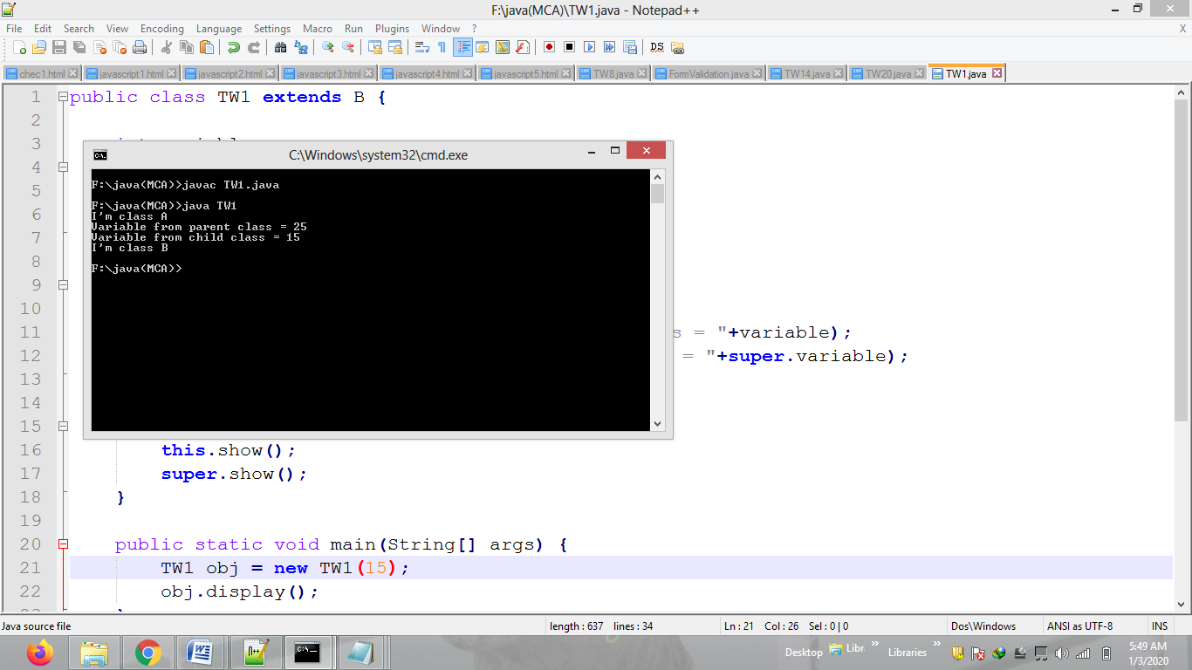

**Problem Statement 2:**

Write a program to convert 2-D array into 1-D array and print it in ascending order.

**int a[][]={{3,4,5},{6},{1,9}};**

**Code:**

import java.util.Arrays;

public class TW2 {

public static void main(String[] args) {

int[][] arr2D={{3,4,5},{6},{1,9}};

int size=0;

System.out.println("2D array: ");

for(int arr1D[]:arr2D) {

for(int element:arr1D) {

System.out.print(element+" ");

size++;

}

System.out.println();

}

int[] arr = new int[size];

int k=0;

System.out.println("1D array after conveting: ");

for(int arr1D[]:arr2D) {

for(int element:arr1D) {

arr[k++] = element;

}

}

Arrays.sort(arr);

System.out.println(Arrays.toString(arr));

}

}

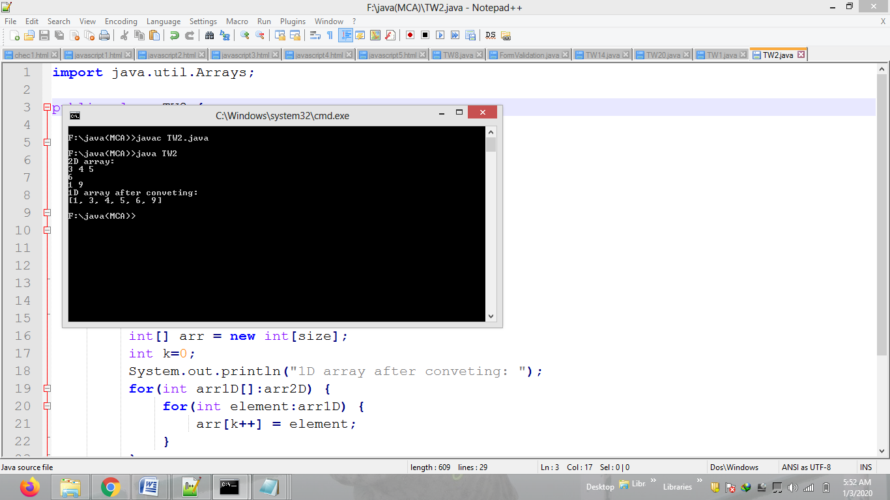

**Problem Statement 3:**

Initialize a string as **"abcaabccbbabc"**. Find least occurred character.

**Code:**

public class TW3 {

public static void main(String[] args) {

String str = "abcabccbbabcddddd";

System.out.println(str);

int freq[] = new int[str.length()];

char minChar = str.charAt(0);

char[] arr = str.toCharArray();

for(int i=0; i<arr.length; i++) {

for(int j=i+1; j<arr.length; j++) {

if(arr[i] == arr[j] && arr[i] !='0') {

freq[i]++;

arr[j] = '0';

}

}

}

int min = freq[0];

for(int i=0; i<freq.length; i++) {

if(freq[i]<min && arr[i] != '0')

minChar = arr[i];

}

System.out.println("Least Character = "+minChar);

}

}

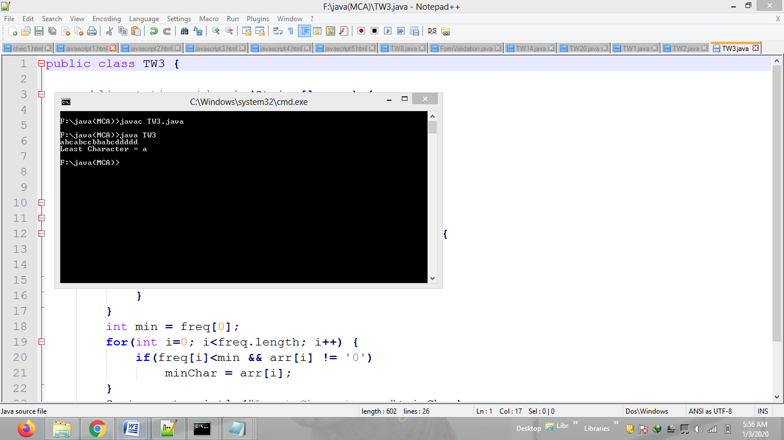

**Problem Statement 4:**

Write a program to enter some values into vector of different types and process them as-

1. Print real values after decimal (.)
2. Print sum of digits of integer values
3. Print string in reverse order.

**Code:**

import java.util.Vector;

public class TW4

{

public static void integerSum(Object ob) {

int num = (int)ob, sum=0;

while(num !=0) {

sum = sum + num%10; num/=10;

}

System.out.println(sum);

}

public static void doubleValues(Object ob) {

Double num = (double) ob;

System.out.println(num.toString().substring(num.toString().lastIndexOf('.')));

}

public String toString(Object ob) {

String str = (String) ob;

return new StringBuffer(str).reverse().toString();

}

public static void main(String[] args) {

Vector<Object> vector = new Vector<Object>();

vector.add(12); vector.add(123.456);

vector.add("StringValue"); vector.add(34);

vector.add(456.789); vector.add("2gnirtSdesreveR");

for(int i=0; i<vector.size(); i++) {

Object ob = vector.get(i);

if(ob instanceof Integer)

integerSum(ob);

if(ob instanceof Double)

doubleValues(ob);

if(ob instanceof String)

System.out.println(new TW4().toString(ob));

}

}

}

