**Problem Statement 5:**

Write a program to pass two command line arguments and print **yes** if first command line argument’s reverse is equal to second command line argument.

**Code:**

public class TW5

{

public static void main(String args[])

{

String s1=args[0];

String s2=args[1];

StringBuffer sb= new StringBuffer(s1);

if(s2.equals(sb.reverse().toString()))

System.out.println("YES");

else

System.out.println("NO");

}

}

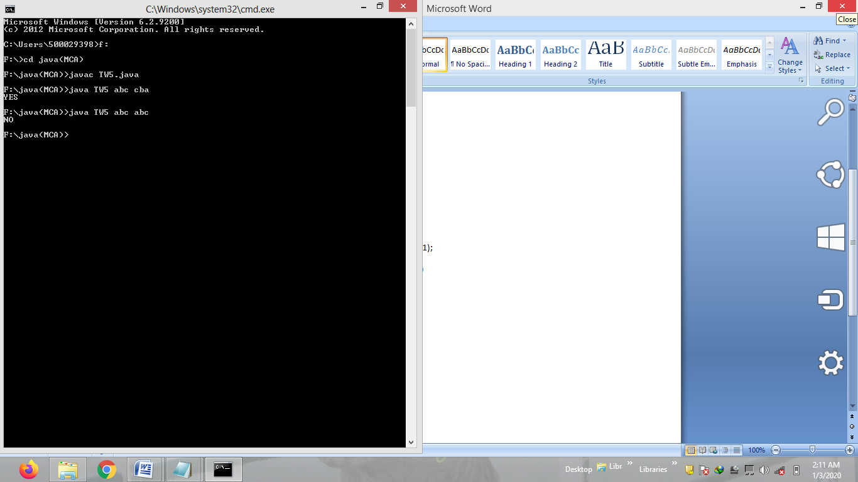

**Problem Statement 6:**

Write a program to create a substring from **"1231345992672"** and the resultant string should contain only even digits but only once.

**Code:**

public class TW6

{

public static void main(String args[])

{

String s="1231344592672";

String s2="";

System.out.println("ORIGINAL STRING : "+s);

for(int i=0;i<s.length();i++)

{ char c=s.charAt(i);

int j=Character.getNumericValue(c);

Integer ii=j;

String m=ii.toString();

if(j%2==0)

{

if(!s2.contains(m))

s2=s2+m;

}

}

System.out.println("RESULTANT STTRING : "+s2);

}

}

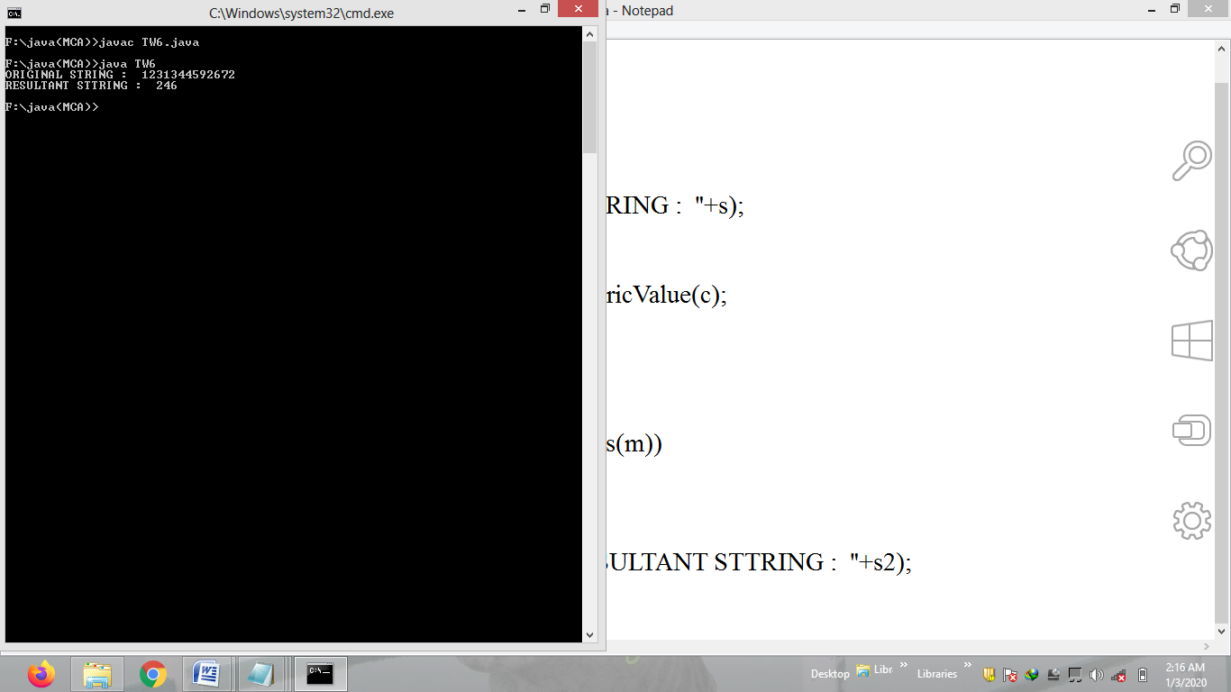

**Problem Statement 7:**

Write a program to show the use of **"throws"** keyword in order to throw more than one exception, exception may occur as:

If your age is below 18, less than age exception should throw.

If your age is 18 to 60, no exception should throw.

If your age is greater than 60, higher age exception should throw.

**Code:**

public class TW7

{

public static void main(String args[])

{

A a= new A();

try

{

a.show(Integer.parseInt(args[0]));

}

catch(LessThanAge e)

{

System.out.println(e);

}

catch(NoException e)

{

System.out.println(e);

}

catch(HigherAge e)

{

System.out.println(e);

}

}

}

class A

{

void show(int age) throws LessThanAge,NoException,HigherAge

{

LessThanAge la=new LessThanAge("age less than 18");

NoException ne=new NoException("age is between 18 to 60");

HigherAge ha=new HigherAge("age greater than 60");

if(age <0)

System.out.println("age cannot be negative");

else if(age< 18)

throw la;

else if(age >= 18 && age <=60)

throw ne;

else if(age >60)

throw ha;

}

}

class LessThanAge extends Exception

{

LessThanAge(String s)

{

super(s);

}

}

class NoException extends Exception

{

NoException(String s)

{

super(s);

}

}

class HigherAge extends Exception

{

HigherAge(String s)

{

super(s);

}

}

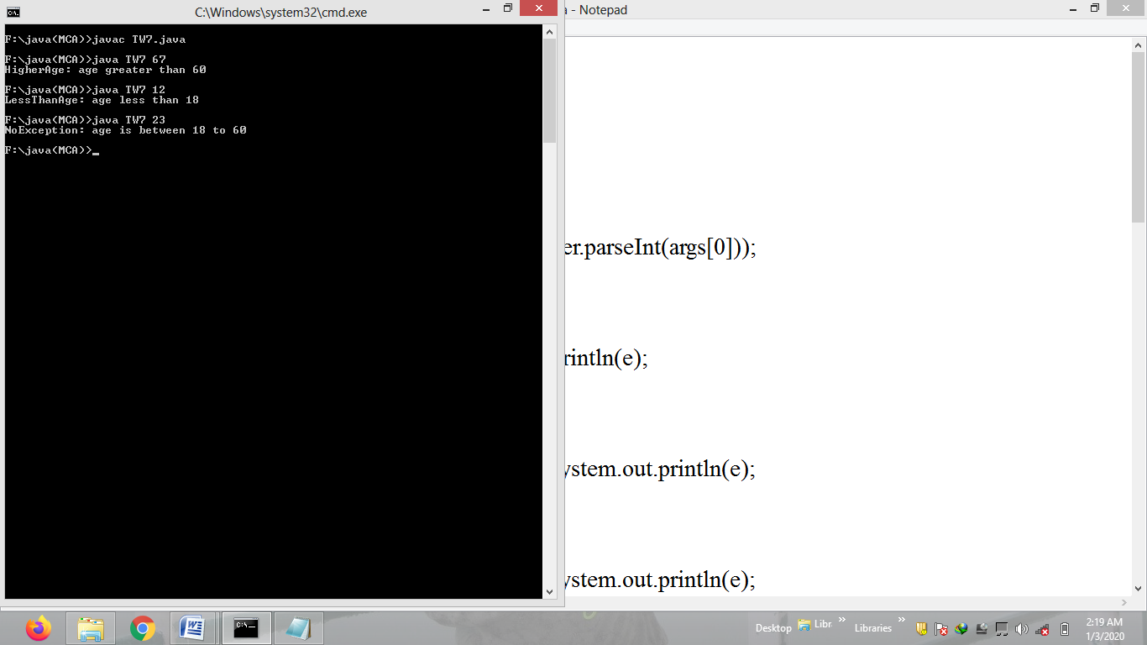

**Problem Statement 8:**

Write a program to copy the content of one file into another, if both file exists and both are having data, after copying second file data should not get deleted and don’t use append true.

**Code:**

import java.io.*;

public class TW8

{

public static void main(String[] args)

{

File f = new File("a.txt");

FileReader fr = null;

try {

fr = new FileReader(f);

}catch(FileNotFoundException e){

System.out.println(e);

}

int c=0; String fileContent = "";

try {

while((c=fr.read()) != -1) {

fileContent += (char)c;

}

} catch (IOException e) {

e.printStackTrace();

}

f = new File("b.txt");

fr = null;

try {

fr = new FileReader(f);

}catch(FileNotFoundException e){

System.out.println(e);

}

c=0; String fileContent2 = "";

try {

while((c=fr.read()) != -1) {

fileContent2 += (char)c;

}

} catch (IOException e) {

e.printStackTrace();

}

FileWriter fw = null;

try {

fw = new FileWriter(f);

}catch(IOException e) {

System.out.println(e);

}

try {

fw.write(fileContent2 + fileContent);

} catch (IOException e) {

e.printStackTrace();

}

try {

fw.close();

fr.close();

System.out.println("File Contents copied successfully.");

} catch (IOException e) {

e.printStackTrace();

}

}

}

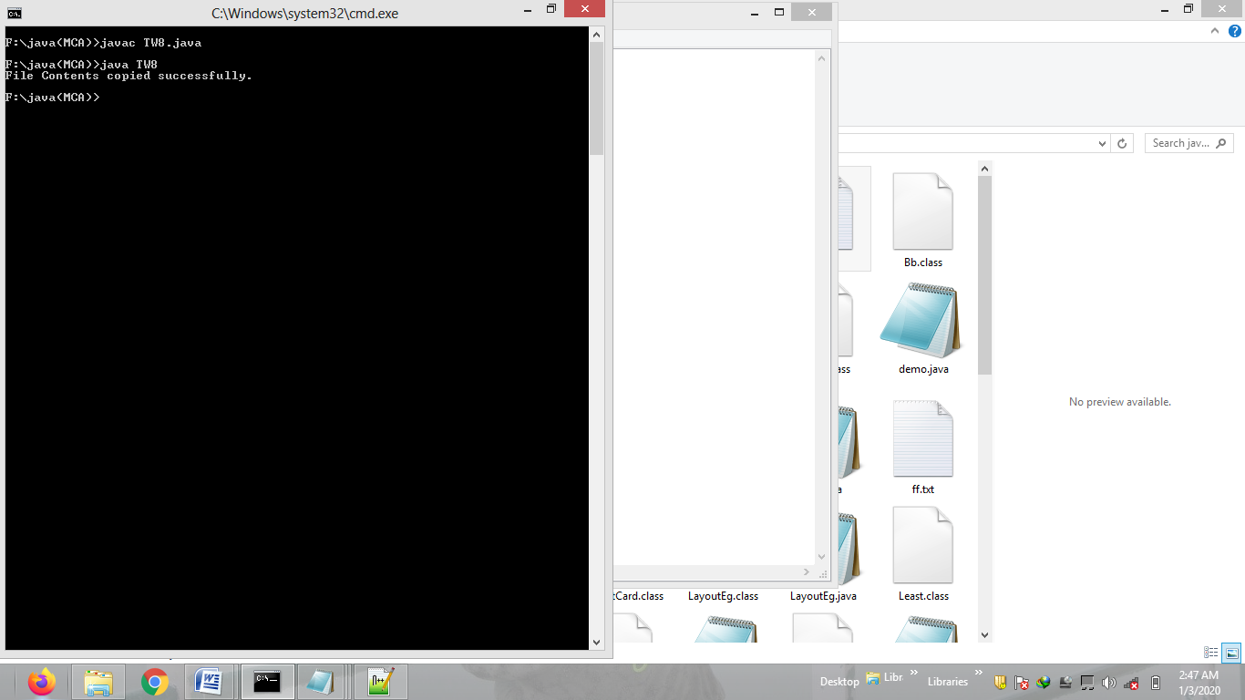

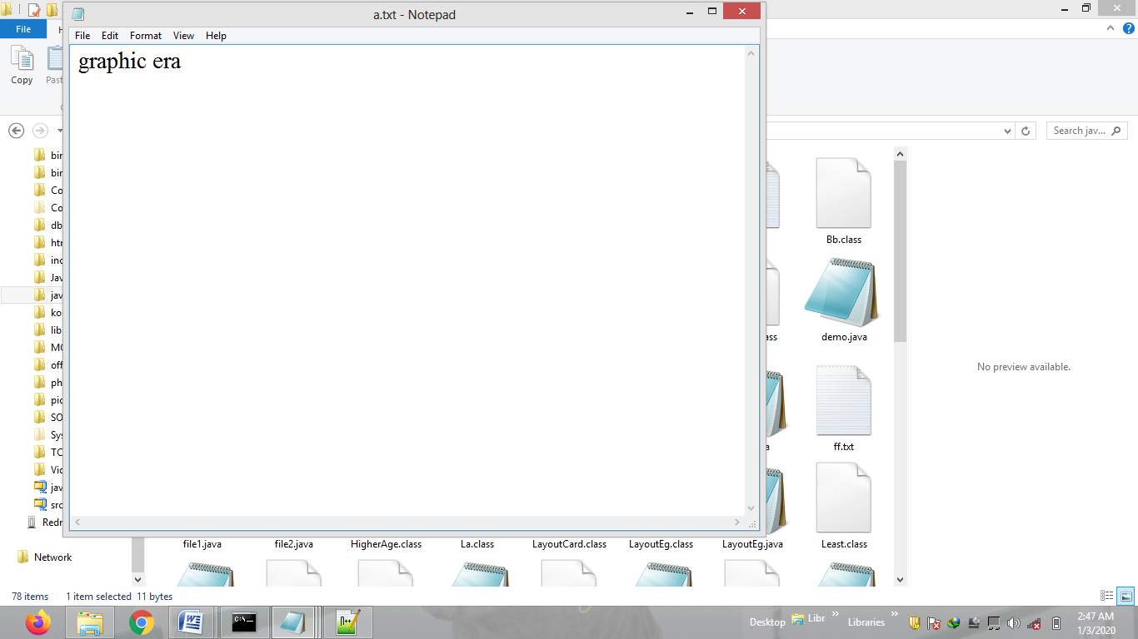

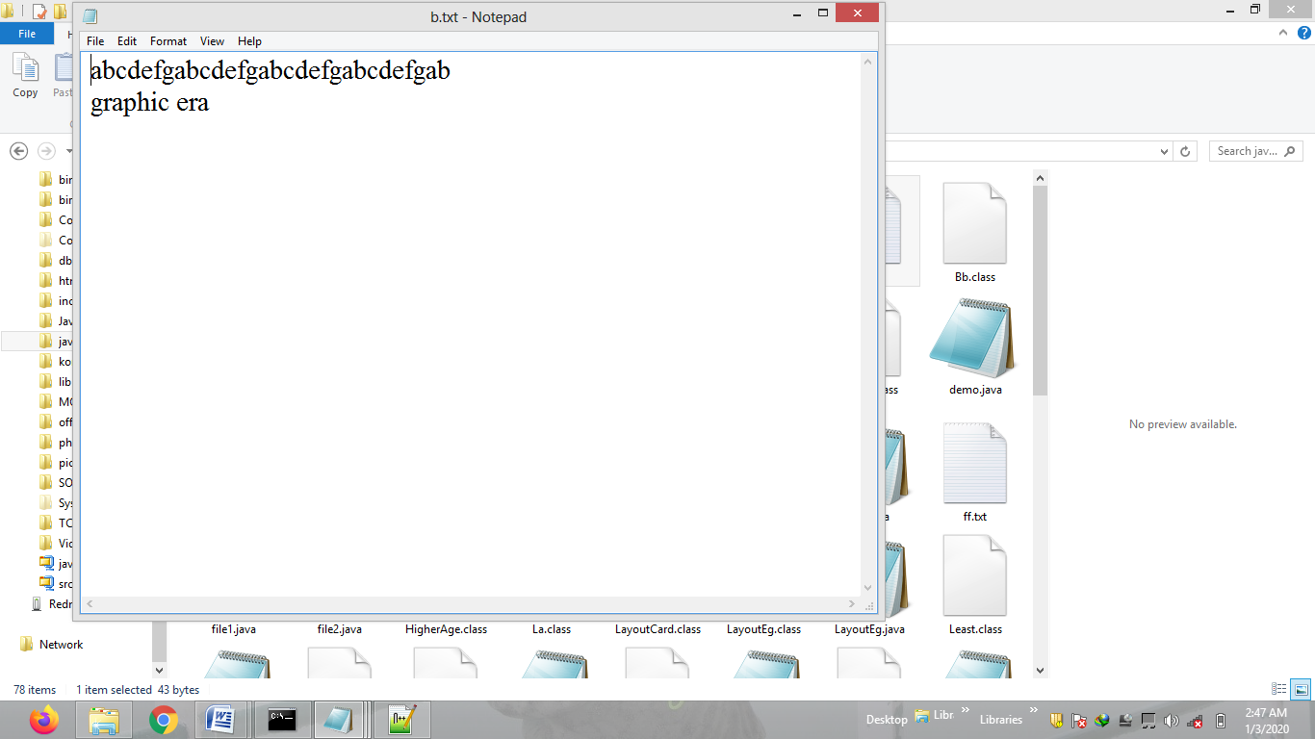

**Problem Statement 9:**

Write a program to show the use of **runnable**, **sleep**, **synchronize**, and **anonymous class** in a single program.

**Code:**

public class TW9

{

public static void main(String args[])throws Exception

{

B b=new B();

A a=new A();

Thread t=new Thread(a);

t.start();

b.start();

Thread t1 =new Thread(){

public void run()

{

for(int i=0;i<5;i++)

{

try

{

sleep(500);

}catch(Exception e){}

System.out.println("anonymous class");

}

}

};

t1.start();

}

}

class A implements Runnable

{

public void run()

{

C.show(20);

}

}

class B extends Thread

{

public void run()

{

C.show(30);

}

}

class C

{

synchronized static void show(int i)

{

for(int j=1;j<=10;j++)

{

try{

Thread.sleep(500);

}catch(Exception e){}

System.out.println(i+"*"+j+"="+i*j);

}

}

}

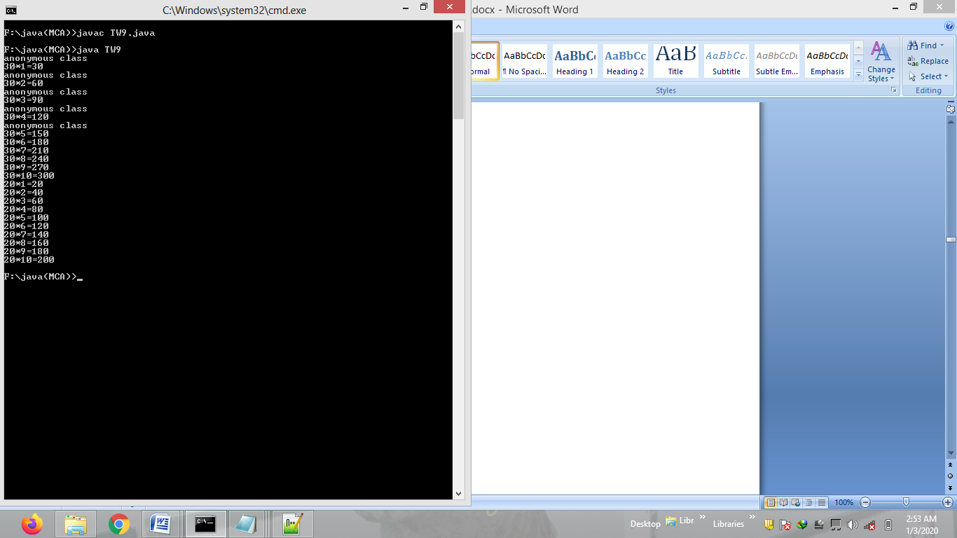

**Problem Statement 10:**

Write a program to show the use of **transient** variable.

**Code:**

import java.io.*;

public class TW10

{

public static void main(String args[])throws Exception

{

FileOutputStream fos=new FileOutputStream("tw10.txt");

ObjectOutputStream oos=new ObjectOutputStream(fos);

A a=new A();

oos.writeObject(a);

oos.close();

System.out.println("reading object..");

FileInputStream fis=new FileInputStream("tw10.txt");

ObjectInputStream ois=new ObjectInputStream(fis);

Object o=ois.readObject();

A m=(A)o;

System.out.println("name:"+m.name);

System.out.println("password:"+m.password);

ois.close();

}

}

class A implements Serializable

{

String name="Sheetal";

transient String password="qwerty12";

}

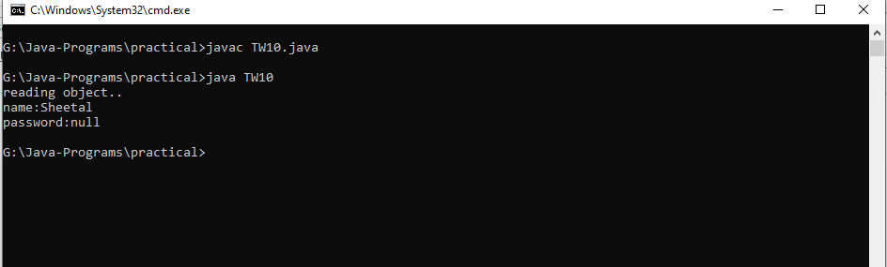

**Problem Statement 11:**

Write a program to write your name into a file if it is having more than 500 characters and if it is having less than 500 characters you have to write exact 500 characters by reading from initial file and then write your name.

**Code:**

import java.io.*;

public class TW11

{

public static void main(String args[])throws Exception

{

File f = new File("a.txt");

FileReader fr= new FileReader(f);

FileWriter fw= new FileWriter(f,true);

int k=0,i;

String s="";

if(f.exists())

{

while( (i=fr.read()) != -1)

{

k++;

s=s+(char)i;

}

if(k>=500)

fw.write("sheetal kanyal");

else if(k<500)

{

int l=s.length();

int n=500/l;

int r=500%l;

//System.out.println(n +"\t"+r);

for(int j=0; j<n-1;j++)

fw.write(s);

for(int j=0; j<r;j++)

{

char c=s.charAt(j);

fw.write(c);

}

fw.write(“sheetal kanyal");

}

fw.close();

fr.close();

}

}

}

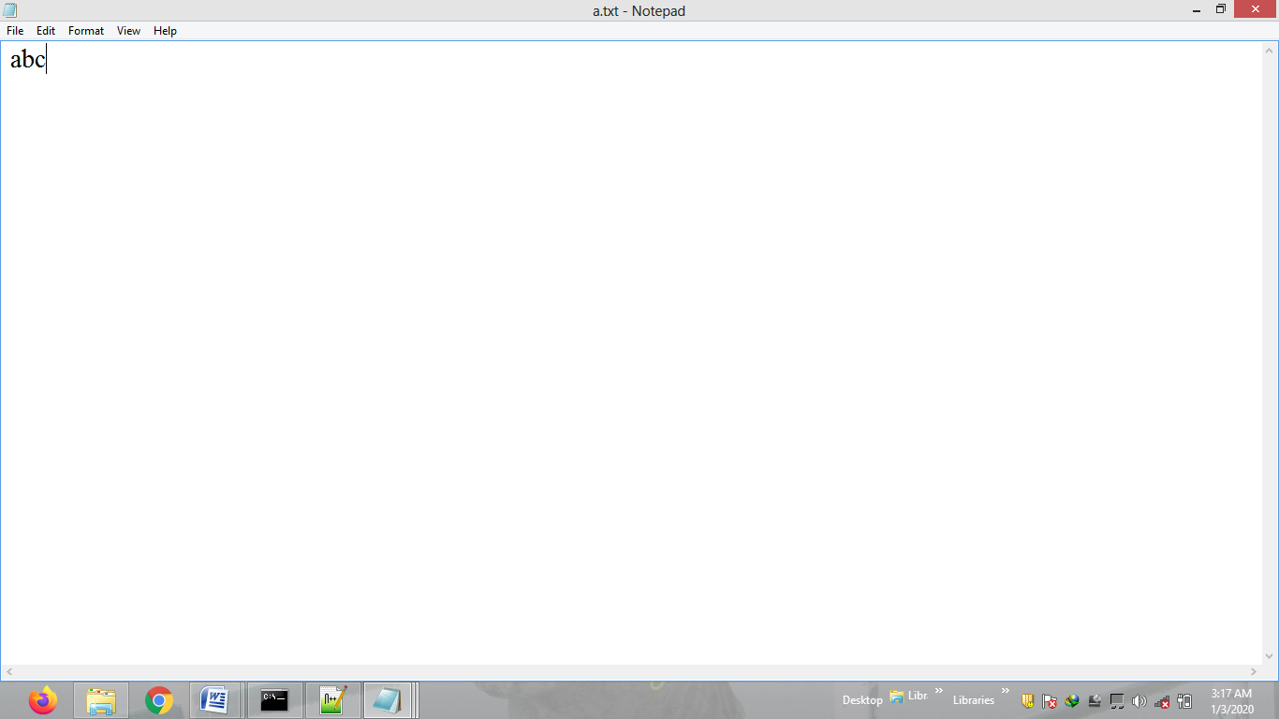

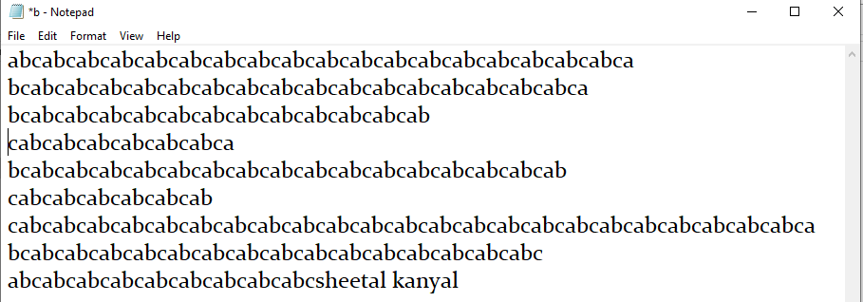

**Problem Statement 12:**

Write a program to draw a circle inside and outside a square using applet.

**Code:**

import java.applet.*;

import java.awt.*;

import java.util.*;

public class TW12 extends Applet

{

int a=50,b=50,c=512,d=512;

public void paint(Graphics g)

{

g.drawRect(a,b,c,d);

g.drawOval(a,b,c,d);

float f=c/2;

int aa=Math.round(f);

double p=Math.pow(aa,2);

double h=Math.sqrt(p+p);

float h1=(float)h;

int z=Math.round(h1);

int y=z-aa;

int i=a-y;

g.drawOval(i,i,(c+y+y),(c+y+y));

}

}

/*<applet code="TW13" width=200 height=200></applet>*/

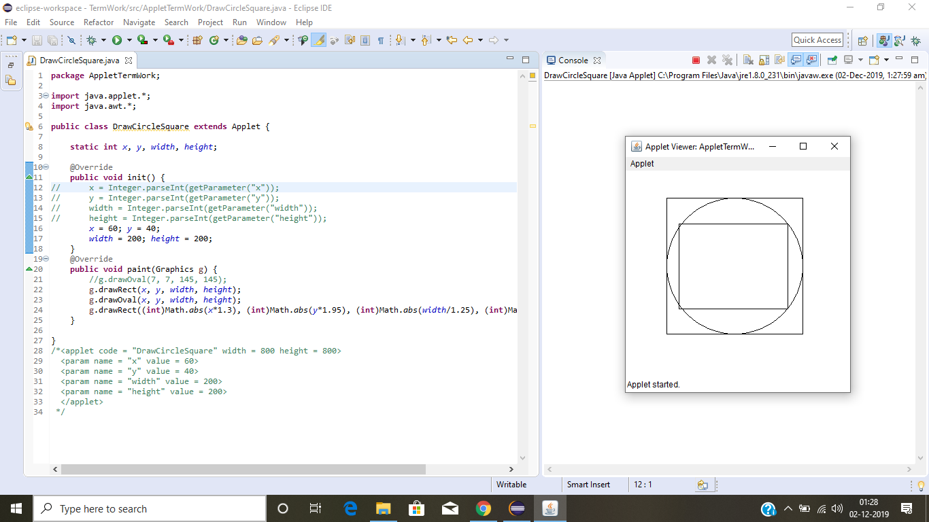

**Problem Statement 13:**

Create a form with following fields-

1. Login Id
2. Password
3. Name , it should contain only alphabets and space
4. Subjects, utmost choice of three subjects (use checkbox)
5. Gender (use radio button)
6. Submit Button

Such that if values of Login Id field and password field are equal, Welcome Mr. X will be displayed on new window, X is value of login id.

**Code:**

import java.awt.*;

import java.awt.event.*;

import java.util.regex.Pattern;

public class FormValidation extends Frame implements ActionListener {

static Frame main, second;

static TextField loginId, password, name;

static Checkbox subject1, subject2, subject3;

static Checkbox male, female, other;

static Button show;

static Label err;

public void intialise() {

main = new Frame("Login Form");

main.setLayout(new FlowLayout());

main.setVisible(true);

main.setSize(300,400);

name = new TextField(20);

loginId = new TextField(20);

password = new TextField(20);

password.setEchoChar('*');

subject1 = new Checkbox("Java");

subject2 = new Checkbox("ITA");

subject3 = new Checkbox("DBMS");

CheckboxGroup gender = new CheckboxGroup();

male = new Checkbox("Male", gender, false);

female = new Checkbox("Female", gender, false);

other = new Checkbox("Other", gender, false);

main.add(new Label("Name: "));

main.add(name);

main.add(new Label("Login Id: "));

main.add(loginId);

main.add(new Label("Password: "));

main.add(password);

main.add(new Label("Subjects: "));

main.add(subject1);main.add(subject2);main.add(subject3);

main.add(new Label("Gender: "));

main.add(male);main.add(female);main.add(other);

show = new Button("Submit");

show.addActionListener(this);

show.setBounds(150, 180, 50, 20);

main.add(show);

main.addWindowListener(new B());

}

public void actionPerformed(ActionEvent e) {

boolean result = check();

if(result)

createNewFrame();

else

createErrorFrame();

}

static public boolean check() {

String login = loginId.getText();

String pass = password.getText();

String fname = name.getText();

if(!Pattern.matches("[a-zA-Z]+[ a-zA-Z]*", fname)) {

err = new Label("Invalid Name");

return false;

}

if(login.equals("") && pass.equals("")) {

err = new Label("Incorrect Login Id or Password");

return false;

}

else if(login.equals(pass)) {

return true;

}

err = new Label("Incorrect Login Id or Password");

return false;

}

static public void createNewFrame() {

second = new Frame("Second Page");

second.setVisible(true);

second.setLayout(new FlowLayout());

second.setSize(300, 400);

second.add(new Label("Welcome "+name.getText()));

second.addWindowListener(new B());

}

static public void createErrorFrame() {

main.dispose();

new FormValidation().intialise();

if(err != null) {

err.setForeground(Color.RED);

main.add(err);

}

}

static public class B extends WindowAdapter {

public void windowClosing(WindowEvent e) {

String str = e.getSource()+"";

if(str.contains("Login Form"))

main.dispose();

else if(str.contains("Second Page"))

second.dispose();

}

}

public static void main(String[] args) {

new FormValidation().intialise();

}

}

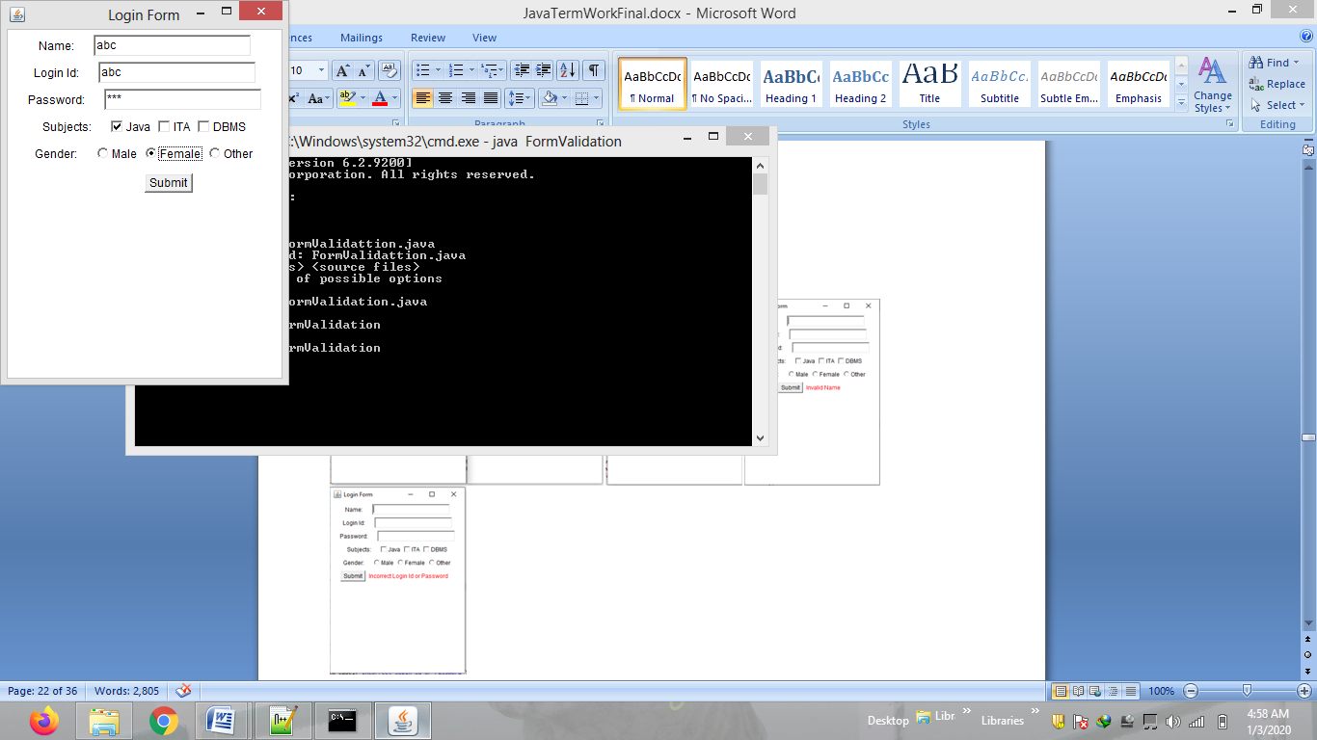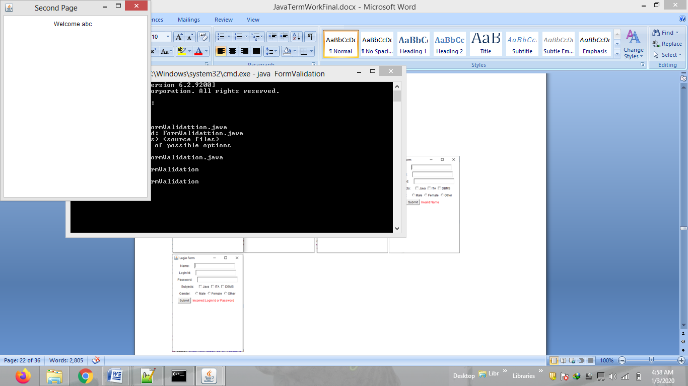 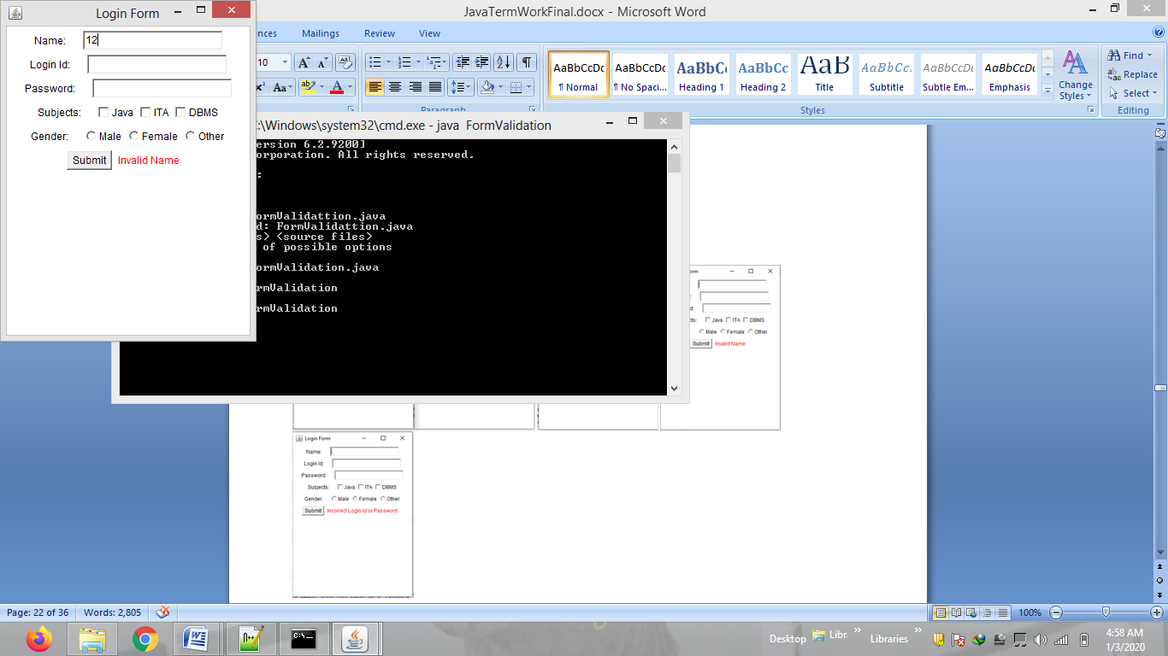 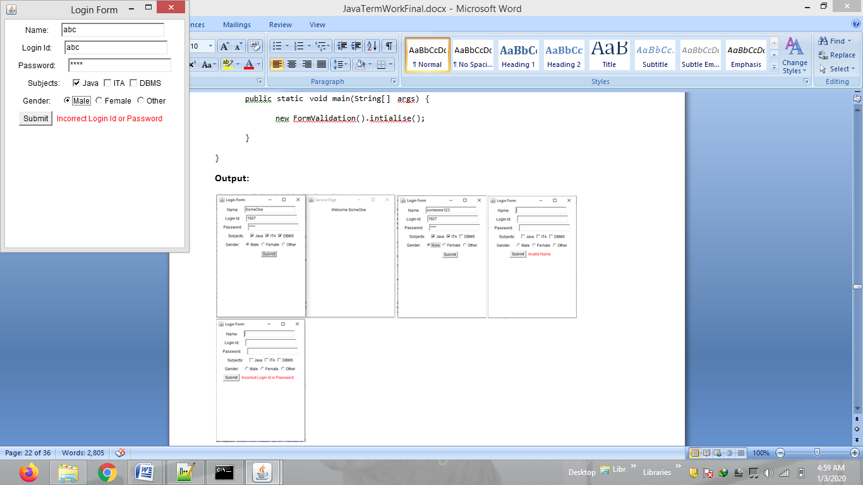

**Problem Statement 14:**

Write a program to find the difference between 2 dates and show the difference as number of days between the inputted dates.

**Code:**

import java.util.*;

import java.util.regex.*;

public class TW14 {

static Scanner sc = new Scanner(System.in);

public static void main(String[] args) {

System.out.println("Enter two dates in DD/MM/YYYY format");

String date1 = sc.nextLine();

String date2 = sc.nextLine();

String regex = "^(0[1-9]|[12][0-9]|3[01])/(0[1-9]|1[012])/(19|20)\\d\\d$";

if(Pattern.matches(regex, date1) && Pattern.matches(regex, date2)) {

String arr[] = date1.split("/");

int day = Integer.parseInt(arr[0]);

int month = Integer.parseInt(arr[1]) - 1;

int year = Integer.parseInt(arr[2]);

Calendar cal1 = new GregorianCalendar(year, month, day);

arr = date2.split("/");

day = Integer.parseInt(arr[0]);

month = Integer.parseInt(arr[1]) - 1;

year = Integer.parseInt(arr[2]);

Calendar cal2 = new GregorianCalendar(year, month, day);

long diff = Math.abs(cal1.getTimeInMillis() - cal2.getTimeInMillis());

double days = diff/(1000*60*60*24);

Date d = cal1.getTime();

System.out.println(d);

d = cal2.getTime();

System.out.println(d);

System.out.println((int)days+" days");

}

else {

System.out.println("Wrong Date Entered");

}

}

}

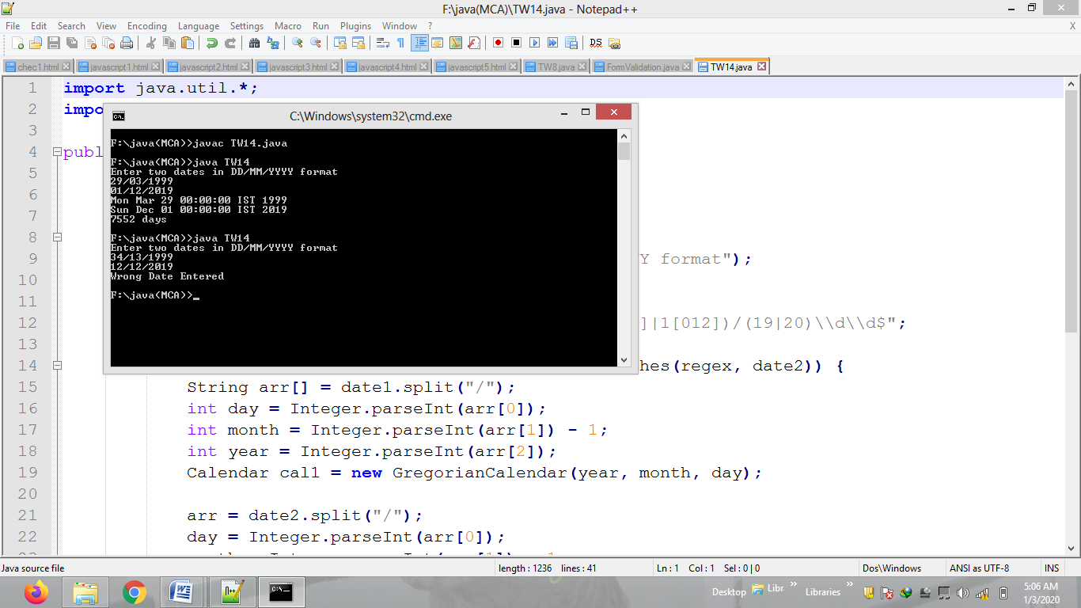

**Problem Statement 15:**

Write a program to draw a line using consecutive mouse clicks and adapter class in applets.

**Code:**

import java.applet.*;

import java.awt.*;

import java.awt.event.*;

public class TW15 extends Applet

{

int c=0;

int a,b,x,y;

public void init()

{

addMouseListener(new B());

}

class B extends MouseAdapter

{

public void mouseClicked(MouseEvent e)

{

c++;

if(c%2==1)

{

a=e.getX();

b=e.getY();

}

if(c%2==0)

{

x=e.getX();

y=e.getY();

}

repaint();

}

}

public void paint(Graphics g)

{

if(c%2==0)

g.drawLine(a,b,x,y);

}

}

/*<applet code="TW16" width=200 height=200></applet>*/

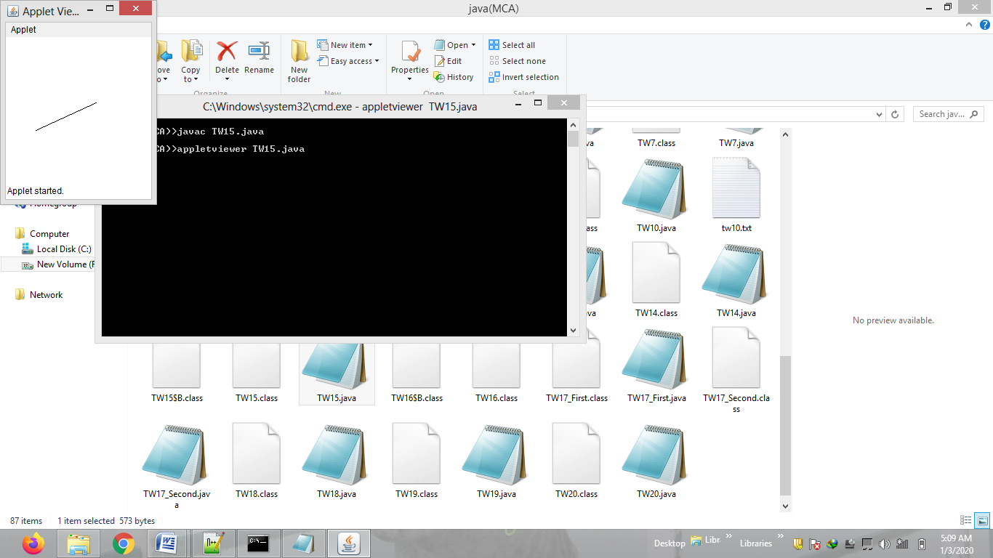

**Problem Statement 16:**

Write a program to send a string from first machine to second and second machine will send string by converting it into each character’s next position character (eg: abd -> bce).

**Code:**

**First.java –**

import java.net.*;

import java.io.*;

public class TW16_First

{

public static void main(String args[])throws Exception

{

ServerSocket ss=new ServerSocket(5000);

Socket s=ss.accept();

OutputStream os=s.getOutputStream();

DataOutputStream dos=new DataOutputStream(os);

dos.writeUTF("san");

InputStream is=s.getInputStream();

DataInputStream dis=new DataInputStream(is);

String m=dis.readUTF();

System.out.println("Second machine sending" +" "+m);

dos.close();

}

}

**Second.java –**

import java.net.*;

import java.io.*;

public class TW16_Second

{

public static void main(String args[])throws Exception

{

Socket s= new Socket("localhost",5000);

InputStream is=s.getInputStream();

DataInputStream dis=new DataInputStream(is);

String m=dis.readUTF();

System.out.println("first machine sending" +" "+m);

char ch[]={'a','b','c','d','e','f','g','h','i','j','k','l','m','n','o','p','q','r','s','t',

'u','v','w','x','y','z'};

String w="" ;

DataOutputStream dos=new DataOutputStream(s.getOutputStream());

for(int i=0;i<m.length();i++)

{

char c=m.charAt(i);

for(int j=0;j<ch.length;j++)

{

if(c==ch[j])

w=w+ch[j+1];

}

}

dos.writeUTF(w);

dos.close();

}

}

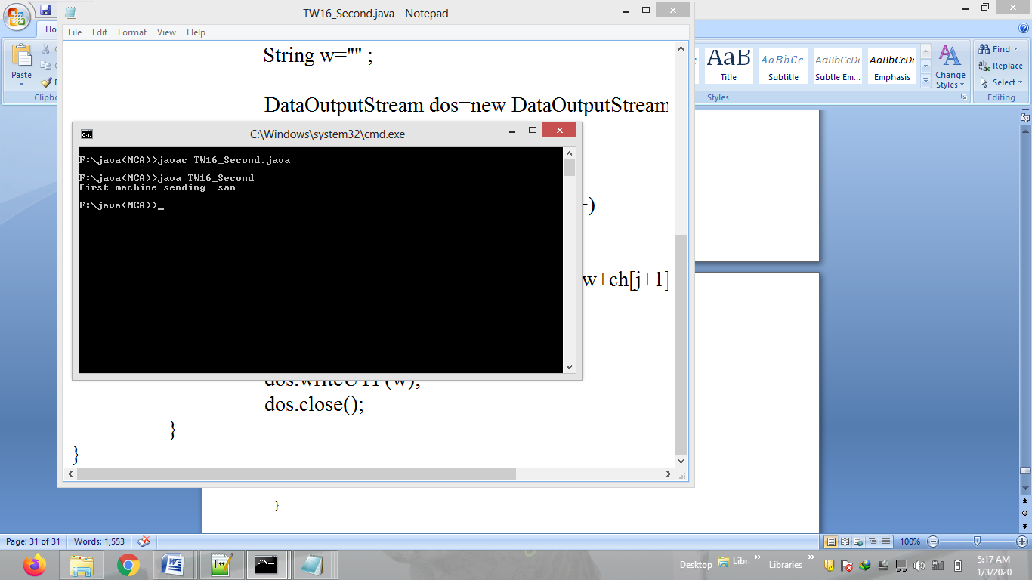

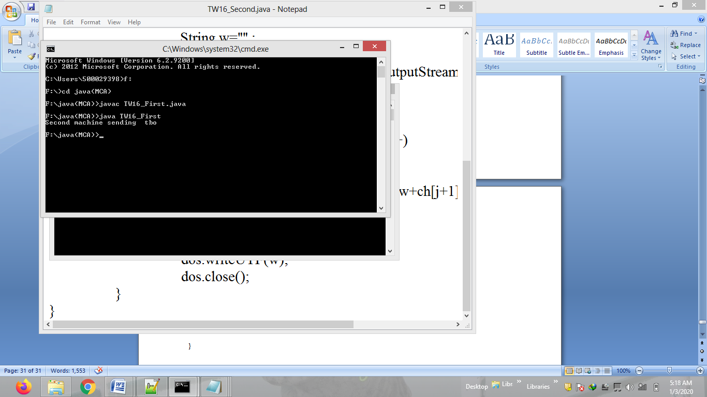

**Problem Statement 17:**

Write a program to read from a URL.

**Code:**

import java.io.*;

import java.net.*;

public class TW17

{

public static void main(String args[])throws Exception

{

URL url=new URL("file:///F:/java(MCA)/TW4.html");

String str="";

StringBuffer data=new StringBuffer();

InputStream is=url.openStream();

BufferedReader bfr=new BufferedReader(new InputStreamReader(is));

while((str=bfr.readLine())!=null)

data=data.append(str+"\n");

bfr.close();

System.out.println(data);

}

}

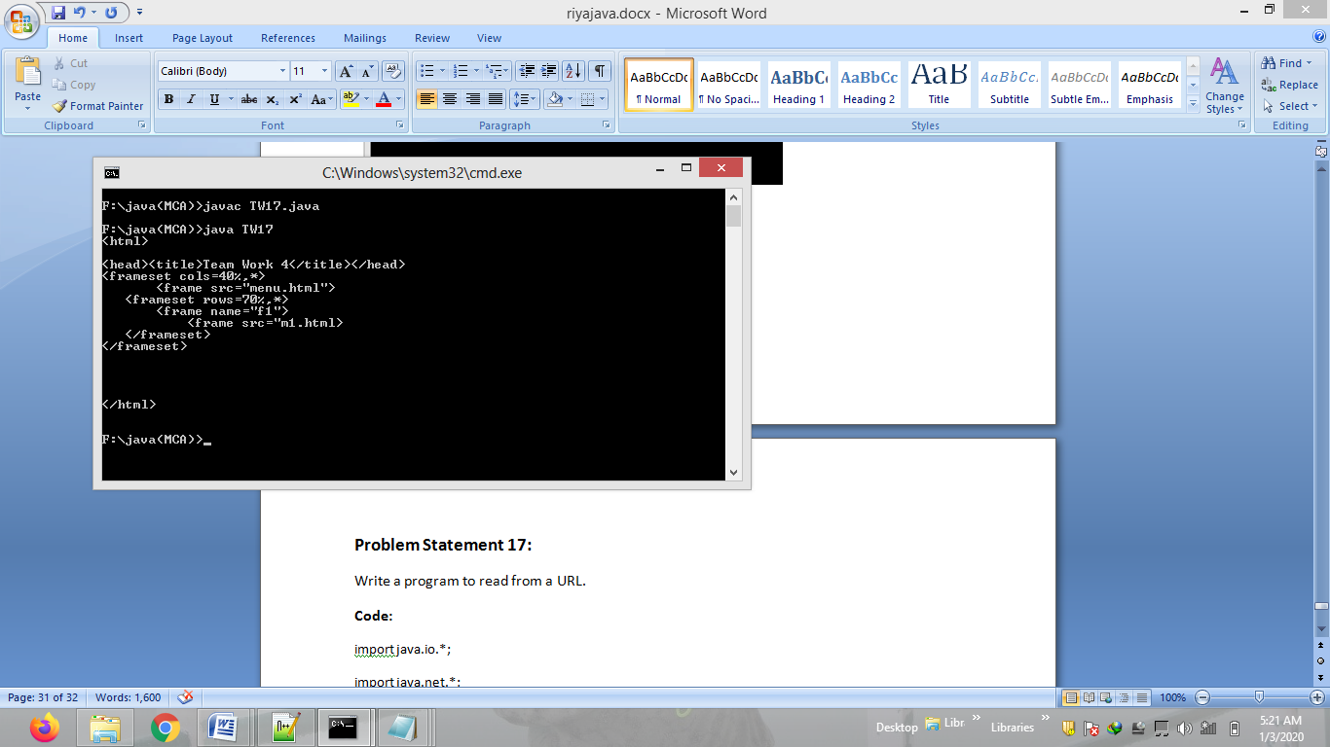

**Problem Statement 18:**

Write a program to process array list values using iterator.

**Code:**

import java.util.*;

public class TW18

{

public static void main(String args[])

{

ArrayList a=new ArrayList();

a.add(13);

a.add(13.25);

a.add("hello");

a.add("array list");

a.add(34);

Iterator ia=a.iterator();

while(ia.hasNext())

System.out.println(ia.next());

}

}

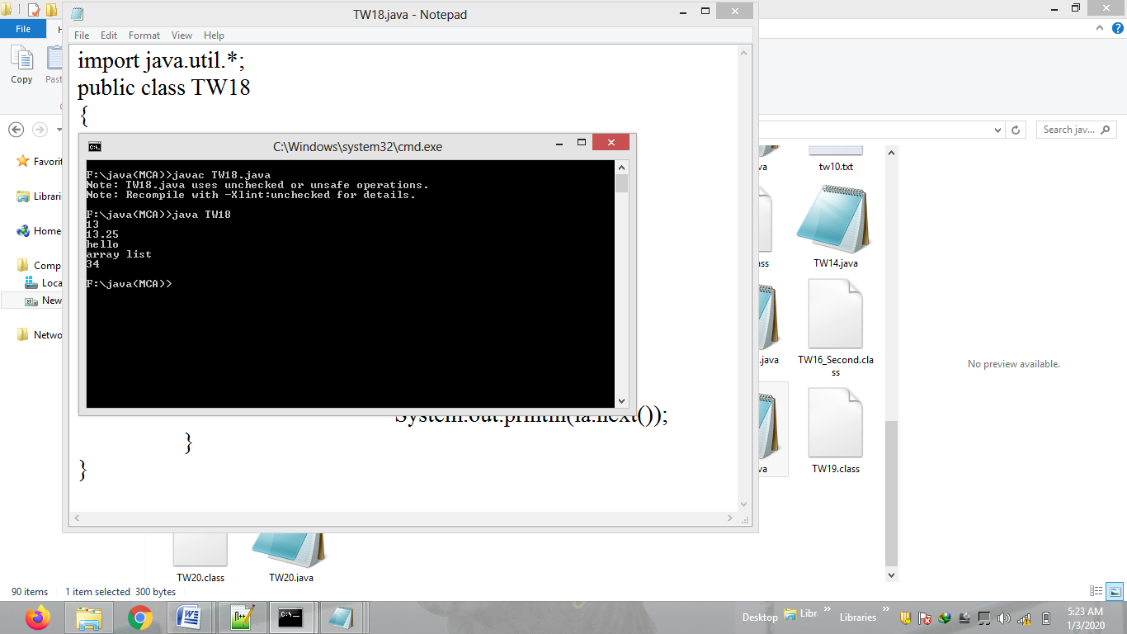

**Problem Statement 19:**

Write a program to create a function with following implementation.

**String show (String s1, String s2, int key, int index);**

Print the first character of smaller string and last character of second string as per alphabetical order along with the value of key from both left to right of index, if the two strings are equal, print reverse of a string and key without value of index.

e.g.: show (“abc”,”ram”, 12345, 2) O/P: am234.

e.g.: show (“abc”,”abc”, 12345, 2) O/P: cba135.

**Code:**

public class TW19

{

public static void main(String args[])

{

B b =new B();

String str_main=b.show("bc","abc",12345,2);

String st="";

System.out.println(str_main);

for(int i=0;i<str_main.length();i++)

{

Character c=str_main.charAt(i);

if(Character.isLowerCase(c))

c=Character.toUpperCase(c);

else if(Character.isUpperCase(c))

c=Character.toLowerCase(c);

st=st+c;

}

System.out.println("OUTPUT=" + st);

}

}

class B

{ String e="",s="",str="",newstr="",str1="",rev="";

String show(String s1,String s2,int key,int index)

{

str=Integer.toString(key);

char cl=str.charAt(index-1);

char cr=str.charAt((str.length())-index);

str1=(str.substring(0,index-1))+(str.substring(index,str.length()));

if(s1.compareToIgnoreCase(s2)>0)

{

e= s2.substring((s2.length())-1,s2.length());

s= s1.substring(0,1);

newstr=e+s+cl+cr;

}

else if(s1.compareToIgnoreCase(s2)<0)

{

e= s1.substring((s1.length())-1,s1.length());

s= s2.substring(0,1);

newstr=e+s+cl+cr;

}

else if(s1.compareToIgnoreCase(s2)==0)

{

for(int i=(s2.length())-1;i>=0;i--)

{

rev=rev + s2.charAt(i);

}

newstr=rev+str1;

}

return newstr;

}

}

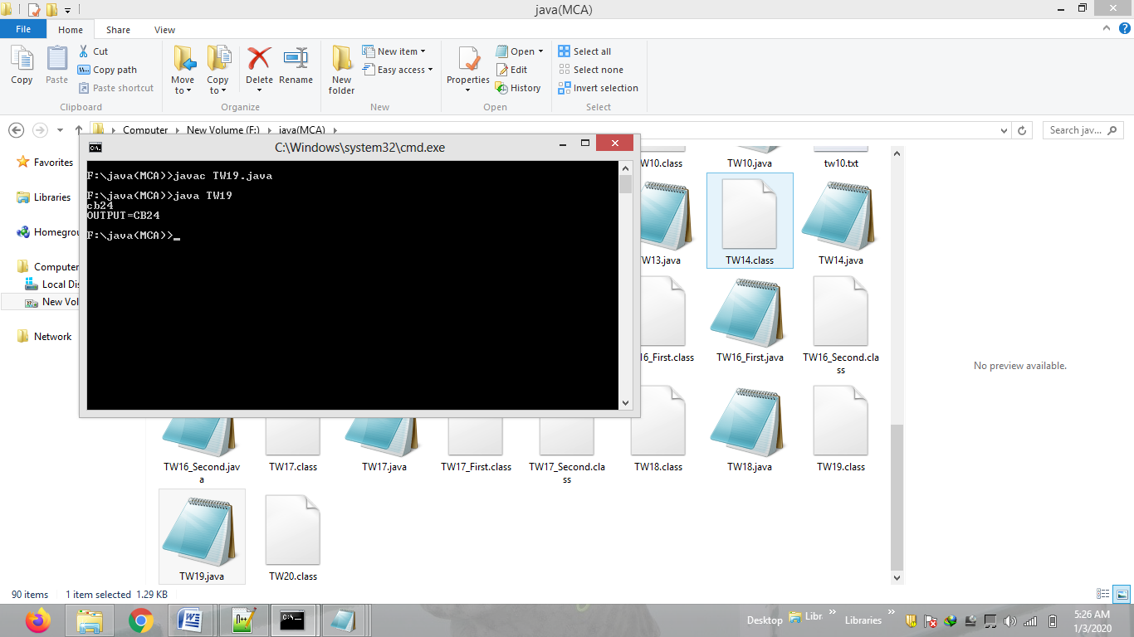

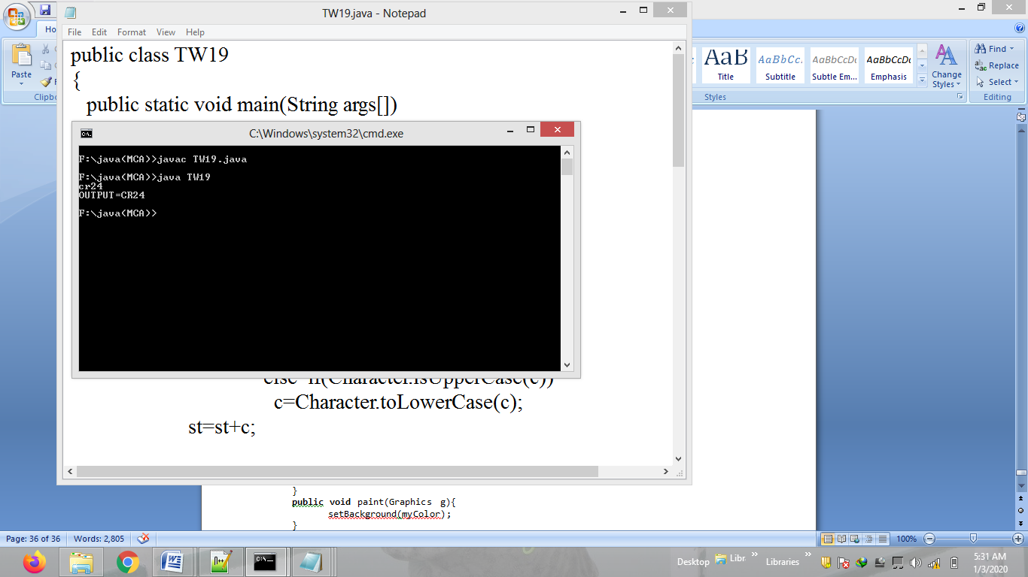

**Problem Statement 20:**

Write a program to change background of an applet using custom (r,g,b) value from param tag.

**Code:**

import java.awt.*;

import java.applet.*;

import java.awt.event.*;

public class TW20 extends Applet implements ActionListener {

Button btn;

String parameter;

int r,g,b;

Color myColor;

public void init(){

btn = new Button("Change Color>>");

btn.addActionListener(this);

parameter = getParameter("r");

r = Integer.parseInt(parameter);

parameter = getParameter("g");

g = Integer.parseInt(parameter);

parameter = getParameter("b");

b = Integer.parseInt(parameter);

add(btn);

}

public void actionPerformed(ActionEvent e){

repaint();

System.out.println("color value :"+r+" "+g+" "+b);

myColor = new Color(r,g,b);

}

public void paint(Graphics g){

setBackground(myColor);

}

}

/*

<applet code="TW20" height = "300" width="300">

<param name = "r" value = 20>

<param name = "g" value = 200>

<param name = "b" value = 10>

</applet>

*/

