**SHRI RAMSWAROOP MEMORIAL COLLEGE OF ENGINEERING & MANAGEMENT, LUCKNOW**

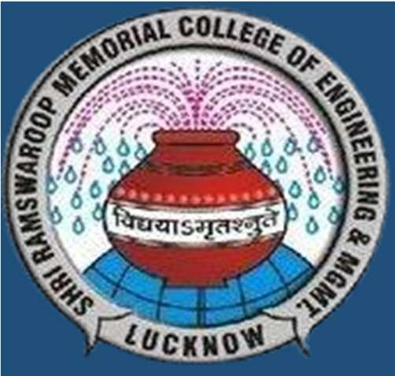

**Automatic Subject Allocator using AI**

**Team Members:**

**Mohammad Aqleem (2101220100067) Mohd. Yahya Rizwan (2101220100071)**



FLOW CHART

ADVANTAGES

**Project Guide:**



India’s agriculture sector supports about 55% of the population but faces issues like poor marketing and middlemen exploitation. The **Farming Assistance Web Application** helps farmers sell directly to suppliers, access market data, and manage resources efficiently. It connects farmers with experts and ensures secure, mobile-friendly access, promoting sustainable and profitable farming.

INTRODUCTION

**Dr. Pankaj Kumar**

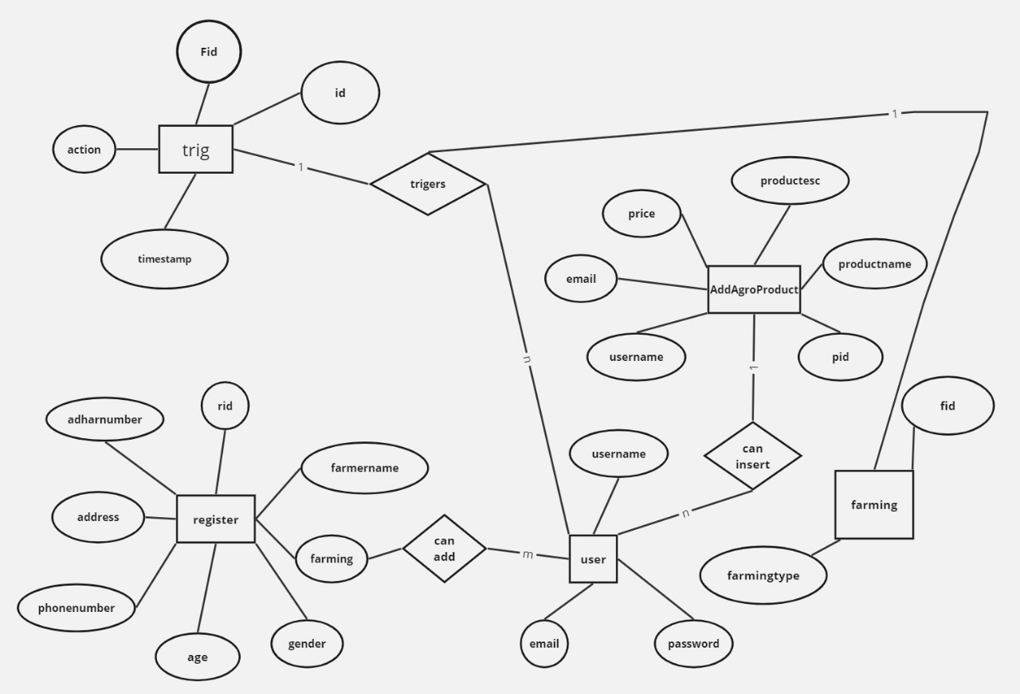

* Farmers have access to a wealth of information, enabling informed decisions for increased productivity and profitability.
* Farmers can connect with potential buyers, expanding market reach and improving sales opportunities, leading to better income and market stability.
* Farmers can advertise their crops to showcase products directly to suppliers.
* Farmers can sell their products directly to suppliers, eliminating middlemen.

METHODOLOGY

METHODOLOGY

LIMITATIONS



OBJECTIVE

Limited internet access, low literacy, high costs, and the digital divide may hinder app adoption, while excessive data could lead to fraud and poor insights.

SCREENSHOTS



The project aims to develop a digital platform to support farmers, agricultural workers, and stakeholders by addressing key challenges in the farming sector. It connects farmers directly with buyers, reduces costs through an economical, user-friendly GUI, and offers smart suggestions to simplify communication without needing full translations.

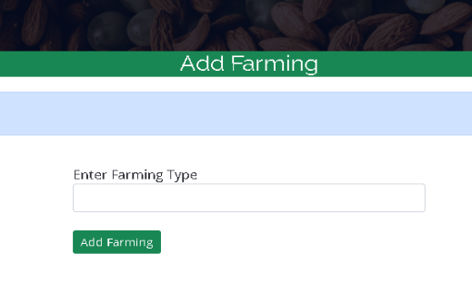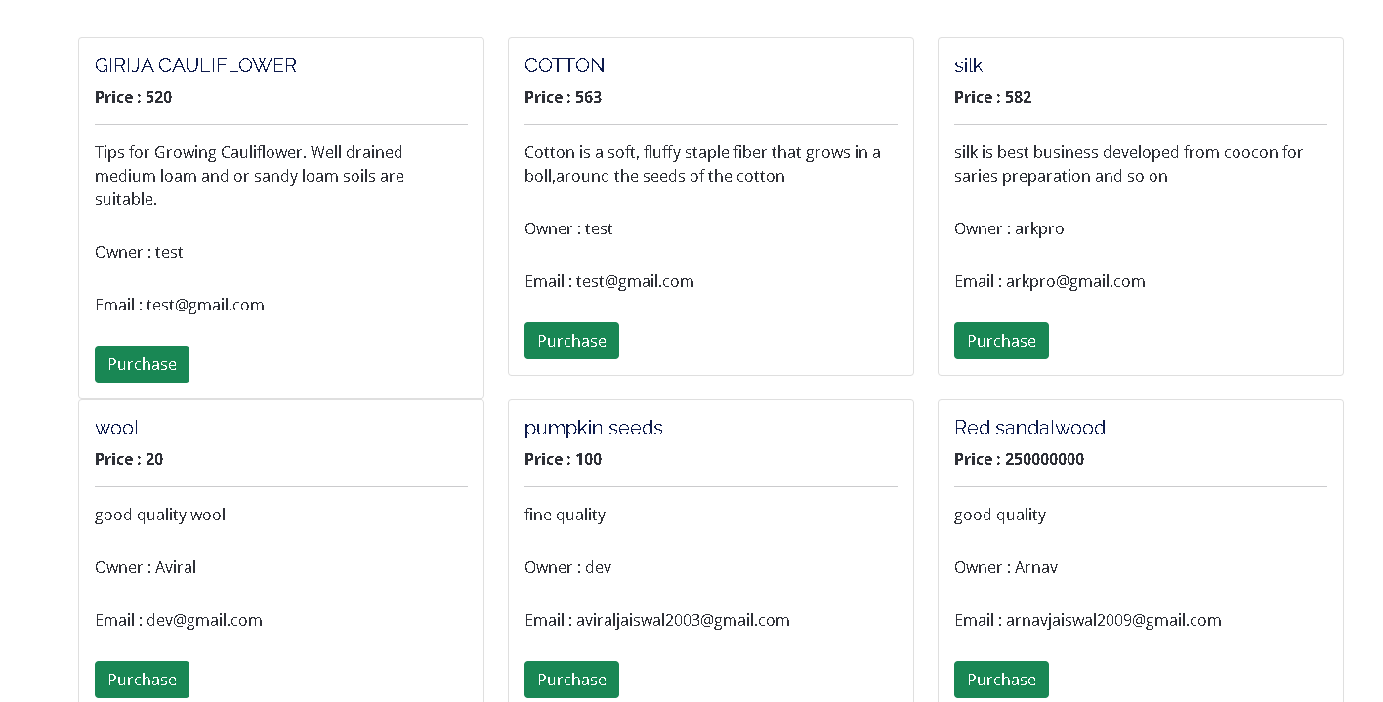

CONCLUSION

FUTURE SCOPE

REFERENCES

In conclusion, IoT, blockchain, and AI can optimize farming, enhance traceability, and improve decision-making, while partnerships boost credibility and effectiveness.

RESULT ANALYSIS

METHODOLOGY



1. T. J. Pettit et al. (2010) proposed a conceptual framework to enhance supply chain resilience.
2. ISO 28000-2007 provides guidelines for security management in supply chains.
3. Md. Razu Ahmed et al. (2020) explored the use of blockchain in electronic voting systems.
4. Srisruthi et al. (2016) focused on sustainable agriculture using eco-friendly sensor technologies.
5. Shankar M. Patil et al. (2019) developed an Android app to assist farmers with various agricultural tasks.
6. Abishek A.G. et al. (2016) highlighted the role of web and mobile technologies in agriculture marketing.
7. Shital Chaudhari et al. (2018) presented a smart farming approach through an Android-based application for modern agriculture practices.

The project delivers a user-friendly digital platform that empowers farmers by connecting them directly with buyers and providing real-time market insights. It ensures efficient, adaptable, and sustainable farming support through a robust and flexible development approach. Collaborations with research institutions and government bodies further enhance the application’s effectiveness, contributing to a more sustainable and efficient agricultural system.

The Farming Web Assisting Services project uses the **Iterative Waterfall model**, combining the structured phases of traditional Waterfall with the flexibility of iterative feedback. This ensures each development stage builds clearly on the last while allowing improvements based on user needs. The approach delivers a robust, adaptable, and user-focused farming service system.

The project successfully created a user-friendly and economical platform connecting farmers directly with buyers, reducing middlemen costs. It provides real-time market insights and smart suggestions to aid decision-making. Using the Iterative Waterfall model ensured a robust, adaptable, and user-focused system.