**Practical-1**

**Aim:** Recapitulation of Basic concepts of Programming.

**(i)** WAP to find the sum of an array of integers

**Input:**

#include<iostream.h>

#include<conio.h>

int main(){

clrscr();

int a[100],n,sum = 0;

cout<<"Enter the number of elements: ";

cin>>n;

cout<<"Enter "<<n<<" integers:\n";

for(int i=0;i<n;i++){

cin>>a[i];

sum+=a[i];

}

cout<<"Sum of the numbers is: "<<sum;

getch();

return 0;

}

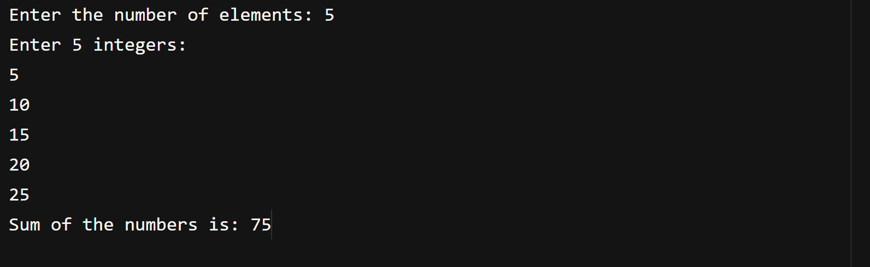**Output:**

**(ii)** WAP to find the factorial of a number

**Input:**

#include<iostream.h>

#include<conio.h>

int main(){

clrscr();

int n;

long fact=1;

cout<<"Enter a number: ";

cin>>n;

if(n < 0){

cout<<"Factorial of negative number is not defined.";

}

else{

for(int i=1;i<=n; i++){

fact=fact* i;

}

cout << "Factorial of "<<n<<" is: " << fact;

}

getch();

return 0;

}

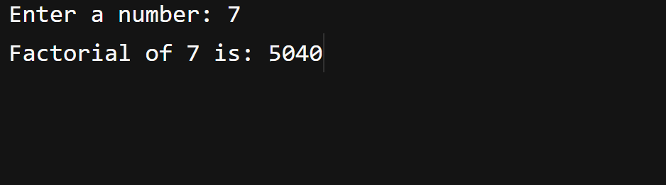**Output**

**Practical-2**

**Aim:** To implement insertion and deletion operations in array.

**INSERTION :**

**(i)** WAP to insert a value at the end of an array of integers

**Input:**

#include <iostream>

using namespace std;

int main(){

    int arr[100], n, value;

    cout << "Enter the number of elements: " << endl;

    cin >> n;

cout << "Enter the values :" << endl;

for (int i = 0; i < n; i++)

{

        cin >> arr[i];

    }

    cout << "Enter the value to add at end : " << endl;

    cin >> value;

arr[n] = value;

    n = n + 1;

cout<<"The new array is :"<<endl;

for (int i = 0; i < n; i++)

{

  cout << arr[i] << endl;

    }

    return 0;

}

**Output:**

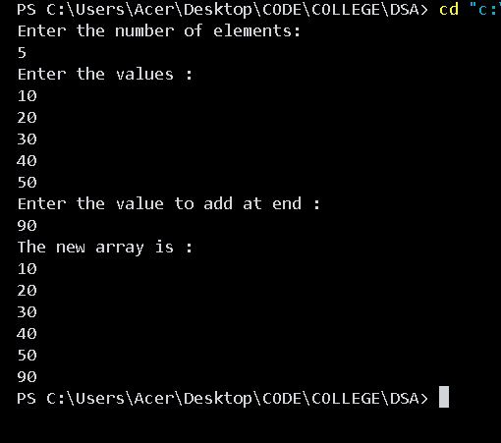

**(ii)** WAP to insert a value at a specified position in an array of integers

**Input:**

#include <iostream>

using namespace std;

int main()

{

    int arr[100], n, value,pos;

    cout << "Enter the number of elements: " << endl;

    cin >> n;

    cout << "Enter the values :" << endl;

    for (int i = 0; i < n; i++)

    {

        cin >> arr[i];

    }

    cout << "Enter the value to add : " << endl;

    cin >> value;

    cout << "Enter the position  : " << endl;

    cin >> pos;

    pos--;

    for(int i=n-1; i>=pos; i--){

        arr[i+1]=arr[i];

    }

    arr[pos] = value;

    n = n + 1;

    cout<<"the new array is :"<<endl;

    for (int i = 0; i < n; i++)

    {

        cout << arr[i] << endl;

    }

    return 0;

}

**Output:**

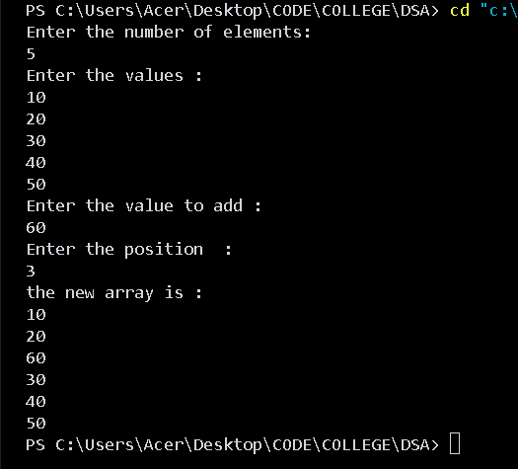

**DELETION :**

**(ii)** WAP to delete an element from a specified position in a one-dimensional array.

**Input:**

#include <iostream>

using namespace std;

int main()

{

    int arr[100], n, pos;;

    cout << "Enter the number of elements: " << endl;

    cin >> n;

    cout << "Enter the values :" << endl;

    for (int i = 0; i < n; i++) {

        cin >> arr[i];

    }

        cout<<"enter the position : ";

        cin>>pos;

    for (int i = pos; i < n; i++)

    {

        arr[i-1]=arr[i];

    }

    n = n-1;

    cout<<"The new array is : "<<endl;

    for (int i = 0; i < n; i++){

  cout<<arr[i]<<endl;

    }

    return 0;

}

**Output:**

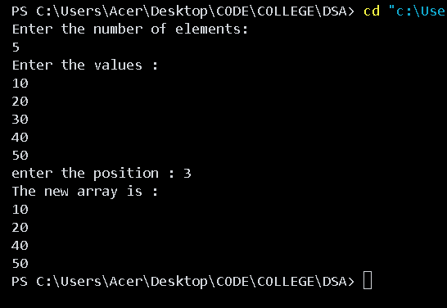

**(ii)** WAP to delete the first occurrence of a given value from a one-dimensional array.

**Input:**

#include <iostream>

using namespace std;

int main()

{

    int arr[100], n, value, pos = -1;

    cout << "Enter the number of elements: ";

    cin >> n;

    cout << "Enter the values: " << endl;

    for (int i = 0; i < n; i++)

    {

        cin >> arr[i];

    }

    cout << "Enter the value to delete: ";

    cin >> value;

    for (int i = 0; i < n; i++)

    {

        if (arr[i] == value)

        {

            pos = i;

            break;

        }

    }

    if (pos == -1)

    {

        cout << "Value not found!" << endl;

        return 0;

    }

    for (int i = pos; i < n - 1; i++)

    {

        arr[i] = arr[i + 1];

    }

    n--; // Reduce size

    cout << "The new array is:" << endl;

    for (int i = 0; i < n; i++)

    {

        cout << arr[i] << endl;

    }

    return 0;

}

**Output:**

