**PROGRAM NO. 1**

**OBJECTIVE :** WRITE a program that uses a class where the member functions are defined inside a class.

**INPUT :**

#include <iostream>

using namespace std;

class car{

    private:

    int car_number;

    char car_model[10];

    public:

    void getdata(){

        cout<<"Enter car number: "; cin>>car_number ;

        cout<<"Enter car model: "; cin>>car_model ;

    }

    void showdata(){

        cout<<"Car number is "<<car_number;

        cout<<"\nCar model is "<<car_model;

    }

};

int main(){

    car c1;

    c1.getdata();

    c1.showdata();

    return 0;}

**OUTPUT :**

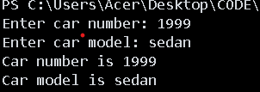

**PROGRAM NO. 2**

**OBJECTIVE :** WRITE a program that uses a class where the member functions are defined outside a class.

**INPUT :**

#include <iostream>

using namespace std;

class car{

private:

    int car_number;

    char car_model[10];

public:

    void getdata();

    void showdata();

};

    void car::getdata()  {

      cout << "Enter car number: ";

        cin >> car_number;

        cout << "Enter car model: ";

        cin >> car_model;

    }

    void car::showdata() {

        cout << "Car number is " << car_number;

        cout << "\nCar model is " << car_model;

    }

int main()

{

    car c1;

    c1.getdata();

    c1.showdata();

    return 0;

}

**OUTPUT :**



**PROGRAM NO. 3**

**OBJECTIVE :** Write a program to demonstrate the use of static data members .

**INPUT :**

#include<iostream>

using namespace std;

class Demo{

    private:

    static int x;

    public:

    static void func(){

        cout<<"Value of X :"<<x<<endl;

    }

};

int Demo::x = 10;

int main(){

    Demo x;

    x.func();

    return 0;

}

**OUTPUT :**

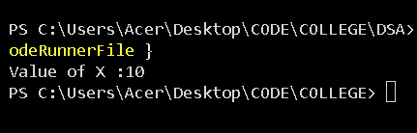

**PROGRAM NO. 4**

**OBJECTIVE :** Write a program to demonstrate the use of const data members .

**INPUT :**

#include <iostream>

using namespace std;

class abc{

    int x;

    public :

    int func1(int a){

        x = a;

    }

    void func2() const

    {

        ++x;

        cout<<"value of x : "<<x<<endl;

    }

};

int main(){

    abc d;

    d.func1(15);

    d.func2();

    return 0;

}

**OUTPUT :**

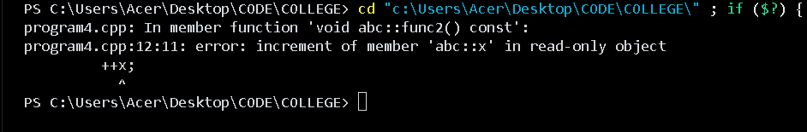

// The error occurs because we are trying to modify a member variable x inside a const **member function**, which is **not allowed**.

//A const function promises **not to modify any member variables** of the class (unless they're marked mutable).