AICTE | IBM SkillsBuild
Data Analytics with AI Internship 2026
Conducted by BharatCares in association with AICTE
PROJECT REPORT
California House Price Prediction
using Machine Learning
Submitted by
Himanshu Namdev
B.Tech Computer Science and Engineering (Final Year)
Samrat Ashok Rajkiya Engineering College, Mirzapur
Affiliated to Dr. A.P.J. Abdul Kalam Technical University, Lucknow, Uttar Pradesh
Domain: Data Analytics | Problem type: Supervised regression
October 2026

Abstract
Accurate house-price estimation supports buyers, sellers, lenders, investors and planners. This project builds an end-to-end machine-learning solution that predicts the median house value of a neighbourhood from its demographic, housing and location characteristics. It uses the California Housing Prices dataset (20,640 census block groups, 9 raw features) and follows the full analytics life-cycle: data understanding and cleaning, exploratory analysis, feature engineering, pipeline-based preprocessing, model comparison, hyper-parameter tuning, evaluation, error analysis and interpretation.
Nine engineered features (per-household ratios and distances to five major cities) were added to the raw data. Eight regression algorithms were compared with 5-fold cross-validation against a mean-value baseline, and the two strongest families were tuned with randomised search. The selected model, a HistGradientBoosting (tuned) pipeline, achieves on an untouched test set an R² of 0.866, a mean absolute error of $27,329 and an RMSE of $41,718. This reduces RMSE by 36% relative to linear regression and by 63% relative to the baseline.
Permutation importance shows that latitude, longitude, median_income are the dominant drivers of price, i.e. location and neighbourhood income explain most of the variation. The report also documents the limitations of the data (1990 census, prices capped at $500,001, aggregated block-group records) and proposes directions for future work. All code is delivered as a reproducible Jupyter notebook.
Keywords: house price prediction, regression, gradient boosting, random forest, feature engineering, cross-validation, permutation importance, scikit-learn

Acknowledgement
I would like to thank AICTE and IBM SkillsBuild for the Data Analytics with AI internship programme, and BharatCares for conducting it and providing the learning resources and project guidelines. I am also grateful to the faculty of the Department of Computer Science and Engineering, Samrat Ashok Rajkiya Engineering College, Mirzapur, for their continued support, and to the open-source community behind Python, scikit-learn, pandas, matplotlib and seaborn, without whose tools this project would not have been possible.

Contents
1 Introduction
2 Dataset Description
3 Tools and Technologies
4 Methodology
5 Data Cleaning and Preprocessing
6 Exploratory Data Analysis
7 Feature Engineering
8 Model Building and Evaluation
9 Error Analysis
10 Model Interpretation
11 Insights and Practical Applications
12 Limitations
13 Conclusion and Future Scope
References
A Appendix A - Project Files and How to Run
B Appendix B - Key Code Excerpts

List of figures and tables
Every chart in this report (except the workflow diagram) was produced by the accompanying notebook and is stored in its figures folder; every table of results is generated from the notebook's output files, so the numbers in this document match the executed code exactly.

1. Introduction

1.1 Background and motivation
A home is usually the largest purchase a household makes, and property is a major asset class for banks, investors and governments. Prices depend on many interacting factors: the income of the people living nearby, the size and age of the housing stock, how crowded the area is, and above all where it is. Experienced agents estimate prices by comparison and intuition; data analytics and machine learning make that process systematic, scalable and measurable.
Regression models can learn the relationship between these factors and price directly from historical data. Beyond pure prediction, a well-analysed model also explains which factors matter most, which is valuable for urban planning, taxation and investment decisions.

1.2 Problem statement
Problem statement
Given the demographic, housing and geographic characteristics of a California census block group, predict its median house value (in US dollars) as accurately as possible, and identify the factors that influence the price the most.

1.3 Objectives
- Load, inspect and clean the dataset, handling missing, censored and extreme values appropriately.
- Explore the data visually and statistically to understand the drivers of house prices.
- Engineer additional features that describe living conditions and geographic accessibility.
- Build a leak-free preprocessing and modelling pipeline and compare several regression algorithms using cross-validation.
- Tune the best-performing models and evaluate the final model once on a held-out test set.
- Analyse the model's errors, interpret its behaviour and document the limitations.
- Package the work as a reproducible project: notebook, dependency list, README and this report.

1.4 Scope and deliverables
The project covers the complete analytics workflow on a public, well-known dataset. Following the programme guidelines, four files are submitted:
- HimanshuNamdev_HousePricePrediction.ipynb - complete, executed code with outputs and explanations.
- requirements.txt - Python libraries needed to run the notebook.
- HimanshuNamdev_ProjectReport.docx - this document, the full project documentation.
- README.md - overview, dataset link, technologies used, setup and run instructions.

2. Dataset Description

2.1 Source
The project uses the California Housing Prices dataset, derived from the 1990 US Census and first used by Pace and Barry (1997). It is a standard benchmark for regression and is available publicly:
- Kaggle: https://www.kaggle.com/datasets/camnugent/california-housing-prices
- CSV used by the notebook: https://raw.githubusercontent.com/ageron/handson-ml2/master/datasets/housing/housing.csv
Each of the 20,640 rows is a block group - the smallest geographical unit for which the Census Bureau publishes data, typically 600 to 3,000 people. The dataset has 9 input columns and one target column.

2.2 Variables
Table 1: Variables in the dataset
Column | Type | Description | Observed range
longitude | Numeric | Block-group longitude (west-east position) | -124.35 to -114.31
latitude | Numeric | Block-group latitude (south-north position) | 32.54 to 41.95
housing_median_age | Numeric | Median age of the houses (years) | 1 to 52
total_rooms | Numeric | Total rooms in all houses of the block group | 2 to 39,320
total_bedrooms | Numeric | Total bedrooms in all houses of the block group | 1 to 6,445
population | Numeric | Number of residents | 3 to 35,682
households | Numeric | Number of households | 1 to 6,082
median_income | Numeric | Median household income (tens of thousands of US$) | 0.50 to 15.00
ocean_proximity | Categorical | Distance to the ocean: <1H OCEAN, INLAND, NEAR OCEAN, NEAR BAY, ISLAND | 5 categories
median_house_value | Numeric (target) | Median house value in US$ | $14,999 to $500,001

2.3 Data quality summary
Table 2: Data quality findings and the action taken
Issue | Finding | Action
Missing values | total_bedrooms is missing in 207 rows (1.00%) | Median imputation, fitted on training data only (inside the pipeline)
Censored target | 965 rows (4.7%) have median_house_value capped at $500,001 | Rows kept; effect measured in the error analysis
Censored feature | 1273 rows (6.2%) have housing_median_age capped at 52 | Kept; documented as a limitation
Outliers | Very large block groups give extreme total_rooms, population, households | Kept (genuine values); per-household ratios and tree models reduce their influence
Duplicates | 0 duplicate rows | None needed

3. Tools and Technologies
The entire project is implemented in Python using open-source libraries. Versions below are those used to produce the results in this report.
Table 3: Technology stack
Tool | Version | Purpose
Python | 3.13.16 | Programming language
pandas | 3.0.5 | Data loading, cleaning and aggregation
NumPy | 2.5.3 | Numerical computation, vectorised distance formulas
scikit-learn | 1.9.1 | Pipelines, preprocessing, models, cross-validation, tuning, metrics, interpretation
matplotlib | 3.11.2 | Charts
seaborn | 0.13.2 | Statistical visualisation
joblib | - | Saving and loading the trained pipeline
Jupyter Notebook | - | Interactive, documented, reproducible analysis

4. Methodology
The project follows a standard supervised-learning workflow, summarised in the figure below. Every step is implemented in the notebook and uses a fixed random seed (42), so the results are reproducible.
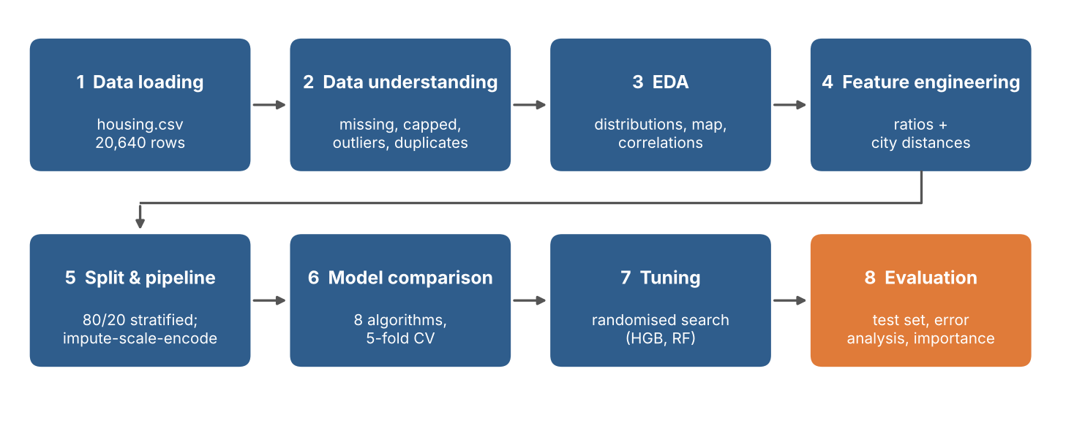
Figure 1: End-to-end project workflow

4.1 Evaluation strategy
- Hold-out test set (20%) - split once, stratified by income category, and used only for the final evaluation.
- 5-fold cross-validation on the training set (80%) - used to compare models and select the best one without touching the test set.
- Pipelines - imputation, scaling and encoding are fitted only on the training part of each fold, which prevents data leakage.
- Baseline - a model that always predicts the training mean shows what 'no skill' looks like.

4.2 Evaluation metrics
Table 4: Metrics used
Metric | Meaning | Better when
RMSE | Root mean squared error in US$; penalises large mistakes more | Lower
MAE | Mean absolute error in US$; the average size of a miss | Lower
R² | Share of the variance in house values explained by the model (0 = no better than the mean, 1 = perfect) | Higher
MAPE | Mean absolute percentage error; the typical error relative to the price | Lower

5. Data Cleaning and Preprocessing

5.1 Missing values
Only total_bedrooms contains missing values (207 of 20,640 rows). They are replaced by the median of the training data using scikit-learn's SimpleImputer. The median is robust to the heavy right tail of this variable. Because the imputer lives inside the pipeline, it is re-fitted for every cross-validation fold, so no information from validation or test rows is used.

5.2 Censored and extreme values
The Census survey capped house values at $500,001 and house age at 52 years. These rows contain real information (the true values are at least that high), and removing them would bias the sample towards cheaper, newer areas, so they were kept. Their influence on prediction accuracy is quantified in Section 9. Extreme values of total_rooms, population and households correspond to unusually large block groups rather than data-entry errors and were also retained; per-household ratios (Section 7) normalise for block-group size.

5.3 Encoding and scaling
- ocean_proximity is converted to indicator (one-hot) columns; categories unseen at prediction time are ignored safely.
- Numeric features are standardised (zero mean, unit variance) after imputation. This is essential for linear, Ridge/Lasso and k-nearest-neighbour models and harmless for tree-based models.

5.4 Train / test split
The data were split into 16,512 training rows and 4,128 test rows (80/20). Because income is the strongest predictor, the split is stratified on five income categories so that the test set mirrors the income mix of the full data. This makes the final performance estimate more reliable than a purely random split.

6. Exploratory Data Analysis

6.1 Distribution of house values
The target is right-skewed: the mean ($206,856) is higher than the median ($179,700), and the skewness is 0.98. A distinct spike at $500,001 is the survey cap described in Section 5.
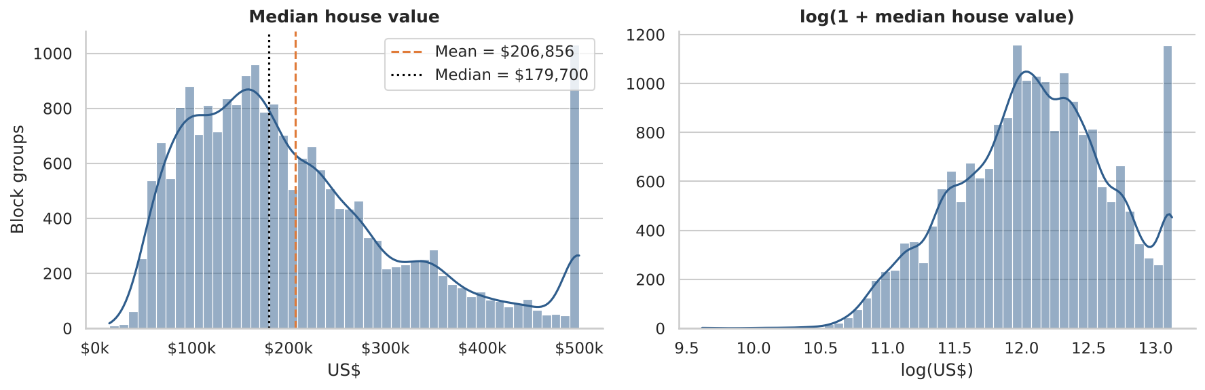
Figure 2: Distribution of median house value (left) and its logarithm (right)

6.2 Distribution of the features
Most count-type variables (total_rooms, total_bedrooms, population, households) are strongly right-skewed with long tails, reflecting a few very large block groups. Median income is also right-skewed; housing_median_age shows the cap at 52 years.
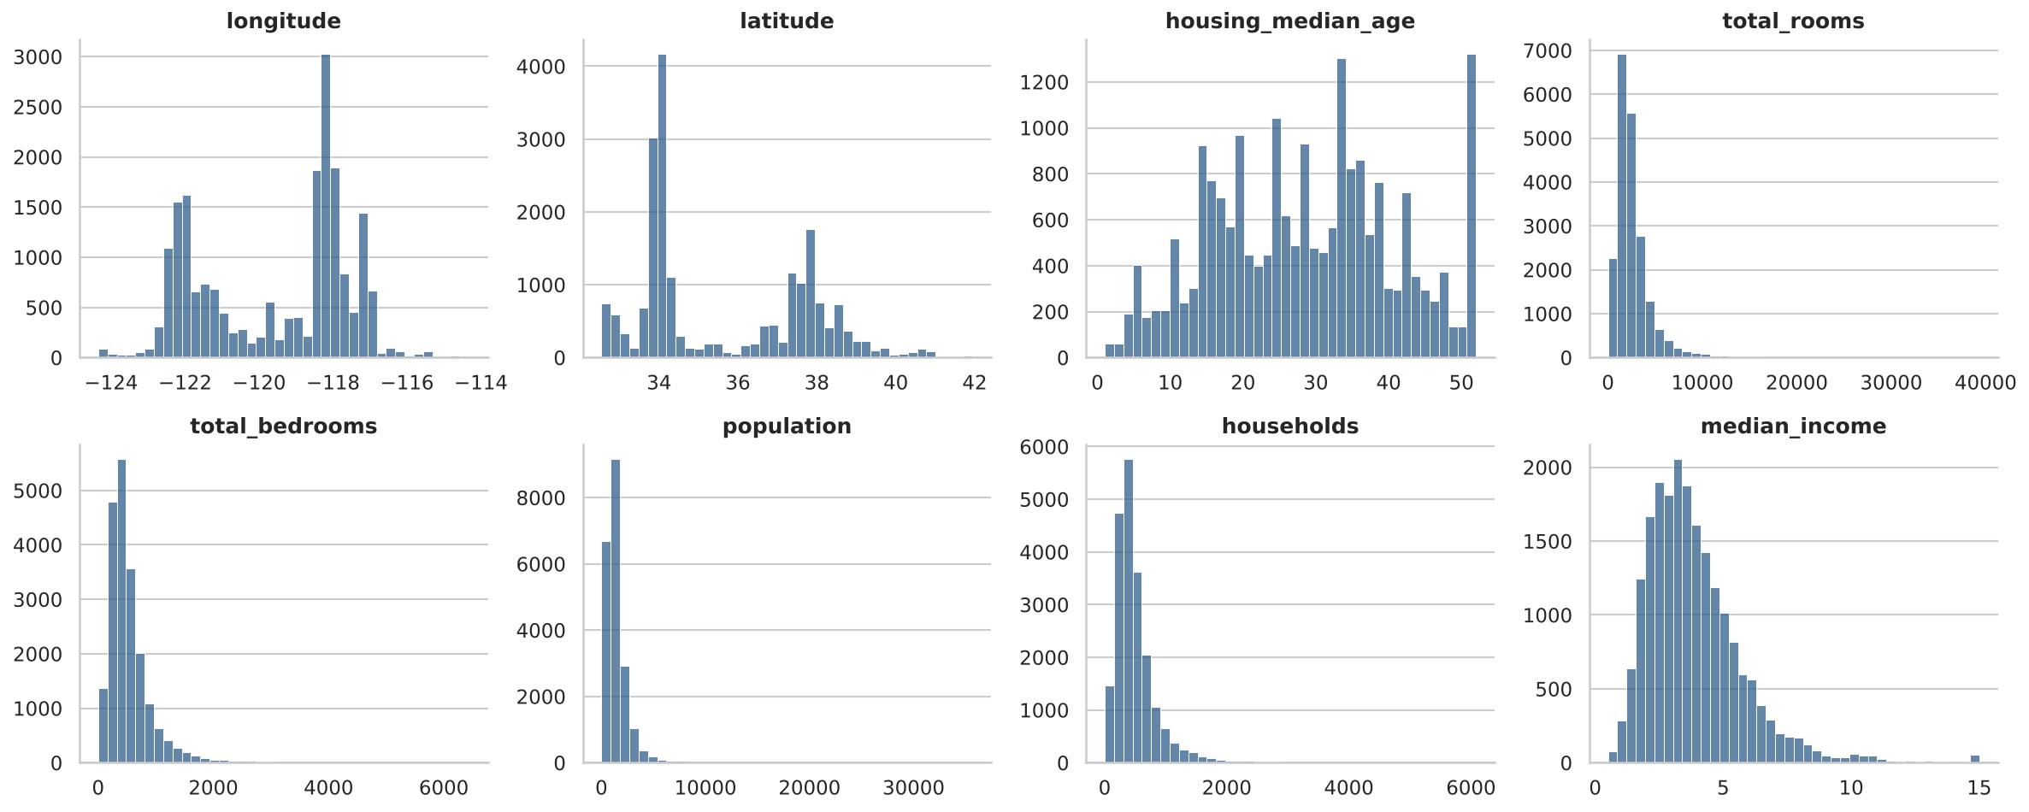
Figure 3: Histograms of the eight numeric input features

6.3 Geography
Plotting longitude against latitude reproduces the outline of California. The most expensive block groups form clear clusters along the coast - the San Francisco Bay Area and the Los Angeles and San Diego coastline - while the Central Valley and the desert interior are much cheaper. Location is clearly a decisive factor, so the model must exploit latitude and longitude well.
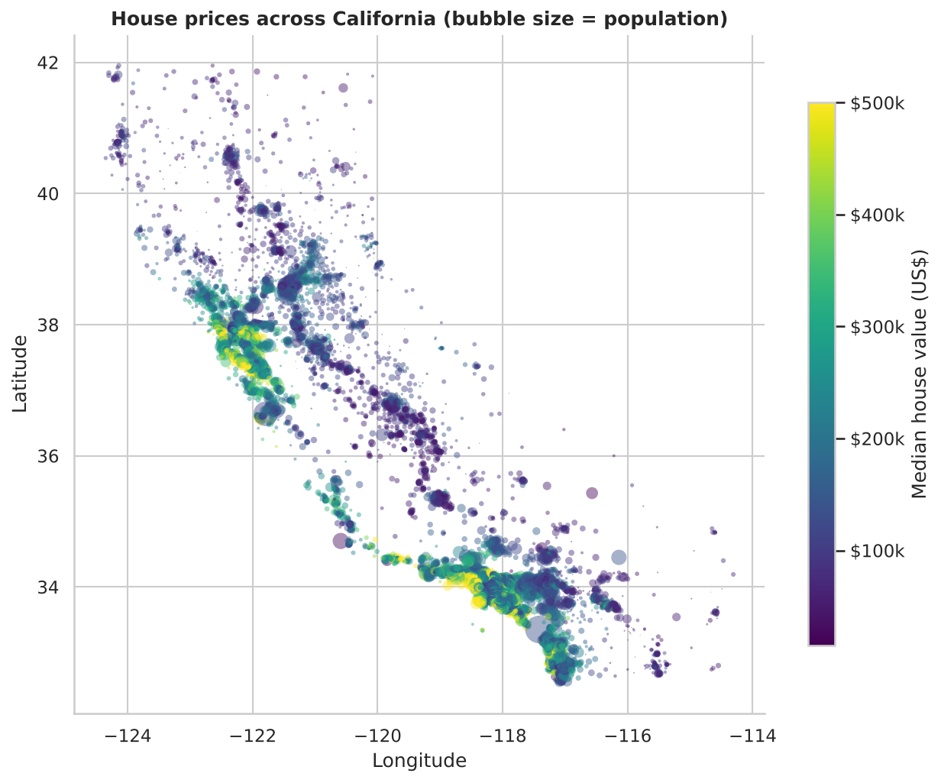
Figure 4: House prices across California (colour = price, bubble size = population)

6.4 Correlations
median_income has by far the strongest linear relationship with price (r = 0.69); every other raw feature has |r| below 0.15. The size-related variables total_rooms, total_bedrooms, population and households are very highly inter-correlated (r between 0.86 and 0.98) because they all grow with the size of the block group; this multicollinearity is one reason to replace them with per-household ratios.
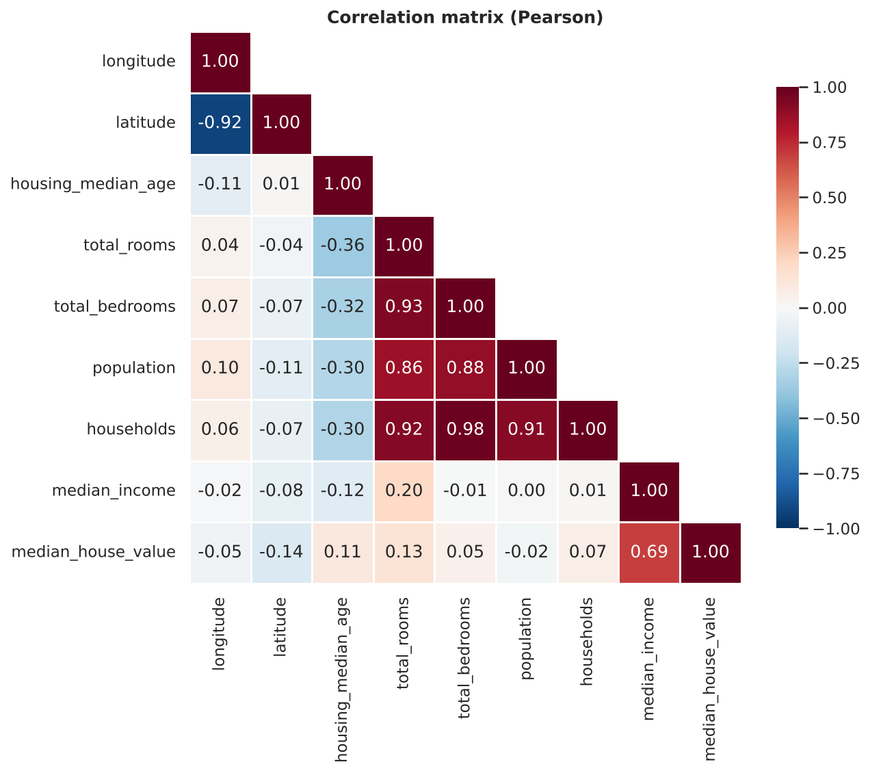
Figure 5: Pearson correlation matrix of the numeric variables

6.5 Income and price
The scatter plot shows an approximately linear, positive relationship between median income and price, with increasing spread at higher incomes. The horizontal line of points at $500,001 is the survey cap.
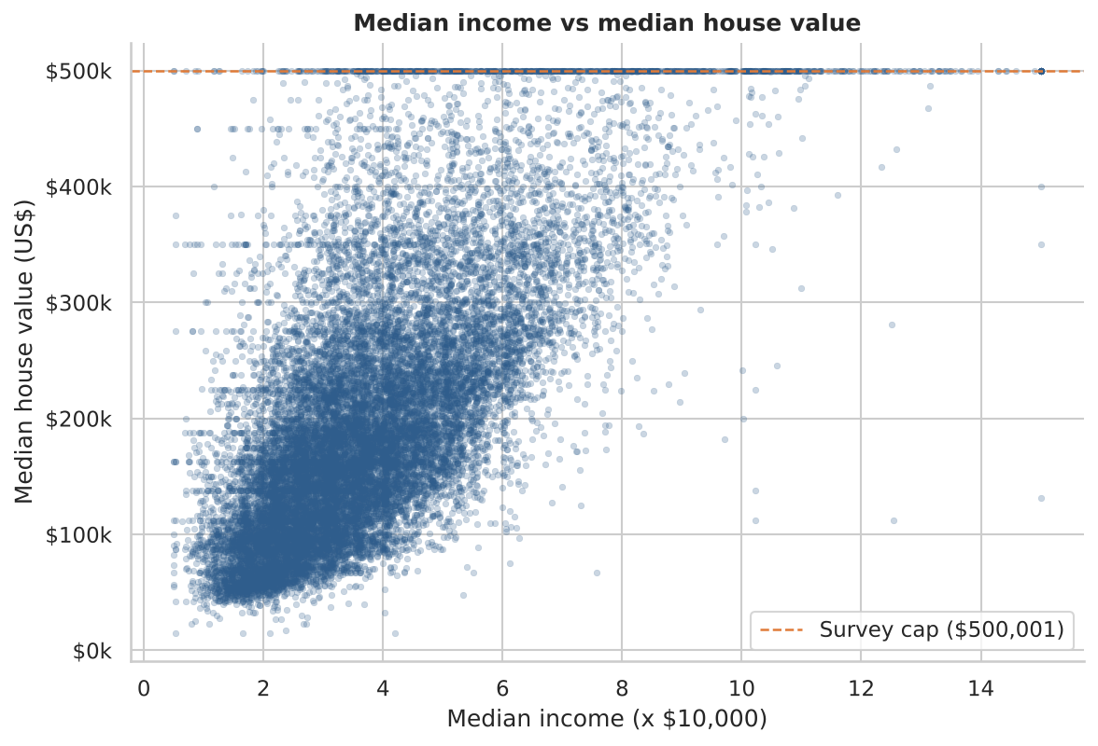
Figure 6: Median income versus median house value

6.6 Ocean proximity
Distance to the ocean strongly affects price. INLAND block groups have the lowest median value ($108,500), while the coastal categories are roughly twice as expensive (for example $229,450 for NEAR OCEAN and $233,800 for NEAR BAY). The ISLAND category contains only 5 block groups, so conclusions about it are unreliable.
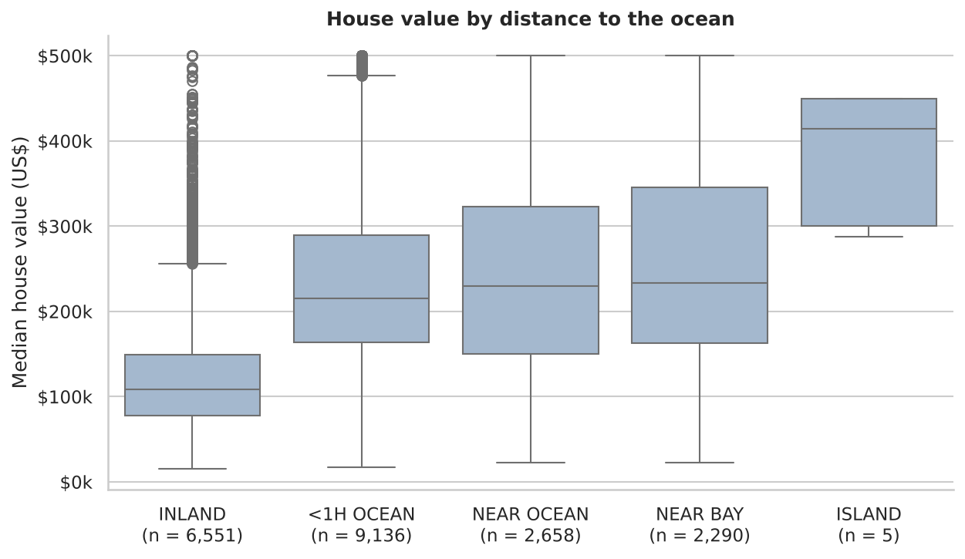
Figure 7: House value by distance to the ocean
Key EDA takeaways
(1) Prices are right-skewed and censored at the top. (2) Median income is the strongest linear predictor. (3) Geography is decisive - coastal and Bay/LA areas are expensive. (4) Size-related counts are redundant and are better expressed per household.

7. Feature Engineering
Nine features were added. All are deterministic, row-wise formulas, so they can be computed before the train/test split without leaking information. Distances use the haversine (great-circle) formula in kilometres.
Table 5: Engineered features
Feature | Formula | Rationale
rooms_per_household | total_rooms / households | Average home size
bedrooms_per_room | total_bedrooms / total_rooms | Bedroom share; low values suggest larger, more upscale homes
population_per_household | population / households | Crowding / household size
dist_los_angeles_km | haversine distance to Los Angeles | Access to the largest job market
dist_san_francisco_km | haversine distance to San Francisco | Bay Area proximity
dist_san_diego_km | haversine distance to San Diego | Southern coast proximity
dist_san_jose_km | haversine distance to San Jose | Silicon Valley proximity
dist_sacramento_km | haversine distance to Sacramento | State-capital proximity
dist_nearest_major_city_km | minimum of the five distances | Overall urban accessibility

The chart below shows how the new features relate to price. The distance to the nearest major city has the strongest negative correlation with price among all engineered features, and bedrooms_per_room is also clearly negative. Both are stronger than any raw feature except median income, which supports the decision to engineer them.
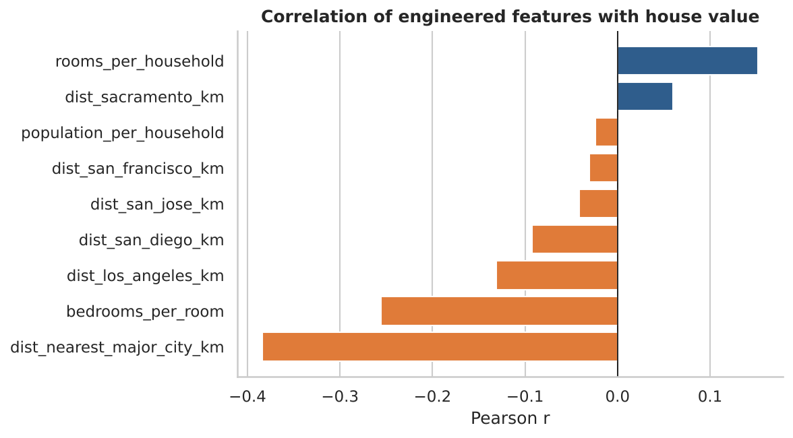
Figure 8: Correlation of the engineered features with house value

8. Model Building and Evaluation

8.1 Candidate algorithms
Eight algorithms of increasing flexibility were compared with the mean-value baseline, to see how much each additional level of model complexity contributes.
Table 6: Models compared
Model | Idea | Why it is included
Dummy (mean baseline) | Always predicts the training mean | Reference for 'no skill'
Linear Regression | Ordinary least squares | Simple, interpretable baseline
Ridge / Lasso | Linear models with L2 / L1 regularisation | Reduce variance, Lasso can drop features
KNN (k = 10) | Average of the 10 most similar block groups (distance-weighted) | Captures local, spatial patterns
Decision Tree | Single tree, depth 10 | Non-linear, interpretable rules
Random Forest | Average of many de-correlated trees (bagging) | Strong, robust, little tuning
Gradient Boosting | Trees built sequentially, each correcting the previous errors | Often the most accurate on tabular data
HistGradientBoosting | Fast, histogram-based gradient boosting | Accurate and efficient on 10k+ rows

8.2 Cross-validated results
All models were evaluated with identical 5-fold cross-validation on the training set. The table below lists the validation metrics together with the training RMSE; a large gap between the two indicates over-fitting. The linear models (RMSE about $66,935) are far better than the baseline ($115,699) but cannot capture the non-linear geography of prices. Tree ensembles reduce the error substantially: Random Forest reaches $47,795 and HistGradientBoosting $45,936 before any tuning.
Table 7: Cross-validation results on the training set (US$; sorted by CV RMSE)
Model | CV RMSE | CV MAE | CV R² | Train RMSE
HistGradientBoosting (tuned) | 44,074 | 28,222 | 0.855 | 20,148
Random Forest (tuned) | 44,428 | 28,325 | 0.852 | 16,574
HistGradientBoosting | 45,936 | 30,151 | 0.842 | 36,942
Gradient Boosting | 47,596 | 31,548 | 0.831 | 38,459
Random Forest | 47,795 | 30,538 | 0.829 | 22,247
KNN (k=10) | 58,216 | 38,630 | 0.747 | 0
Decision Tree | 59,220 | 39,074 | 0.738 | 46,475
Ridge | 66,931 | 47,644 | 0.665 | 66,444
Lasso | 66,934 | 47,643 | 0.665 | 66,442
Linear Regression | 66,935 | 47,643 | 0.665 | 66,442
Dummy (mean baseline) | 115,699 | 91,302 | -0.000 | 115,697

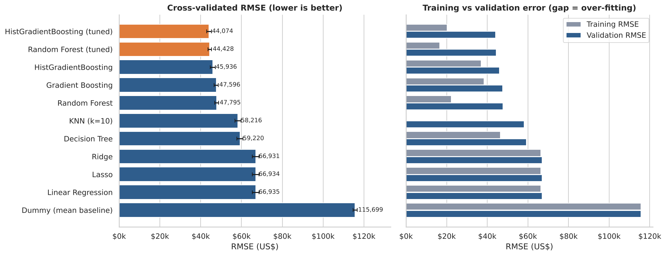
Figure 9: Cross-validated RMSE of all models (left) and training versus validation error (right)
Two observations stand out. First, the ensemble models show a sizeable gap between training and validation error (for example $20,148 versus $44,074 for the final model): they fit the training data very closely and generalise less well. Even so, their validation error is by far the lowest, so they remain the best choice. Second, KNN has a training error of almost zero simply because, with distance weighting, each training point is its own nearest neighbour; this is not a sign of a perfect model.

8.3 Hyper-parameter tuning
The two best families, HistGradientBoosting and Random Forest, were tuned with randomised search (20 candidate settings for HistGradientBoosting and 5 for Random Forest, 3-fold cross-validation, RMSE as the score). The table below shows the search space for HistGradientBoosting and the values selected. Tuning improved the cross-validated RMSE of HistGradientBoosting from $45,936 to $44,074, and that of Random Forest from $47,795 to $44,428.
Table 8: HistGradientBoosting - search space and selected values
Hyper-parameter | Values searched | Selected
learning_rate | 0.03, 0.05, 0.08, 0.1, 0.15 | 0.08
max_iter | 300, 500, 800 | 800
max_leaf_nodes | 15, 31, 63, 127 | 31
min_samples_leaf | 10, 20, 40, 80 | 10
l2_regularization | 0, 0.1, 1, 10 | 10
max_depth | None, 6, 10, 14 | 14

The tuned model with the lowest cross-validated RMSE, HistGradientBoosting (tuned), was chosen as the final model.

8.4 Final evaluation on the test set
The test set was used exactly once, to estimate how the final model performs on unseen block groups. The baseline and plain linear regression are shown for reference.
Table 9: Test-set performance (US$)
Model | MAE | RMSE | R² | MAPE | Median AE
Dummy baseline | $90,807 | $114,165 | -0.000 | 63.0% | $77,805
Linear Regression | $47,390 | $64,887 | 0.677 | 27.7% | $36,418
HistGradientBoosting (tuned) | $27,329 | $41,718 | 0.866 | 15.2% | $17,148

The final model explains 86.6% of the variance in house values. Its typical (median) error is $17,148, its mean error $27,329 (15.2% of the price), and it cuts the RMSE by 36% compared with linear regression and by 63% compared with the baseline. The test RMSE ($41,718) is close to the cross-validated RMSE ($44,074), indicating that model selection did not over-fit the validation folds.
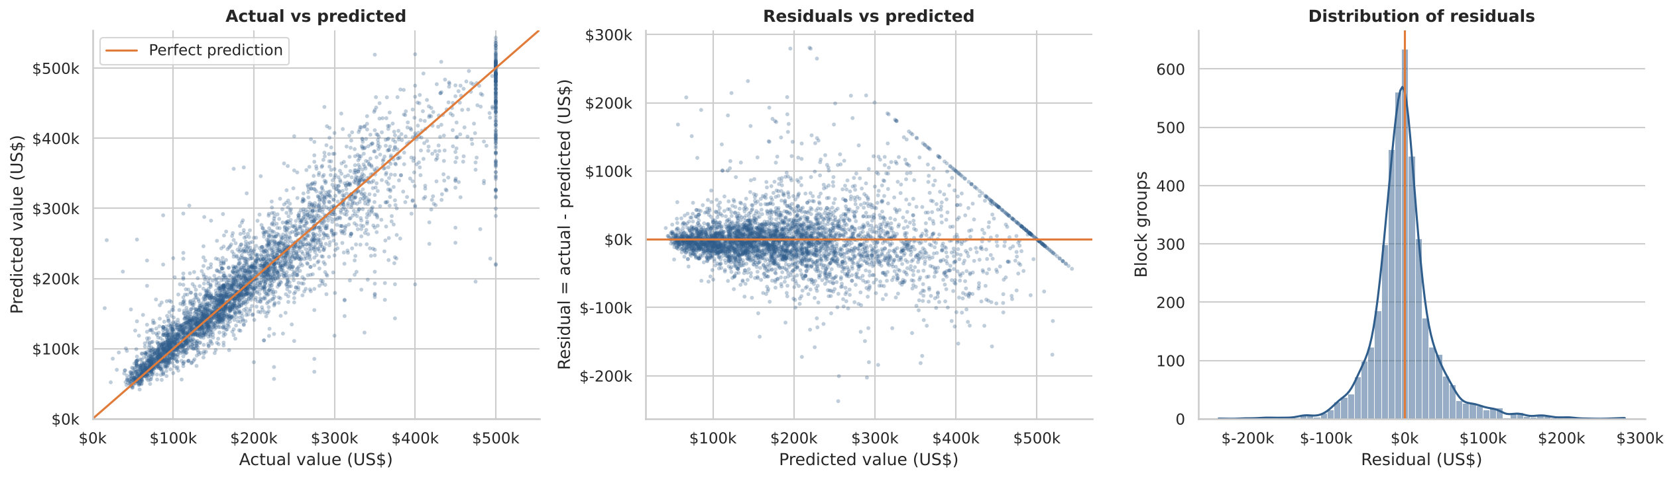
Figure 10: Actual vs predicted values, residuals vs predicted values, and the distribution of residuals
In the left panel the points follow the diagonal closely over the whole price range. The residual histogram is centred on zero and roughly symmetric. The vertical column of points at an actual value of $500,001 and the straight diagonal streak in the middle panel are caused by the survey cap, not by a model fault: all capped districts share the same 'actual' value.

9. Error Analysis
Knowing where a model fails is as important as knowing its average accuracy. Errors were broken down by ocean proximity and by actual price quintile; 'bias' is the mean of (predicted - actual), so a negative bias means under-prediction.
Table 10: Test-set error by ocean proximity (US$)
Ocean proximity | Block groups | MAE | MAPE | Bias
<1H OCEAN | 1,859 | 29,045 | 13.6% | 231
INLAND | 1,289 | 19,607 | 17.4% | 700
ISLAND | 3 | 90,951 | 23.1% | -39,074
NEAR BAY | 443 | 31,484 | 14.0% | 3,048
NEAR OCEAN | 534 | 36,190 | 16.6% | -1,263

Table 11: Test-set error by actual price quintile (US$)
Price quintile | Block groups | MAE | MAPE | Bias
Q1 (cheapest) | 826 | 16,092 | 24.3% | 11,955
Q2 | 825 | 19,350 | 14.9% | 8,654
Q3 | 827 | 22,369 | 12.4% | 7,347
Q4 | 824 | 30,542 | 12.3% | -2,402
Q5 (priciest) | 826 | 48,297 | 12.4% | -23,271

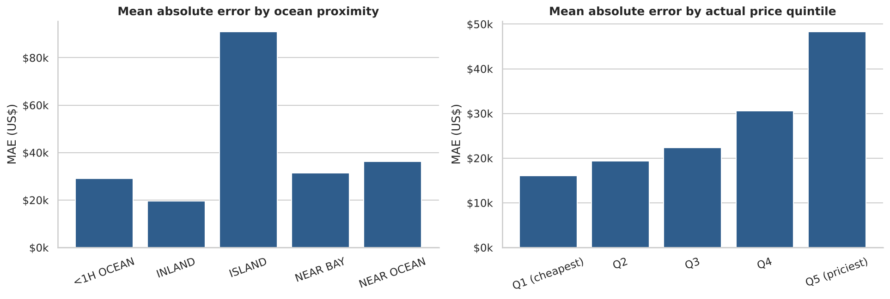
Figure 11: Mean absolute error by ocean proximity (left) and by actual price quintile (right)

9.1 Findings
- Absolute errors grow with price. The MAE rises from $16,092 in the cheapest quintile to $48,297 in the most expensive one, while the percentage error is fairly stable at 12-15% for quintiles Q2 to Q5 (it is higher, 24%, for the cheapest quintile) - i.e. errors are roughly proportional to price.
- Regression to the mean. The model over-predicts the cheapest districts (bias $11,955) and under-predicts the most expensive ones (bias -$23,271). This is a typical behaviour of regression models; for the top quintile it is amplified by the $500,001 cap, which hides how expensive the capped areas really are.
- INLAND areas are predicted most accurately in absolute terms (MAE $19,607) because prices there are lower, but their percentage error (17.4%) is the highest among the large groups - low-priced areas are harder to predict in relative terms.
- ISLAND has the largest error, but only 3 test block groups, so this figure is statistically meaningless.

9.2 Effect of the price cap
179 test block groups have a capped target. When they are excluded the model scores an MAE of $26,149, an RMSE of $39,371 and an R² of 0.837. The absolute errors are slightly lower. R² is also lower than on the full test set, because without the extreme capped values the price range - and therefore the total variance that R² is measured against - is smaller.

10. Model Interpretation

10.1 Permutation importance
Permutation importance measures how much the test-set RMSE increases when the values of one feature are randomly shuffled - the larger the increase, the more the model depends on that feature. The method is model-agnostic and, unlike impurity-based importances, is computed on unseen data.
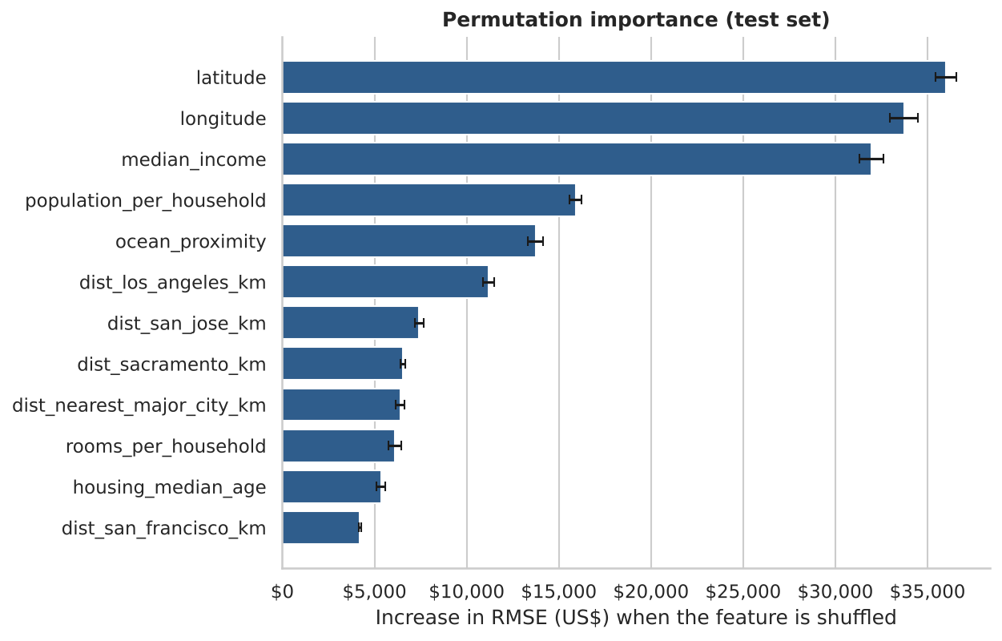
Figure 12: Permutation importance of the twelve most important features (test set)
Table 12: Top ten features by permutation importance
Rank | Feature | Increase in RMSE when shuffled
1 | latitude | $36,004
2 | longitude | $33,726
3 | median_income | $31,959
4 | population_per_household | $15,917
5 | ocean_proximity | $13,731
6 | dist_los_angeles_km | $11,193
7 | dist_san_jose_km | $7,424
8 | dist_sacramento_km | $6,556
9 | dist_nearest_major_city_km | $6,389
10 | rooms_per_household | $6,100

Location and income dominate. latitude, longitude, median_income head the ranking; together they account for the bulk of the model's predictive power. The engineered distance features together contribute $38,036 of RMSE increase, confirming that city accessibility adds information beyond raw coordinates. ocean_proximity and population_per_household (average household size, a likely proxy for the type of neighbourhood) also matter.

10.2 Partial dependence
Partial dependence plots show the average predicted price as one feature is varied while the others keep their observed values.
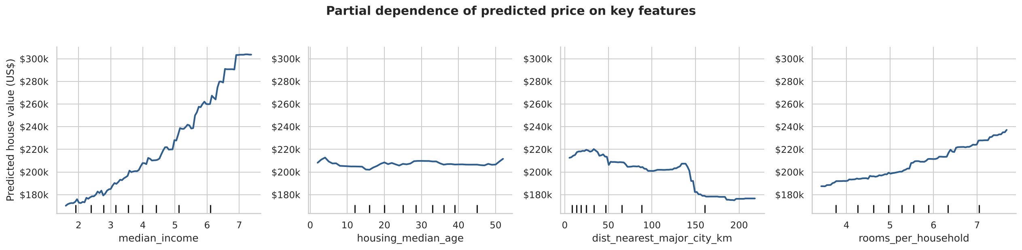
Figure 13: Partial dependence of the predicted price on four key features
- median_income: predicted price rises steadily and almost linearly with income, from roughly $170k at the low end to about $300k at the highest incomes in the data.
- housing_median_age: the effect is almost flat once location and income are accounted for - age alone has little influence.
- dist_nearest_major_city_km: prices are higher close to a major city and drop markedly beyond roughly 150 km, where block groups are rural or desert areas.
- rooms_per_household: larger homes are associated with higher predicted prices, as expected.

11. Insights and Practical Applications

11.1 What the analysis tells us
- Location and neighbourhood income explain most of the price differences between California block groups.
- Simple linear models leave a lot of accuracy on the table: the relationship between geography and price is strongly non-linear, and boosted trees capture it well.
- Thoughtful feature engineering (accessibility to major cities, per-household ratios) improves how well location and living conditions are represented.

11.2 Possible uses
Table 13: Practical applications
Stakeholder | How the model can help
Home buyers and sellers | Quick, data-driven reference price for a neighbourhood to support negotiation
Banks and lenders | Independent estimate of collateral value to complement formal valuation
Real-estate investors | Screening of areas by predicted value relative to income and location
Urban planners and policy-makers | Understanding which factors drive affordability; identifying under-priced or over-priced areas

The model should be viewed as a decision-support tool, not a replacement for a professional valuation: its mean error of $27,329 is acceptable for screening and planning but too large for an individual transaction.

12. Limitations
- Age of the data. The data are from 1990. Absolute price levels, income levels and neighbourhood patterns have changed greatly; the method transfers, the numbers do not.
- Censoring. Values are capped at $500,001 (target) and 52 years (age), so the model cannot learn the true level of the most expensive areas and tends to under-predict them.
- Aggregated records. Rows describe block groups, not individual houses. Lot size, condition, floor area, schools, crime and transport are unavailable.
- Spatial dependence. Neighbouring block groups are similar, so a random train/test split is somewhat optimistic compared with predicting an entirely new region.
- Ensemble over-fitting gap. The final model fits the training data much more closely than validation data; regularisation limits but does not remove this.
- Small categories. The ISLAND category has only five block groups in the whole dataset, so nothing reliable can be said about it.

13. Conclusion and Future Scope

13.1 Conclusion
This project delivered a complete, reproducible machine-learning solution for house-price prediction. After cleaning the data, exploring it and engineering nine new features, eight algorithms were compared with cross-validation and the best ones were tuned. The final HistGradientBoosting (tuned) pipeline reaches an R² of 0.866 with a mean absolute error of $27,329 on unseen data, a 36% lower RMSE than linear regression. Interpretation with permutation importance and partial dependence shows that location and neighbourhood income are the main drivers of price, in line with common sense, which increases confidence that the model has learned meaningful patterns rather than noise.
Beyond the numerical result, the project demonstrates good practice: leak-free pipelines, a held-out test set used once, a baseline for comparison, honest treatment of data limitations, error analysis and a saved, reusable model.

13.2 Future scope
- Use more recent data and add external features such as distance to the coastline, school quality, crime, transport and amenities.
- Try target transformation (log price), stacking and blending, and libraries such as XGBoost and LightGBM.
- Use spatial cross-validation (holding out whole regions) for a more honest estimate of generalisation to new areas.
- Add SHAP explanations for individual predictions and prediction intervals to communicate uncertainty.
- Deploy the saved pipeline as a web application (Streamlit or Flask) or a REST API, with an interactive map.
- Apply the same workflow to Indian housing data to support local affordability analysis.

References
- Pace, R. K., and Barry, R. (1997). Sparse spatial autoregressions. Statistics & Probability Letters, 33(3), 291-297.
- Kaggle. California Housing Prices dataset. https://www.kaggle.com/datasets/camnugent/california-housing-prices
- Geron, A. Hands-On Machine Learning with Scikit-Learn, Keras and TensorFlow (datasets/housing/housing.csv). https://github.com/ageron/handson-ml2
- Pedregosa, F. et al. (2011). Scikit-learn: Machine Learning in Python. Journal of Machine Learning Research, 12, 2825-2830.
- Breiman, L. (2001). Random Forests. Machine Learning, 45(1), 5-32.
- Friedman, J. H. (2001). Greedy function approximation: a gradient boosting machine. Annals of Statistics, 29(5), 1189-1232.
- Altmann, A., Tolosi, L., Sander, O., and Lengauer, T. (2010). Permutation importance: a corrected feature importance measure. Bioinformatics, 26(10), 1340-1347.
- McKinney, W. (2010). Data structures for statistical computing in Python. Proceedings of the 9th Python in Science Conference, 56-61.
- Hunter, J. D. (2007). Matplotlib: a 2D graphics environment. Computing in Science & Engineering, 9(3), 90-95.
- Waskom, M. L. (2021). seaborn: statistical data visualization. Journal of Open Source Software, 6(60), 3021.

Appendix A - Project Files and How to Run

A.1 Project structure
house-price-prediction/
|-- HimanshuNamdev_HousePricePrediction.ipynb# complete code
|-- requirements.txt # dependencies
|-- HimanshuNamdev_ProjectReport.docx # this report
|-- README.md # overview
|-- housing.csv # dataset (auto-downloaded if missing)
|-- figures/ # charts (created by the notebook)
`-- outputs/ # metrics, tables, trained model

A.2 Running the project
- Install Python 3.10 or newer.
- Create and activate a virtual environment (optional but recommended).
- Install the dependencies: pip install -r requirements.txt
- Start Jupyter: jupyter notebook and open HimanshuNamdev_HousePricePrediction.ipynb
- Choose Kernel > Restart and Run All. The dataset is downloaded automatically if housing.csv is not present. Total run time is about 10 minutes on a 2-core machine; set FAST_MODE = True in the configuration cell for a faster run.
Alternatively, upload the notebook to Google Colab; all required libraries are pre-installed there.

Appendix B - Key Code Excerpts

B.1 Feature engineering
def add_features(data):
out = data.copy()
out['rooms_per_household'] = out['total_rooms'] / out['households']
out['bedrooms_per_room'] = out['total_bedrooms'] / out['total_rooms']
out['population_per_household'] = out['population'] / out['households']
dist_cols = []
for city, (lat, lon) in MAJOR_CITIES.items():
col = f'dist_{city}_km'
out[col] = haversine_km(out['latitude'], out['longitude'], lat, lon)
dist_cols.append(col)
out['dist_nearest_major_city_km'] = out[dist_cols].min(axis=1)
return out

B.2 Leak-free preprocessing pipeline
preprocess = ColumnTransformer(
transformers=[
('num', Pipeline([('imputer', SimpleImputer(strategy='median')),
('scaler', StandardScaler())]), NUMERIC_FEATURES),
('cat', OneHotEncoder(handle_unknown='ignore'), CATEGORICAL_FEATURES),
],
sparse_threshold=0,
)

def build_pipeline(model):
return Pipeline([('prep', clone(preprocess)), ('model', model)])

B.3 Cross-validation and tuning
cv5 = KFold(n_splits=5, shuffle=True, random_state=42)
scores = cross_validate(pipeline, X_train, y_train, cv=cv5,
scoring={'rmse': 'neg_root_mean_squared_error',
'mae': 'neg_mean_absolute_error', 'r2': 'r2'},
return_train_score=True)

hgb = HistGradientBoostingRegressor(early_stopping=False, random_state=42)
hgb_search = RandomizedSearchCV(
build_pipeline(hgb), param_distributions=hgb_params, n_iter=20, cv=cv3,
scoring='neg_root_mean_squared_error', random_state=42, n_jobs=-1)
hgb_search.fit(X_train, y_train)

B.4 Saving the model and predicting new data
joblib.dump(final_model, 'outputs/house_price_model.joblib')

reloaded = joblib.load('outputs/house_price_model.joblib')
def predict_house_price(raw_df):
return reloaded.predict(add_features(raw_df))

