**Naive Bayes Classifier in Python**

# Classification of Diabetes using Naive Bayes in Python

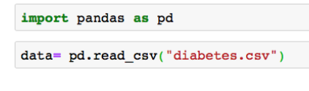

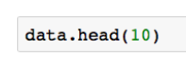

**SPLITTING DATA**

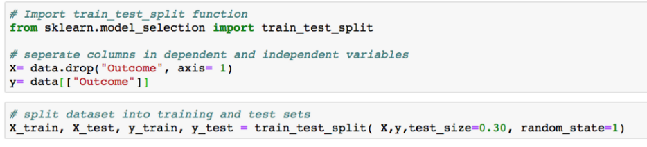

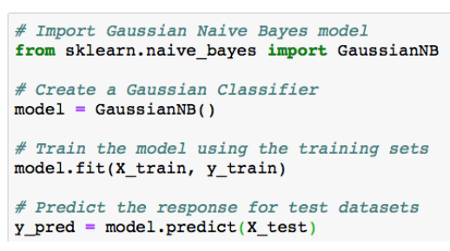

# Evaluating Model

# 

# we also generated a classification report to measure the quality if prediction from Naive Bayes model.

# 