Sales Performance Dashboard
End-to-End Business Intelligence Project — Executive Report
Prepared by: [Your Name]
Data Period: 2015 – 2018 | Superstore Sales Dataset

Executive Summary
This report documents an end-to-end analysis of four years of transactional sales data (9,994 order lines, 5,009 orders, $2,297,200.65 in total revenue) to identify the drivers of profit performance across products, regions, and customer segments. While total revenue grew 51.4% between 2015 and 2018 and overall profit margin held steady near 12.5%, that stability masks significant localized problems: Furniture generates 32.3% of revenue but only 6.4% of profit, five states account for roughly $78,000 in combined losses, and discounting above ~20% turns average transactions unprofitable. This report documents the full methodology — data cleaning, exploratory analysis, SQL modeling, and dashboard design — behind five targeted recommendations to recover profit without sacrificing revenue growth.

Objectives
- Quantify revenue, profit, and sales trends over the 2015–2018 period
- Identify which products, categories, and sub-categories help or hurt profitability
- Compare regional and state-level performance on margin, not just volume
- Segment customers by value, frequency, and profitability (RFM, ABC, CLV)
- Deliver specific, data-backed recommendations to improve profit

Dataset
Superstore Sales Dataset (Kaggle) — order-level retail transactions including order and ship dates, customer segment, geography (region/state/city), product category/sub-category, sales, quantity, discount, and profit. After cleaning, the analysis dataset contains 9,994 valid order lines across 34 columns (12 engineered on top of the original 22).
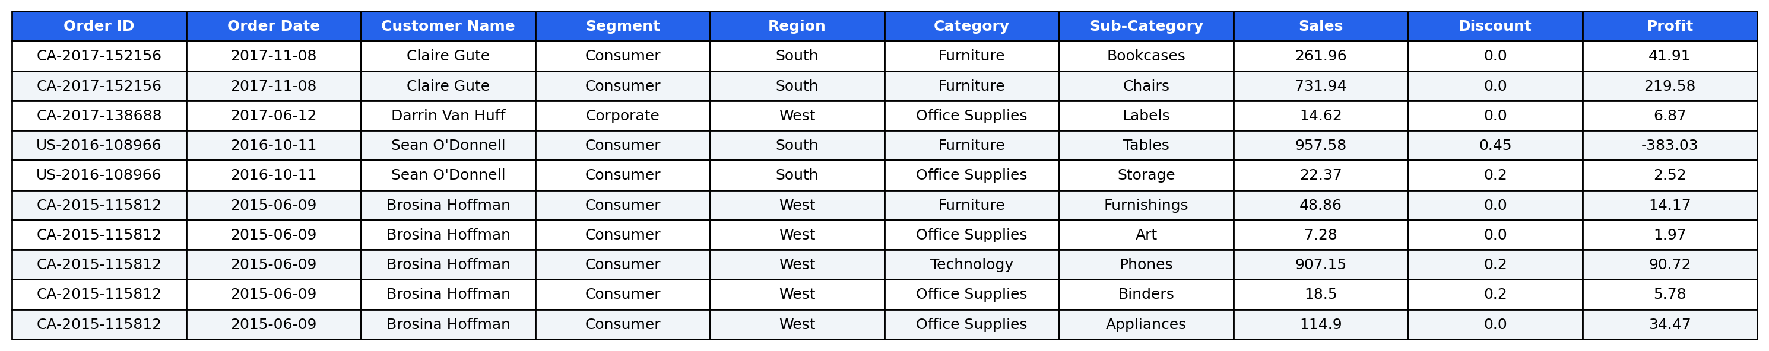
Figure 1: Sample records from the cleaned dataset.

Methodology
The raw export was cleaned in Python (Pandas/NumPy) using a modular, logged, and validated pipeline. A structural issue was diagnosed where three separate source sheets (Orders, People, Returns) had been concatenated into one file — this was identified and corrected by isolating genuine Orders rows via the Row ID column, rather than treating the resulting nulls as ordinary missing data. 504 duplicate rows were removed, business-rule filters were applied (positive Sales/Quantity, Discount in [0,1], Ship Date ≥ Order Date), and 12 features were engineered, including Profit Margin, calendar fields, Sales/Discount tiers, and Customer Type.
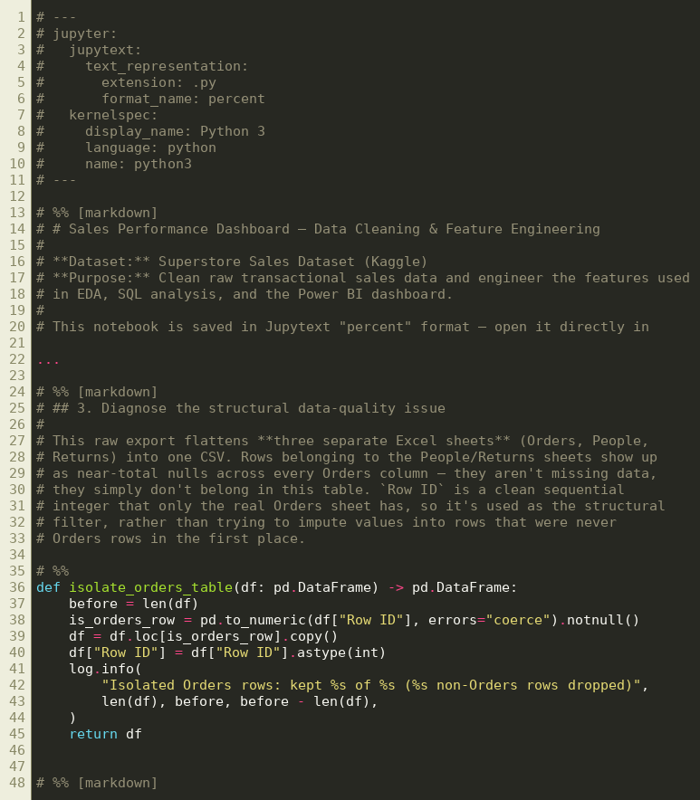
Figure 2: Excerpt from the data cleaning notebook (01_data_cleaning.py).

Exploratory Data Analysis
20 visualizations were produced covering sales and profit distributions, category/sub-category performance, regional and state comparisons, top and bottom products, discount-tier impact on margin, shipping-mode performance, monthly/quarterly/yearly trends, a correlation matrix and pairplot across key numeric fields, and RFM / ABC (Pareto) / Customer-Lifetime-Value segmentation. Every chart is paired with a printed Business Insight and Business Recommendation in the notebook. Selected charts are shown below; the full set is included in the accompanying code package.
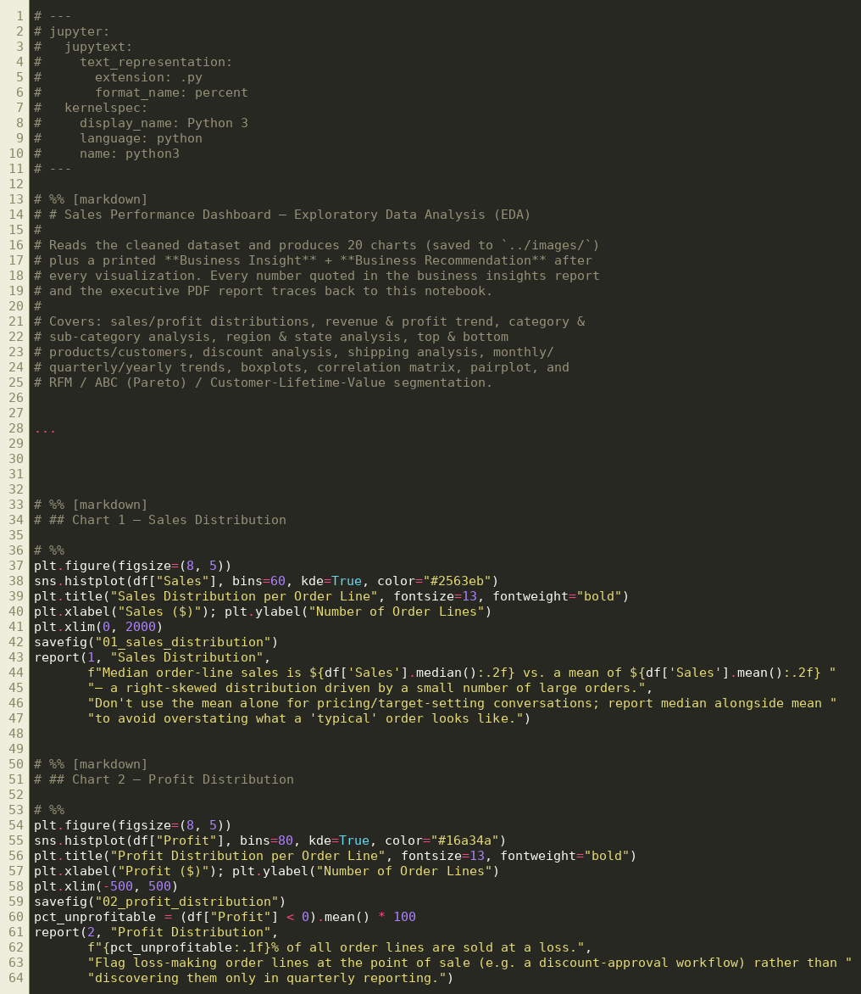
Figure 3: Excerpt from the EDA notebook (02_eda.py).
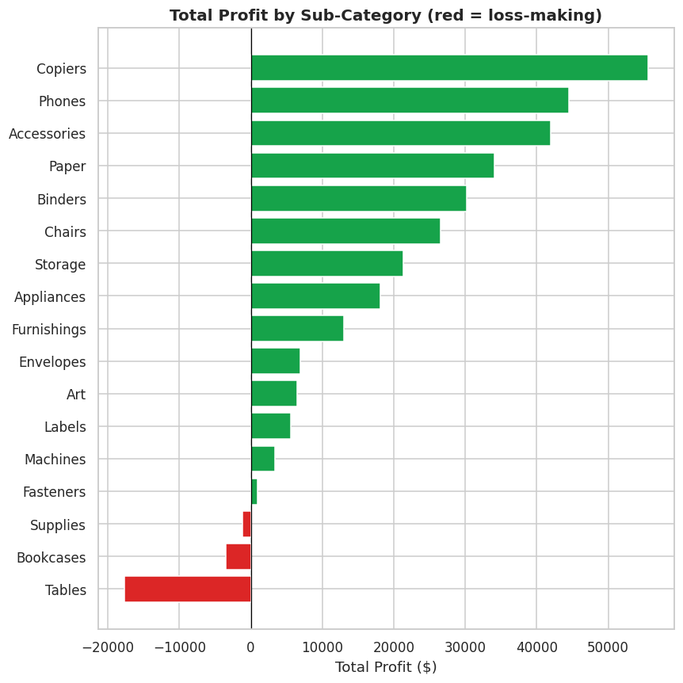
Figure 4: Total Profit by Sub-Category — Tables, Bookcases, and Supplies are loss-making.
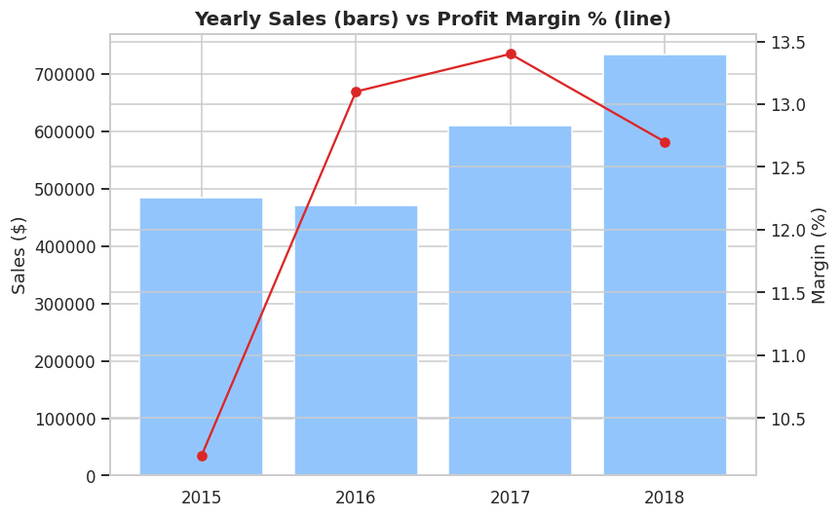
Figure 5: Yearly Sales (bars) vs Profit Margin % (line), 2015–2018.
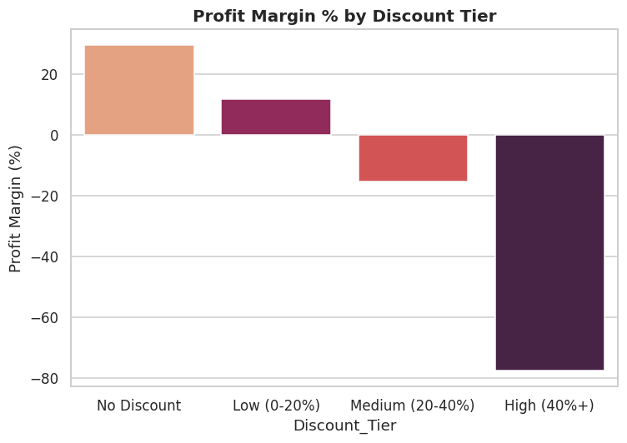
Figure 6: Profit Margin collapses as Discount Tier increases.
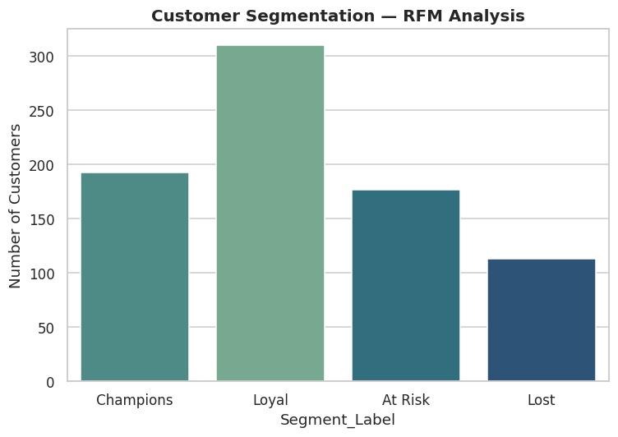
Figure 7: RFM Customer Segmentation — Champions drive a disproportionate share of revenue.

SQL Analysis
A normalized star schema (fact_orders + dim_customers, dim_products, dim_locations) was built in SQLite and queried with 40 business questions covering top/worst products, regional and state profitability, year-over-year/quarter-over-quarter/month-over-month growth, running and rolling totals, moving averages, Pareto/NTILE customer segmentation, repeat-purchase analysis, and reusable views. Every query was executed and verified against the live database — for example, the top 20% of customers by revenue were confirmed to generate 48.15% of total sales.
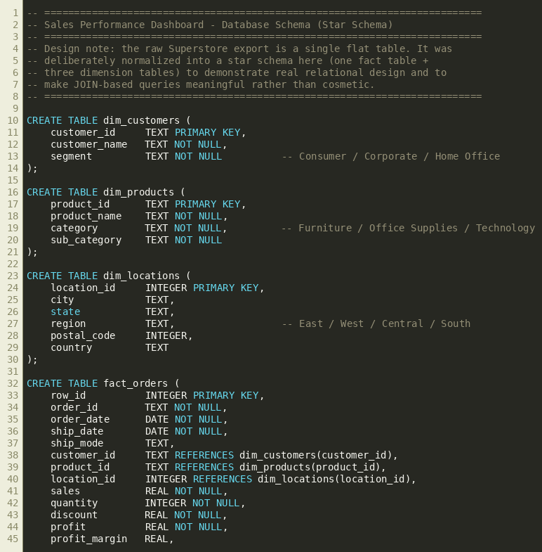
Figure 8: Star schema DDL (00_schema.sql).
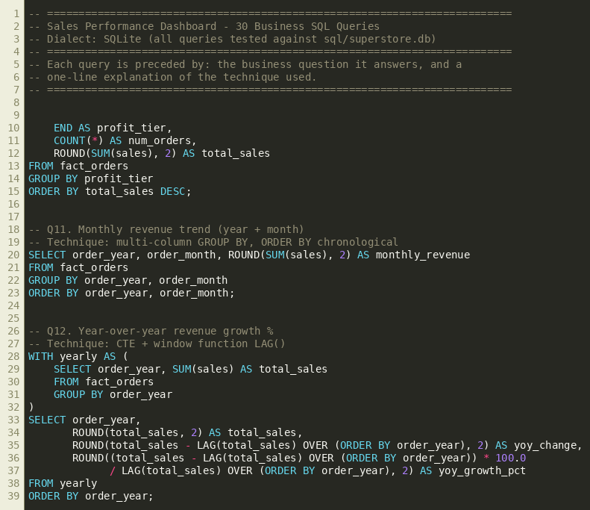
Figure 9: Sample business queries (01_business_queries.sql).

Dashboard
A 3-page Power BI dashboard was designed and built: an Executive Overview (KPI cards, monthly trend, category and regional mix, top products/customers), a Product & Category Deep Dive (sub-category profit ranking, discount-tier margin analysis, a category profitability matrix), and a Regional & Customer Performance page (state-level profit analysis, RFM/segment mix, a Top-20-customers matrix). All pages share a consistent color system — blue for sales, green for profit, red for loss, amber for caution — applied via conditional formatting rules throughout, not static color choices.
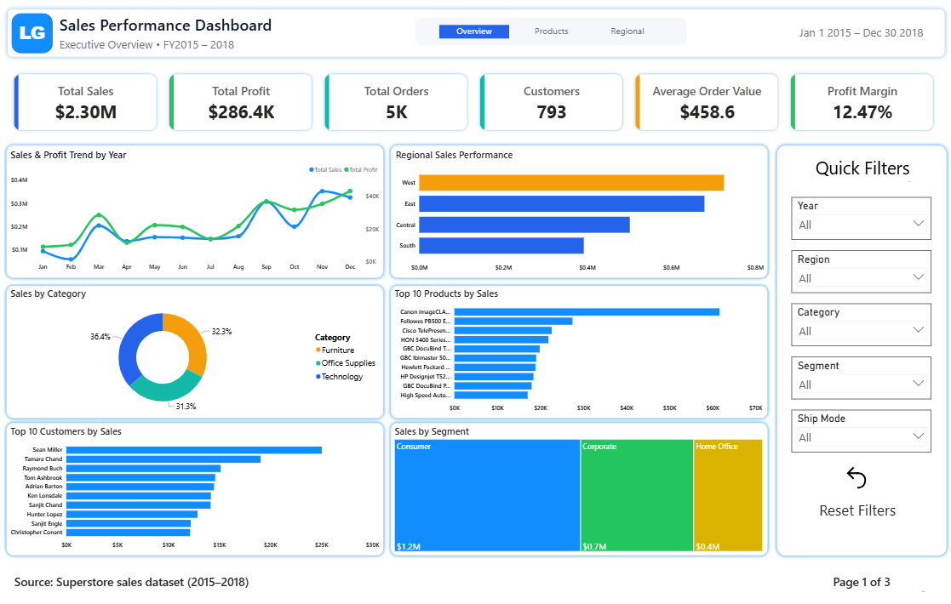
Figure 10: Dashboard Page 1 — Executive Overview.
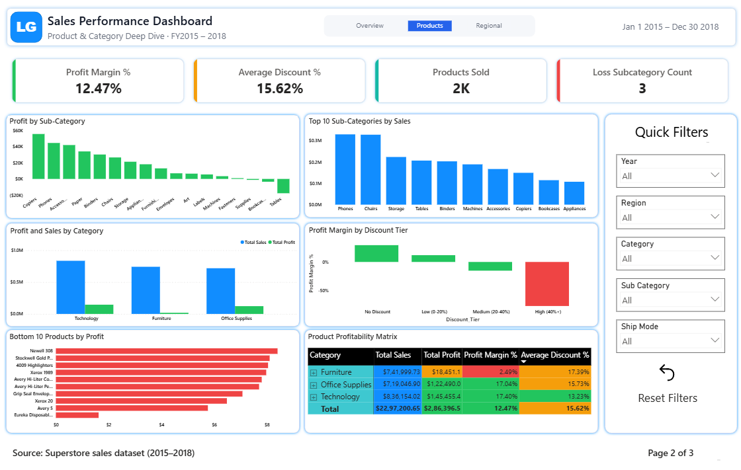
Figure 11: Dashboard Page 2 — Product & Category Deep Dive.
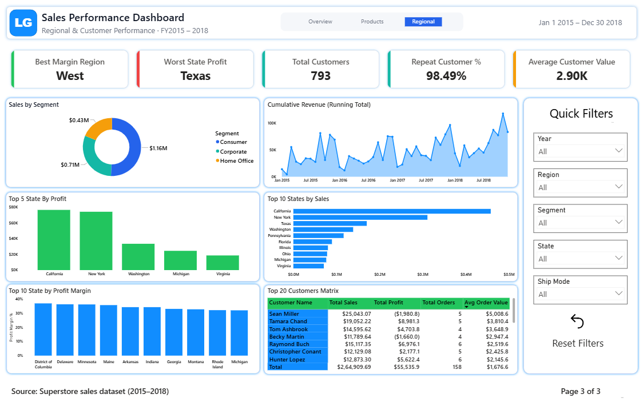
Figure 12: Dashboard Page 3 — Regional & Customer Performance.

Business Insights
Metric | Finding
Revenue growth (2015–18) | +51.4% ($484K → $733K)
Overall profit margin | 12.47% (improved +2.5pp over the period)
Furniture category | 32.3% of revenue, only 6.4% of profit (2.5% margin)
Worst sub-category | Tables (-8.6% margin, -$17,726 total loss)
Worst state | Texas (-$25,729 total profit)
Best region | West (14.9% margin) vs Central (7.9%)
Discount impact | Margin falls from 29.5% (no discount) to -77.4% (40%+ discount)
RFM "Champions" segment | 24% of customers drive ~40% of revenue
Repeat customer revenue share | 99.8% of total revenue
Top 20% of customers | Generate 48.15% of total revenue (SQL-verified)

Full list of 21 insights, each grounded in the EDA notebook's computed output, is included in the project's business_insights.md file within the code package.

Recommendations
1. Cap discounts on Furniture — especially Tables — at 20%. Discounting past this threshold turns a marginal product deeply unprofitable; Furniture's discount-profit correlation (-0.48) is more than double the company-wide figure (-0.22), confirming discounting practice, not underlying cost, is the driver.
2. Open a targeted profitability review in Texas, Ohio, and Pennsylvania. These three states alone account for roughly $58,000 in lost profit — investigate whether this is a discounting pattern, a shipping-cost issue, or a sales-incentive structure specific to these markets.
3. Prioritize marketing and inventory investment in Technology and the West region. Both show the strongest margin profile in the business and the best expected return on incremental investment.
4. Launch a retention/loyalty program for the RFM "Champions" segment rather than broad customer-acquisition spend. With 98.5% of customers already repeat buyers and Champions alone driving ~40% of revenue, protecting this specific group outperforms undifferentiated marketing.
5. Route the confirmed high-volume, negative-profit product list through a repricing or supplier-cost renegotiation process. These products are quantified, ongoing losses at meaningful scale, not marginal or ambiguous cases.

Conclusion
The evidence does not support broad pricing or marketing changes — the business is fundamentally healthy, with revenue growth and stable overall margin. The opportunity is precise: a small number of specific sub-categories, states, and discounting practices are responsible for a disproportionate share of lost profit, and each has a clear, low-risk, testable fix. Addressing these five items is the fastest, lowest-risk path to measurable margin improvement without putting current revenue growth at risk.

