



**2024-03-27**

**By**

**Himanshu Singh**

**Contact: +91 8382835630**

**Email:** [**info@trustingbrains.com**](mailto:info@trustingbrains.com)

**Proposal: Website Design**

**Your Trust Our Commitment**

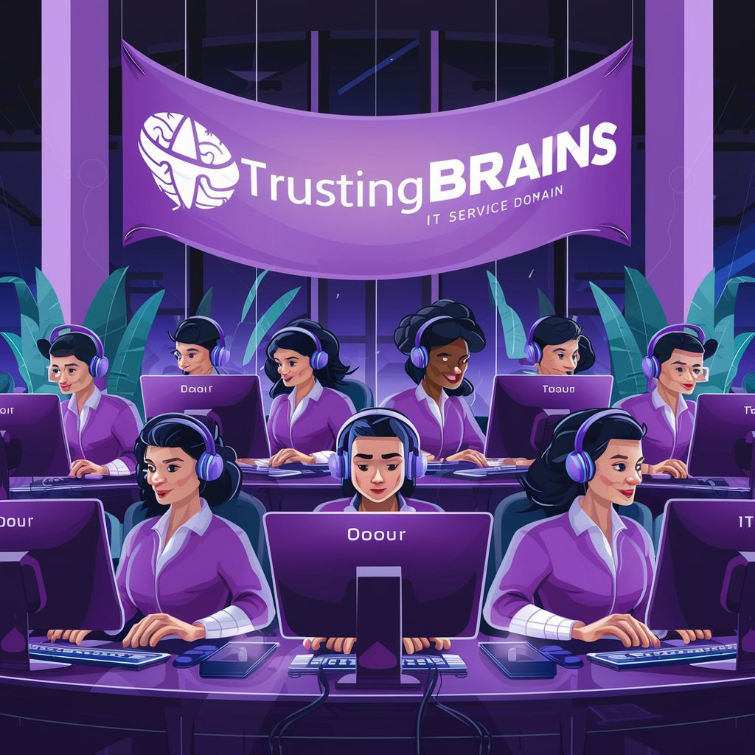



**Trustingbrains IT Services Pvt. Ltd.**

**Address :** 1527 Brhampuri,Meerut ,UttarPradesh . 250002 India

**Mobile:** +91 8382835630, 9837100731

**Email :** [info@trustingbrains.com](mailto:info@trustingbrains.com)

**Web :** [www.trustingbrains.com](http://www.trustingbrains.com)

**GSTIN :** 09AAKCT4922D1ZA

# KNOW US

[trustingBrains](https://trustingbrains.com/) IT Service Private Limited, founded in 2023, emerged as a dynamic initiative aimed at delivering a comprehensive range of IT services. Initially rooted in the vision of integrated communication and IT services, our journey mirrors a commitment to bolstering IT capabilities since inception. Beginning with web applications, our trajectory expanded into desktop applications, mobile solutions, and a spectrum of IT-enabled services. Today, we stand as a beacon in the IT industry, offering holistic IT solutions tailored to meet the diverse communication needs of our clientele.

At [trustingBrains](https://trustingbrains.com/), our mission is to empower clients with innovative and aesthetic Information Technology solutions. By seamlessly deploying IT solutions, we liberate our clients to concentrate on their core competencies, transcending the confines of traditional workspaces. Our ethos revolves around surpassing customer expectations, delivering solutions that not only meet but exceed their business objectives.

Driven by a vibrant team comprising system analysts, developers, designers, and digital marketing experts, [trustingBrains](https://trustingbrains.com/) ensures the timely delivery of strategically designed, efficient solutions to propel your e-business aspirations. Our ethos emphasizes cultivating enduring partnerships with clients, co-creating solutions that foster tangible long-term value for their brands, businesses, and organizational culture.

At [trustingBrains](https://trustingbrains.com/), we prioritize client engagement and value their insights. Whether you seek to establish a credible online presence for your business or revamp your existing web design, we stand ready to assist. Utilizing the finest imagery, typography, photography, and design elements, we craft visually captivating web experiences. Our commitment to evolution and continuity is evidenced by our expanding clientele across diverse sectors including Healthcare, Manufacturing, Real Estate, Education, Software, and Travel Hospitality.

[trustingBrains](https://trustingbrains.com/) envisions a future illuminated by client satisfaction and sustained growth. With a proven track record of expertise honed over the years, we eagerly anticipate the opportunity to serve and innovate, ushering our clients into a brighter tomorrow

# OUR SERVICES

**Web Services**

* Domain, Hosting & Cloud Solutions
* Web Site Design & Development
* Software Development
* Database Solutions
* E-Commerce Solutions
* Forums & Blogs Development
* Website Maintenance

##### Mobile Apps Development

* Android App Development
* iOS App Development

##### Game Development

* Android Game Development
* iOS Game Development

##### Corporate Solutions

* + ERP (School / College Management System)
  + CRM
  + Creative Concept Development
  + Food Ordering System (For Personal Restaurant)
  + Hotel Booking System
  + Bus Management & Monitoring System

# OUR CLIENTS

##### BELOW ARE SOME OF OUR WEB DESIGN & E-COMMERCE CLIENTELE

|  |  |
| --- | --- |
| **DEVD RESTRO** – Food Ordering System  [**https://devdrestro.in/**](https://devdrestro.in/) |  |
| **GVS LINE – Web Design**  [**https://gvsline.com/**](https://gvsline.com/) |  |
| **MYGSVENTURES – Portfolio Web Design**  [**https://mygsventures.com/**](https://mygsventures.com/) |  |
| **MYGSVENTURES – Web Design**  [**https://tech.mygsventures.com/**](https://tech.mygsventures.com/) |  |
| **EST AGRX – Marketplace E-commerce**  [**https://marketplace.trustingbrains.com/**](https://marketplace.trustingbrains.com/) |  |
| **KEEPOUTOFKITCHEN – Web Design**  [**https://keepoutofkitchen.com/**](https://keepoutofkitchen.com/) |  |

For full portfolio details please visit at 👉 www.trustingbrains.com

1. Website Design & Development

[TrustingBrains](https://trustingbrains.com/) IT Service Private Limited proposes to develop a dynamic and user-friendly website with an emphasis on UI/UX design, wireframe design, illustration vector work, and efficient technology stack implementation. The website will include an admin panel for content management and email handling. Additionally, the website will feature 2-3 forms similar to the reference website provided.

#### Scope of Work:

* + **UI/UX Design** - Our team will create a modern and intuitive design aimed at enhancing user experience. This will involve meticulous attention to detail in terms of layout, color scheme, typography, and overall visual appeal. We will prioritize ease of navigation and accessibility to ensure that visitors have a seamless browsing experience.
  + **Wireframe Design** -Prior to the development phase, we will create clear wireframes that outline the layout and structure of the website. These wireframes will serve as a blueprint for the website's design, ensuring that all elements are strategically placed for optimal user engagement and navigation. Clear wireframes will help streamline the development process and minimize revisions.
  + **Illustration Vector Work** -Our team will integrate custom illustrations using vector graphics to enhance the visual appeal of the website. These illustrations will be tailored to reflect your brand identity and resonate with your target audience. By incorporating unique and eye-catching visuals, we aim to captivate visitors and leave a lasting impression.
  + **Admin Panel & CMS** - The admin panel will empower you to manage website content seamlessly. You will have the ability to add, edit, and delete content, as well as manage emails and other communications. This intuitive interface will allow for effortless content updates and administrative tasks.
  + **Website Deliverables:**- Upon completion, you will receive a fully functional website equipped with an admin panel for content management. The website will be rigorously tested to ensure compatibility, performance, and security across all platforms.
  + **After Service:**- We offer post-launch support and maintenance, with the initial 3 months included free of charge. During this period, minor changes such as image and content updates will be covered at no additional cost. This ensures that your website remains up-to-date and responsive to your evolving needs.
  + **Maintenance Costs:-** Following the initial 3-month period, maintenance services will be available at a nominal fee. The estimated cost for maintenance is expected to range between 5500 to 7000 INR per year, depending on the complexity and frequency of updates required. This maintenance package covers changes to existing content and images on the website.
  + **Additional Add-Ons:-** For any extra add-ons, theme changes, or new features that require implementation post-launch, separate charges will apply. The pricing for these additional services will be determined based on the scope of work involved and will be communicated to you beforehand for approval.

#### **Technology Stack:**

* + **Frontend** :- For the frontend, we will utilize HTML5, CSS3, and JavaScript, along with the React.js library, to create a responsive and interactive user interface. React.js offers a component-based approach to UI development, facilitating the creation of reusable UI elements and ensuring a smooth and efficient rendering process. This will ensure compatibility across various devices and browsers, providing a consistent and engaging user experience.
  + **Backend** :- On the backend, we will leverage the power of Node.js and Express.js to build a robust and scalable infrastructure. Node.js, with its event-driven architecture and non-blocking I/O operations, is well-suited for building high-performance, real-time applications. Express.js, a minimalist web framework for Node.js, will provide a streamlined development experience and enable us to handle HTTP requests efficiently.

Additionally, we will use MySQL as the database management system to store and manage data efficiently. MySQL is a reliable and widely-used relational database that offers robust features for data storage, retrieval, and management. With its support for ACID transactions and scalability, MySQL ensures data integrity and performance for your application.

|  |  |
| --- | --- |
| **Front End**  Design: Photoshop, HTML 5.0, Bootstrap 5.0, CSS, JavaScript React | **Back End /Admin Panel**  Development: Node js , Express Js |
| **Database**  DB: MySQL Server 6.2 | |

## COMMERCIALS

|  |  |  |
| --- | --- | --- |
| **SN** | **Description** | **Cost (INR)** |
| 1. | **Website Design & Development** | **Rs. 20,000 /-** |
| 2. | **Hosting Service** | **Rs.1200/Year** |
| 3. | **Maintenance (After 3-Months from Service)** | **6000* / Year** |

**Payment Schedule**

|  |  |
| --- | --- |
| **Activity** | **Amount** |
| **Website Design & Development** | 50% Advance, 50% After live the website |
| **Hosting Services** | Advance Quarterly |

**Terms & Conditions**

* The commercial quotation is valid only for the 15 days the date of quotation.
* All Above costs are excluding the taxes. 18% GST is applicable extra.
* All payments will be made in favor of [Trustingbrains](https://trustingbrains.com/) IT Services Pvt. Ltd. through NEFT/IMPS Only.
* Any Third-party cost like domain, Hosting, SSL renewal cost will be payable every year.
* All conditions are valid only in case the payments are made as per payment terms & conditions on time.
* First, we will focus on website page content, alt tag, creating on-site blog, generate xml sitemap, increase page content After that we create back links for website.
* Ranking and other results also depends current status of website in search engine and social media.
* Raw contents like images, video etc. will be provided by client. [Trustingbrains](https://trustingbrains.com/) shall not use any third party’s copyright materially like image, video etc. If any such material is required for campaign or website and social media, it should be purchased by client..
* In case of Global Pandemic, Natural Disaster support services response time may be affected

