
Your Trust Our Commitment

PROJECT

PROPOSAL


Contact: +91 8382835630, 9837100731, 7838002294 Email: info@trustingbrains.com

Web : www.trustingbrains.com


Your Trust Our Commitment

OUR SERVICES

Web Services

·Domain, Hosting &Cloud Solutions

·Web Site Design& Development

·Software Development

·Database Solutions


- E-Commerce Solutions ·Forums & BlogsDevelopment ·Website Maintenance

Mobile Apps Development

·Android App Development

·iOS App Development

Game Development

·Android Game Development

·iOS Game Development

Corporate Solutions

·ERP (School / College Management System)

·CRM

·Creative Concept Development

·Food Ordering System (For Personal Restaurant)

·Hotel Booking System

·Bus Management & Monitoring System
Your Trust Our Commitment

OUR MARQUEE CLIENTS

BELOW ARE SOME OF OUR WEB DESIGN & E-COMMERCE CLIENT
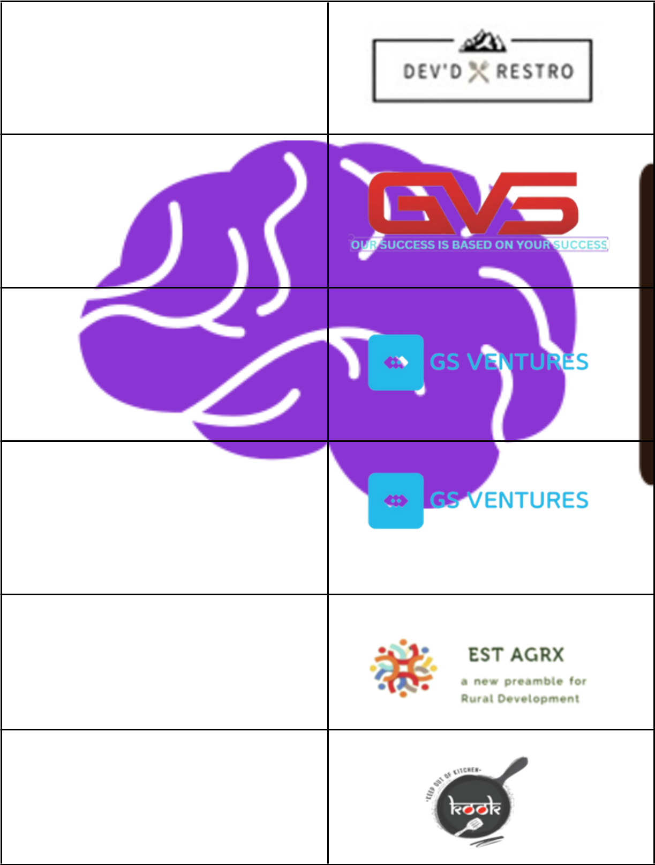

DEVD RESTRO – Food Ordering System https://devdrestro.in/

GVS LINE –

Web Design

https://gvsline.com/

MYGSVENTURES

– Portfolio Web Design https://mygsventures.com/

MYGSVENTURES

– Web Design https://tech.mygsventures.com/

EST AGRX

– Marketplace E-commerce https://marketplace.trustingbrains.com/

KEEPOUTOFKITCHEN

– Web Design https://keepoutofkitchen.com/
Your Trust Our Commitment

APPLICATION DESIGN AND DEVELOPMENT

This proposal outlines the design and development of a mobile application with OTP (One-Time Password) verification during registration, leading to a main page with various service options. The primary functionalities in Phase 1 include ITR (Income Tax Return) and Referral features. The application aims to provide a user-friendly platform for income tax-related services, where users can easily access, view, and download their ITR data, along with other financial services like LOANS, INSURANCE, and PF (Provident Fund).

Deliverables:

Mobile Application: A React Native-based mobile application for users with OTP-based registration.
Admin Panel: A web-based admin panel for managing and uploading user data, with user access and notification features.
User Registration with OTP: A registration process with OTP verification to ensure secure user onboarding.
Main Page with Service Options: A landing page with four

primary options: ITR, LOANS, INSURANCE, and PF.

ITR Form and Functionality: A form for users to submit their ITR-related information (Name, PAN number, Email Address, etc.), with the ability for admins to upload related data for user access and download. Users can claim amounts through a payment feature within the app. Referral System: A referral feature to encourage users to share the app with others.

Push Notifications: Functionality to send push notification for updates and other important messages to users.
Your Trust Our Commitment

APPLICATION DESIGN AND DEVELOPMENT

Scope of Work:

1. User Interface Design:

Description: The user interface (UI) design is crucial for creating a visually appealing and user-friendly experience. This involves creating wireframes, mockups, and high-fidelity designs that guide the development process.

Implementation:

Consider incorporating a simple navigation structure, consistent color schemes, and easily accessible buttons and options.

2. OTP Verification:

Description: OTP (One-Time Password) verification is used to ensure the security of user registrations. This step involves sending a unique code to the user's mobile device for verification during the registration process.
Implementation:

Integrate with a third-party service like Firebase Authentication or Twilio for sending OTPs. Implement an OTP input field in the registration flow, allowing users to enter the code received via SMS or email.

Include error handling for invalid OTPs and ensure the code is time-bound to prevent misuse.
Your Trust Our Commitment

APPLICATION DESIGN AND DEVELOPMENT

3. Main Page Development:

Description: The main page is the first screen users see after registration. It should offer quick access to key features and guide users to the next steps.
Implementation:

Design a main page with clear options for ITR, LOANS, INSURANCE, and PF.
Use simple icons and labels to represent each section. Implement a dynamic welcome message or notifications to engage users when they open the app.

4. ITR Form Creation:

Description: This form allows users to submit their ITR-related information, which will be processed by the admin. The admin can then upload the relevant ITR data for users to view and download.
Implementation:

Create a form with fields for Name, PAN number, Email Address, and other necessary information.
Use validation to ensure correct data input. Develop a backend endpoint to receive and process form submissions.
Provide a clear success message upon submission and allow users to download their ITR data once uploaded by the admin.
Your Trust Our Commitment

APPLICATION DESIGN AND DEVELOPMENT

5. Referral Feature:

Description: The referral system encourages users to share the app with others, rewarding them for successful referrals. This feature can boost user growth and engagement.

Implementation:

Implement a unique referral code for each user. Create a simple way to share the code via social media, email, or messaging apps.
Track referrals on the backend and set up a reward system to incentivize users to refer others.
Provide a leaderboard or similar feature to display top referrers.

6. Admin Panel Development:

Description: The admin panel allows administrators to manage and upload user data, send push notifications, and monitor app activities.
Implementation:

Develop a web-based admin panel using React.js or a similar framework.
Create a secure login system for admins.

Implement features to upload ITR data, manage user information, and send push notifications.
Include user activity tracking and basic analytics to monitor app usage.
Your Trust Our Commitment

APPLICATION DESIGN AND DEVELOPMENT

7. Push Notification Integration:

Description: Push notifications are used to communicate important updates, offers, or other information to users. This feature keeps users engaged and informed.
Implementation:


Integrate with a push notification service like Firebase Cloud Messaging.
Implement features to send notifications based on specific events or manually through the admin panel. Ensure users can opt in or out of notifications according to their preferences.
Include error handling for failed notifications.

8. Testing and Quality Assurance:

Description: Thorough testing ensures that the application functions correctly and is free from critical bugs. Quality assurance validates the user experience and ensures compliance with requirements.
Implementation:

Perform unit tests, integration tests, and end-to-end tests to ensure all components work together seamlessly.
Conduct user acceptance testing to gather feedback on the user experience.
Implement automated tests to ensure stability during development.
Address any issues found during testing and ensure the final product meets quality standards.
Your Trust Our Commitment

Technological Stack

Frontend: React Native

Framework: React Native is chosen for its cross-platform capability, allowing the development of a mobile application that works on both iOS and Android platforms.
Features: Offers a consistent look and feel across different platforms. It has a vast ecosystem of libraries and tools, enabling efficient development and seamless integration with native features.


Backend:

Server-Side Logic: Node.js is used due to its asynchronous, event-driven architecture, which is ideal for handling multiple concurrent requests.
Routing: Express.js provides a simple and flexible way to create server-side routes and middleware for handling HTTP requests and responses.

Data Storage: A NoSQL database like MongoDB is considered for its flexibility in storing unstructured data, while PostgreSQL, a relational database, is chosen for structured data storage and complex queries.

Admin Panel:

Framework: React.js is used for building a responsive and dynamic web-based admin panel. It allows for the creation of interactive UIs and easy integration with back-end services.
Benefits: React.js provides component-based architecture, making the admin panel modular and maintainable. It also has a large community and a variety of libraries for additional functionalities.

Authentication:

Firebase Authentication or similar for OTP-based user verification.

Push Notifications:

Firebase Cloud Messaging or similar for sending notifications to users.
Your Trust Our Commitment

Payment Structure

 | Activity | Amount
 | Phase 1
 | Application Design &
 | Development included | ₹ 45,000
 | above features + Admin
 | features (website)
 |  | 25% Advance,
 | Design & Development | remaining After live
 |  | the Application


 | Additional Cost
Domain Cost | Google play store registration fee
Hosting Cost | App store registration fee

Maintenance Cost

Sms Cost

Any additinoal services may cost Extra

Timeline (3 Week ):

Design and Development Phase-1

Testing and Debugging Phase-1

Deployment and Launch

Your Trust Our Commitment

TERMS AND CONDITIONS

The commercial quotation is valid only for the 15 days the date of quotation.
All Above costs are excluding the taxes. 18% GST is applicable extra.
All payments will be made in favor of Trusting Brains IT Services Pvt. Ltd. through NEFT/IMPS Only.

Any Third-party cost like domain, Hosting, SSL renewal cost will be payable every Quarterly/yearly *.
All conditions are valid only in case the payments are made as per payment terms & conditions on time.. Ranking and other results also depends current status of website in search engine and social media.
Raw contents like images, video etc. will be provided by client. Trusting Brains shall not use any third party’s copyright materially like image, video etc. If any such material is required for campaign or website and social media, it should be purchased by client.
In case of Global Pandemic, Natural Disaster support services response time may be affected
Your Trust Our Commitment
