7505026843

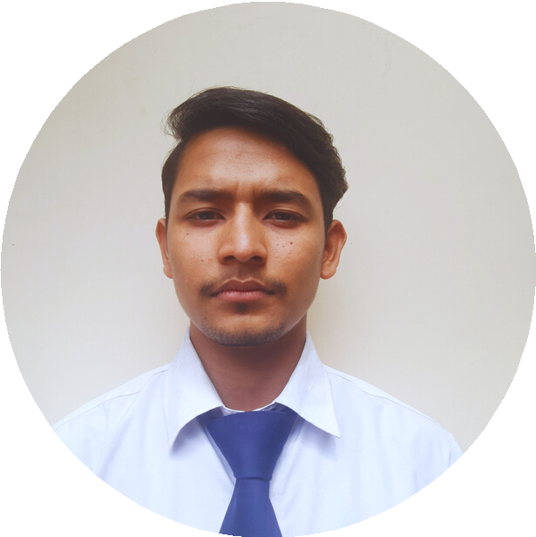

**H I M A N S H U R A W A T**

[himanshurawat25691@gmail.com](mailto:himanshurawat25691@gmail.com)

# P R O F I L E

Dehradun

<https://github.com/Himanshu2021rawat>

[https://www.linkedin.com/in/himanshu-](https://www.linkedin.com/in/himanshu-rawat-046a35222/) [rawat-046a35222/](https://www.linkedin.com/in/himanshu-rawat-046a35222/)

[https://www.youtube.com/channel/UCdWKrm1xNRx](https://www.youtube.com/channel/UCdWKrm1xNRxMsWJ91RrNp1Q) [MsWJ91RrNp1Q](https://www.youtube.com/channel/UCdWKrm1xNRxMsWJ91RrNp1Q)

# S K I L L S

HTML5, Semantic HTML, Web Development, Markup Language

CSS3, Responsive Design, CSS Frameworks (like Bootstrap), Styling

Javascript ES6, DOM Manipulation, Frontend Development

GSAP (GreenSock Animation Platform)

Looking forward to a challenging and rewarding position in the company by utilizing technical and managerial skills to the optimum and growing along with the company.

# I N T E R N S H I P

## DATA ANALYTICS

Brillica Services,Dehradun

2022

Visualization of Data using Power Bi managment of data using SQL

Ms-Office-Tools(Ms-Word,Ms-excel,Ms-powerpoint)

Java Fundamentals, Object-Oriented Concepts



Basics of C++ , C programming

**E D U C A T I O N**

## Bachelor's in Computer Application (B.C.A) (Pursuing)

Hemvati Nandan Bhuguna University Uttarakhand

7.54

2020- 2023

## SECONDARY SCHOOL( 12 TH)

Scholar's Home, Dehradun

2019- 2020

66.8%

## HIGH SCHOOL( 10TH)

Scholar's Home, Dehradun

2017 - 2018

70.6%

# P R O J E C T

Portfolio website by using Javascript, HTMl, CSS and Gsap.

[Portfolio website](https://himanshurawatportfoliohr.netlify.app/)

Recreating OpenAI.com Homepage | Full Responsive Design Using HTML, CSS, JS & GSAP.

[OpenAi.com Homepage](https://openaihim.netlify.app/)

Recreating Homepage of award winning website with html,css,js and Gsap.

[Toogoodwebsite](https://toogoodchim.netlify.app/)

**H O B B I E S / I N T E R E S T**

Listening podcasts Watching Animes Travelling