Problem Set 6

27 September 2024

1. The diagram below shows a farmer’s choice between free time and grain before and after an improvement in technology

Based on this information which of the following statements are true?

1. If the MRS of the indifference curve at B is larger than the MRS of the indifference curve at A, then the farmer will have an incentive to take more free time after the technology improvement.
2. The MRT of the new feasible frontier of at B is larger than the MRT of the old feasibility frontier at A. This gives the farmer an incentive to take more free time after the technology improvement.
3. The farmer may choose a point to the left of B after the technology improvement.
4. The farmer may choose a point to the right of B after the technology improvement.
5. Consider the game regarding two neighbors, the Joneses and the Smiths are considering buying a new car, which could be either a luxury model or a modest model. The payoff matrix is given below

1. Suppose the government imposed a tax of 0.6 on luxury cars. Draw the new (after-tax) payoff matrix and explain if the new NE is pareto efficient.
2. How large would the tax have to be in order to completely account for the Veblen effect? Draw the new payoff matrix (with this tax), and explain with reference to external effects, why a tax of this size also solves the social dilemma of a pareto inefficient outcome.
3. Suppose Ritwika’s budget constraint is c = w(24 – t) + m, where c is her maximum level of consumption, w is here hourly wage, t is hours of leisure time, and m is income from your investments. Assume that m is strictly positive. If Ritwika’s budget constraint is drawn with t on the horizontal axis and c on the vertical axis, which of the following statements are correct.
4. The slope of the budget constraint curve is constant at -w
5. A lower wage flattens the budget constraint curve, pivoted at the horizontal intercept.
6. Ritwika’s marginal rate of transformation between the free time and consumption is constant, irrespective of the amount of free time and consumption.
7. A higher m reduces the opportunity cost of free time.
8. The figure shows the budget constraints of a worker, given by c = 15(24 – t) + m, where c is his consumption, 8 $≤t≤$ 24 is his hours of free time, and m is the fixed income that he receives irrespective of whether he works or not. Two cases are shown here; m = 0 and m = ₹50. If the farmer’s choice is A when m = 0, which of the following statements are true?

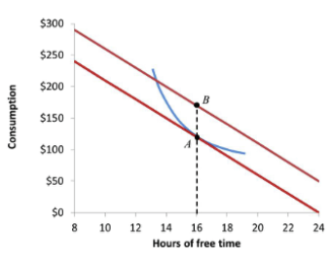

1. If the farmer chooses B, then he consumes exactly ₹50 worth more without changing his working hours.
2. If the farmer chooses a point to the right of B, then he consumes exactly ₹50 worth more while working fewer hours.
3. If the farmer chooses a point to the right of B, then the income effect of a rise in his income on the hours of free time is positive.
4. At B, the farmer’s income effect on the hours of free time is negative.
5. The diagram below depicts the effects of change in wage level on a worker’s choice of consumption and hours of free time. The choice before and after the wage rise are given by A and D, respectively. Which of the following statements are correct?

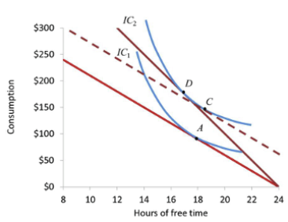

1. The change in the choice from A to C represents the substitution effect.
2. The change in the choice from C to D represents the effect of a higher MRT.
3. The income effect on the hours of free time is always positive.
4. The substitution effect on the hours of free time is always positive.
5. Currently, Poorva works for 40 hours per week for a wage of $20 an hour. Poorva’s free hours are defined as the number of hours per week not spent working, which in this case is (24 x 7 – 40) = 128 hours per week. Suppose now that the wage rate has increased by 25%. If Poorva is happy to keep her total weekly income constant, then which of the following choices are correct?
6. Poorva’s total number of working hours per week will fall by 25%
7. Poorva’s total number of working hours per week will be 30 hours
8. Poorva’s total number of free hours per week will increase by 25%
9. Poorva’s total number of free hours per week will increase by 6.25%