**Exp. 2 Design Christmas dual led chaser lights.**

**Circuit Diagram:**

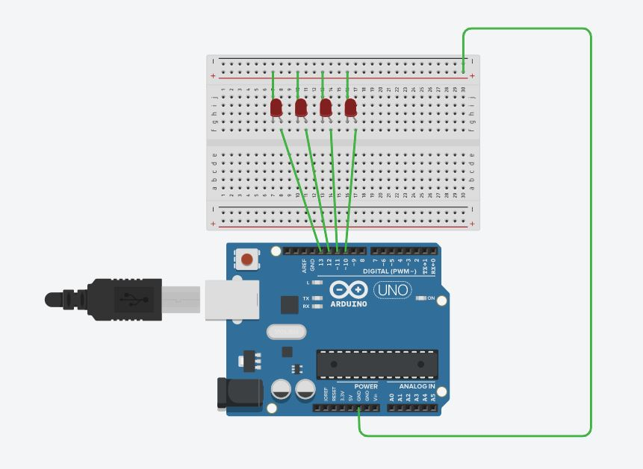

**Theory:** 555 timer IC. The 555 timer IC is an integrated circuit (chip) used in a variety of timer, pulse generation, and oscillator applications. The 555 can be used to provide time delays, as an oscillator, and as a flip-flop element. Derivatives provide two (556) or four (558) timing circuits in one package.

Learning & Observation:

1. Working of LED chaser.
2. Code for Arduino to Run LED Chaser.

**Precautions:**

1. **There should not be any loose connection in the circuit.**
2. **Code should be written properly.**
3. **Arduino should be attached to pc/laptop properly.**

**Code:**

**void setup(){**

**// setting up output pins**

**for (int i = 10; i <= 13; i++) {**

**pinMode(i, OUTPUT);**

**}**

**}**

**void loop(){**

**for (int i = 10; i <14; i++) {**

**allLEDsOff();**

**if (i!=13){**

**digitalWrite(i,HIGH);**

**digitalWrite(i+1,HIGH);**

**delay(200);**

**}**

**else**

**digitalWrite(i,HIGH);**

**digitalWrite(i-3,HIGH);**

**delay(200);**

**allLEDsOff();**

**}**

**}**

**void allLEDsOff(void)**

**{**

**for (int i = 10; i <= 14; i++) {**

**digitalWrite(i, LOW);**

**}**

**delay(100);**

**}**