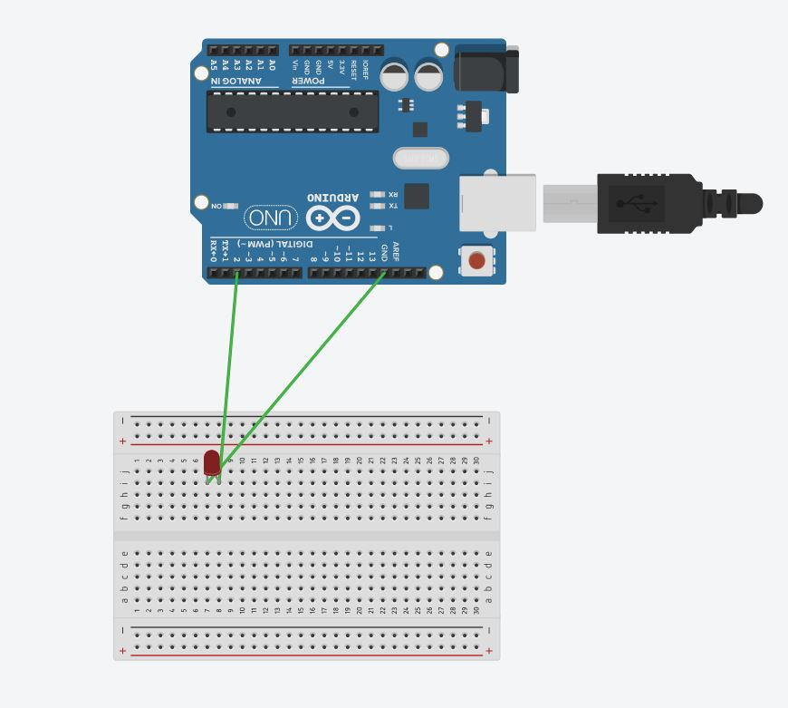
Exp. 3 Design a door bell using push button.

Circuit Diagram:
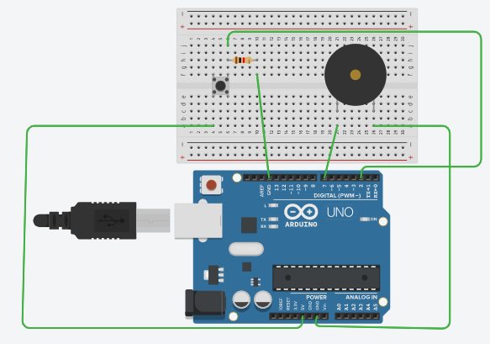
Precautions:
- There should not be any loose connection in the circuit.
- Code should be written properly.
- Arduino should be attached to pc/laptop properly.

Code:
const int switchPin = 2; // the number of the pushbutton pin
const int bellPin = 7;int bellState = LOW;
int switchState=LOW;
unsigned long lastDebounceTime = 0;
unsigned long debounceDelay = 10;
void setup() {
pinMode(switchPin, INPUT);
pinMode(bellPin, OUTPUT);
digitalWrite(bellPin, bellState);
}

void loop() {
int reading = digitalRead(switchPin);
if (reading != lastswitchState) {
lastDebounceTime = millis();
}
if ((millis() - lastDebounceTime) > debounceDelay) {
if (reading != switchState) {
switchState = reading;
if (switchState == HIGH) {
bellState = !bellState;
}
}
}
digitalWrite(bellPin, bellState);
lastswitchState = reading;
}

Result:
Door bell using push button was verified after uploading the program.

