***Lab Record***

*Aim*

To design a system for a gift-box such that whenever it is opened, it produces sound for 1000 ms and blinks red and green LEDs alternatively, as long as it is open

*Apparatus*

Arduino Uno , Breadboard , Buzzer , LDR , 2 LEDs(Red, Green) , Connecting Wires

*Circuit Diagram*

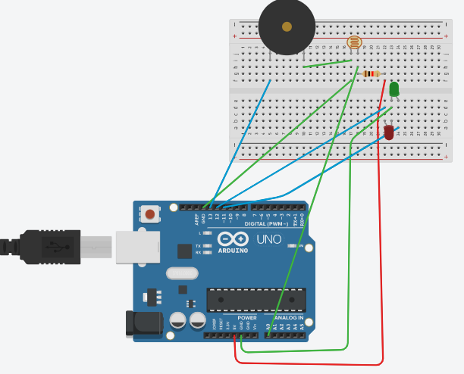

*Code*

void setup()

{

pinMode(13,OUTPUT);

pinMode(12,OUTPUT);

pinMode(11,OUTPUT);

}

int b=0;

void loop()

{

int a=analogRead(A0);

if(a<600)

{

if(b==0)

{

digitalWrite(13,HIGH);

delay(1000);

digitalWrite(13,LOW);

b++;

}

digitalWrite(12, HIGH);

delay(100);

digitalWrite(12, LOW);

delay(100);

digitalWrite(11, HIGH);

delay(100);

digitalWrite(11, LOW);

delay(100);

}

}