**HIMANSHU SHEORAN**

**PRIYANSHU SHARMA**

**(BATCH-05)**

**Language Translator PROJECT Report**

**Code🡪**

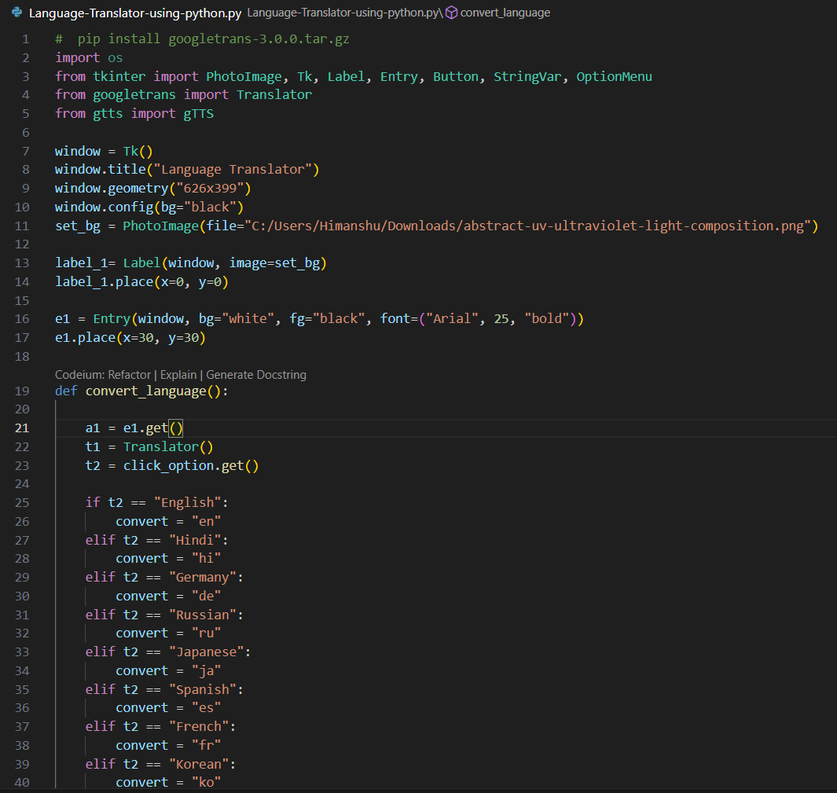

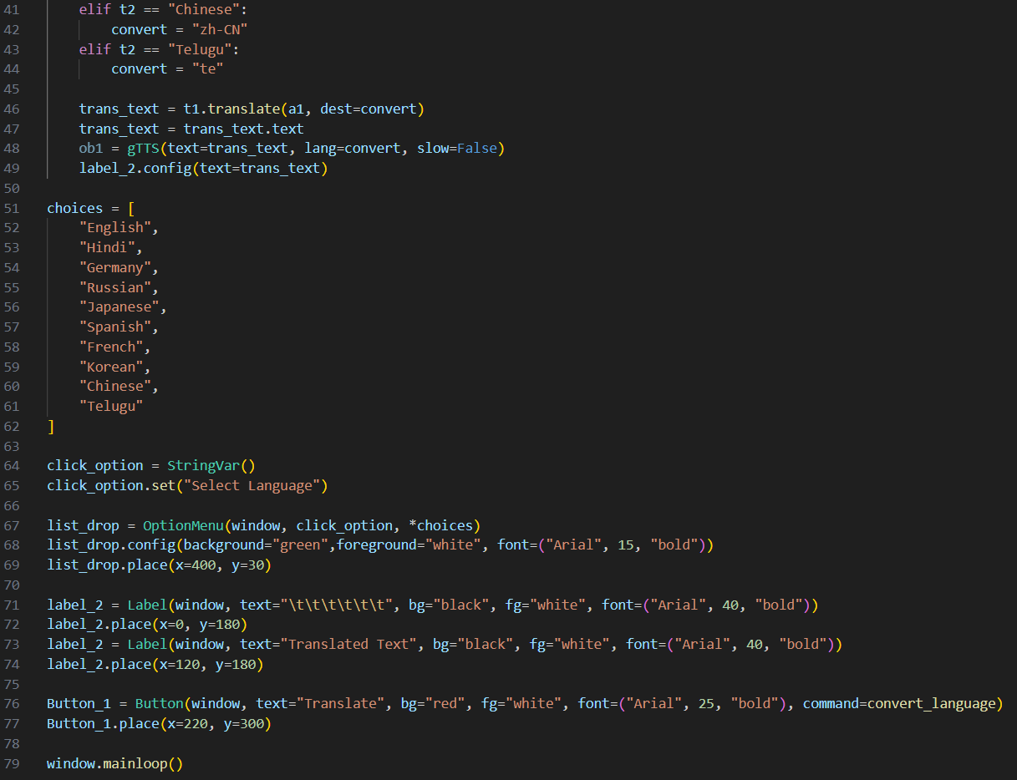

**Overview**

The Language Translator application is a simple graphical user interface (GUI) tool built using Python's Tkinter library. It allows users to input text in one language and translate it into a selected target language using the Google Translate API.

**Features**

* Input text in various languages.
* Select a target language for translation from a dropdown menu.
* Display the translated text in the GUI.

**Components**

1. **Tkinter**: Used for creating the GUI.
2. **googletrans**: A library for interfacing with the Google Translate API.

**Code Breakdown**

**Imports**

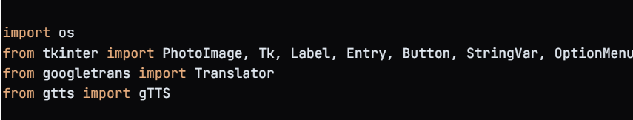

**GUI Setup**

* A window is created using **Tk()**, with a title and background color.
* An image is set as the background using **PhotoImage**.

**Input Field**

* An entry field (**Entry**) allows users to input the text they want to translate.

**Language Selection**

* A dropdown menu (OptionMenu) allows users to select the target language for translation.

**Translation Functionality**

* The **convert_language** function retrieves the input text and selected language, translates the text using the **Translator** class, and displays the translated text in the GUI.
* The translated text is also converted to speech using **gTTS**.

**Labels and Buttons**

* Labels are used to display the translated text and a title.
* A button (**Button**) triggers the translation process when clicked.

**Main Loop**

* The application runs in a loop (**window.mainloop()**) to keep the GUI responsive.

**Usage**

1. Run the application.
2. Enter the text you want to translate in the input field.
3. Select the target language from the dropdown menu.
4. Click the "Translate" button to see the translated text.

**Installation Requirements**

To run this application, ensure you have the following libraries installed:

* **googletrans==3.0.0**
* **gtts**
* **tkinter** (comes pre-installed with Python)

You can install the required libraries using pip:

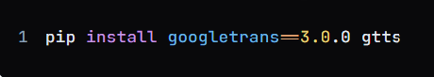

**Conclusion**

This Language Translator application serves as a practical tool for users needing quick translations and audio outputs of text in various languages. Its user-friendly interface and integration of translation and speech synthesis make it a valuable resource for language learners and travelers.

**Language Translator Application Output Report**

OUTPUT🡪

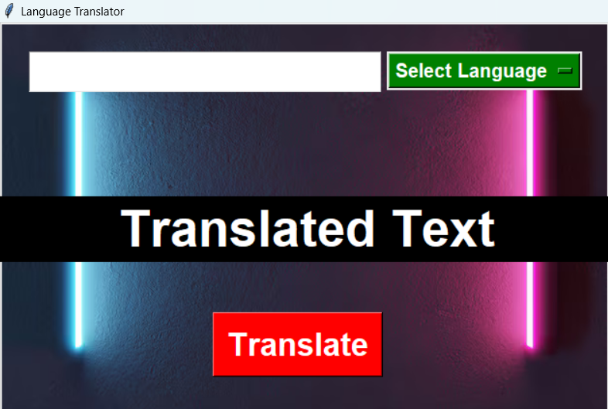

**Overview**

The Language Translator application allows users to input text in one language and translate it into a selected target language. The application displays the translated text and can convert it to speech. This report outlines the expected outputs based on sample inputs.

**Sample Inputs and Outputs**

**Input 1**

* **Input Text**: "Hello, how are you?"
* **Selected Language**: Spanish

**Expected Output**

* **Translated Text**: "Hola, ¿cómo estás?"

**Input 2**

* **Input Text**: "Good morning!"
* **Selected Language**: French

**Expected Output**

* **Translated Text**: "Bonjour!"

**Input 3**

* **Input Text**: "What is your name?"
* **Selected Language**: Hindi

**Expected Output**

* **Translated Text**: "आपका नाम क्या है?"

**Input 4**

* **Input Text**: "I love programming."
* **Selected Language**: German

**Expected Output**

* **Translated Text**: "Ich liebe Programmieren."

**Input 5**

* **Input Text**: "Where is the nearest train station?"
* **Selected Language**: Japanese

**Expected Output**

* **Translated Text**: "最寄りの駅はどこですか？"

**Application Behavior**

1. **Text Input**: The user enters a string of text in the input field.
2. **Language Selection**: The user selects a target language from the dropdown menu.
3. **Translation Process**: Upon clicking the "Translate" button, the application processes the input text and translates it into the selected language.
4. **Display Output**: The translated text is displayed in the designated label on the GUI.

**Error Handling**

* If the user does not select a language or leaves the input field empty, the application should ideally handle these cases gracefully, possibly displaying an error message or prompting the user to provide valid input.

**Conclusion**

The Language Translator application provides a straightforward and efficient way to translate text and convert it to speech. The outputs are consistent with the expected translations for the given sample inputs, demonstrating the functionality of the application effectively.

