stepped impedance low pass filter

**OBJECTIVE:**

* To design, fabricate and measure a stepped-impedance low-pass filter having a maximally flat response and cut-off frequency of 2.5 GHz with an attenuation of more than 20 dB at 4 GHz. The line impedance of filter is 50 Ω, highest line impedance is 120 Ω, and the lowest is 20 Ω.

**THEORY**

Filter is a two-port device which passes microwave of certain frequencies I while rejecting or absorbing other frequencies.

Low pass filter is a two-port device which will let pass the frequencies below the cut-off frequencies and attenuates microwave of frequencies higher than the cut-off frequency.

We have to implement this Low Pass filter using the microstrip transmission line using alternating sections of very high and very low characteristic impedance lines where the series inductors of a low-pass prototype can be replaced with high-impedance line sections ( $Z_{o}$ = $Z_{H}$), and the shunt capacitors can be replaced with low-impedance line sections ( $Z_{o}$ = $Z_{L}$). Low impedance elements will be kept close to the ground while the high impedance elements will be kept far from the ground as we ca wee in the fig 1.

For this LPF implementation, we can have lumped element network of low-pass prototype filter beginning with a shunt element or with a series element.

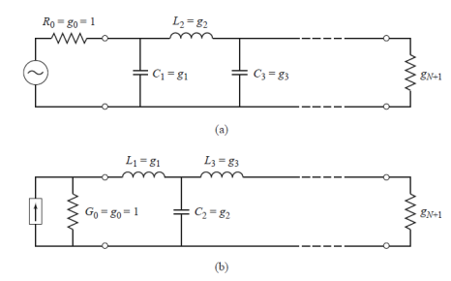

Fig.1. (left) Prototype beginning with a shunt element (right) Prototype beginning with a series element.

Now, we have to calculate the no. of element we can have in out LPF prototype based on the given data is termed as “n”.

For the n calculation, we will use the following mathematical equation

$n≥\frac{log\left({10}^{(0.1L_{As})} -1\right)}{2logΩ_{s}}$ (1)

On putting the value of $L_{As}$ as 20(given) and $Ω_{s}=\frac{ω_{s}}{ω_{s}}= \frac{4}{2.5}=1.6$

We got the RHS value as 4.88 but n should be integer because how can we have no. of elements in fraction value hence immediate integer will be 5.

So, 5 element circuit. We have chosen the LPF prototype beginning with the shunt element.

The Five element RLC circuit and it’s equivalent microstrip model will look like the shown below.

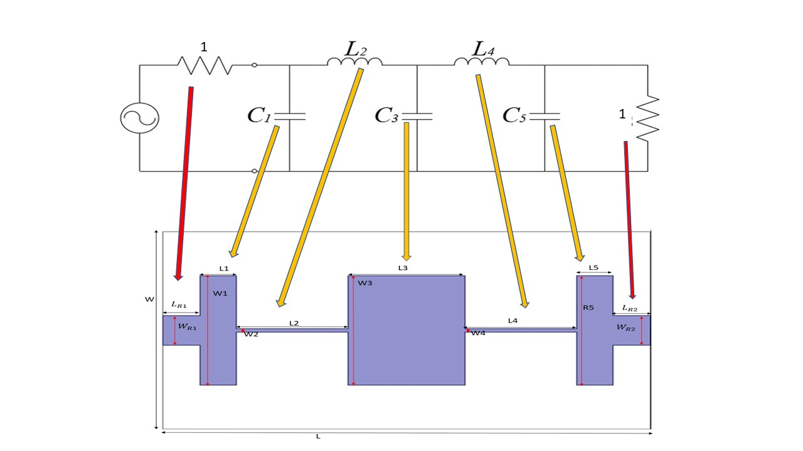

Fig .2. Five element RLC model and its microstrip equivalent model

**Calculation of the electrical length ($θ$) of capacitor $θ=βl= \frac{LR_{o}}{Z_{h}}$**   
 (2)

Where,

L is for Low pass prototype

$R_{o}$ is the characteristics impedance is values 50 Ω

$Z_{h}$ is the highest line impedance

**Calculation of the electrical length ($θ$) of Inductor**

$θ=βl= \frac{Z_{h}C}{R_{o}}$ (3)

Where

C is for Low pass prototype.

$R_{o}$ is the characteristics impedance is values 50 Ω

$Z_{l}$ is the lowest line impedance

Now in order to find the electrical length we need the L and C which can be calculated using the $g_{i}$

$g_{i}=2sin\left(\frac{(2i-1)π}{2n}\right)$ (4)

Where i= 1, 2, ….. ,n

And n is the number of elements we have calculated using the formula (1)

$g_{i}$ will give the capacitance(C) and inductance(L) for 1st, 3rd, 5th element and 2nd ,4th element respectively.

Using these C and L values we will find the electrical length. Now we have these electrical lengths and putting these in the microstrip line dimension calculator, we will get the dimensions of each of the five elements.

**LOW PASS FILTER DESIGN**

The proposed LPF uses the FR-4 epoxy substrate with thickness of 1.6 mm and dielectric constant of 4.4. Cut-off frequency of this LPF is kept at 2.5 GHz. The specific design of the LPF can be seen in the fig 1(a). The lumped port feeding technique is used to provide the excitation to the designed LPF. I have used the full ground plane with length and width equal to the substrate which can be seen in the fig 1(b). The dimensions of each of the elements of the LPF can be seen in the fig 2 and it is tabled below in Table I.

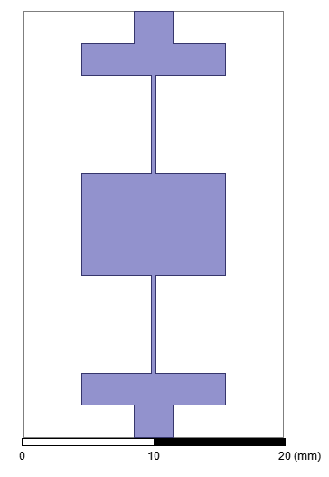 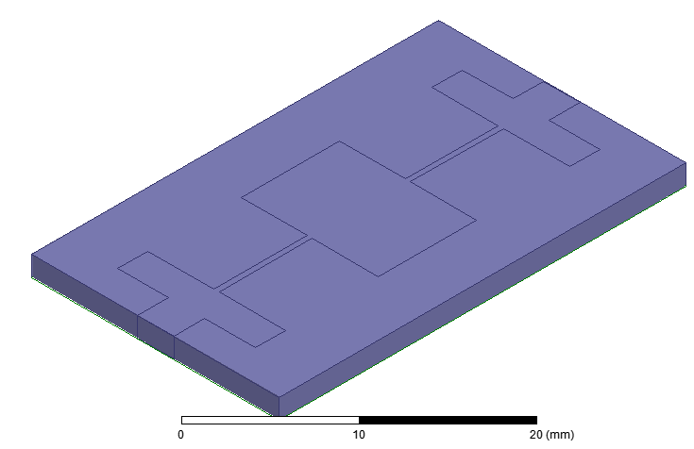

Fig. 1. Simulated Low pass filter design; (a) Front view, (b) Isometric View

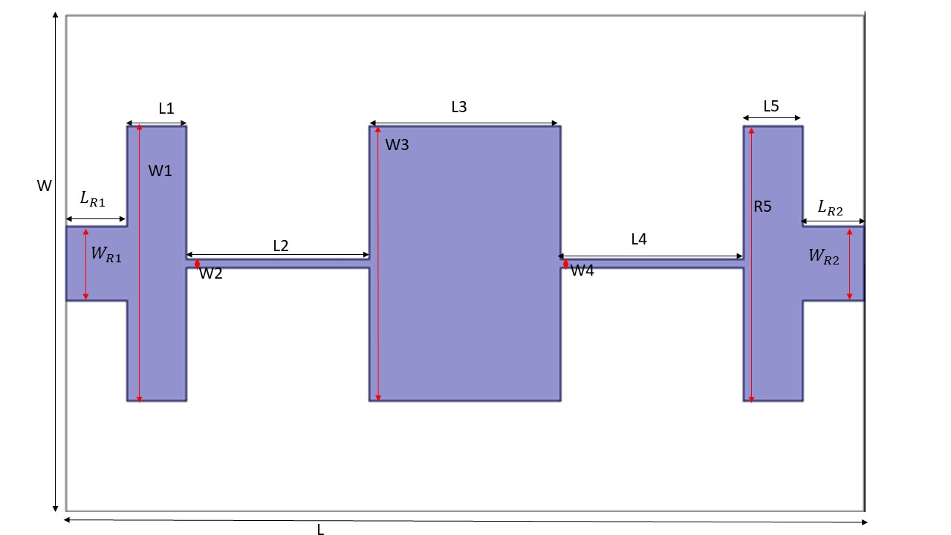

Fig. 2. Dimensions of different elements

**MATHEMATICAL ANALYSIS AND CONFIGURATIONS**

By using the equation (4) and putting the values in microstrip calculator, we got the dimensions of each elements of fig 2 and is shown in the Table 1 below.

Table I. Parametric Values of proposed LPF

|  |  |  |
| --- | --- | --- |
| W | Width of dielectric | 20 mm |
| L | Length of dielectric | 32.80565 mm |
| W1 | Width of first element | 11.1056 mm |
| L1 | Length of first element | 2.444 mm |
| W2 | Width of second element | 0.40844 mm |
| L2 | Length of second element | 7.5028 mm |
| W3 | Width of third element | 11.1056 mm |
| L3 | Length of third element | 7.91205 mm |
| W4 | Width of fourth element | 0.40844 mm |
| L4 | Length of fourth element | 7.5028 mm |
| W5 | Width of fifth element | 11.1056 mm |
| L5 | Length of fifth element | 2.444 mm |
| $$W_{R1}$$ | Width of port 1 feeding microstrip transmission line element | 2.95127 mm |
| $$L_{R1}$$ | Length of port 1 feeding microstrip transmission line element | 2.5 mm |
| $$W_{R2}$$ | Width of port 2 feeding microstrip transmission line element | 2.95127 mm |
| $$L_{R2}$$ | Length of port 2 feeding microstrip transmission line element | 2.5 mm |

I have used below shown formula for the patch microstrip transmission line for the resistor element for the 50 Ω impedance match to the port 1 and 2

$w= \frac{7.48 ×h}{e^{\left(Z_{o}\frac{\sqrt{ε_{r}+1.41}}{87}\right)}}-1.25×t$ (5)[1]

Where,

W is the width of the microstrip transmission line

h is the dielectric thickness

t is the metal patch thickness

$Z_{o}$ is the target characteristics impedance

$ε_{r}$ is the relative dielectric constant

The value of these terms are shown in the Table II.

Table II. Values of different variables used in the above equation

|  |  |
| --- | --- |
| h | 0.035 mm |
| t | 1.6 mm |
| $$Z_{o}$$ | 50 ohms |
| $$ε_{r}$$ | 4.4 |

On putting the value of all the variables in the equation shown, we got the value of the width of the microstrip transmission line as **2.95127 mm**.

Calculation of different electrical lengths of the elements are done using equation (1),(2),(3) and (4) and are shown in the Table III.

Table III. Dimensions of the LPF

|  |  |  |  |  |  |  |  |
| --- | --- | --- | --- | --- | --- | --- | --- |
|  | $$g_{i}$$ | element | $Z_{i}$ = $Z_{H} or Z_{L}$ | $θ_{i} = βI_{i}$ (rad) | $θ_{i} = βI_{i}$ (degrees) | $$W_{i}(mm)$$ | $I_{i}$ (mm) |
| 1 | 0.618 | C1 | 20 ohm | 0.2472 | 14.16 | 11.1056 | 2.444 |
| 2 | 1.618 | L2 | 120 ohm | 0.6742 | 38.62 | 0.40844 | 7.5028 |
| 3 | 2 | C3 | 20 ohm | 0.8 | 45.83 | 11.1056 | 7.91205 |
| 4 | 1.618 | L4 | 20 ohm | 0.6742 | 38.62 | 0.40844 | 7.5028 |
| 5 | 0.618 | C5 | 120 ohm | 0.2472 | 14.16 | 11.1056 | 2.444 |

**RESULT AND DISCUSSIONS**

This section presents the complete detail of simulated performance parameters of the proposed antenna such as return loss and Forward transmission. All the parameters have been obtained by using Finite Element Method (FEM) based simulator called High Frequency Structure Simulator (HFSS) version 15.

**Return loss (S11) and Forward Transmission (S21)**

S parameter describes the relationship between the terminals and input-output ports of antenna system in terms of power. Return loss of the proposed filter is also called as the S11 parameter. S11 parameter represents the amount of power at input port of LPF which is reflected back and the remaining power which is transmitting in LPF. It is basically the reflected power calculation. S21 represents the power received at port 2 due to the excitation at port 1. For instance if the S21 is 0 dB means that all the power entering at port 1 is delivered to the port 2. If the S21 is -10 dB means that only 10% of the entering power at port 1 is reaching at the port 2. Same analogy can be taken for the reflected power at port 1.

Fig 3 represents the S21 plot of the LPF. It is maximally flat response step impedance LPF hence the flat S21 should be 0 dB ideally. In my LPF simulation, I got the flat S21 response of -0.5 dB. It means nearly 90% of the input power is reaching at the output port which is good in real world scenario. Coming to the Cut-off frequency (2.5 GHz) S21 value. It is showing the S21 of -5.5 dB which is pretty accurate according to the Pozar book. There should be difference of -5dB between the S21 values at flat frequency and at the cut-off frequency. At last we needed the S21 below -20 dB at the frequency of 4 GHz which is also accurate as we are getting nearly -23 dB at 4 GHz.

Fig 4 represents the S11 plot of this LPF. After simulation, I am getting the S11 of -2.5 dB at the cut-off frequency and -0.4 dB at the 4 GHz frequency.

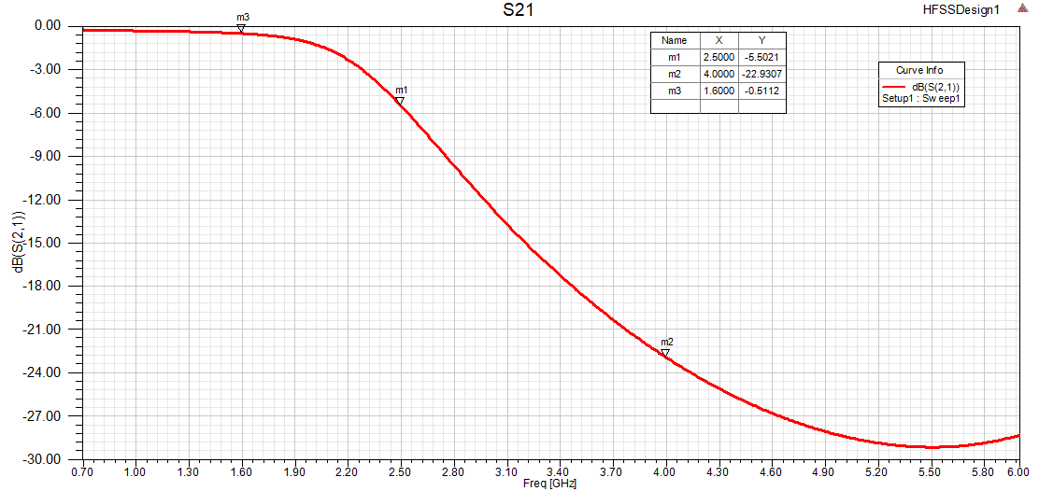

Fig. 3. Forward Transmission versus frequency plot of the Low pass filter

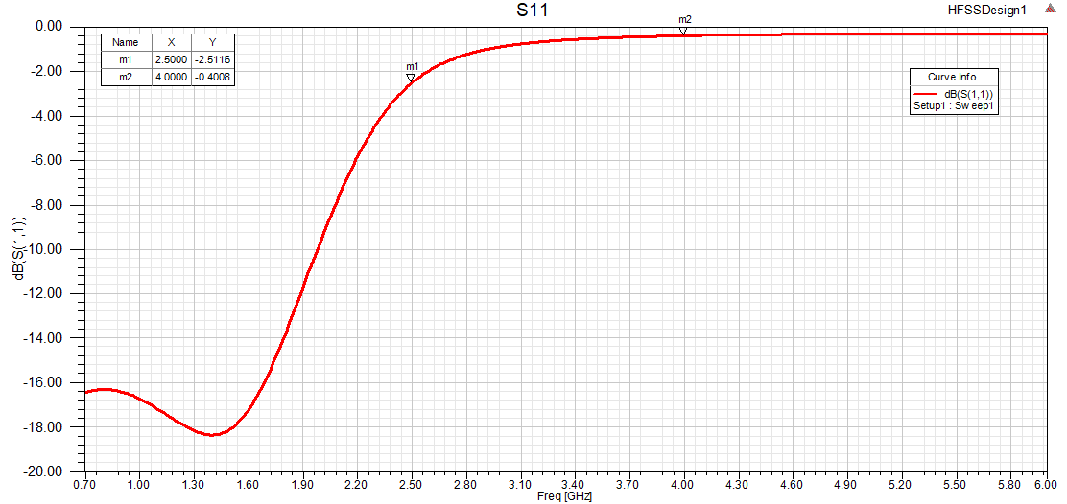

Fig. 4. Return loss versus frequency plot of the low pass filter

**CONCLUSIONS**

The conclusion about this simulation work is that we are able to get a good trade-off between the steepness of Forward transmission curve and the complexity of the proposed LPF by keeping the n (no. of the elements) at 5. If we somehow increase the n (no. of elements) to a greater value then we will be able to get the more steepness in the curve of forward transmission or the frequency response of the LPF will be rectangular function but our device complexity will be much greater and the compactness of the LPF will severely hampered.

In this paper, a fifth order Low pass filter with lumped port feeding technique was simulated and investigated in this report. The main advantage of this proposed LPF structure is to get a very good forward transmission at cut-off frequency. Thus, a microstrip low pass filter with a good forward transmission is achieved.