Microstrip Power Divider

**OBJECTIVE:**

To design, fabricate and measure an equal-split (3-dB) Wilkinson power divider for mobile communication operating at 915 MHz.

**THEORY**

Power divider is passive microwave component used for power division. In power division, an input signal is divided into two (or more) output signals of lesser power. The divider may have three ports, four ports, or more, and may be (ideally) lossless. Power dividers usually provide in-phase output signals with an equal power division ratio (3 dB), but unequal power division ratios are also possible.

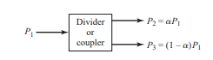

Fig.1. Power division

The simplest type of power divider is T junction. With 3 ports. The S parameter will have 9 elements.

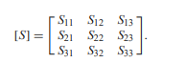

Fig.2. Scattering matrix

If the device is passive and contains no anisotropic materials, then it must be reciprocal and its scattering matrix will be symmetric (${ S}_{ij}={ S}_{ji}$). Usually, to avoid power loss, we would like to have a junction that is lossless and matched at all ports. We can easily show, however, that it is impossible to construct such a three-port lossless reciprocal network that is matched at all ports. The scattering matrix will look like [1]

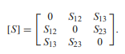

The network is also lossless, then energy conservation requires that the scattering matrix satisfy the unitary properties.

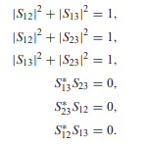

By the above six equations, it is clear that atleast two of the three $({ S}_{12}$, ${ S}_{13}, { S}_{23})$ will be zero. However, this condition will always be inconsistent with one of the first three equations, implying that a three-port network cannot be simultaneously lossless, reciprocal, and matched at all ports. If any one of these three conditions are relaxed, then a physically realizable device is possible [1].

if the three-port network is allowed to be lossy, it can be reciprocal and matched at all ports; this is the case of the resistive divider, which will be discussed in Section 7.2. In addition, a lossy three-port network can be made to have isolation between its output ports (e.g., ${ S}_{23}={ S}_{32}$ =0).

The lossless T-junction divider suffers from the disadvantage of not being matched at all ports, and it does not have isolation between output ports. The resistive divider can be matched at all ports, but even though it is not lossless, isolation is still not achieved. we know that a lossy three-port network can be made having all ports matched, with isolation between output ports. The Wilkinson power divider is such a network, with the useful property of appearing lossless when the output ports are matched; that is, only reflected power from the output ports is dissipated. The simplest two-way Wilkinson power divider consists of two quarter-wavelength transmission line sections (θ = 90°) and a resistor connected between the output ports for improving isolation between them. For an equal-split Wilkinson power divider with system impedance of 50 Ω, the quarter-wave transmission lines in the divider should have a characteristic impedance of $Z=\sqrt{2}Z_{0}=70.7Ω$, and the shunt resistor a value of $R=2Z_{0}=100Ω$ [1].

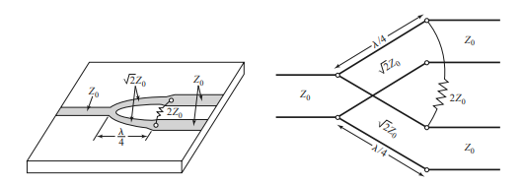

Fig.3. (a) Equal split Wilkinson power divider in microstrip form (b) in transmission line model.

It should be noted that when a signal is applied at port two, only half of the power of the incident signal is observed at port one. This implies that half of the initial power is dissipated through the resistor, but reciprocity is achieved ( ${ S}_{12}$ = ${ S}_{21}$). Furthermore, due to the isolation between ports two and three, no power is observed at port three when power is applied at port two for an ideal Wilkinson ( ${ S}_{23}$ and ${ S}_{32}$ are set equal to zero) [2].

The Wilkinson power divider is also capable of handling reflections in the system quite effectively. A reflection at an output port is essentially the equivalent of applying a signal at an output port. The reflected signal travels back to the other output port through two paths: one path through the resistor, and a second path through the initial input junction. Since the transmission lines are quarter-wave lengths, the signal through the resistor arrives at a specific phase, while the signal traveling along the two quarter-wave lines (two 90° phase shifts) arrives 180° out of phase. When these out of phase reflections are of equal amplitude, they result in complete cancellation (the isolation between the output ports) [2].

If two signals of equal amplitude and phase are applied simultaneously to the two output ports of an equal split Wilkinson, the sum of the signals will be observed at port one (typically the input port). Since the signals are of equal amplitude and phase, the resistor will see the same potential at each port, and no power will be dissipated. Once the signals arrive at the junction they will constructively interfere, and the power divider acts as a power combiner. [2]

The Frequency response of equal split Wilkinson power divider should ideally be like shown below:

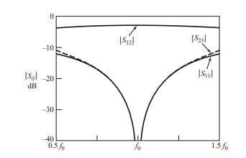

Fig.4. Frequency Response of equal split Wilkinson power divider

**DESIGN**

The design of the Wilkinson divider is composed of a transmission line (typically microstrip) that has been split into a specific number of transmission lines, each one quarter-wavelength long. Resistors are connected between each output transmission line and a common junction. When the outputs are connected to matched loads for an equal split Wilkinson, the voltages along each output transmission line are of the same magnitude and phase. This causes the connecting resistors to have no voltage drop across them, and consequently, dissipate no power.

The proposed design of the Wilkinson power divider is shown below.

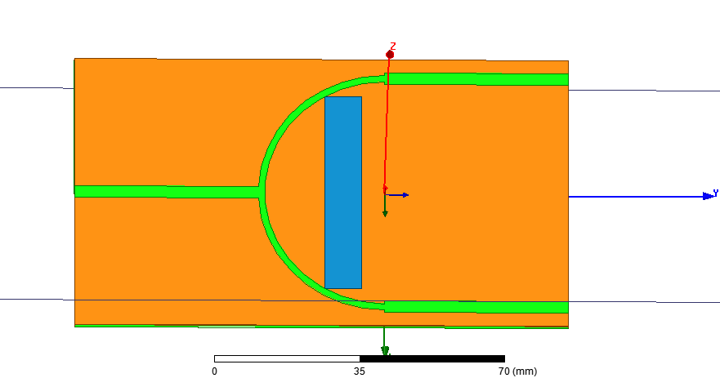

Fig.5 schematic of Wilkinson power divider

**MATHEMATICAL ANALYSIS AND CONFIGURATIONS**

The curved arm length of Wilkinson power divider is of quarter wavelength. The length and width of the microstrip(resistor) at the ends of each ports is 44.855mm and 3.053mm. The width of the curved part of the microstrip line is 1.62148 mm while the curved length is 47.2599 mm. There is resister between the port 2 and 3. This resistance is having lumped RLC features with resistance of 100m ohm with no capacitance and inductance.

**RESULTS AND DISCUSSIONS**

**Scattering parameters**

The simulation results for the magnitudes of $S_{11}$, $S_{21}$, and $S_{23}$ in dB are shown in fig 5(a)-5(c). The center frequency for each parameter is approximately 915 MHz, confirming the calculations for the phase velocity in the microstrip and the quarter-wave length sections. Additionally, near 915 MHz the return loss for $S_{11}$ near -35 dB, or very near reflection coefficient of zero. Similarly, $S_{23}$ has a transmission coefficient that is close to -6.8 dB, implying not so high isolation between ports two and three. It should have been as low as possible juts like the $S_{11}$. The equal-split nature of the Wilkinson is confirmed because $S_{21}$ is essentially -3 dB (50% power delivered from port one to port two) at 915 MHz.

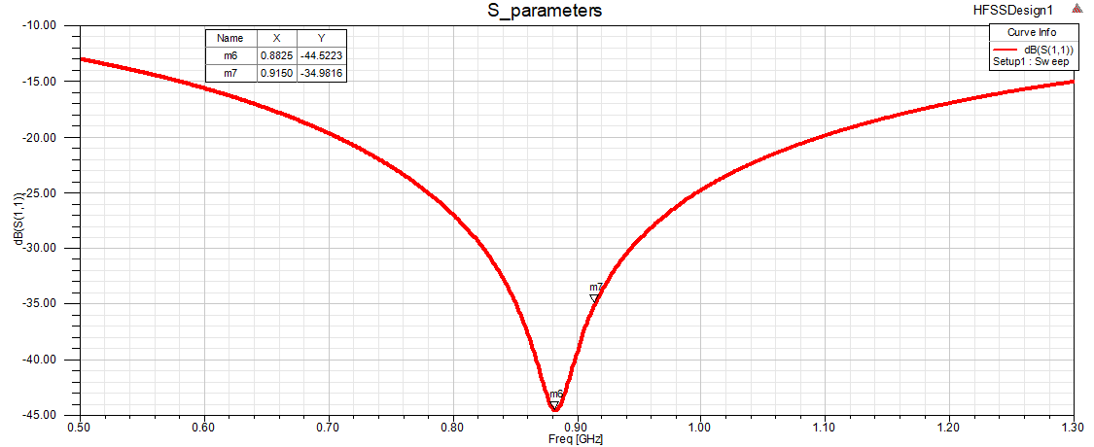

Fig.6(a) Return loss at the input port

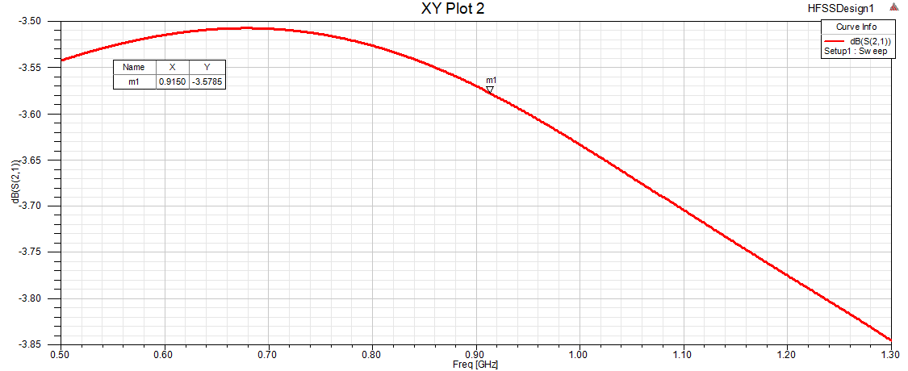

Fig.6(b) Transmission coefficient at port 2 due to input at port 1

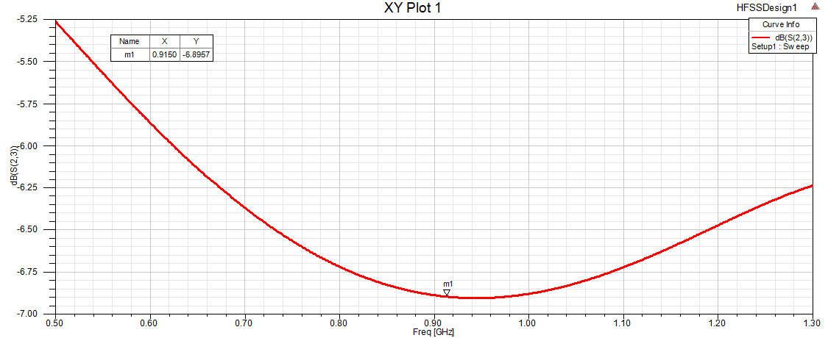 Fig.6(c) Transmission coefficient between port 2 and port 3.

**CONCLUSIONS**

In this report, Equal split Wilkinson power divider networks 2:1(two output port and one input port) is designed and simulated. The reflection and transmission coefficients of the proposed equal split power divider are studied. There is almost equal power division at the all output ports and good isolation between the output ports is obtained at the required frequency. By changing the gap width of quarter wave sections, isolation between output ports can be achieved. Wilkinson power dividers are very robust devices, and different designs can achieve similar performance, particularly when constructed using simple microstrip fabrication techniques and operating at reasonable frequencies. Straight Quarter wave section can also be used for the for same performance without the fear of degradation and more compact and smaller width design. The Wilkinson power divider is, in its most basic form, a relatively simple yet incredibly effective RF device. There are many different ways in which this design can be tweaked and same performance can be achieved with simpler designs.