WORKFORCE PRESENCE ANALYTICS
PROJECT CASE STUDY
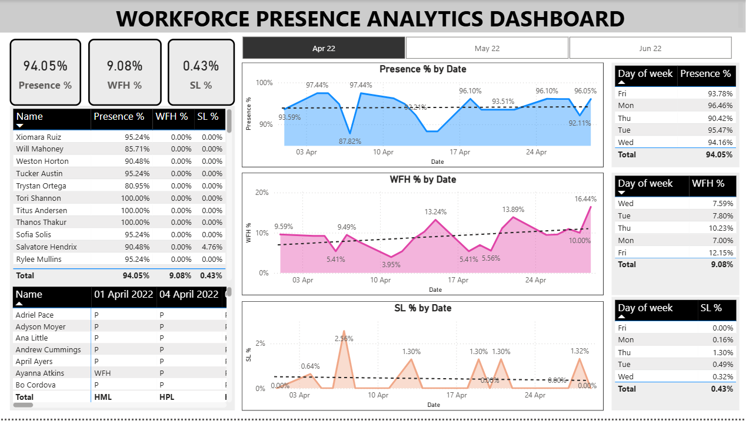

1. Project Overview
Workforce Presence Analytics is an HR analytics project created in Power BI to explore employee attendance patterns and working preferences. It focuses on three attendance indicators—Presence, Work From Home (WFH), and Sick Leave (SL)—and presents them through monthly filters, daily trend charts, weekday summaries, and employee-level attendance views.
The project uses attendance records for April, May, and June 2022. The original dashboard was developed in 2023 and has since been given a refreshed visual presentation while retaining its original scope and analysis.

2. Business Context and Problem Statement
The HR team wanted a clearer view of employee attendance and work arrangements, including how often employees were present, worked from home, or took sick leave. The attendance information was organized across monthly records, making it useful to have a consolidated interactive view for reviewing trends over time and comparing weekdays.

3. Business Questions
- What is the employee presence percentage for the selected month?
- How does presence change from one date to another?
- How frequently do employees work from home, and how does WFH vary by date and weekday?
- How frequently is sick leave recorded, and how does it vary by date and weekday?
- How do attendance patterns differ across individual employees?

4. Project Objectives
- Summarize the key attendance indicators in a single Power BI report.
- Monitor Presence %, WFH %, and SL % for the selected month.
- Compare daily attendance patterns and weekday-level percentages.
- Provide employee-level summary and date-wise attendance details.
- Make the attendance data easier for HR stakeholders to explore.

5. Dataset Description
The source workbook, Attendance Sheet 2022–2023 (masked), contains three monthly attendance worksheets and a separate attendance-key worksheet. The monthly worksheets cover April, May, and June 2022. Each monthly sheet contains employee codes, employee names, daily attendance-status entries, and monthly attendance/leave summary fields.
Dataset component | Description
Reporting period | April 2022 to June 2022
Monthly worksheets | Apr 2022, May 2022, June 2022
Employee information | Employee code and employee name
Daily attendance | Date-wise attendance status for each employee
Summary fields | Total present days and attendance/leave category totals
Reference | Attendance key defining the status codes
The attendance key includes codes such as P (Present), WFH (Work From Home), SL (Sick Leave), PL (Paid Leave), HPL (Half-day Paid Leave), HSL (Half-day Sick Leave), WO (Weekly Off), HO (Holiday Off), BL (Birthday Leave), FFL (Floating Festival Leave), BRL (Bereavement Leave), LWP (Leave Without Pay), and ML (Menstrual Leave). The workbook's own attendance key should be treated as the reference for interpreting these codes.

6. Data and Analysis Approach
The report is organized around the employee attendance records and the status codes supplied in the workbook. The dashboard provides a month selection control and displays attendance information at summary, date, weekday, and employee levels. This case study documents the visible report functionality; detailed Power Query transformations and the underlying DAX formulas are not specified here because the exact implementation has not been independently documented.

7. Dashboard Design and Features
- Monthly selection: A selector allows the report viewer to switch between April 2022, May 2022, and June 2022.
- KPI cards: Three headline indicators show Presence %, WFH %, and SL % for the selected month.
- Presence % by Date: A line/area trend visual shows how the presence percentage changes across dates.
- WFH % by Date: A trend visual shows daily work-from-home percentages.
- SL % by Date: A trend visual shows daily sick-leave percentages.
- Weekday summaries: Separate weekday tables compare Presence %, WFH %, and SL % across days of the week.
- Employee summary: A table displays employee-level Presence %, WFH %, and SL %.
- Daily attendance detail: A date-wise employee table displays attendance status codes for individual employees.

8. Dashboard Snapshot — April 2022
The updated dashboard screenshot included in this case study has April 2022 selected. The three KPI cards in that view display 94.05% Presence, 9.08% WFH, and 0.43% SL. These values describe the selected April view shown in the screenshot only; they are not combined results for the full April–June reporting period.

9. Observations and Interpretation
The dashboard makes it possible to review changes in presence, WFH, and sick leave across dates and weekdays, while also checking individual employee records. The weekday comparison tables and daily trend charts provide complementary views: one highlights differences by day of the week, while the other shows how the indicators move through the selected month.
The report can identify when attendance patterns differ, but the attendance records alone do not establish the reasons behind those differences. Explanations for employee work preferences would require additional context, such as employee feedback, team schedules, or company policies.

10. Business Value
- Provides HR with a consolidated view of key attendance indicators.
- Makes monthly, daily, and weekday attendance patterns easier to review.
- Allows attendance trends to be considered alongside employee-level details.
- Can support HR discussions about work arrangements, attendance monitoring, and leave patterns.

11. Tools Used
- Microsoft Excel — source attendance workbook.
- Microsoft Power BI — interactive dashboard, visual analysis, and reporting.

12. Conclusion
Workforce Presence Analytics demonstrates how employee attendance records can be presented in an interactive HR dashboard. By combining monthly KPI cards, daily trends, weekday comparisons, and employee-level attendance details, the report gives HR stakeholders a structured way to explore presence, work-from-home activity, and sick-leave patterns.

Project Reference
Original LinkedIn project post:
https://www.linkedin.com/posts/hsharma98765_connections-powerbi-powerbidashboard-activity-7131566606089879553-tYSm
Repository: https://github.com/Himanshu584/Workforce-Presence-Analytics

