E-Commerce Sales Performance and Customer Analytics
Final Data Visualization Project

1. Introduction
This project analyzes e-commerce transaction data to understand sales, profitability, products, regions, payment modes, customer segments, and monthly trends. The project demonstrates an end-to-end workflow using Excel, SQL, Python, and Power BI.

2. Objectives
- Measure sales and profit performance.
- Identify top categories and products.
- Compare regional performance.
- Analyze payment modes and customer segments.
- Study monthly sales trends.
- Build an interactive business dashboard.

3. Tools and Technologies
Excel: data inspection and analysis
SQL: business queries and aggregation
Python: data cleaning, validation, EDA and charts
Power BI: interactive dashboard and business storytelling

4. Dataset
The dataset contains 1,200 synthetic e-commerce transactions covering January to December 2025. Fields include order date, customer, category, product, quantity, unit price, discount, sales, profit, region, payment mode and customer segment.

5. Key Results
Total Sales: ₹18,044,834.95
Total Profit: ₹2,647,799.11
Total Orders: 1,200
Total Quantity: 3,530
Average Order Value: ₹15,037.36
Profit Margin: 14.67%

6. Dashboard Visualizations
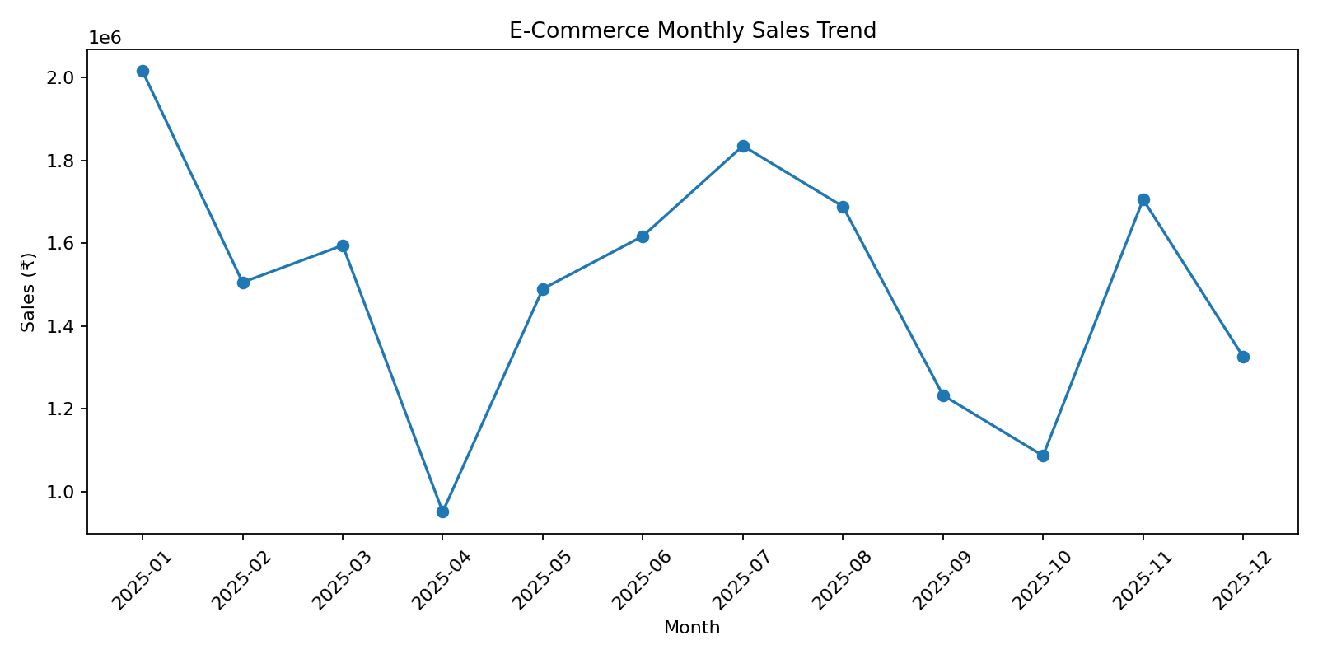
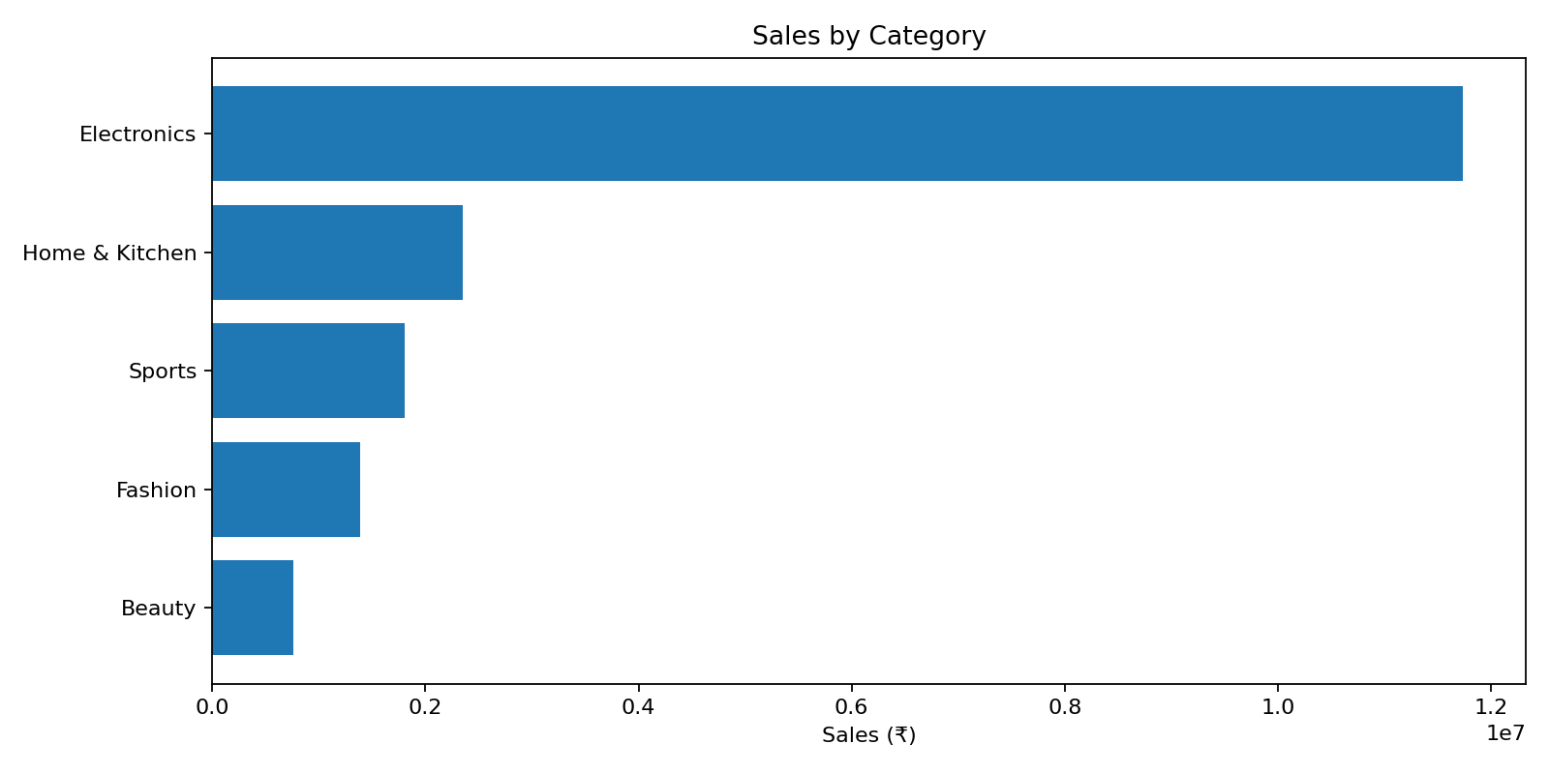
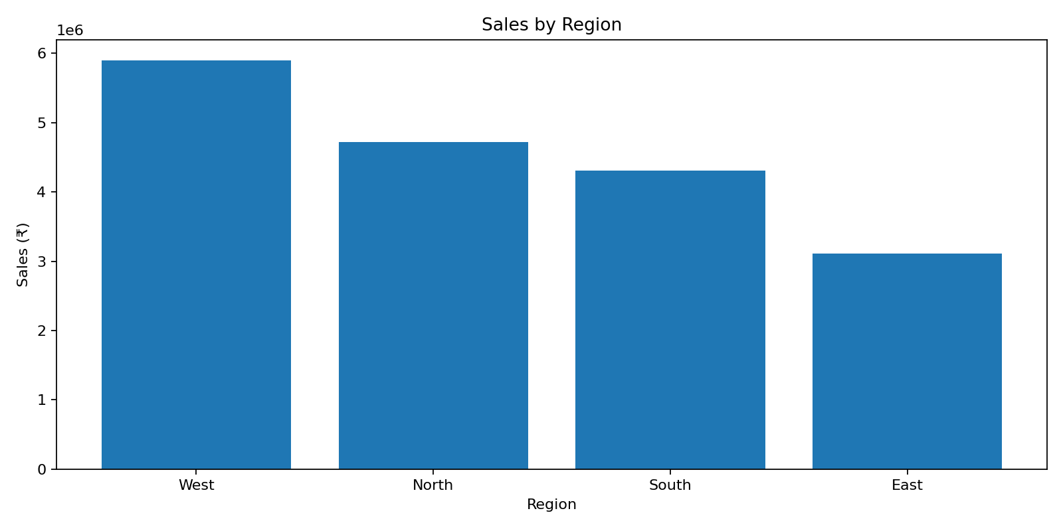
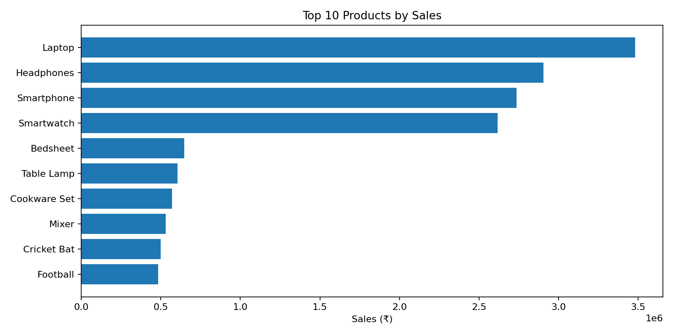
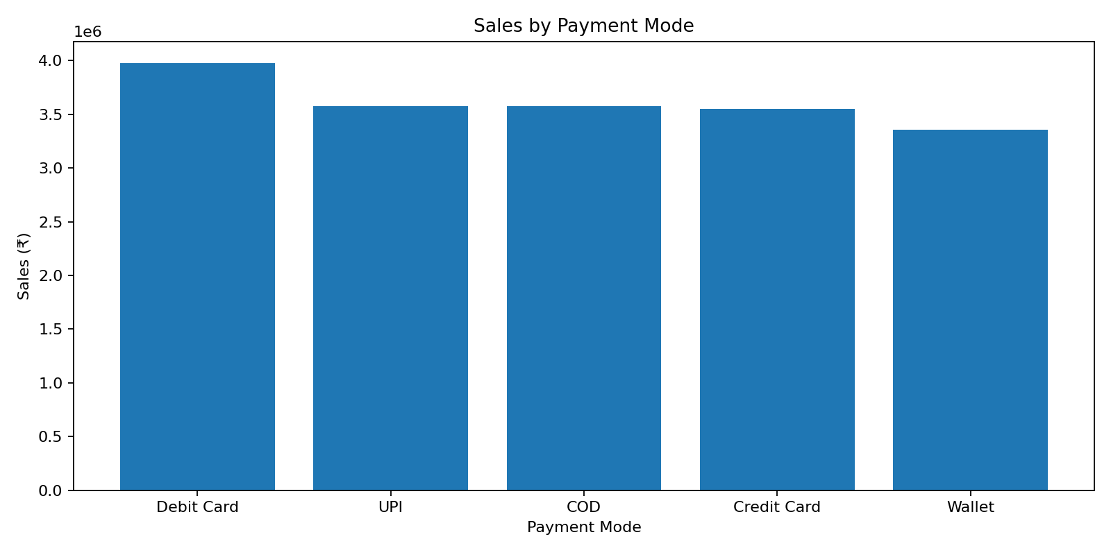
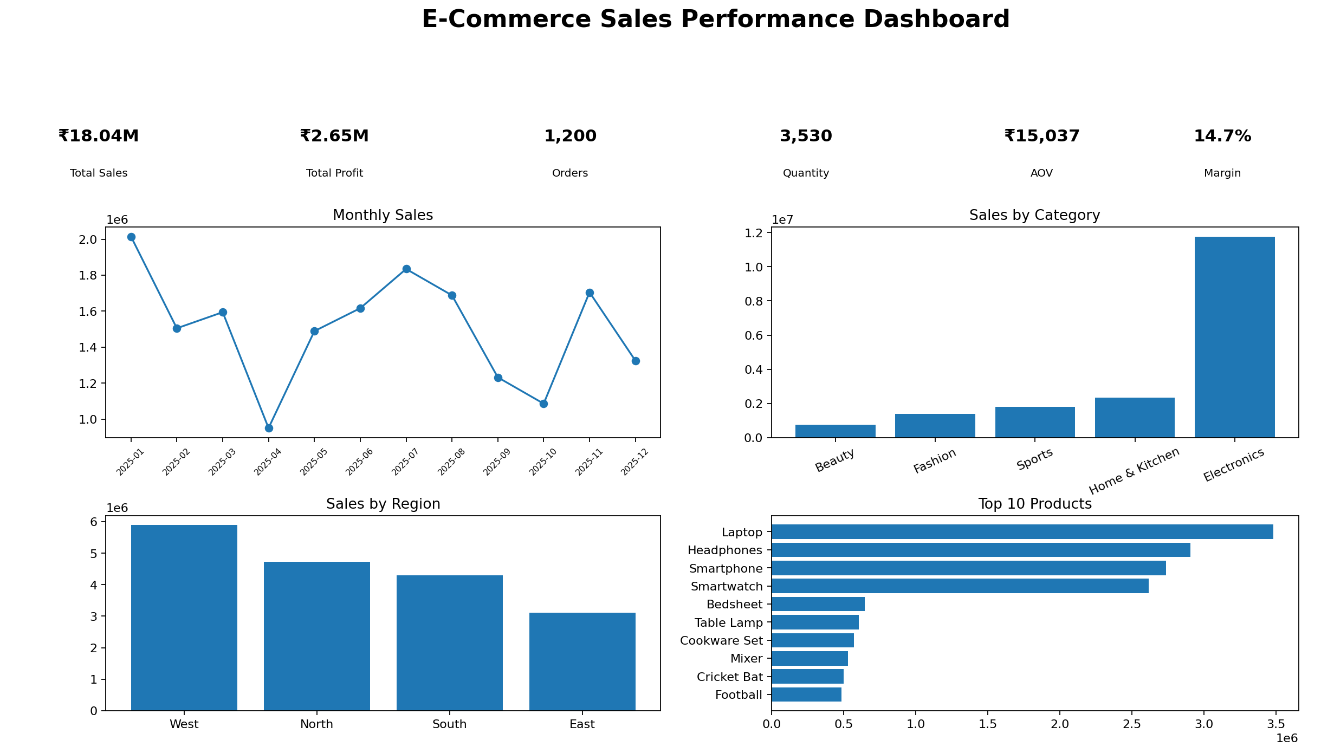

7. Conclusion
The project demonstrates how raw transaction data can be transformed into meaningful business insights. The combined use of Excel, SQL, Python and Power BI creates a complete analytics workflow from data preparation to visualization and decision support.
Note: The dataset is synthetic and intended for academic demonstration.

