<strong>Natural Number -></strong> Counting numbers are known as natural number .

<strong>Example -</strong> 1 , 2 , 3 , . . . . . . . , ∞

<strong>Whole Number -></strong> counting number along with zero are known as whole number .

<strong>Example -</strong> 0 , 1 , 2 , 3 , . . . . . . , ∞

<strong>Integer -></strong> Natural number along with 0 and negative natural number are known as integer .

<strong>Example -</strong> -∞ , . . . . . , -2 , -1 , 0 , 1 , 2 , . . . . . . , ∞

<strong>Note -</strong> Every whole number and natural number is an integer but vice versa is not true .

<strong>Rational Number -></strong> All those numbers are rational number which can be written in the form of $\frac{p}{q}$, where q ≠ 0 .

<strong>Example -</strong> 0 is rational number as $\frac{0}{1}$.

<strong>Note -</strong> Every whole number , natural number and integers are rational number .

<strong>Equivalent Rational Number -></strong> Rational number after solving the values become same .

<strong>Example -</strong> $\frac{15}{30}$ = $\frac{1}{2}$& $\frac{144}{288}$ = $\frac{1}{2}$ both are equivalent rational number because after solving both values are $\frac{1}{2}$.

<strong> Representation of Rational number on Number Line </strong><br />

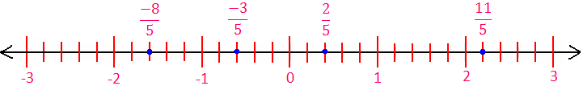

This is number line where each unit is divided into 5 sub-unit so that these values can be represented very easily and in a simple manner .

<u><strong> Two ways to represent numbers on number line 🡪 < strong></u>

<strong>1. If the number was in decimal -- </strong> firstly check the number suppose the number was 3.766 , so this number can be situated between 3 and 4 . make a 10 sub-unit between 3 and 4 than move to 7<sup>th</sup> sub-unit . since rest of the number was now .065( from 3.<b>765</b> ) so make another 10 sub-unit between 3.7 and 3.8 , than move to the 6<sup>th</sup> sub-unit . now the number was 0.005 ( from 3.7<b>65</b> ) so make another sub-unit between 3.76 and 3.77 and than move to the 6<sup>th</sup> sub-unit and now you are on the number 3.766 on that number line .

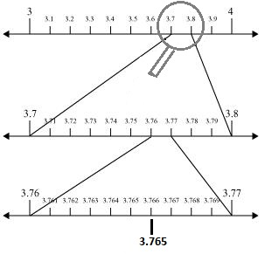

<strong> 2. If the number are in fractional </strong> so it contains numerator and denominator so first of all make sub-unit of the value of denominator and than count the value of numerator from zero .

You can easily reach to the position on the number line .

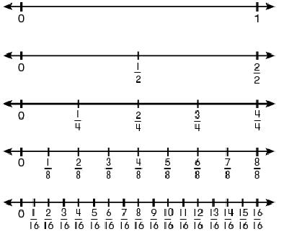

<strong>Suppose if you want to represent $\frac{1}{2}$ on number line divide each unit by 2 . <br /> if you want to represent $\frac{3}{4}$ on number line divide each unit by 4 . <br /> if you want to represent $\frac{11}{16}$ divide each unit by 16 parts and represent as shown in figure . </strong>

**3.**  Show how http://www.careerlauncher.com/cbse-ncert/class-9/9-math-num-4-UntitOE12.JPG can be represented on the number line.

**Ans.** Let us take the horizontal line XOX’ as the x-axis. Mark O as its origin such that it represents 0.

           Cut off OA = 1 unit, AB = 1 unit.

           ⇒ OB = 2 units

           Draw a perpendicular http://www.careerlauncher.com/cbse-ncert/class-9/9-math-num-4-UntitOE13.JPG

           Cut off BC = 1 unit.

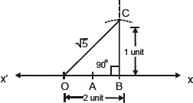

           Since OBC is a right triangle.

           OB2 + OC2 = OC2

           22 + 12 = OC2 4 + 1 = OC2

           OC2 = 5

http://www.careerlauncher.com/cbse-ncert/class-9/9-math-num-4-UntitOE15.JPG

           With O as centre and OC as radius, draw an arc intersecting OX at D.

           Since OC = OD

