Project
Analysis of IPL Dataset Using Pandas
Introduction:
The Indian Premier League (IPL) is one of the world's most popular cricket tournaments, generating rich match and player data across every season. This project analyses two datasets — matches.csv and deliveries.csv — to extract meaningful insights from ball-by-ball and match-level records spanning multiple IPL seasons.
Objectives:
The main objectives of this project are:
- Analyse team performance while chasing and batting first
- Study toss decisions and their impact across different venues
- Identify top-performing players in specific match scenarios
- Analyse batting statistics such as dot balls, dismissals, and scoring patterns
- Analyse bowling statistics including runs conceded by type
- Explore rare and interesting match situations within the data
Tools Used:
- Python
- Pandas
- Excel datasets
- Google Colab

Dataset Used:
- Matches dataset

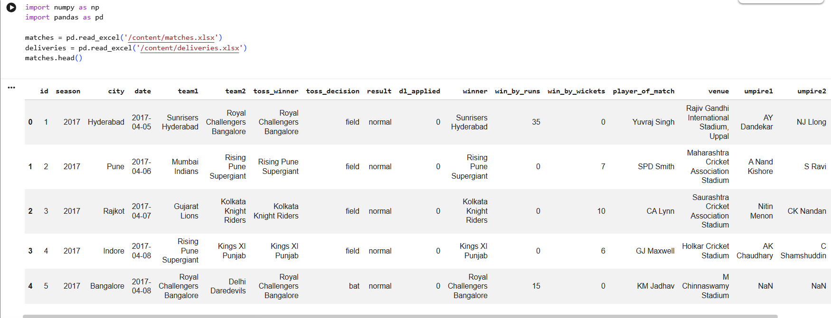

- Deliveries Dataset
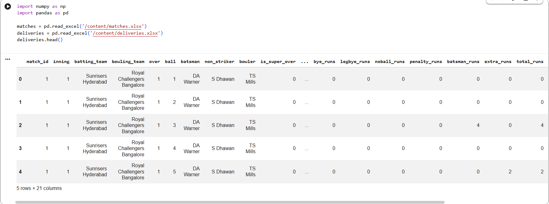

Q1 - Which team has won/lost maximum number of matches while chasing?

Q2 - Which toss decision is best for each ground?

Q3 - Which player has won maximum number of MoM awards while chasing?

Q4 - Which batsman has played maximum number of dot balls?

Q5 - Which batsmen came to crease but never got a chance to face a ball?

Q6 - Which bowler has hit for maximum number of 1s/2s/3s/4s/6s?

Q7 - Which batsman got stumped out maximum number of times?

Q8 - Which non-striker has been part of maximum number of runouts?

Q9 - Which team has won the most tosses?

Q10 - Which batsman has scored the most total runs in IPL?

Q11 - Which team scored the most runs in a single match?

Q12 - Which bowler has taken the most wickets?

Q13- Which is the venue where most matches have been played ?

Q14 - Which bowler has bowled the most no balls?

Q15 - Which bowler has taken the most wickets in powerplay (overs 1-6)?

Q16 - Which bowler has bowled the most wides?

Q17 - Which team has lost the most matches overall?

Q18- Which team has won most matches batting first?

