TASK 1:

git config --global user.email "himanshudon142@gmail.com"

git config --global user.name "HimanshuDhone"

git config --global --list
user.email="himanshudon142@gmail.com"
user.name "HimanshuDhone"
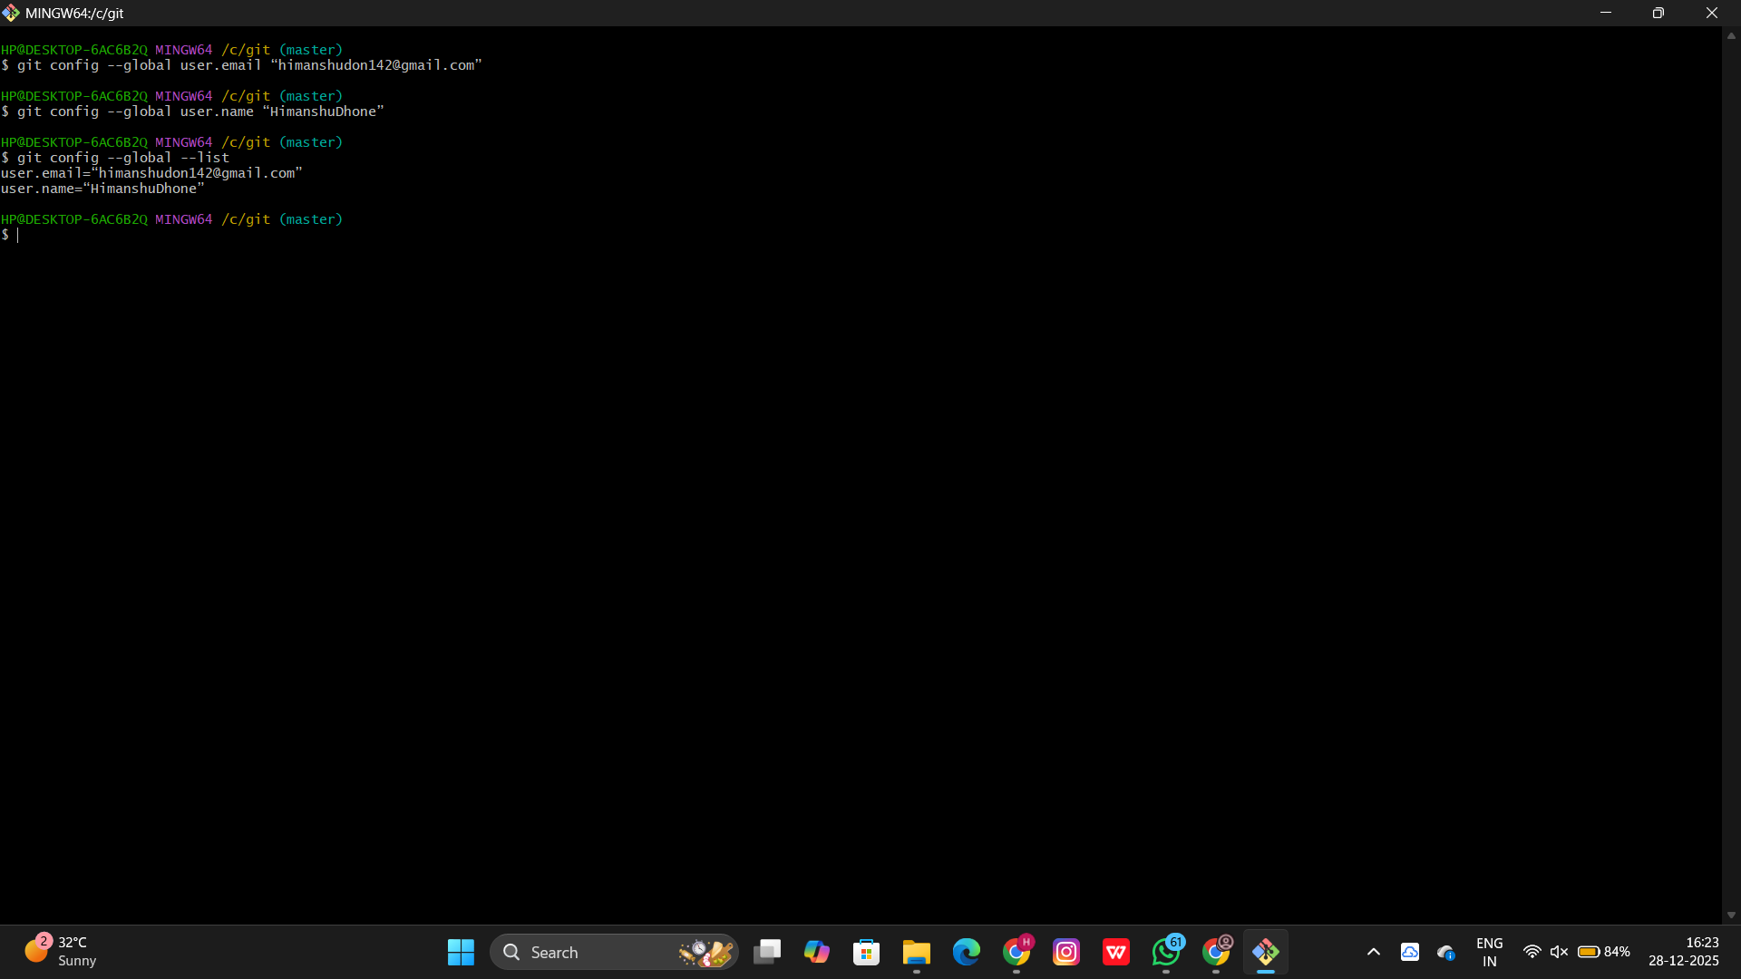

TASK 2:

git init
git status
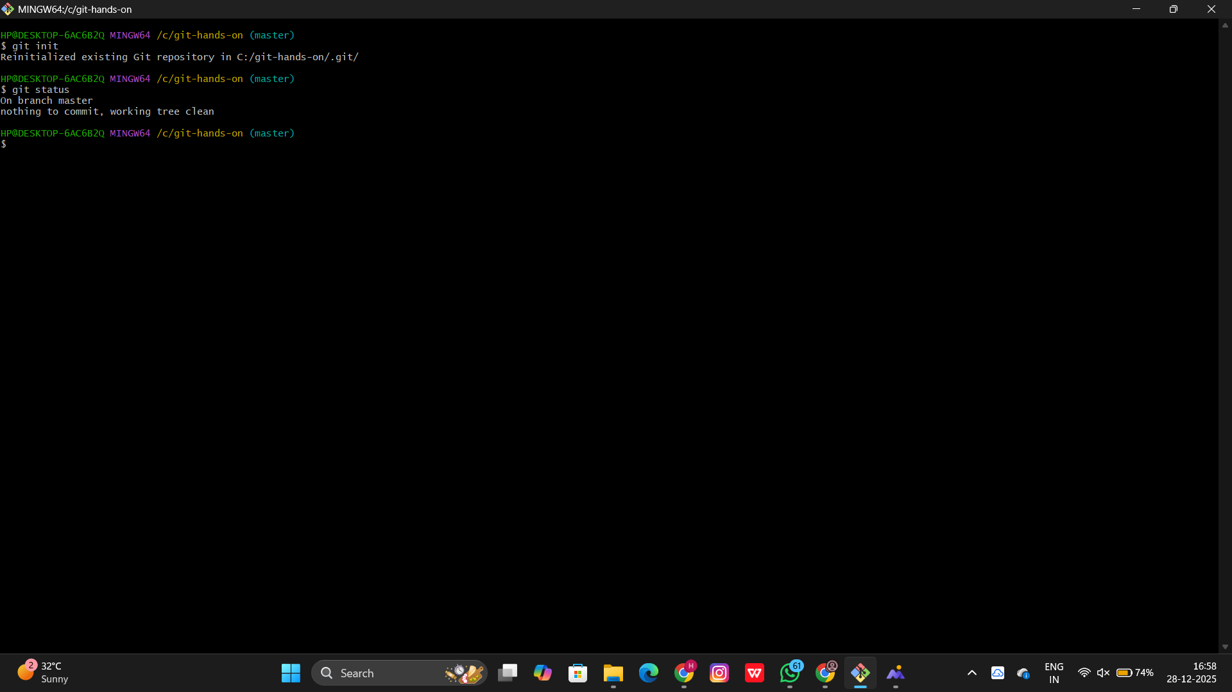

TASK 3:
git add .

git commit -m "commit all"

git status
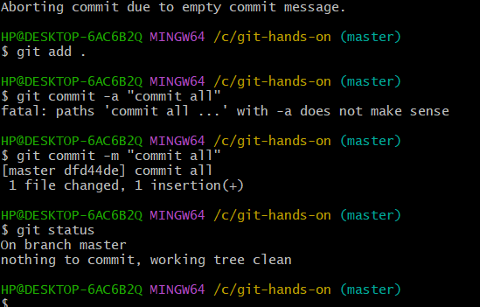

TASK 4:
git status

git diff

git add .

git commit – m "operated commit"

$ git status

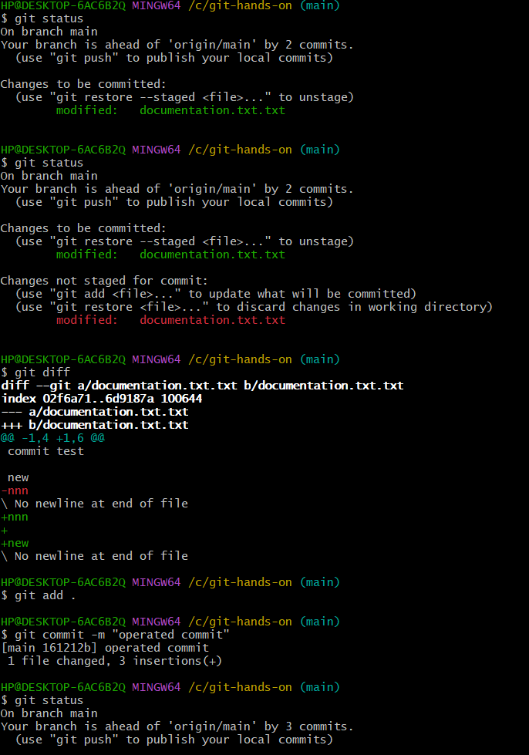

TASK 5:

git log

git log --oneline

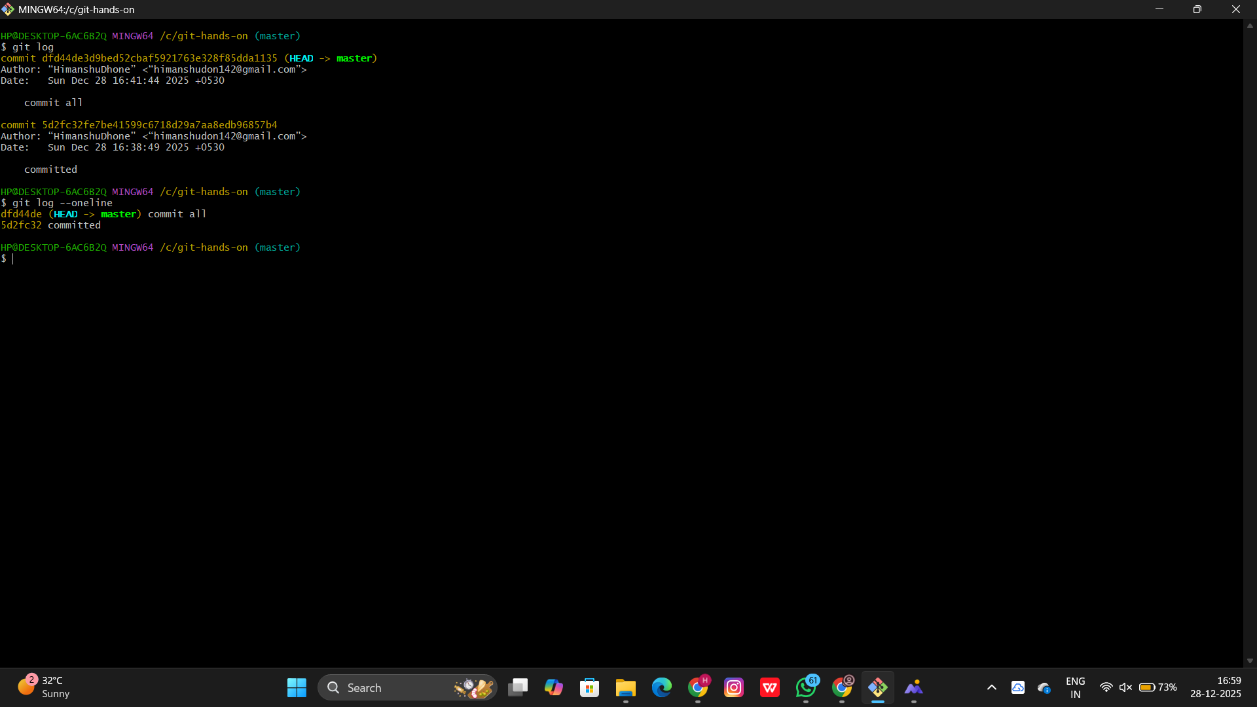

TASK 6:
git branch feature-1
git checkout feature-1
git status
git add .
git status
git commit -m "feature committed"
git status
git checkout main
git branch
git branch main
git checkout main
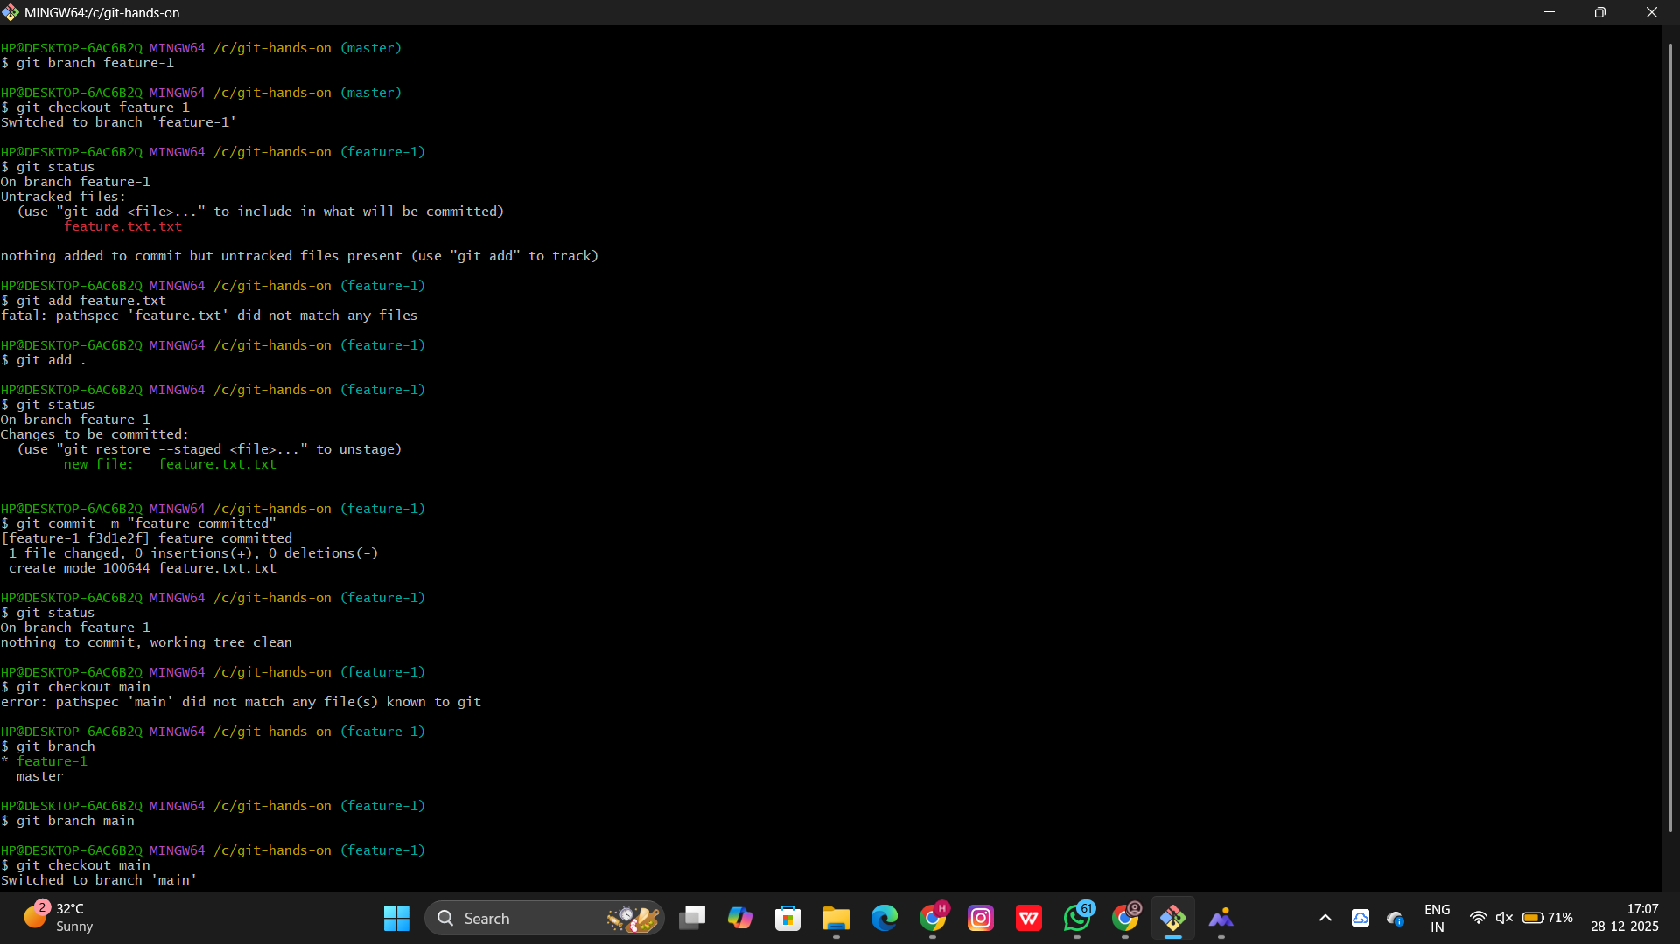

TASK 7:
git checkout main
git merge feature-1
git log
git log --oneline
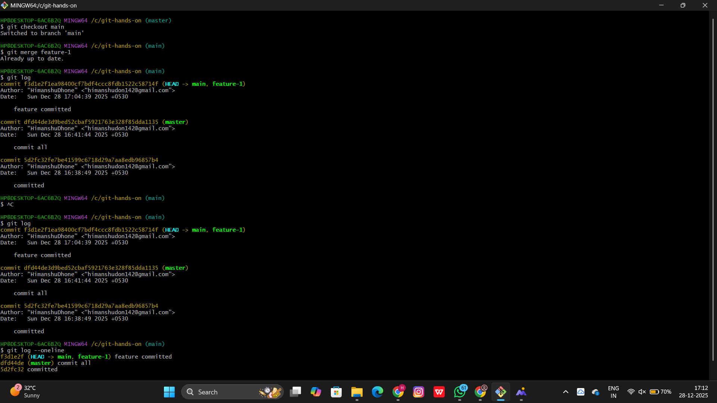

TASK 8:
git remote add origin https://github.com/HimanshuDhone/assignment.git
git remote -v

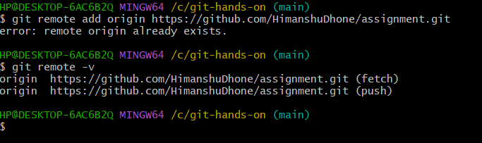

TASK 9:
Git push -u origin main
Git log --oneline

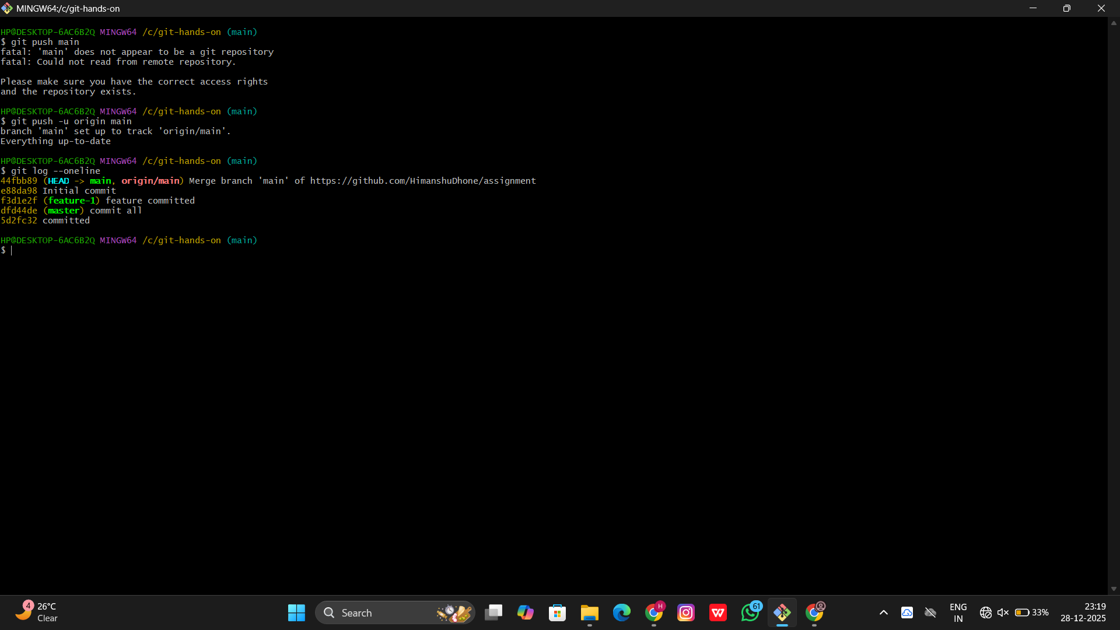

TASK 10:
git clone https://github.com?HimanshuDhone/assignment.git git.copy
git status
git commit -m “git copy”
cd git-copy
ls -a
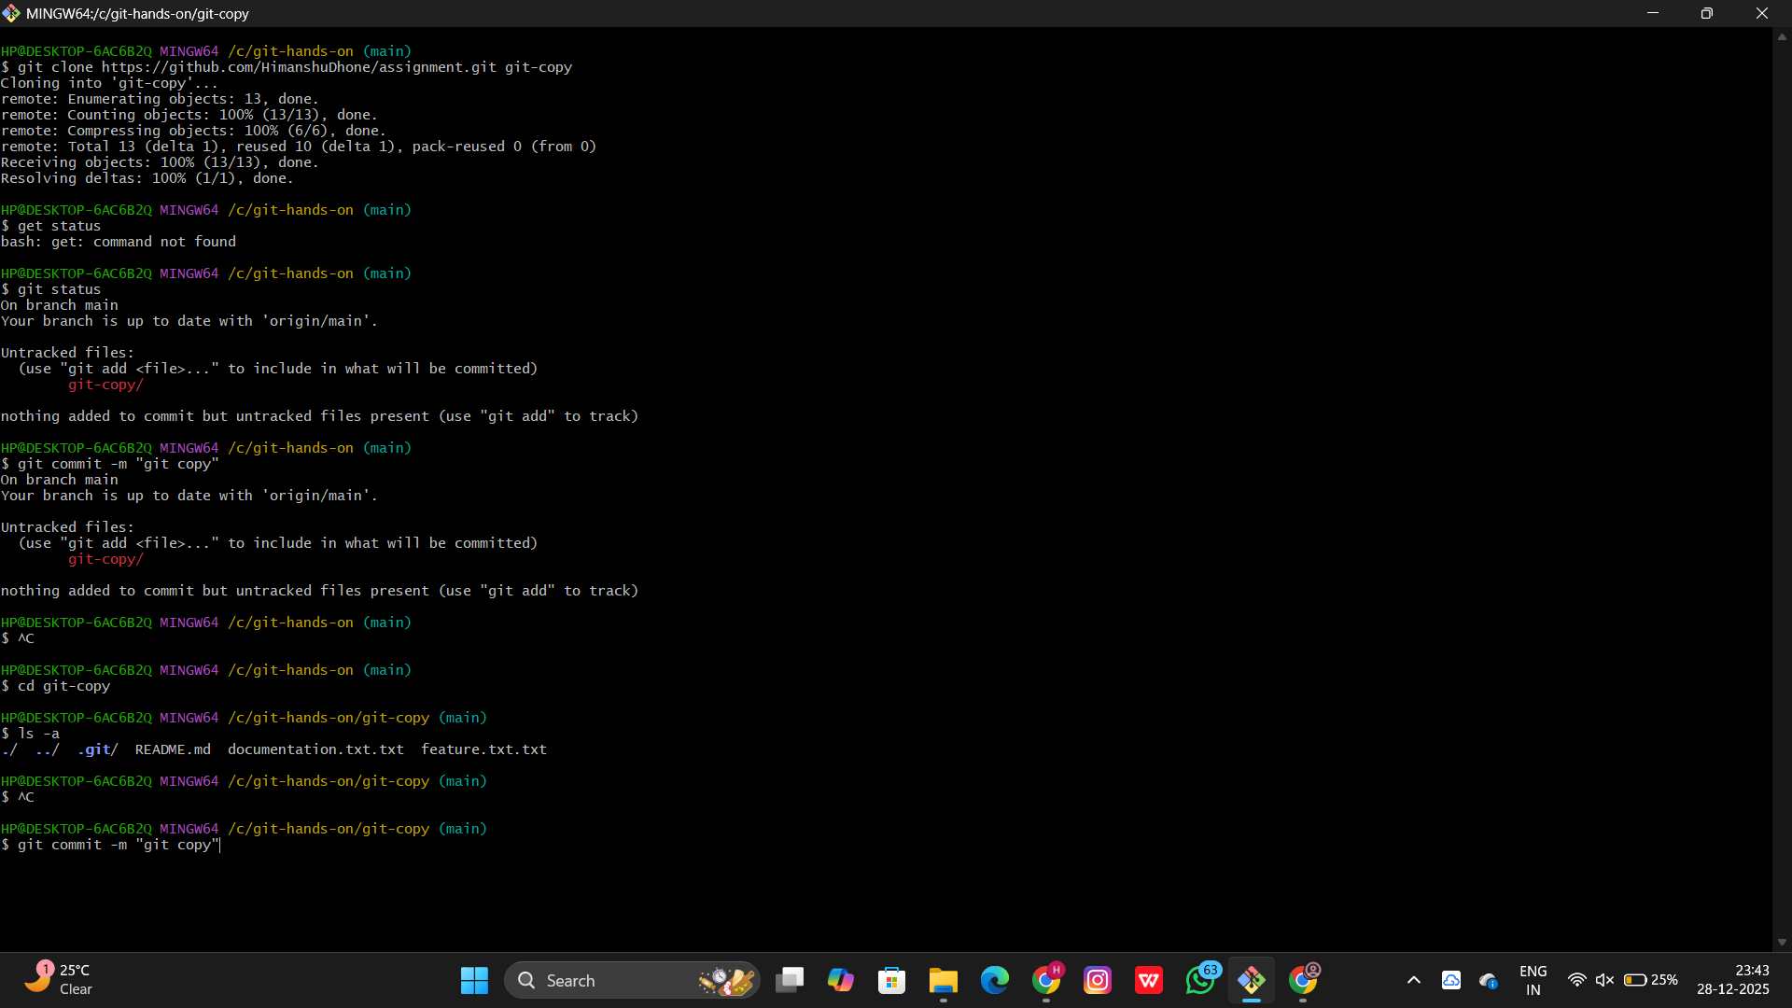

TASK 11:
git checkout –documentation.txt.txt
git status

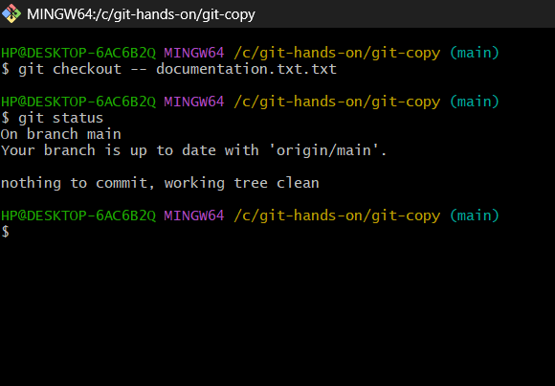

TASK 12:
git rm feature.txt.txt
git commit -m removed
git status
ls -a

