PowerPoint Foundations
We can create different shapes like below –
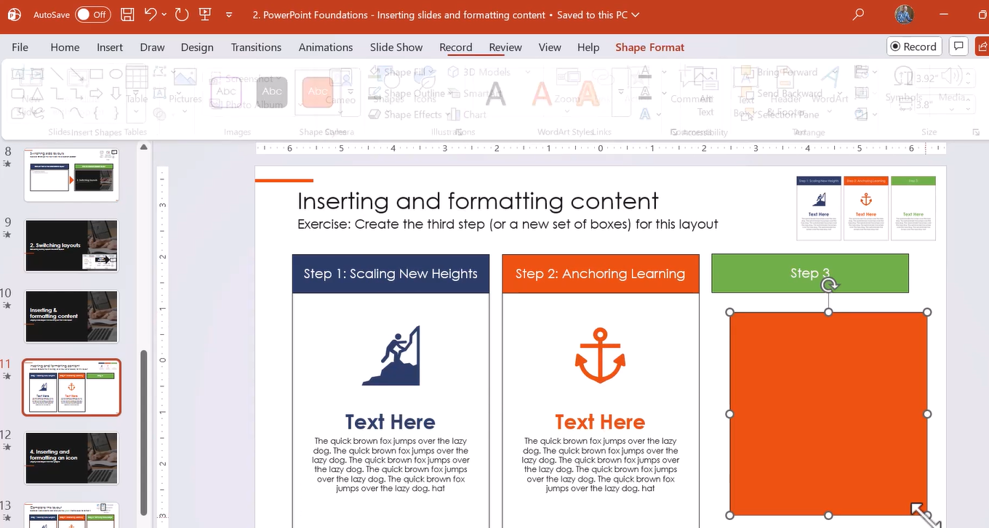
We can apply different animation on the slides –
