User Experience – Best Practices

**[Practice 1]** Cognitive load: Don’t make users think harder than they need to

* One main action per screen is usually enough.
* Don’t overload users with 12 menu options when 4 will do.
* Hide complexity until it’s needed (advanced settings can stay advanced).

**[Practice 2]** Hick’s Law: Too many choices = decision paralysis

* Use progressive disclosure (show options gradually).
* Highlight the most common or recommended choices.
* Pre-fill defaults (most users won’t change them anyway).

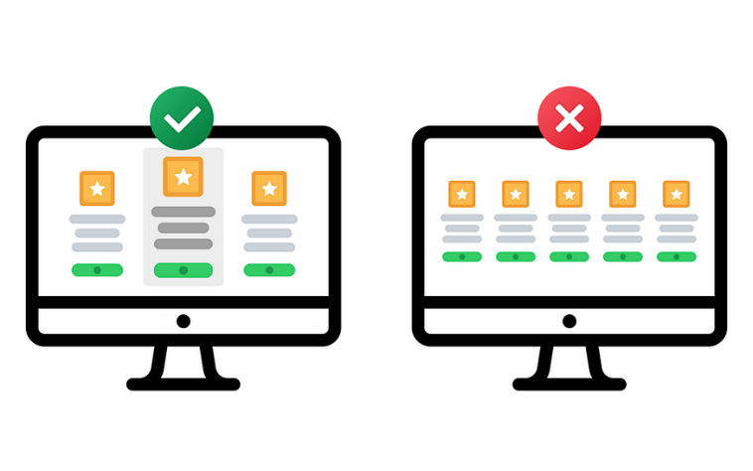

**[Practice 3]** Fitts’ Law: Make targets easy to hit

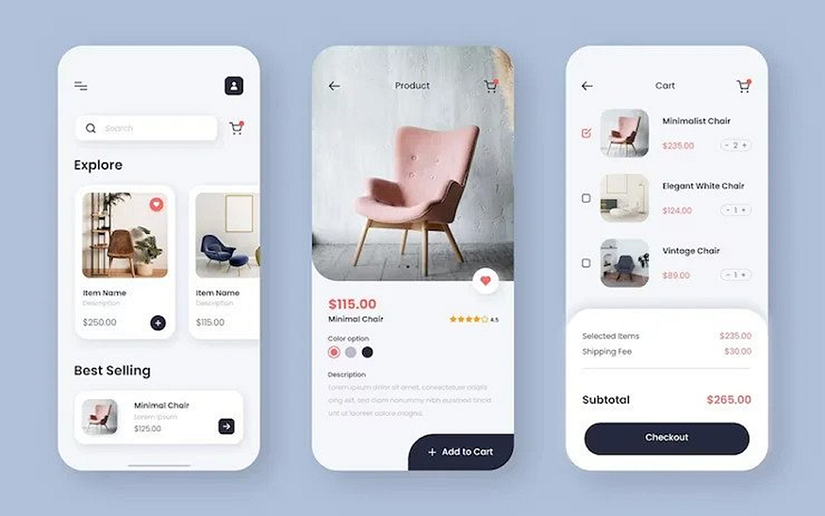

* Touch targets on mobile should be at least 44px (unless you enjoy lawsuits from people with normal-sized thumbs).
* Put primary actions in easy-to-reach “thumb zones.”
* Don’t put destructive actions (“Delete account”) right next to safe ones (“Save changes”).

**[Practice 4**] Familiarity > originality

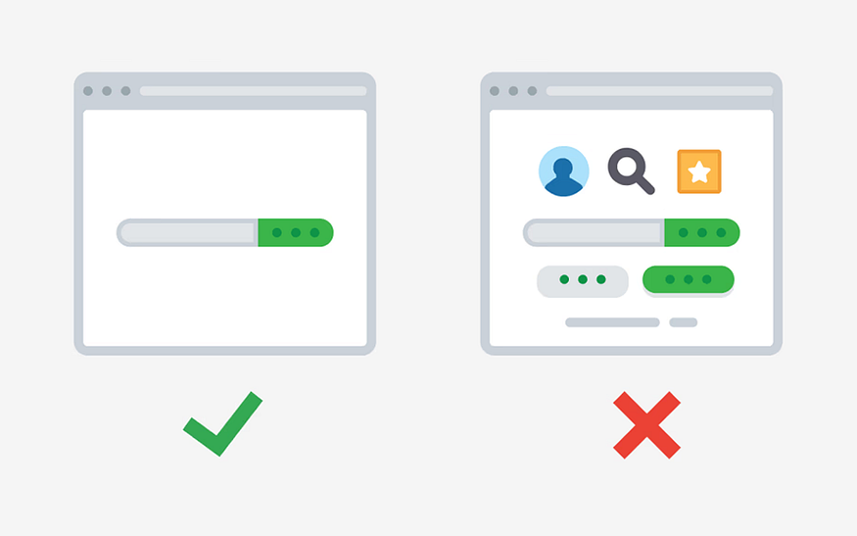

Familiar patterns feel safe. Login forms, navigation bars, checkout flows, they all follow conventions for a reason. Break them, and your users will break up with you.

* Keep common flows standard (sign-up, login, navigation).
* Save your creativity for visuals, animations, and micro interactions.
* Remember: weird = suspicious, familiar = trustworthy.

There’s a reason nobody messes with the order of “email” then “password.” Keep the basics boring and make the extras delightful.

**[Practice 5]** Don’t disable text selection / copying

The inability to copy text interrupts user workflow and forces hacks (screenshots + OCR) just to read or use content. It “turns text into media,” which is less interactive or manipulable.