System Design
What is Redis – it is a single threaded in-memory data structure server. It keeps data in RAM for low latency, it only stores as cache not permanent persistence.
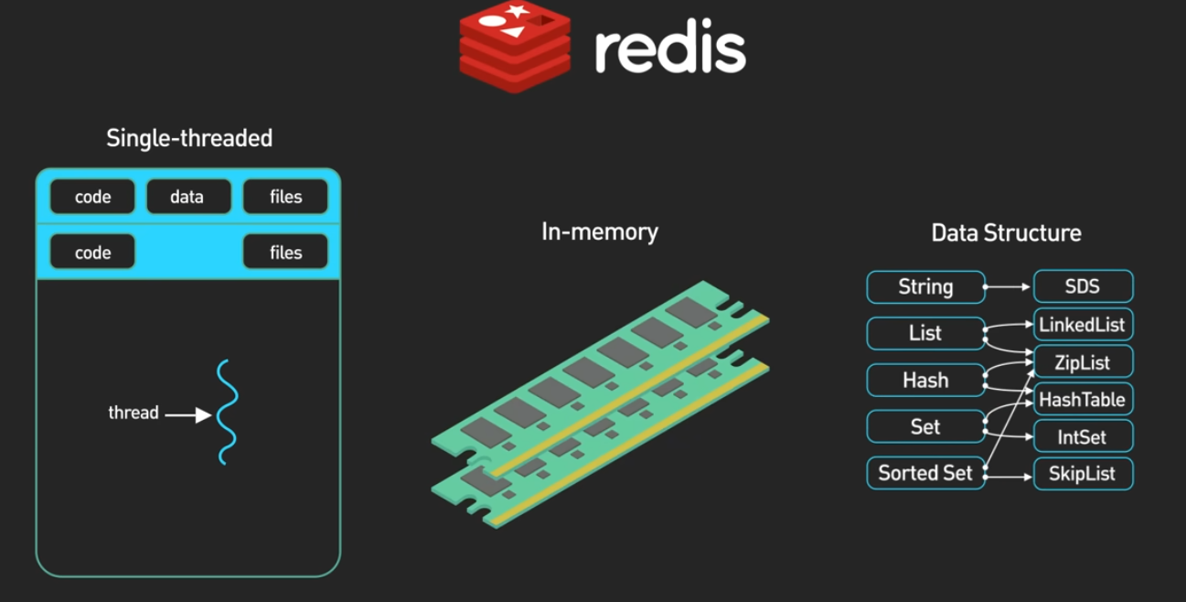
System design - basic layers like for Zomato platform –
