CSS Advanced Features
Creating rounded corners – border-radius. It is to avoid photographic photo album look.
The long form of border-radius property –
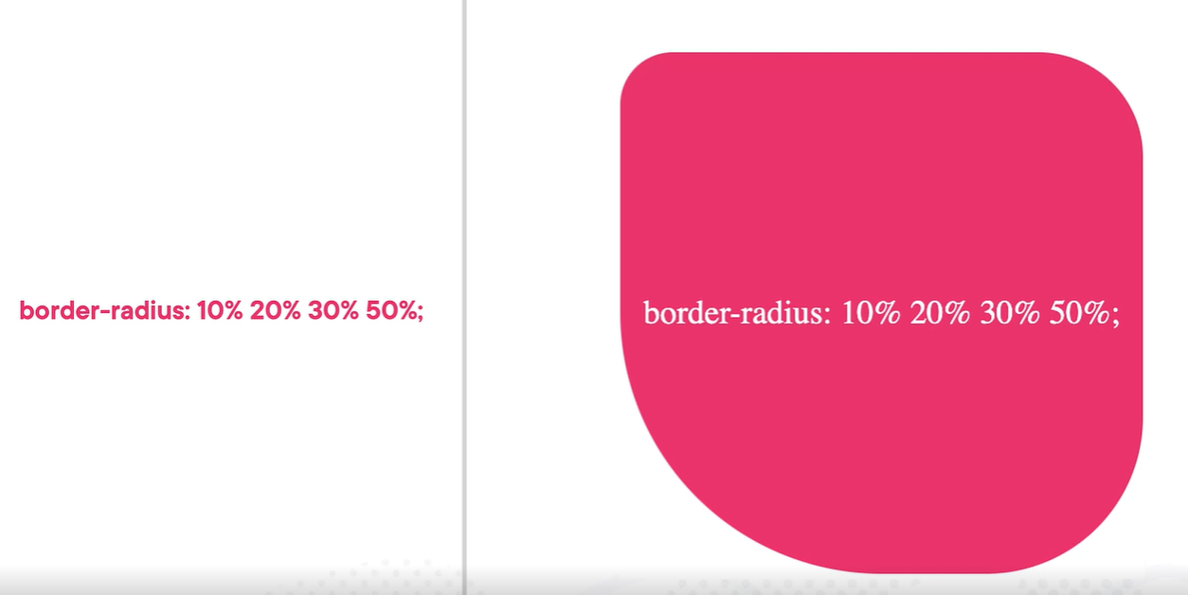
We can specify the border-radius value in pixels, percentage and complex radii (horizonal and vertical radius separately) like below –
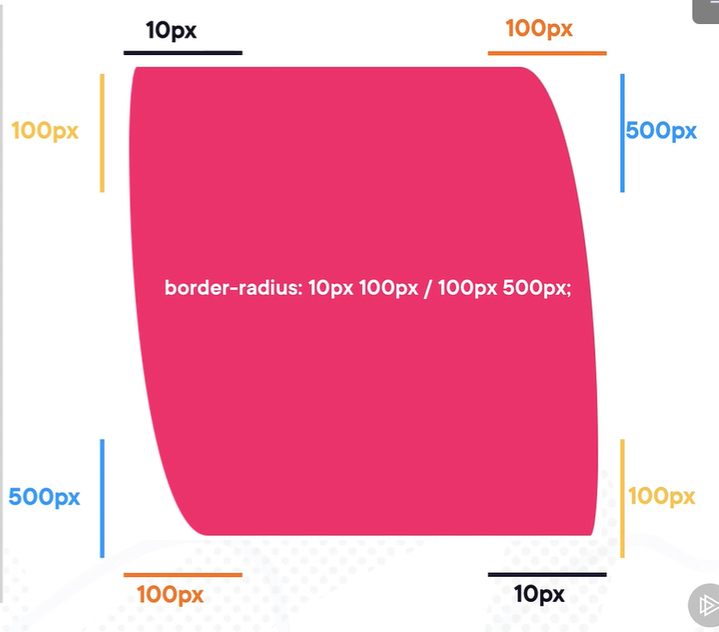
Adding box shadows – box-shadow, blur-radius. It is to avoid flat look.
Applying gradients – background: linear-gradient()
Applying transitions – to make the websites less static. :hover, transition-duration, transition-property, transition-delay.
Backface visibility attribute – this CSS property sets whether the back face of an element is visible when turned towards the user. It is used to avoid a problem when building a 3D object in a 2D space.
Text and typography – font-family, font-weight, color, text-transform, text-align, word-spacing, text-shadow, text-decoration (overline, underline, line-through, dashed, wavy, dotted).

CSS – Misc.
Modern CSS Styles You Should Know In 2024
Container Queries
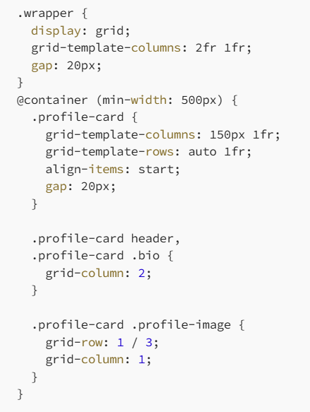
Pseudo-Classes
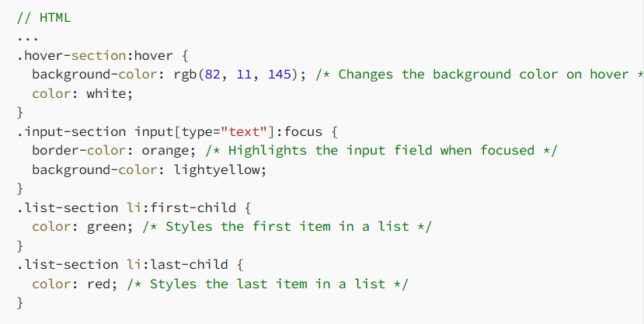
Lab Color Space
